**Original Article (DOI)**: --

**Author(s):** Jingmai O’Connor

**Position:** Professor

**Affiliations:** Institute of Vertebrate Paleontology and Paleoanthropology

**Corresponding Author:** Jingmai O’Connor

**Word count (700-750 max):** --

**Field:** Paleontology

**Twitter handle:** Jugolik

**Keywords**: *Microraptor*; Jehol ecosystem; *Indrasaurus*; stomach contents; predator-prey relationship

***Microraptor* and *Indrasaurus*: food for thought**

*Abstract:* Flying is hard so bird digestion is super-efficient, many casting pellets like owls. The flying dromaeosaur *Microraptor* lacked this ability, which was previously linked with flight. Stomach contents are rare in fossils but this new *Microraptor* preserves a new species of lizard, *Indrasaurus*.

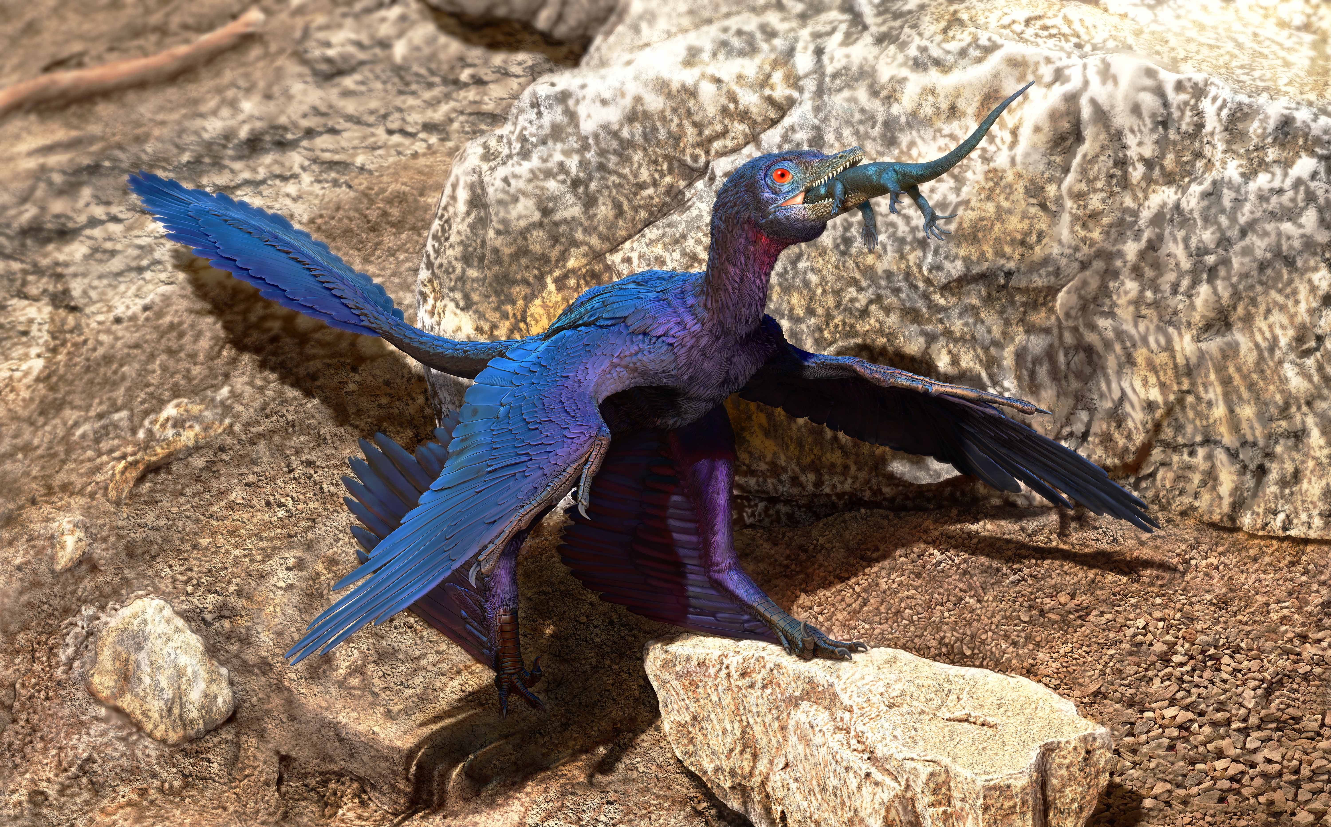

*Image credits: Doyle Trankina*

-- Fossils are rare, period. Fossils with traces of food even more so, but only these can tell us what an extinct species was *really* eating (hypotheses based on morphology are really just educated guesses and isotope analyses can only give us ball-park estimates). Knowledge of predator-prey relationships is necessary to better understand ancient ecosystems, like the 131-120 million year old Jehol Biota in northeastern China. Through this knowledge we not only know more about an individual species’ biology but we also know how different species interacted with each other. Characteristics of these ingested remains such as location within the body and level of articulation can also tell us about the design and function of the digestive system itself. The rocks preserving the Jehol Biota are unusually rich in fossils (and these fossils are unusually well preserved), revealing lots of animals but is most famous for preserving a whole diversity of feathered dinosaurs (like *Guan long*, a feathered tyrannosaurid and *Caudipteryx*, the most primitive dinosaur with wings that definitely wasn’t flying). These include the flying four-winged dinosaur *Microraptor* (it had wings on its hands AND feet). We used to think that birds were the only flying dinosaurs but now we know at least two other groups of dinosaurs evolved flight, scansoriopterygids and some dromaeosaurids like *Microraptor* (but the flying reptiles pterosaurs are not dinosaurs, only close relatives).

Over 200 exceptional (nearly complete, bones still in their original anatomical location) specimens of *Microraptor* have been collected but this is only the fourth to preserve stomach contents: a new species of lizard (*Indrasaurus wangi*) with teeth unlike any other currently known. These teeth suggest a diet different from other lizards currently recognized from the Jehol but other than that we can’t say what it was specialized to feed on (again, without direct evidence in the form of stomach contents, any hypothesis based on tooth morphology is just a guess). Other specimens show that *Microraptor* also ate birds, mammals, and fish (meaning it was an opportunistic predator that ate what it could get) but food is only found in the stomach, whereas the troodontid *Anchiornis* (an older but fairly closely related dinosaur in which flight is a maybe… but probably not) preserves food only in the form of pellets (like those cast by owls). One specimen preserves a pellet in the throat about to be regurgitated consisting of lizard bones indicating that *Anchiornis* and *Microraptor* had similar diets, but they didn’t compete with each other, *Anchiornis* being about 40 million years older. Three other specimens preserve pellets near the body, considered by previous researchers to have been regurgitated shortly before death. But since the pellets are outside the body and consist of fish bones, to be accurate we cannot be absolutely certain these pellets were actually made by *Anchiornis*.

The ability to form and egest pellets, present in many living birds and evolved multiple times in animals independently (such as whales and crocodilians), suggests *Anchiornis* had a better digestive system than most other dinosaurs, which lacked this ability. Pellet egestion means that food can be digested faster and thus more efficiently. Many improvements of the dinosaurian digestive system evolved in the avian lineage (absent in other groups of dinosaurs), like the forming of pellets, are thought to be related to flight, to have evolved to help meet the energetic demands of bird flight, which is the most physically demanding form of locomotion currently utilized by animals (you need large amounts of calories to fly). But *Microraptor* could fly and *Anchiornis* probably could not, which suggests that the ability to form pellets actually evolved independent of flight, at least in *Anchiornis*, and may even have evolved more than once, depending on how *Anchiornis* and birds are related to each other. If *Anchiornis* is part of the group of dinosaurs most closely related to birds than maybe pellet formation evolved once. But currently there is no evidence that the most primitive birds (like *Archaeopteryx* or *Confuciusornis*) had this ability, which among Mesozoic birds is only known in the more advanced group that includes all living birds (Neornithes) nested within it (this large group is called the Ornithuromorpha). This may suggest pellet formation evolved in dinosaurs twice – once in birds and once in the *Anchiornis* lineage. In contrast, *Microraptor* would have probably taken longer to digest each meal and small bits of bone would be present in its feces, similar to what we know about *T. rex*.

The incredible preservation of the Jehol Biota has revealed 20 occurrences of direct evidence of diet – essentially 20 links in the incredibly complex food web that existed 131-120 million years ago. Although very incomplete, this preliminary food web pointed out the importance of fish in supporting secondary consumers (predatorial animals) in this ecosystem.