**Original Article (DOI)**: 10.1126/science.aav3409

**Author(s):** Nandini Ramesh; Kimberly L. Oremus; James A. Rising

**Position:** Postdoctoral Scholar; Assistant Professor; Assistant Professorial Research Fellow

**Affiliations:** University of California, Berkeley; University of Delaware; London School of Economics

**Corresponding Author:** Nandini Ramesh (nandiniramesh@berkeley.edu)

**Word count (700-750 max):** 750

**Field:** Marine Fisheries

**Twitter handle:**

**Keywords**: Fisheries, Ocean Sciences, Economics, Small-World Networks, Marine Policy

**A Connected Ocean: Drifting Fish Larvae Bind Nations' Marine Territories**

*Abstract: Fish in the early stages of their life cycle are carried by ocean currents across international boundaries, making nations dependent on each other to manage their marine fisheries sustainably.*

Marine fisheries are an important source of food, employment, and income for millions of people. Over 90% of the marine fish we eat are caught within countries’ coastal waters, and policies to conserve these fish often assume they stay within those waters their whole lives. However, our study finds that fisheries around the world are tightly connected by the drift of larvae along ocean currents. This implies that countries depend on each other to maintain a healthy population of marine fish, and a collapse in one country could spread to others.

Many fish lay eggs that float. When the eggs hatch, larvae emerge measuring only a few millimeters, and drift with ocean currents until they grow large enough to swim. Fish in these two stages can drift for multiple months, meaning that their movements are determined by currents at the ocean surface. This raises the question of to what extent larvae drift across international boundaries, or how much of the fish caught in one country were spawned in another.

Answering this question requires an understanding of the drivers of larval drift for different species. Ocean surface currents form in response to the winds above them and vary with the seasons. Different species of fish spawn at different times of year, in different locations. The durations for which the eggs and larvae drift also vary by species. We matched these characteristics for over 700 species of marine fish with the currents during the seasons and at the locations of spawning.

Then, using a computer simulation, we calculated where fish spawn are most likely to be carried by the currents. This type of simulation, which calculates the spreading of “particles” of any kind in a moving fluid, has been used to study phenomena such as the dispersal of plastic pollution in the ocean, and to trace where debris from an airplane crash over the ocean may have washed ashore.

Using the results of this simulation, and information on how suitable the conditions are for each species in each country’s territory, we estimated what fraction of each species of fish caught in each country was spawned in other countries’ territories. If a country usually receives fish spawn carried into its territory by currents, its fisheries are dependent on the countries where those fish were spawned. If the number of adult fish in those “source” countries were to decline for any reason, such as overfishing or habitat destruction, then the country would lose a source of fish. Therefore, this poses a risk to the country’s resources.

We mapped all of these dependencies between countries and found that the ocean’s coastal fisheries form a single network, composed of over two thousand linkages. This highly-interconnected network falls under the category of networks known as small-world networks. An important property of these networks is that while they typically have clusters of densely connected nodes (countries), the number of “steps” along the network that are needed to get between any two nodes is quite small.

This means that anything that can be passed along such a network can easily spread. If a fishery were to collapse in one country, the neighbors that usually depend on it for spawn will lose a portion of the fish they catch. This may cause them to overfish, or the ecosystem in these fisheries to be disturbed. This type of disturbance could travel from neighbor to neighbor along the network with relative ease, meaning that within a few years, a large number of countries may feel the effects of a fishery collapse in a single country.

Countries depend on their marine fisheries in different ways. For some, they are an important source of food, while in others, they employ many people or generate a large amount of income. We evaluated how dependent each country is on the fish it receives from other countries’ spawning grounds in terms of food security, employment, and Gross Domestic Product (GDP). We found that the countries most affected by these exchanges are in the Caribbean, West Africa, the western Pacific, and Northern Europe, where many coastal countries lie close together. All of these regions except the last also have relatively rapid ocean surface currents.

In addition to the flows of fish spawn due to ocean currents, countries’ fisheries are also connected by the migrations of adult fish, and treaties allowing various countries to fish in each others’ waters. The more we understand how connected marine fisheries are, the clearer the need for international cooperation to manage them sustainably.

*Suggested Picture*

We have the following images that may be used, as well as an animation. Captions below:

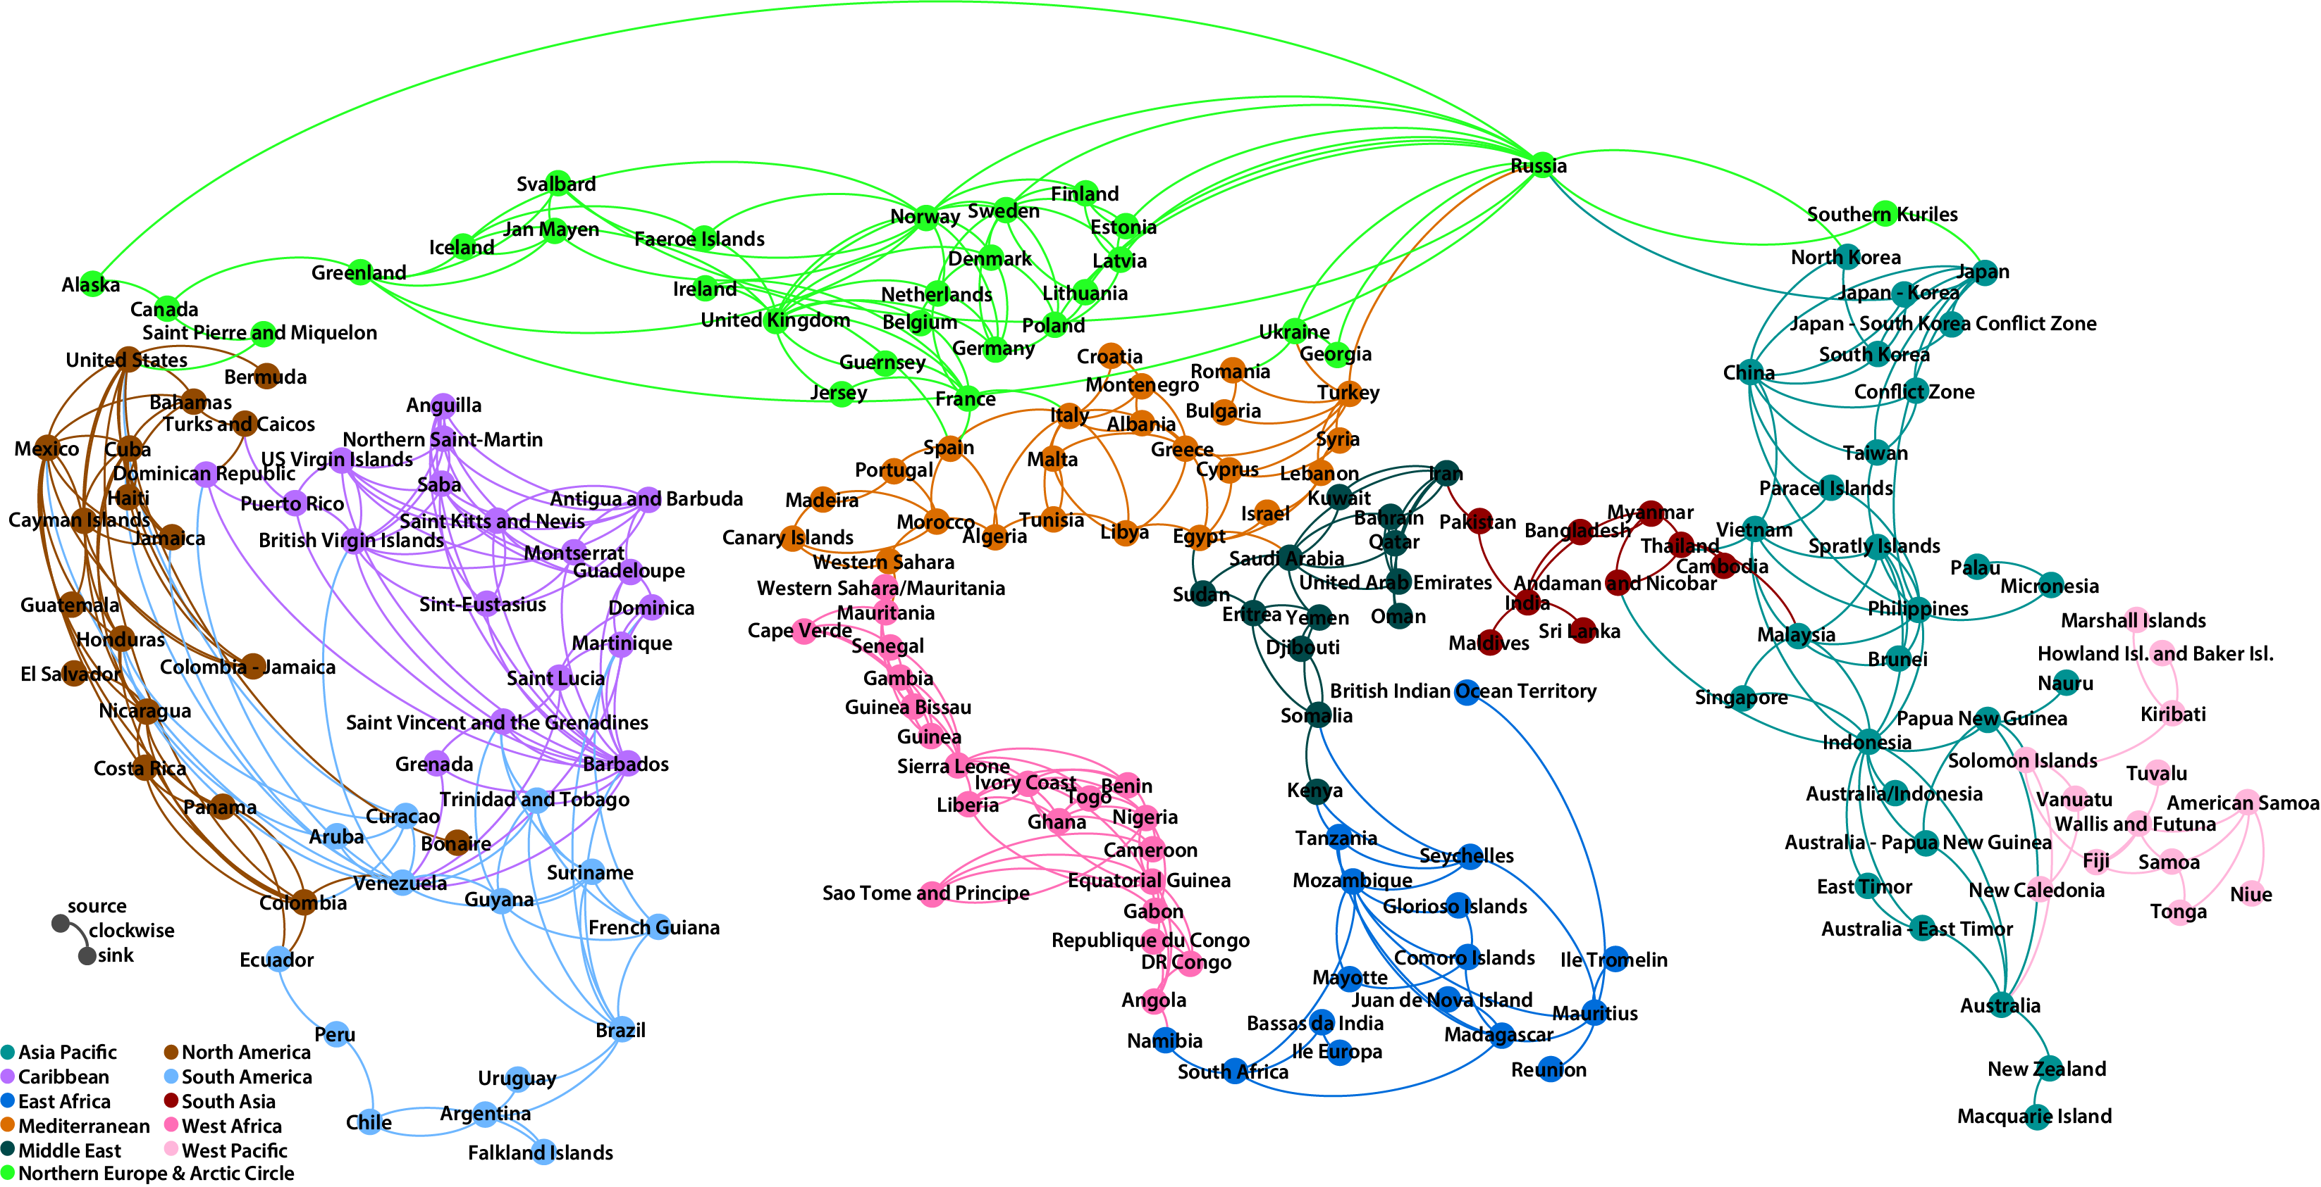

The network of the international connections due to fish larvae. Only the strongest third of all connections is shown.

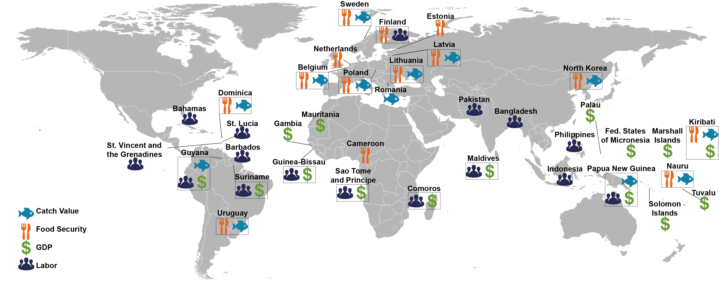

The countries most affected by international flows of fish spawn in terms of total catch, food security, jobs, and GDP.

Animated schematic illustrating our methodology (Available on YouTube at <https://youtu.be/7-tNQ0-Y5K0>)

Caption:

A schematic of our simulation for the Largehead Hairtail, which spawns in Tunisia in July and August. The fraction of this species caught in each country that originates in Tunisia is shown in green on the pie charts.