Bloody-Minded Parasites and Sex

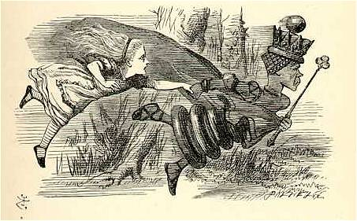The Red Queen hypothesis gets its name from Lewis Carroll’s, *Through the Looking Glass*. The Red Queen tells Alice, “It takes all the running you can do to stay in the same place.” This is a metaphor for the interaction of hosts and their parasites: host populations continually evolve to resist their parasites, but they can never escape them, because parasites themselves continually evolve to overcome that resistance. Credit: commons.wikimedia.org

Most plants and animals reproduce sexually. Why is sex so common? This question has intrigued scientists for generations. Even Darwin pondered its prevalence. Sex occurs when two organisms merge their genetic material. Sexual parents produce genetically distinct offspring. Many organisms, however, reproduce asexually, meaning a single organism produces offspring genetically identical to itself. In some species, sexual and asexual females even live together in the same population.

Asexual reproduction has a numeric advantage over sex. Asexual females invest all their energy into the production of daughters. Meanwhile, sexual females devote half of their energy to the production of sons. Males cannot directly produce offspring. In populations where sexual and asexual individuals live together, we expect asexual individuals to increase in number faster and outcompete sexual individuals.

Despite this disadvantage, sex is everywhere. Why?

The Red Queen hypothesis suggests that sexual individuals have an advantage when parasites are present.

Parasites must infect hosts to survive. In doing so, they may kill hosts or reduce host reproduction. Hosts that can resist infection have an advantage over those that cannot, so we expect host populations to evolve resistance to their parasites. Parasite populations can quickly adapt to overcome that resistance, countering each evolutionary advance made by their hosts. Evolution of parasite populations is so relentless that one evolutionary biologist described parasites as “bloody-minded.”

This bloody-minded nature of parasites puts asexual hosts in a particularly bad position. Asexual offspring are genetically identical to their parents. This means that the same parasites that infect asexual parents can also infect their offspring. Sexual individuals produce genetically distinct offspring, so the same parasites that infect sexual parents may fail to infect their offspring.

Current evidence supports the Red Queen hypothesis. Although, the hypothesis has a problem: for sexual individuals to outcompete asexual individuals, parasites must be highly virulent.

What do we mean by virulent?

Hosts experience costs when infected by parasites. Costs include decreased survival and reproduction. The term *virulence* provides a measure of this cost of infection. Highly virulent parasites strongly reduce host survival and reproduction, while low virulence parasites have little effect. For example, we consider Ebola highly virulent because it kills many who contract it. The common cold has low virulence -- death is very uncommon.

The Red Queen requires parasites to kill most of their hosts for sex to persist. Lots of parasites are not that virulent!

So is the Red Queen hypothesis wrong?

We tested a potential solution to this problem. We know that parasites may be highly virulent one season but exhibit low virulence the next. For example, some years the flu virus is mild. Other years, virulence increases, and more people die.

Can sex persist when parasite virulence varies from high to low?

We used a mathematical model to assess whether variation in parasite virulence can maintain sex. Mathematical models are useful when experiments prove challenging.

In our model, we simulated populations with both sexual and asexual hosts. Hosts were exposed to parasites that varied in virulence through time. In some simulations, virulence varied a lot. In others, we introduced small amounts of variation. We aimed to simulate a variety of conditions that might represent the true nature of interactions between hosts and parasites.

Did variation in virulence maintain sex?

Yes!

Variation in virulence increases the prevalence of sex. Sexual individuals even outcompeted asexual individuals when mean virulence was low, as long as virulence varied enough that it was occasionally high.

Why does variation in virulence maintain sex?

Variation in parasite virulence presents greater challenges for asexual hosts than sexual hosts. This happens because asexual individuals tend to be heavily infected. Asexual offspring get the same parasites that their parents have. This is not a problem when parasite virulence is low, but the number of asexuals then crashes when parasite virulence increases. Sexual hosts tend to be less infected, so they outcompete asexual hosts during periods of high parasite virulence.

In nature, host populations likely experience variation in parasite virulence. Previous studies have investigated the abundance of sex under constant levels of parasite virulence. This study provides evidence that sexual populations still have an advantage in the presence of parasites when conditions more closely resemble the real world. Using mathematical models, we laid a foundation for future studies to experimentally evaluate the maintenance of sex when parasite virulence varies.