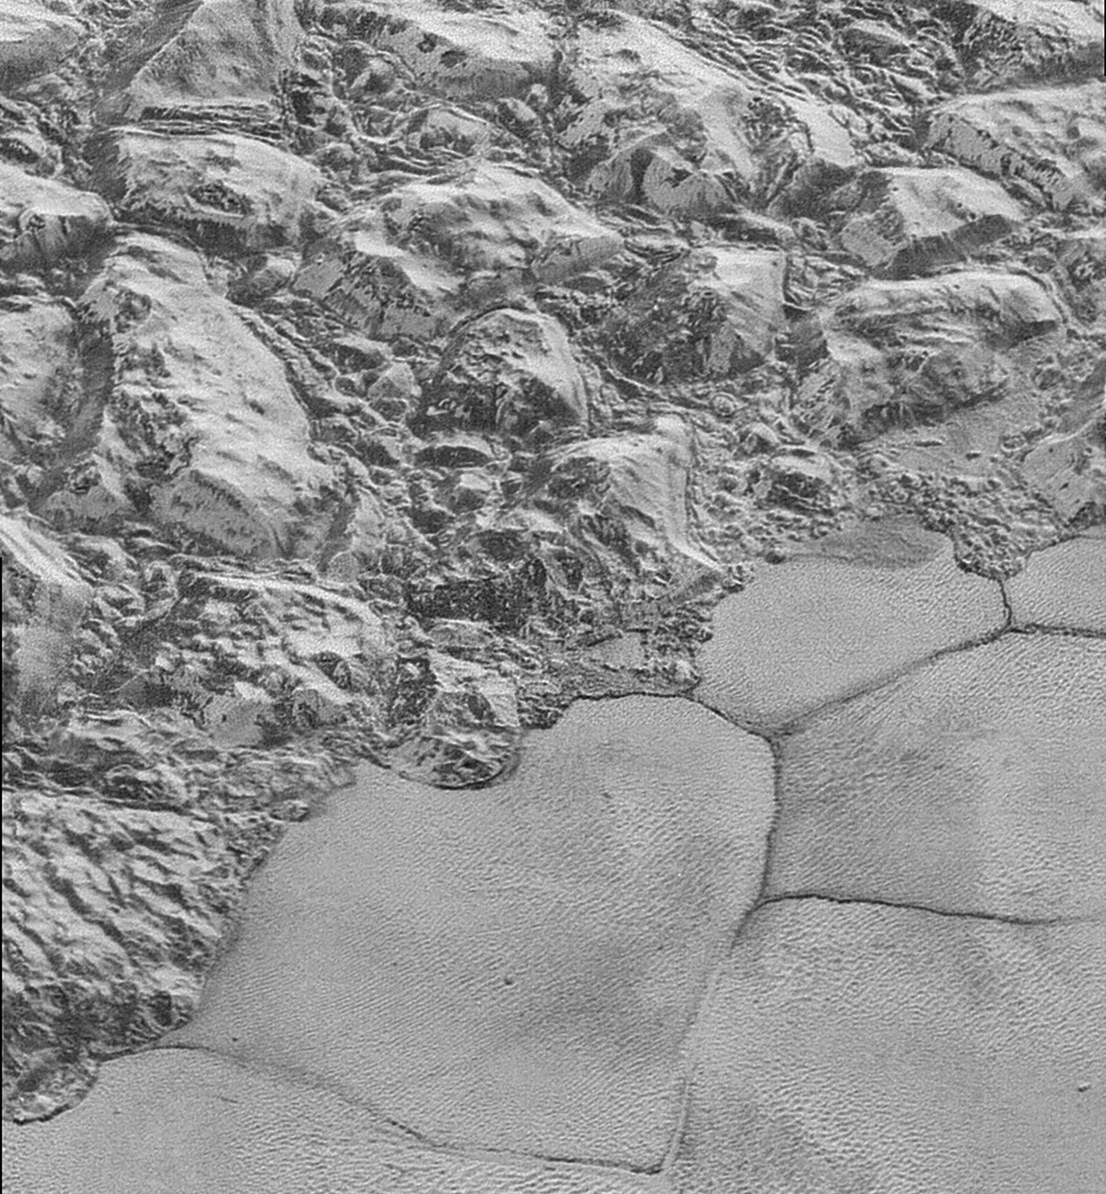

*Image credit: NASA/Johns Hopkins University Applied Physics Laboratory/Southwest Research Institute.*

**Methane ice dunes on Pluto**

Prior to NASA’s New Horizons mission to Pluto in July 2015, the highest resolution image of the dwarf planet was just twelve pixels across the whole world. New Horizons’ images, from its single 30000 mph fly-by, were at best around 80 m *per* pixel, and revealed a geologically diverse and dynamic surface, with mountains, ice caps and, on the whole, amazingly recognizable terrain. This is especially remarkable, given the frigid temperatures (-230°C, or only around 40°C above absolute zero), which in turn lead to exotic compositions. At this temperature, the mountains are formed of water-ice, acting as an analogue for the earth’s rocky crust, and the ice-caps are formed of solid nitrogen, methane and carbon monoxide.

A small team with past experience of working on dunes on other worlds, such as Mars and Saturn’s moon Titan, noticed that on the surface of the large ice-cap Sputnik Planitia, there were also many ridges, with a remarkable similarity to Earth’s dunefields. The dunes were regular and repeating, like Earth’s dunes, they occasionally branched, as dunes on Earth do, and they clearly appeared to be sitting on the surface of the ice.

Moreover, they were located perpendicular to some nearby ‘wind streaks’, where erodible material had been smeared across the landscape by the wind; similar examples are easy to find from satellite images of the Sahara. And these, in turn lined up beautifully with the margin of the ice, where it is bounded by an Alpine-scale mountain range, suggesting that winds driven down from the mountains, just as Earth’s mountains often drive persistent winds onto the surrounding lowlands.

The spectral response of the both the dunes and the wind streaks suggested that they were likely made of methane ice. Because the ice below the dunes moves, which would disrupt the regular patterning observed, it also meant these dunes must have been formed recently (probably no more than thousands of years at most).

But there was a problem. Pluto’s surface pressure was shown by New Horizons to be just 1 Pa, or around 1/100 000th that of Earth. How could it be possible to have dunes – which, by definition, require wind – when there was almost no atmosphere to create a wind?

The answer came in stages, and was initially driven by collaboration with numerical modellers, who showed that, due to the thin atmosphere, reduced gravity and low density of the likely grains, once grains were initially lifted into the air, they would be much, much more prone to staying airborne. The effect of grains ‘splashing’ back onto the surface and launching more grains is also enhanced, and creates a positive feedback that would promote more movement, even in the rarefied atmosphere. This reduced the necessary wind speeds needed to keep grains going to a level thought to be found on Pluto’s surface (about 10 ms-1; on Earth, this would be a fresh breeze, enough to start small trees swaying gently). But the numerical work also gave one more detail; the only grains that would credibly form the observed dunes would be around ¼ mm across; in other words, the same size as Earth’s mineral sand dunes.

This still left a problem; how did the grains get airborne in the first place? By this point, the team had grown, and now included the New Horizons Geology and Geophysics Imaging Team, who provided the crucial final insight. Although Pluto is so far from the sun as to never be lit more than a dusky twilight, the sun still warms the surface a little; enough to sublimate (that is, turn directly from solid to gas) the solid surface a little. As the surface of the mixed ice (methane/nitrogen) sublimated, the nitrogen would preferentially be lost first due to its lower freezing point. This would create as a gaseous pressure at the surface with enough force to loft the still-solid methane grains. Moreover, an independent method based on the scattering of the spectral reflectance used to identify the composition of the ice provided confirmation; it was consistent with a granular surface with grains of ¼ mm across, as the model had predicted.

The discovery of dunes on Pluto shows that even the cold, icy, outer worlds of the solar system (and thus presumably those of other solar systems, with exoplanets being identified weekly) can have dynamic, active geological surfaces and atmospheric interactions, which shape a world strangely familiar to our own.