Airfoil analysis

Computer Science Non-Exam Assessment

Tatiana Kapitonova

Candidate Number: 6059

STAGE 1: Analysis 4
1.1 Background 4
1.2 Problem Development 4
2.1 Client interview 4
2.2 Interview takeaways 5
2.3 Addressed problem 6
1.3 Existing system observation 6
3.1 XFOIL 6
3.2 XFLR5 7
1.4 Research of problem 8
4.1 Historical background 8
4.2 Thin Aerofoil Theory 8
4.3 Vortex Panel Method 9
1.5 Objectives 9
5.1 Quantitative objectives 10
5.2 Qualitative objectives 11
1.6 Critical Path 11
6.1 Aerofoil Geometry 12
6.1.1 Importing Geometries 13
6.1.2 User-defined Geometry 13
6.2 Flow velocity profile: VPM 13
6.3 Pressure Distribution 14
6.4 Coefficient Computation 15
6.5 Plot, Analysis, and Comparison 15
1.7 User requirements and Limitations 16
7.1 User requirements 16
7.2 Limitations 16
STAGE 2: Design 17
2.1 Program Structure 17
1.1 Design Diagram (UML) 17
1.2 Main Encapsulation Modules 21
1.3 Data items & file structures 21
1.3.1 Aerofoil geometry 21
1.3.2 Key Variables 22
1.3.3 Databases: SQLite (Not implemented) 22
1.3.4 Matrix Array 23
1.4 Libraries 23
1.4.1 MatPlotLib 24
1.4.2 NumPy 24
1.4.3 Pygame 24
1.4.3 SciPy [potential] 24
2.2 Main Algorithms 24
2.1 Mathematical Modelling 24
2.2 GUI Interaction Algorithm 26
2.3 Prototyping 27
3.1 Graphic User Interface 27
3.2 Aerofoil Editor 29
3.3 Panel Class 31
3.6 Integrating the program files 32
STAGE 3: Testing 33
Program Demonstration Video Link 33
4.1 VPM 33
1.1 Testing Strategy 33
1.2 Version 1.1 Preliminary testing :: the matrix [ver1.1.py] 34
1.3 Ver 1.5 Smoke testing :: determining data validity [ver1.5.py] 35
4.2 GUI 37
2.1 Testing Strategy 37
2.2 Unit testing: sliders [ver2.1.py] 38
2.3 Stress Testing (attempted erroneous input) 41
2.4 GUI-VPM linked testing 43
4.3 Exception Handling 44
3.9.1 Arithmetic errors 44
3.9.2 User Input Exceptions 45
STAGE 4: Evaluation 47
5.1 Evaluating objectives 47
5.2 Addressing feedback 49
5.3 Possible improvements 52
Citations 53
Python Code 54
Main1.4.py 54
Runfile.py 81

STAGE 1: Analysis

1.1 Background

My client is the Headington school Science department, and my end users are the students studying Physics. My primary users will be U3 (year 7) students participating in the ‘Lift-off challenge’, who will be able to use my software to increase their understanding of drag, lift, and how this understanding can be applied in designing aeroplanes, which is vital for being successful in the challenge. They will be able to design and compare different aerofoil shapes, choose the best performing one, and then output it to a 3D printer, which creates a product (aeroplane wing) that could be used in the challenge. Additionally, I will have secondary end users, who are future L6 students conducting practical investigations on forces of air resistance as well as gravity and acceleration. The software will not only help them understand the physics behind it, but also gain experience operating programmes used by physicists and engineers in university and in the field. My product will also be available to be used by any amateurs interested in analysing and designing aeroplane wings or car spoilers.

1.2 Problem Development

2.1 Client interview

For research into a potential problem, I interviewed the Head of the Science Department at my school, Mr Jason Morris.

What is the lift off challenge? What is the process and the objectives?

The lift-off challenge was devised as a STEM initiative extended project for year 7s. It gives them scope to think about flight in animals and humans, it gives them scope to think about the history of plane design, from very old designs to modern aircraft. It also gives them the opportunity to design their own propeller planes using materials we have got in school, and they’re expected to build them themselves. They also get to test fly them and see how their design fares, then redesign the planes in an iterative process, similar to what real engineers do. Within that, we give them the chance to look at CAD packages, which show them how real design engineers work on aircraft development. The mathematics department introduces them to the numbers and calculations involved, and they also get a chance to personalise the planes. They spend two weeks building it during various lessons.

What materials do they make the aeroplanes out of?

Primarily they are using balsa wood, tissue paper, resins, glue guns, small pieces of metal, very stretchy rubber bands, and in some cases thin polystyrene rings. None of the materials are pre-cut, the students get to construct and cut out the shapes, ang glue them together.

What do you think is the hardest part of the challenge?

Working collectively and productively as teams. And the other thing I’ve noticed - the way they launch their planes. Most of them throw planes forward and into the ground. Understanding about the torque coming from the propeller when they launch it is important, because otherwise the plane spirals immediately into the ground.

Do you have any suggestions regarding the software, and how I can make it accessible to year 7s?

Right now there is very little scope to adjust the shape and curvature of the wing considering the material that is used. So I would suggest connecting the software to some sort of laser-cutting or 3D printing device to make the intricate aerofoil shape.

What teachers are involved in coordinating the challenge?

All the science teachers, maths department, computing, technicians.

2.2 Interview takeaways

The Lift-Off Challenge presents a diverse and very comprehensible learning experience for aspiring young scientists, giving them a taste of what engineers do and how they overcome challenges. It is also a great introduction to the basics of rocket science, as participants get acquainted with all the main stages - design, digital modelling, computational analysis, manufacturing, and testing - of a small-scale aeroplane.

Students are provided with a variety of raw materials that they have to measure and cut themselves, giving them the opportunity to engage in the manufacturing process themselves. However, the nature of the materials and available tools limits the degree to which the wing shape can be altered, so constructing a precise shape akin to that of an aerofoil, which has curvature variation in all 3 dimensions, will require a 3D printer. The technical limitations with making the wing using hand tools means making designs with high resolution won’t be feasible - they should ideally be simple shapes.

Students at this level are also less familiar with how different kinds of forces and torques will affect their aeroplane, and hence may not be able to predict its motion and figure out an optimal launching strategy. In the Lift-off challenge, the model aeroplanes are launched by hand, making it difficult to predict precise launching conditions including pitch/yaw/roll. The aim of the program

2.3 Addressed problem

The field of aerodynamic analysis is widely applied in the aerospace and racing industries, and is essential for developing any lift-generating component. Therefore, there is a lot of specialised and highly configurable software available to aid this process, however the entry threshold for using such software is very high as it is highly technical and inaccessible for people outside the industry. The solution I aim to provide is software which would make it easy and convenient to design aerofoils for anyone without the knowledge of the theory behind it. I intend to reduce some of the functionality to avoid overwhelming the user, make an intuitive interface, add configuration options, and simplify some of the calculation processes but ensure the result is still reasonably accurate for amateur aerodynamic analysis. This will enable my program to be used by students in concurrence with the Lift-Off-Challenge, while investigating drag in a L6 experiment, or for a personal interest project. The primary aim of this project will be not to provide the user with precise launch conditions for optimal lift to drag ratio nor give any exact solutions, but rather to help them develop a better intuition behind basic aerodynamic concepts. This way, the students can obtain better results in a project such as the Lift-Off Challenge, even though it entails a lot of imprecise making-by-hand and measuring-by-eye.

1.3 Existing system observation

3.1 XFOIL

XFOIL algorithm flowchart
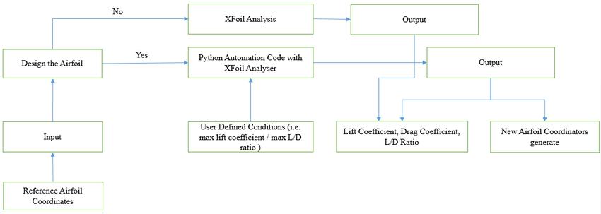
(Immanuel & Somashekar, 2021, Fig 1)

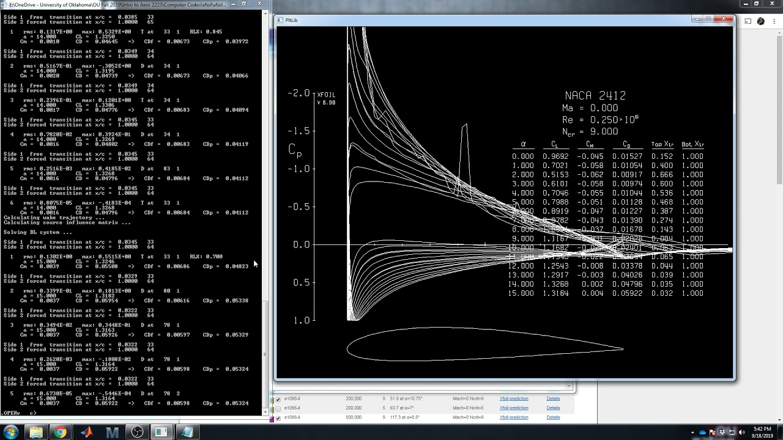
Industry standard software, XFOIL is known for its fast speeds when generating Aerofoil tables. It is used in both viscous and inviscid flow, but only for low Reynolds numbers, meaning only in laminar flow. It is very highly configurable, although lacking in accessible interface, because everything has to be configured manually.

3.2 XFLR5

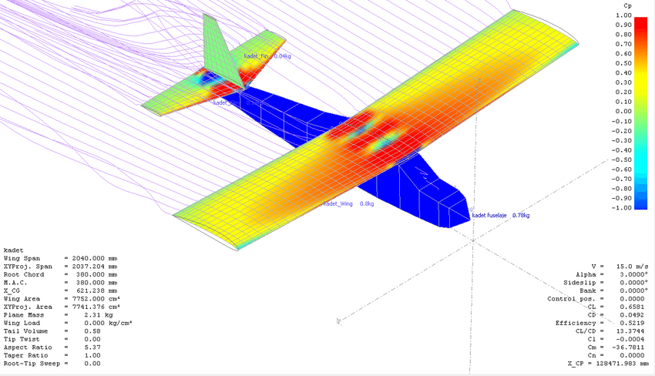

XFLR5 supports the development of airfoils, wings, and planes at low Reynolds numbers, by generating detailed, gradiented 3D velocity profiles and pressure distribution to assess aerodynamic properties and stability. I will refer to and compare with this program as I will be working on implementing these features

1.4 Research of problem

4.1 Historical background

Sir George Cayley (1773-1854), now often referred to as “the father of aviation”, is a pioneer in the field of Aerodynamics. His life was spent investigating the mechanics of flight and engineering systems to sustain it, including the successful launch of the first piloted glider. His most import contributions to the future of aerial flight were:
- Identifying the four forces monumental to a flying vehicle - weight, lift, drag, and thrust
- Researching and identifying the importance of cambered wings, which are asymmetrical on the top and bottom and are hence more effective at generating lift
- His research on streamlining and longitudinal & lateral stability
- The idea of separate systems for thrust, lift, and manoeuvring

Following Cayley, physicists and mathematicians such as Prandtl, Lanchester, and Kutta continued research on the lift and drag generated by aerofoils and the relationship between them. These methods were rudimentary until the advent of wind tunnels in the early 20th century, which allowed different aerofoil shapes to be tested easily. It provided a controlled environment for recording precise measurements of lift, drag, and other aerodynamic properties.

In 1915, NACA (National Advisory Committee for Aeronautics) researched and developed standardised aerofoil shapes to be used in the aviation industry. The series of NACA aerofoils are still widely used today, as choosing a standardised design alleviated the need for companies to perform their own testing, which can be a long and expensive process. In my analysis software, users would be able to use NACA aerofoils with predefined geometries if they choose so.

4.2 Thin Aerofoil Theory

Thin aerofoil theory, developed in the 1920s, provided a simplified model to estimate the lift distribution of an aerofoil. As the name suggests, the theory assumes the aerofoil to have an infinitesimal thickness. This way, only the coordinates of the camber line - the mean line connecting the leading and trailing edges - is considered.

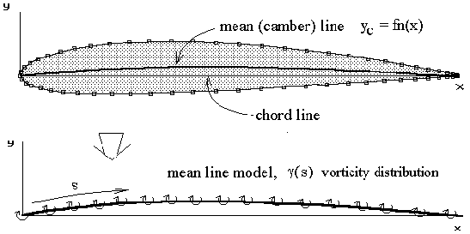
Simplifying the geometry in this way transforms the potential flow equations to be linear and more easily computable, which was necessary during the times when computers weren’t as widespread or powerful.

(Houghton & Carpenter, 2003, p173)

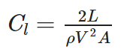

The theory allows the lift coefficient to be calculated as (Dasilva, 2024)

On the other hand, the crude simplification of the
geometry limits the potential applications of the theory to small angles of attack and small camber, as otherwise non-linear effects become too significant. Because of that, today thin aerofoil theory is only used in education or preliminary development stages.

4.3 Vortex Panel Method

As technology advanced and computational power increased, it became possible to run complex calculations, make detailed simulations of aerodynamic behaviour, and consider the effects of fluid viscosity and turbulence.

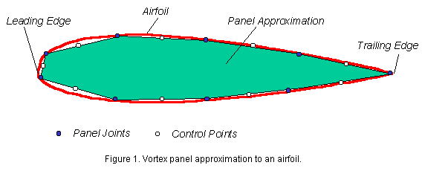
One tool used in CFD (computational fluid dynamics) is the vortex panel method. Rather than the chord line analogous to thin aerofoil theory it looks at the shape of the aerofoil outline, dividing it into panels. Each panel is defined by 2 points and represents the straight line between them. Here it becomes apparent that an aerofoil approximated by N panel joints hosts N-1 panels. Increasing the number of panels will provide a more accurate estimate of the wing geometry and hence velocity profile, however after a certain point the change becomes negligible as the result converges towards a value.
(Davenport, 1998)

The specifics of the VPM algorithm will be explained in detail in a later section, as this is the one I chose to implement in my project for its significantly greater precision and versatility, albeit also more challenging in complexity and taxing in computational requirements.

1.5 Objectives

In order to ensure I remain on track with the project and achieve all my aims, it is important to set out clear objectives. I intend to design, implement, and test the solutions to each before moving onto the next in an iterative development process

5.1 Quantitative objectives

- 1. Airfoil geometry: to achieve this objective, I must implement a system for declaring the aerofoil geometry to be used in calculations and modelling, implemented in a visual manner, through a python library such as matplotlib. The displayed shape should directly correspond to the values used in analysis calculations. It should correctly and consistently identify the leading and trailing edges (as in those are handled differently in calculations).
- 2. Aerofoil editor: to make the geometry interactable, I intend to use a GUI library to construct an interactive development screen where the student will use a computer mouse to drag and adjust the shape of the aerofoil in real time, with the geometry being displayed dynamically.
- 3. Velocity profile and pressure distribution: this aim is dependent on subsequent outputs of my model. I intend to break down the geometry into smaller sections (‘panels’) and implement the vortex panel method in order to create a pressure distribution. This will then allow me to calculate parameters like the different aerodynamic coefficients.
- 4. Graphical output: in order to match this target, I will ensure my program is able to compute, output, and explain the following graphs: Angle of Attack (AoA) against lift coefficient, AoA against drag coefficient, lift coefficient against drag coefficient, all using a graphing library. The values of these are dependent on the execution of the previous objective.
- 5. Time complexity: ensure the analysis runs in a reasonable time scale.
  - The initial plan to determine whether the time complexity and accuracy are adequate involved comparing my result with the output of an XFOIL program (an aerofoil analysis software often used in higher education and industry). However, after further research it became apparent the comparison isn’t sensible, as XFOIL uses a method significantly different from the Vortex Panel Method which I’m using.
- 6. Aerofoil comparison: to alleviate some challenges of developing a wing design, I will implement an automatic system to compare between different aerofoils, making it easier to choose the most appropriate one. This will include a table listing the Cd and Cl values for different AoA of each aerofoil, as well as a same-axis plot of all the graphs and distributions.

- [potential] 3D printing: will involve a way to convert a chosen wing design into a version ready to be 3D printed with appropriate dimensions and materials.

Outside the scope of the problem:
- Reynolds compatibility: this aim includes making my algorithms take into account the Reynolds number of the fluid flow and ensure compatibility with different values of it. A reynold number is a quantity describing the fluid and taking into account its density, flow velocity, and dynamic viscosity. It is necessary for predicting turbulence and flow behaviour.
I’ve chosen against doing this objective, because at higher Reynolds numbers (turbulent flow), the vortex panel method I’m using becomes increasingly inaccurate and a potential alternative solution greatly increases in difficulty. Furthermore, it is not as applicable towards the programs’ intended users, as they will use the program’s output in flow conditions where they are unaware of the Reynond’s number, on the surface of the Earth. Instead, I will assume it to be constant, and relatively low.

5.2 Qualitative objectives

- 7. GUI Graphic User Interface: As my main objective is to create software accessible to school students without technical knowledge of the subject, the primary measure of my success will be a thought-out interface that is easy to navigate. All its functions should be in visible places and clearly explained, so that my end-users would not need an instruction manual to operate the system. There should ideally also not be any interaction with the console, only the GUI elements.
- 8. Output and data representation: the only visible outputs of my analysis software will be the tables and graphs (and the editor screen), so they need to be extensively labelled to give the user all the information they may find useful in their design and comparison. I will determine whether this objective is met by conducting user tests on people without prior knowledge of the program or the theory behind it, and asking for feedback on how easy it was to navigate.

As each of these aims is highly subjective, I intend to test the outlined functionalities by giving them to a range of potential end-users (U3 to L6 students), observing whether they would be able to operate the system without external support, and asking them for improvement feedback.

1.6 Critical Path

In order to develop a critical plan for the project, I started by determining what the core functionality of the program should look like. This resulted in a flowchart, roughly outlining the steps the program should go through. Using the method of abstraction, I tried to identify the core elements I should focus on first.

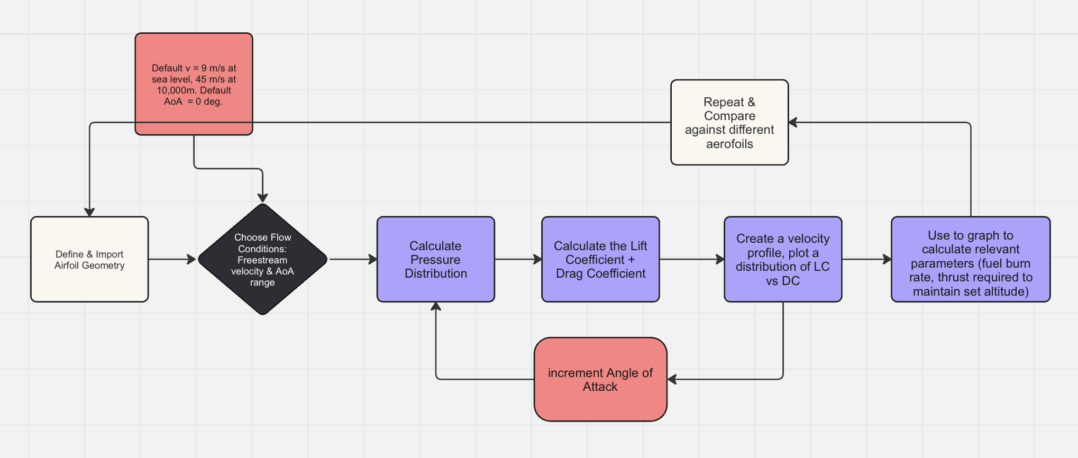Made using graphic editor ‘Miro’

Following that, I worked to decompose the problem by breaking it down into smaller and more manageable parts, resulting in the following tree diagram. The end nodes represent the core necessary elements I must begin with before being able to add functionality to them and build up towards a complete solution.

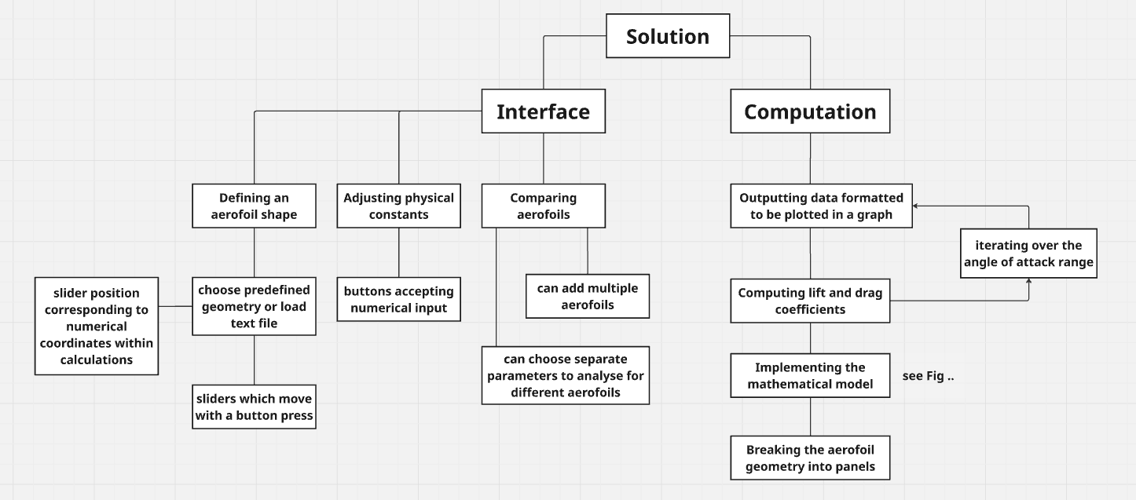

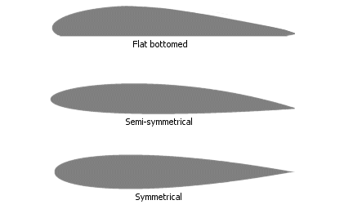
6.1 Aerofoil Geometry

The shape of an aerofoil will be defined by a set of coordinate points, which start at the trailing edge, go anti clockwise and return back to the trailing edge. The rightmost and leftmost points will be automatically as the leading and trailing edge respectively. A straight line between them is the chord line, whereas a curved line which follows the mean position between the top and bottom edges is the camber line. The base program will have 1-3 pre-installed airfoil shapes that the user can select from.

6.1.1 Importing Geometries

One way to use a non pre-installed geometry will be to upload a text file containing the coordinates of the shape. These can be found online and are widely used in other similar applications. Examples of such geometries will include the industry-standard NACA (previously mentioned) and RAF. The coordinate system and scale used for these airfoils will be consistent with that used in the pre-installed options or the editor.

6.1.2 User-defined Geometry

For those looking to design their own shape or compare it to an existing one, the software will include a live editor. Using peripheral devices such as the keyboard and mouse, students will be able to drag different points along the curve, altering the entire edge along with it to ensure the outline remains a smooth curve. This will give freedom to choose the chord length and orientation, type of shape and curvature of the between the edges.

To help and guide the user in the right direction, the editor will impose restrictions on their design. This will include the maximum and minimum length and thickness, as well as curvature.

Implementing this feature will require more research into rendering and dynamic geometry as it will need to perform complex geometrical computations as the user is using the system. With consideration of the potential challenges associated with implementing this feature, it will not be a primary focus of the critical path, giving way to other essential features.

6.2 Flow velocity profile: VPM

Once the geometry is defined, my algorithm will use the Vortex Panel Method to create a flow velocity profile which demonstrates how the flow lines curve around the aerofoil. Each two adjacent coordinate points will represent one panel in the approximation.

The angle of attack (AoA) defines the angle between the freestream flow and the chord length. It starts at the lower end of a user-defined range and increments at regular intervals before reaching the upper bound of the range. Each time it increments, the flow velocity profile and each subsequent computation will need to be recalculated, to demonstrate how aerodynamic properties of the aerofoil change as the AoA does. An
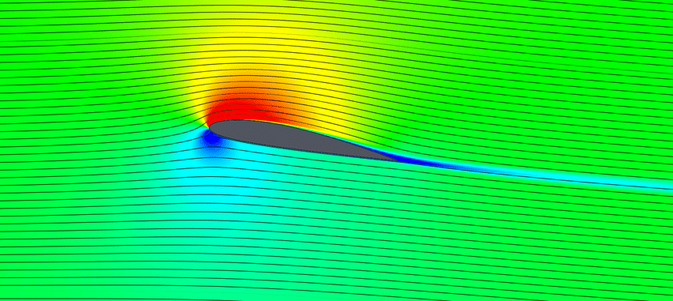
additional functionality would allow the user to input their own freestream velocity

(Hetyei et al., 2020)

(velocity of the fluid far from the wing), although the default conditions would be horizontal (neutral) wind and a choice of either 9 m/s velocity at sea level or 45m/s at 10,000m (Kite Gen, 2007). The freestream velocity influenced the Reynold number, which is an important metric in later calculations.

Boundary conditions

- The flow next to a control point can never be oriented perpendicularly to it, meaning the normal velocity to it is always 0.
- At the trailing edge, the normal and tangential vortex strength are equal and opposite → their sum is 0

Method

- After the surface is defined into panels according to the coordinate points, we calculate the control point, which is the midpoint of the panel.
  - Then, the panel lengths and angles with the horizontal are calculated
- For each panel, the normal and tangential vectors, ni and ti respectively, will be defined by:
N_{i} = (-sinθ_{i}, cosθ_{i}) & t_{i} = (cosθ_{i}, sinθ_{i})

- Using potential flow theory formulas, calculate the set of matrices representing influence coefficients Aij, each corresponding to a panel defined by the control point (i,j)
- Formulate and solve the system linear equations simultaneously, having applied the boundary conditions, to get a vortex strength at each panel [A]{g} = {B}. Using that, calculate the tangential velocity at each control point.

6.3 Pressure Distribution
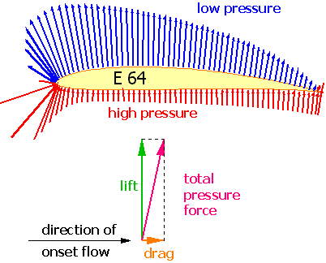

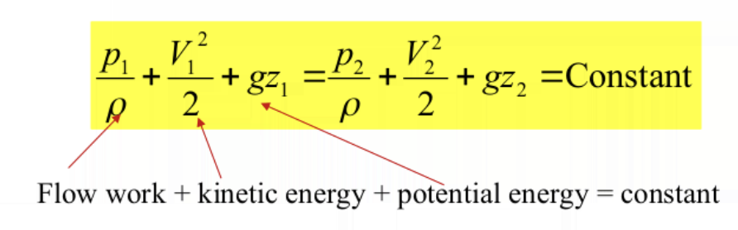
Having calculated the tangential velocity at each panel, I will then use Bernoulli’s equation for inviscid flow to calculate the pressure coefficient to be plotted as a pressure distribution. This demonstrates the magnitudes and directions of forces the fluid exerts on the aerofoil, allowing visual representation of the resultant force generating lift on a wing. The regions with higher flow velocity coincide with lower pressures and thus the higher pressure from the bottom, where fluid is moving slower, creates an upward force.

I will aim to make both graphical outputs from the velocity profile and pressure distribution coloured using a gradient to raise understanding of what causes lift to generate from a wing.

6.4 Coefficient Computation
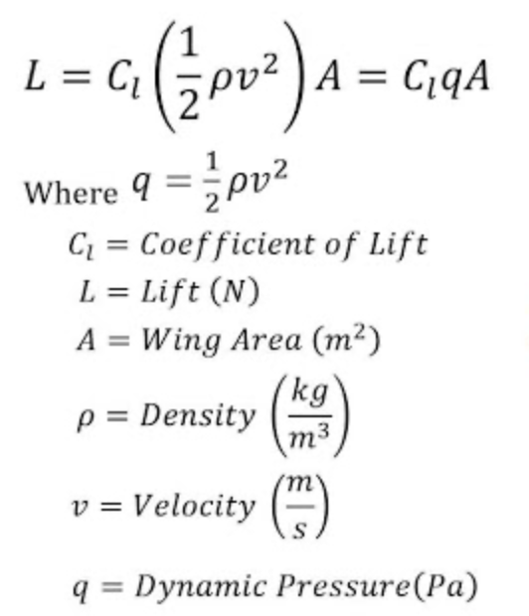
Using the pressure distribution, it is possible to calculate the two coefficient important for aerodynamic analysis

- Lift Coefficient represents the magnitude of the lift force per unit of wing span. In order to compute it according to the given equation, I will first need to calculate lift. This will be equal to the vertical component of the resultant force given by the pressure distribution.

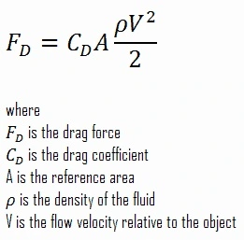

- Drag Coefficient, similarly to lift, is the value of the drag force per unit of wing span. To obtain it, I need to first determine the drag force, which will be equal to the horizontal component of the resultant force given by the pressure distribution.
Both of these coefficients will be recalculated for each increment in the angle of attack to monitor how they change relative to AoA and to each other.

6.5 Plot, Analysis, and Comparison

The program will iterate itself with the number of cycles dependent on the given AoA range. After each cycle, the values of AoA, Lift coefficient, and drag coefficient will be appended to an array. The velocity profile and pressure distribution will be deleted and remade every cycle, but they will be shown to the user as graphical output, so that they can monitor the program running as the parameters change. As the iteration runs, two graphs, synchronised with the tables, will be plotted in real time: Lift Coefficient against Drag Coefficient & Lift Coefficient against Angle of Attack, adding new points after each cycle is complete.

In order to make the output of the algorithm useful for an unspecialised user, I will calculate the following values after the iteration is completed.

- The maximum lift to drag coefficient is the point at which, if it is taken from the origin, the gradient is at its maximum value. This will provide useful data for the optimal ascend angle, one which yields the most lift.
- The AoA at which the drag coefficient is at its minimum value is useful in aeroplane design as reducing drag helps to conserve fuel over long flights

After the desired parameters specific to that aerofoil have been calculated, they are appended into a new table, under the aerofoil’s name. After this, the entire process can be repeated with an altered shape geometry or different initial conditions to allow the user to make necessary comparisons and choose the most appropriate design for their purposes.

1.7 User requirements and Limitations

7.1 User requirements
Considering that the end users will be students starting from ages 12 and above, it is necessary to make the system easy to use without prior coding experience or theoretical knowledge of the physics concepts behind the program. Therefore, the user interface must reflect all the functionality of the program and also be designed in an intuitive way similar to what the students will already be familiar with using. Additionally, I should avoid using technical language in GUI components the students will interact with. In case this is
unavoidable, any new concepts should be explained or demonstrated visually.

7.2 Limitations

Several factors, including the technical limitations of the Python language and difficulty of underlying theoretical concepts, have led me to use simplified algorithms such as the Panel method instead of the more accurate Navier-Stokes based CFD or Euler equations-based solutions. This increases the speed of simulation, which I deemed to be an important part of the user experience. To increase end-user satisfaction, it is important for them to be able to see how changes to aerofoil geometry and conditions reflect on performance. Slower performance may create a point of friction for the user, as they would encounter it after each alteration, discouraging them from using the program. Despite this trade-off, the algorithm I am using is still able to provide reasonably accurate results, consistent with the expectations for an amateur project. The panel method is unable to simulate viscous effects, high Reynolds numbers and compressibility, which wouldn’t have as much impact in the windless conditions the testing of the Lift-Off challenge is conducted in.

STAGE 2: Design

2.1 Program Structure

Overall program functionality flowchart:


1.1 Design Diagram (UML)

First iteration UML diagram (prototype):
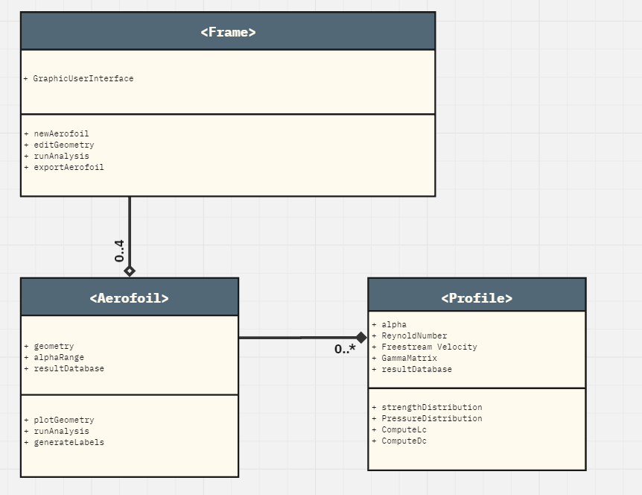
Made using graphic editor ‘Miro’

Main Features:
- GUI display in encapsulated frame class
- Frame contains methods to manage aerofoil entities - aggregation relationship
- runAnalysis method causes Profile entity instantiation - composition relationship
- Frame contains 0-4 Aerofoils
- Aerofoil contains 0 or more Profiles

2nd Iteration UML Diagram:

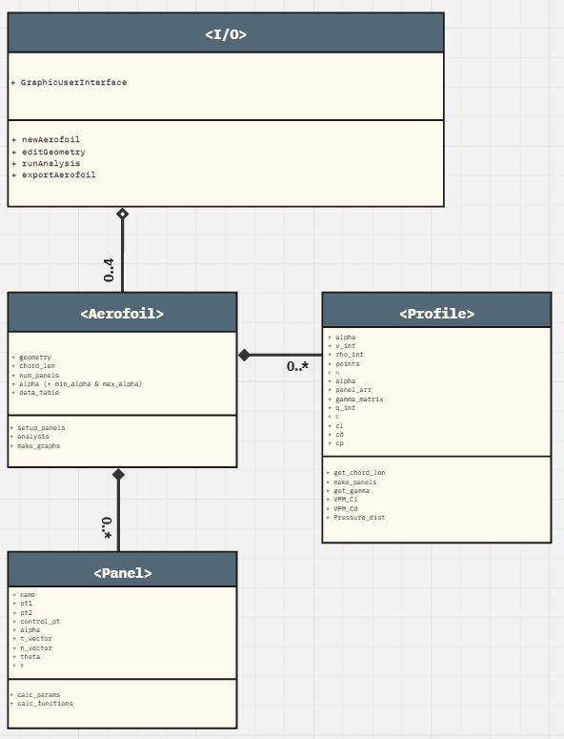

Summary of Changes:
- New Panel class added: each instance of the panel class is called by and stored in the Aerofoil class using functions make_panels & var:panel_arr respectively.
- Composition and aggregation properly implemented

3rd iteration UML Diagram:

At this point, the UML is split into 2 separate diagrams, as during the development process I decided to split the program into 2 different python files. Furthermore, the class which was previously “I/O” has been split into

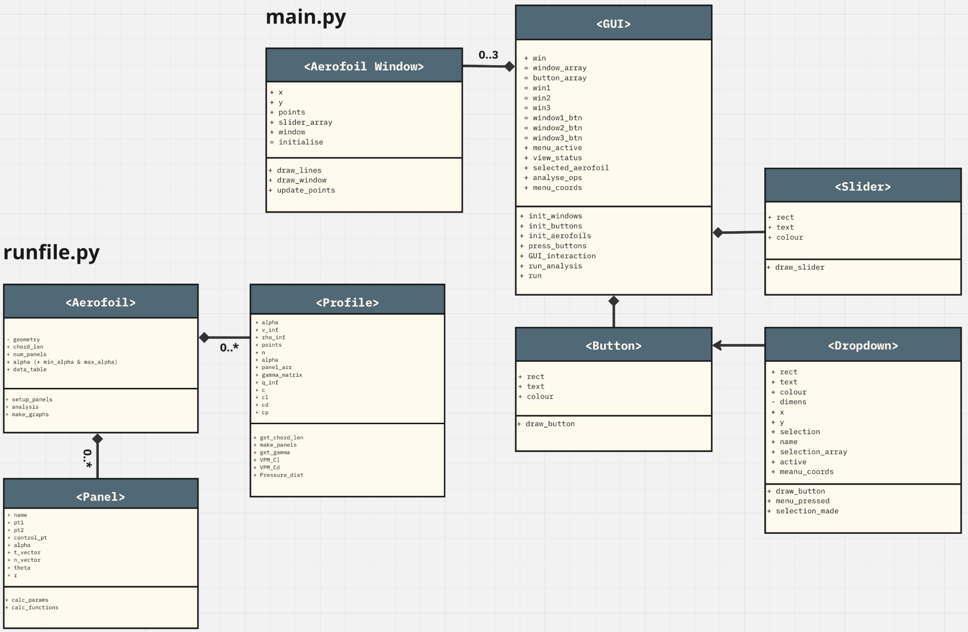

At this point the UML diagram has been split into 2 separate ones corresponding to the different python files.

Summary of changes:
- <I/O> class is renamed into <GUI> class and separated from the other classes. 4 Additional classes have been added, all of which correspond to interface elements and get instantiated within the <GUI> class
- There can be between 0 and 3 <Aerofoil Window> instances composing the GUI class.
- There’s a predefined number of <Button> and <Slider> objects instantiated in the respective functions init_buttons and init_aerofoils within the <GUI> class
- <Dropdown> inherits from <Button> in order to make use of its draw_button function.
- run_analysis function executes the runfile.py program which is stored in a separate python file. It also loads the output graphs image which runfile.py automatically stores on the computer, ready to blit it onto the aerofoil window.

1.2 Main Encapsulation Modules

In order to maximise my program's efficiency, improve readability, and aid in development, I will introduce encapsulation in the form of the Object Oriented paradigm. It will contain three main classes, as outlined below:

- Frame
The Frame is a class instantiated by default and cannot be deleted. It handles storing data about active aerofoils, so that they can be easily compared. It is also the class which will bridge the main program and the user interface. It will store and show outputs, as well as accepting inputs from the user.

- Aerofoil
This class is responsible for handling data relating to individual aerofoil objects. It is related to the Frame class by association, meaning both classes can exist independently and continue to exist if one is deleted, while sharing information. The frame, or each instance of the AA program running, will contain between 0 and 4 aerofoils concurrently.

- Profile
The Profile class is the main tool used during the analysis process. It stores and executes methods relating to velocity diagrams and pressure distributions as the most mathematically intensive functions. The methods are passed into the Aerofoil class following a composition relationship, where they can be called. If the associated Aerofoil object is deleted, the Profile it instantiates also ceases to exist.

1.3 Data items & file structures

1.3.1 Aerofoil geometry

The shape of the aerofoil within the program will be defined by a set of coordinates describing points around the perimeter. Starting at the leading edge, and listing the points in clockwise order, they will be stored in a 2-dimensional array
Although not the standard form used for describing airfoil shapes in the industry, using separate arrays is necessitated by the functionality of the plotting methods in the data visualisation libraries I’m using.

Example geometry:
pt_array=[[100, 214], [250, 150], [400, 150], [550, 177], [700, 212], [850, 250], [100, 316], [250, 375], [400, 340], [550, 319], [700, 310], [850, 306]]

1.3.2 Key Variables

The following variables will play an important role in the mathematical model of aerofoil analysis. ɑ, and U∞ will be configurable by the user, but will start with default values most suitable for that of my end-users application. γ will be an intermediate variable represented by a matrix of values, calculated based on the input geometry, although the user will never directly interact with γ itself.

Alpha [ɑ] : the angle of attack, refers to the angle between the chord line and the freestream velocity direction.

Reynold Number [Re] : defined as the ratio of inertial to viscous forces. At Re below 2000, fluid flow is laminar (smooth and regular), whereas higher values constitute turbulent behaviour. Turbulent flow exhibits chaotic properties, which means it is very sensitive to initial conditions, where a small precision error leads to a snowballing effect of increasingly inaccurate predictions. The difficulty of analysing turbulent flow is coupled with its limited usefulness in case of my objective, as its main use case lies in risk assessment and reduction in aviation, which isn’t applicable when constructing model aeroplanes. Therefore, the system will be operating at low Reynolds numbers, those consistent with the Panel method.

Freestream velocity [U∞] : the assumed velocity of the fluid (air) relative to the aircraft/aerofoil. A greater freestream velocity will cause more lift to generate, with a trade off of creating more drag as well.

Gamma [γ] : refers to the strength of a source/sink. In this case, it describes the effect a panel (small section of the aerofoil) has on the fluid flow, and is extensively used in the panel method when generating the velocity profile.

1.3.3 Databases: SQLite (Not implemented)

In order to store and retrieve the data processed during aerofoil analysis, the original intention was to employ a relational database - for each degree in the angle of attack range selected by the user, it would store values for the coefficients of lift and drag, their ratio, source strengths. This data could then be accessible to output onto the interface as required, while the analysis would only need to be executed once.

Database structure:

Aerofoil (🗝Aerofoil_ID, 🗝AoA, Net_Pressure_x, Net_Pressure_y, C_lift, C_drag)

Panel (🗝Control_pt, 🗝Aerofoil_ID, phi, psi, A_ij, Vortex_strength, tangential_v, C_pressure)

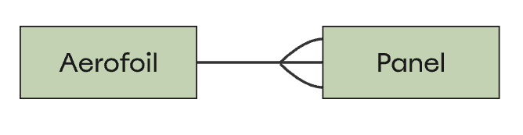
One-to-many relationship, where the Panel object contains the foreign key [Aerofoil_ID] of the Aerofoil object.

However, as it stands, the amount of data generated by the program isn’t sufficient to warrant a database and python lists are able to handle it well. This is mainly because the implementation uses a smaller amount of panels, hence the time and space requirements remain small as well.

1.3.4 Matrix Array

In order to store the influence coefficients and perform operations to obtain source strengths, I intend to use the Python NumPy library’s np.array data structure. This will enable me to greatly improve the efficiency of mathematical calculations as I will be able to perform calculations on all relevant data points simultaneously, and increase the speed of execution. The latter is a vital component for achieving my objective of executing the program within reasonable time complexity.

Given that item [A_ij] = influence of i’th panel vortex on jth panel
Matrix array for vortex strengths for n panels will be given by:

[A_1,1] [A_1,2] [A_1,3] … [A_1,n]
[A_2,1] [A_2,2] [A_2,3] … [A_2,n]
[A_3,1] [A_3,2] [A_3,3] … [A_3,n]
…
[A_n,1] [A_n,2] [A_n,3] … [A_n,n]

1.4 Libraries

1.4.1 MatPlotLib
MatPlotLib was chosen for its easy-to-implement and highly configurable visualization capabilities for plotting graphs and displaying data effectively - handling data being a core part of my project. I used it for creating a graph in the runfile.py program, saving the graph outside the program, and then importing it into the main file, which proved an effective solution.

1.4.2 NumPy
NumPy was selected for its support of mathematical functions including differential equations and trigonometric calculations, particularly with easy handling of complex equations and matrix operations, all of which were present in my mathematical model.

1.4.3 Pygame
Pygame was a more intuitive library for me to grasp compared to other alternatives, when it comes to GUI development. I also chose it for its built-in methods, particularly pygame.widgets, which offers ready-to-use components for interface construction. However, I didn’t end up using those, creating my own instead, which Pygame was versatile enough to let me do.

1.4.3 SciPy [potential]
SciPy was identified as a potentially useful library for handling integration calculations, as NumPy is limited to approximating integrals via the trapezoid rule. It was never used, as the program didn’t end up dealing with integrals.

2.2 Main Algorithms

2.1 Mathematical Modelling

Key/Variable definition for the equations in this section

Cl = coefficient of lift
Cd = coefficient of drag
Fd = force of drag
Cp = coefficient of pressure
C = chord length
q_inf = dynamic pressure
Γ = Total circulation
L’ = Lift per unit span
v_inf = freestream velocity
rho_inf = freestream density
gamma = panel strength

Assuming incompressible flow, which is a core assumption of the vortex panel method, the following equations will yield coefficients of lift and drag respectively. These are the 2 outputs I will focus on producing as a result of the aerofoil analysis program. They will be the variables plotted on the graph which is visible to the user.
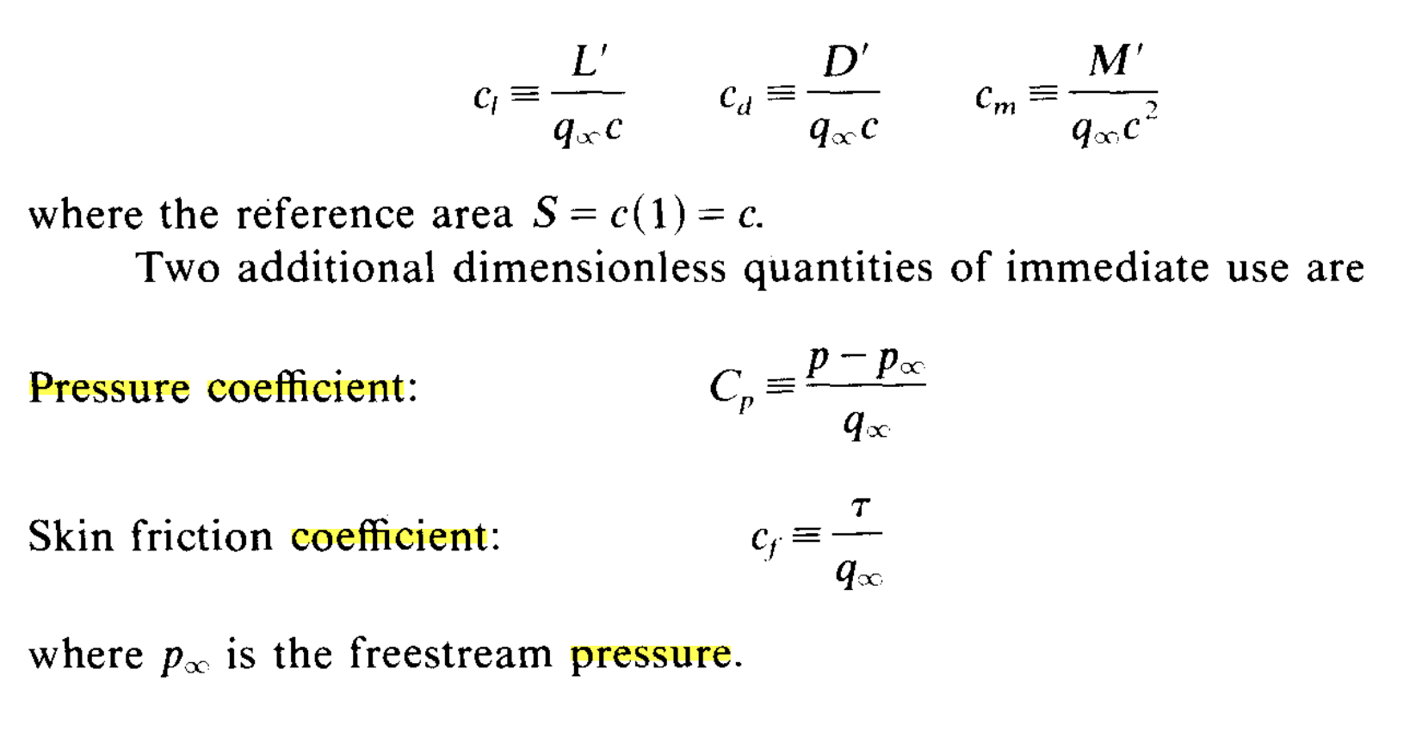 (Anderson, 1991)

Another intermediate value which may become useful is the pressure coefficient, given by the following equation:

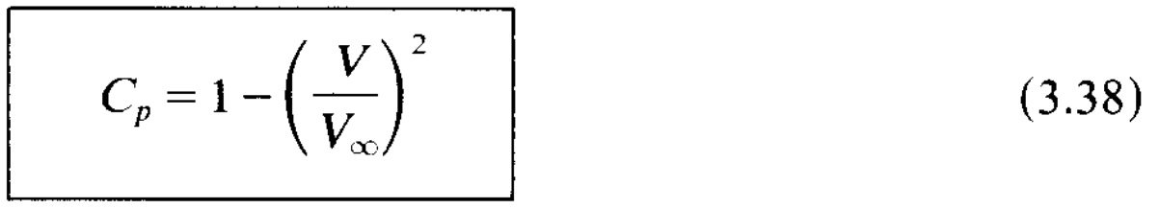 (Anderson, 1991)

It is used in determining the drag force and the subsequence drag coefficient, and would also be used in a pressure distribution if I implemented it as a potential output option.

Starting with the desired outcome -calculating lift and drag coefficients - I used the method of decomposition to research how to calculate each of the intermediate variables which appear in the equations.
The resulting mathematical model is represented as a hierarchy chart below. Starting from the bottom branches, I will need to use values from the user input and some physical constants inside these equations until I get the desired result.

The separately labeled boxes represent the way I have split up different sections of the hierarchy chart to implement them into different methods within the Profile class. Each method implements 1-4 successive steps/equations and is split up into logical groups in a way that would both make testing and debugging easier as well as the code more efficient.

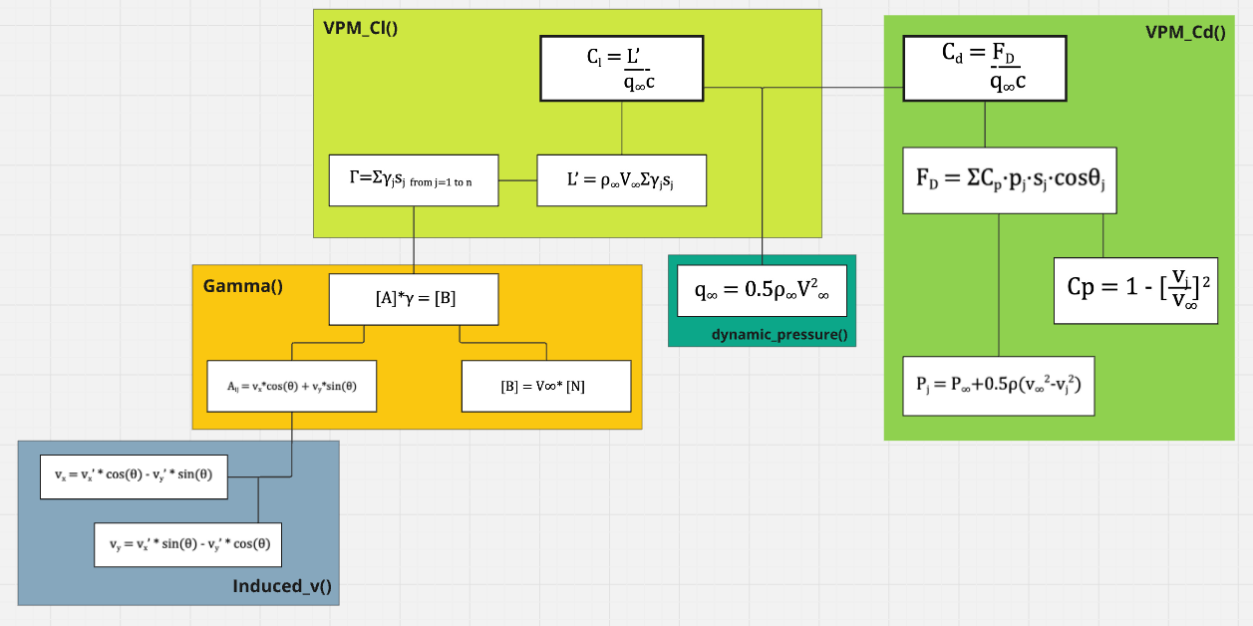

Made using information from (Anderson, 1991)

The following model summarises the mathematical manipulations implemented in the Profile class’ [get_gamma], [VPM_Cl], & [VPM_Cd] functions, which use the input geometry and predefined global constants to calculate the drag and lift coefficients - the 2 most important values in aerofoil analysis.

2.2 GUI Interaction Algorithm

State transition diagram below describes the algorithm behind the interface functionality. It is centered behind the main GUI elements I developed through pygame - and the mechanism to interact with those.

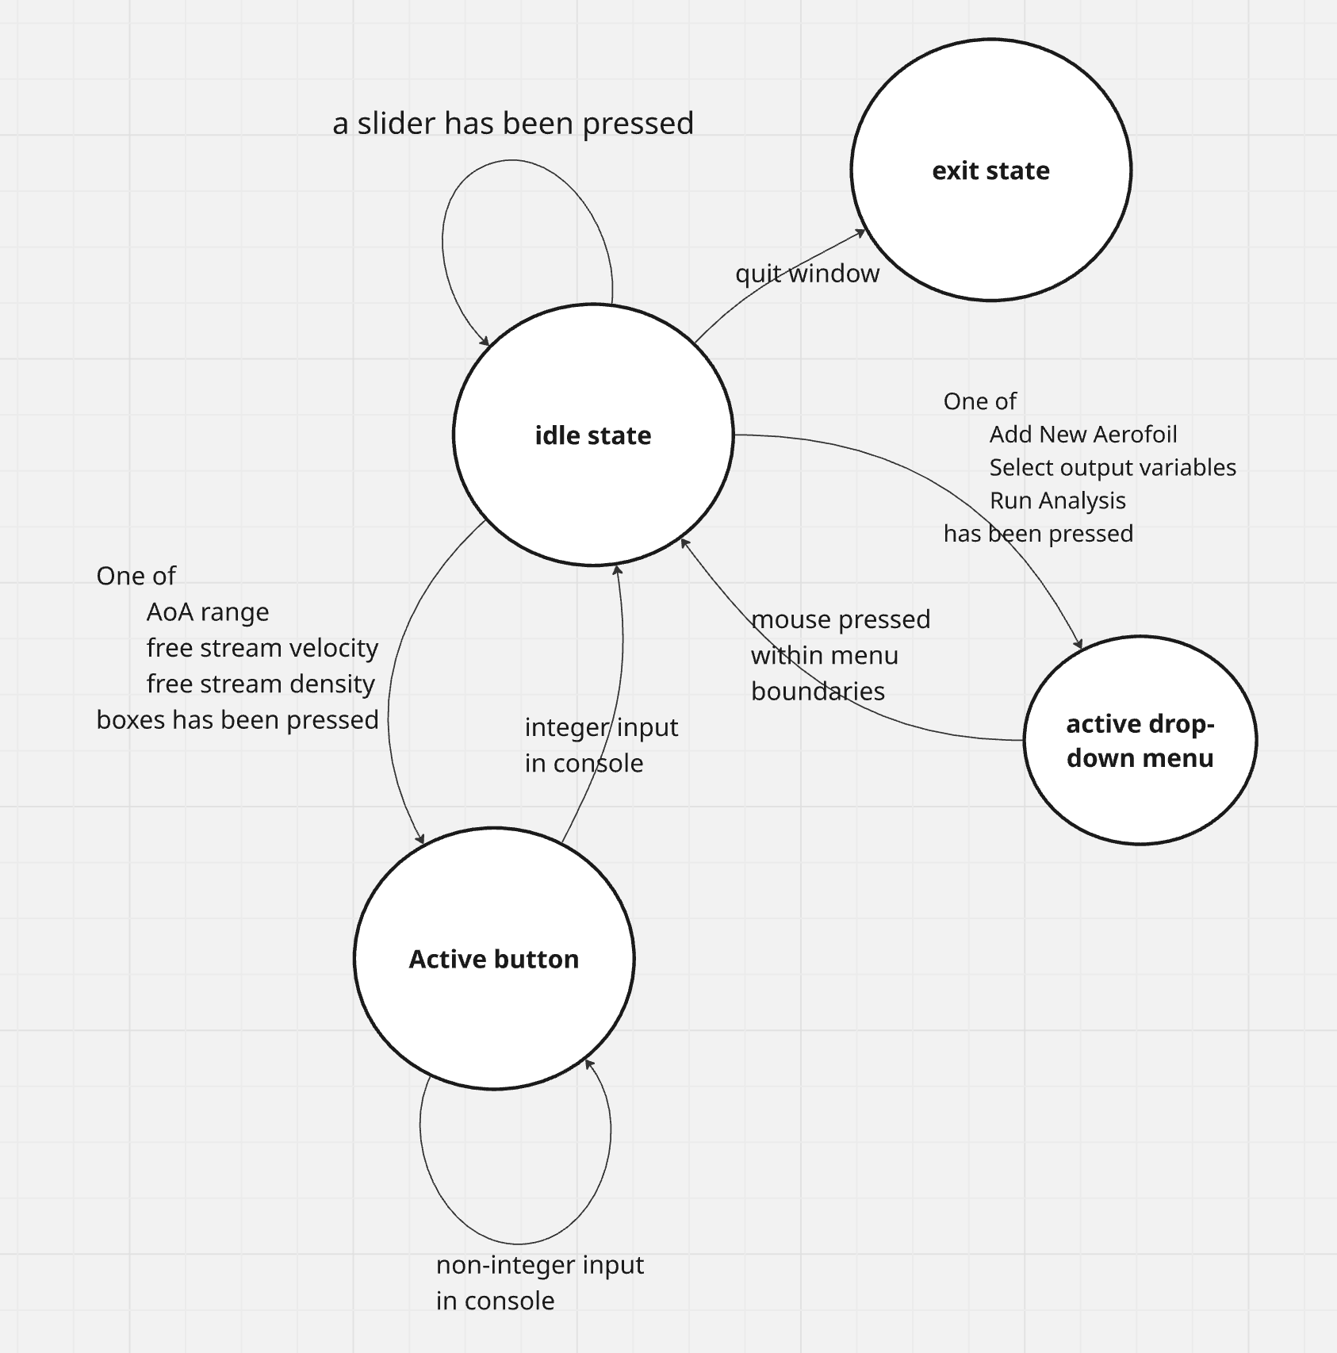

2.3 Prototyping

3.1 Graphic User Interface

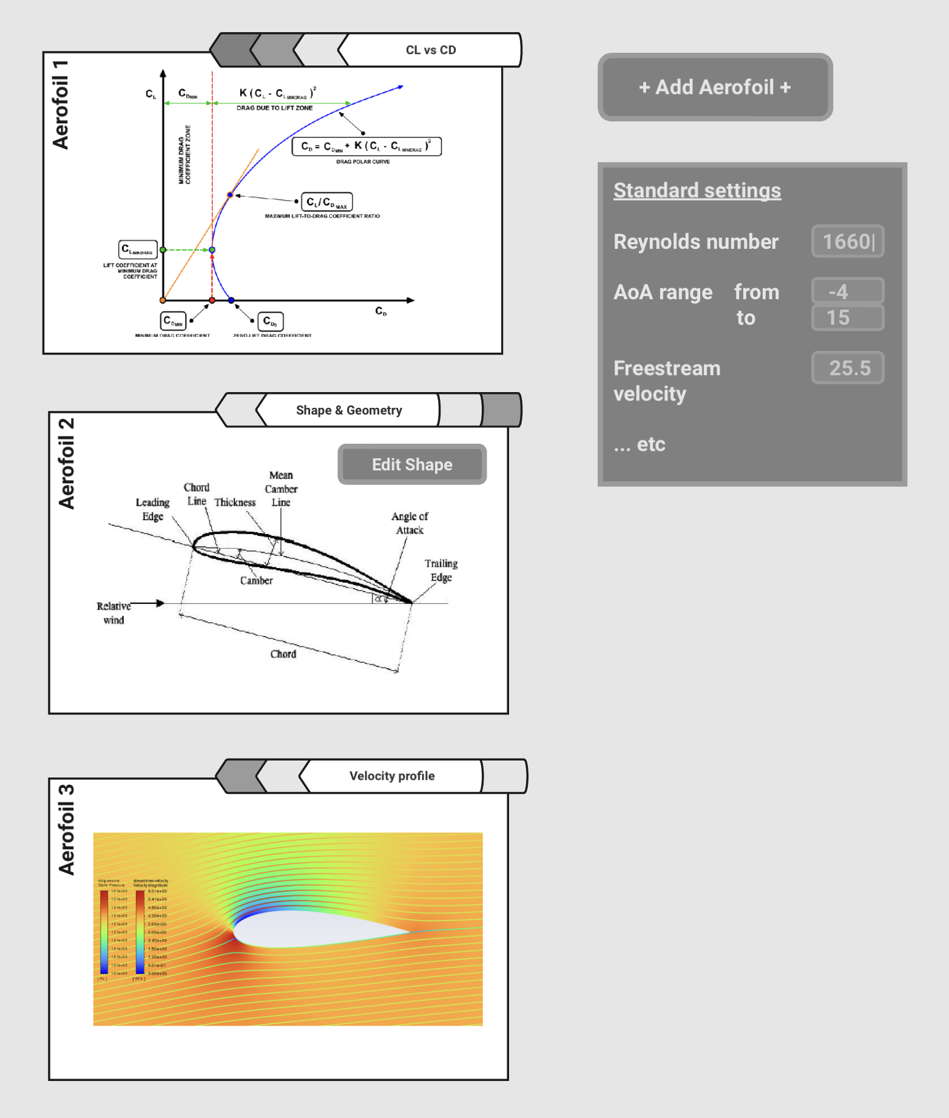
Made using graphic editor ‘Miro’

Above I have included the basic idea for what the user interface may look like, focusing on identifying key mechanics and points of input or interaction. Although the end-result may have a significantly different design, my aim is to work on optimising the following key components:

- Intuitive mechanic intended for switching between different view windows relating to the same aerofoil. These include the geometry editor, pressure distribution diagram, and results graph.
- A way to add/delete new windows for successive aerofoils and configure an option to display multiple windows side by side to aid direct comparison

The resulting images will not look like those pasted into this reference prototype, they will likely be a lot less detailed.

3.2 Aerofoil Editor

As the present project tackles a complex problem which has to undergo multiple stages of decomposition, the GUI is not an exception. I have decided to begin by making the minimum viable product (MVP). The aim of it is to achieve 2 goals - display the geometry of an aerofoil and allow the user to alter it, both achieved in most basic ways. As the project progresses, the GUI along with other components will be altered in an iterative manner, adding complexity with each new version.

Before prototyping my MVP for the GUI design, I needed to ensure it would be consistent with user limitations. To make the design intuitive, I employed constrictions, within which the aerofoil has to be designed. The geometry will be defined by 12 points, which have a fixed, evenly spaced out horizontal position. Their vertical position can change from the default within a certain specified range, as a response to user interaction. To make the constrictions of said range obvious to the user, my first idea was to utilise the Slider widget from the python pygame.widgets package.

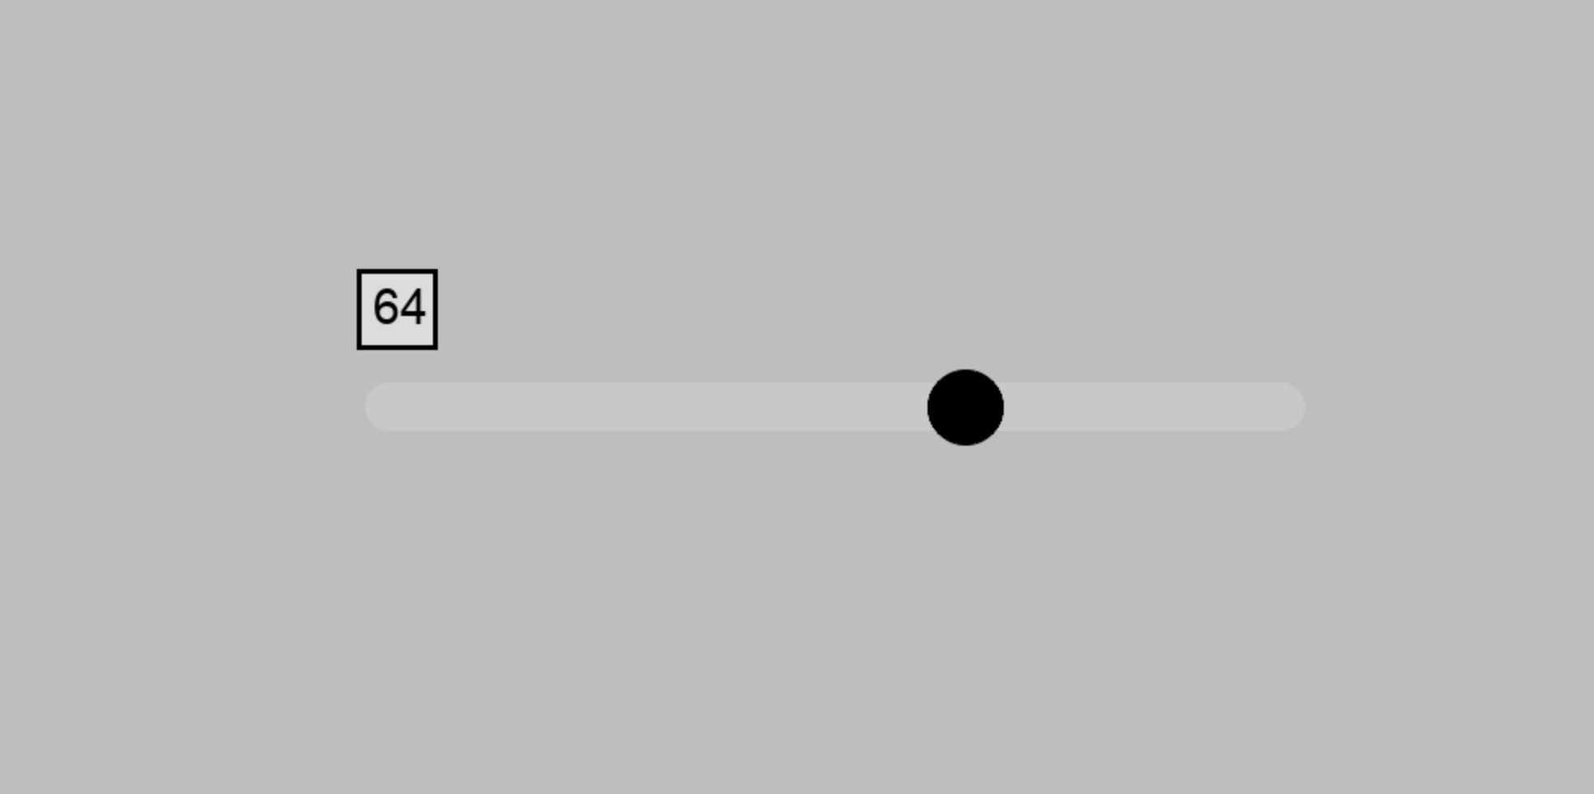

Using a slider is an intuitive way for the user to prove input in this scenario, as the slider track visually implements the constrictions mentioned earlier. However, after testing the widget package, I realised the sliders are only able to be implemented horizontally. By contrast, I needed to use vertical sliders, as the horizontal position of each point on the aerofoil should be fixed.

To circumvent this obstacle, I decided to imitate the slider without using a widget package. Instead, I am using 2 pygame.rect objects to draw each of the sliders - one rectangle for the track and one for the node. Their common parameters, like height and width, are stored as global constants. In order to record user interaction, I am using the pygame in-built MOUSEBUTTONDOWN/UP method, which records the coordinates of the cursor when the mouse is pressed/released. This, with some simple calculations, allows me to identify which slider has been interacted with.

Plan regarding how it will be developed in future iterations:
- More panels increases accuracy, so increase resolution by adding more sliders on each row
- In order to help the user retain a smooth curve, I could implement a logarithmic scale, by which editing the position of one point also affects neighbouring points.

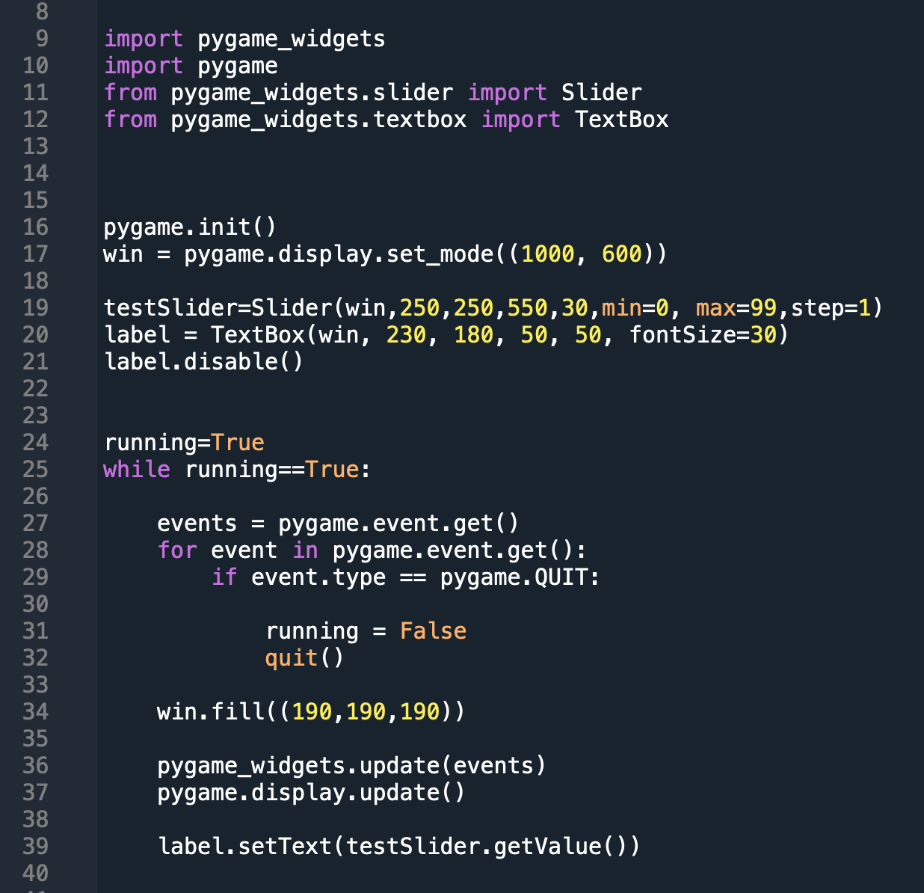

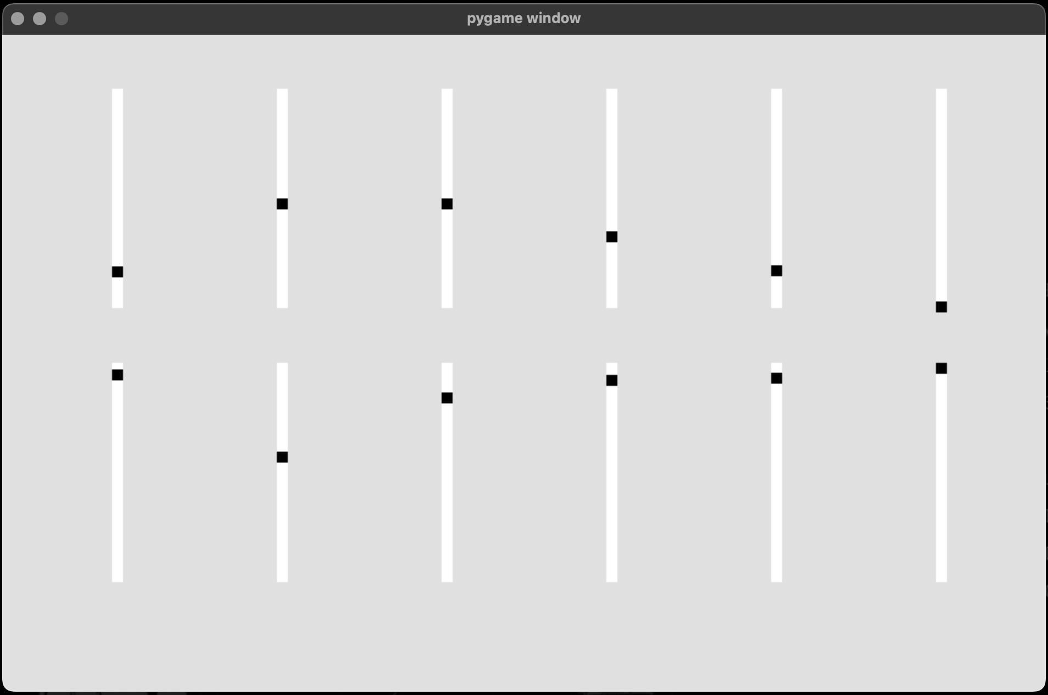
Code from [ver2.1.py] file

Method to update the sliders:

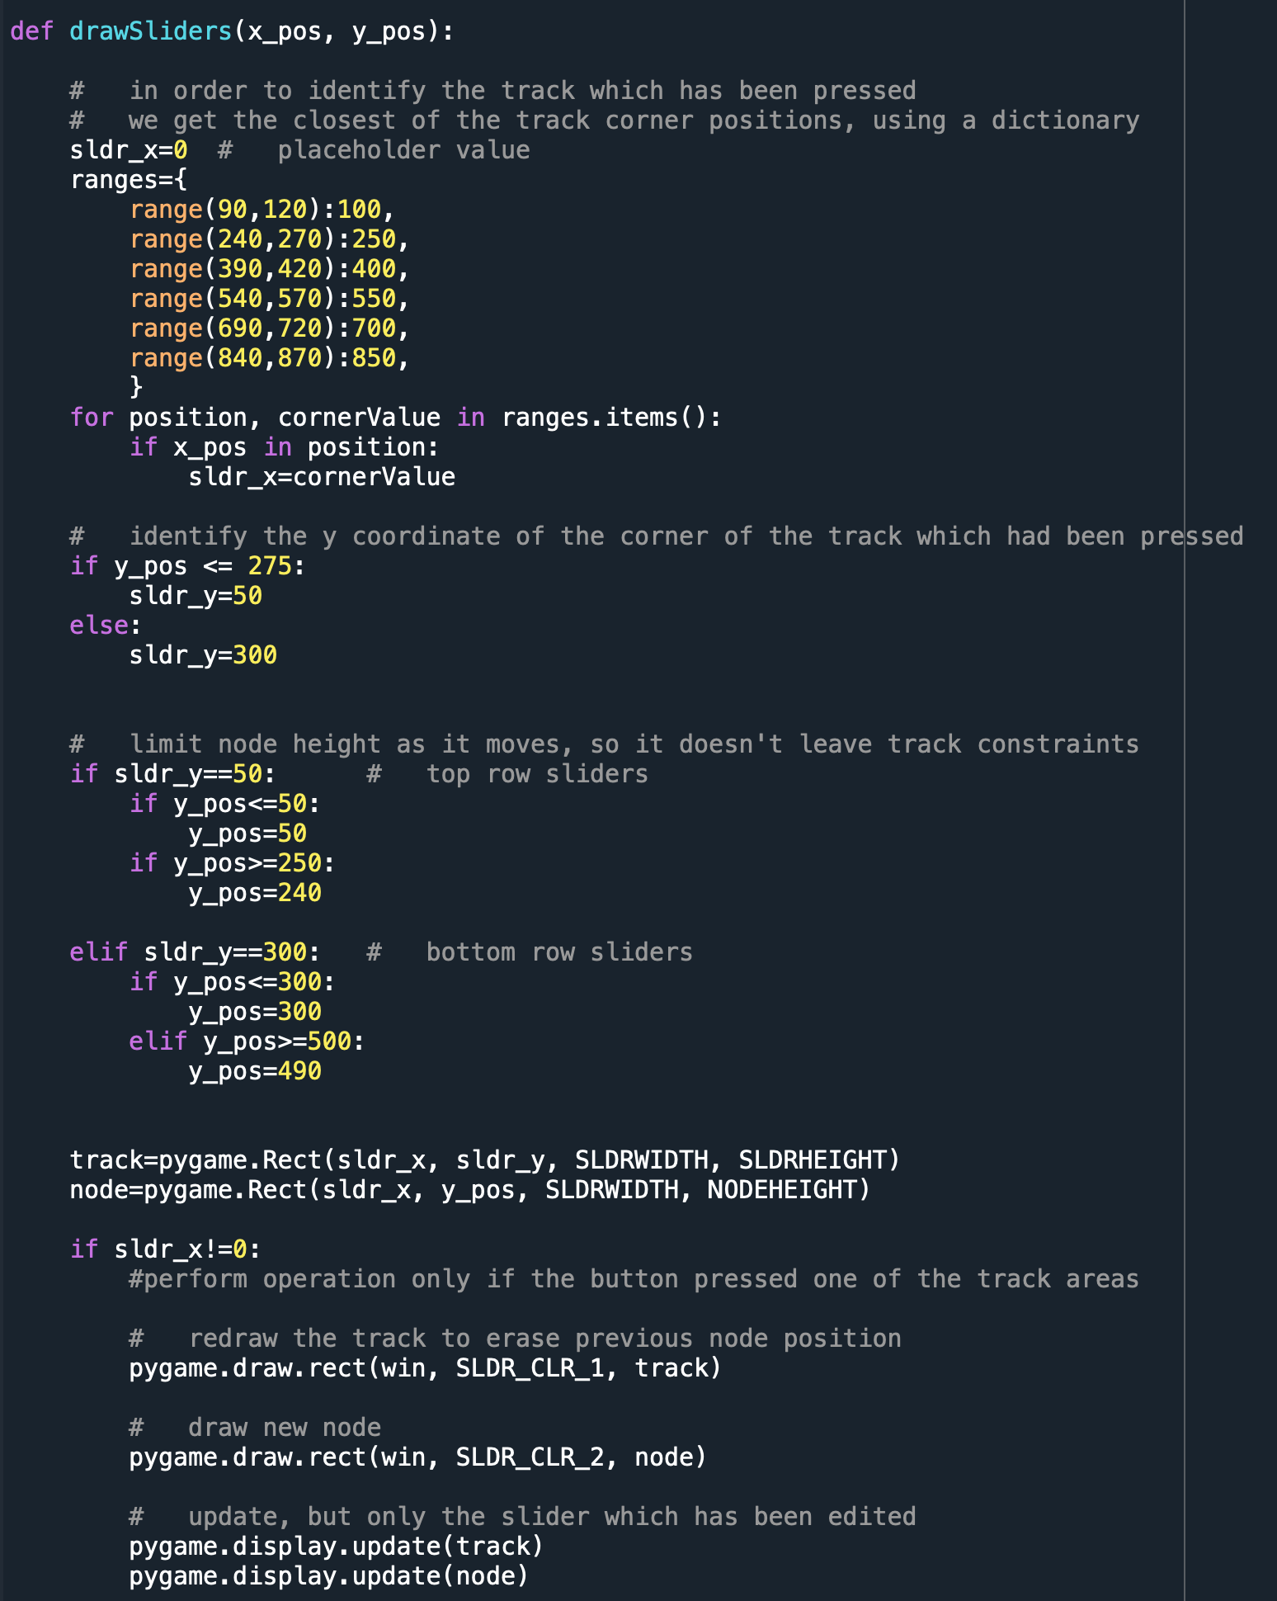
Code from [ver2.1.py] file

3.3 Panel Class

Within the panel class, I initially intended to explore different basic flow types, and how they can be combined to simulate fluid moving around a solid shape, all in order to calculate variables such as flow circulation, and subsequently all the relevant coefficients I intend to output.

In order to model the flow passing over the airfoil with the most accuracy I can at this level, I would need to calculate the velocity potential function and stream function for each panel, for 3 standard flows, which are outlined below.
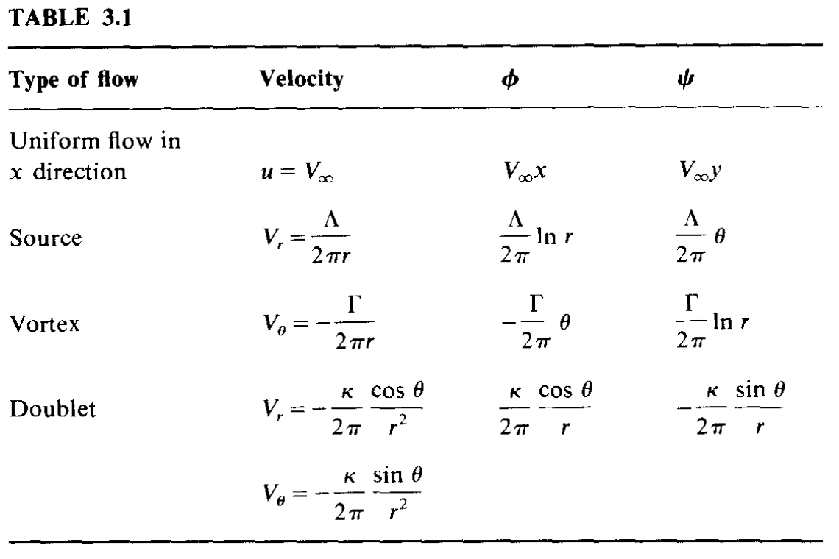(Anderson, 1991)

Combining the Flows:

Superimposing the 3 pairs of equations for each panel will allow me to obtain an equation for combined flow, modelling the behaviour of the fluid at any point. By applying the boundary conditions (V.n = 0 and the Kutta condition), I will be able to form a system of equations describing the entire aerofoil. In my first prototype I have defined 13 panels, so I will have 26 equations with 26 unknowns. Solving them simultaneously will allow me to calculate the pressure distribution and output and a fluid flow diagram.

However, upon further research into fundamentals of aerodynamics, I discovered these flow equations aren’t used in the vortex panel method, and hence will not be implemented. Instead, all the relevant equations are presented in 2.2.1 Mathematical Modelling

3.6 Integrating the program files

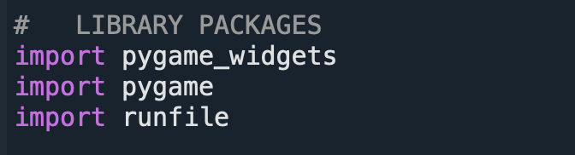
When simplifying the problem through decomposition at the beginning of the development process, the first step was separating code related to the interface and user interaction from that which executes the processing. To solve the separate problems more easily, I have coded them in separate python files. This modularised my program, making it easier to iterate through and debug. Although not initially intended, at a point it became more sensible to keep the programs completely separate. Thus, the runfile.py, which contains all the components associated with the mathematical side of the analysis, was instead imported into the main file externally, as a library package.

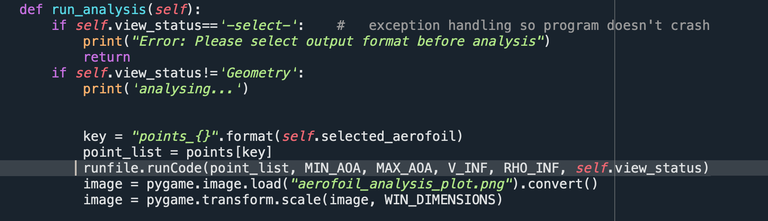
runfile.runCode(), given the physical parameters and the coordinate array, executes the main loop of the supplemental program, creating the corresponding graph.

STAGE 3: Testing

Program Demonstration Video Link

https://drive.google.com/file/d/1256F0xDdWzWanggSDYjxP76Lxuakbqbc/view?usp=share_link

Overall Testing strategy

- Regression averse strategy: methodical implementation of predefined test cases after each relatively significant change/addition to the functionality of the system in order to ensure nothing breaks after each coding iteration. The programmed solution is decomposed into parts, each is coded and tested separately before being put together.
- After achieving any of my major objectives, I intend to use the methods outlined below to evaluate the quality of the solution, and identify further refinements to be made.

4.1 VPM

1.1 Testing Strategy

Accuracy

In order to test the accuracy of the system with each iteration of the coded solution, I am employing a methodical strategy consisting of the same testing conditions used each time. It will include regular and boundary data. Erroneous data testing will be conducted separately, when evaluating the system’s fault tolerance and identifying errors and defects in the code.

To evaluate accuracy, I am using a standards-compliant testing strategy, by comparing the output of my system to analogous software and calculating percentage disparity in the results.

Efficiency

Evaluating efficiency also involves using a standards-compliant strategy, this time to directly compare the difference in software speed.
To pass this test, my result should not take more than 50% more time to generate the output than software analogs used in higher education on Aerodynamics programs or Aerospace/automotive industries.

1.2 Version 1.1 Preliminary testing :: the matrix [ver1.1.py]

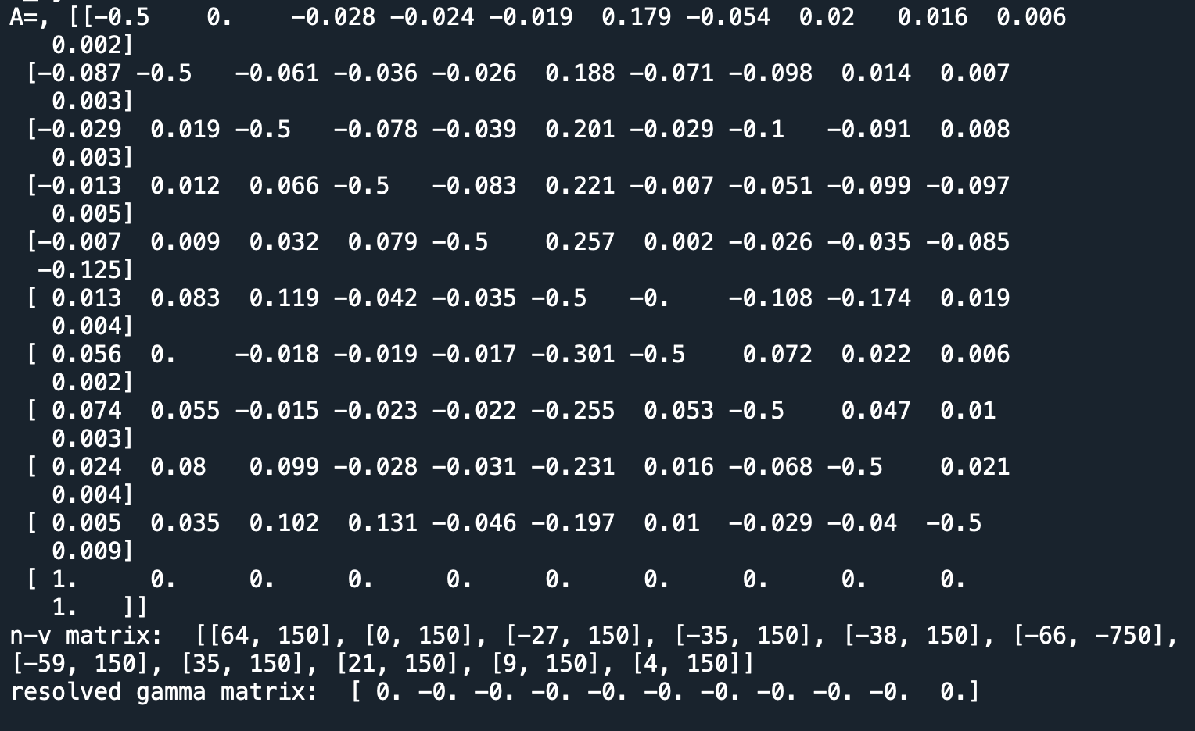

In this preliminary test, the objective is to identify whether the mathematical model has been implemented correctly. Regarding the influence matrix A, it appears to be behaving as expected: 1- there’s a diagonal of [-0.5] values
2- the last row contains 0s with 1s in the first and last positions
3- the remaining values mostly appear appropriate, as they all have small magnitudes of similar scales.
However, at the point this test is conducted, it is not yet possible to fully verify whether matrix A’s values match what is expected, as this will only become apparent later on, after I will be able to output a graph.

During this test, using numpy’s [linalg.solve] function to obtain gamma values did not work as expected - it generated signed zeros. This is likely because the program automatically chose the trivial solution.

Version 1.2 Test [ver1.2.py]

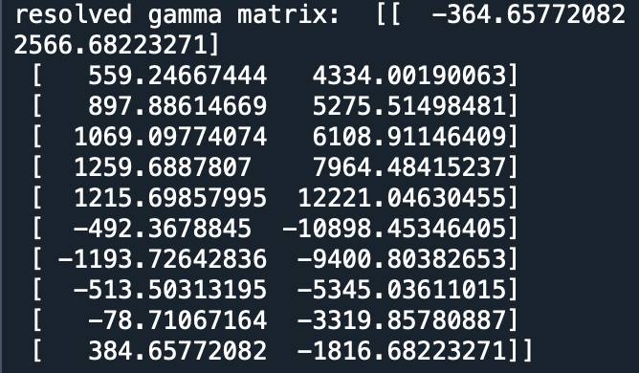

1.3 Ver 1.5 Smoke testing :: determining data validity [ver1.5.py]

Smoke testing ensures that the critical parts of a program are all functional before the program is passed for the next stage of development. As of version 1.4, my programmed solution represents a minimum viable product, as it takes in an array of points and outputs a table of values of drag and lift coefficients for angles of attack between 0 and 15 degrees. At this point, I can start to input values to verify my mathematical model and test for accuracy of results.
This is necessary before I can move on to continue to the next iteration of development, as well as before I can start implementing elements of GUI into the main program, as they are currently separated.

Test | Input data | Expected result
Elementary geometry | An array of [[0,0], [1,0], …] | Flat line shouldn’t produce any lift or drag at 0° tilt
A known aerofoil geometry | NACA 2412: [dat file] | Compare with known values
Basic custom geometry | Pt_array: [[100, 214], [250, 150], [400, 150], [550, 177], [700, 212], [850, 250],[1000,275],[100, 316], [250, 375], [400, 340], [550, 319], [700, 310], [850, 306]] | Similar graph shape to a NACA aerofoil

Inputs:

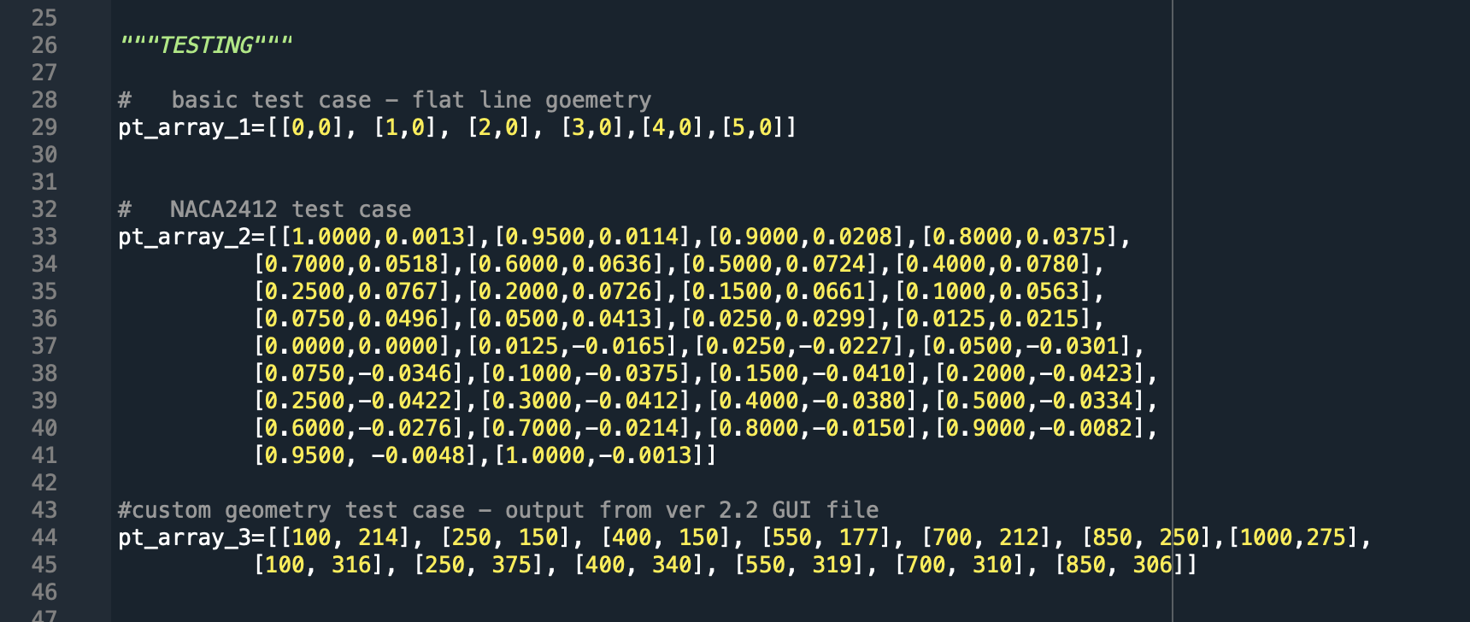

Outputs:

Test case 1:
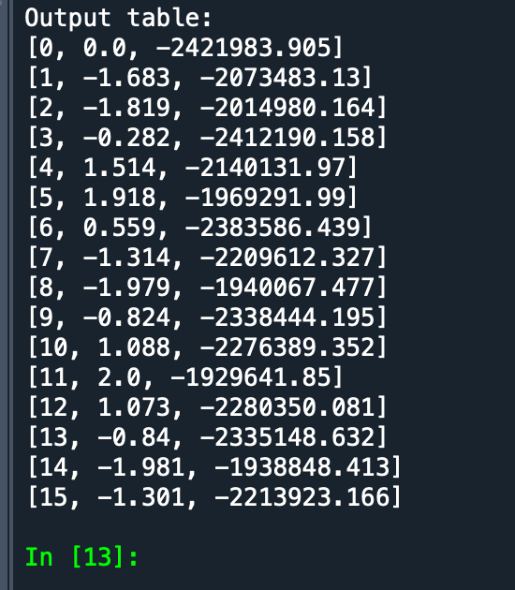

Test case 2:
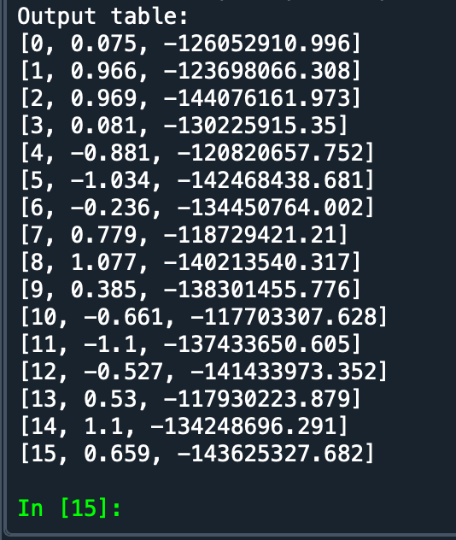

Test case 3:
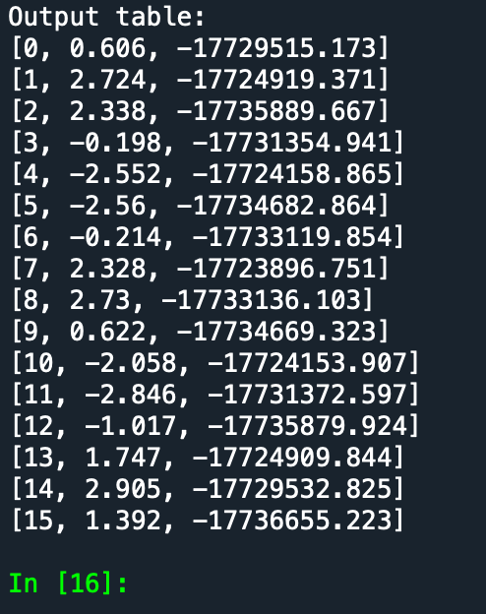

4.2 GUI

2.1 Testing Strategy

Test user-friendliness
model -based strategy, simulating the users behaviour.

Negative Testing > Test to break Approach

When testing GUI elements, I will alleviate my understanding of the software in order to try and break it, by choosing unexpected pathways when navigating the interface and attempting to input boundary and erroneous data. When I will conduct tests with real users at the later stages of the project, I will also present them with the objective to break the software in order to identify bugs.

2.2 Unit testing: sliders [ver2.1.py]


Normal Data Input:
The sliders are shown to be functional and responsive to mouse movements, moving the indicator node to the height at which the right mouse button has been released.
There are 2 ways to interact with the sliders: either by pressing the node, dragging, and releasing in the desired position, or by clicking the track in that position straight away. Both are identical as the program only records the position of the mouse at the moment of release, using the python.pygame MOUSEBUTTONUP command.

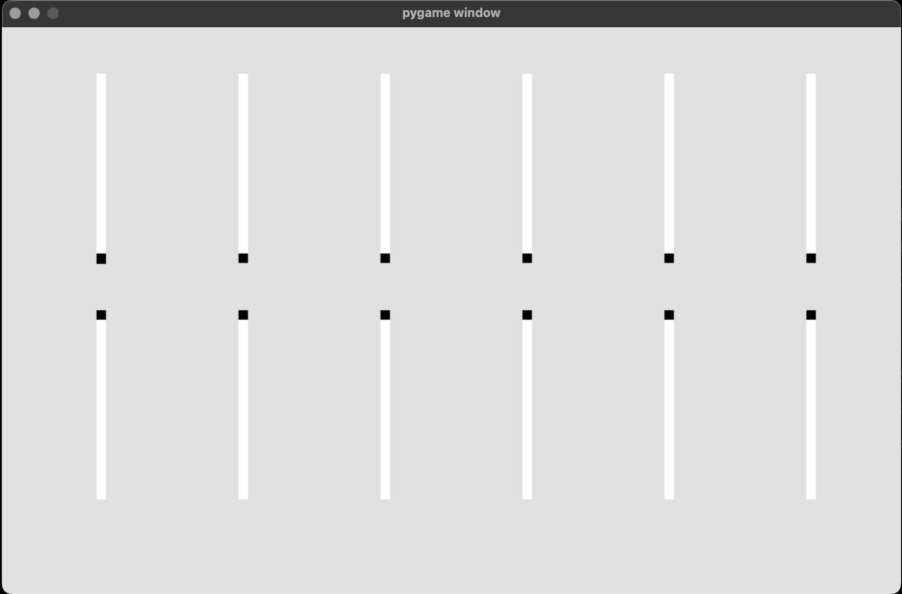
Boundary Data:
As the slider tracks are quite narrow, there is an area of leeway around each track, so that button presses slightly to the right/left of the slider are still recorded, and their x-coordinate gets extrapolated into the track.
Interacting slightly above and below each track will automatically move the slider to its highest/lowest possible position respectively, as defined by the track constraints.

Erroneous Input:
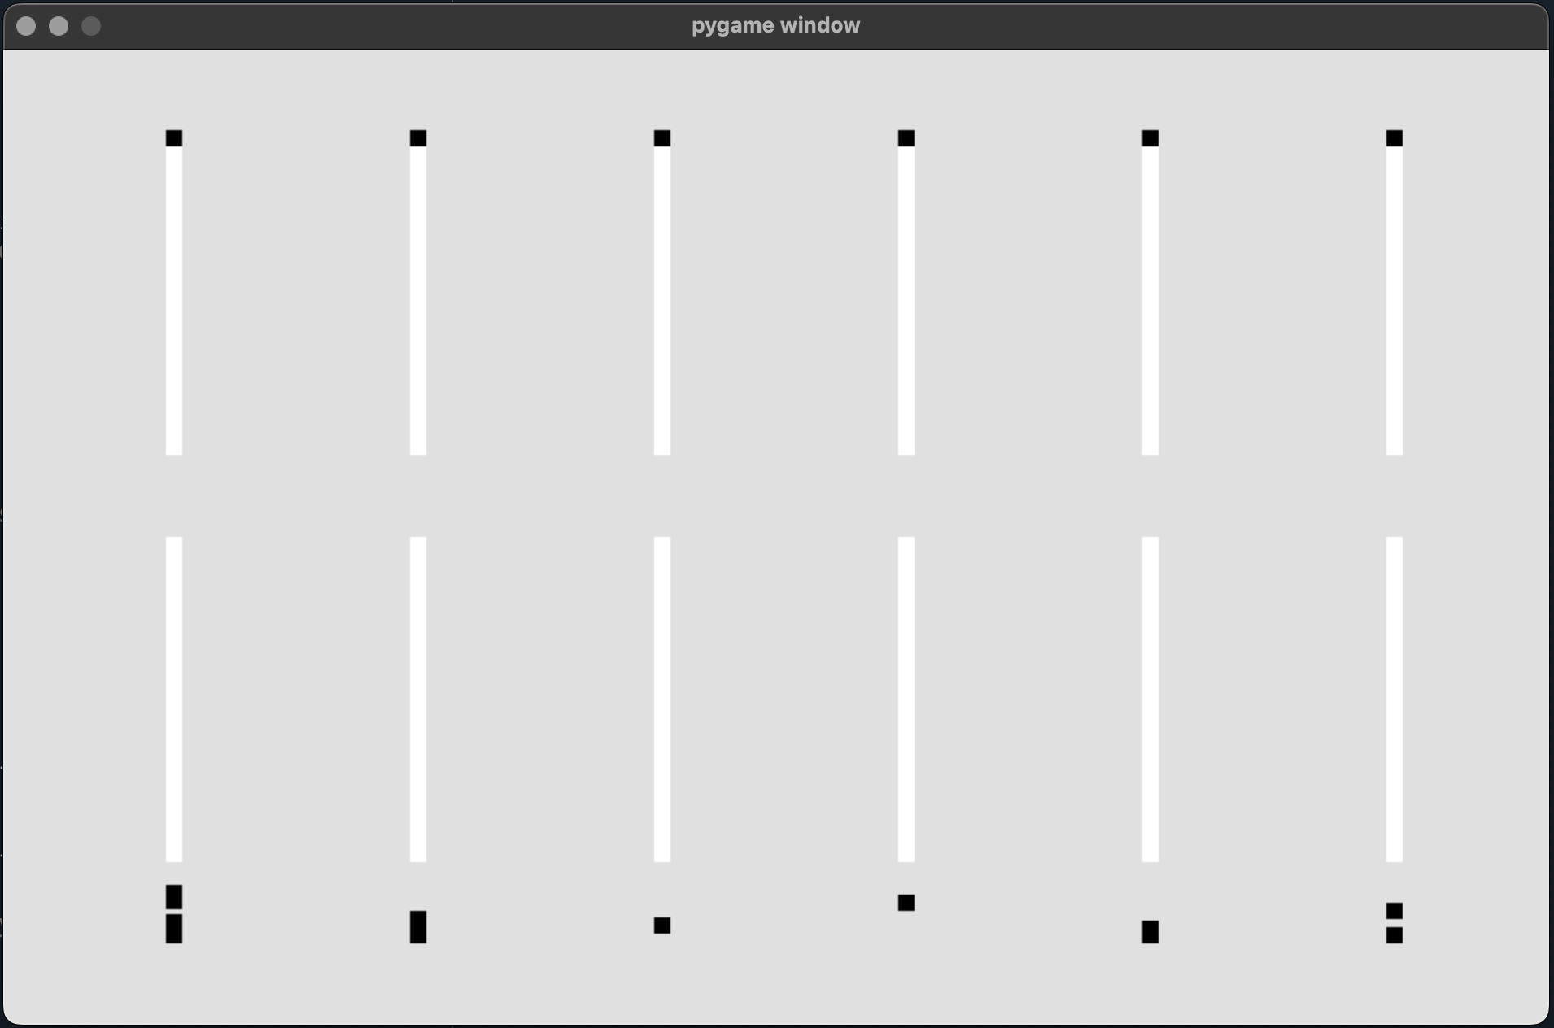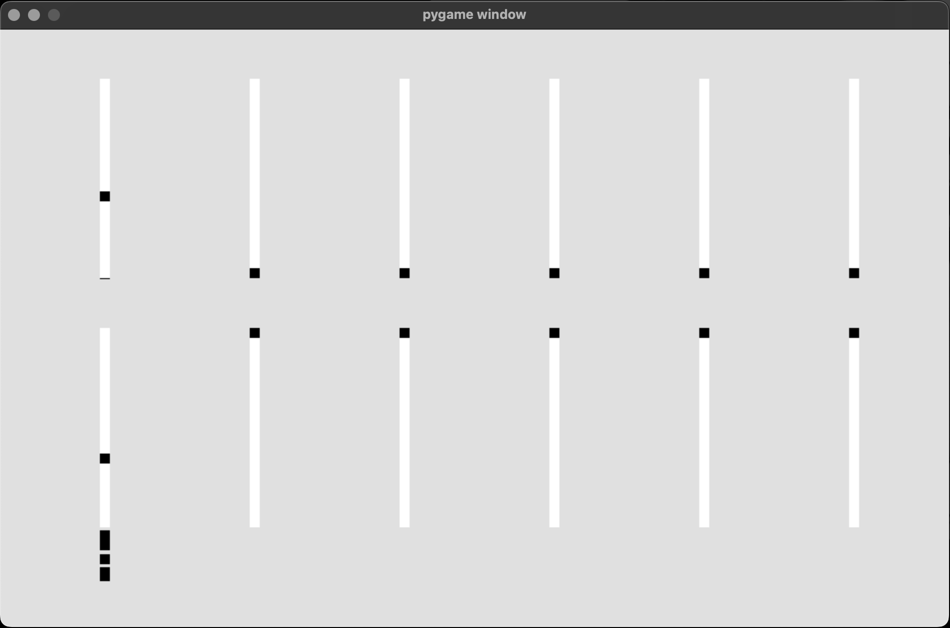
Upon further testing, it was discovered that the button row of the sliders is not properly constrained, as the nodes can jump below the end of the track. This has been caused by a minor error in the drawSliders() method, where the minimum height was defined 50 units lower than intended.

Another issue which has been uncovered through broad testing was the fact that button clicks outside the defined interaction areas of any slider - i.e. right in the middle between 2 tracks or along the edges of the window - will cause the far left slider nodes to move. This has been fixed in the drawSliders() method by ensuring a node is redrawn only if the user input matches one of the track value ranges from the dictionary.

Further unit testing [ver2.3.py]
When testing the GUI after having implemented 2 more aerofoil screens, 3 errors were identified:
- The function responsible for drawing lines wouldn’t refresh after a slider has been pressed, so additional lines kept appearing
- Some of the lines from all 3 screens would always connect to a point on the 1st aerofoil.
- The leading edge points wouldn’t connect with each other

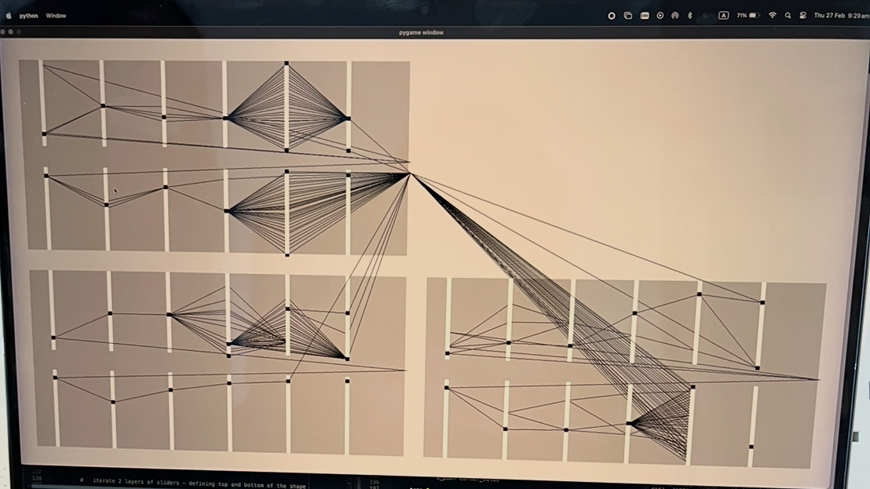

Control Buttons

Buttons controlling the values of some physical constants used in calculations

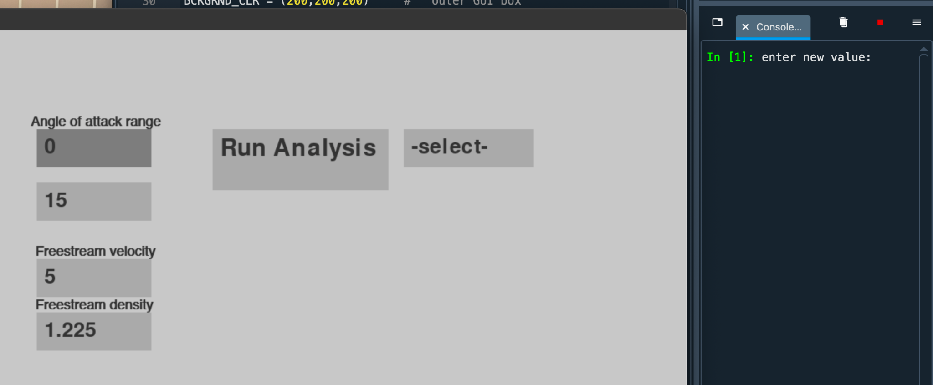
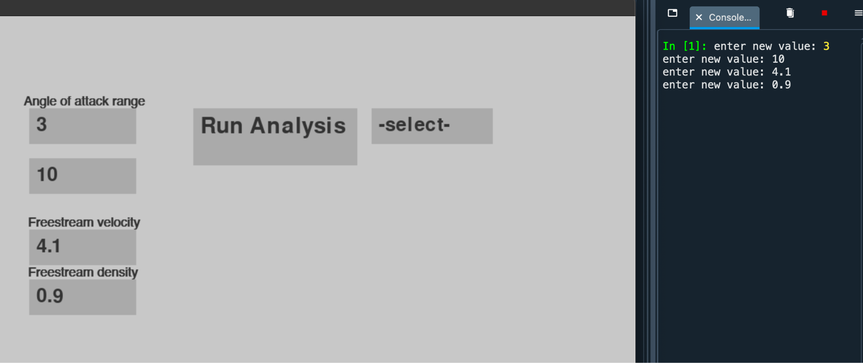

Dropdown Menu
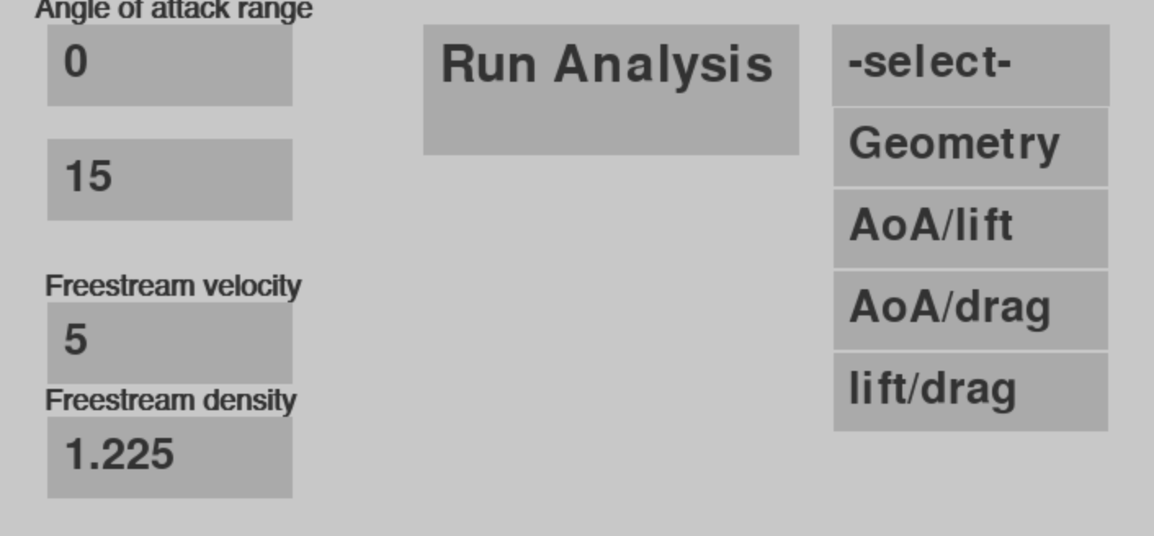

“Run Analysis” button

When pressed it will create a dropdown menu with numbers 1-3 depending on the number of aerofoils which has been added. Then the selected aerofoil’s output will be displayed instead of its geometry. If no aerofoils have been added, the buttons will do nothing.
If the user wishes to go back to editing the aerofoil’s geometry after it has been replaced with a graph, they can select “Geometry” in the dropdown menu and click “Run Analysis” again, which makes the interactable shape come back.

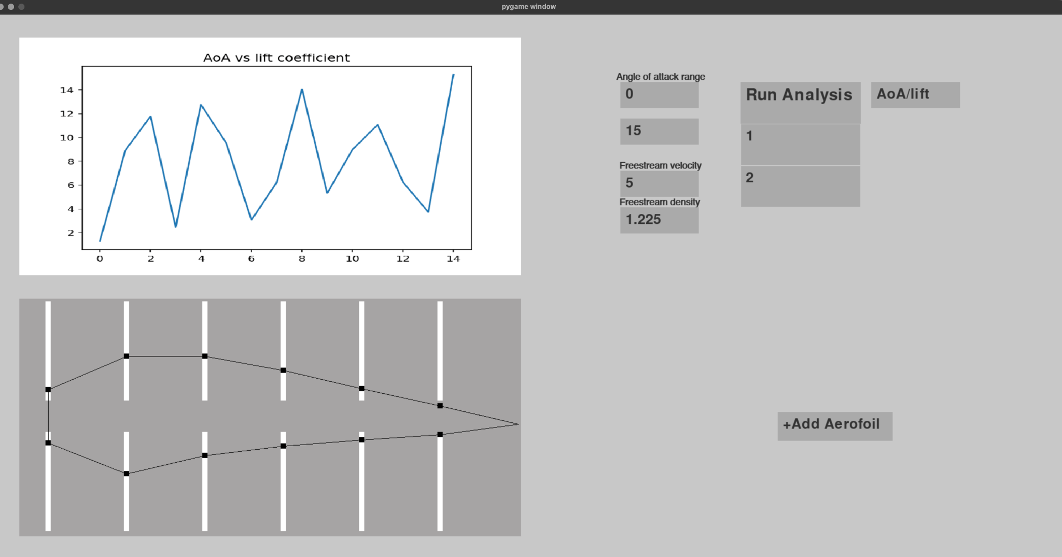

If the [Run Analysis] button is pressed while the value of the dropdown menu is still “-select-” as it is by default, the console outputs the following error.
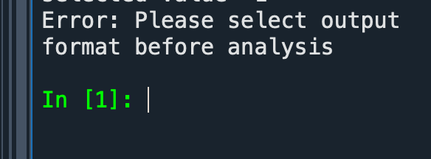

2.3 Stress Testing (attempted erroneous input)

Sliders: Boundary & Erroneous Input

The following test focused to verifying the behavior of sliders simulating unexpected user behaviour.

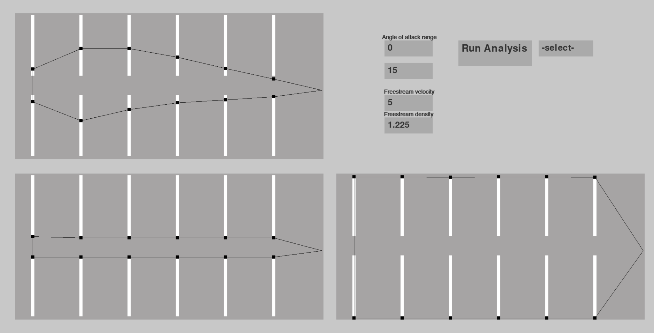

These were the findings:
- Clicking slightly above/below the edge of the slider snaps the node position to it’s edge, so the black dots can’t do beyond the white lines
- When clicking slightly to the right/left of a slider, the program will still register it. This works as intended, ensuring the interface is easier to interact with.
- When clicking anywhere else (i.e. in between sliders or on the light grey background between slider windows, the program doesn’t register it.

This test verifies that sliders are robust and work as intended, allowing the user to make any desired shape within the confines of the sliders.

Note: Some of the shapes which can be created are not sensible options for an aerofoil (for example, the bottom two on the photo above), but that is not necessarily a disadvantage, as restricting the user further to prevent this may not be helpful in their understanding of aerofoils.

To help make the process more intuitive, when the [+ New Aerofoil] → [Edit new] buttons are selected, the program loads the shape on the top left of the photo. This gives the user an idea of what a typical aerofoil may look like, which they can then edit from there.

2.4 GUI-VPM linked testing

Testing if the program behaves as intended in the interaction between the 2 programs.

cambered vs symmetrical airfoil
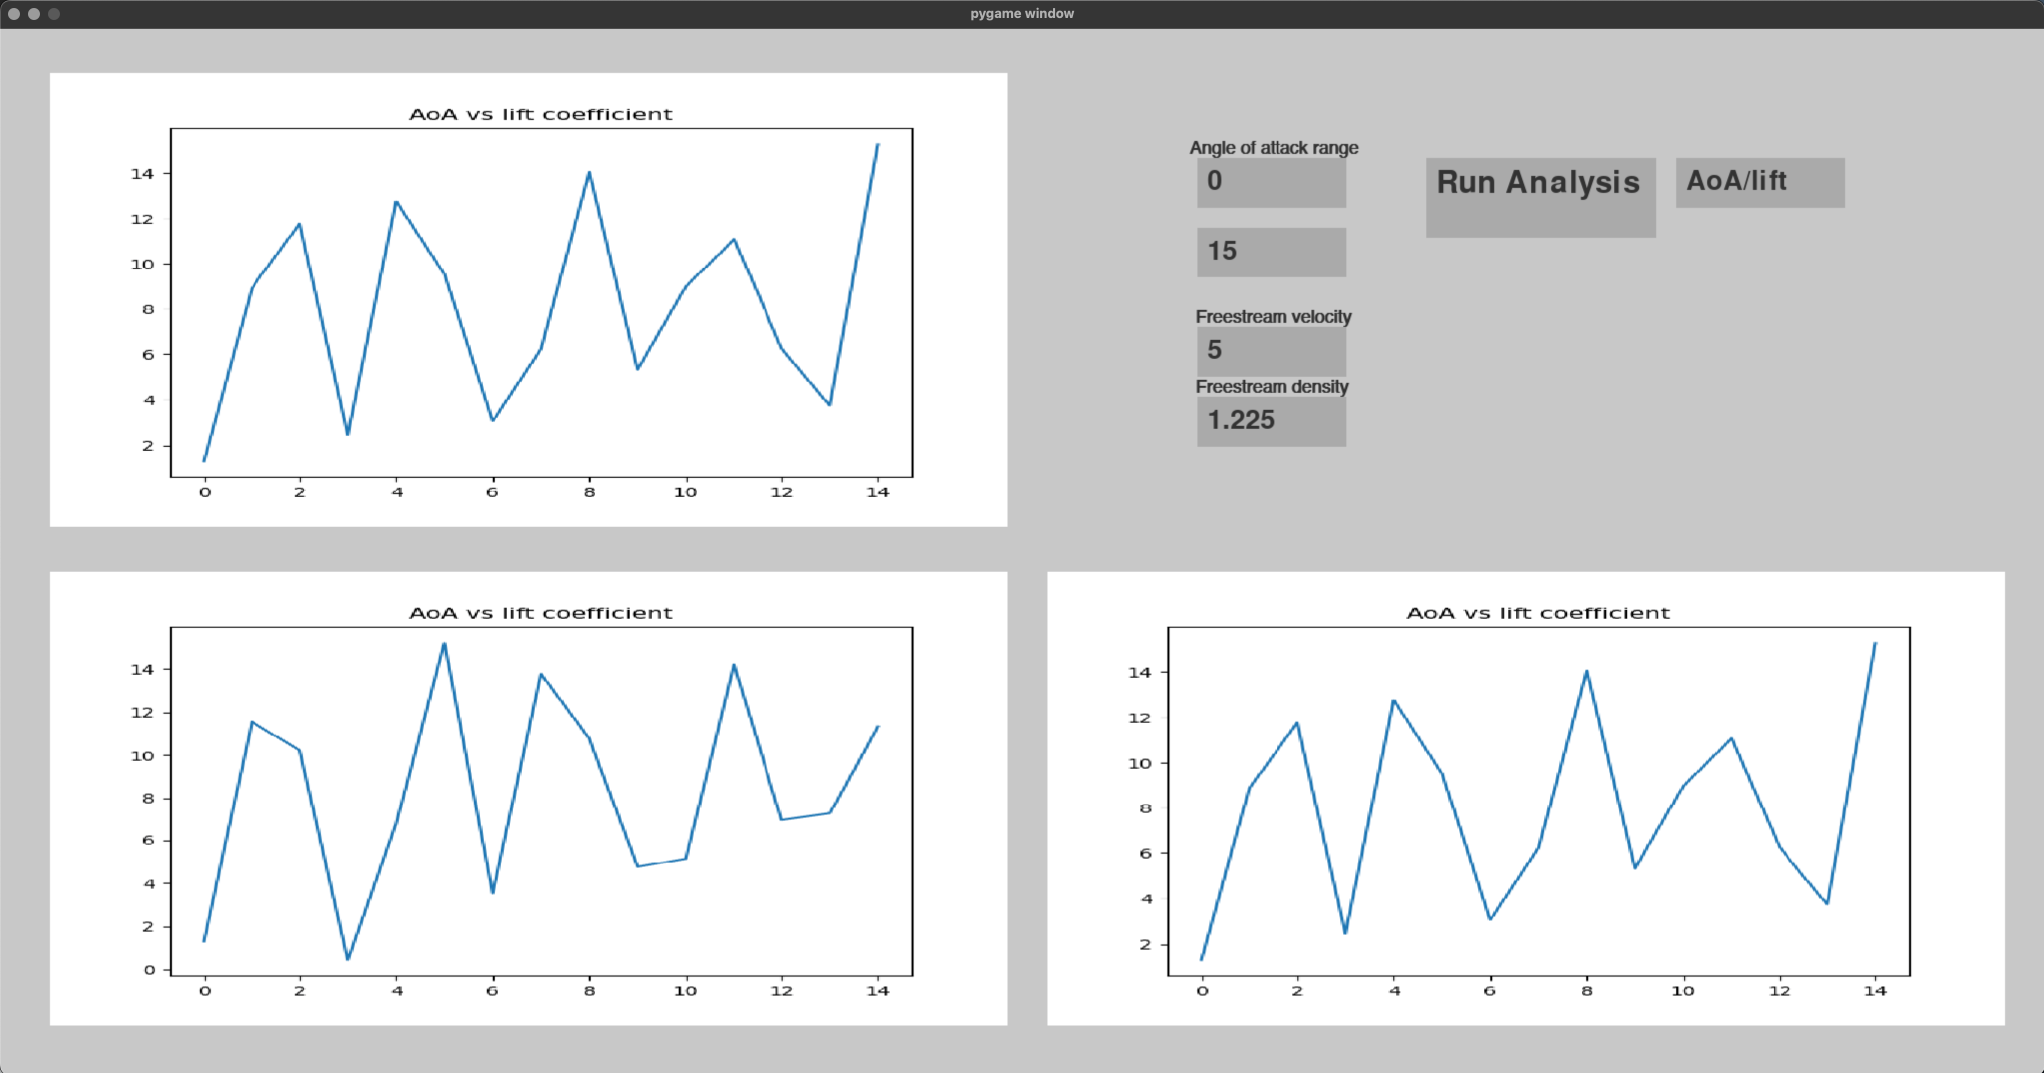
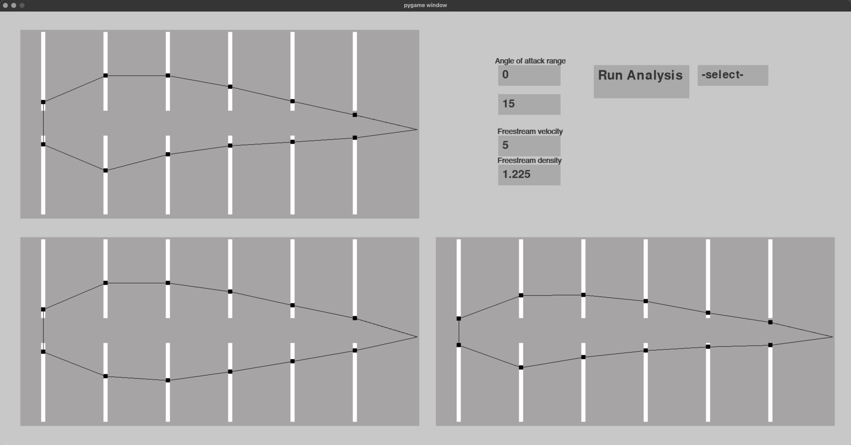

Default geometry and default constants

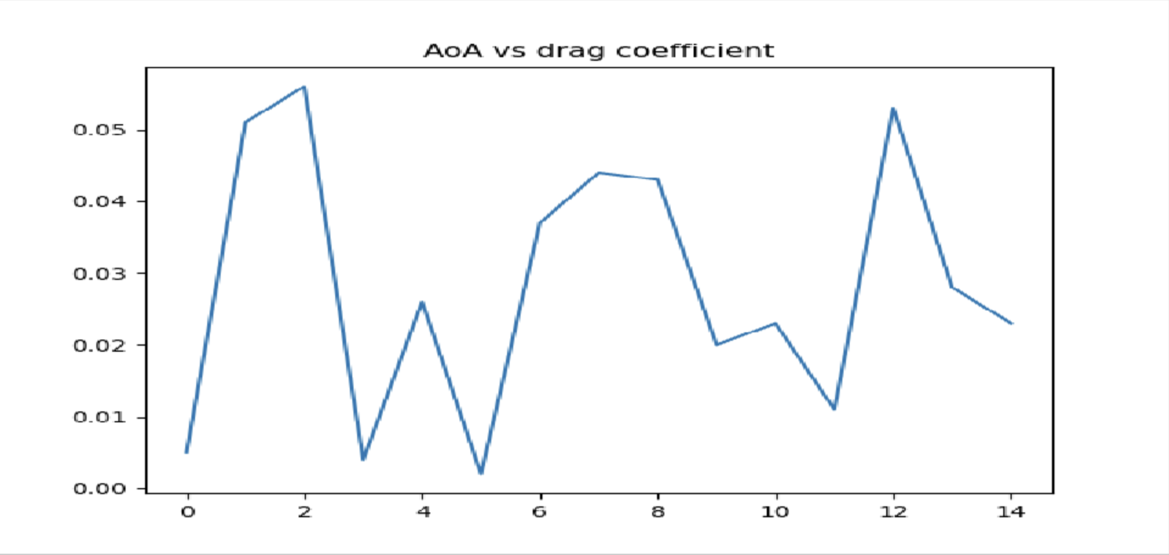

Freestream density change 1.225 → 0.9

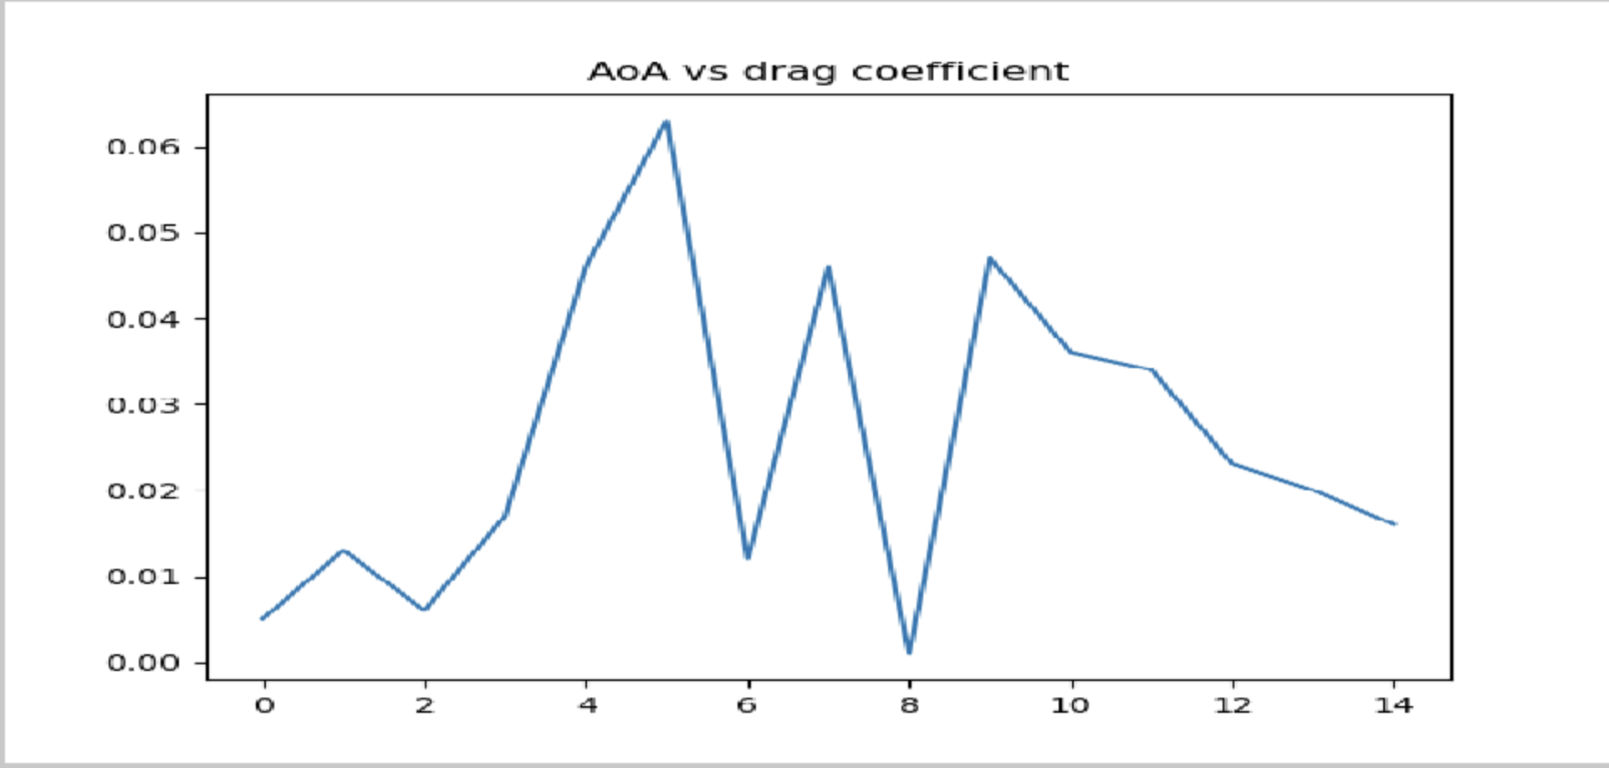

4.3 Exception Handling

3.9.1 Arithmetic errors

Within the mathematical mode, there are numerous instances where a set of inputs could inadvertently cause a division by 0 error, which would cause the program to crash. Instead, the program will divide by a very small number instead (arbitrarily chosen to be 1e-8)

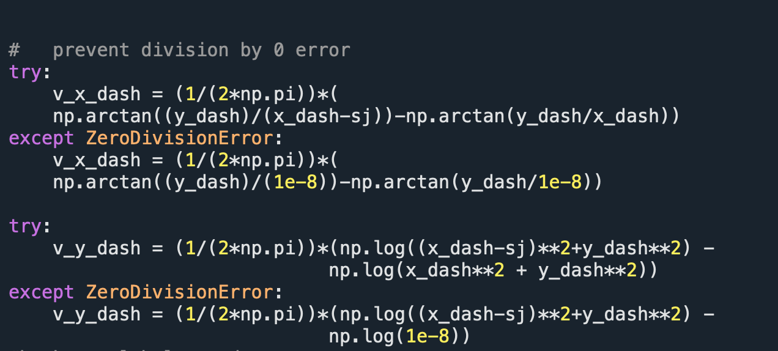
(From induced_v method of the Profile class of runfile.py file.)

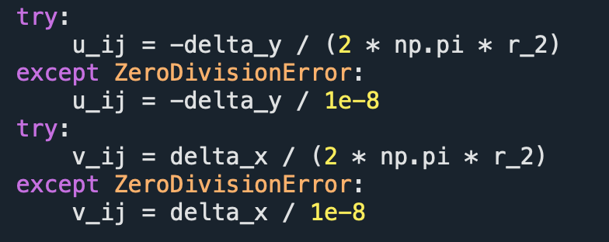
(from VPM_Cd)

3.9.2 User Input Exceptions

Import file format validation

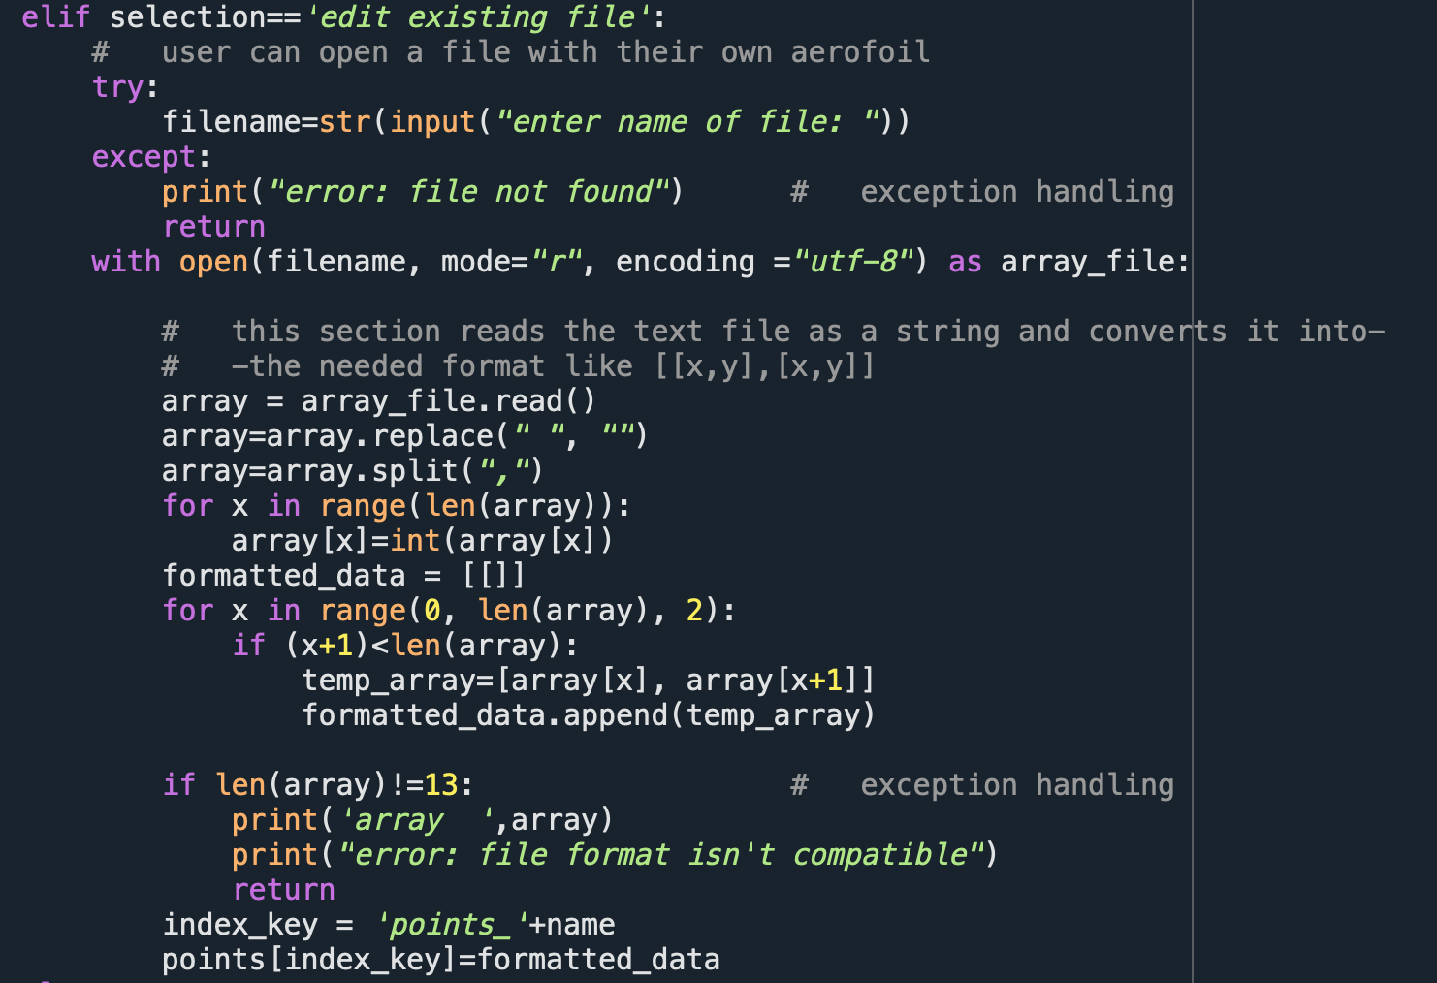
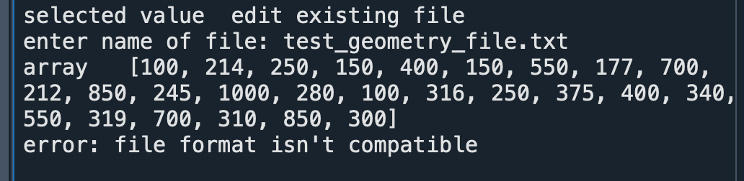
The program will print an error message if the length of file doesn’t match the set number of sliders available, as then the shape wouldn't get drawn on the editor screen to be edited.

Inputting a non-integer type as a physical constant:

Ensures the user inputs integers when altering any constants.

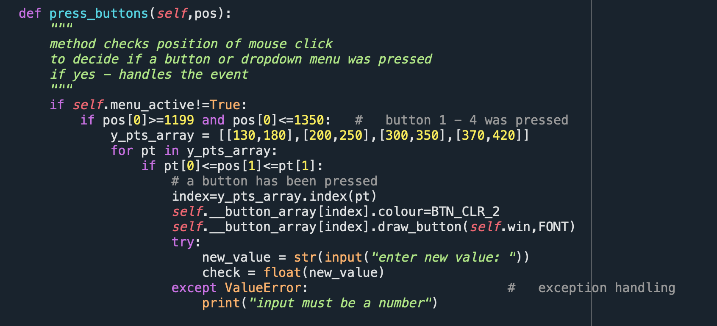

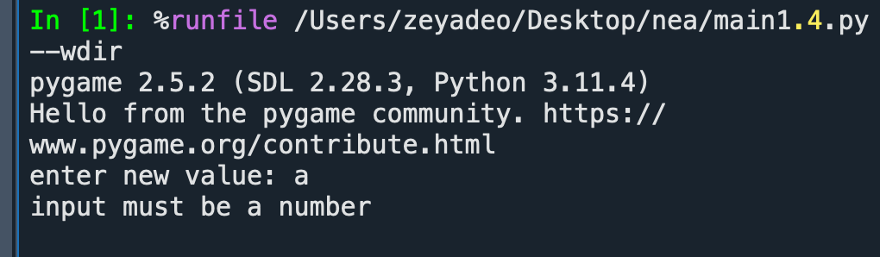

3. Not selecting an output format before calling analysis

By default, the output format is set to “-select-”. This is done to hint the user that they can plot different variables on the graphs. If the user attempts to run the analysis before making a selection for the first time, however, the program will crash, so this avoids the problem.

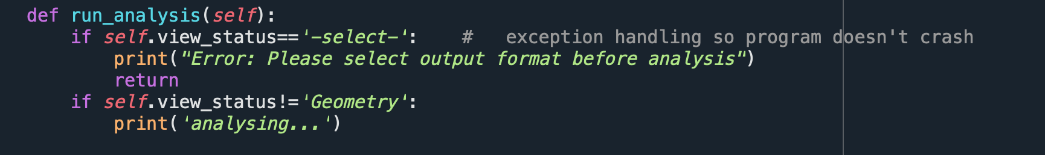
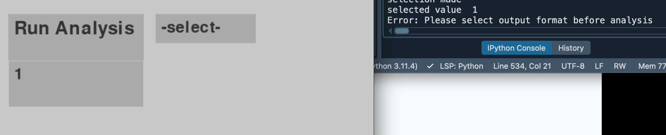

STAGE 4: Evaluation

5.1 Evaluating objectives

- 1. Airfoil geometry: to achieve this objective, I must implement a system for declaring the aerofoil geometry to be used in calculations and modelling, implemented in a visual manner, through a python library such as matplotlib. The displayed shape should directly correspond to the values used in analysis calculations. It should correctly and consistently identify the leading and trailing edges (as in those are handled differently in calculations).

This objective was achieved through implementing an array of adjustable sliders, their nodes connected with lines to form the aerofoil shape. This implementation ended up successful as it left the user sufficient flexibility to employ different kinds of shapes - cantered, symmetrical, flat, etc - while providing constraints to remain in reasonable bounds. As testing showed, altering the shape affected the calculations as expected, while constraining the number of panels (by using a fixed amount of sliders) made implementing the mathematical model easier. This also brought a shortcoming, as a smaller amount of panels meant decreased precision both in declaring the desired the shape and accuracy in subsequent outputs.

- 2. Aerofoil editor: to make the geometry interactable, I intend to use a GUI library to construct an interactive development screen where the student will use a computer mouse to drag and adjust the shape of the aerofoil in real time, with the geometry being displayed dynamically.

The sliders implemented as part of objective (1) were made using the pygame library. A functional editor screen was achieved through recording the user’s mouse clicks, comparing those with positions of the sliders and changing the node height accordingly. However, the position only changed visually once the mouse click was released, meaning it wasn’t possible to hold and drag the slider, which a user is likely to attempt.

- 3. Velocity profile and pressure distribution: this aim is dependent on subsequent outputs of my model. I intend to break down the geometry into smaller sections (‘panels’) and implement the vortex panel method in order to create a pressure distribution. This will then allow me to calculate parameters like the different aerodynamic coefficients.

Objective 3 was achieved within the supplemental python file through development and implementation of a mathematical model, which uses select parameters and the array of points defining the aerofoil shape. The coordinates for each window were normalised to account for the differences between coordinate systems for pygame and that assumed in my model. As the positions and amount of sliders were predefined, it was easy to separate the array of coordinates into panels, identify leading/trailing edges and process them accordingly (as detailed in Design section 2.2).

- 4. Graphical output: in order to match this target, I will ensure my program is able to compute, output, and explain the following graphs: Angle of Attack (AoA) against lift coefficient, AoA against drag coefficient, lift coefficient against drag coefficient, all using a graphing library. The values of these are dependent on the execution of the previous objective.

Each of the graph outputs proposed in objective 4 have been implemented. This required the user to select the desired graph, then press the button to run the analysis, and the corresponding graph appeared on screen. Judging from user testing results, the interface mechanism was intuitive enough to be used without any assistance, hence the objective was met effectively.

- 5. Time complexity: ensure the analysis runs in a reasonable time scale.
  - The initial plan to determine whether the time complexity and accuracy are adequate involved comparing my result with the output of an XFOIL program (an aerofoil analysis software often used in higher education and industry). However, after further research it became apparent the comparison isn’t sensible, as XFOIL uses a method significantly different from the Vortex Panel Method which I’m using.

Despite concerns regarding calculation method and how it would affect assessing the result, the objective of implementing a solution running on a reasonable scale was met easily. In fact, no further testing to determine precise program duration was necessary beyond the initial user tests, as the delay between pressing “Run analysis” and the graph output was judged negligible. This may or may not be the case with a larger number of points, however as the program uses a fixed number of sliders, assessing time complexity for larger data sets becomes redundant.

- 6. Aerofoil comparison: to alleviate some challenges of developing a wing design, I will implement an automatic system to compare between different aerofoils, making it easier to choose the most appropriate one. This will include a table listing the Cd and Cl values for different AoA of each aerofoil, as well as a same-axis plot of all the graphs and distributions.

This objective was partially achieved: I have implemented 3 separate windows so that the user can compare up to 3 shapes simultaneously, side by side. However, technical limitations meant the output graphs couldn’t be plotted on the same axis and had to be separated from one another, so direct comparison may not be as efficient as intended.

- 7. GUI Graphic User Interface: As my main objective is to create software accessible to school students without technical knowledge of the subject, the primary measure of my success will be a thought-out interface that is easy to navigate. All its functions should be in visible places and clearly explained, so that my end-users would not need an instruction manual to operate the system. There should ideally also not be any interaction with the console, only the GUI elements.

Although this objective was achieved for the most part, resulting in a clean yet intuitive interface, changing certain physical constants and the range of angles required interaction with the console, for failure to implement a dynamic text box. This was not intuitive to users less familiar with programming, and in one instance required me to interfere during the user testing.

- 8. Output and data representation: the only visible outputs of my analysis software will be the tables and graphs (and the editor screen), so they need to be extensively labelled to give the user all the information they may find useful in their design and comparison. I will determine whether this objective is met by conducting user tests on people without prior knowledge of the program or the theory behind it, and asking for feedback on how easy it was to navigate.

This objective was met through a thought-out interface algorithm to minimise any unnecessary elements/explanations on screen while keeping it easy to navigate. As per the user testing results, all presented information on screen was sufficient in their comparison, and data representation was clear and useful.

5.2 Addressing feedback

As part of the user interface testing strategy, I employed some real user testing, with an U6 (Yr 13) and an U4 (Yr 9) students. I explained the general purpose of the program without detailing technicalities of how it works, and had them use it. The intention was seeing how intuitive the interface mechanism is without guidance as well as identifying bugs and possible improvements. One of the students provided extensive feedback below:

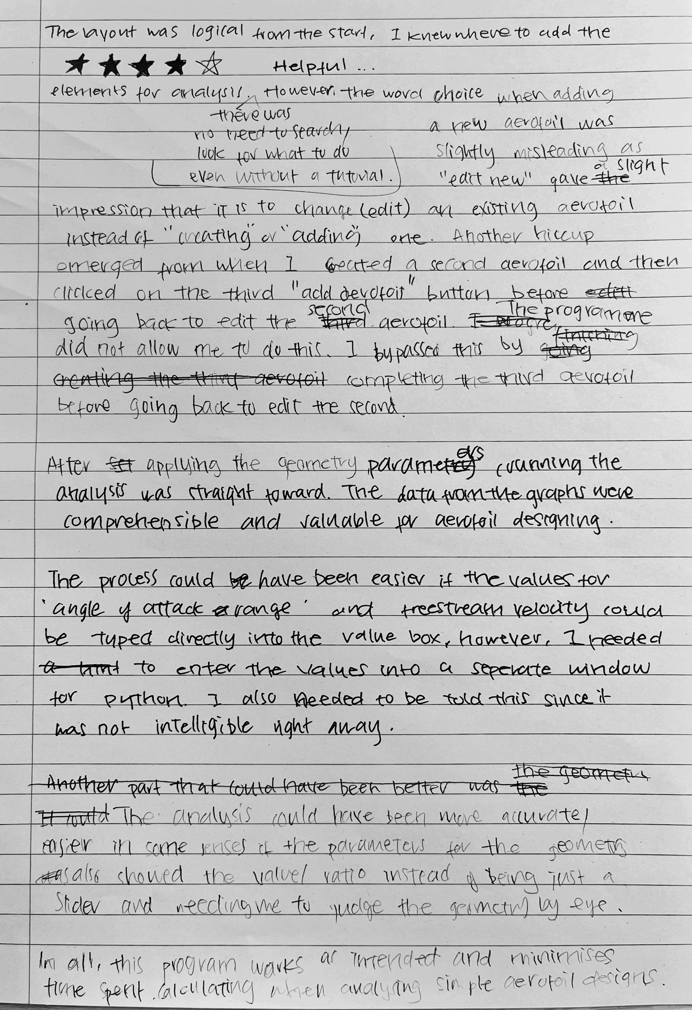
Transcript:
The layout was logical from the start, I knew where to add the elements for analysis. There was no need to search or look for what to do, even without a tutorial. However, the word ‘choice’, when adding a new aerofoil was slightly misleading as “edit new” gave a slight impression that it is to change (edit) an existing aerofoil instead of ‘creating’ or ‘adding’ one. Another hiccup emerged from when I created a second aerofoil and then circled the “add aerofoil” button before going back to edit the second aerofoil. The programme did not allow me to do this. I bypassed this by completing the third aerofoil, before going back to edit the second.

After applying the geometry parameters, running the analysis was straightforward. The data from the graphs were comprehensible and valuable for aerofoil designing.
The process could have been easier if the values for ‘angle of attack range’ and freestream velocity could be typed directly into the value box, however, I needed to enter the value into a separate window for python. I also needed to be told this since it was not intelligible right away.

The analysis could have been more accurate/easier in some senses if the parameters for the geometry also showed the value/ration instead of being just a slider and needing me to judge the geometry by eye.

In all, this program works as intended and minimises the time spent calculating when analysing simple aerofoil designs.

Feedback Summary
- The GUI layout and program functionality are intuitive without needing a tutorial
- Unable to interact with the rest of the screen after ‘add aerofoil’ is pressed, until one of the choices is selected
- Ambiguous wording when naming buttons
- Data output is comprehensible for intended purpose
- Inconvenient and at first unclear that user must input values into the console rather than straight into the text box
- Could use numerical indicators to make geometry design process less subjective
- Program works as intended and is time efficient

Feedback response
A large part of this project focused on ensuring the program is accessible to users less familiar with programming and any aerodynamics/physics concepts in the underlying functionality of aerofil analysis. The feedback raised several valid points which could provide points of resistance to the user, and hence should be addressed.

Firstly, unlike in most cases when interacting with interface day-to-day, my program locks the user out of performing any action once they click a button which activates a drop-down menu and until they make a selection. Essentially, they can’t interact with the rest of the screen while the menu is active. I chose not to change this feature as the possibility of multiple drop-down menus being active at once was problematic and would need me to rework significant amounts of code.

Adding numerical indicators to the sliders to make defining the shape less subjective is a subtle point which could definitely provide benefit to making more precise shapes, and would be relatively easy to implement through static text boxes displaying normalised coordinate values.

Critique regarding the user having to use the console is very reasonable as I have attempted to counter the issue during development as well. If I had more time, I would look into other widget packages to implement a dynamic text box that could be interacted with on screen.

5.3 Possible improvements

- Eliminating any interaction with the console from the user will go to further objective 7 to increase accessibility and provide a smoother experience. This goal has been identified within the initial objective and commented on by the user, so if I had extra time this would be one of the main things I would focus my attention on.

- Implementing an option to output the geometry as a 3D-printable file format. This was identified as a potential objective and would have been a very useful function for the end user - especially a participant of the Lift-Off Challenge, as it would allow them to test the theory-based data in an experimental setting.

- Adding more sliders to define each shape would be another possible improvement as it would increase the accuracy of the calculations and make subsequent outputs more precise. It would also allow the user to define more varied shapes, providing them with more flexibility, although it may make the interface harder to use if more sliders need to be dragged individually.

Citations

References
Anderson, J. D. (1991). Fundamentals of aerodynamics. McGraw-Hill.
Dasilva, M. (2024, July 23). Lift Coefficient | Glenn Research Center | NASA. NASA Glenn Research Center. Retrieved October 1, 2024, from https://www1.grc.nasa.gov/beginners-guide-to-aeronautics/lift-coefficient/
Davenport, W. J. (n.d.). Panel Method Applet. Vortex Panel Method. Retrieved October 1, 2024, from https://www.engapplets.vt.edu/fluids/vpm/vpminfo.html
Hetyei, C., Szlivka, F., & Molnar, I. (2020, 10 22). Comparing CFD software with NAVA 2412 airfoil. Progress in Agricultural Engineering Sciences, 16. https://www.researchgate.net/publication/348151142_Comparing_different_CFD_software_with_NACA_2412_airfoil/citation/download
Houghton, E. L., & Carpenter, P. W. (2003). Aerodynamics for Engineering Students. Elsevier Science.
Immanuel, S. R. A., & Somashekar, V. (2021). Design Of Airfoil For Low Reynolds Number Flights Using Python Automation Code. IOP conference series: Materials Science and Engineering. 10.1088/1757-899X/1123/1/012010
Kite Gen. (2007). KiteGen. Retrieved October 1, 2024, from http://www.kitegen.com/pages/winddata.html
Velkova, C. (2016). THE IMPACT OF DIFFERENT TURBULENCE MODELS AT ANSYS FLUENT OVER THE AERODYNAMIC CHARACTERISTICS OF ULTRA-LIGHT WING AIRFOIL NACA 2412. Research Gate. https://www.researchgate.net/publication/319483001_THE_IMPACT_OF_DIFFERENT_TURBULENCE_MODELS_AT_ANSYS_FLUENT_OVER_THE_AERODYNAMIC_CHARACTERISTICS_OF_ULTRA-LIGHT_WING_AIRFOIL_NACA_2412

Python Code

Main1.4.py

#MAIN 1.4 - file run by user

# LIBRARY PACKAGES
import pygame_widgets
import pygame
import runfile

pygame.init()
pygame.font.init()

#initialise dictionary with aerofoil defining points

points={
# top left window
"points_1":[[100, 214], [250, 150], [400, 150], [550, 177], [700, 212], [850, 245],[1000,280],
[100, 316], [250, 375], [400, 340], [550, 319], [700, 310], [850, 300]],
# bottom left window
"points_2":[[100, 714], [250, 650], [400, 650], [550, 677], [700, 712], [850, 745], [1000, 780],
[100, 816], [250, 875], [400, 840], [550, 819], [700, 810], [850, 800]],
# bottom right window
"points_3":[[1100, 714], [1250, 650], [1400, 650], [1550, 677], [1700, 712], [1850, 745], [2000, 780],
[1100, 816], [1250, 875], [1400, 840], [1550, 819], [1700, 810], [1850, 800]]
}

# GUI COLOUR CONSTANTS
SLDR_CLR_1 = (255,255,255) # slider track colour
SLDR_CLR_2 = (0,0,0) # slider node colour
BCKGRND_CLR = (200,200,200) # outer GUI box
WINDOW_CLR = (166, 164, 164) # indiv aerofoil window box
BTN_CLR_1 = (170,170,170) # default colour
BTN_CLR_2 = (125,125,125) # alternative colour
TXT_CLR = (200,200,200) # button text colour
TXT_CLR_2 = (50,50,50) #

FONT = pygame.font.SysFont('wilke', 40)
FONT_2 = pygame.font.SysFont('helvetica', 18, bold=True)
FONT_3 = pygame.font.SysFont('wilke', 46)

# GEOMETRIC CONSTANTS
SLDRWIDTH, SLDRHEIGHT, NODEHEIGHT = 10, 190, 10
BTN_DIMENSIONS = (220,55)
WIN_DIMENSIONS = (960,455)
INPUT_BOX_DIMENSIONS = (150,50)

# PHYSICAL CONSTANTS - by default
MIN_AOA = 0
MAX_AOA = 15
V_INF = 5
RHO_INF = 1.225

class Button:
"""
button class draws a box and blits text on it
"""
def __init__(self,x,y,text,_dimens,clr):
self.rect=pygame.Rect(x,y,_dimens[0],_dimens[1])
self.text=text
self.colour = clr
def draw_button(self,win, font):
font=font
pygame.draw.rect(win,self.colour,self.rect)
text_surface=font.render(self.text,True,TXT_CLR_2)
win.blit(text_surface,(self.rect.x+10,self.rect.y+10))
pygame.display.update()

class Slider:
"""
sliders are made by drawing separate boxes controlling the track and the node
"""
def __init__(self,_sldr_x,sldr_y,node_y):
self.node_y=node_y # node_x would be same as sldr_x so its redundant
self._sldr_x=_sldr_x
self.sldr_y=sldr_y

def draw_slider(self,win):
# draw slider track
track=pygame.Rect(self._sldr_x, self.sldr_y, SLDRWIDTH, SLDRHEIGHT)
pygame.draw.rect(win, SLDR_CLR_1, track)

# draw slider node
node=pygame.Rect(self._sldr_x, self.node_y, SLDRWIDTH, NODEHEIGHT)
pygame.draw.rect(win, SLDR_CLR_2, node)
pygame.display.update()

class Dropdown(Button):
"""
Drop-down menu - inheritance from Button class
when pressed, creates n rectangles below the button until any of those are pressed again
"""
def __init__(self,x,y,text,dimens,clr,selection,name):
super().__init__(x,y,text,dimens,clr)
self.x=x
self.y=y
self._dimens=dimens
self.selection=selection # array of items to select from
self.name=name
self.selection_array=[]
self.active=False # True when menu is opened
self.text=text
self.menu_coords=[] # coords of the menu when opened

def menu_pressed(self,win):
# drop down menu is activated and selection items are displayed
print('menu pressed')
y_temp=self.y+self._dimens[1]

# loops through every item in the drop-down menu selection array
for item in self.selection:
selection_item=pygame.Rect(self.x+1,y_temp+1,self._dimens[0]-2,self._dimens[1]-2)
# border added for easier selection
sel_item_border=pygame.Rect(self.x,y_temp,self._dimens[0],self._dimens[1])

pygame.draw.rect(win,(200,200,200),sel_item_border)
pygame.draw.rect(win,self.colour,selection_item)
text_surface=FONT.render(str(item),True,TXT_CLR_2)
win.blit(text_surface,(self.rect.x+10,y_temp+10))
pygame.display.update()
self.selection_array.append([self.x,y_temp,item])

y_temp=y_temp+self._dimens[1]
self.active=True

self.menu_coords=[self.x,self.y,self.x+self._dimens[0],y_temp+self._dimens[1]]
print('self menu coords',self.menu_coords)
print('selection_array ', self.selection_array)
return self.menu_coords

def selection_made(self,pos):
# one of the selection items was pressed
print('selection made')
for item in self.selection_array: # loop determines which item has been pressed and returns it as a string
if item[1]<=pos[1]<=(item[1]+self._dimens[1]):
self.text=str(item[2])
print('selected value ',self.text)
self.active=False
break
return self.text

class AerofoilWindow:
"""
Up to 3 Airfoil window objects can be on the screen
instantiated by pressing 'New Aerofoil+' button
the geometry of each aerofoil window is individually edited or loaded from a txt file
"""
def __init__(self,x,y,points,win):
self.x=x
self.y=y
self.points=points # initial values
self.slider_array=[] # NB: array doesn't contain the trailing edge point (middle one) as it's fixed
self.window=pygame.Rect(self.x, self.y, WIN_DIMENSIONS[0],WIN_DIMENSIONS[1])
pygame.draw.rect(win, WINDOW_CLR, self.window)
self.__initialise=True

def draw_lines(self,win,points): # ???review this
"""
connects all points of the aerofoil to construct the shape
"""
#drawing connecting lines
points=points
y=0
for i in range(2):
for x in range(6):
if x+y !=6:
start_pos=points[x+y]
line_end_1 = [start_pos[0]+5, start_pos[1]+5]
end_pos=points[x+y+1]
line_end_2 = [end_pos[0]+5, end_pos[1]+5]
pygame.draw.line(win, SLDR_CLR_2, line_end_1, line_end_2)
y=6

#leading edge line
start_pos=points[0]
line_end_1 = [start_pos[0]+5, start_pos[1]+5]
end_pos=points[7]
line_end_2 = [end_pos[0]+5, end_pos[1]+5]
pygame.draw.line(win, SLDR_CLR_2, line_end_1, line_end_2)

#trailing edge converging lines
start_pos=points[6]

line_end_1 = [start_pos[0]+5, start_pos[1]+5]
end_pos=points[5]
line_end_2 = [end_pos[0]+5, end_pos[1]+5]
pygame.draw.line(win, SLDR_CLR_2, line_end_1, line_end_2)
end_pos=points[12]
line_end_2 = [end_pos[0]+5, end_pos[1]+5]
pygame.draw.line(win, SLDR_CLR_2, line_end_1, line_end_2)

pygame.display.update()

def draw_window(self,win,window_num):
"""
this method first erases the whole aerofoil window (by putting a rectangle over it)
then draws all sliders/lines from scratch
which is necessary each time a slider is interacted with
"""
pygame.draw.rect(win, WINDOW_CLR, self.window)
# add slider x&y offset from screen edge - accounting for different window positions
sldr_y = 50
if self.y==545:
sldr_y=550

# iterate 2 layers of sliders - defining top and bottom of the shape

#differentiate between points1/2/3 as they are stored as separate arrays
array_name = 'points_{}'.format(window_num)
points_array = points[array_name]

for y in range (2):
_sldr_x = 100
if self.x>=1000:
_sldr_x=1100
for x in range(6): # 6 is the number of sliders in each layer
index=x+(7*(y)) # calculation converts x,y loop cycle indexes into repsective position in the array
if self.__initialise==True: # if window drawn for the first time, slider objects are instantiated into an array-
node = points_array[index]
slider = Slider(_sldr_x,sldr_y,node[1])
self.slider_array.append(slider)
else: # -otherwise, their node position is edited inside relevant object instance
self.slider_array[index].node_y = points_array[index][1]
#print("slider array", self.slider_array)
self.slider_array[index].draw_slider(win)
pygame.display.update()
_sldr_x = _sldr_x + 150

if self.__initialise==True and y==0:
# add the trailing edge here as a slider even though it appears as a fixed point and can't be changed
# it's not drawn on
ghost_point = points_array[6]
ghost_slider = Slider(ghost_point[0],ghost_point[1],ghost_point[1])
self.slider_array.append(ghost_slider)

sldr_y = sldr_y + 250

self.draw_lines(win,points_array) #!!!!!!
pygame.display.update()
self.__initialise=False

def update_points(self,x_pos,y_pos,win_num,win): #xpos and ypos are coords of mousebutton down

"""
method decides if user interacted with a slider
if yes, its coordinates are changed
each slider track has a small tolerance on either side of it where the mouse click will be counted
"""

array_name = 'points_{}'.format(win_num)

#if user pressed within 20 pixels of the track, the value will snap to the edge of the track
track_corner_vals = [100,250,400,550,700,850,
1100,1250,1400,1550,1700,1850]

pressed=False
for x in range(len(track_corner_vals)):
#print('xpos ',x_pos)
#print('corenrval ',track_corner_vals[x])
if (x_pos-track_corner_vals[x]) <=20 and (x_pos-track_corner_vals[x]) >= -20: # tolerance of 20 pixels
pressed=True
x_pos= track_corner_vals[x]
break
if pressed!=True:
#print('return')
return # sliders aren't edited if pressed outside the range, the function stops

temp=0
if win_num!=1:
temp=500

# get y coordiante of top left corner of the track
if y_pos <= 275+temp:
sldr_y=50+temp
else:
sldr_y=300+temp

# exception handling - limits node height, so it stays on the track
if sldr_y==50+temp: # top row sliders
if y_pos<=50+temp:
y_pos=50+temp
if y_pos>=240+temp:
y_pos=240+temp

elif sldr_y==300+temp: # bottom row sliders
if y_pos<=300+temp:
y_pos=300+temp
elif y_pos>490+temp:
y_pos=490+temp
#print('ypos',y_pos)
#print('xpos',x_pos)

# find index of the slider pressed and then input new coords into array
if win_num==3: # sliders on windows 1&2 have the same slider x-coordinates. window 3's is changed here to match
index=((x_pos+50-1000)//150)-1
else:
index=((x_pos+50)//150)-1

if sldr_y==300+temp: # index increments by 7 if item is in the bottom row
index=index+7
#print('index', index)
#print('points',points)
points[array_name][index]=[x_pos, y_pos]
print(points[array_name][index])
self.draw_window(win,win_num)

class GUI:
"""
this class controls the GUI elements defined by other classes
it also runs the analysis python file
and contains the main progrtam loop
"""
def __init__(self):

self.win=pygame.display.set_mode((2050, 1050))
self.win.fill(BCKGRND_CLR)
self.win.set_alpha(None)
self.__window_array = []
self.__button_array=[]
self.__win1=False
self.__win2=False
self.__win3=False
self.__window1_btn = None
self.__window2_btn = None
self.__window3_btn = None
self.menu_active=False
self.view_status = '-select-'
self.selected_aerofoil=None
self.analyse_ops=[]
self.menu_coords=[]

def init_windows(self):
# instantiate the dropdown menu buttons for adding aeorfoils
window_ops = ['edit new','edit existing file']
self.__window1_btn = Dropdown(501,262,"+Add Aerofoil", BTN_DIMENSIONS,BTN_CLR_1,window_ops,'q1')
self.__window1_btn.draw_button(self.win,FONT)
self.__window2_btn = Dropdown(501,762,"+Add Aerofoil", BTN_DIMENSIONS,BTN_CLR_1,window_ops,'q2')
self.__window2_btn.draw_button(self.win,FONT)
self.__window3_btn = Dropdown(1501,762,"+Add Aerofoil", BTN_DIMENSIONS,BTN_CLR_1,window_ops,'q3')
self.__window3_btn.draw_button(self.win,FONT)

def init_buttons(self):
# instantiate all other buttons

# erase top right quadrant of the screen (where all the buttons are)
window=pygame.Rect(1050, 50, WIN_DIMENSIONS[0],WIN_DIMENSIONS[1])
pygame.draw.rect(self.win, BCKGRND_CLR, window)

# instantiate buttons controlling user-defined constants
AoA_text = Button(1182,102,"Angle of attack range", INPUT_BOX_DIMENSIONS,BCKGRND_CLR)
AoA_text.draw_button(self.win,FONT_2)
v_text = Button(1188,272,"Freestream velocity", INPUT_BOX_DIMENSIONS,BCKGRND_CLR)
v_text.draw_button(self.win,FONT_2)
rho_text = Button(1188,342,"Freestream density", INPUT_BOX_DIMENSIONS,BCKGRND_CLR)
rho_text.draw_button(self.win,FONT_2)

AoA_LB = Button(1200,130,str(MIN_AOA), INPUT_BOX_DIMENSIONS,BTN_CLR_1)
AoA_LB.draw_button(self.win,FONT)

AoA_UB = Button(1200,200,str(MAX_AOA), INPUT_BOX_DIMENSIONS,BTN_CLR_1)
AoA_UB.draw_button(self.win,FONT)

v_inf = Button(1200,300,str(V_INF), INPUT_BOX_DIMENSIONS,BTN_CLR_1)
v_inf.draw_button(self.win,FONT)

rho_inf = Button(1200,370,str(RHO_INF), INPUT_BOX_DIMENSIONS,BTN_CLR_1)
rho_inf.draw_button(self.win,FONT)

# button to run the code from supplemental pythion file
self.analyse = Dropdown(1430,130,"Run Analysis", (230,80),BTN_CLR_1,self.analyse_ops,'analyse')
self.analyse.draw_button(self.win,FONT_3)

# button to select which output to put on screen
self.select_ops=['Geometry','AoA/lift','AoA/drag','lift/drag'] # output options
self.select = Dropdown(1680,130,self.view_status, (170,50),BTN_CLR_1,self.select_ops,'select')
self.select.draw_button(self.win,FONT)

self.__button_array.extend([AoA_LB,AoA_UB,v_inf,rho_inf])

self.menu_active=False

#print('all buttons drawn')

def init_aerofoils(self,pos,name,selection):

"""
method controls instantiation of aerofoil windows when
the user presses the button to add new window
"""
if self.menu_active!=True:
# +Add Aerofoil button has been pressed
if name=='1':
self.menu_coords=self.__window1_btn.menu_pressed(self.win)
self.menu_active=True
quadrant='1'
elif name=='2':
self.menu_coords=self.__window2_btn.menu_pressed(self.win)
self.menu_active=True
quadrant='2'
elif name=='3':
self.menu_coords=self.__window3_btn.menu_pressed(self.win)
self.menu_active=True
quadrant='3'
else:
# a selection on the drop-down menu has been made
if selection =='edit new':
index="points_{}".format(name)
print('index',index)
elif selection=='edit existing file':
# user can open a file with their own aerofoil
try:
filename=str(input("enter name of file: "))
except:
print("error: file not found") # exception handling
return
with open(filename, mode="r", encoding ="utf-8") as array_file:

# this section reads the text file as a string and converts it into-
# -the needed format like [[x,y],[x,y]]
array = array_file.read()
array=array.replace(" ", "")
array=array.split(",")
for x in range(len(array)):
array[x]=int(array[x])
formatted_data = [[]]
for x in range(0, len(array), 2):
if (x+1)<len(array):
temp_array=[array[x], array[x+1]]
formatted_data.append(temp_array)

if len(array)!=13: # exception handling
print('array ',array)
print("error: file format isn't compatible")
return
index_key = 'points_'+name
points[index_key]=formatted_data
else:
return
if name=='1':
self.window_1 = AerofoilWindow(50,45,points[index],self.win)
self.window_1.draw_window(self.win,name)
self.__window_array.append(self.window_1)
self.__win1 = True
self.analyse_ops.append('1')
self.menu_active=False

elif name=='2':
self.__win2 = True
self.analyse_ops.append('2')
self.window_2 = AerofoilWindow(50,545,points[index],self.win)
self.window_2.draw_window(self.win,name)
self.__window_array.append(self.window_2)
self.menu_active=False

elif name=='3':
self.__win3 = True
self.analyse_ops.append('3')
self.window_3 = AerofoilWindow(1050,545,points[index],self.win)
self.window_3.draw_window(self.win,name)
self.__window_array.append(self.window_3)
self.menu_active=False

def press_buttons(self,pos):
"""
method checks position of mouse click
to decide if a button or dropdown menu was pressed
if yes - handles the event
"""
if self.menu_active!=True:
if pos[0]>=1199 and pos[0]<=1350: # button 1 - 4 was pressed
y_pts_array = [[130,180],[200,250],[300,350],[370,420]]
for pt in y_pts_array:
if pt[0]<=pos[1]<=pt[1]:
# a button has been pressed
index=y_pts_array.index(pt)
self.__button_array[index].colour=BTN_CLR_2
self.__button_array[index].draw_button(self.win,FONT)
try:
new_value = str(input("enter new value: "))
check = float(new_value)
except ValueError: # exception handling
print("input must be a number")

self.__button_array[index].text=new_value
self.__button_array[index].colour=BTN_CLR_1
self.__button_array[index].draw_button(self.win,FONT)

if (pos[0]>=1430 and pos[0]<=1660): # button 5 or 6 was pressed
if 130<=pos[1]<=210:
self.menu_coords=self.analyse.menu_pressed(self.win)
#print('1')
self.menu_active=True
elif (pos[0]>=1680 and pos[0]<=1850):
if 130<=pos[1]<=210:
self.menu_coords=self.select.menu_pressed(self.win)
#drop down menu pressed
self.menu_active=True

else:
print('menu coords',self.menu_coords)

if self.menu_coords[0]<=pos[0]<=self.menu_coords[2] and self.menu_coords[1]<=pos[1]<=self.menu_coords[3]:
# menu option has been selected
# checks which menu is active to determine which one was pressed
name=None
if self.analyse.active==True:
self.selected_aerofoil=self.analyse.selection_made(pos)
self.run_analysis()
self.selected_aerofoil=None

elif self.select.active==True:
self.view_status=self.select.selection_made(pos)

elif self.__window1_btn.active==True:
selection=self.__window1_btn.selection_made(pos)
name='1'
elif self.__window2_btn.active==True:
selection=self.__window2_btn.selection_made(pos)
name='2'
elif self.__window3_btn.active==True:
selection=self.__window3_btn.selection_made(pos)
name='3'

if name!=None:
self.init_aerofoils(pos,name,selection)
else:
self.init_buttons()

pygame.display.update()

def GUI_interaction(self,pos):

"""
1. determine quadrant of button press. screen is split into 4 quadrants
2. if quadrant 1 or 2 or 3 see if there's an aerofoil there
if yes, update_sliders()
else, check if +AddAerofoil button is pressed
if yes, instantiate aerofoil
3. if quadrant 2 was pressed, run press_buttons() to check if a button was pressed
"""

x=pos[0]
y=pos[1]
if y<=501 and y>=49:
if x<=1001 and x>=49:
quadrant=1
if self.__win1==False:
if pos[0] in range(501,(501+BTN_DIMENSIONS[0])) and pos[1] in range(262,(262+BTN_DIMENSIONS[1])):
#button has been pressed
self.init_aerofoils(pos,'1',None)
else:
#print('sliders on 1 pressed')
self.window_1.update_points(pos[0],pos[1],quadrant,self.win)

elif x<=2001 and x>=1049:
quadrant=4 # top right doesn't contain aerofoil window, so last quadrant

#check if button is pressed in quadrant 4
self.press_buttons(pos)

elif y<=1001 and y>=549:
if x<=1001 and x>=49:
quadrant=2
if self.__win2==False:
if pos[0] in range(501,(501+BTN_DIMENSIONS[0])) and pos[1] in range(762,(762+BTN_DIMENSIONS[1])):
#button has been pressed
self.init_aerofoils(pos,'2',None)
else:
#print('sliders on 2 pressed')
self.window_2.update_points(pos[0],pos[1],quadrant,self.win)

elif x<=2001 and x>=1049:
quadrant=3
if self.__win3==False:
if pos[0] in range(1501,(1501+BTN_DIMENSIONS[0])) and pos[1] in range(762,(762+BTN_DIMENSIONS[1])):
#button has been pressed
self.init_aerofoils(pos,'3',None)
else:
#print('sliders on 3 pressed')
self.window_3.update_points(pos[0],pos[1],quadrant,self.win)

def run_analysis(self):
if self.view_status=='-select-': # exception handling so program doesn't crash
print("Error: Please select output format before analysis")
return
if self.view_status!='Geometry':
print('analysing...')

key = "points_{}".format(self.selected_aerofoil)
point_list = points[key]
runfile.runCode(point_list, MIN_AOA, MAX_AOA, V_INF, RHO_INF, self.view_status)
image = pygame.image.load("aerofoil_analysis_plot.png").convert()
image = pygame.transform.scale(image, WIN_DIMENSIONS)

# put image in the respective quadrant
if self.selected_aerofoil=='1':
self.win.blit(image, (50, 45))
if self.selected_aerofoil=='2':
self.win.blit(image, (50, 545))
if self.selected_aerofoil=='3':
self.win.blit(image, (1050, 545))
pygame.display.update()

else:
# select geometry to return to editor window
if self.__win1==True:
self.window_1.draw_window(self.win,'1')
elif self.__win2==True:
self.window_2.draw_window(self.win,'2')
elif self.__win3==True:
self.window_3.draw_window(self.win,'3')
pygame.display.update()

def run(self):
# main program loop

RUNNING=True

while RUNNING==True:
events = pygame.event.get()
for event in events:
if event.type == pygame.QUIT:
RUNNING=False

if event.type == pygame.MOUSEBUTTONDOWN:
pos_down = pygame.mouse.get_pos()
if self.menu_active==True:
self.press_buttons(pos_down)
break

if event.type == pygame.MOUSEBUTTONUP:
pos_up = pygame.mouse.get_pos()
if self.menu_active!=True:
self.GUI_interaction(pos_up)

"""
x_pos=pos_down[0]
y_pos=pos_up[1]
self.window_1.update_points(x_pos,y_pos,self.win)
"""
pygame_widgets.update(event)
pygame.display.update
pygame.quit()

def runGUI():
test=GUI()
test.init_windows()
test.init_buttons()
test.run()

runGUI()

Runfile.py

#runfile.py

import matplotlib
import matplotlib.pyplot as plt
import numpy as np
import pygame_widgets
import pygame
from pygame_widgets.slider import Slider
from pygame_widgets.textbox import TextBox
import sys

"""GLOBAL CONSTANTS""" # all in SI units
V_INF = None # freestream velocity
RHO_INF = None # freestream density
P_INF = 101000 # freestream static pressure
"""GLOBAL CONSTANTS"""

"""
pt_array=[[100, 214], [250, 150], [400, 150], [550, 177], [700, 212], [850, 250],[1000,275],
[100, 316], [250, 375], [400, 340], [550, 319], [700, 310], [850, 306]] #[1000,275] extrapolated, not from GUI
"""

"""TESTING"""

# basic test case - flat line goemetry
#pt_array=[[0,0], [1,0], [2,0], [3,0],[4,0],[5,0]]

"""
# NACA2412 test case
pt_array=[[1.0000,0.0013],[0.9500,0.0114],[0.9000,0.0208],[0.8000,0.0375],
[0.7000,0.0518],[0.6000,0.0636],[0.5000,0.0724],[0.4000,0.0780],
[0.2500,0.0767],[0.2000,0.0726],[0.1500,0.0661],[0.1000,0.0563],
[0.0750,0.0496],[0.0500,0.0413],[0.0250,0.0299],[0.0125,0.0215],
[0.0000,0.0000],[0.0125,-0.0165],[0.0250,-0.0227],[0.0500,-0.0301],
[0.0750,-0.0346],[0.1000,-0.0375],[0.1500,-0.0410],[0.2000,-0.0423],
[0.2500,-0.0422],[0.3000,-0.0412],[0.4000,-0.0380],[0.5000,-0.0334],
[0.6000,-0.0276],[0.7000,-0.0214],[0.8000,-0.0150],[0.9000,-0.0082],
[0.9500, -0.0048],[1.0000,-0.0013]]
"""
#custom geometry test case - output from ver 2.2 GUI file
pt_array=[[100, 214], [250, 150], [400, 150], [550, 177], [700, 212], [850, 250],[1000,275],
[100, 316], [250, 375], [400, 340], [550, 319], [700, 310], [850, 306]]

class Profile: # pass vars to Aerofoil class :: composition

"""
Profile class contains the methods for performing the vortex panel method.
New Profile obj is created for each AoA increment
"""

def __init__(self,pt_array, alpha):
self.points=pt_array
self.n = len(self.points) # number of panels
self.alpha = alpha
self.panel_arr = {}
self.gamma_matrix=None
self.q_inf=None
self.c=None # chord length
self.cl=0 # lift coefficient
self.cd=0 # drag coefficient
self.cp=0 # pressure coefficient

def get_chord_len(self):
leading_pt = self.points[0]
trailing_pt = self.points[len(self.points)//2] #middle value of array
c = np.sqrt((trailing_pt[0]-leading_pt[0])**2 + (trailing_pt[1]-leading_pt[1])**2) #pythagoras
self.c = c

def normalise_coords(self):
y_min=1050
# normalise coordinates to account for pygame's different coordinate system
for x in range(len(self.points)):
self.points[x][0] = 1050-self.points[x][0]
if self.points[x][0]<=y_min:
y_min=self.points[x][0]
# normalise coordinates with respect to the cord length
x_min = self.points[0][0]
for x in range(len(self.points)):
pt = [(self.points[x][0]-x_min)/self.c,(self.points[x][1]-y_min)/self.c]

def make_panels(self):

# add extra panel - between the first and last points

name = 'panel_0'
pt_1 = self.points[0]
pt_2 = self.points[self.n-1]
pan = Panel(pt_1=pt_1, pt_2=pt_2, alpha=self.alpha, name=name)
pan.calc_params()
self.panel_arr[name] = [pan.pt_1, pan.pt_2, pan.control_pt, pan.n_vector, pan.r, pan.theta, pan.t_vector]

# add all other panels
for x in range(0,self.n-1):
name = 'panel_{}'.format(x+1)
pt_1 = self.points[x]
pt_2 = self.points[x+1]

pan = Panel(pt_1=pt_1, pt_2=pt_2, alpha=self.alpha, name=name)
pan.calc_params()

self.panel_arr[name] = [pan.pt_1, pan.pt_2, pan.control_pt, pan.n_vector, pan.r, pan.theta, pan.t_vector] ### <--- PANEL CONTENTS ###

#print(self.panel_arr)

def dynamic_pressure(self):
q_inf = 0.5 * RHO_INF * (V_INF**2)
return q_inf

def induced_v(self,panel_j, panel_i,j):

j=j # panel index

x_c, y_c = panel_i[2][0], panel_i[2][1]

#local panel origin - whatever pt_1 is
x_0, y_0 = panel_j[0][0], panel_j[0][1]
theta = panel_j[5]
sj = panel_j[4]

x_r = x_c - x_0
y_r = y_c - y_0
x_dash = (x_r*np.cos(theta))+(y_r*np.sin(theta))
y_dash = (-x_r*np.sin(theta))+(y_r*np.cos(theta))

# prevent division by 0 error
try:
v_x_dash = (1/(2*np.pi))*(
np.arctan((y_dash)/(x_dash-sj))-np.arctan(y_dash/x_dash))
except ZeroDivisionError:
v_x_dash = (1/(2*np.pi))*(
np.arctan((y_dash)/(1e-8))-np.arctan(y_dash/1e-8))

try:
v_y_dash = (1/(2*np.pi))*(np.log((x_dash-sj)**2+y_dash**2) -
np.log(x_dash**2 + y_dash**2))
except ZeroDivisionError:
v_y_dash = (1/(2*np.pi))*(np.log((x_dash-sj)**2+y_dash**2) -
np.log(1e-8))
#back to global coords
v_x = v_x_dash * np.cos(theta) - v_y_dash * np.sin(theta)
v_y = v_x_dash * np.sin(theta) + v_y_dash * np.cos(theta)

#print(f"Induced velocity for panel {j}: v_x={v_x}, v_y={v_y}")
return v_x, v_y

def get_gamma(self):

"""
this method:
calculates the matrix of influence coefficients A, using panel geometries
forms the matrices for products of freestream velocity and normal vectors to each panel
forms matrix for unknown gamma values
uses the Kutta condition to generate the last row of the linear algebra equation
so that there is n equations total for n unknown gamma (vortex strength) values
solves resulting equation to obtain an array of gamma values
"""

#initialise empty matrix nxn size
A = np.zeros((self.n, self.n))
A[self.n-1][0] = 1.0 # kutta condition
A[self.n-1][self.n-1] = -1.0 # ensures leading and trailing velocities are equal

# COMPUTE MATRIX A
for i in range (self.n-1):

name_i = 'panel_{}'.format(i+1)
panel_i = self.panel_arr[name_i]
#x_c, y_c = panel_i[2][0], panel_i[2][1]

for j in range (self.n):

# make first row of matrix A
if i==j:
A_ij = -0.5 # special case
#print('special case here, i j', i, j)
else:
# define relative coordinate system
name_j = 'panel_{}'.format(j)
panel_j = self.panel_arr[name_j]

v_x, v_y = self.induced_v(panel_j, panel_i,j)

#compute A_ij
#theta = panel_j[5]

normal_x = panel_i[3][0]
normal_y = panel_i[3][1]

A_ij = round(v_x * normal_x + v_y * normal_y,5)
#print('A_ij= ', A_ij)
A[i][j]=A_ij
#print('A=,', A)

# V_INF x NORMAL ARRAY
n_v_matrix = []
for x in range (self.n): #populating normal array/matrix
name = 'panel_{}'.format(x)
panel = self.panel_arr[name]
normal = panel[3] # normal vector
#print('normal for', name, normal)
scalar_normal = V_INF * (normal[0]*np.cos(self.alpha)+normal[1]*np.sin(self.alpha))
n_v_matrix.append(scalar_normal)
n_v_matrix = np.array(n_v_matrix)

n_v_matrix[self.n-1]=0 #??? is this needed???

#print('n-v matrix: ', n_v_matrix)

#solve for gamma
self.gamma_matrix = np.linalg.solve(A, n_v_matrix)
#print("Gamma matrix:", self.gamma_matrix)

def VPM_Cl(self):

"""
calculates circulation due to flow vortex at each panel to get cp (pressure coefficient) at that panel
calculates total circulation - cgamma (capital greek gamma)
calculates lift per unit span - l_dash
Cl to go in a database
"""

cp_array=[]
cl_array=[]
cd_array=[]

cgamma=0 # cgamma = capital gamma = sum of gamma_j*s_j
for j in range(self.n):
name_j = 'panel_{}'.format(j)
panel_j = self.panel_arr[name_j]

######## CHECK THIS

# Calculate tangential velocity component
u_total = V_INF * np.cos(self.alpha)
v_total = V_INF * np.sin(self.alpha)

# Add induced velocities from all vortices
for i in range(self.n):
if i != j: # Skip self-induced velocity
name_i = 'panel_{}'.format(i)
panel_i = self.panel_arr[name_i]
v_x, v_y = self.induced_v(panel_i, panel_j, i)
u_total += self.gamma_matrix[i] * v_x
v_total += self.gamma_matrix[i] * v_y
#print('t vector', panel_j[6])
v_tang = u_total * panel_j[6][0] + v_total * panel_j[6][1] # Dot product with tangent vector
cgamma += self.gamma_matrix[j] * panel_j[4] # add to sum circulation

#print('cgamma =',cgamma)
l_dash = cgamma*V_INF*RHO_INF # lift per unit span
#print('ldash= ', l_dash)
q_inf = self.dynamic_pressure()

self.cl = l_dash/(q_inf*self.c)
#print('lift coefficient = ', self.cl)
return self.cl

def VPM_Cd(self):

"""
calculates velocity at each panel
& pressure coefficient
to obtain the total force of drag
--> calculate coefficient of drag (Cd)
Cd to go into database

"""

F_drag = 0 # total drag force
q_inf = self.dynamic_pressure()

for j in range(self.n):
name_j = 'panel_{}'.format(j)
panel_j = self.panel_arr[name_j]
j_point = panel_j[2]
s_j = panel_j[4] # panel length
theta = panel_j[5]
u_ij_total = 0
v_ij_total = 0
v_y_total = V_INF * np.cos(self.alpha)
v_x_total = V_INF * np.sin(self.alpha)
# x_j, y_j are j panel's ctrl point coords
for i in range(len(self.panel_arr)):
i_gamma = self.gamma_matrix[i] # strength of panel j
name_i = 'panel_{}'.format(i)
panel = self.panel_arr[name_i]
i_point = panel[2] # ctrl point on panel i = source of vortex
delta_x = j_point[0] - i_point[0]
delta_y = j_point[1] - i_point[1]
r_2 = delta_x**2 + delta_y**2 # r^2 = distance between i and j points squares

try:
u_ij = -delta_y / (2 * np.pi * r_2)
except ZeroDivisionError:
u_ij = -delta_y / 1e-8
try:
v_ij = delta_x / (2 * np.pi * r_2)
except ZeroDivisionError:
v_ij = delta_x / 1e-8

u_ij_total = u_ij_total + (i_gamma*u_ij)
v_ij_total = v_ij_total + (i_gamma*v_ij)

# vertical and horizontal velocity components calculated separately
u_ij_total = u_ij_total + (V_INF*np.cos(self.alpha))
v_ij_total = v_ij_total + (V_INF*np.sin(self.alpha))

v_j = np.sqrt((u_ij_total)**2 + (v_ij_total)**2) # velocity at panel j (tangential, as normal assumed 0)

C_p = 1 - (v_j / V_INF)**2
theta = panel[5] # theta at panel j

F_d_j = q_inf * C_p * s_j * np.cos(theta) # drag force at control point of panel j
F_drag = F_drag + F_d_j

self.cd = F_drag/(q_inf*self.c)
#print("drag coefficient = ", self.cd)
return self.cd

def pressure_dist(self):

"""
finds velocity at control point of each panel
from that finds pressure coefficient at cp of each panel
adds Cp to the array which will go in a database?
"""

#Draw pressure distribution from cp array

"""◾◾◾◾◾◾◾◾◾◾◾◾◾◾◾◾◾◾◾◾◾◾◾◾◾◾◾◾◾◾◾◾◾◾◾◾◾◾◾◾◾◾◾◾◾◾◾◾◾◾◾◾◾◾◾◾◾"""

class Panel:

"""
v_inf = freestream velocity
"""

def __init__(self, pt_1, pt_2,alpha,name):
#print('done,', name)
self.name=name
self.pt_1=pt_1
self.pt_2=pt_2
self.control_pt = None
self.gamma=0 # vortex strength
self.t_vector=None
self.n_vector=None
self.alpha=np.radians(alpha) # angle of attack
self.theta = (np.arctan2((pt_2[1]-pt_1[1]), (pt_2[0]-pt_1[0])))-self.alpha # angle between panel and horizontal
# r - length of panel
self.r=np.sqrt((pt_2[0]-pt_1[0])*(pt_2[0]-pt_1[0])+(pt_2[1]-pt_1[1])*(pt_2[1]-pt_1[1]))

self.phi=0 # velocity potential
self.psi=0 # stream function
self.lmda=0 # lambda - mass flow rate per unit length

def calc_params(self):

"""
determine centre point,
angle with neutral chord line (x-axis),
tangential vector
normal vector
"""
#centre point
self.control_pt = [(self.pt_2[0]+self.pt_1[0])/2,
(self.pt_2[1]+self.pt_1[1])/2]

dx = self.pt_2[0] - self.pt_1[0]
dy = self.pt_2[1] - self.pt_1[1]
self.t_vector = np.array([dx, dy])/self.r # tangenttial vector

self.n_vector = np.array([-dy, dx])/self.r # normal vector

"""◾◾◾◾◾◾◾◾◾◾◾◾◾◾◾◾◾◾◾◾◾◾◾◾◾◾◾◾◾◾◾◾◾◾◾◾◾◾◾◾◾◾◾◾◾◾◾◾◾◾◾◾◾◾◾◾◾"""

class Aerofoil: # access methods from Profile class

"""
contains all info relating to an aerofoil
defines panels
Outputs relevant info to the GUI class
"""

def __init__(self,points,min_alpha,max_alpha):
self._geometry=points # points defining the airfoil
self.chord_len=0 # distance from leading edge to trailing edge
self.num_panels= len(self._geometry)-1 # number of panels
self.alpha=0 # current angle of attack
self.min_alpha=min_alpha # lower bound of AoA range
self.max_alpha=max_alpha # upper bound of AoA range
self.data_table=[] # table of AoA & cl & cd values

def setup_panels(self):
temp=0
"""insert front panel here"""
new_panel=Panel(self._geometry[6], self._geometry[0])
self.panel_array.append(new_panel)

for y in range(2):
for x in range ((len(self._geometry)-2)/2):
new_panel=Panel(self._geometry[x+temp], self._geometry[x+1+temp])
self.panel_array.append(new_panel)

if temp==0:
""" trailing edge panels """
new_panel=Panel(self._geometry[5], self._geometry[1000,300])
self.panel_array.append(new_panel)
new_panel=Panel(self._geometry[1000,300], self._geometry[11])
self.panel_array.append(new_panel)
temp=6

def analysis(self):

"""
executes VPM for the range of Alpha values (currently manually set o 0-15)
"""

self.alpha=self.min_alpha
for x in range (self.max_alpha-self.min_alpha):
data = []
data.append(x)
prof=Profile(pt_array,self.alpha)
prof.get_chord_len()
prof.normalise_coords()
prof.make_panels()
prof.get_gamma()
cl=abs(round(prof.VPM_Cl(),3))
cd=abs(round(prof.VPM_Cd(),3))

data.append(cl)
data.append(cd)

self.alpha=self.alpha+1

self.data_table.append(data)
#print('alpha=', self.alpha)
#print('data=', data)

print('table', self.data_table)
print("Output table: ")
for item in self.data_table:
print(item)

def make_graph(self,view_status):

data = np.array(self.data_table)
num_rows = len(data)
x = data[:,0] # first column only - all alpha values
#print('x',x)
y_lift = data[:,1] # 2nd column - all cl values
#print('y',y_lift)
y_drag = data[:,2] # 3rd column - all cd values

#fig = plt.figure()

if view_status == 'AoA/lift':
plt.plot(x, y_lift,label='cl vs aoa')
plt.title("AoA vs lift coefficient")
elif view_status == 'AoA/drag':
plt.plot(x,y_drag)
plt.title("AoA vs drag coefficient")

elif view_status == 'lift/drag':
y_lift_drag=y_lift
for i in range(len(y_lift)):
y_lift_drag[i]=round(y_lift[i]/y_drag[i],3)
print('ylift/drag',y_lift_drag)
plt.plot(x,y_lift_drag)
plt.title("AoA vs lift coefficient/drag coefficient")
else:
print("error: view_status doesn't exist")
print("view status: ",view_status)
plt.savefig('aerofoil_analysis_plot.png')
plt.show()

def runCode(pt_array,min_aoa,max_aoa,v_inf,rho_inf,VIEW_STATUS):
pt_array = pt_array
# variable have to be declared global here as they are passed from outside the python file
# othersise they would be declared at the start of the script
global min_alpha, max_alpha
min_alpha, max_alpha = min_aoa, max_aoa
global V_INF,RHO_INF
V_INF,RHO_INF = v_inf,rho_inf

A = Aerofoil(pt_array,min_alpha, max_alpha)
A.analysis()
A.make_graph(VIEW_STATUS)

