Cloud Removal for GeoPACHA-AI: Documentation
Tatiana Kapitonova
Table of Contents
1. Introduction 2
1.1 Project Overview 2
1.2 System Overview 3
2 Dataset and Data Preparation 4
2.1 8-Band Data Source 4
2.2 Areas of Interest (AOIs) 5
2.3 Dataset Organization 5
3 Model Architecture 6
3.1 Model Selection and Implementation 6
3.2 Loss Function 6
3.3 Evaluation Metrics 7
4 Model Implementation 7
4.1 Training Process 7
4.2 Inference Pipeline 8
5 Engineering Challenges 9
5.1 Maximizing Training Speed 9
5.2 Mask Boundary Accuracy 9
5.3 The Normalization Problem 10
5.4 Reducing False Positives with Hard Negatives 10
6 Experimental Results 10
6.1 Quantitative Evaluation 10
6.2 Qualitative Results 12
6.3 Discussion 12

1. Introduction

1.1 Project Overview
Satellite imagery has become an essential resource for archaeological research, environmental monitoring, and geospatial analysis. High-resolution multispectral imagery enables researchers to identify subtle surface features, monitor changes over time, and investigate regions that would otherwise require costly field surveys. One persistent limitation of optical satellite imagery is cloud contamination. Clouds partially or completely obscure the Earth's surface, preventing archaeological features from being observed. Even scenes with relatively low cloud coverage may become unsuitable for analysis if clouds overlap areas of interest. Consequently, automated methods for identifying and removing clouds represent an important preprocessing step before imagery can be used for downstream archaeological analysis.
This project develops the first stage of an automated cloud-removal pipeline for the GeoPacha project by creating a semantic segmentation model capable of identifying cloud-covered pixels in WorldView-2 satellite imagery. The objective of this work is to generate accurate binary cloud masks that can be used to construct images with clouds automatically removed during preprocessing. The completed system should operate on large georeferenced images while preserving spatial metadata required for subsequent processing stages. Although cloud detection is the focus of this report, it represents only the first stage of the broader GeoPacha image restoration pipeline.
GeoPACHA is an archaeological research initiative that applies remote sensing and computer vision techniques to analyze high-resolution satellite imagery. Large collections of commercial satellite imagery provide valuable information for identifying archaeological features, monitoring landscapes, and supporting historical investigations. Because these datasets cover extensive geographic regions and span multiple acquisition dates, automated image processing techniques are essential for efficient analysis.

1.2 System Overview
The developed system consists of four major stages: dataset preparation, model training, inference, and generation of georeferenced cloud masks. Emphasis was placed on modular software organization, reproducible training procedures, comprehensive logging, and clear documentation so that future researchers can continue development without reconstructing the original implementation.
The workflow begins by identifying labeled areas of interest (AOIs) within each multispectral GeoTIFF image. These AOIs define the regions used for training while avoiding unlabeled portions of the imagery. The selected regions are subdivided into overlapping image chips suitable for GPU-based training, with corresponding binary cloud masks generated from manually annotated labels.
Training is performed using a Feature Pyramid Network (FPN) with a ResNet-50 encoder adapted for eight-channel WorldView-2 imagery. The network performs semantic segmentation, producing a binary prediction for every pixel within an input image chip. Model optimization uses weighted cross-entropy loss to account for class imbalance between cloud and background pixels.
During inference, the trained model processes unseen satellite imagery by applying the same tiling strategy used during training. Individual chip predictions are reassembled into a single georeferenced raster matching the dimensions of the original image. The resulting cloud mask preserves the spatial reference information required for integration into downstream preprocessing workflows.
The modular organization of the pipeline allows individual components to be modified independently without requiring substantial changes to the remainder of the system.

2 Dataset and Data Preparation

2.1 8-Band Data Source
The training dataset consists of high-resolution WorldView-2 multispectral satellite imagery accompanied by manually annotated cloud masks. Each WorldView-2 scene contains eight spectral bands that provide significantly more information than standard RGB imagery, allowing the model to exploit differences in spectral reflectance that are not visible to the human eye. This is particularly useful for differentiating between clouds and other features which may appear similar to the human eye (i.e. snow caps and salt lakes), but carry different properties in the IR bands of the spectrum.
Unlike conventional computer vision datasets, each source image is a large georeferenced GeoTIFF that may contain hundreds of millions of pixels. Processing these images directly is computationally impractical and exceeds the memory limitations of modern GPUs. Consequently, a preprocessing pipeline was developed to transform the raw imagery into smaller image chips suitable for semantic segmentation while preserving the spatial relationship between imagery and annotations.
Cloud labels are stored as vector polygons describing the boundaries of visible cloud regions. During preprocessing, these annotations are rasterized into binary segmentation masks that align with the corresponding image chips.

2.2 Areas of Interest (AOIs)
Only portions of each satellite image contain manually annotated cloud labels. Training on unlabeled regions would incorrectly treat unknown pixels as background, introducing label noise and reducing model performance. To avoid this issue, the preprocessing pipeline restricts dataset generation to Areas of Interest (AOIs), which define the spatial extent of valid training data.
Each AOI is associated with a single satellite image and specifies the region where cloud annotations are available. During dataset construction, image chips are generated exclusively from these AOIs, ensuring that every training sample contains reliable ground-truth labels. This allows additional labeled imagery to be incorporated into the dataset simply by defining new AOIs, without requiring modifications to the preprocessing pipeline, making it easier to add future model improvements
Because the original imagery is substantially larger than the input dimensions supported by the neural network, each AOI is subdivided into smaller fixed-size image chips of 512x512 pixels. Following the sliding window approach, each chip overlaps its neighboring chips by 50% (128 pixels) to ensure that all features get analyzed equally and there are no errors at tile borders.

2.3 Dataset Organization
To prevent information leakage, the dataset is divided into training, validation, and test sets at the image level rather than the chip level. This distinction is particularly important for satellite imagery because adjacent chips extracted from the same image often contain highly correlated spatial information.
If neighboring chips were assigned to different dataset splits, the model could effectively observe portions of the same geographic scene during both training and validation, resulting in overly optimistic performance estimates. By assigning entire source images to a single split, the evaluation more accurately measures the model's ability to generalize to previously unseen imagery.
The preprocessing pipeline automatically generates the dataset structure expected by Raster Vision, including imagery, segmentation masks, metadata, and configuration files required for reproducible experiments.

3 Model Architecture

3.1 Model Selection and Implementation
The cloud detection problem is formulated as a binary semantic segmentation task in which every pixel is classified as either cloud or background. Unlike image classification, semantic segmentation requires accurate localization of cloud boundaries while simultaneously recognizing cloud structures that may vary dramatically in size, texture, and opacity. The most suitable backbone for this was selected to be Feature Pyramid Network (FPN) with a ResNet-50 encoder. This architecture is very common to use for a task like this – it combines the strong feature extraction capabilities with multi-scale feature fusion, enabling accurate segmentation across a wide range of cloud sizes. At first, the ResNet-18 encoder was tried out, which gave good baseline performance. However, a deeper model with 50 layers was selected to maximize the precision of the resulting cloud masks. The model was implemented using the rastervision library. To use this architecture, the 8-band input was normalized to the [0,1] range expected by FPN. The normalization was carried out by taking a sample of 7 images and obtaining the ranges of their 2nd-99th percentiles, to avoid including outlier pixels in the normalization.

3.2 Loss Function
Cloud pixels typically occupy only a fraction of each satellite image, resulting in substantial class imbalance between cloud and background classes. Training with an unweighted loss function would bias the model toward predicting background for the majority of pixels, producing deceptively high accuracy but poor cloud detection performance.
To compensate for this imbalance, training uses a weighted cross-entropy loss that assigns greater importance to cloud pixels during optimization. Initially clouds were weighted 10 times more, which was later adjusted to 8 times. This weighting encourages the network to learn meaningful cloud representations rather than minimizing loss through majority-class predictions.

3.3 Evaluation Metrics
The main evaluation metrics include:
Metric | Purpose
Intersection over Union (IoU) | Measures overlap between predicted and ground-truth cloud masks.
F1 Score | Balances precision and recall.
Precision | Measures the fraction of predicted cloud pixels that are correct.
Recall | Measures the fraction of true cloud pixels successfully detected.
These metrics provide a more representative assessment of segmentation performance than overall accuracy and allow comparison between successive model versions throughout development.

4 Model Implementation
The training workflow is built on the Rastervision framework, which provides dataset management, experiment configuration, and geospatial data handling for remote sensing applications. While Raster Vision offers a robust foundation for semantic segmentation, several components were extended to support the requirements of the project: custom learner classes, dataset implementations, and preprocessing utilities were developed to integrate multispectral WorldView-2 imagery, support eight-channel inputs, and streamline the generation of reproducible experiments.

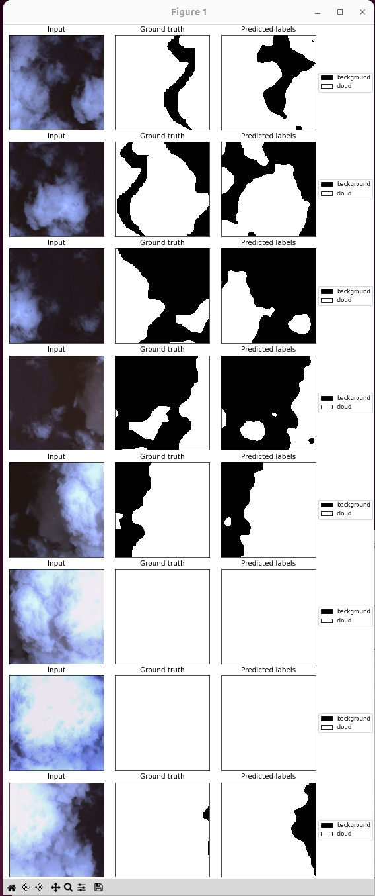
4.1 Training Process
One of the primary engineering challenges involved efficiently loading very large multispectral images from network storage. Reading high-resolution GeoTIFF files introduces substantial I/O overhead, particularly when thousands of image chips are required during training.
To improve throughput, the project employs custom dataset classes that perform on-demand chip extraction while minimizing unnecessary disk access. The data loading pipeline also performs normalization, tensor conversion, and optional data augmentation before samples are passed to the neural network. Additionally, each relevant image is downloaded locally before being accessed, as the main source of time delay was communication with the server.
Each training iteration consists of four stages:
- A batch of multispectral image chips and corresponding segmentation masks is loaded from the dataset.
- The Feature Pyramid Network generates dense pixel-wise predictions.
- Weighted cross-entropy loss is computed by comparing predicted probabilities with the ground-truth cloud masks.
- Model parameters are updated using backpropagation and gradient-based optimization.
Training periodically evaluates performance on the validation dataset while recording loss values and segmentation metrics. Checkpoints are automatically saved throughout training, allowing interrupted experiments to resume and enabling comparison between different model versions. TensorBoard logs training loss, validation loss, and evaluation metrics for subsequent analysis.
Because the project is intended as a long-term research platform, considerable effort was devoted to ensuring experiment reproducibility. Model configuration, dataset parameters, checkpoint files, and logging outputs are stored separately from source code, allowing experiments to be repeated or modified without changing the underlying implementation.

4.2 Inference Pipeline
Following training, the semantic segmentation model is used to generate cloud masks for previously unseen WV-2 imagery. This is the process of actually implementing the model after it’s been trained, and getting it ready for further processing within the larger GeoPACHA pipeline. Because inference is performed on full-resolution satellite scenes rather than isolated image chips, it must efficiently process very large raster datasets while preserving geographic metadata.
Since complete satellite images exceed GPU memory limitations, each scene is partitioned into overlapping 512 × 512 pixel tiles using the same sliding-window strategy employed during dataset generation. This approach allows arbitrarily large images to be processed while maintaining a fixed input size for the neural network. Image overlap is particularly important during inference because predictions near tile boundaries often exhibit reduced accuracy. By processing overlapping regions and reconstructing a single output image, boundary errors are significantly reduced.
Each image chip is processed independently by the trained segmentation model, producing a probability map representing the likelihood that each pixel belongs to the cloud class. These probability maps are subsequently converted into binary segmentation masks using a predefined classification threshold.
Individual tile predictions are then stitched together to reconstruct a complete cloud mask matching the dimensions of the original satellite image. Overlapping predictions are combined to minimize discontinuities introduced by tile boundaries. The final predictions are output as GeoTIFFS and GeoJSON files with preserved coordinate systems, ready to be used in GIS software.

5 Engineering Challenges

Developing the cloud segmentation model required iterative engineering beyond selecting and training a neural network. Several challenges emerged during training and evaluation, particularly around computational efficiency, annotation quality, image preprocessing, and false-positive predictions. Addressing these issues required repeated testing and changes to both the training pipeline and the underlying dataset.

5.1 Maximizing Training Speed

During model training, periods of low GPU utilization caused training to run significantly slower than expected. The primary bottleneck was not always the model itself, but the rate at which training data could be prepared and delivered to the GPU. To improve throughput, the data-loading pipeline was adjusted to use more parallel workers so that multiple samples could be prepared simultaneously. In addition, the relevant satellite images were downloaded locally before training rather than repeatedly requesting image data from the server. This reduced network communication overhead and allowed the GPU to spend more time performing model computations instead of waiting for data.

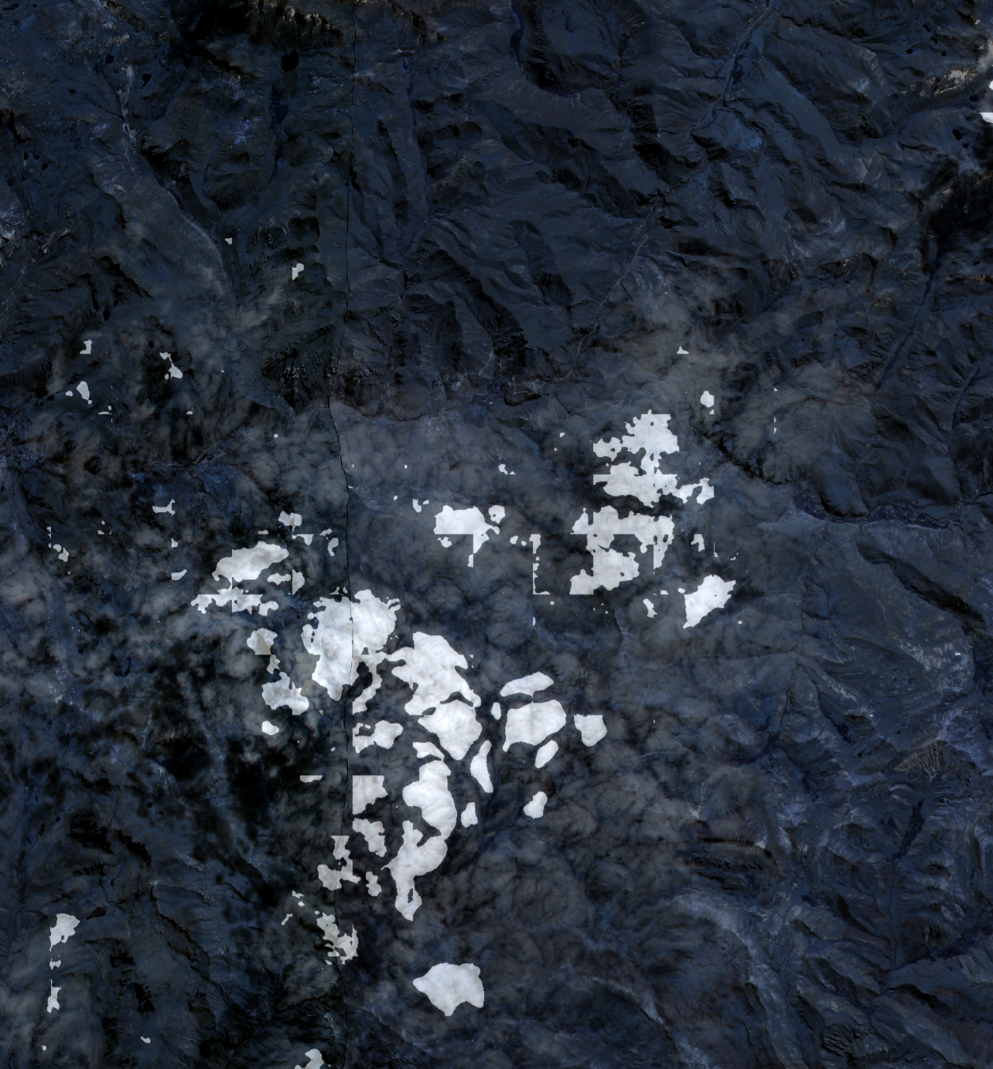
5.2 Mask Boundary Accuracy

Although early versions of the model were generally able to identify clouds correctly, the predicted cloud boundaries were often blurry or less precise than desired. Because semantic segmentation quality is strongly dependent on the quality of the ground-truth masks, the training annotations themselves became an important engineering consideration. The cloud labels were manually created in QGIS, so improving the model required revisiting and refining a substantial portion of the training data to produce sharper, more accurate cloud boundaries. The revised annotations provided the model with clearer examples of where cloud pixels ended and background pixels began, improving the expected precision of the resulting masks.

5.3 The Normalization Problem
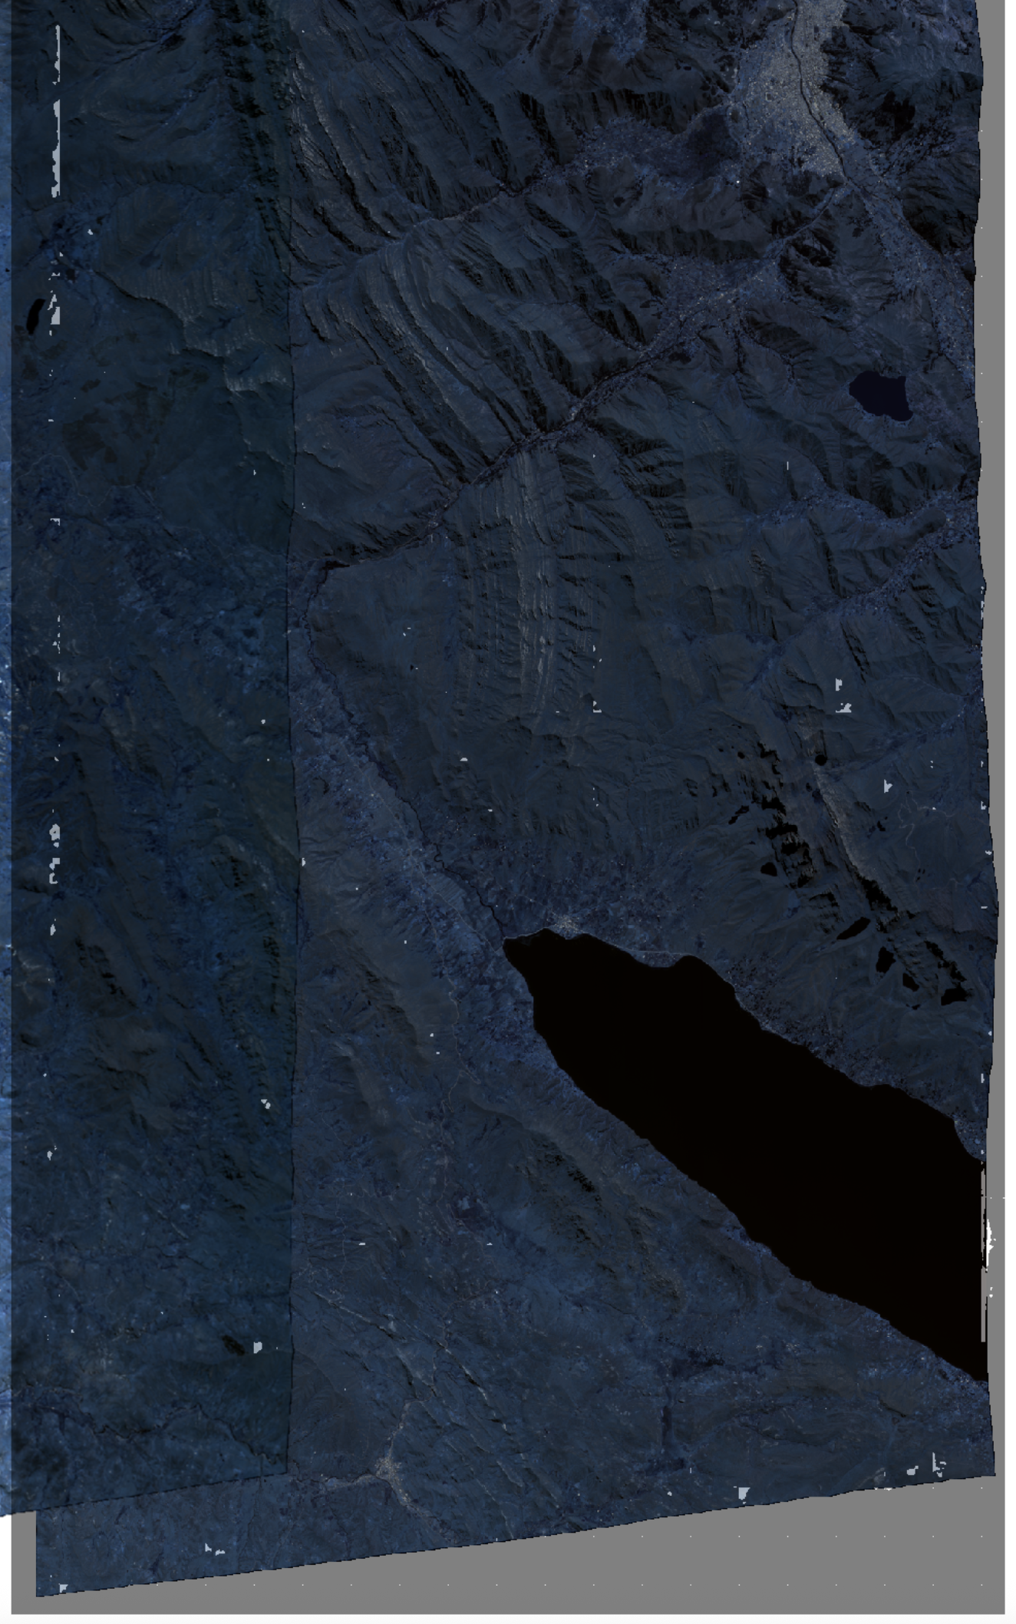
A significant source of false-positive cloud predictions appeared as small cloud-like artifacts around image boundaries and in other regions where clouds were not actually present. One initial approach was to add more training examples from these regions as hard negatives, but this produced limited improvement. Further investigation showed that the underlying issue was the normalization procedure: each image chip was initially normalized independently, which caused inconsistent scaling between images and allowed extreme values, including null values around image edges, to influence the normalization.
The normalization procedure was therefore changed to use a representative sample of seven images and calculate the 2nd and 99th percentiles across the sample. These percentile values were used to normalize the eight-band imagery while excluding extreme pixel values from the scaling range. This produced a more consistent numerical representation across images and substantially reduced the artificial cloud-like artifacts caused by the previous normalization method.

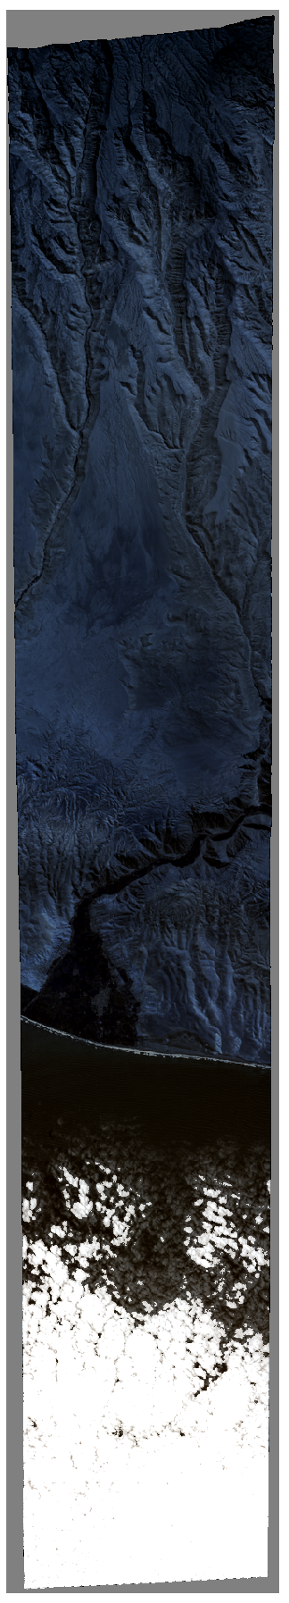
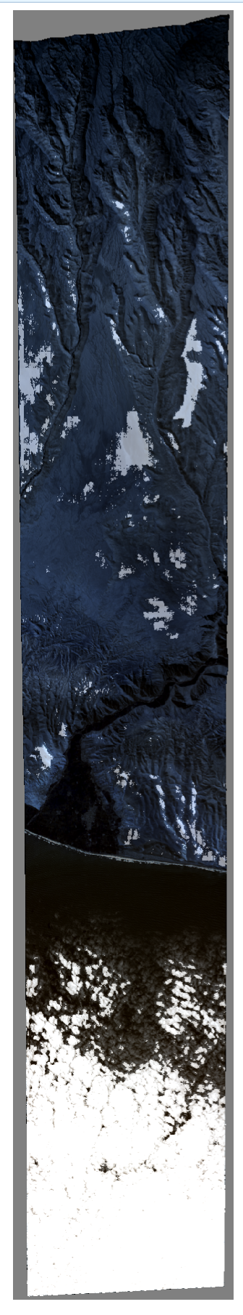
5.4 Reducing False Positives with Hard Negatives

A separate issue occurred in a small number of images where the model detected clouds in areas that contained no clouds. These errors appeared to be associated with terrain features whose shapes or spatial patterns were similar to cloud structures. Because these examples represented difficult cases for the model, additional hard-negative samples were added to the training dataset from the affected regions. By explicitly showing the model examples of terrain that should be classified as background despite resembling clouds, the training data was made more representative of challenging real-world conditions.

6 Experimental Results

6.1 Quantitative Evaluation
Model performance was evaluated throughout development using precision, recall, and F1 score for both the background and cloud classes. These metrics were used to compare model versions and assess the effects of changes to the training data, preprocessing pipeline, and model configuration. Because cloud detection is the primary objective of the system, particular attention was given to the cloud-specific metrics.
Figure 9 shows the progression of model performance across model versions 2–5. The results demonstrate substantial improvement between the early and later model versions. Cloud precision increased from approximately 80% in version 2 to approximately 98% in version 5, while cloud recall remained above 97% across the later versions. Average F1 score also increased from approximately 96% in version 2 to approximately 99% in the final model.
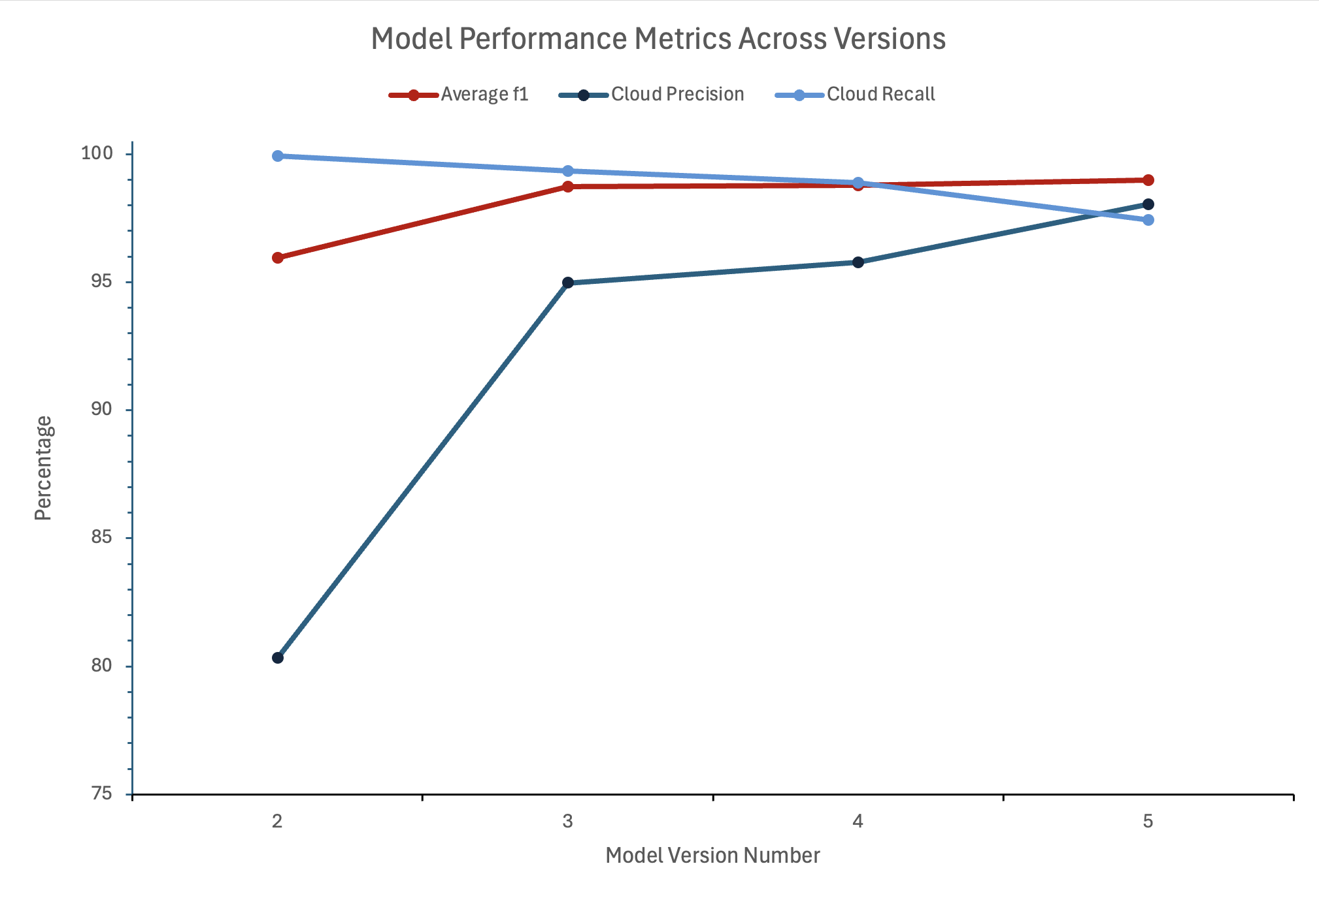
Figure 9. Model performance metrics across model versions.
The final model, version 5, achieved the following metrics.
Metric | Overall | Background | Cloud
Precision | 98.99% | 99.26% | 98.05%
Recall | 98.99% | 99.44% | 97.44%
F1 Score | 98.99% | 99.35% | 97.75%
The close agreement between precision and recall indicates that the final model was able to identify cloud-covered pixels reliably while limiting false-positive predictions. The slightly lower cloud recall compared with cloud precision indicates that some cloud pixels were missed, although overall cloud segmentation performance remained strong.
Figure 10 shows the performance of model version 4 across individual training epochs. These metrics were tracked while training to ensure the model wasn’t overfitting.
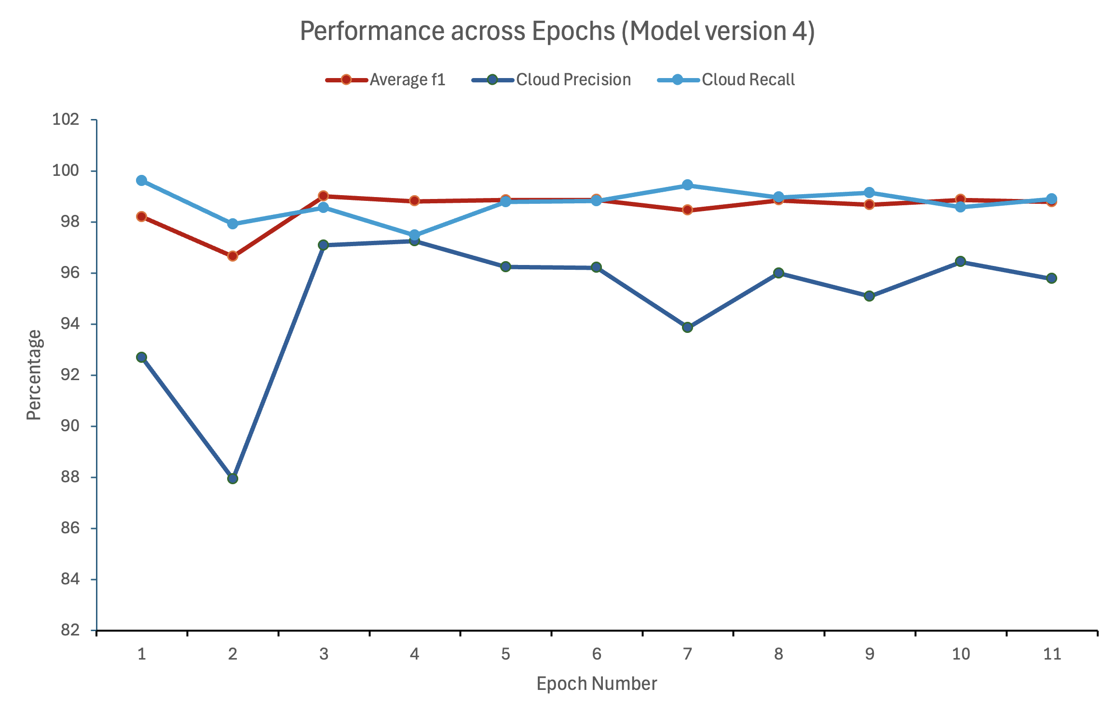
Figure 10. Performance metrics across training epochs for model version 4.

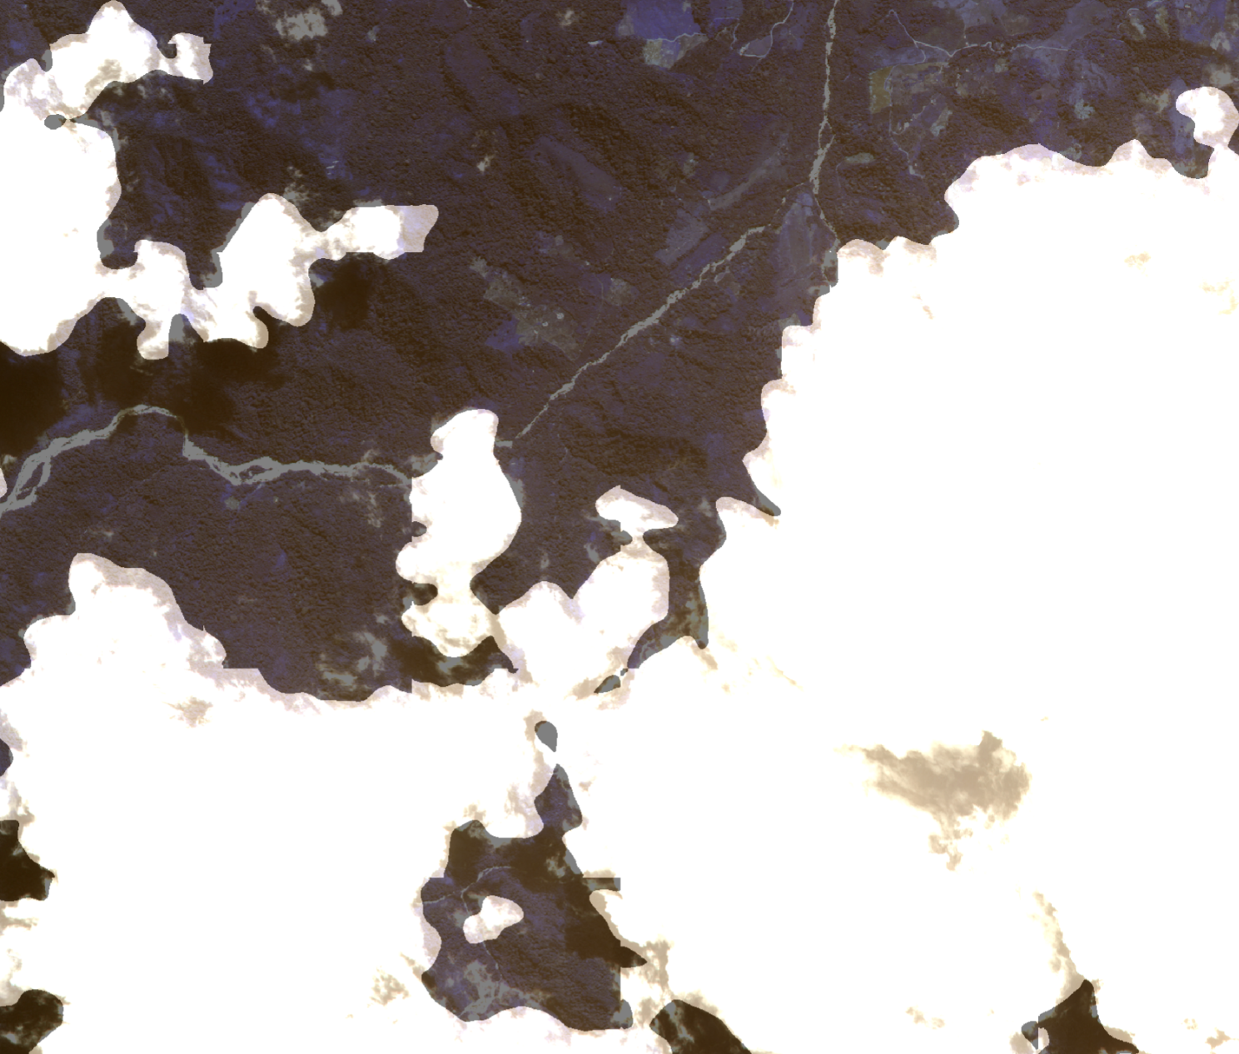
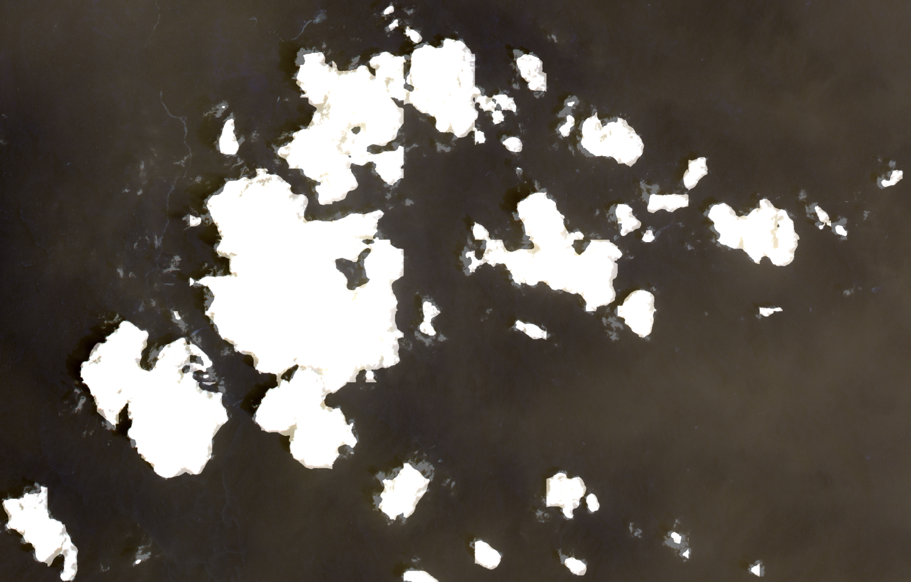
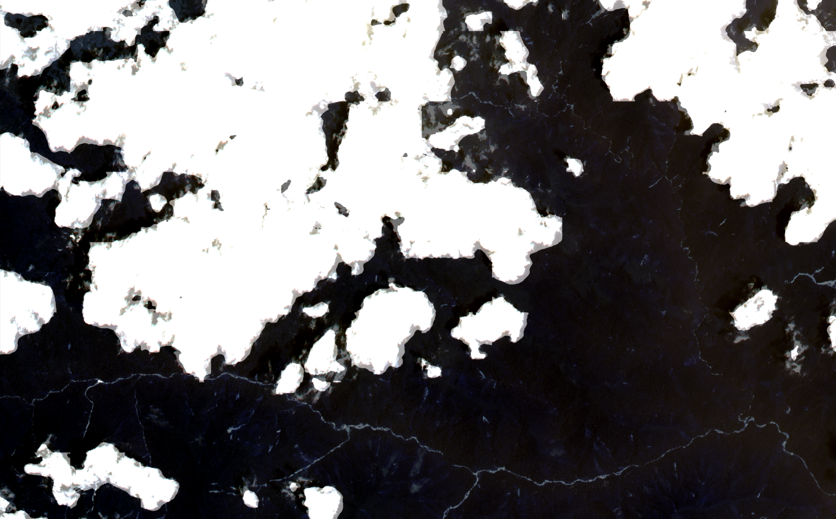
6.2 Qualitative Results

The final model was generally able to identify cloud structures and produce well-defined cloud masks. Improvements to the manually labeled training data were particularly important for boundary accuracy. Because the training masks were manually created in QGIS, refining the annotations provided the model with more precise examples of cloud boundaries and reduced the tendency toward blurry or poorly localized predictions.

6.3 Discussion
The final results demonstrate that the developed pipeline successfully achieved its primary objective of generating accurate pixel-level cloud masks from eight-band WorldView-2 imagery. On the test dataset, the final model achieved an overall F1 score of 98.99% and a cloud-specific F1 score of 97.75%, indicating strong performance in both identifying clouds and limiting false-positive predictions.
As the GeoPacha project continues to evolve, this cloud detection pipeline provides a robust foundation for subsequent research into automated cloud removal and enhanced archaeological image analysis.

