Recommended Installation Steps for CodeBlocks on Windows

1. Go to CodeBlocks website: <http://www.codeblocks.org/>

2. Click “Download”, then click “Download the binary release”

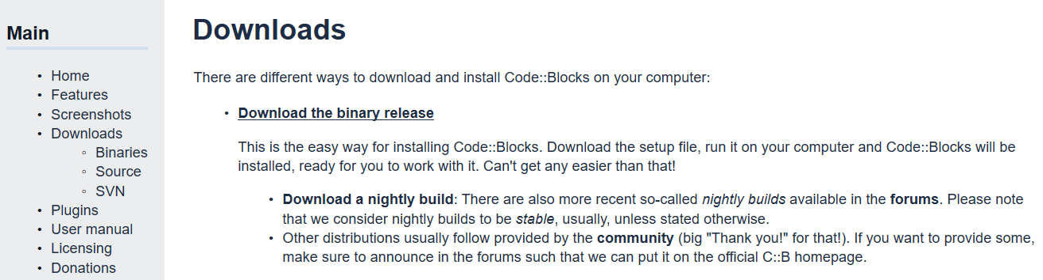

Click here!

3. Pick the one with mingw-setup

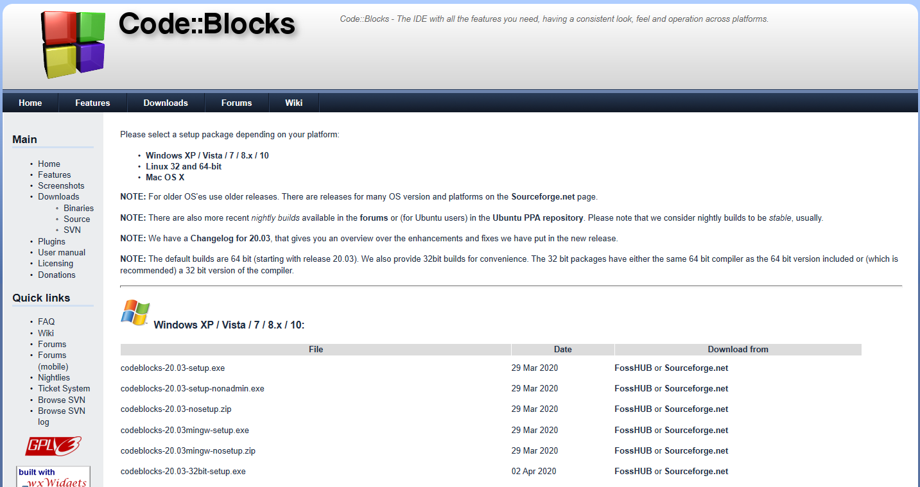

4. Save the installation file



5. Once the file has been downloaded, click “Run”



6. Follow the installation instruction. Installation process may take a while.

7. Once the installation is done, you may see the shortcut icon as follows.

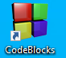

8. Double-click the CodeBlocks to have it run.