**EN 001203 Computer Programming**

**L005: Function Exercises**

**Faculty of Engineering, Khon Kaen University**

Submission: https://autolab.en.kku.ac.th

==================================================================

* Submit an answer to a question with a file with txt extension. E.g., an answer for Q1 should be submitted in a text file “Q1.txt”

* Submit a program to a (programming) problem with a file with cpp extension. E.g., a program for P2 should be named “P2.cpp”

* All answers and programs must be packaged together in a tar file.

* Each question or problem is worth 60 points. The 240 points are counted as full score. Students are encouraged to work on as many problems as they can, but seeing 50 points makes me super content already.

==================================================================

“The best way to cheer yourself up is to try to cheer somebody else up.”

--- Mark Twain

Q1. According to VIA institute (viacharacter.org), what character strengths are categorized as humanity? Answer one for each line and put them in order.

[Hint: they are kindness, love, social intelligence.]

P2. Squaring. Write a function taking a number and its squared value. Make a function interface

float squared(float x)

[Hint: a2 = a ⋅ a.]

Illustration:

* Piece of Code

...

x2 = squared(4);

cout << "x squared = " << x2 << endl;

...

* Related Part of Output

=========================================================

x squared = *16*

=========================================================

Submission suggestion: use P3_template.cpp.

P3. Area of a triangle. Write a function taking width and height of a triangle and returning an area of the triangle. Make a function interface

float area(float w, float h)

[Hint: area = width ⋅ height.]

Illustration:

* Piece of Code

...

sqm = area(4, 5);

cout << "area size is " << sqm << endl;

...

* Related Part of Output

=========================================================

area size is *20*

=========================================================

Submission suggestion: use P4_template.cpp.

P4. Tangent. Write a function taking an angle in degree and returning a tangent value of the angle. Make a function interface

float tangent(float degree)

Use 3.1415926536 for estimation of π.

[Hint: library <cmath> has tan function, which takes an angle in radian. Radian = π ⋅ degree/180.]

Illustration:

* Piece of Code

...

t = tangent(10);

cout << "tangent = " << t << endl;

...

* Related Part of Output

=========================================================

tangent = *0.176327*

=========================================================

Submission suggestion: use P6_template.cpp and build it with BuildP6.bat, which needs P6.h and P6_aux.cpp.

**P5.** Arctangent. Write a program to take (x, y) coordinate of a point and compute and an angle between a vector from the origin to the point and the x-axis.

[Hint: logically, (1) arctangent of (y/x) can do the job when x > 0. (2) When x = 0, the angle is 90° if y > 0 or it is -90° if y < 0. If both x and y are 0, the angle is not defined. (3) When x < 0, the angle is the arctangent of y/x + 180°.

Technically, function atan in <cmath> library can be handy. Don’t forget to check out the unit of an angle. It may not be degree!]

P6. Cover price. Write a function to calculate a cover price for a book. The function takes a printing cost (in baht/book), shipping cost (in baht/50 books), retailer share (% of the cover price), and the author’s expected share (baht/book). Assuming the books are shipping in multiple of 50. Make a function interface

float cover_price(float printing, float shipping,   
float retailer, float author)

[Hint: the final cover price c = p + s/50 + c * r/100 + a, where c is cover price; p is printing cost; s is shipping cost; r is retailer share in % of c; and a is author’s share.]

Illustration:

* Piece of Code

...

price = cover_price(80, 400, 25, 50);

cout << "The cover price should be " << price << endl;

...

* Related Part of Output

=========================================================

The cover price should be *184*

=========================================================

Submission suggestion: use P7_template.cpp and build it with BuildP7.bat, which needs P7.h and P7_aux.cpp.

P7. Chuck’s chance (Cast Away 2000). A lone plane-crash survivor found himself on an uninhibited island tries to figure out his chance to be found by a search team. He was on a plane traveling at speed **v** mph. The plane lost its contact for **T** hours before crash.

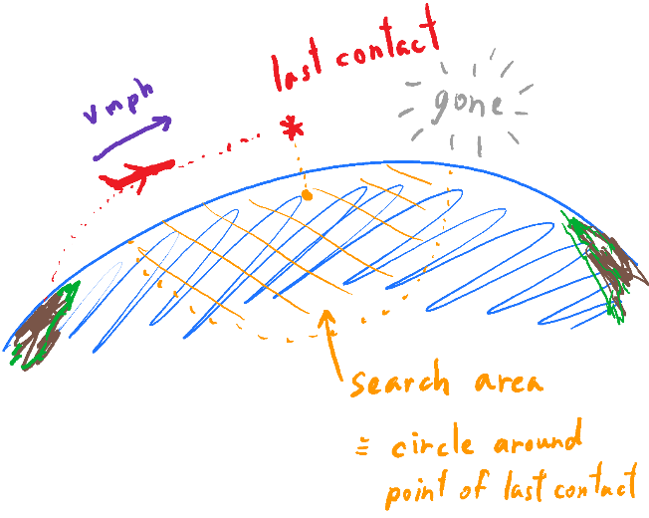

Write a function to calculate a search area for the crash site. The function takes plane speed (in mph) and time (in hour) between the plane last contact and its crash and calculates the search area (in squared miles, sq. mi.). Make a function interface

float search_area(float speed, float time)

Use 3.1415926536 for estimation of π.

[Hint: (1) search area = π⋅r2; (2) r = v * T.]

Illustration:

* Piece of Code

...

sarea = search_area(475, 1);

cout << "Search area (in sq. mi.) = " << sarea;

...

* Related Part of Output

=========================================================

Search area (in sq. mi.) = *708822*

=========================================================

Submission suggestion: use P8_template.cpp and build it with BuildP8.bat, which needs P8.h and P8_aux.cpp.

------------------------------------------------------------------------------------------------

“I think a hero is any person really intent on making this a better place for all people.”

Maya Angelou

------------------------------------------------------------------------------------------------