**EN 001203 Computer Programming**

**L000: Warm Up Exercises 1**

**Faculty of Engineering, Khon Kaen University**

Submission: <https://autolab.en.kku.ac.th>

(Walkthrough exercises)

==================================================================

* Submit an answer to a question with a file with txt extension. E.g., an answer for Q1 should be submitted in a text file “Q1.txt”

* Submit a program to a (programming) problem with a file with cpp extension. E.g., a program for P2 should be named “P2.cpp”

* All answers and programs must be packaged together in a tar file.

Windows: use tar utilities, e.g., 7-zip, PeaZip.

Mac: there usually is a tar utility, e.g., tar -cvf myfiles.tar * on terminal.

==================================================================

Q1. What is a programming language we will use in this course?

[Hint: it is C++.]

Q2. Write down 4 key hardware components of a computer.

[Hint: they are cpu, memory, input, and output. Write them in order and write each a line.]

Q3. Fuel efficiency. Estimate fuel efficiencies (in km/L) of the following vehicles:

* Vehicle a runs 700km for 50L of gasoline.

* Vehicle b runs 200km for 12L of gasoline.

* Vehicle c runs 28 miles for 8L of gasoline.

* Vehicle d runs 50 miles for 1gal of gasoline.

Calculate using 1 mile = 1.60934 km and 1 gallon = 3.78541 liters. Round the answers to 2-digit precision.

Q4. Which ones of the following terms are keywords in C++?

Terms to check: return, char, false, for, if, whether, int, long, sizeof, and try.

[Hint: check <https://en.cppreference.com/w/> under keywords.]

Q5. Which ones of the following terms are C++ standard library headers?

Terms to check: <cstdlib>, <ctime>, <cplace>, <climits>, <exception>, <cstring>, <cmath>, <cphysics>, <iostream>, and <cstdio>.

[Hint: check <https://en.cppreference.com/w/> under headers.]

Q6. Which ones of the following terms are functions in the standard library <cmath>?

Terms to check: round, sin, asin, bsin, pow, sqrt, log, cabin, remainder, and abs.

[Hint: check out <cmath> under headers of https://en.cppreference.com/w/.]

P7. Write a C++ program to print out:

====================================================================

Aloha, fellows. I am really happy.

====================================================================

See Figure 1 for how the output looks.

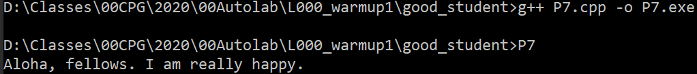

Figure

P8. Write a C++ program ask a user to rate his/her learning experience and reflect it back, as shown in the example,

====================================================================

How would you rate this learning experience?

From -10 to 10, -10 is for learning something very bad; ...

0 is for learning nothing; ...

and 10 is for learning something very valuable.

***8***

Your learning experience is rated ***8***.

====================================================================

Use the exact word and pay attention to all the details (including space and punctuation marks).

! Noting that, a font effect using above is to emphasize the input and its corresponding effect. The program is not expected to produce any of these font effects. See Figure 2 along.

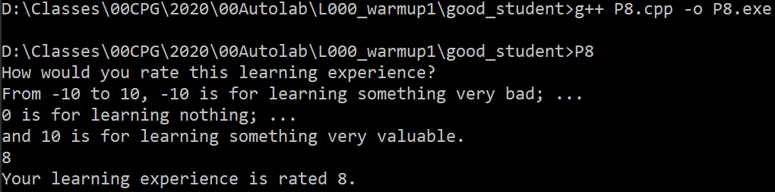

Figure