JOB HUNTER AI
Implementation Blueprint
  - Visa-aware job discovery, evidence-backed CV tailoring, recruiter contact discovery, and human-approved applications

Recommended starting architecture
Angular 22 SPA + ASP.NET Core / .NET 10 LTS modular monolith + SQL database + private object storage + durable worker queue. Add AI provider adapters and a separate Playwright worker. Keep every final application and outreach email under explicit, version-bound user approval.

Prepared: 15 October 2026
Purpose: an implementation-ready product and engineering plan based on the full Job Hunter AI requirements discussed so far.
Audience: product owner, frontend/backend engineers, AI engineer, QA and DevOps.
Status: proposed baseline; confirm provider credentials, target countries, data-source permissions and hosting costs before production build.

1. Executive summary
Job Hunter AI should be an evidence-first job search and application workspace, not a bulk-scraping bot. Its differentiator is the complete trace from vacancy → sponsorship evidence → candidate evidence → tailored documents → reviewed application → approval → recorded outcome.

Product goals
- Find current software-development jobs across the UK and European countries, retaining the original employer/application URL and the source date.
- Classify sponsorship using job-description evidence plus the relevant country-specific official sources; clearly label uncertainty.
- Match each job to a verified candidate profile, explain strengths and gaps, and produce a role-specific ATS-readable CV and cover letter.
- Show an editable preview of the CV, cover letter and every application field, with supporting evidence and verification status at field level.
- Find relevant recruiter contact details only from trustworthy public/authorised sources. If no relevant email is found, state that explicitly and keep the job/application route available.
- Prepare a browser-based application and stop until the user approves the exact application version. Separately require explicit approval before an outreach email is sent.
- Track draft, approval, application outcome and email outcome separately, with auditable history and safe retry handling.

Non-negotiable design rules
Rule | Implementation consequence
Source of truth | Master CV/profile facts are canonical. AI may propose edits, but must not invent skills, dates, qualifications, achievements or legal answers.
Traceability | Every material claim and form answer links to supporting profile/document evidence or is marked user-provided / unverified.
Version-bound approval | Approval applies only to one immutable application version and its document/form hashes. Any edit invalidates that approval.
Honest source state | No guessed recruiter emails; no fake “verified” sponsor status; no claim that ATS success is guaranteed.
Permitted access | Use documented public APIs or authorised connectors and permitted browser workflows. Do not bypass CAPTCHA, login gates, robots/site terms or platform controls.
Safe submission | If form contents differ from approved data, approval is stale, or submission result is ambiguous, stop and request review; never blindly retry a possibly successful submission.

What is deliberately not promised
- No promise to cover every European vacancy on day one; coverage depends on source permissions, available listings and tested country-specific rules.
- No guarantee of passing a particular employer ATS, being shortlisted, obtaining sponsorship or receiving an interview.
- No automatic final application submission without explicit approval for the exact version and a supported, permitted submission path.

2. System architecture
Prefer a modular monolith for the core domain and separate workers only where runtime, retry, browser, or Python dependencies justify isolation. This keeps the first release testable without overbuilding microservices.
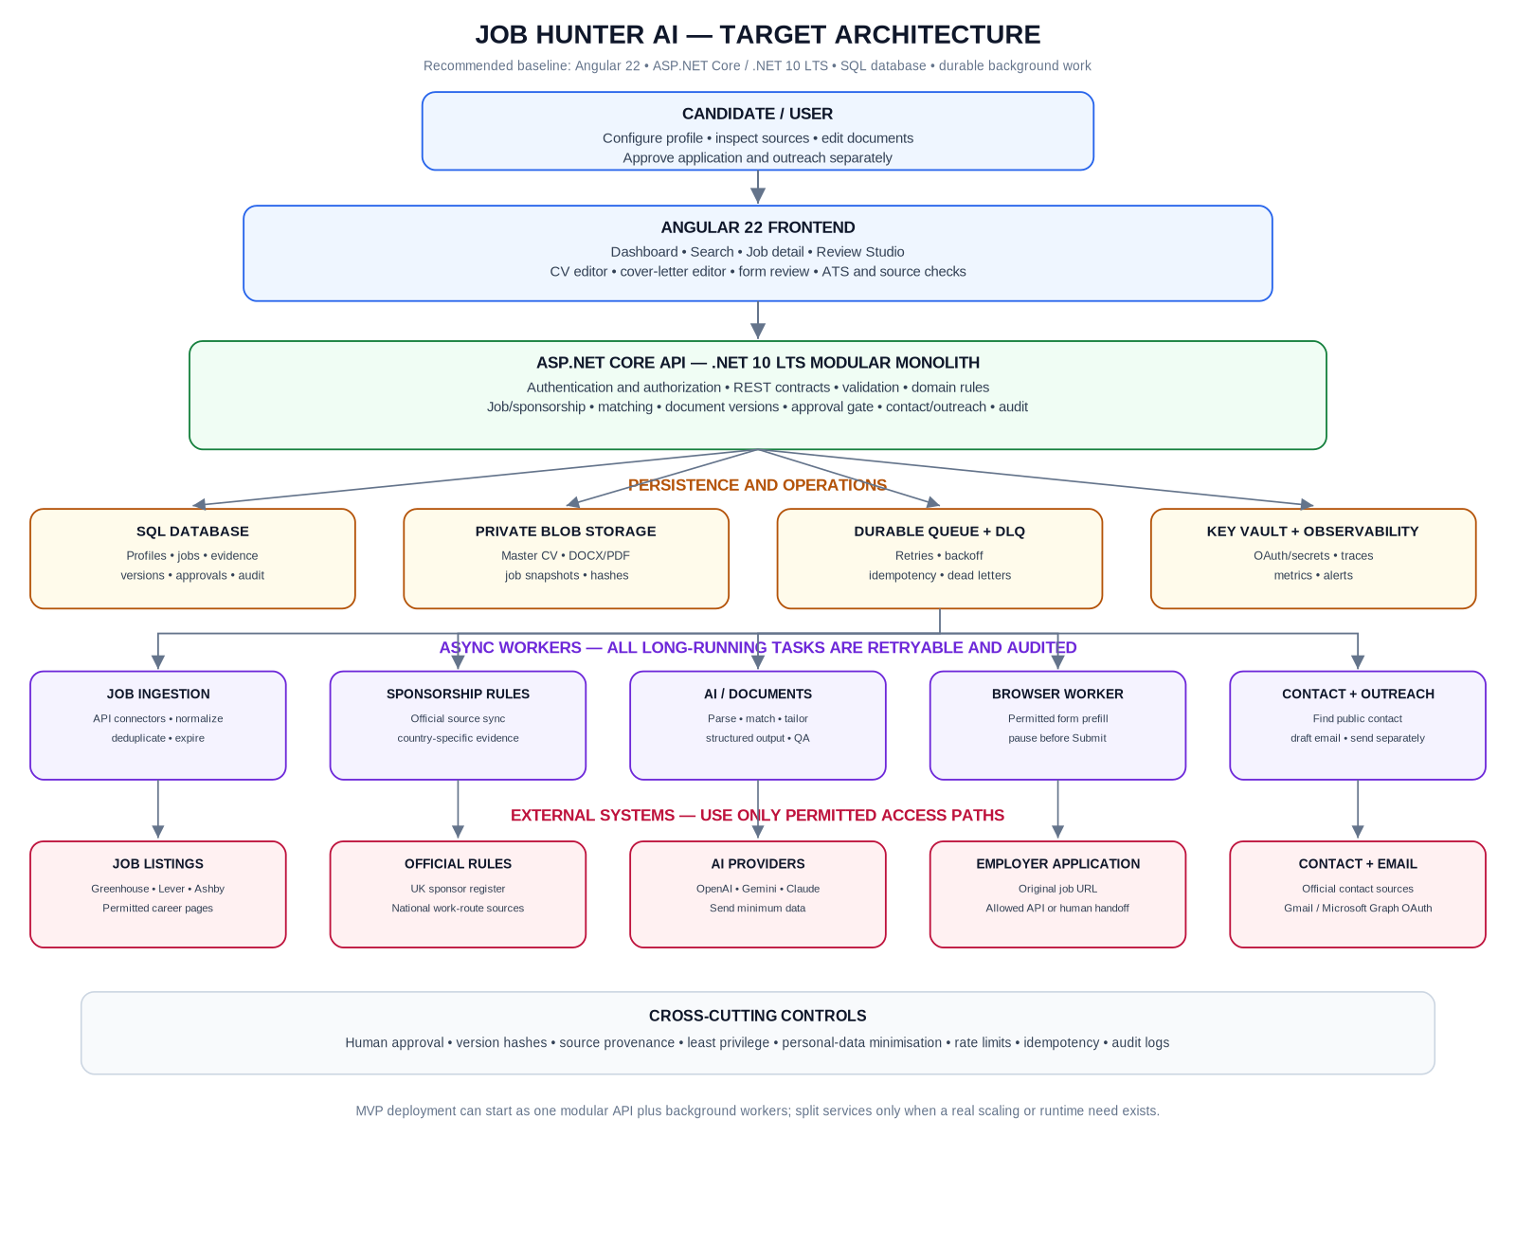
Figure 1. Target architecture. All external calls should pass through source/provider adapters; the API owns application state and approval checks.

Architecture decisions
Area | Decision for first production-ready release | Why
Frontend | Angular 22 standalone components, Reactive Forms, signals for local UI state, typed API clients. | Matches requested stack and supports an editable review studio.
Core API | ASP.NET Core Web API on .NET 10 LTS; modular monolith with explicit application/domain/infrastructure boundaries. | One deployable core is simpler to test and operate than many small services.
Persistence | SQL Server / Azure SQL with EF Core code-first migrations. | Strong relational consistency for versioning, evidence, approvals and audit history.
Artifacts | Private object storage for master CV, generated DOCX/PDF, source snapshots and hashes. | Avoid storing large binary files or public document URLs in relational rows.
Async work | Durable queue, retry/backoff, dead-letter handling, idempotency keys. Local development can use a database-backed queue; production should use a managed queue or a proven equivalent. | Ingestion, AI calls and browser automation are long-running and failure-prone.
AI | Provider abstraction; one primary provider in MVP; additional OpenAI/Gemini/Claude adapters after evaluation. Structured outputs validated server-side. | Avoids coupling business logic to one model and controls cost/data exposure.
Browser automation | Isolated Playwright worker with allow-listed destinations and a strict approval/version check immediately before submission. | Browser state, selectors and browser dependencies must not be allowed to bypass domain rules.
Mail | OAuth-based Gmail API or Microsoft Graph adapter; create drafts first; send only after explicit confirmation. | Do not store mailbox passwords or silently send outreach.
Hosting | Azure App Service/Container Apps, Azure SQL, private Blob Storage, Key Vault, Application Insights. Choose hosting after an MVP load/cost test. | Consistent managed infrastructure for API, files, secrets and worker monitoring.

Version pinning as of 15 October 2026
Angular 22 compatibility documentation lists Node.js ^22.22.3, ^24.15.0 or ^26.0.0 and TypeScript >=6.0.0 <6.1.0; pin one supported Node version in local development and CI. .NET 10 is LTS with support listed through 14 November 2028. Re-check official release pages at implementation time and use current security patches.

3. End-to-end workflow — discovery and preparation
The first workflow produces a complete, evidence-linked application pack. Discovery and document generation must be repeatable; they should not directly trigger final submission.
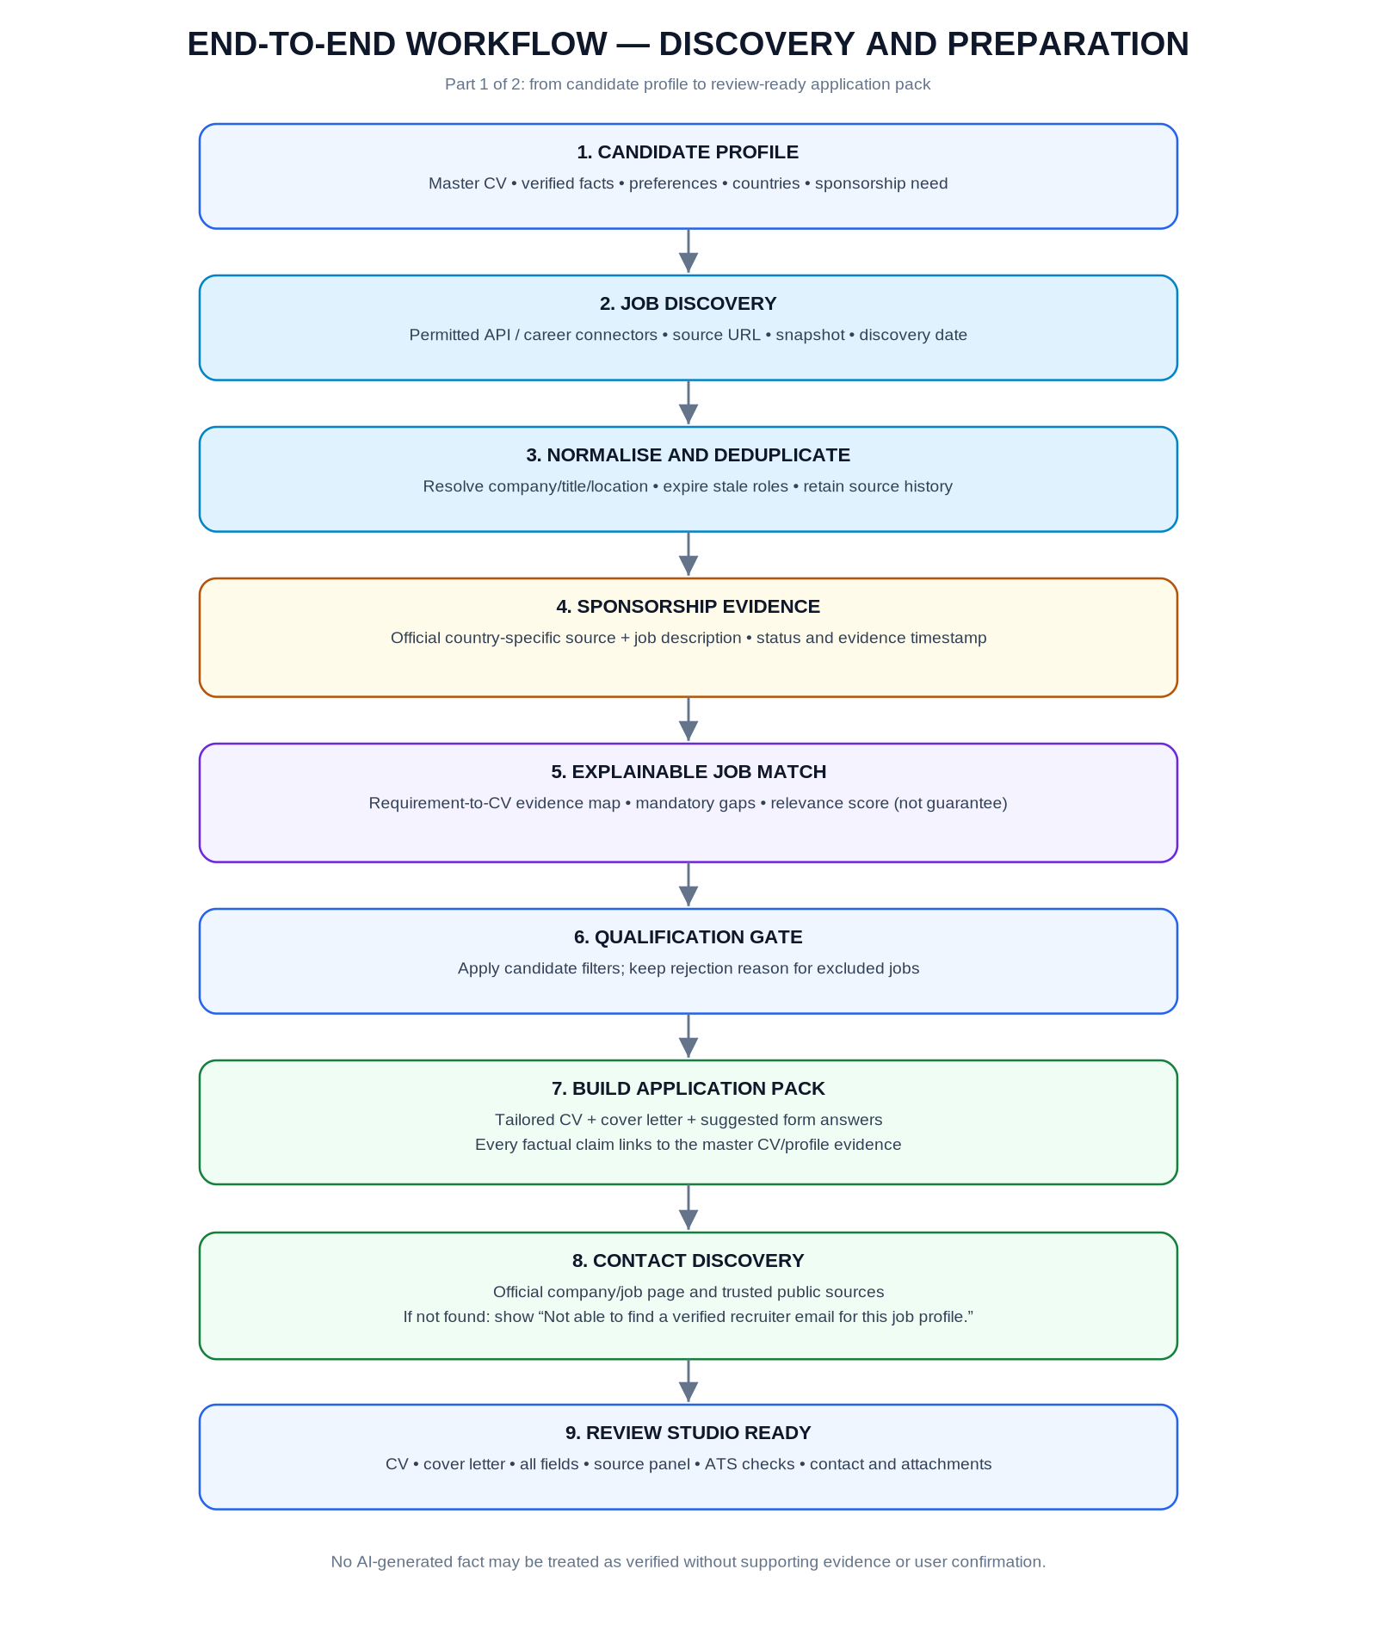
Figure 2. Job discovery, sponsorship verification, matching, document generation and recruiter contact discovery.

Core user journeys
Journey | Expected result
Candidate setup | Upload master CV; verify parsed facts; maintain canonical work history, skill evidence, links, preferences, location, salary range and sponsorship need.
Job discovery | Search/filter by country, city/remote, title, technology, seniority, freshness, salary when published, and sponsorship evidence. Always show source and original link.
Sponsorship review | Show status, reason, official source URL, checked timestamp, job-text evidence and uncertainty. “Employer on register” alone never means that every job offers sponsorship.
Job fit | Display must-have vs preferred requirements; map each to candidate evidence; explain match score and missing evidence. Keep scoring versioned and reproducible.
Application pack | Generate CV, cover letter and form-answer drafts from facts and job requirements. Keep master CV immutable and document versions distinct.
Recruiter discovery | Search only permitted trusted public sources for a contact relevant to the vacancy. If none, display the exact not-found state and retain the original job link.
Review studio | Allow field-by-field editing; show source citations, conflicts, confidence and status; permit DOCX/PDF preview/download and before/after comparison.

4. End-to-end workflow — approval and delivery
Application approval and outreach approval are separate. The same approval may authorise submission of one exact version once the browser worker confirms that the rendered form is unchanged; any mismatch sends the process back to review.
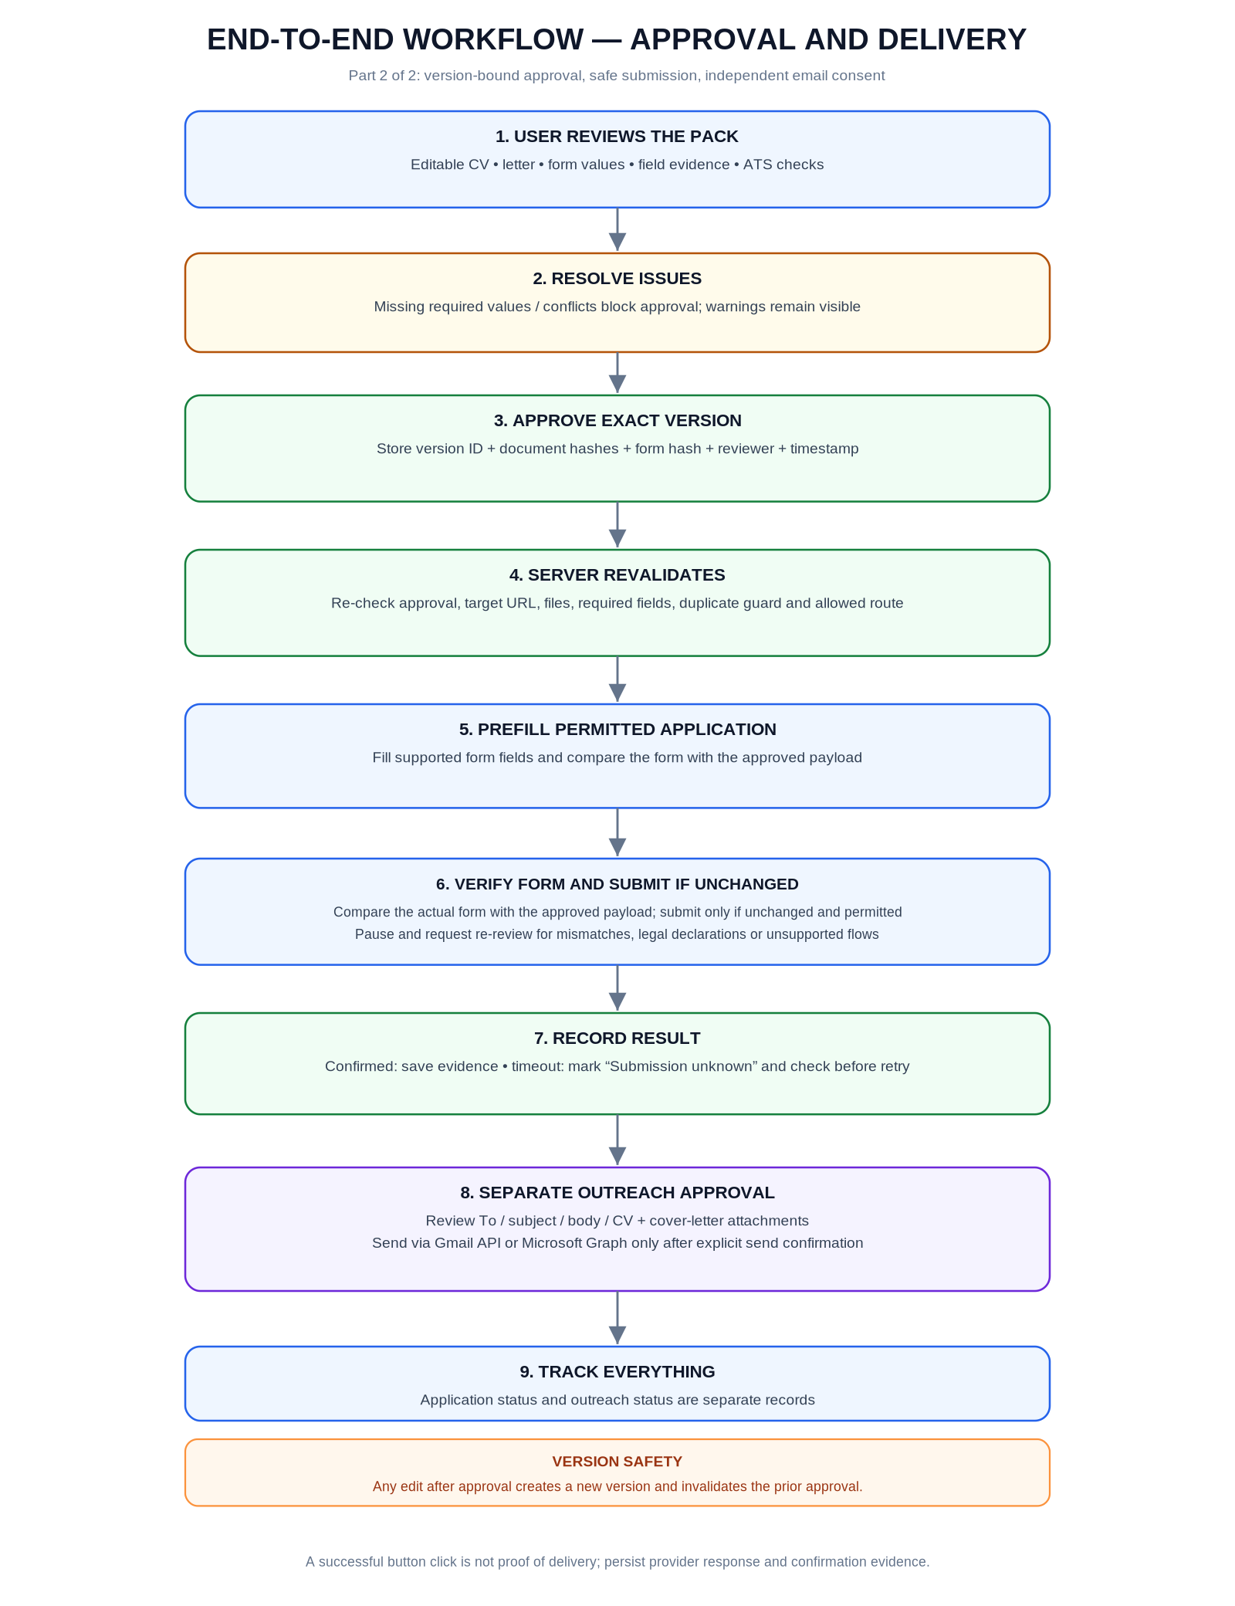
Figure 3. Version-bound approval, form comparison, submission outcome handling and independent outreach sending.

5. Functional modules and ownership
Keep module boundaries explicit. Every state transition must be implemented in domain services and persisted in the backend; Angular buttons are a convenience, not a security boundary.
Module | Responsibilities | Output / contract
Candidate Profile | Master facts, preferences, work authorisation answers, links, contact details, skills, employment/education and source documents. | Versioned profile facts with evidence; profile completeness report.
Job Sources | Adapters for documented public APIs and permitted career pages; source throttling, source terms and connector health. | Raw source record + normalised posting + original URL + source timestamp.
Job Normalisation | Canonical employer, title, location, employment type, salary, description and closing date; dedupe and expiry. | Canonical Job + immutable JobSnapshot.
Sponsorship Rules | Country-specific configured rules; official source ingestion; job-description evidence extraction; state and confidence. | SponsorshipAssessment with evidence URL, excerpt, source date and last checked.
Match Engine | Extract job requirements and compare them with verified candidate facts and embeddings/skills. | Explainable match score, requirement coverage and genuine gaps.
Document Builder | Generate role-specific CV/cover letter; preserve master; export DOCX/PDF; text-extraction regression checks. | Immutable ApplicationVersion and document artifacts.
Review Studio API | Editable field records, evidence panel, change log, validation state and draft save. | Field-level review models; validation issues; version hash.
Contact Finder | Search official/company job pages and trusted permitted sources; retain provenance; do not guess email. | Contact result: FoundSourceSupported / NeedsReview / NotFound.
Outreach | Personalised subject/body, reviewed attachments, user-authorised email account and explicit send confirmation. | Separate OutreachDraft and SendAttempt lifecycle.
Submission Worker | Fill supported forms, compare live fields to approved version, submit only via supported path, record evidence. | Attempt status and submission evidence; no blind retries.
Audit / Operations | Actor, time, version, action, connector runs, provider trace IDs, usage/cost and exception history. | Queryable audit trail and operational dashboards.

6. Job discovery, source policy and sponsorship verification
Implement connectors as plug-ins. A source can be enabled only when its API, access path, terms, request limits and permitted data retention have been reviewed.

Recommended source order
- Start with documented job-posting APIs such as Greenhouse, Lever and Ashby where published listings are accessible. Their public job-listing capabilities do not grant universal permission to submit candidate applications through a custom app; inspect each source’s application pathway and credentials separately.
- Use official company career pages when crawling or structured extraction is permitted. Respect rate limits, robots rules where applicable, site terms and source attribution; prefer link-outs over copying entire listings when reuse is not authorised.
- Use official government/immigration sources for sponsorship/work-route evidence. Refresh on a schedule, retain a snapshot/last-checked timestamp and show the source to the user.
- Treat EURES and large platforms such as LinkedIn/Indeed as link-out or authorised-integration sources unless the relevant terms and permissions explicitly allow bulk collection. Do not scrape LinkedIn profiles or bypass access restrictions.
- Add country support incrementally. The UK has its own sponsor register and visa routes; other European countries have distinct work-permit rules. Do not re-use one country’s decision logic across all countries.

Sponsorship classification
Status | Rule | UI behaviour
Confirmed for this vacancy | Job description explicitly describes sponsorship for the role and the relevant employer/route evidence is current enough for the configured policy. | Show evidence and date. Do not imply visa approval is guaranteed.
Possible | Employer appears on a relevant sponsor source or wording suggests potential, but vacancy-specific sponsorship is not explicit. | Show “Possible — verify with employer” and keep a warning.
Unknown / needs review | No reliable evidence, conflicting text or stale country source. | Do not label as sponsored; preserve the job link and request review.
Not offered / unsuitable | Vacancy explicitly says no sponsorship or a configured mandatory rule disqualifies it. | Exclude from “strong sponsorship matches” and explain why.
Expired evidence | Source age threshold exceeded or official register cannot be refreshed. | Display last checked timestamp; schedule refresh; do not silently treat stale evidence as current.

Scope control
“All UK and European jobs” is the product vision, not a realistic first-release acceptance claim. Launch with a source allow-list and a tested subset of countries; add a country only after its source/visa logic, evidence examples, tests and operational owner are in place.

7. CV tailoring and ATS-quality engine
The goal is truthful relevance and machine-readable formatting, not keyword stuffing. ATS readiness is a quality report, not a prediction of an employer’s hidden ranking algorithm.

Pipeline
- Parse the master CV into structured facts: contact details, experience, dates, education, skills, certifications and achievements. Retain original text spans and document/page positions where possible.
- Parse the vacancy into typed requirements: must-have, preferred, responsibility, domain, qualification, location, salary, sponsorship language and application questions.
- Map each requirement to supporting candidate evidence. Use deterministic rules for dates and exact facts, embeddings/keyword scoring for retrieval, and an LLM for explanation and controlled rewriting.
- Generate a new per-job document from an ATS-readable template (single column, standard headings, consistent dates, selectable text, no critical facts hidden in images or decorative headers/footers). Optionally preserve the user’s preferred visual template if it passes extraction checks.
- For every changed bullet or summary statement, store the previous text, new text, reason, source evidence IDs and generation run ID. If support is absent, mark it unsupported and block approval until removed or corrected.
- Create DOCX and PDF artifacts, extract text back from both and compare against expected sections. Flag broken reading order, missing symbols, empty pages and unexpected content loss.
- Run final cross-document checks: CV, cover letter, profile and application form must agree on employers, titles, dates, skills, qualification and answers.

Review metrics — never a fake ATS pass score
Metric | What it measures | Blocking?
Must-have evidence coverage | Required vacancy criteria with mapped candidate evidence / total must-haves. | Usually a warning; block only if profile data is incomplete or user policy says so.
Preferred evidence coverage | Preferred criteria with evidence / preferred criteria. | No; explain gaps.
Document extraction quality | Core headings, contact, dates, skills and experience survive text extraction. | Yes, when a core section is missing/unreadable.
Claim traceability | Every material claim maps to profile/CV facts or explicit user confirmation. | Yes for unsupported material claims.
Cross-artifact consistency | No contradictory facts between CV, letter and application form. | Yes for factual conflicts.
Sponsorship evidence freshness | Evidence source, date and freshness policy are recorded. | Block strong-sponsorship label if evidence is stale/unknown; job remains viewable.

Master CV rule
Never overwrite the original. Store a master-document ID and immutable file hash. Generate a separate artifact per job/version. Let the user restore the original text of any tailored section before approval.

8. Recruiter contact finder and email outreach
Contact discovery is a separate evidence workflow. Do not infer addresses from a company’s email pattern, and do not treat a search result snippet alone as proof that the person handles the vacancy.

Source priority
- First: recruiter/HR contact explicitly named on the vacancy or the official company recruitment page.
- Second: official company leadership/team/contact page that links the person or published email to Talent Acquisition, Recruitment or the relevant department.
- Third: reputable contact data provider through its documented API and permitted use; retain the provider and evidence metadata.
- LinkedIn: store a link to the relevant profile or search results for user-directed inspection. Do not scrape profiles, collect hidden data or bypass platform controls.
- If no relevant email is found, store NotFound and display: “Not able to find a verified recruiter email for this job profile.” Keep the original job URL and allow the user to apply directly.

Contact state model
State | Meaning
FoundSourceSupported | Email is explicitly published in a trusted source that is captured in provenance metadata. This is not proof the mailbox is active.
NeedsReview | An apparent contact exists but identity/relevance/source quality needs human review.
NotFound | No appropriate publicly supported email was found. Do not generate or guess one.
NoEmailContactRoute | No email found, but official application/contact form URL exists.
Invalidated | Source removed, contradicted or too old under policy; re-check before use.

Outreach lifecycle
Draft -> NeedsReview -> ReadyToSend -> Sending -> SentAcceptedByProvider
-> Failed / SendOutcomeUnknown
- Generate a personalised subject and concise body tied to the specific job and supported CV evidence. Avoid mass-mail templates that make generic or false claims.
- Show To, subject, body, original source, tailored CV filename, cover-letter filename and attachment version/hash in one preview.
- Keep sending separate from application submission. Require a user action such as “Send this email now” on the current draft version.
- Use delegated OAuth for the user’s Gmail or Microsoft 365 account; least-privilege scopes; protected token storage; revoke/disconnect support.
- Record the provider response. For Microsoft Graph, HTTP 202 means accepted for processing, not confirmed delivery. Treat delivery as unknown unless a later signal proves it.

9. Application state machine and approval contract
The server is authoritative. UI disabled buttons improve usability but are never the gate that protects the final submission.
State | Entry condition / action | Allowed next states
Discovered | A normalized, active job with source URL is saved. | Qualified, Excluded, Expired
Qualified | Candidate filters pass and job has enough usable data. | Tailoring, Excluded
Tailoring | AI/document worker creates structured requirement map and artifacts. | Prepared, NeedsReview, Failed
Prepared | Artifacts and candidate answers exist; validations completed. | AwaitingApproval, NeedsReview
AwaitingApproval | Preview is available; blocking issues resolved. | Approved, Rejected, NeedsReview
Approved | Backend stores approval for exact immutable version and hashes. | Preflight, Invalidated
Preflight | Worker validates destination, file/form hashes, required fields, policies and idempotency key. | Submitting, NeedsUserAction, Invalidated
Submitting | Submission is actually attempted via supported path. | Submitted, SubmissionUnknown, Failed
SubmissionUnknown | Network/browser ended after possible submit without clear confirmation. | Submitted after evidence, NeedsUserAction, Failed after safe investigation
Submitted | Reliable confirmation evidence recorded. | Closed / outcome tracking
Rejected / Withdrawn | User declines or withdraws the application. | Closed; do not submit

Approval record contract
- Persist ApplicationId, immutable ApplicationVersionId, canonical form-payload hash, CV hash, cover-letter hash, job snapshot ID, reviewer/user ID, approval timestamp and the intended action.
- At submission, recompute hashes and verify the approval record is still current, unexpired under policy, and bound to the same destination and artifacts.
- If any content or target URL changes, set the version to Invalidated and return to AwaitingApproval. Never “carry over” approval.
- Use optimistic concurrency (row version / ETag) to prevent two browser tabs from approving or sending conflicting edits.
- Use a unique idempotency key for each intended application submission and outreach send. A timeout after a submit attempt must become SubmissionUnknown; verify before retrying.
- If CAPTCHA, unsupported fields, login challenges, legal declarations, or platform restrictions prevent safe automation, stop and present a manual handoff. Never bypass controls.
One deliberate approval flow
User reviews the completed draft and approves the exact version. The worker then validates and fills the form. If the live form exactly matches the approved payload and the path is permitted, it may submit; any mismatch or sensitive unanswered declaration returns the job to the user.

10. Data model and persistence
Use EF Core code-first migrations. Keep source snapshots and generated artifacts immutable; mutable job/application status should reference those snapshots rather than rewriting historical evidence.
Entity / table | Key fields and responsibilities
User / CandidateProfile | UserId, country preferences, role preferences, location/remote, salary, seniority, sponsorship need, consent/settings.
CandidateDocument | DocumentId, type, storage key, original filename, MIME type, SHA-256, created time, immutable master flag.
CandidateFact | FactId, profile ID, type/value, normalized value, source document/version, source excerpt, verification status, user-confirmed flag.
JobSource / SourceRun | Connector ID, terms/policy reference, last success/failure, run time, cursor, rate-limit state, errors.
Job / JobSnapshot | Canonical employer/title/location, country, original URL, source ID, posting ID, first seen/last seen/expiry, description snapshot/hash.
JobRequirement | JobSnapshotId, requirement text, type (must/preferred), normalised skills, source span and parser run ID.
SponsorshipAssessment / Evidence | Country route, status, rationale, evidence URL/excerpt, official source snapshot, checked timestamp, freshness result, assessment version.
JobMatch / MatchEvidence | Profile version, job snapshot version, score components, requirement coverage, mapped fact IDs, missing evidence and scoring version.
Application / ApplicationVersion | Job ID, profile version, state, version number, canonical payload hash, job snapshot ID, created/updated by.
ApplicationField / FieldEvidence | Field key, value, required flag, source type, evidence ID/source excerpt, verification state, confidence, edited flag.
DocumentArtifact / ClaimEvidence | CV/letter type, storage key, format, SHA-256, template version, generated time, source fact IDs per changed claim.
ApprovalRecord | Application/version IDs, document hashes, form hash, approved by, approved at, invalidated at/reason.
SubmissionAttempt / SubmissionEvidence | Idempotency key, route, start/end times, attempt result, provider/page confirmation, screenshot/text snapshot reference where appropriate.
RecruiterContact / ContactEvidence | Name/role/email/domain, status, official source URL, quoted excerpt, discovery method/date, source trust, reviewed by.
OutreachDraft / OutreachSendAttempt | Recipient, subject/body version, attachment artifact IDs/hashes, email provider, approved-by/at, send status and provider message ID.
IntegrationConnection / AuditEvent / AiRun | OAuth provider/scopes, redacted audit event, actor, correlation ID, model/provider/schema version, token usage/cost and validation result.

Integrity constraints
- Unique constraint on normalized job source + source posting ID (and a conservative canonical-URL fallback).
- Unique active application per user + canonical job ID unless user explicitly overrides duplicate warning.
- Unique idempotency key per logical submit/send attempt.
- Foreign keys from every evidence record to the source snapshot/document/version where possible.
- Row-version/ETag concurrency on profile drafts, application versions, approval records and outreach drafts.
- Soft-delete/retention policy for operational records; enforce user deletion/export workflow for personal data.

11. Proposed API surface
Use versioned JSON contracts and OpenAPI. Apply authentication and authorization to every candidate-owned resource; never trust a user-supplied user ID to select another user’s records.
Endpoint (illustrative) | Purpose / validation
POST /api/v1/profile/documents | Upload master CV/other supporting document; type/size/malware validation; private blob write; create parse job.
GET /api/v1/profile / PATCH /api/v1/profile | Read/update preferences and candidate facts. Edits update profile version and invalidate drafts derived from old facts as applicable.
GET /api/v1/jobs?country=&query=&sponsorship= | Search stored normalized postings with freshness and source filters; always return original URL and source timestamp.
GET /api/v1/jobs/{jobId} | Return job detail, source snapshot, country, sponsorship assessment, evidence links and match reasons.
POST /api/v1/jobs/{jobId}/evaluate | Queue requirement extraction/matching; idempotent and versioned by job/profile snapshot.
POST /api/v1/jobs/{jobId}/application-drafts | Create a new draft, source map, tailored document jobs and form-answer draft.
GET /api/v1/applications/{id}/review | Return current version, artifacts, fields, source evidence, issues and approval eligibility.
PATCH /api/v1/applications/{id}/versions/{versionId} | Edit CV/letter/field data with If-Match/ETag; create a new draft revision, not overwrite approved version.
POST /api/v1/applications/{id}/approve | Approve exact current version; server validates blockers and persists hashes/reviewer/time.
POST /api/v1/applications/{id}/submit | Enqueue submission with idempotency key; server revalidates approval, hashes and destination immediately before submit.
POST /api/v1/jobs/{jobId}/contacts/search | Queue permitted public contact discovery; return evidence/source or explicit NotFound result.
POST /api/v1/applications/{id}/outreach-drafts | Generate outreach message with exact current artifacts attached by ID.
POST /api/v1/outreach/{id}/approve | Persist approval for exact recipient/body/attachment version.
POST /api/v1/outreach/{id}/send | Send only if current draft approval, recipient and attachment hashes still match; idempotency key required.
GET /api/v1/dashboard / GET /api/v1/audit | Return status summaries and user-authorized history; redact secrets and sensitive payloads.

API behaviour conventions
- Return stable error codes and field-level validation errors, not raw provider/browser exception text.
- Return operation IDs for long jobs; expose status polling or server-sent events after basic reliability is established.
- Use cancellation tokens, per-source timeouts, request size limits, rate limiting and consistent UTC timestamps.
- Use problem-details responses and correlation IDs; log the correlation ID across API, queue, AI provider and browser worker.

12. Repository structure and code boundaries
The solution should be easy to test with the AI provider, email provider, job sources and browser worker replaced by fakes. Do not put LLM calls or browser selectors directly in Angular components or domain entities.
job-hunter/
frontend/
src/app/core/ # auth, interceptors, typed API client
src/app/features/
candidate-profile/
job-search/
job-details/
application-review/ # CV, letter, form, source panel, ATS checks
recruiter-outreach/
application-tracker/
settings-integrations/
backend/
JobHunter.Api/ # REST controllers / minimal API endpoints
JobHunter.Application/ # use cases, validators, orchestration interfaces
JobHunter.Domain/ # entities, invariants, state machine
JobHunter.Infrastructure/ # EF Core, storage, source, email, AI adapters
JobHunter.Worker/ # queue consumers / schedules
JobHunter.Tests.Unit/
JobHunter.Tests.Integration/
ai-service/ # optional Python/FastAPI/LangGraph adapter layer
schemas/ prompts/ evaluations/
browser-worker/ # isolated Playwright worker + allowed-host policies
docs/ # ADRs, API specs, data model, diagrams
infra/ # Bicep/Terraform, Key Vault, storage, queues
tests/e2e/ # browser test fixtures and mock ATS pages

Recommended interfaces
Interface | Purpose
IJobSourceConnector | Discover published jobs; return raw listing and source metadata; report capability/terms and throttle status.
ISponsorshipEvidenceProvider | Refresh/read official country sources and return dated evidence, not an unqualified yes/no.
IAiProvider | Generate schema-constrained structured output; expose provider/model/schema version and usage metadata.
ICandidateFactResolver | Resolve a claim to evidence and current profile version; reject unsupported factual claims.
IDocumentGenerator | Generate DOCX/PDF from versioned data/template; return hash and extraction validation result.
IRecruiterContactProvider | Search permitted public/trusted source; return email only with explicit evidence URL and source quote.
IEmailSender | Create/send a message through user-authorized provider; return provider outcome and message ID where available.
IApplicationAutomationProvider | Open permitted host, fill form, compare normalized live fields, submit only after persisted approval checks; otherwise pause/hand off.

13. Delivery plan — build in gated increments
Each phase ends with a demo and test evidence. Do not start production browser submission before the approval, versioning and duplicate-protection gates pass their negative tests.
Phase | Implementation tasks | Exit criteria
0 — Architecture & foundation | Create ADRs; repo/solution; dev environments; secure configuration; CI checks; health checks; OpenAPI; logging/correlation IDs. | Clean build in CI; secrets are not committed; baseline unit/integration test pipeline runs.
1 — Candidate profile & document ingest | Profile, preferences and country settings; upload master CV; parse into candidate facts; verify/edit facts; private storage and version/hash. | Original CV is immutable; parsed fields are editable and evidence-backed; unsupported parse results are flagged.
2 — Job ingestion & dashboard | Implement source connector contract; first 2–3 permitted connectors; ingestion schedule; normalisation, dedupe, expiry and original links; job list/detail UI. | Fixtures from each connector pass contract tests; duplicate/expired listings are handled; every job has source/date/URL.
3 — Sponsorship & match | UK sponsor source sync; configurable country-rule/evidence adapter; sponsorship statuses; requirement extraction; candidate requirement mapping and gap report. | Test cases cover explicit sponsorship, employer listed only, explicit no, no evidence, conflicting wording and stale source.
4 — Tailored CV and cover letter | Versioned templates; source-claim map; provider abstraction; structured output; document generation; DOCX/PDF extraction checks. | Master not overwritten; every generated factual claim is traceable or rejected/flagged; generated docs open and extract cleanly.
5 — Review Studio | Angular editor components; document preview; form answers; source panel; diff report; ATS checks; edit autosave and optimistic concurrency. | User can inspect/edit all content; any edit creates a new revision and invalidates previous approval; blockers visible.

Recommended frontend pages
- Onboarding/Profile: master CV, skill facts, location/country preferences and visa answers.
- Job Search/Job Detail: filters, source link, sponsorship evidence, skill match and gaps.
- Application Review Studio: CV editor + preview, cover-letter editor, form review, ATS analysis, source panel and change history.
- Recruiter Outreach: contact provenance, explicit not-found status, editable message, attachment version and send approval.
- Application Tracker/Settings: state timeline, failed actions, source sync health, connected email accounts and data export/delete controls.

14. Delivery plan — automation, quality and release
After the Review Studio works with mock forms and test data, integrate browser and email automation in guarded mode. Real external submissions must be excluded from automated tests.
Phase | Implementation tasks | Exit criteria
6 — Recruiter finder & outreach | Implement contact-provider adapters and provenance; not-found state; generate job-specific email; attach current artifacts; Gmail/Graph OAuth; send confirmation and separate status. | No guessed email; source is visible; no send without exact draft/recipient/attachment approval; tests use a fake sender.
7 — Application automation | Playwright worker; domain allow-list; ATS capability detection; prefill supported fields; compare current form to approved payload; handle login/CAPTCHA/unsupported forms by handoff; idempotent submit attempts. | Worker cannot submit stale/unapproved version; mismatches force review; ambiguous timeout becomes SubmissionUnknown; no blind retry.
8 — Hardening & launch | Security/privacy review; per-country source checks; rate-limit/retry policies; metrics/alerts; backups and restore; data retention/export/delete; low-volume canary; production readiness sign-off. | All release gates below pass; errors are diagnosable without exposing secrets or full sensitive payloads.

Testing strategy
Test layer | Must cover
Unit tests | Sponsorship rules, country rule versioning, status transitions, match calculations, canonical payload hashing, approval invalidation, duplicate checks and safe retry rules.
Connector contract tests | Saved API fixtures; missing fields; changed schema; HTML changes; rate limits; 401/403/429/5xx; source unavailable; stale postings; canonical URL resolution.
Integration tests | EF Core migrations against disposable SQL; blob upload/read; queue enqueue/consume/retry/dead letter; secret/key reference; provider timeouts.
AI evaluation tests | Golden job/CV dataset; claim support precision; invented-fact detection; requirement extraction; sponsorship rationale; structured schema compliance; consistency checks.
Document regression | DOCX/PDF opens; section order; plain-text extraction; word order; hyperlinks; layout/template fixtures; page count anomalies; master unchanged.
Browser E2E | Local mock ATS pages with varied field types, required/optional fields, file uploads, changed selectors, duplicate submission, expired approval, CAPTCHA/login/manual handoff.
Email tests | Fake provider; recipient/attachment mismatch; expired approval; duplicate send; OAuth revoked; provider 429/5xx; 202 accepted but delivery not confirmed.
Security/privacy tests | IDOR/tenant isolation, XSS/HTML sanitisation, SSRF/URL allow-list, secret redaction, upload scanning, access control, retention/delete/export, prompt injection in job content.

15. Security, privacy, reliability and AI controls
Job Hunter stores a valuable concentration of personal information: CVs, employment history, addresses/contact information, immigration answers, OAuth connections and application history. Treat it as sensitive from the start.

Security baseline
- Authentication: OIDC/OAuth sign-in; use a proven identity provider. Enforce resource ownership on the server and minimise roles/scopes.
- Secrets: store AI keys, OAuth refresh tokens and API credentials in Key Vault/managed secret storage. Encrypt at rest and in transit; never log token values.
- Documents: private blob containers, short-lived signed read links, content type/size limits, malware scan, safe filename handling and no public static URLs.
- Browser: dedicated least-privilege worker; allow-listed domains; isolate profiles/sessions by user; never share cookies across accounts; scrub downloaded files and screenshots.
- SSRF/prompt injection: validate schemes and hosts; block private/reserved IPs; never let job text instruct tools; treat job descriptions, web pages and CV content as untrusted data; tool permissions come only from application policy.
- AI privacy: send only necessary fields; configure retention and training settings per provider; do not fan the same CV to multiple models unless user settings/policy permit it.
- Audit: record who changed/approved/sent/submitted what version and when; redact secrets, tokens and sensitive full field values; restrict audit access.
- User rights: provide data export, delete, disconnect email provider, retention settings and a clear privacy notice. Review UK/EU data-protection obligations for intended users and processing before launch.

Reliability baseline
- All scheduled ingestion and AI/browser work runs asynchronously with timeout, retry, exponential backoff, jitter, per-provider rate limits and dead-letter handling.
- Use idempotency keys for source imports, document generation, form submission and email sends. Idempotency must be backed by a persisted unique constraint, not only in-memory state.
- Record connector heartbeat, last successful sync, job counts, rejected records, queue age, provider latency/cost, generated artifact errors, send errors and submission-unknown count.
- Do not claim a submission/email was delivered just because a local button was pressed or an API accepted an asynchronous request. Record the evidence level.
- Keep a manual fallback for every critical external integration: original job URL, downloadable reviewed CV/letter, copyable email draft and clearly labelled status.

AI output policy
- Prefer schema-constrained outputs and server-side validation; a syntactically valid response is not proof of factual correctness.
- Use deterministic code for dates, field validation, URLs, sponsorship status enum mapping, hashes, approval rules and final state transitions.
- A second model may critique a document in a later phase, but it is not a substitute for claim-to-source checks or user review.
- Do not include demographic or other sensitive personal attributes in match ranking unless strictly necessary and lawfully reviewed. Optimise job fit and candidate preferences, not protected traits.

16. Deployment, configuration and release gates
Keep environments separate and repeatable. A local dev profile should use mock external sources, fake email sender and a local mock ATS; it must be impossible for the ordinary test suite to send real applications.

Environment layout
Environment | Configuration
Local | Angular CLI; .NET 10 SDK; SQL Server developer/local container; local blob/queue emulator or test adapters; AI mock by default; Playwright mock ATS; email fake sender.
Test / CI | Disposable database; contract fixtures; synthetic CVs; mock provider endpoints; deterministic tests; no real email or employer submissions; secrets from CI secret store only.
Staging | Separate resources/keys; limited test accounts; explicit allow-list of test destinations; low-volume connectors; production-like monitoring; no real send/submit unless a separately approved controlled test is arranged.
Production | Azure-managed resources; managed identity; Key Vault; private storage; durable queue and DLQ; alerting; backups/restore; retention and data-export/delete process; connector allow-list.

Core configuration
JobHunter:Sources:EnabledConnectors
JobHunter:Sources:PerHostRequestsPerMinute
JobHunter:Sponsorship:EvidenceMaxAgeDays
JobHunter:Matching:MinimumScore / RequiredEvidenceThreshold
JobHunter:Documents:TemplateVersion / MaxUploadBytes / AllowedTypes
JobHunter:Automation:AllowedHosts / SubmissionEnabled / HeadlessMode
JobHunter:Approval:RequireCurrentHashes / MaxApprovalAgeMinutes
JobHunter:Email:Provider / AllowedAttachmentTypes / RequireExplicitSendConfirm
AI:PrimaryProvider / Model / MaxTokens / Timeout / RetentionPolicy
Store secret values outside appsettings files. Keep non-secret policy settings versioned and auditable.

Release acceptance criteria
- A discovered job has a working original source URL, source timestamp, normalized location and deduplication identity.
- Sponsorship classification has evidence and freshness metadata; absence of evidence is shown as Unknown, not Yes.
- Every material tailored CV/letter claim has supporting evidence or is explicitly flagged; the master CV hash remains unchanged.
- Every application field has value, required flag, source/evidence metadata, status and edit history.
- Approval can be created only for a complete current version; changing text, answer, target job, CV, letter or attachments invalidates approval.
- Submission is blocked without a current server-side approval; current live form is compared to approved data; unknown outcomes are investigated before retry.
- Email can be sent only after explicit approval of recipient, message and attachment hashes; NotFound contact flow does not block application preparation.
- Dashboard distinguishes Draft, Awaiting approval, Submitted, Submission unknown, Failed, Rejected, Email sent, Email failed and Email outcome unknown.
- Automated test runs contain no real send/submit capability; security and data-retention checks pass before launch.

17. Failure handling and risk register
The system should fail closed on approval, factual accuracy and destination safety, while degrading gracefully for optional features such as contact discovery or one unavailable source.
Failure / risk | Expected behaviour | Test / mitigation
Source API changes or is rate-limited | Mark connector degraded; backoff; retain prior jobs with last-checked timestamps; never erase valid history. | Fixture contract tests; 429/5xx and schema-drift simulation.
False sponsorship signal | Downgrade to Unknown/Possible; show evidence and explain why employer-level listing is not job-specific promise. | Golden set for “sponsorship offered”, “not offered”, ambiguous and sponsor-register-only cases.
AI fabricates a CV fact | Block/flag the claim; show missing evidence and diff; do not permit approval with unsupported material claim. | Claim-evidence precision tests plus adversarial samples.
DOCX/PDF layout breaks | Keep artifact in NeedsReview; show extraction/render failure; preserve last good version. | Word/PDF render regression suite with sample templates.
Recruiter contact not found | Return NotFound with exact UI wording; provide official application URL and documents. | Test no-result, irrelevant contact, generic HR mailbox and stale contact.
OAuth token revoked / email provider throttles | Do not send; preserve draft; ask user to reconnect or retry later. | Fake provider tests for 401/403/429 and invalid refresh token.
ATS form layout changes | Stop prefill; do not guess selectors or submit partially; hand off to user. | Local mock forms with altered labels, controls and nested fields.
Approval becomes stale | Reject submission request and return application to review. | Change each artifact/field/job URL after approval and assert blocked.
Timeout immediately after submit | Set SubmissionUnknown; check page/email/provider evidence; no immediate retry. | Simulate request timeout after submit accepted but before response.
Duplicate application/email | Block duplicate logical operation by uniqueness + idempotency; allow explicit user override with warning if appropriate. | Parallel request/race and double-click tests.
External page prompt injection | Treat text as data; no credentials/tools disclosed; only pre-authorised capabilities. | Adversarial job description and page content tests.
Privacy leak / cross-user document access | Deny access, log safely, alert on abnormal pattern; support revoke/delete/export. | Authorization/IDOR and storage URL expiry tests.

18. First backlog and project decisions
Convert the following into epics with the acceptance criteria above. Keep the first release limited to source/country combinations that can be demonstrated and tested reliably.
Epic | Starter stories / tasks
EPIC A — Foundation | Repo + CI; environment config; auth; API contracts; EF Core migrations; storage; audit/correlation IDs; basic error handling.
EPIC B — Candidate profile | Master CV upload; parser; fact review UI; canonical facts; source snippets; version/hash; export/delete.
EPIC C — Job discovery | Connector interface; first permitted ATS APIs; normalized jobs; dedupe; expiry; source status; search/filter UI.
EPIC D — Sponsorship + match | UK sponsor-list importer; country-rule model; evidence freshness; requirement extraction; match explanation; golden test data.
EPIC E — CV/letter + ATS checks | Provider abstraction; structured schemas; claim-level evidence; document template; DOCX/PDF worker; extraction QA; before/after diff.
EPIC F — Review & approval | Angular review components; application fields; ETags; immutable versions; validation gate; approval hash contract; invalidation tests.
EPIC G — Contact + outreach | Source-supported contact finder; exact NotFound state; email draft; document attachments; Gmail/Graph delegated OAuth; separate send approval.
EPIC H — Browser submission | Allowed-host policy; local mock ATS; Playwright prefill; exact form compare; approval check; idempotency; unknown-outcome handling; manual fallback.
EPIC I — Production readiness | Privacy/security review; monitoring/alerts; backup restore; retention/export/delete; country/source readiness checklist; canary rollout.

Decisions to record as Architecture Decision Records (ADRs)
- Which countries are in MVP vs later rollout, and the source/visa evidence owner for each?
- Which AI provider is primary at launch and may CV data be sent to secondary providers?
- Azure SQL vs self-managed SQL Server; production queue choice; document-to-PDF conversion strategy.
- Gmail, Microsoft 365, or both for user-authorised outreach?
- Which job-source connectors are permitted and what are each source’s refresh, retention and application rules?
- Which document template is canonical: retain user template when compatible, or generate using the ATS-friendly template?

Official and primary technical references
Angular release schedule and support stages
Angular compatibility: Node.js, TypeScript and RxJS
.NET support policy — .NET 10 LTS
Greenhouse Job Board API
Lever Postings API repository/documentation
Ashby public job posting API
UK Register of Licensed Sponsors: Workers
EURES — official European employment network
LinkedIn User Agreement
Playwright documentation
OpenAI Structured Outputs
LangGraph persistence and checkpoints
Gmail API — create and send mail
Microsoft Graph — sendMail
UK ICO — automated decision-making and profiling
Version note: source availability, terms, framework support, APIs and immigration rules change. Re-check the official documentation and access terms during implementation and before enabling each production connector. This blueprint is an engineering plan, not legal/immigration advice.

