OPERATIONS GUIDE
HPC Client Management
User Guide
Version 0.2.2 | Windows desktop
Role-aware instructions for secure client records, documentation, reporting, care-team access, backups, and signed application updates.
For authorized clinic use. Screens use redacted staging test records.

Guide at a glance
Use the numbered sections for the complete workflow. The quick access table shows what each role is permitted to see and change.
- Sign in and set up MFA
- Dashboard
- Clients
- 4Ps case conceptualization and narrative draft
- Documents and Assessments
- Analytics and exports
- Care Team
- Settings
- Profile and account security
- Check for and install updates
- Common messages
- End-of-session checklist

About this guide
This guide covers the installed Windows application for Admin, Staff, and Psychologist / Counselor accounts. The screens shown use redacted staging test records.

Important use rules
- Use only your own account. Do not share passwords or authenticator codes.
- Complete multi-factor authentication (MFA) whenever the application requests it.
- Sign out when leaving a shared computer. The application also locks after 15 minutes of inactivity and requires password and MFA verification again.
- Do not enter client names or other identifying details in 4Ps information sent for AI narrative generation. The current Gemini data-handling arrangement has not been approved for identifying clinical information.
- Upload from Phone is not available in version 0.2.2. Use the desktop Documents and Assessments tabs.

Access by role
Area | Admin | Staff | Psychologist / Counselor
Dashboard and client list | All permitted clinic records | All permitted clinic records | Assigned clients only
Create clients | Yes; Doc Don is the default representative | Yes; must choose an Admin or Psychologist / Counselor representative | Yes; assigned to their own representative profile
Client Overview | Edit | Edit | Edit assigned clients
4Ps, C-SSRS, and progress notes | Edit | Read-only | Edit assigned clients
Documents and Assessments | Upload, download, rename, and delete | Upload, download, and rename; no deletion | Upload, download, rename, and delete for assigned clients
Analytics and exports | Clinic-wide | Clinic-wide | Assigned clients only
Care Team | Full administration | Manage non-Admin accounts only | View directory only
Clinic notice banner | Manage | Manage | Manage
Clinic information and categories | Manage | Manage | Not available
Backup export and review | Yes | Yes | Not available
Backup restore | Yes, with fresh MFA | No | No
System Activity / Audit Log | Yes | No | No

Permissions are enforced by both the application and Supabase. If a control is not available for your role, do not attempt to work around it.

1. Sign in and set up MFA

First sign-in from an invitation
- Open the invitation email on the Windows computer where the application is installed.
- Select the invitation link and allow it to open HPC Client Management.
- Create your own password. An administrator should never give you a shared or temporary password.
- Follow the on-screen steps to add an authenticator app.
- Enter the six-digit code from the authenticator app to enter the workspace.

Later sign-ins
Enter your email and password, then enter the current six-digit authenticator code. Password recovery is not currently available from the sign-in screen. If you cannot sign in, contact the clinic Admin.
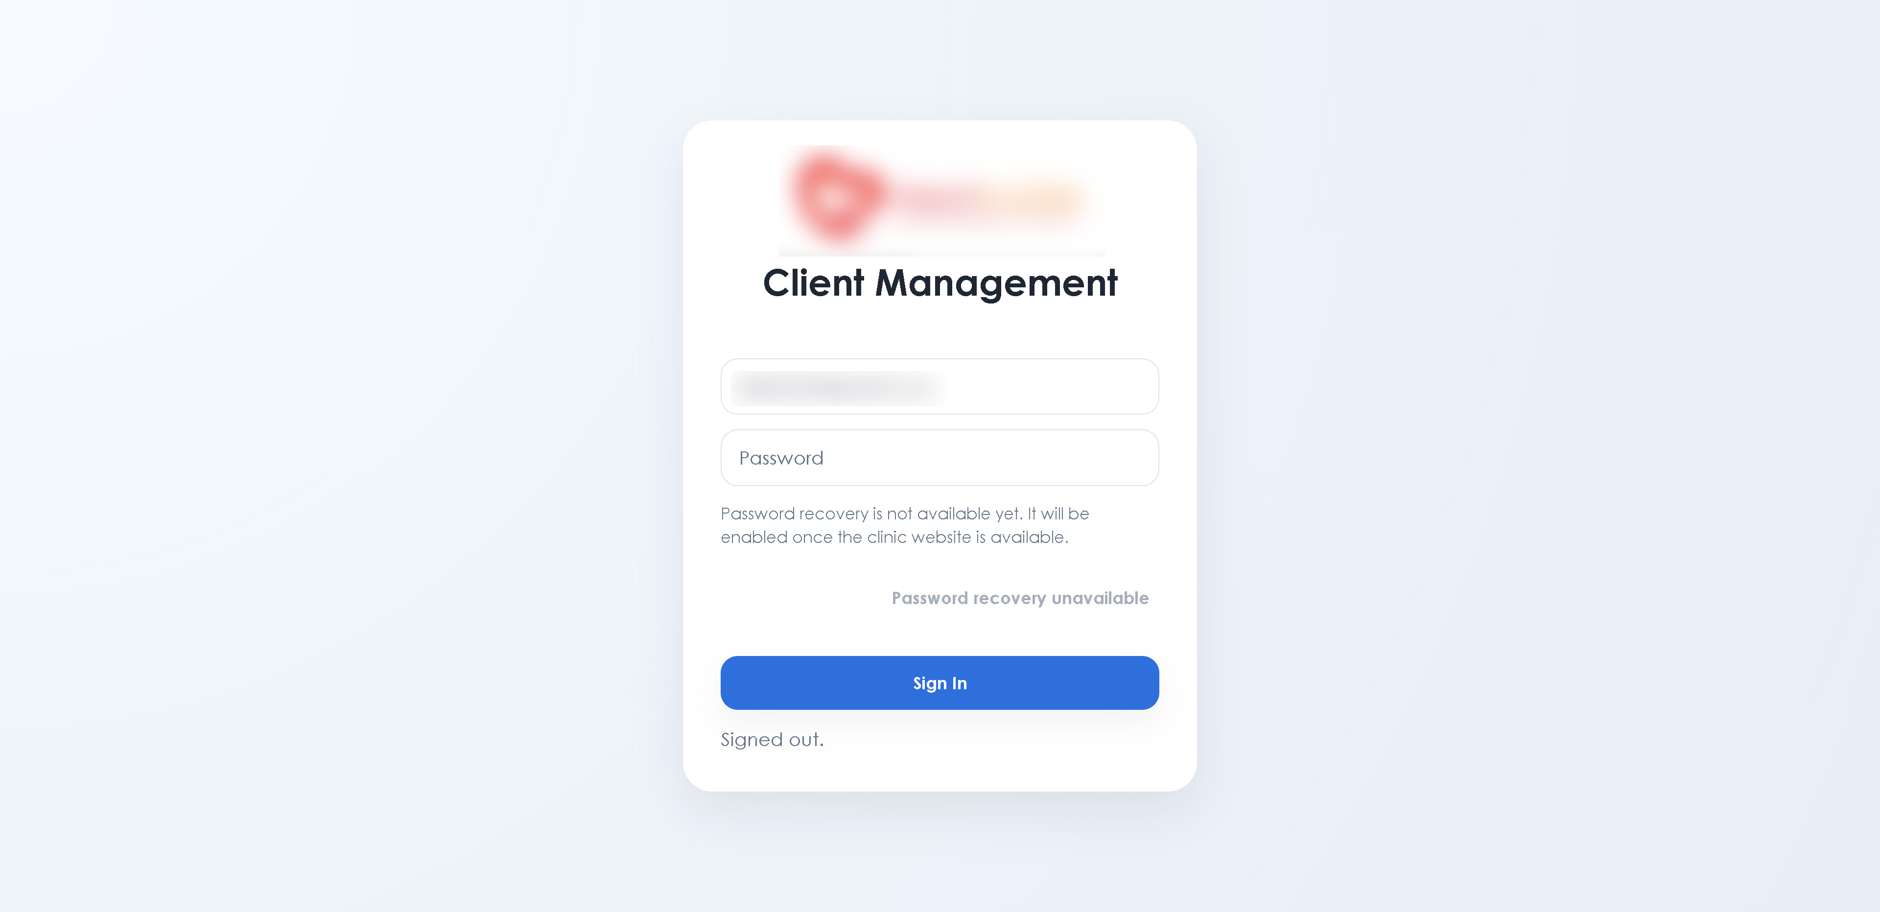
HPC Client Management sign-in screen

2. Dashboard
Dashboard summarizes the records your role is allowed to access. It shows caseload totals, recent documentation, the next client to continue, follow-up priorities, and recent work.
- Select a client in Needs attention or Recent work to open that record.
- Psychologist / Counselor totals and activity include only assigned clients.
- Staff and Admin see their permitted clinic-wide operational view.
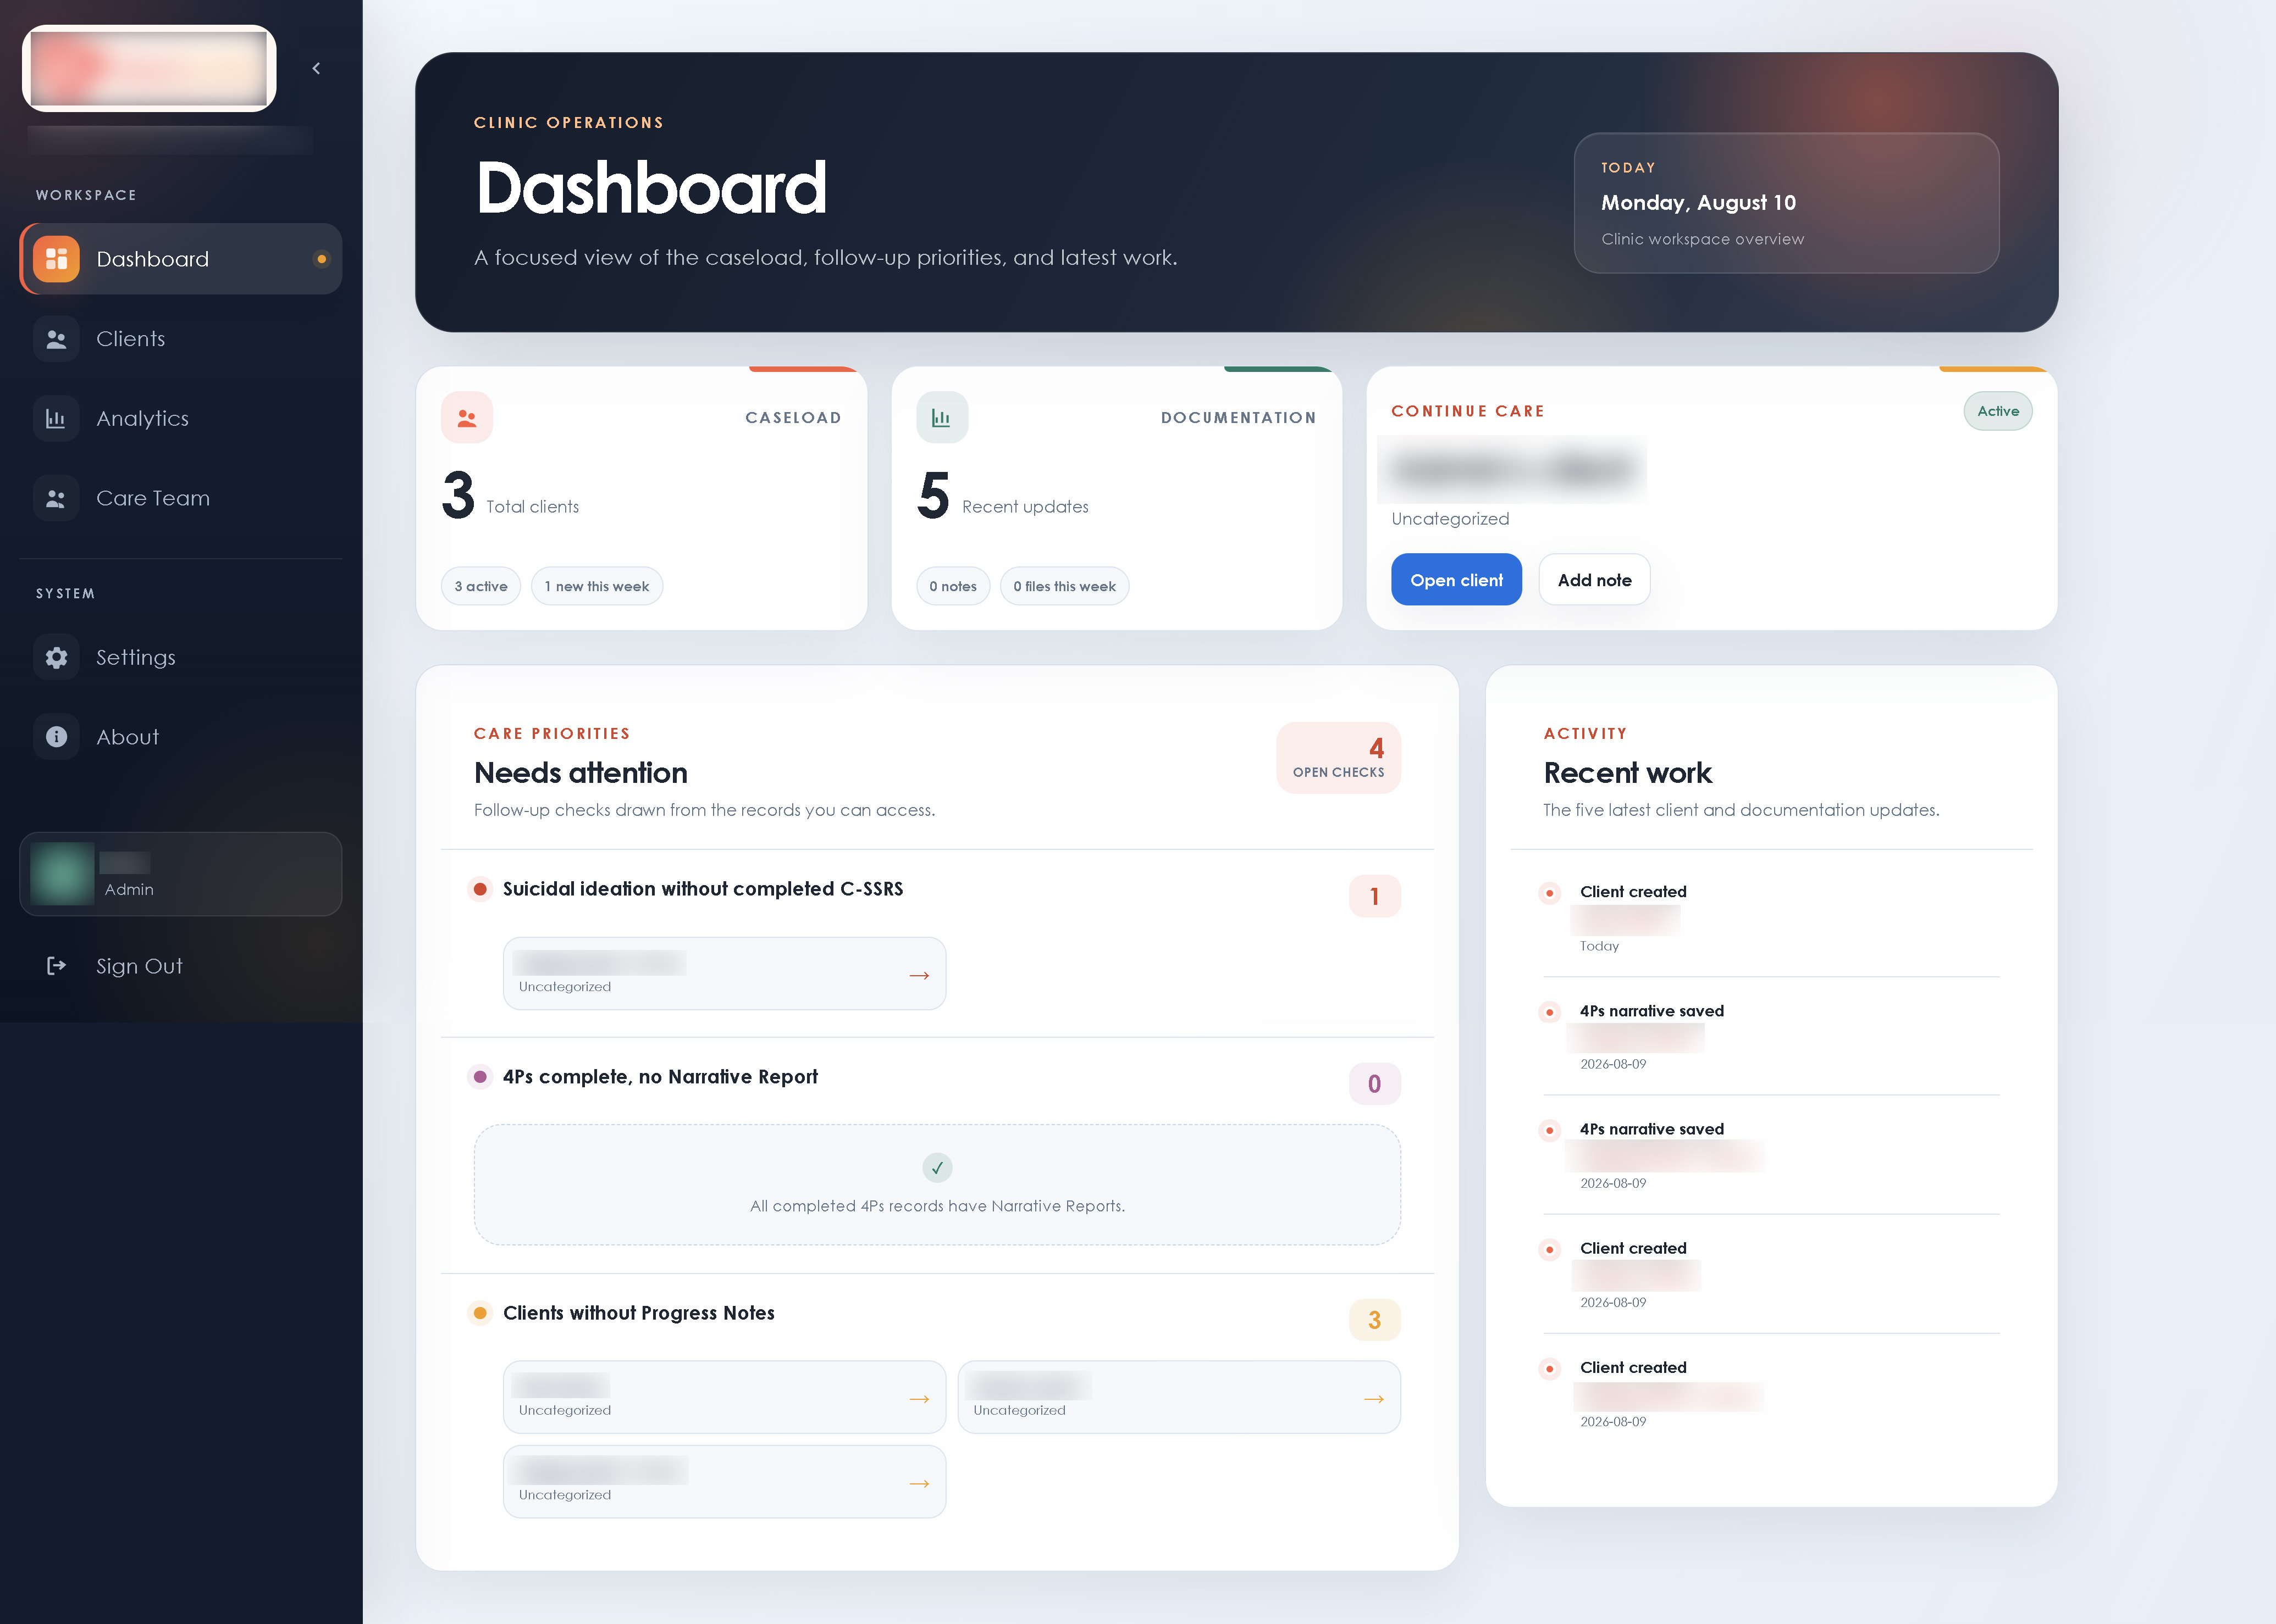
HPC Client Management dashboard

3. Clients
Use Clients to search, filter, create, and open client records.

Find a client
Use the search box or filter by status, category, year, or month. Select a client from the directory to open the record workspace.

Create a client
- Select Add Client.
- Enter the required intake information.
- Confirm the HPC Representative:
- Admin starts with Doc Don and may transfer the client to another active clinical representative.
- Staff must choose an active Admin or Psychologist / Counselor representative. Staff cannot assign a client to Staff.
- Psychologist / Counselor accounts use their own assigned representative.
- Save the record.

Client tabs
- Overview: intake source, identity and contact details, demographics, representative, status, and other client information.
- 4Ps: biological, psychological, and social predisposing, precipitating, perpetuating, and protective factors.
- Progress Notes: dated clinical notes.
- Documents: scanned or uploaded client paperwork.
- Assessments: scanned or uploaded assessment paperwork.
Staff can maintain Overview information and upload, download, or rename Documents and Assessments. Staff cannot edit clinical 4Ps, C-SSRS, or progress notes and cannot delete uploaded paperwork.
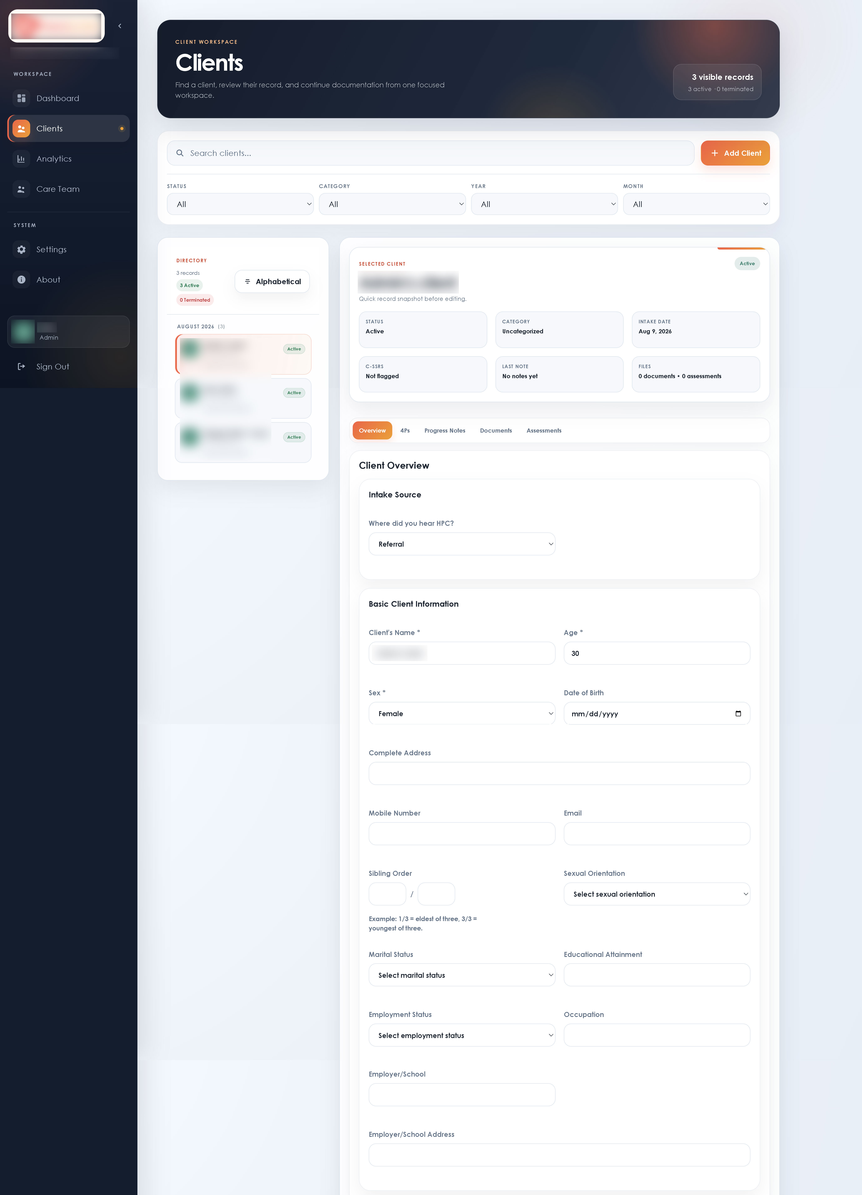
client workspace

4. 4Ps case conceptualization and narrative draft
Complete the four 4Ps rows across the Biological, Psychological, and Social columns. Save the record before leaving the client.
When the required 4Ps information is complete, an Admin or the assigned Psychologist / Counselor can generate a narrative draft. Review and edit every draft before using it clinically. AI output is a drafting aid, not an assessment or clinical decision.
Privacy restriction: Do not place client names, contact details, addresses, employer or school names, record numbers, or other identifying details in 4Ps content that will be sent for narrative generation.
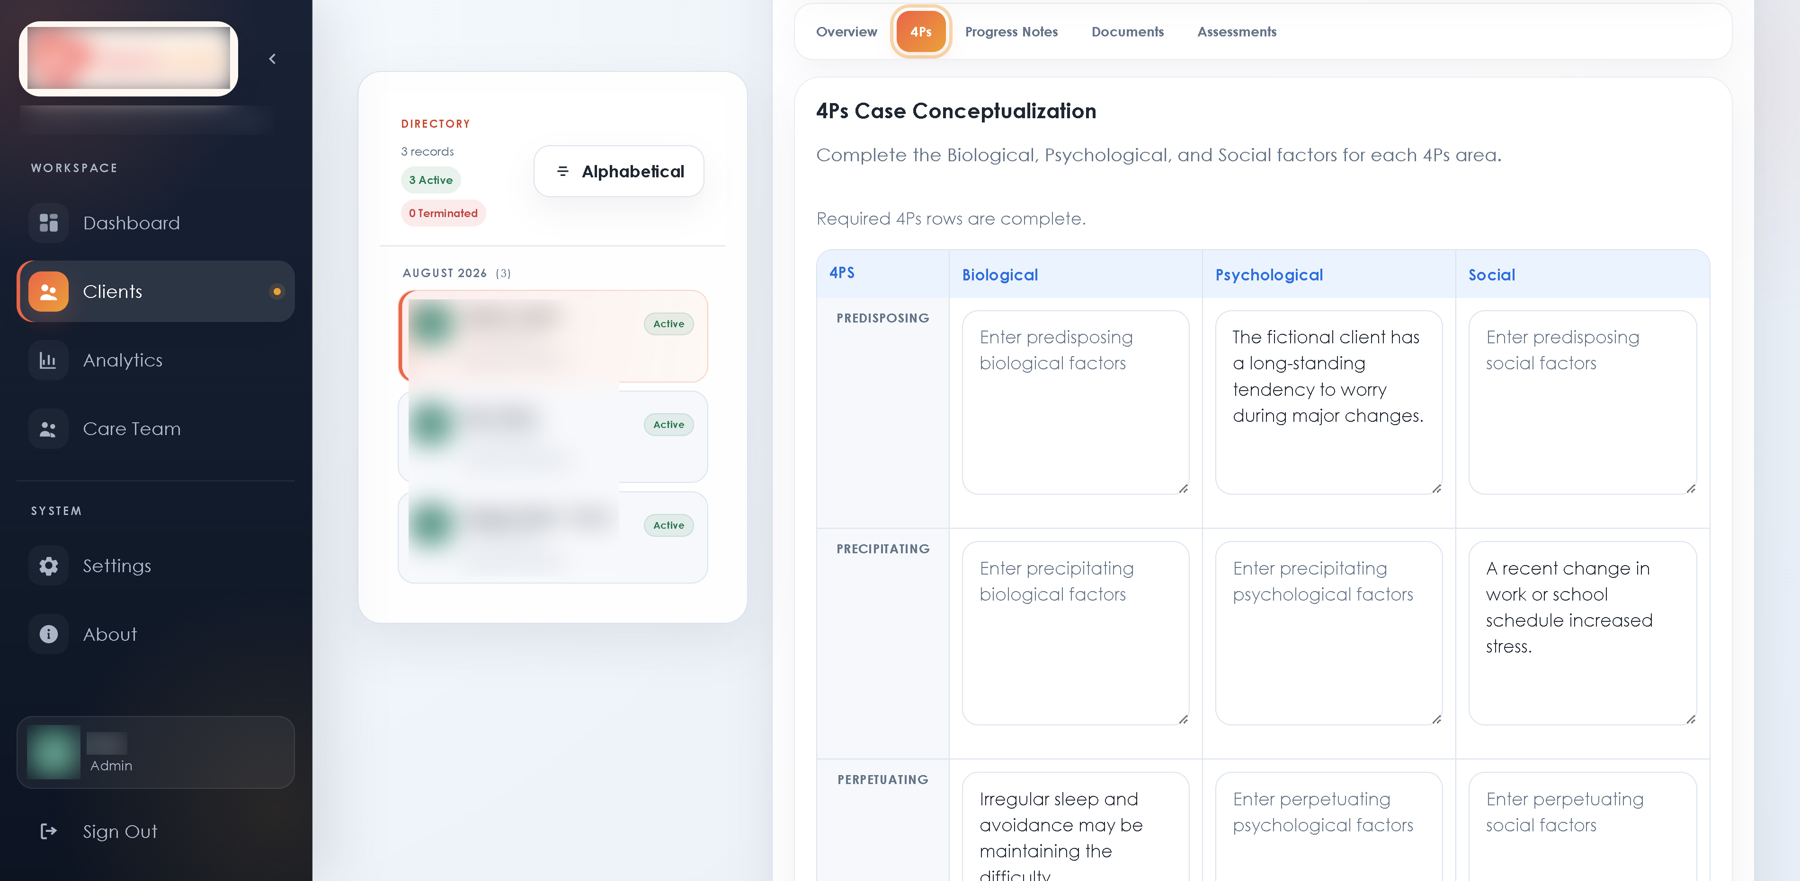
4Ps case conceptualization workspace

5. Documents and Assessments
- Open the client and select Documents or Assessments.
- Choose the appropriate desktop upload control.
- Select the file and enter a clear display name.
- Wait for the application to confirm that the upload and validation finished.
All three approved roles can upload, download, and rename paperwork for clients they can access. Staff cannot delete uploads. Admin and the assigned Psychologist / Counselor should delete only after confirming that the correct record and file have been selected.

6. Analytics and exports
Use Analytics to review caseload, documentation coverage, demographics, presenting concerns, C-SSRS follow-up, 4Ps completion, and records activity.
- Set the date range and any status, category, representative, age-group, or sex filters.
- Review the selected-view strip and charts.
- Select Export CSV for data or Export Presentation for a branded PowerPoint summary.
Exports follow the same access rules as the screen. A Psychologist / Counselor export contains only assigned-client data.

analytics workspace

7. Care Team

Admin
Admin can invite approved roles, assign representative names, change roles, and deactivate accounts. Admin accounts are protected from Staff changes.

Staff
Staff can invite and manage non-Admin members. The Admin role is not available when Staff sends an invitation. Staff cannot change, deactivate, or otherwise affect any Admin account.

Psychologist / Counselor
Psychologist / Counselor can view the directory but cannot invite members or change account roles.
New members receive an email invitation, create their own password, and enroll in MFA. Use Deactivate instead of deleting an account so its history remains available. A deactivated account cannot enter the workspace.
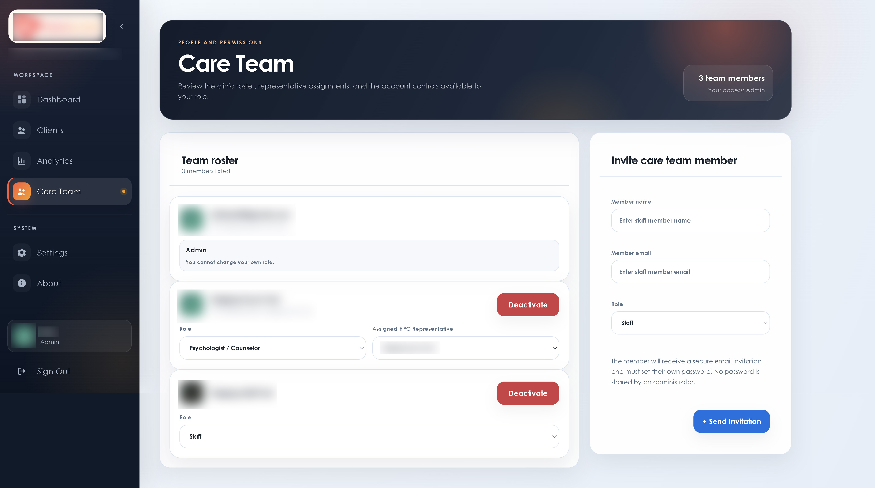
Care Team workspace

8. Settings
The modules shown in Settings depend on the signed-in role.
- Contact details: Admin and Staff can update clinic mobile, landline, email, and location information.
- Appearance: choose Light, Dark, HPC, or HPC Dark. The preference is saved on the current device.
- Clinic notice banner: all active roles can publish or disable a shared Dashboard notice.
- Client categories: Admin and Staff can add, rename, or remove list choices. Existing client records retain their saved category value.
- Backup and restore: Admin and Staff can export and inspect a JSON package. Only Admin can perform a merge restore after fresh MFA verification.
- System Activity / Audit Log: Admin only.

Backup and restore boundary
Before a major administrative or data change, export a new backup and store it in an approved private location. Restore works only with a package created by the same Supabase project. It updates matching application records and adds missing records; it does not delete current records absent from the package.
The in-app package does not recreate Supabase Auth accounts and does not restore deleted Storage file contents. A full disaster-recovery process requires separate database and Storage backups.
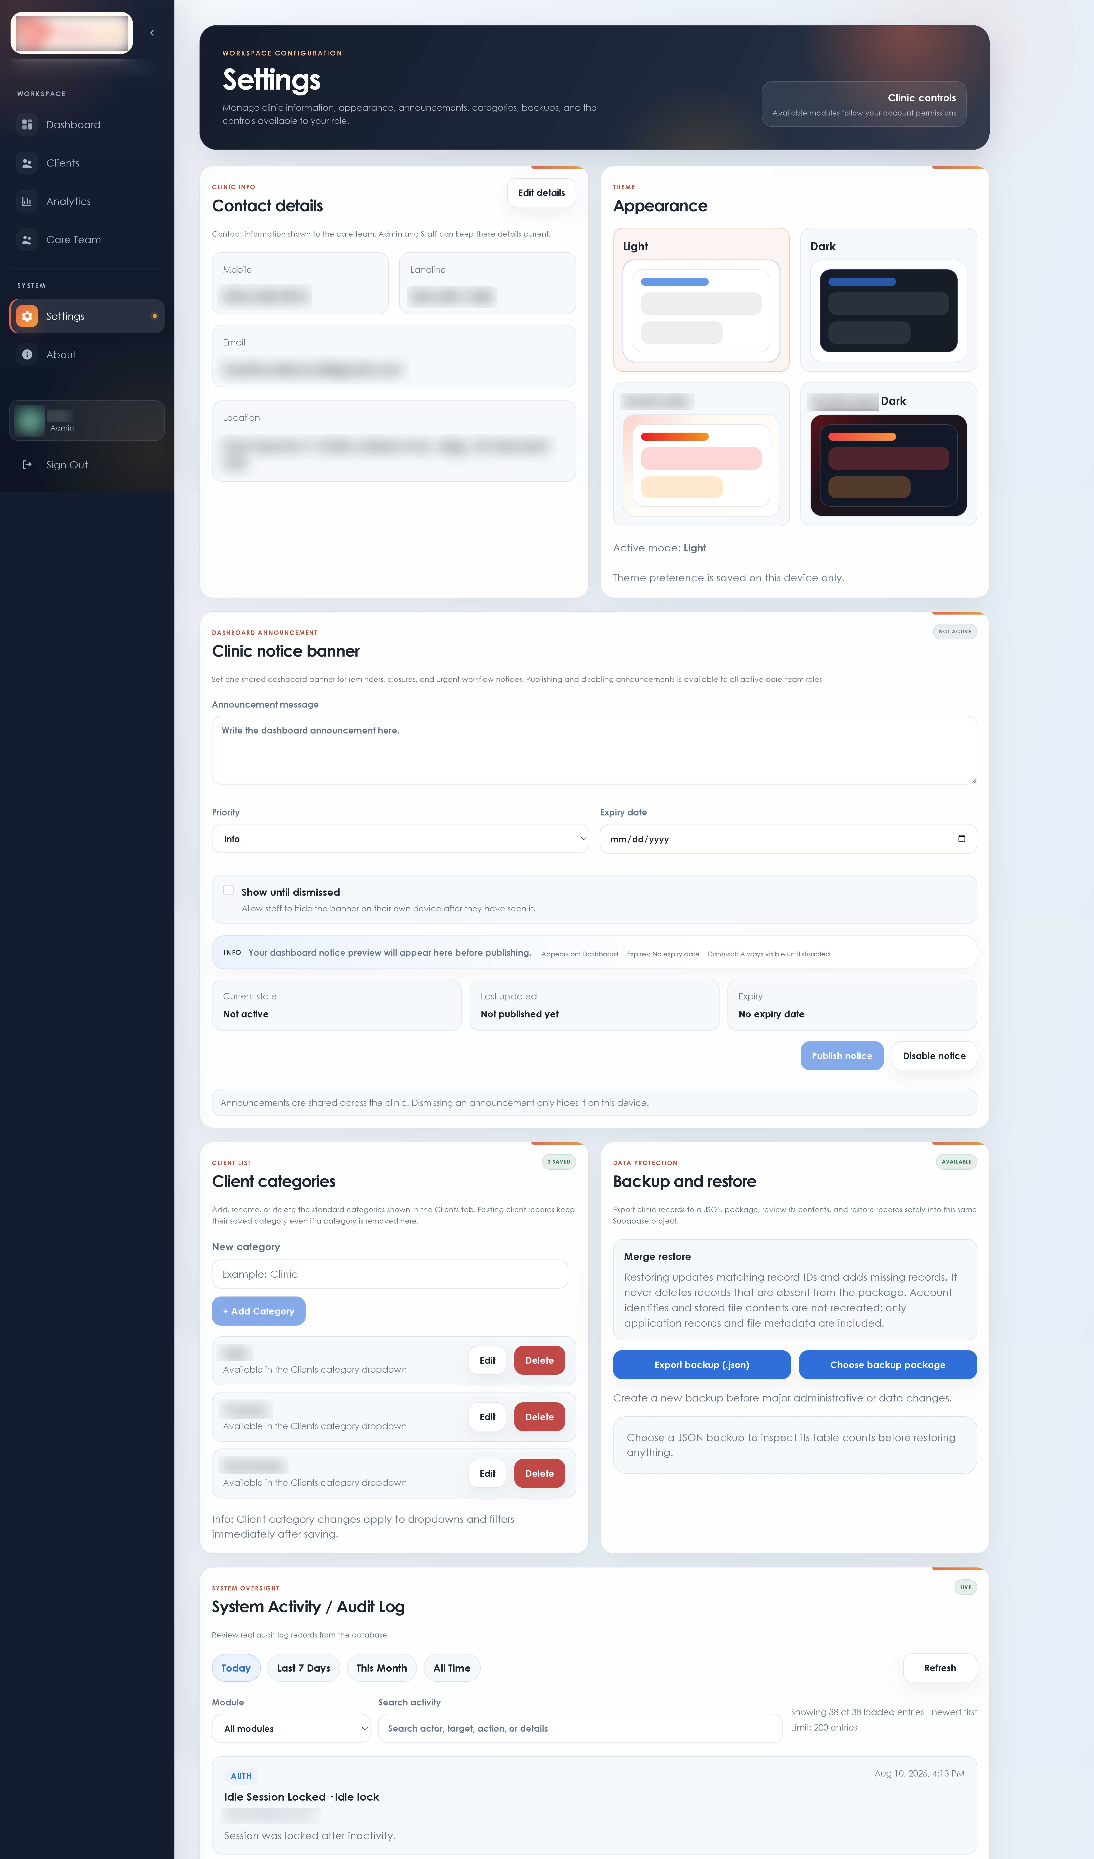
Settings workspace

9. Profile and account security
Select your name or profile card in the lower-left sidebar to open Profile. From this screen you can:
- upload or remove your profile picture;
- update your display name;
- request an email-address change using your current password and MFA code;
- change your password using your current password and MFA code; and
- add or remove an authenticator app.
Use one authenticator device per staff account whenever possible. Removing the only working authenticator may prevent the account from completing MFA.
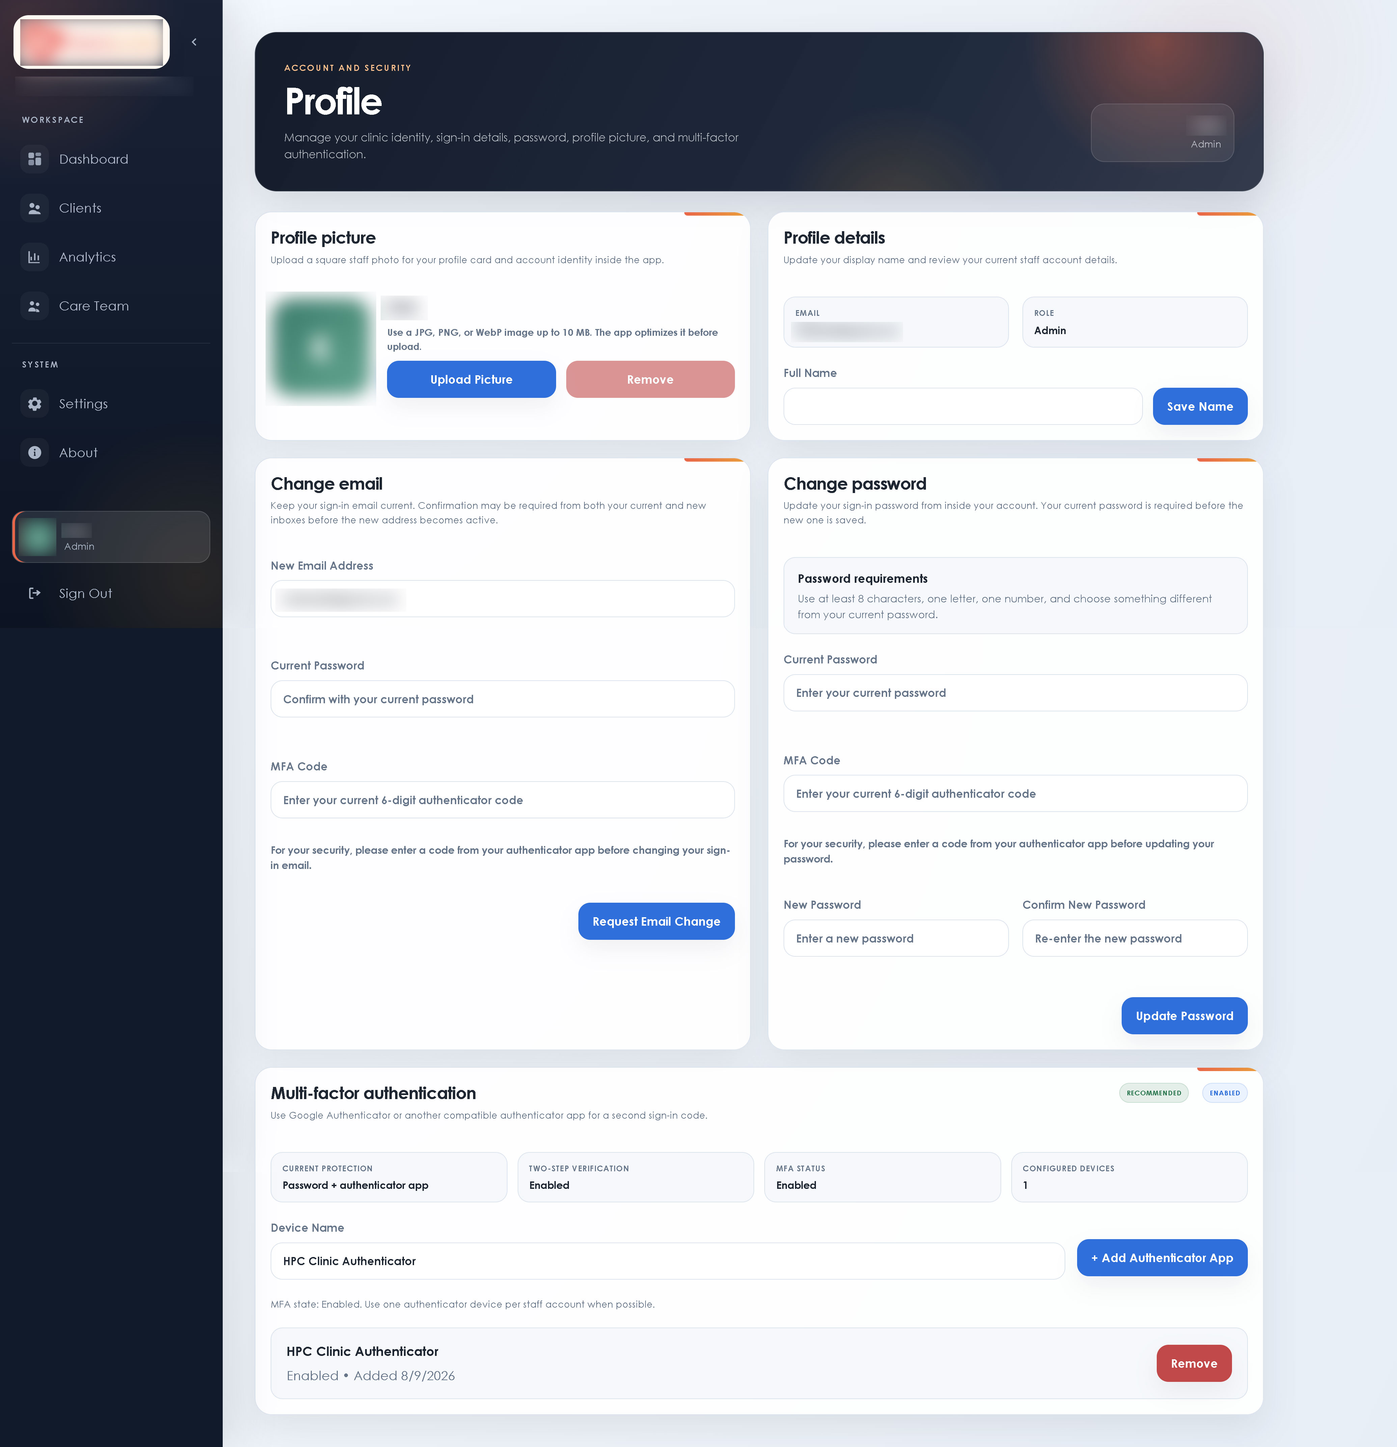
Profile and MFA workspace

10. Check for and install updates
- Open About.
- Select Check for Updates.
- If a newer version is offered, review its version and release notes.
- Confirm installation. The application privately downloads the signed installer, verifies its signature, installs it, and restarts.
- Return to About and confirm the installed version.
An active account with completed MFA is required. The update comes from the private application release channel; pushing source code to Git does not update the clinic application automatically.
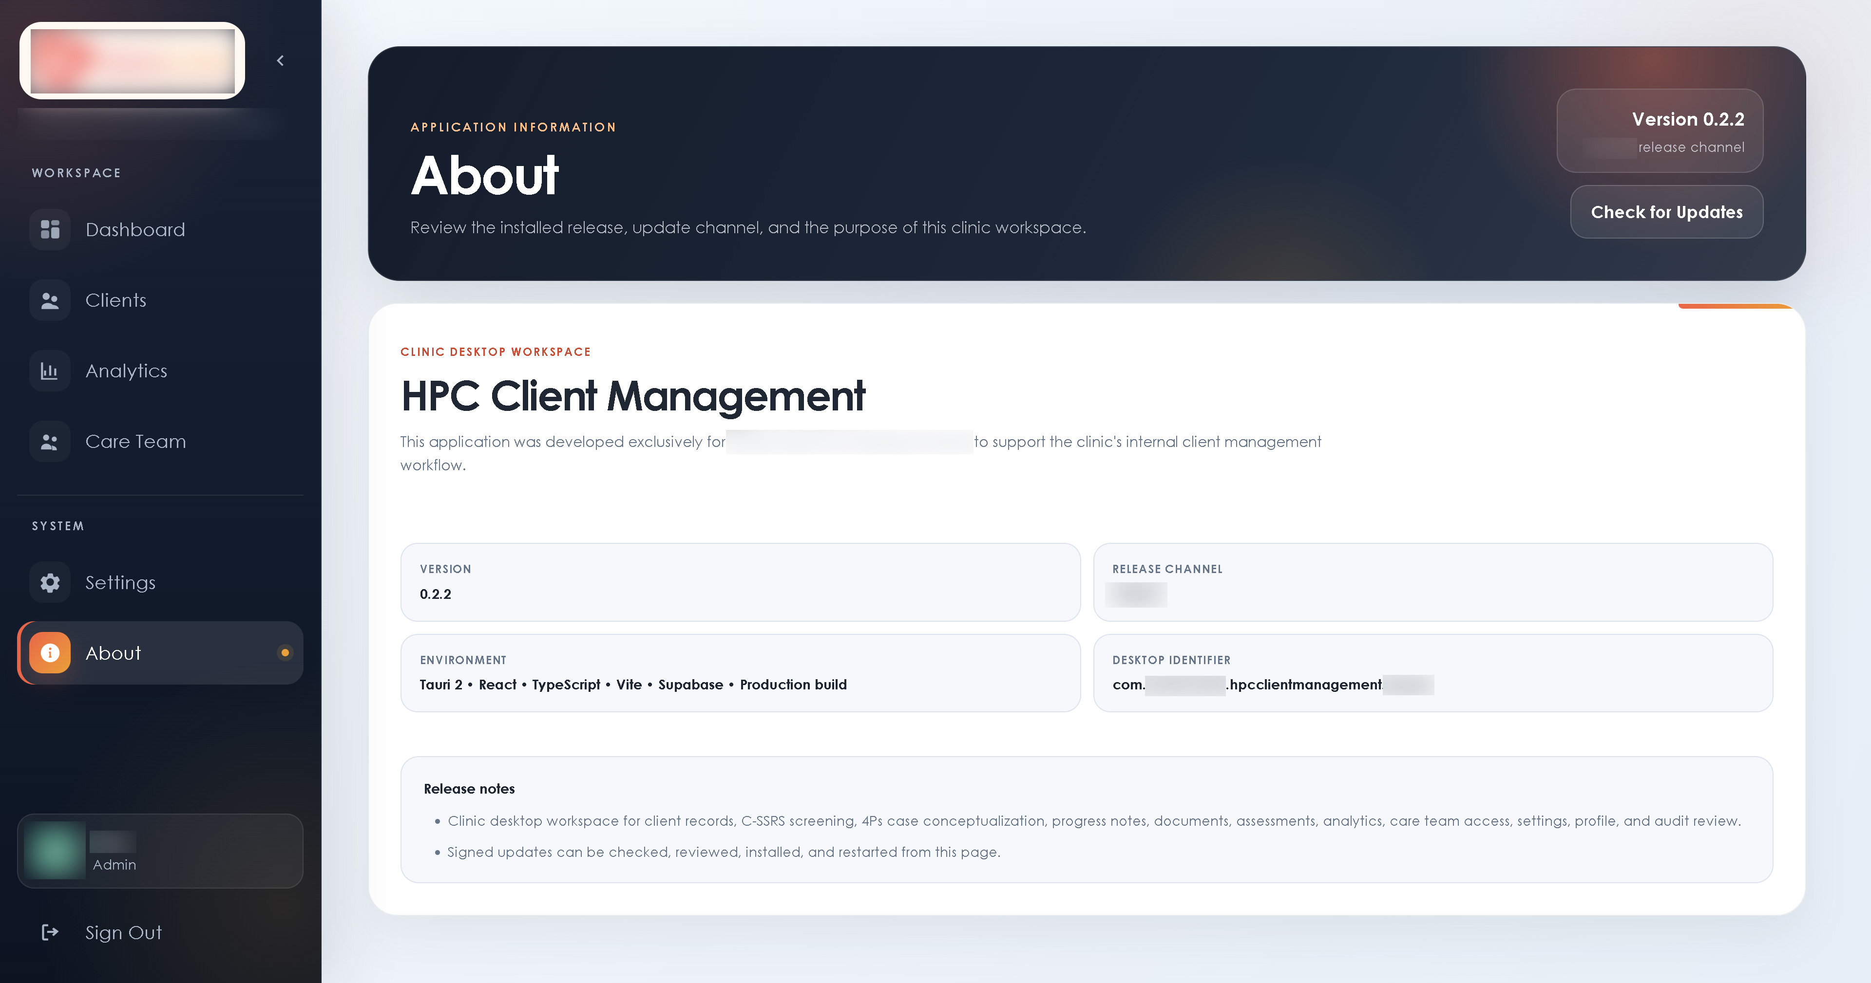
About and signed updater screen

11. Common messages
Message or situation | What to do
Session locked after inactivity | Sign in again with password and MFA. Unsaved work may need to be re-entered.
Please sign in again and complete MFA | Reauthenticate, complete MFA, then repeat the protected action.
Your account has been deactivated | Contact the clinic Admin. The account cannot enter the workspace while inactive.
Your account profile was not found | Contact the clinic Admin so the invitation and profile can be checked.
Invitation email rate limit | Wait for the Supabase mail limit to clear before sending another invitation. Avoid repeated retries.
Narrative generation failed | Confirm the required 4Ps rows are complete, save the record, and try again without identifying details.
Update cannot be installed | Confirm internet access, sign in with MFA again, and retry from About. Do not install an unsigned file from another source.

12. End-of-session checklist
- Save the current client record.
- Confirm uploads finished and appear in the correct client tab.
- Close any exported files that contain clinic information.
- Store exports and backups only in approved private locations.
- Sign out of HPC Client Management.

