Azure Practice 1
Online Cooking Ingredient Inventory
Tatsiana Halaburda
FR · NFR · Services Diagram · Tables Diagram

1. Functional Requirements
The following tables describe what each service is responsible for, the user actions or system events that trigger each operation, and how services interact.

1.1 Inventory Service
Manages ingredients, stock levels, and warehouses. Exposes a REST API through the API Gateway.

# | Operation | When / Trigger | Interactions with other services
1 | Create ingredient (name, category, unit, reorder level) | Admin sends POST /ingredients | Writes to InventoryInventoryFeedbackDB only
2 | Get list of ingredients (filter by category or name) | Any user sends GET /ingredients | Reads InventoryInventoryFeedbackDB
3 | Update ingredient details | Admin sends PUT /ingredients/{id} | Writes to InventoryInventoryFeedbackDB
4 | Soft-delete ingredient (mark as inactive) | Admin sends DELETE /ingredients/{id} | Writes to InventoryInventoryFeedbackDB; publishes IngredientDeactivated event to Service Bus
5 | Add stock for an ingredient in a warehouse | Warehouse operator sends POST /stock | Writes to InventoryInventoryFeedbackDB
6 | Reserve stock when an order is created | Order Service calls PUT /stock/reserve | Writes to InventoryInventoryFeedbackDB; publishes StockLow event to Service Bus if stock drops below reorder level
7 | Release reserved stock when an order is cancelled | Order Service calls PUT /stock/release | Writes to InventoryInventoryFeedbackDB
8 | Get current stock level for an ingredient | Any user sends GET /stock/{ingredientId} | Reads InventoryInventoryFeedbackDB

1.2 Order Service
Handles ingredient purchase orders from creation through to cancellation. Calls Inventory Service synchronously to reserve or release stock.

# | Operation | When / Trigger | Interactions with other services
1 | Create a new order with a list of ingredients and quantities | Procurement manager sends POST /orders | Calls Inventory Service PUT /stock/reserve; writes Order and OrderItems to InventoryInventoryFeedbackDB
2 | Confirm a pending order | Manager sends PUT /orders/{id}/confirm | Updates order status in InventoryInventoryFeedbackDB
3 | Cancel an order and release reserved stock | Manager sends PUT /orders/{id}/cancel | Calls Inventory Service PUT /stock/release; updates status in InventoryInventoryFeedbackDB
4 | Get order details | Any user sends GET /orders/{id} | Reads InventoryInventoryFeedbackDB
5 | List orders (filter by status or date) | Any user sends GET /orders | Reads InventoryInventoryFeedbackDB
6 | Record stock reservations per order item | Triggered automatically when an order is created | Writes to StockReservations table in InventoryInventoryFeedbackDB

1.3 Feedback Service
Collects ingredient quality feedback from users and from events published by Inventory Service via the message broker.

# | Operation | When / Trigger | Interactions with other services
1 | Submit feedback (rating 1–5, optional comment) for an ingredient | User sends POST /feedback, or a StockLow event arrives from Service Bus | Writes FeedbackEntry to InventoryFeedbackDB; no calls to other services
2 | Get feedback for an ingredient | Any user sends GET /feedback/{ingredientId} | Reads InventoryFeedbackDB
3 | Get aggregated summary (average rating, count) for an ingredient | Any user sends GET /feedback/{ingredientId}/summary | Reads InventoryFeedbackDB
4 | Update the summary after new feedback is added | Runs automatically after any new FeedbackEntry is written | Reads and writes FeedbackSummary in InventoryFeedbackDB
5 | Handle IngredientDeactivated event — archive its feedback | Service Bus message arrives | Marks affected FeedbackEntries as archived in InventoryFeedbackDB

2. Non-Functional Requirements
These requirements define the quality characteristics expected from each service regardless of the specific feature being used.

2.1 Inventory Service
# | Category | Requirement | Acceptable failure rate
1 | Availability | Service must be accessible at all times for both reads and writes. | No more than 0.1 % of requests per month may fail due to downtime.
2 | Performance | Read requests should respond quickly. | 95 % of GET requests complete in under 200 ms.
3 | Reliability | Stock changes (reserve / release) must not be applied twice. | Zero duplicate deductions — all operations must be idempotent.
4 | Security | All endpoints require a valid JWT token; admin actions additionally require the admin role. | 100 % of unauthenticated requests must return 401.

2.2 Order Service
# | Category | Requirement | Acceptable failure rate
1 | Availability | Order creation and retrieval must be accessible. | No more than 0.1 % of requests per month may fail.
2 | Performance | Creating an order (including the synchronous call to Inventory Service) should complete quickly. | 95 % of order-creation requests complete in under 600 ms.
3 | Reliability | If Inventory Service is unreachable, the order must not be partially created. | A failed reservation must roll back the order — no orphan orders allowed.
4 | Security | Only users with the procurement role may create, confirm, or cancel orders. | 100 % of unauthorised attempts must return 403.

2.3 Feedback Service
# | Category | Requirement | Acceptable failure rate
1 | Availability | REST endpoints should be available at all times; event processing may have short delays. | No more than 0.5 % of REST requests may fail per month.
2 | Reliability | Every event from the broker must be processed at least once. | Messages that fail processing go to a dead-letter queue — no silent data loss.
3 | Performance | Writing and reading feedback should be fast. | 95 % of feedback writes complete in under 300 ms.
4 | Security | Only authenticated users may submit or read feedback. | All unauthenticated requests must return 401.

3. Services Communication Diagram
The diagram below shows all entry points and how the services communicate.

Solid arrows = synchronous REST calls. Dashed arrows = asynchronous events through the message broker.

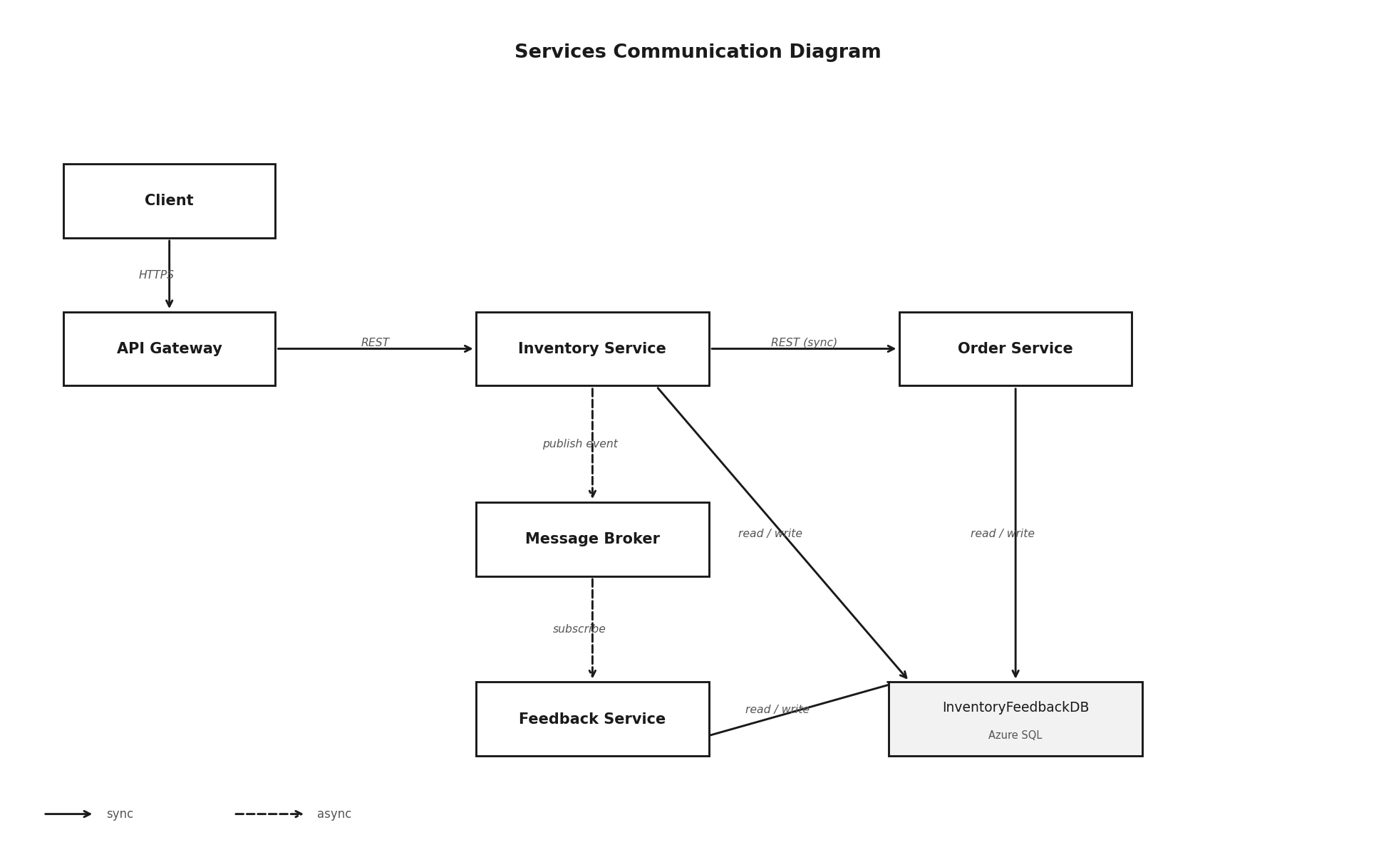
Figure 1 — Services Communication Diagram

4. Database Tables Diagram
All services share a single Azure SQL database (InventoryInventoryFeedbackDB). All cross-table references are enforced by real foreign-key constraints.

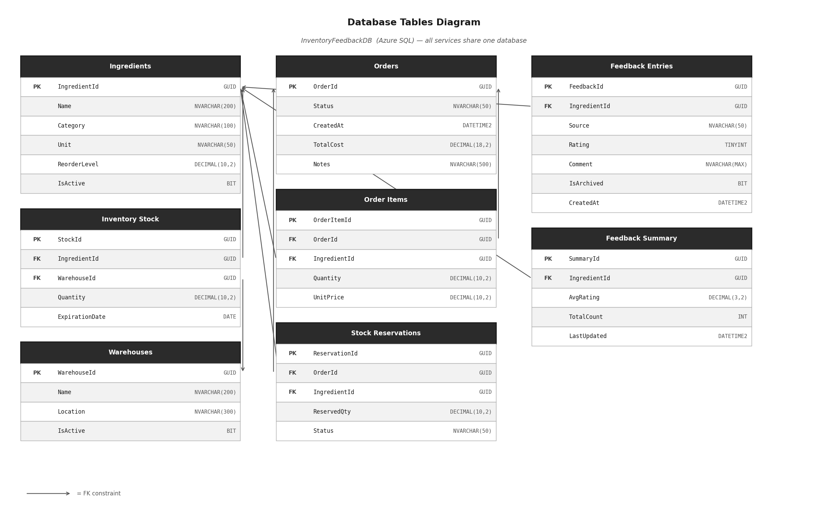
Figure 2 — Database Tables Diagram

5. Table Schemas
All tables live in a single shared Azure SQL database. PK = Primary Key, FK = Foreign Key enforced by a database constraint.

InventoryInventoryFeedbackDB (Azure SQL)

Ingredients
Key | Column | Type | Description
PK | IngredientId | GUID | Unique identifier for the ingredient.
 | Name | NVARCHAR(200) | Ingredient name — must be unique.
 | Category | NVARCHAR(100) | e.g. Dairy, Spice, Vegetable.
 | Unit | NVARCHAR(50) | Unit of measure, e.g. kg, litre.
 | ReorderLevel | DECIMAL(10,2) | Stock threshold that triggers a StockLow event.
 | IsActive | BIT | 0 = soft-deleted, 1 = active.

InventoryStock
Key | Column | Type | Description
PK | StockId | GUID | Unique identifier for this stock entry.
FK | IngredientId | GUID | References the Ingredients table.
FK | WarehouseId | GUID | References the Warehouses table.
 | Quantity | DECIMAL(10,2) | Current quantity in stock — must be ≥ 0.
 | ExpirationDate | DATE | Expiry date for perishable items (nullable).

Warehouses
Key | Column | Type | Description
PK | WarehouseId | GUID | Unique identifier.
 | Name | NVARCHAR(200) | Warehouse name.
 | Location | NVARCHAR(300) | Address or region.
 | IsActive | BIT | Soft-delete flag.

Orders

Key | Column | Type | Description
PK | OrderId | GUID | Unique order identifier.
 | Status | NVARCHAR(50) | Draft | Confirmed | Cancelled | Fulfilled.
 | CreatedAt | DATETIME2 | When the order was created (UTC).
 | TotalCost | DECIMAL(18,2) | Sum of all order-item costs.
 | Notes | NVARCHAR(500) | Optional comment from the manager.

OrderItems

Key | Column | Type | Description
PK | OrderItemId | GUID | Unique line-item identifier.
FK | OrderId | GUID | References the Orders table.
FK | IngredientId | GUID | References the Ingredients table.
 | Quantity | DECIMAL(10,2) | Ordered quantity.
 | UnitPrice | DECIMAL(10,2) | Price per unit at the time of the order.

StockReservations

Key | Column | Type | Description
PK | ReservationId | GUID | Unique reservation identifier.
FK | OrderId | GUID | References the Orders table.
FK | IngredientId | GUID | References the Ingredients table.
 | ReservedQty | DECIMAL(10,2) | Quantity locked in stock.
 | Status | NVARCHAR(50) | Active | Released | Fulfilled.

FeedbackEntries

Key | Column | Type | Description
PK | FeedbackId | GUID | Unique feedback identifier.
FK | IngredientId | GUID | References the Ingredients table.
 | Source | NVARCHAR(50) | "user" or "system" (auto-created from a StockLow event).
 | Rating | TINYINT | Quality rating from 1 to 5.
 | Comment | NVARCHAR(MAX) | Optional free-text review.
 | IsArchived | BIT | 1 = archived after IngredientDeactivated event.
 | CreatedAt | DATETIME2 | Submission time (UTC).

FeedbackSummary

Key | Column | Type | Description
PK | SummaryId | GUID | Unique summary identifier.
FK | IngredientId | GUID | References the Ingredients table — one row per ingredient.
 | AvgRating | DECIMAL(3,2) | Running average rating.
 | TotalCount | INT | Total number of feedback entries.
 | LastUpdated | DATETIME2 | When the summary was last recalculated (UTC).

