Elevator System

Software Engineering
Assignment 3

Chris Hanshew
Mike Spritzer
Peter Clough
William Scalise

Table of Contents

Finalized System Model Page 3
Use Case Diagrams Page 3
Class Diagrams Page 5
Sequence Diagram (Original) Page 6
Design Classes Page 7
Design Class Diagram Page 7
Class Table Page 8
Traceability Table Page 9
Design Class Dictionary Page 10
Sequence Diagrams (New) Page 11
Conclusion Page 12

Finalized System Model

Use Case Diagrams

Control Case Diagram
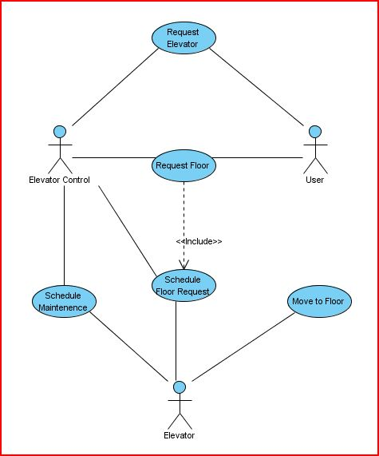

Simulation Case Diagram
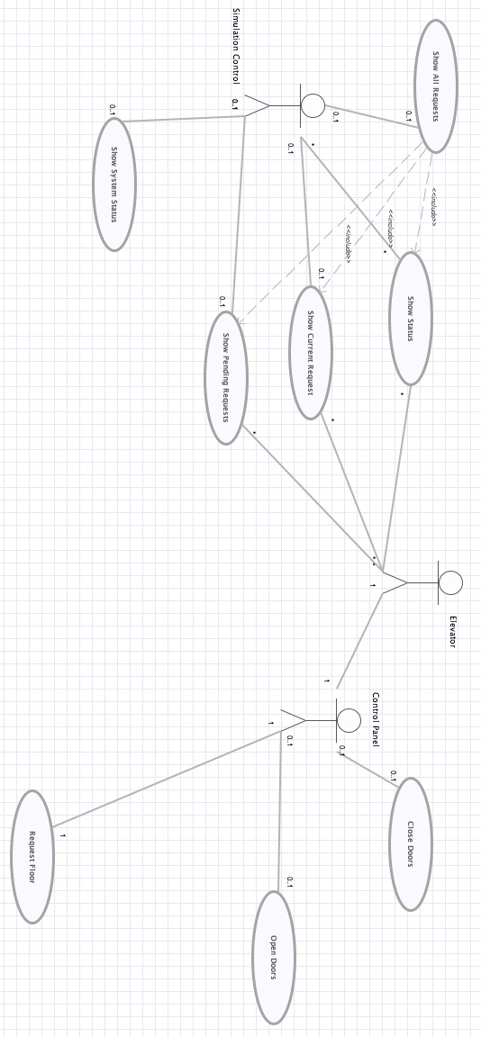
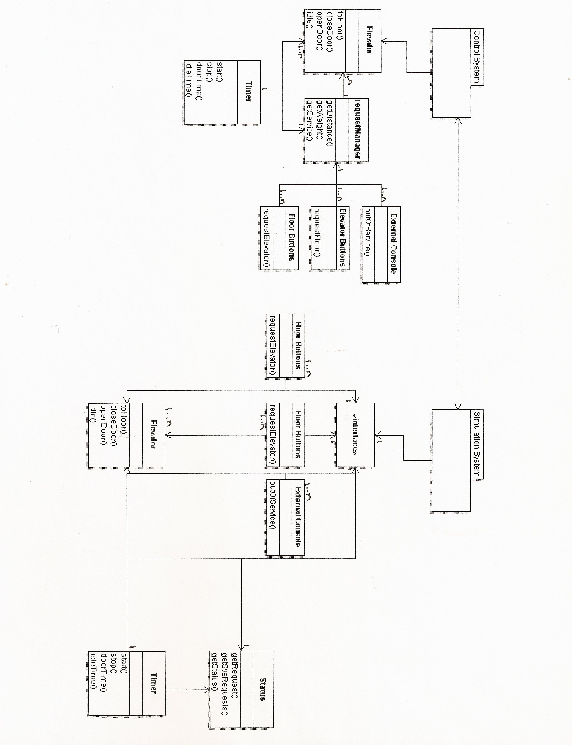
Class Diagrams

Sequence Diagram (Original)
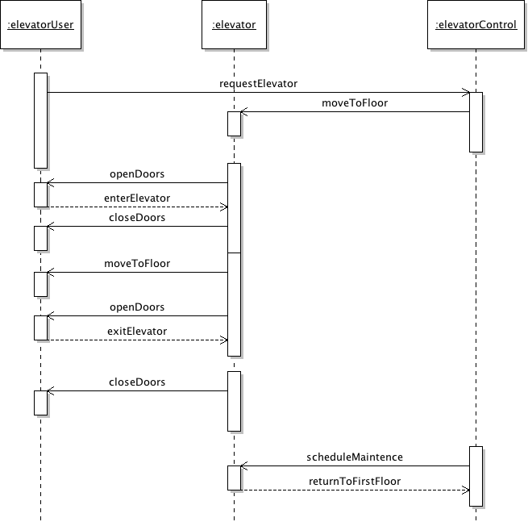

Design Classes
Design Class Diagram
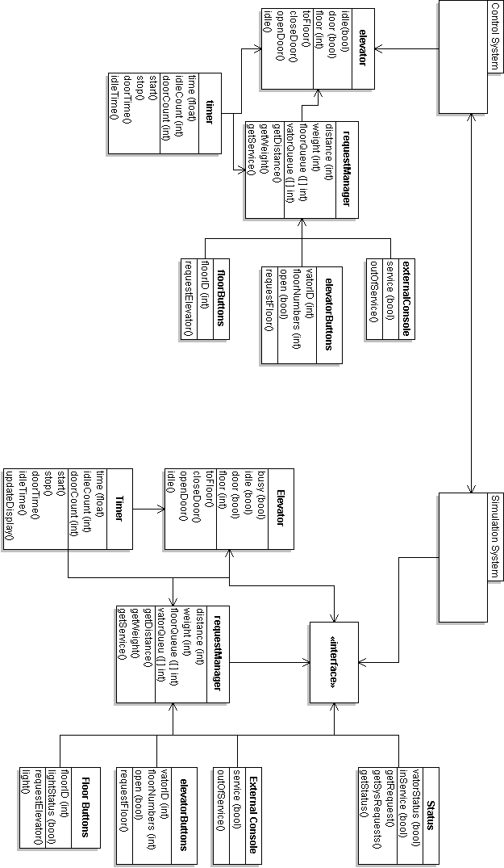

Request Manager
Responsibilities | Collaborators
The Request Manager accepts floor requests from users and adds them to a request queue. Once an elevator signals that it is ready to accept a request, the Request Manager sends the request to the elevator and removes it from the queue. The Request Manager also tracks which elevators are in service and which are out of service. | Elevator Buttons  Floor Buttons

External Console
Responsibilities | Collaborators
Displays information regarding the state of the elevator. | Elevator

Timer
Responsibilities | Collaborators
Determines how long the elevator the elevator doors stay open before they close. Also determines how long an elevator will remain idle if it is scheduled for maintenance. | Elevator

Elevator
Responsibilities | Collaborators
Accepts floor requests from the Request Manager and moves to the requested floor. | Request Manager  External Console  Timer

Elevator Buttons
Responsibilities | Collaborators
- Opens or closes elevator doors  - Sends a floor request to be served by the elevator | Request Manager

Floor Buttons
Responsibilities | Collaborators
- Sends request for an elevator to arrive at current floor | Request Manager

RequestManager
Responsibilities | Collaborators
- Adds requests to queue.  - Sends requests to elevator | ElevatorButtons  FloorButtons

ExternalConsole
Responsibilities | Collaborators
- Displays elevators state  - Displays whether elevator is in maintenance | Elevator

Timer
Responsibilities | Collaborators
- Determines how long elevator doors will remain open  - Determines how long an elevator will be down for maintenance | Elevator

Elevator
Responsibilities | Collaborators
- Accepts floor requests  - Moves to requested floor  - Accepts maintenance request | RequestManager  ExternalConsole  Timer

ElevatorButtons
Responsibilities | Collaborators
- Requests an elevator to the floor | RequestManager

Floor Buttons
Responsibilities | Collaborators
- Sends a floor request | RequestManager

Traceability Table

Design Class

D = Depends On
R = Relationship

 | Elevator | Request Manager | External Console | Elevator Buttons | Floor Buttons | Interface | Status | Timer
Elevator |  | R | R |  |  |  | R | D
Request Manager |  |  |  | D | D
External Console |  |  |  | D
Elevator Buttons |  |  | R
Floor Buttons
Interface |  |  |  | D | D |  | D
Status
Timer

Design Class Dictionary

Sequence Diagrams (w/ main methods)

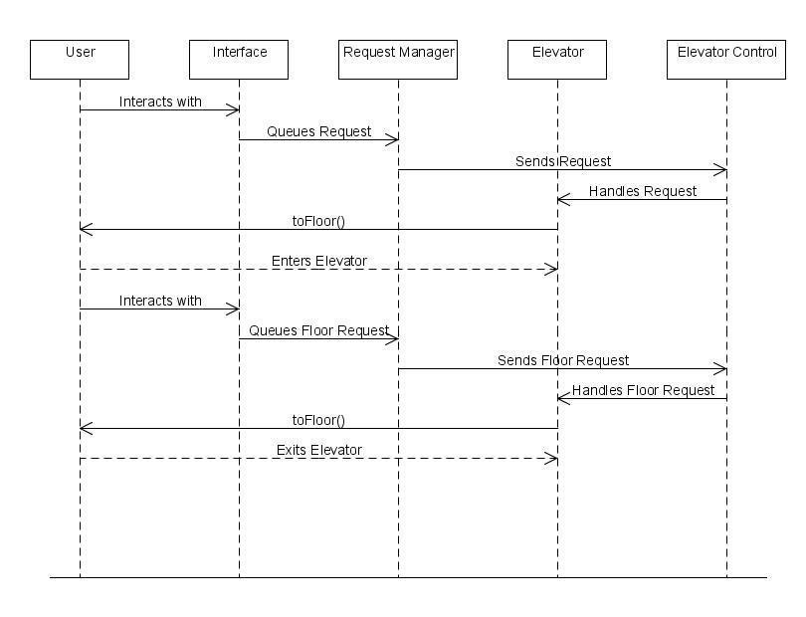

Conclusion

After finally getting our group together, a little late, we divvied up the sections of Assignment 3 and we each started to get to work. Mike's responsibility was the traceability tables for the analysis classes and the design classes. Pete was in charge of doing the sequence diagram with main methods and getting together the conclusion. Chris made the table with the class names and responsibilities, as well as the design class dictionary. And William took on the task of creating the finalized system model, table of contents and Design Class Diagram from the two of our previous assignments.
When making the finalized system model, we exchanged our reports from Assignment 2 and had each group look over the others diagrams. After some discussion, we decided that one person would combine the reports into a cohesive system model. We ended up using Chris and Williams as a base, adding what they had misunderstood or forgot about from Pete and Mikes report. Most of this invlolved level of detail – we did not originally understand the scope of the elevator system. Then, using the knowledge we have gained since Assignment 2, we corrected errors in the Class Diagrams and Use Case Diagrams.
The Design Class Diagrams are more detailed than the original Class Diagrams from Assigned 2, so these required considerable thought. Trying to determine which classes contain vital information, and how they will pass that information on in a secure fashion is no easy task. Once we developed attributes and methods for the classes, our overall design was begin to take shape.
The Sequence Diagram was relatively easy to go from our old two diagrams to our new one. After the Design Class Diagram was completed I just took the main methods and expanded on our previous diagrams. I also revised our paths as both our previous sequence diagrams weren't very sequential (lack of knowledge in the area). Our new Sequence diagram is very sequential and a true combination of both of groups ideas.
The traceability table was not part of the previous assignment that we could find so Mike ended up doing some research and creating the table from scratch. After researching what the traceability table is and finding out a general idea of what needed to be done we created a rough draft of what we thought it was, circulated it amongst our group members, whom all seemed satisfied with the end result.
Overall I think our biggest challenge was getting started working as a group. We all had trouble just getting into the project until we started communicating often through emails, and eventually setting up google talk. Once we got our channels of communication going though everyone seemed to step up and get done what needed to be done without question. William and Chris put a lot of effort into making sure we had an easy way to communicate(Chris ended up setting up a google group for our elevator project), and they did an incredible job on their parts of the project. We all did a good job on our parts of the project as far as any of us are concerned, so our member contribution would probably be Chris(30%), William(30%), Mike(20%), Pete(20%). Mainly because Chris and William bent over backwards trying to get everything setup and everyone working together.

