Elevator System

Software Engineering
Assignment 3

Chris Hanshew
Mike Spritzer
Peter Clough
William Scalise

Table of Contents

Finalized System Model Page 3
Use Case Diagrams Page 3
Class Diagrams Page 5
Sequence Diagram (Original) Page 6
Design Classes Page 7
Design Class Diagram Page 7
CRC Page 8
Traceability Table Page 9
Design Class Dictionary Page 10
Sequence Diagrams (New) Page 12
Conclusion Page 13

Finalized System Model

Use Case Diagrams

Control Case Diagram
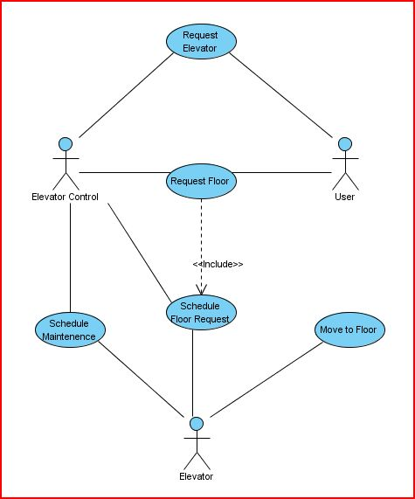

Simulation Case Diagram
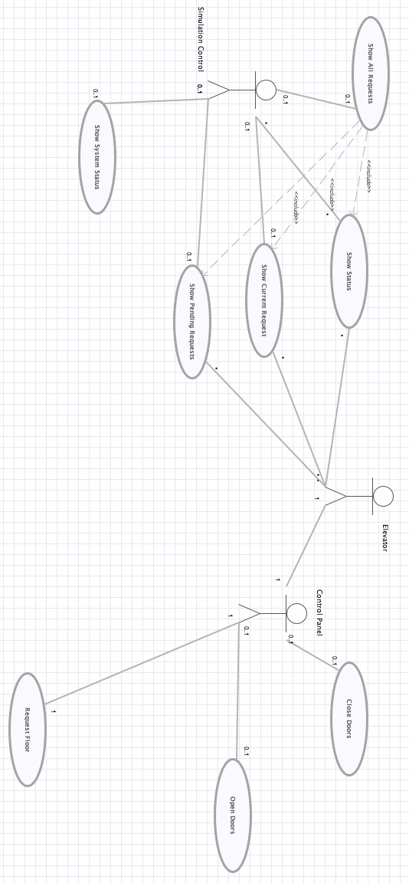
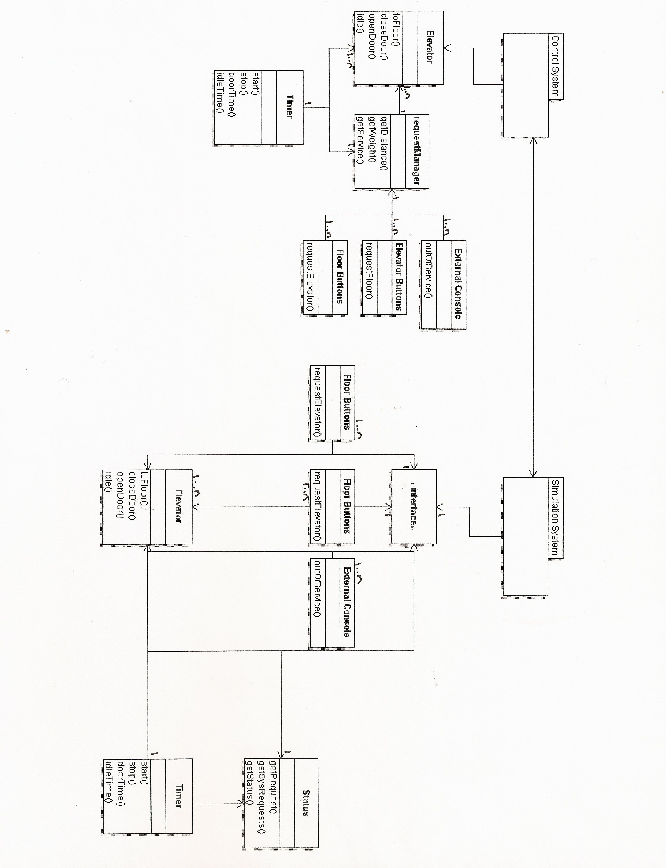
Class Diagrams

Sequence Diagram (Original)
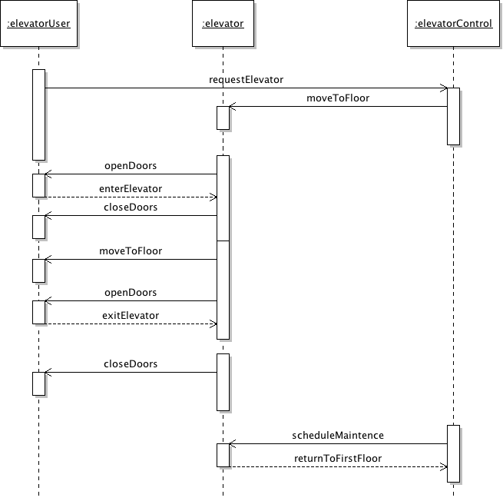

Design Classes

Design Class Diagram
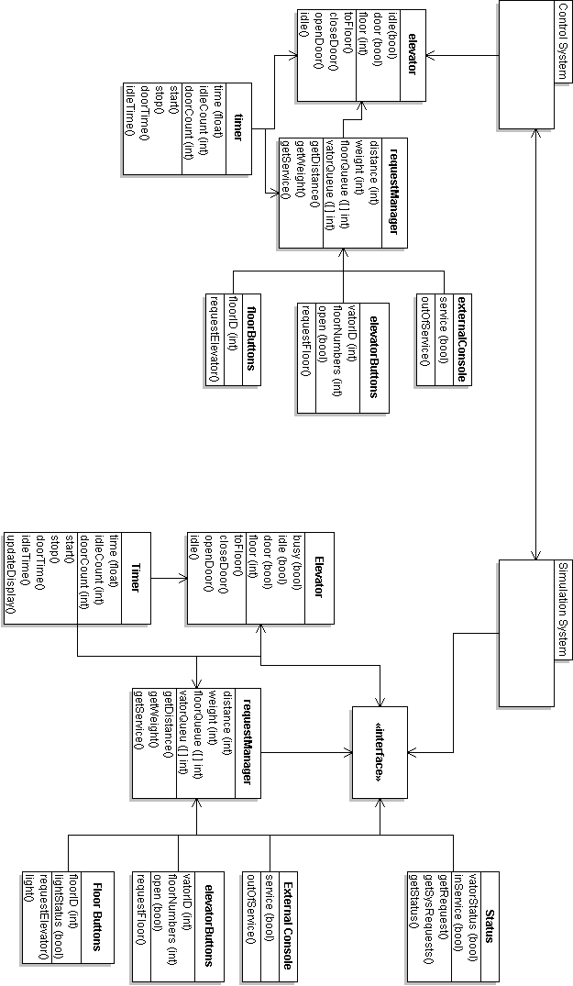
CRC

RequestManager
Responsibilities | Collaborators
- Adds requests to queue.  - Sends requests to elevator | ElevatorButtons  FloorButtons

ExternalConsole
Responsibilities | Collaborators
- Displays elevators state  - Displays whether elevator is in maintenance | Elevator

Timer
Responsibilities | Collaborators
- Determines how long elevator doors will remain open  - Determines how long an elevator will be down for maintenance | Elevator

Elevator
Responsibilities | Collaborators
- Accepts floor requests  - Moves to requested floor  - Accepts maintenance request | RequestManager  ExternalConsole  Timer

ElevatorButtons
Responsibilities | Collaborators
- Opens or closes elevator doors  - Sends a floor request to be served by the elevator | RequestManager

Floor Buttons
Responsibilities | Collaborators
- Sends request for an elevator to arrive at current floor | RequestManager

Traceability Table

Design Class

D = Depends On
R = Relationship

 | Elevator | Request Manager | External Console | Elevator Buttons | Floor Buttons | Interface | Status | Timer
Elevator |  | R | R |  |  |  | R | D
Request Manager |  |  |  | D | D
External Console |  |  |  | D
Elevator Buttons |  |  | R
Floor Buttons
Interface |  |  |  | D | D |  | D
Status
Timer

Design Class Dictionary

Attributes:

Class:
Attribute | Type | Details

FloorButtons:
floorID | int | Represents the floor number where the buttons are located.

Elevator:
idle | boolean | Represents whether or not the elevator is in motion or stationary.
door | boolean | Value indicating whether or not the elevator doors are closed.
floor | int | Indicates the current floor where the elevator resides.

ElevatorButtons:
floorNumbers | int[] | Destination floor numbers that are sent to the request manager when the user selects a floor.
ElevatorID | int | Unique ID that corresponds to an individual elevator.
open | bool | Value that indicates whether or not the elevator doors should be open.

ExternalConsole:
service | boolean | Indicates whether or not the elevator is currently in service.

RequestManager
distance | int | Represents the distance an elevator has to travel before reaching its destination floor.
weight | int | Value representing an individual elevators current weight.
floorQueue | int[] | Array of values representing floor requests that have not been assigned to an elevator.
elevatorQueue | int[] | Array or values representing what elevators are in service and serving floor requests.

Timer:
time | float | A value that is incremented at set intervals to be compared conditionally against other values.
idleCount | int | A constant value that determines how long it takes an elevator to idle.
doorCount | int | A constant value that determines how long doors are to remain open before they close.

Methods:

Class:
Method | Details

FloorButtons:
requestElevator() | Sends a request to the request manager to send an elevator to the floor.

Elevator:
toFloor() | Moves elevator to the requested floor.
closeDoor() | Closes the elevators door.
openDoor() | Opens the elevator doors.
idle() | Puts the elevator into an idle state.

ElevatorButtons
requestFloor() | Sends a floor request to the RequestManager.

ExternalConsole
outOfService() | Displays a message communicating that the elevator is out of service.

RequestManager
getDistance() | Gets an individual elevators distance to the destination floor.
getWeight() | Gets an individual elevators weight.
getService() | Gets the service state of an individual elevator.

Timer
start() | Starts the timer.
stop() | Stops the timer.
doorTime() | Sends a message to the elevator to close the doors once the time interval has been achieved.
idleTime() | Sends a message to the elevator to idle once the time interval has been achieved.

Sequence Diagram

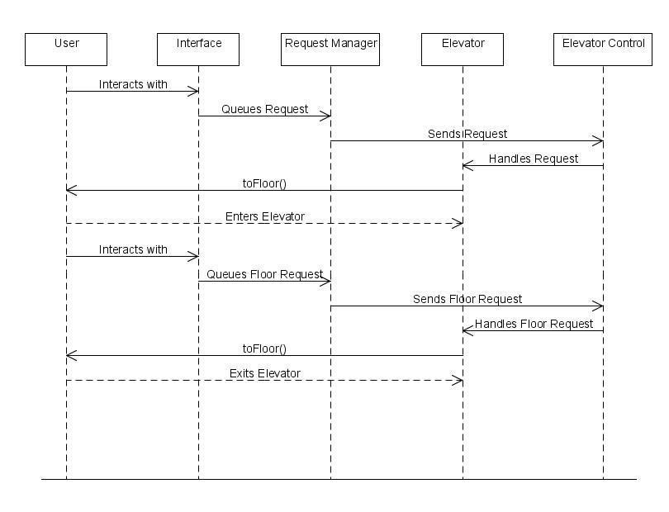

Conclusion

After finally getting our group together, a little late, we divided up the sections of Assignment 3 and got to work. Mike's responsibility was the traceability tables for the analysis classes and the design classes. Pete was in charge of doing the sequence diagram with main methods and getting together the conclusion. Chris made the table with the class names and responsibilities, as well as the design class dictionary. And William took on the task of creating the finalized system model, table of contents and Design Class Diagram from the two of our previous assignments.
When making the finalized system model, we exchanged our reports from Assignment 2. We compared diagrams and after some discussion decided that one person would combine the reports into a cohesive system model. We ended up using Chris and William's as a base, adding what they had misunderstood or forgot about from Pete and Mike's report. Most of this involved level of detail – we did not originally understand the scope of the elevator system. Then, using the knowledge we have gained since Assignment 2, we corrected errors in the Class Diagrams and Use Case Diagrams.
The Design Class Diagrams are more detailed than the original Class Diagrams from the previous assignment. These required considerable thought. Trying to determine which classes contain vital information, and how they will pass that information on in a secure fashion is no easy task. Once we developed attributes and methods for the classes, our overall design was begin to take shape.
The Sequence Diagram was relatively easy to go from our old two diagrams to our new one. After the Design Class Diagram was completed, I just took the main methods and expanded on our previous diagrams. I also revised our paths as both our previous sequence diagrams weren't very sequential (lack of knowledge in the area). Our new Sequence diagram is very sequential and a true combination of both of groups ideas.
The traceability table was not part of the previous assignment that we could find so Mike ended up doing some research and creating the table from scratch. After researching what the traceability table is and finding out a general idea of what needed to be done we created a rough draft of what we thought it was, circulated it amongst our group members, whom all seemed satisfied with the end result.
Overall I think our biggest challenge was getting started working as a group. We all had trouble just getting into the project until we started communicating often through emails, and eventually setting up Google Talk. Once we got our channels of communication going though everyone seemed to step up and get done what needed to be done without question. William and Chris put a lot of effort into making sure we had an easy way to communicate(Chris ended up setting up a Google Code project for our group). We all did a good job on our parts of the project as far as any of us are concerned, so our member contribution would probably be Chris(30%), William(30%), Mike(20%), Pete(20%). Mainly because Chris and William bent over backwards trying to get everything setup and everyone working together.

