Elevator System

Software Engineering
Assignment 3

Chris Hanshew
Mike Spritzer
Peter Clough
William Scalise

Table of Contents

Finalized System Model Page 3
Use Case Diagrams Page 3
Class Diagrams Page 4
Sequence Diagram (Original) Page 5
Design Classes Page 6
Design Class Diagram Page 6
Class Table Page 7
Traceability Table Page 8
Design Class Dictionary Page 9
Sequence Diagrams (New) Page 10
Conclusion Page 11

Finalized System Model

Use Case Diagrams

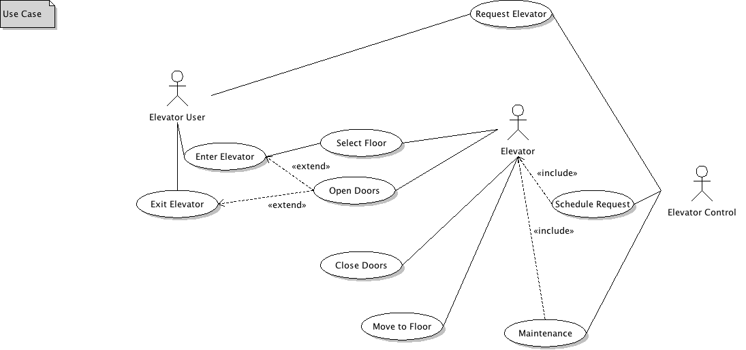

(Second Use Case needed, I think Chris has this?)

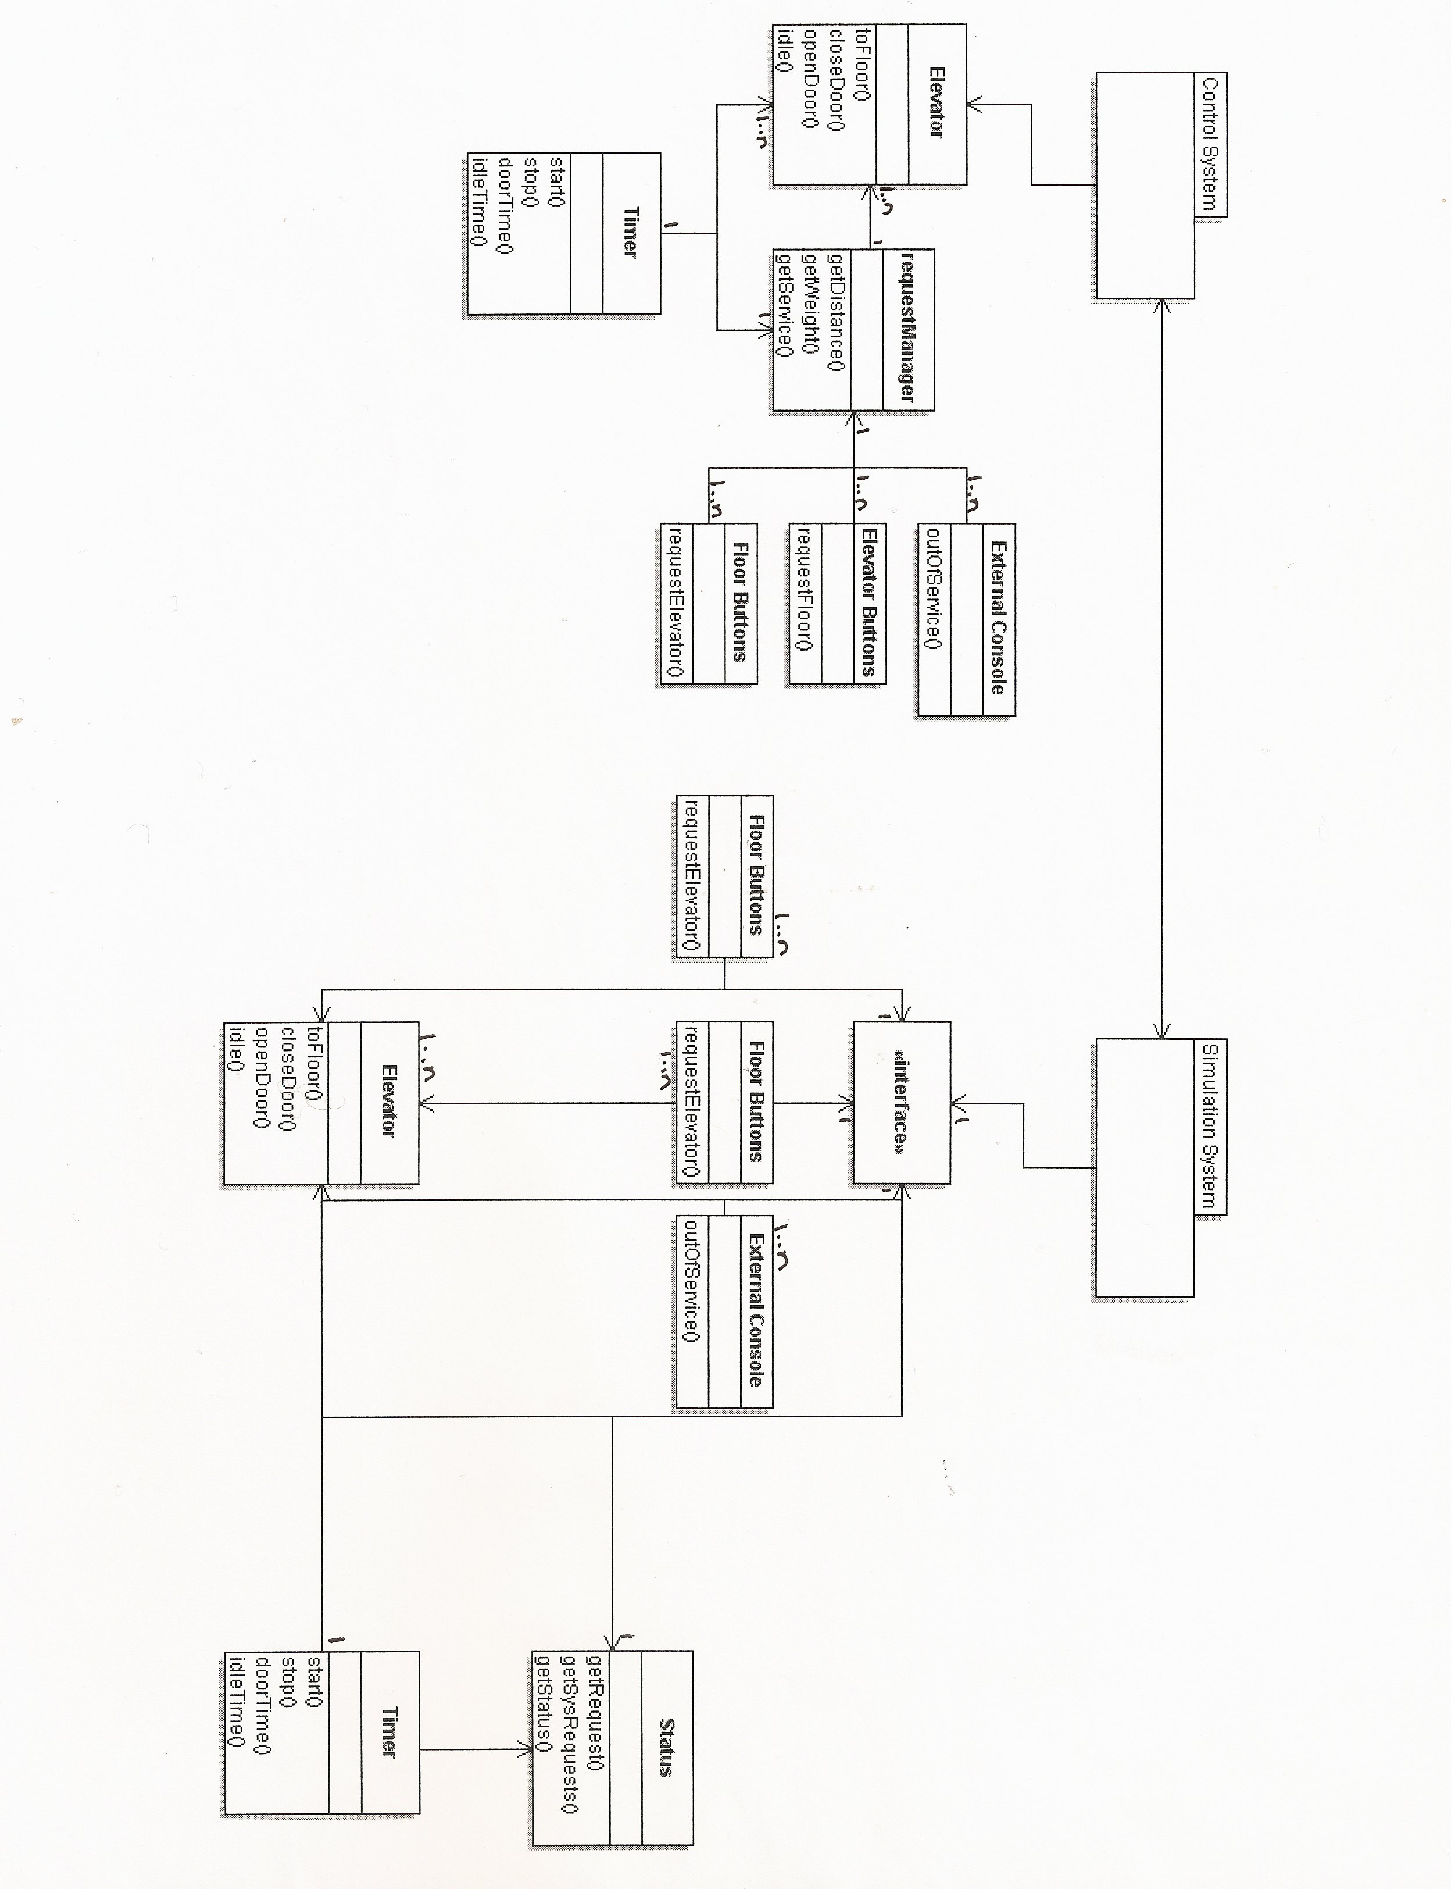
Class Diagrams

Sequence Diagram (Original)
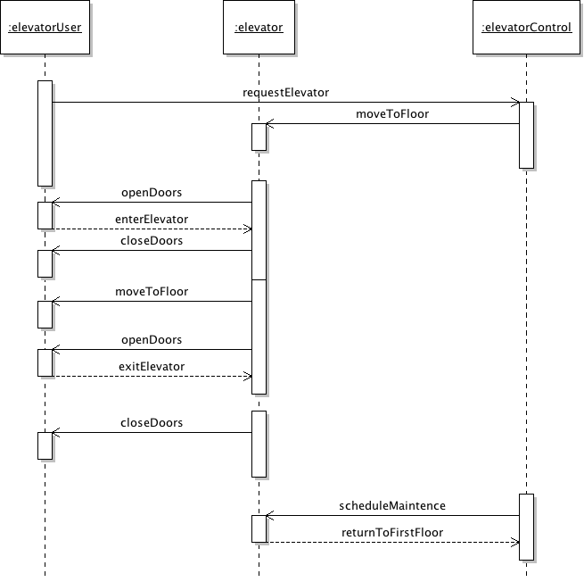

Design Classes
Design Class Diagram

Table listing class names and responsibilities

Traceability Table

Design Class Dictionary

Sequence Diagrams (w/ main methods)

Conclusion

