
14A Bridge
Quick Installation and Commissioning Guide
Complete these seven steps in order to send the RSE 100% / 60% / 30% / 0% commands safely to up to six inverters.
Applicable versions
M5Stack StampPLC | SmartPLC firmware V1.0.2 | Windows USB Configurator V1.0.2

Before you start
- M5Stack StampPLC and a 12 V DC power supply.
- An RSE with four potential-free relay contacts.
- RS485 twisted-pair cable and a USB Type-C data cable.
- The Modbus ID, maximum PV power, and RS485 terminal definition for each inverter.
- A Windows PC with 14A Bridge USB Configurator installed.
STOP
Never connect a 230 V RSE output directly to StampPLC. Use a correctly rated interface relay or isolation module. StampPLC digital inputs accept only 5-36 V DC.

Completion path
Step | Action | Successful result
1 | Connect 12 V, RSE, and RS485 | StampPLC starts normally
2 | Connect USB and read settings | The GUI shows CONNECTED
3 | Scan IDs 1-6 | Installed inverters show FOUND
4 | Configure IDs and maximum power | Status shows OK / PENDING / LIMITED
5 | Test all four RSE inputs | The display shows 100 / 60 / 30 / 0% in sequence
6 | Enable LIVE control | Mode shows LIVE and reads the physical RSE
7 | Optional Wi-Fi / OTA | Wi-Fi Connected; AUTO OTA ON

Step 1 | Wiring
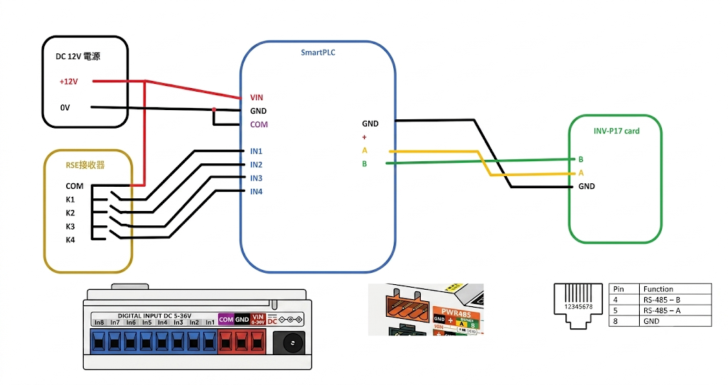
Figure 1. Complete 12 V, RSE, StampPLC, and inverter wiring

1A. 12 V and RSE
Source | StampPLC terminal | Purpose
+12 V | VIN | StampPLC power input
12 V 0 V | GND | StampPLC power return
12 V 0 V | COM | Digital-input common reference
+12 V | RSE relay common | Supplies +12 V through the selected contact
RSE K1 | IN1 | 100%
RSE K2 | IN2 | 60%
RSE K3 | IN3 | 30%
RSE K4 | IN4 | 0%

1B. RS485
StampPLC PWR485 | Inverter terminal
A | A / D+ (follow the inverter manual)
B | B / D- (follow the inverter manual)
GND | Connect Signal GND only when required by the inverter manual
VIN | Do not connect to the inverter

SUCCESS
After power-up, the StampPLC screen lights and shows V1.0.2. If the inverter does not respond, switch off power and check A/B, ID, and baud rate.

Step 2 | Connect USB and read settings
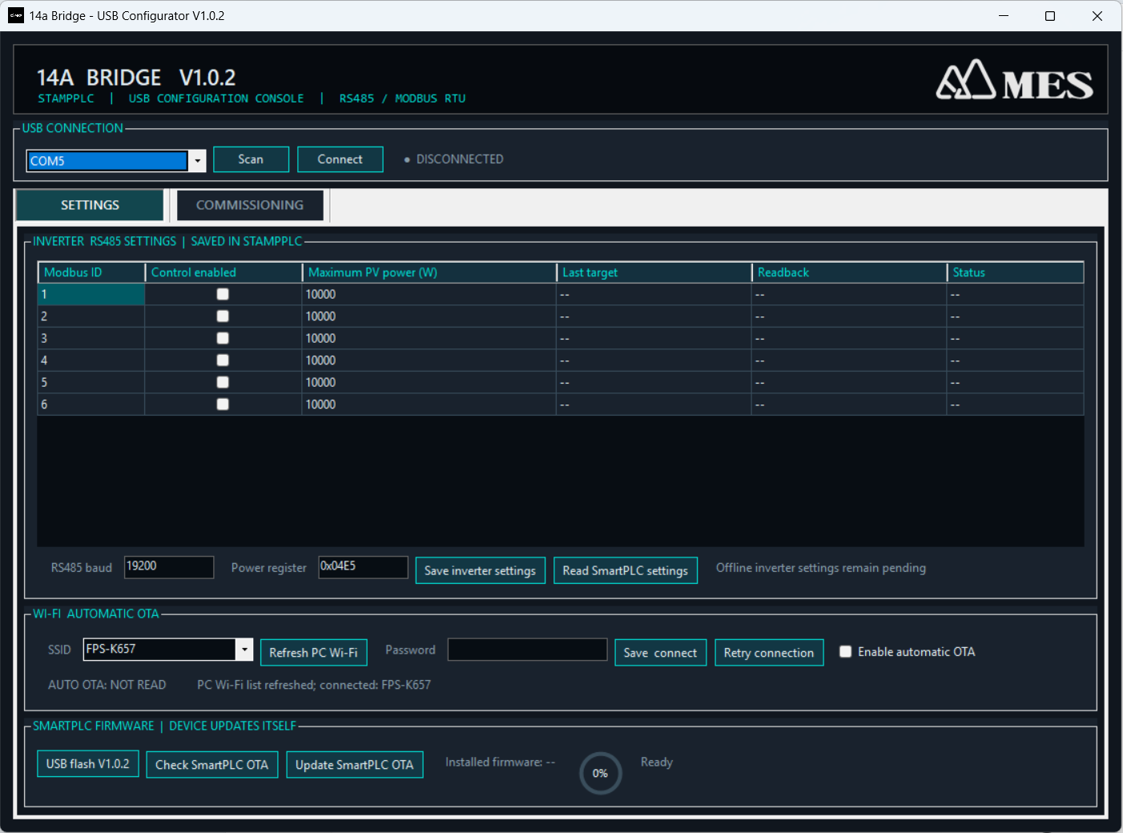
Figure 2. GUI Settings tab
- Connect USB Type-C
Use a data-capable USB cable between the PC and StampPLC.
Success: Windows detects a new COM port.
- Click Scan
In USB CONNECTION, click Scan and select the new COM port on the left.
- Click Connect
Do not change settings immediately after connecting.
Success: The right side shows CONNECTED COMx.
- Click Read SmartPLC settings
Read the current firmware, inverter, RS485, Wi-Fi, and AUTO OTA settings.
Success: Installed firmware shows V1.0.2 and the table shows the saved values.
New StampPLC
If the project firmware is not installed, select the COM port and click USB flash V1.0.2. Wait for the circular progress indicator to finish. Do not unplug USB or remove power.

STOP
Do not configure the device while it shows DISCONNECTED or no COM port is available. Change the USB data cable or USB port, then click Scan again.

Step 3 | Scan inverters
- Confirm that the inverters are powered
Testing one inverter first makes troubleshooting easier. Every device must use a unique Modbus ID.
- Open COMMISSIONING
Switch to the Commissioning tab.
- Click Scan all IDs
The controller scans IDs 1-6 with read-only FC03 requests. It does not write to an inverter.
Success: Connected IDs show FOUND and the current 0x04E5 readback value.
NOTE
Scan all IDs shows the current power-limit register value. It may not equal the inverter nameplate maximum power. Enter the rated maximum in the next step and verify it.

Step 4 | Configure inverters
- Return to SETTINGS
Select Control enabled only for installed IDs. Leave unused IDs disabled.
- Enter the maximum PV power
Enter 10000 for a 10 kW inverter or 15000 for a 15 kW inverter.
- Keep the default communication settings
Normally use RS485 baud 19200 and power register 0x04E5. Change them only when the inverter documentation specifies different values.
- Click Save inverter settings
The controller saves the configuration. An online inverter briefly validates the candidate maximum and then restores its previous value.
Success: Status shows OK; an offline device may show PENDING; if the inverter accepts a lower limit, status shows LIMITED and the GUI automatically corrects the setting.
STOP
If 20000 W is entered but a 15 kW inverter accepts only 15000 W, use the GUI-corrected 15000 W value. Do not enter 20000 W again.

Step 5 | Test the RSE and power calculation
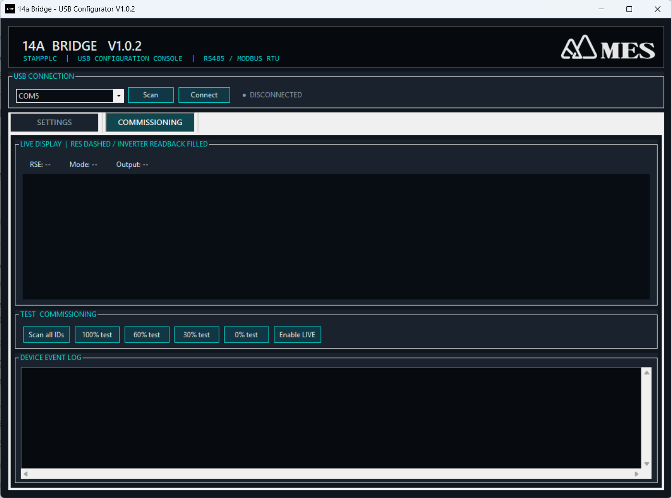
Figure 3. GUI Commissioning tab
Confirm Mode first
A new device starts in DRY-RUN. Test buttons do not write to inverters in DRY-RUN. If the GUI already shows LIVE, confirmed tests will write. To return to DRY-RUN, enter dryrun on in a USB serial terminal.

- Test the physical RSE contacts
Close K1, K2, K3, and K4 in sequence. Only one contact may be closed at a time.
Success: The GUI and StampPLC show 100%, 60%, 30%, and 0% in sequence.
- Test the calculated values
In DRY-RUN, click 100% test, 60% test, 30% test, and 0% test in sequence.
Success: A 15 kW inverter shows 15.0 / 9.0 / 4.5 / 0 kW; a 10 kW inverter shows 10.0 / 6.0 / 3.0 / 0 kW.
STOP
INVALID 0x00 means all four contacts are open. Another INVALID state normally means two or more contacts are closed. No new limit is sent while the RSE state is invalid.

Step 6 | Enable LIVE control
- Set the RSE to 100%
Before enabling LIVE for the first time, activate K1 / IN1 so the system does not begin in a restricted-output state.
- Click Enable LIVE
Read the warning and click Yes. The GUI clears the temporary test display and reads the physical RSE. It does not reuse the GUI test value.
Success: Mode shows LIVE and RSE shows the physical percentage.
- Test all four RSE states
Under supervision, switch 100% -> 60% -> 30% -> 0% -> 100% and wait for every inverter readback.
Success: The white dashed line is the RSE target. The liquid level and center kW value are the inverter readback. The system must finish at 100%.
No repeated writes
When the RSE state is unchanged, the controller does not repeatedly write to the inverter. Background health checks are FC03 reads only. Writes occur only after an RSE transition, a confirmed LIVE test, or configuration validation. A failed write is retried no more than three times.

Reading the screen and GUI
Display | Meaning | Action
Dashed line | RSE target percentage | Confirm that it matches the physical contact
Liquid level | Inverter FC03 readback percentage | It should move toward the dashed line
Center kW | Current inverter limit | Compare it with the calculated value
Amber border / RETRY | Temporary read failure | Wait for the next poll; a successful read clears it automatically
Full red ERROR tile | Three consecutive read failures or write verification failure | Check A/B, ID, baud, inverter power, and the bus
INVALID | Illegal RSE contact state | Check COM, +12 V, and contact interlocking

Step 7 | Wi-Fi and OTA (optional)
- Select an SSID
In the SETTINGS Wi-Fi section, click Refresh PC Wi-Fi, select a 2.4 GHz Wi-Fi network, and enter its password.
- Click Save connect
Wait for the Wi-Fi status to update.
Success: The GUI shows Connected, IP, and RSSI.
- Enable automatic OTA when required
Select Enable automatic OTA.
Success: The status explicitly shows AUTO OTA: ON.
- Manual update check
Click Check SmartPLC OTA. Click Update SmartPLC OTA only after a newer version is found. Keep power connected throughout the update.
Automatic check timing
The first check occurs about 60 seconds after boot, about 5 seconds after AUTO OTA is enabled, and then every 24 hours. Installation starts only when Wi-Fi is connected, the RSE state is valid, and Modbus is idle.

Troubleshooting
Symptom | Check in this order
COM port not found | Change the USB data cable -> change USB port -> restart the GUI -> click Scan again.
All IDs show NO_RESPONSE | Confirm inverter power -> baud 19200 -> correct IDs -> switch off power and verify A/B.
One inverter occasionally shows RETRY | Wait for the next poll -> check cable, shield, and termination -> confirm that no second Modbus master is connected.
Full red ERROR tile | Check the event log -> A/B -> ID -> baud -> 0x04E5 -> inverter power.
RSE INVALID 0x00 | Confirm the RSE common is connected to +12 V, COM is connected to 0 V, and at least one contact is closed.
Multi-contact RSE INVALID | Ensure that only one of K1-K4 can be closed at any time.
Maximum power was reduced | The inverter rejected the higher value. Use the actual limit automatically verified by the GUI.
AUTO OTA remains OFF | Connect -> Read SmartPLC settings -> enable OTA again -> wait for AUTO OTA: ON.
USB flash failed | Select the COM port again. If required, hold BOOT until the red LED lights, release it, and retry.

Final commissioning checklist
- Only physically installed Modbus IDs are enabled.
- Each maximum power value matches the inverter rating.
- The four RSE inputs map to 100 / 60 / 30 / 0%.
- Every enabled ID completes an FC16 write and FC03 readback in LIVE mode.
- The system recovers normally from 0% or 30% to 100%.
- After RS485 is disconnected and restored, the fault is detected and clears automatically.
- AUTO OTA shows ON when used, or remains OFF when not used.
SUCCESS
The system is ready for handover when every check above passes. Record each ID, maximum power, baud rate, register, and firmware version, and keep the record with the device.

Official interface information: https://docs.m5stack.com/en/core/StamPLC

