ISSUING TOOLS — SOP
Quality, compliance and scanner process — applies to every Coates shutdown toolstore and issuing point. Mandatory for every issue.
The Double Scan — Our Standard
Two scans. Two looks. One standard.
The scan isn't complete until you've looked.
Right first time. Every item. Every time.
A Coates Way discipline — Stop. Check. Verify. The same standard we apply to every safety-critical process.
Nothing leaves the store that you wouldn't use yourself.
Every item is checked for quality and compliance before it is scanned out. If it's out of date, due for inspection within a week, damaged, dirty, or not scanned, it does not go out. Gas monitors must be bumped and charged, batteries fully charged. No exceptions.

1. Store Access & Security
The front door is always closed.
No one enters the store unattended. No one apart from the stores team handles equipment — not to grab it, take it, or return it — in any form, unless directly supervised by a stores team member.
- The main front door stays closed at all times.
- No one is to enter the store unattended.
- No hirer, contractor, or visitor walks into the store to get gear, take gear, or return gear themselves — under any circumstance, unless directly supervised by a stores team member.
- All equipment is issued by the stores team. No one grabs equipment themselves — issuing gear is a staff action, not a self-serve one.
- This applies to returns as well as issues — gear is handed to a stores team member, not placed back by the hirer unsupervised.

2. Quality & Compliance Check — Before You Scan
This check happens before the item is scanned out, every single time. Do not scan first and check later.
- Check test & tag status — the tag must be current, not expired.
- Check compliance/inspection due date — must be in date.
- Do not issue if the item is out of date, or due for inspection within the next week. Treat “due soon” the same as “out of date.”
- Check the item for damage — look it over properly, don't just glance at it.
- Check for cleanliness. If it's dirty, clean it before it goes out — never issue it dirty.
- If it's damaged, it does not go out. Pull it aside for repair, tagging out, or write-off as appropriate.
- Gas monitors must be bump tested and fully charged before they are issued.
- Any item with a battery must be fully charged before it is issued — never send out on a partial charge.
- Do not scan the box. Scan the barcode on the actual item inside it. A box barcode does not confirm what's actually in your hand.
Common sense rule
If you wouldn't use it yourself, don't expect someone else to. This applies above and beyond the checklist — use judgement.
Nothing is issued unless it is scanned.
Every single item leaving the store must go through the scanner — no exceptions, no “I'll add it later.” If it isn't scanned, it isn't tracked, and if it isn't tracked it doesn't leave. This applies to gas monitors, radios, and every other item without exception.

3. Scanner Process — Step by Step
The Double Scan — Scan, look. Scan, look.
Every item is scanned twice, and you look at the scanner both times. Scan, then stop and look. Scan again, then stop and look again. The scan isn't complete until you've looked.
It adds seconds per item and does not delay any works being done. It is how we ensure the description on screen matches the item in your hand and the count is correct before the gear leaves the store.
This is a Coates Way discipline. If we don't scan it properly, it goes out wrong. If it goes out wrong, we can't track it. If we can't track it, we've broken the standard — the same as skipping a pre-start, isolating without a lock, or entering a permit space without a tag. Same discipline, same accountability.
This is our standard on every shutdown, in every store, at every scanner. No exceptions.

Step 1 — Starting screen
Always clear the screen before you scan any hirer — new or existing. Fresh screen, fresh transaction, every time. No transaction is ever started on top of another. The screen must show an empty search bar and “No Hirer or Item to Display” before you scan a hirer barcode. If anything else is on screen, cancel it out and reset before you go any further.
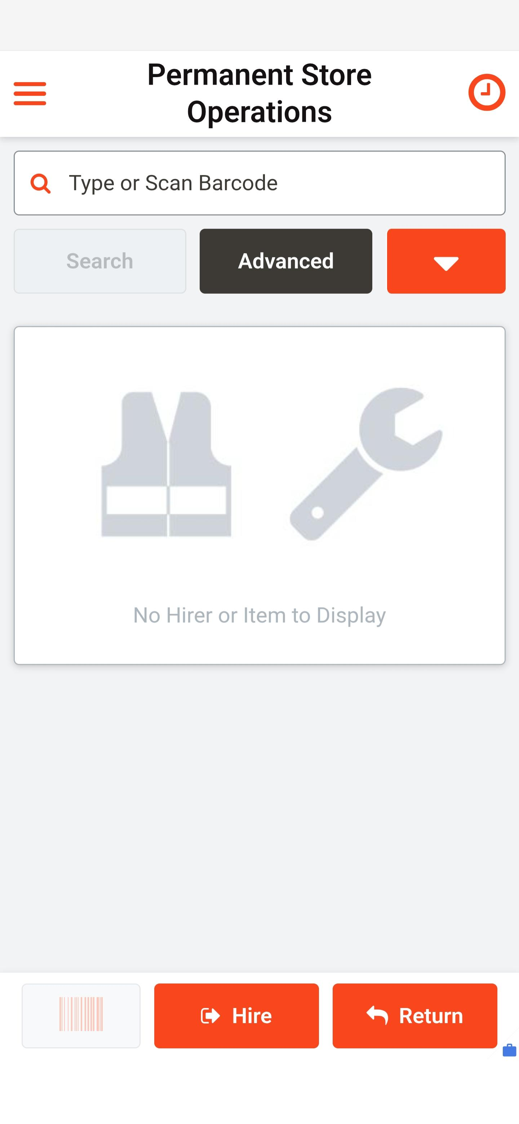
Starting screen — nothing scanned yet

Step 2 — Scan the hirer's barcode
- Scan the hirer's barcode.
- Wait for all details to load on screen — name, status, hirer ID, and company.
- Check the details carefully. Confirm it's the correct person and the correct company. If you're unsure, ask before proceeding.
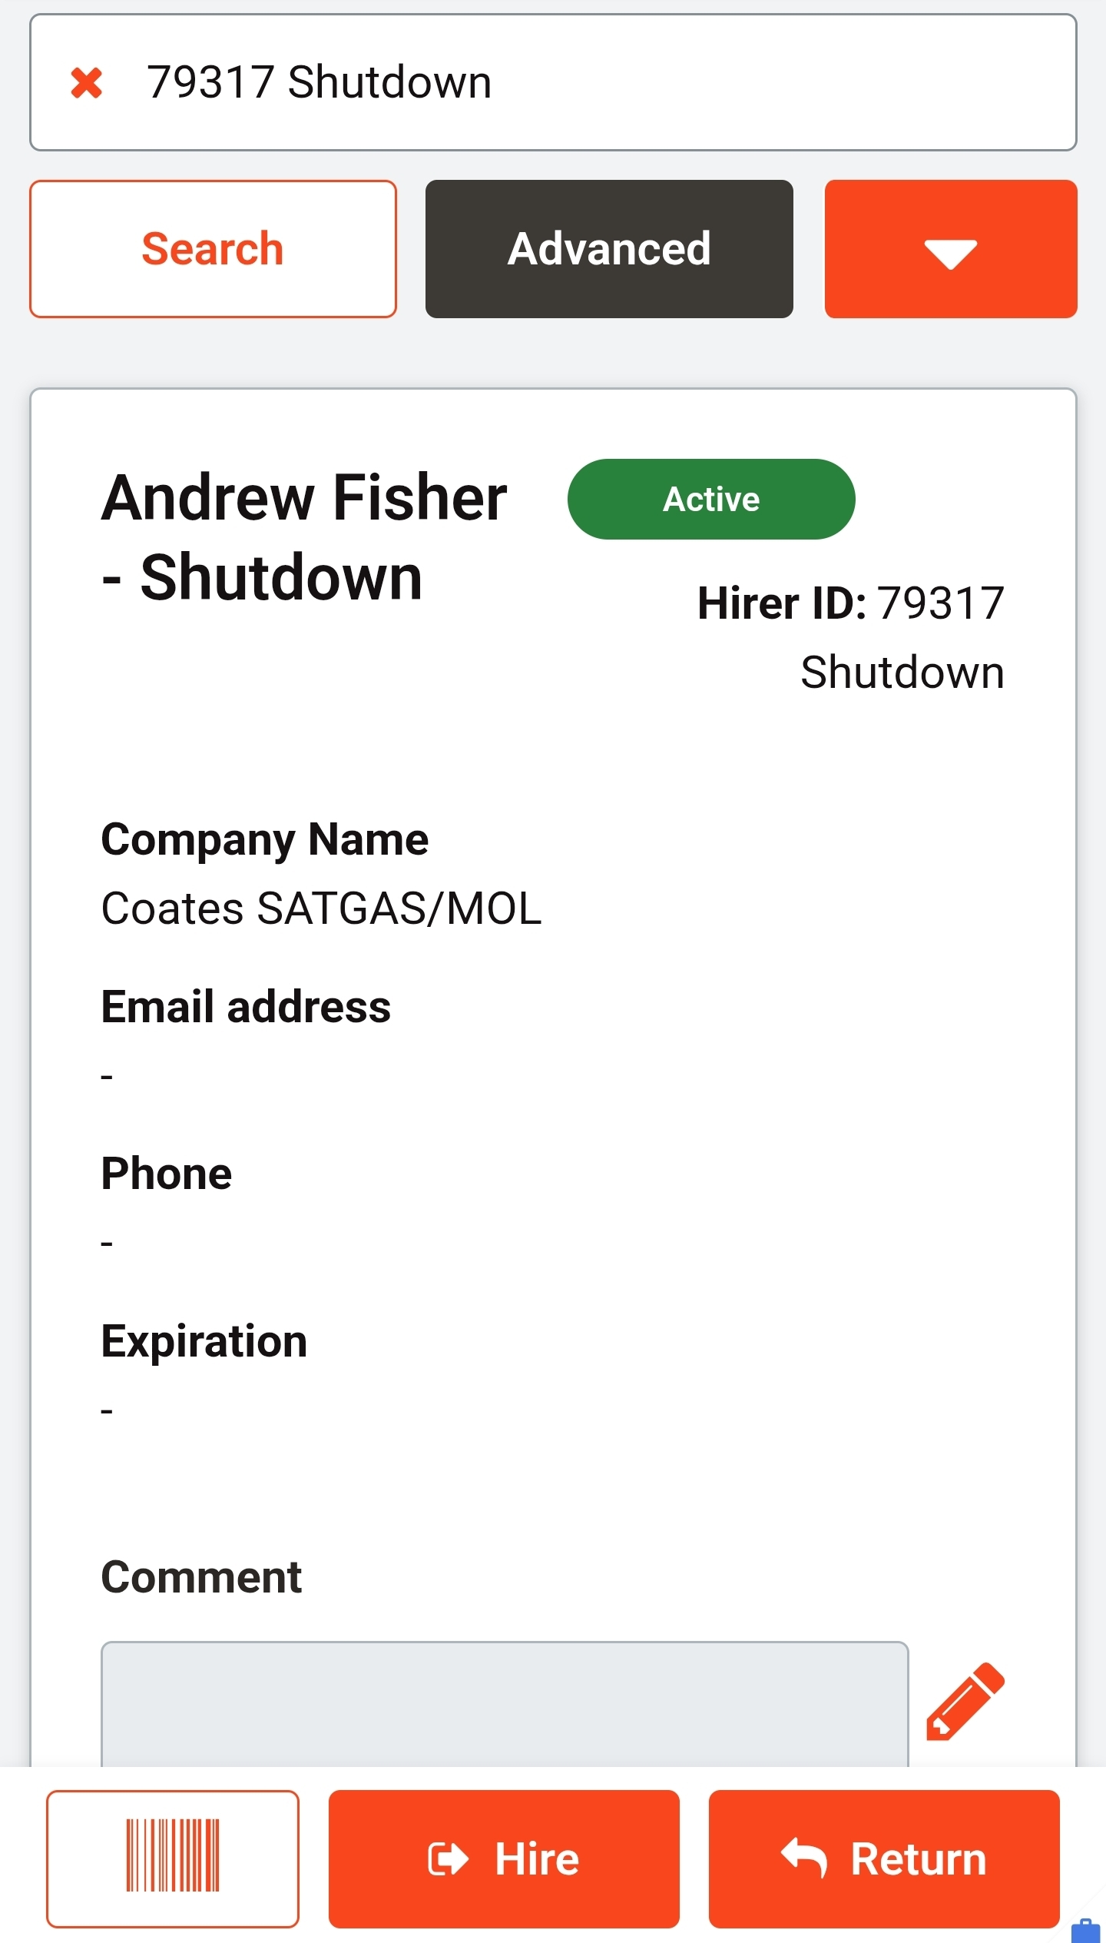
Hirer confirmed — check name, status, and company match

Step 3 — Press Hire
- Once the hirer is confirmed correct, press “Hire.”
This opens the item entry screen. Note the “Finish” button shows a running count in brackets — it starts at Finish (0) because nothing has been scanned yet.
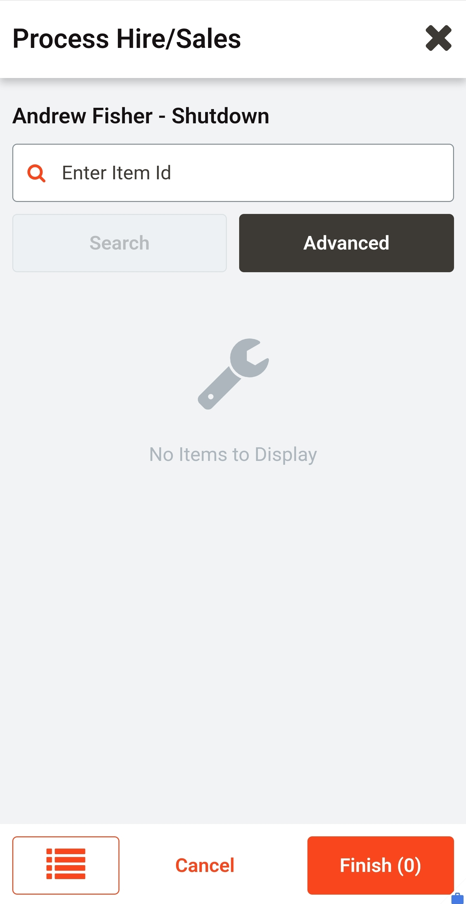
Process Hire/Sales screen — no items scanned, Finish (0)

Step 4 — Scan the first item (double scan: scan, look. Scan, look.)
- Scan the first item's barcode — not the box or packaging it came in.
- Stop. Look at the scanner. Read the description on screen and confirm it matches the item in your hand. Check the Finish button — it should now read Finish (1).
- Scan the same barcode a second time. The scan isn't complete until you've looked at it twice.
- Stop. Look at the scanner again. Confirm the description is still correct and the count is still right. If anything doesn't match, stop and sort it out before you go any further.
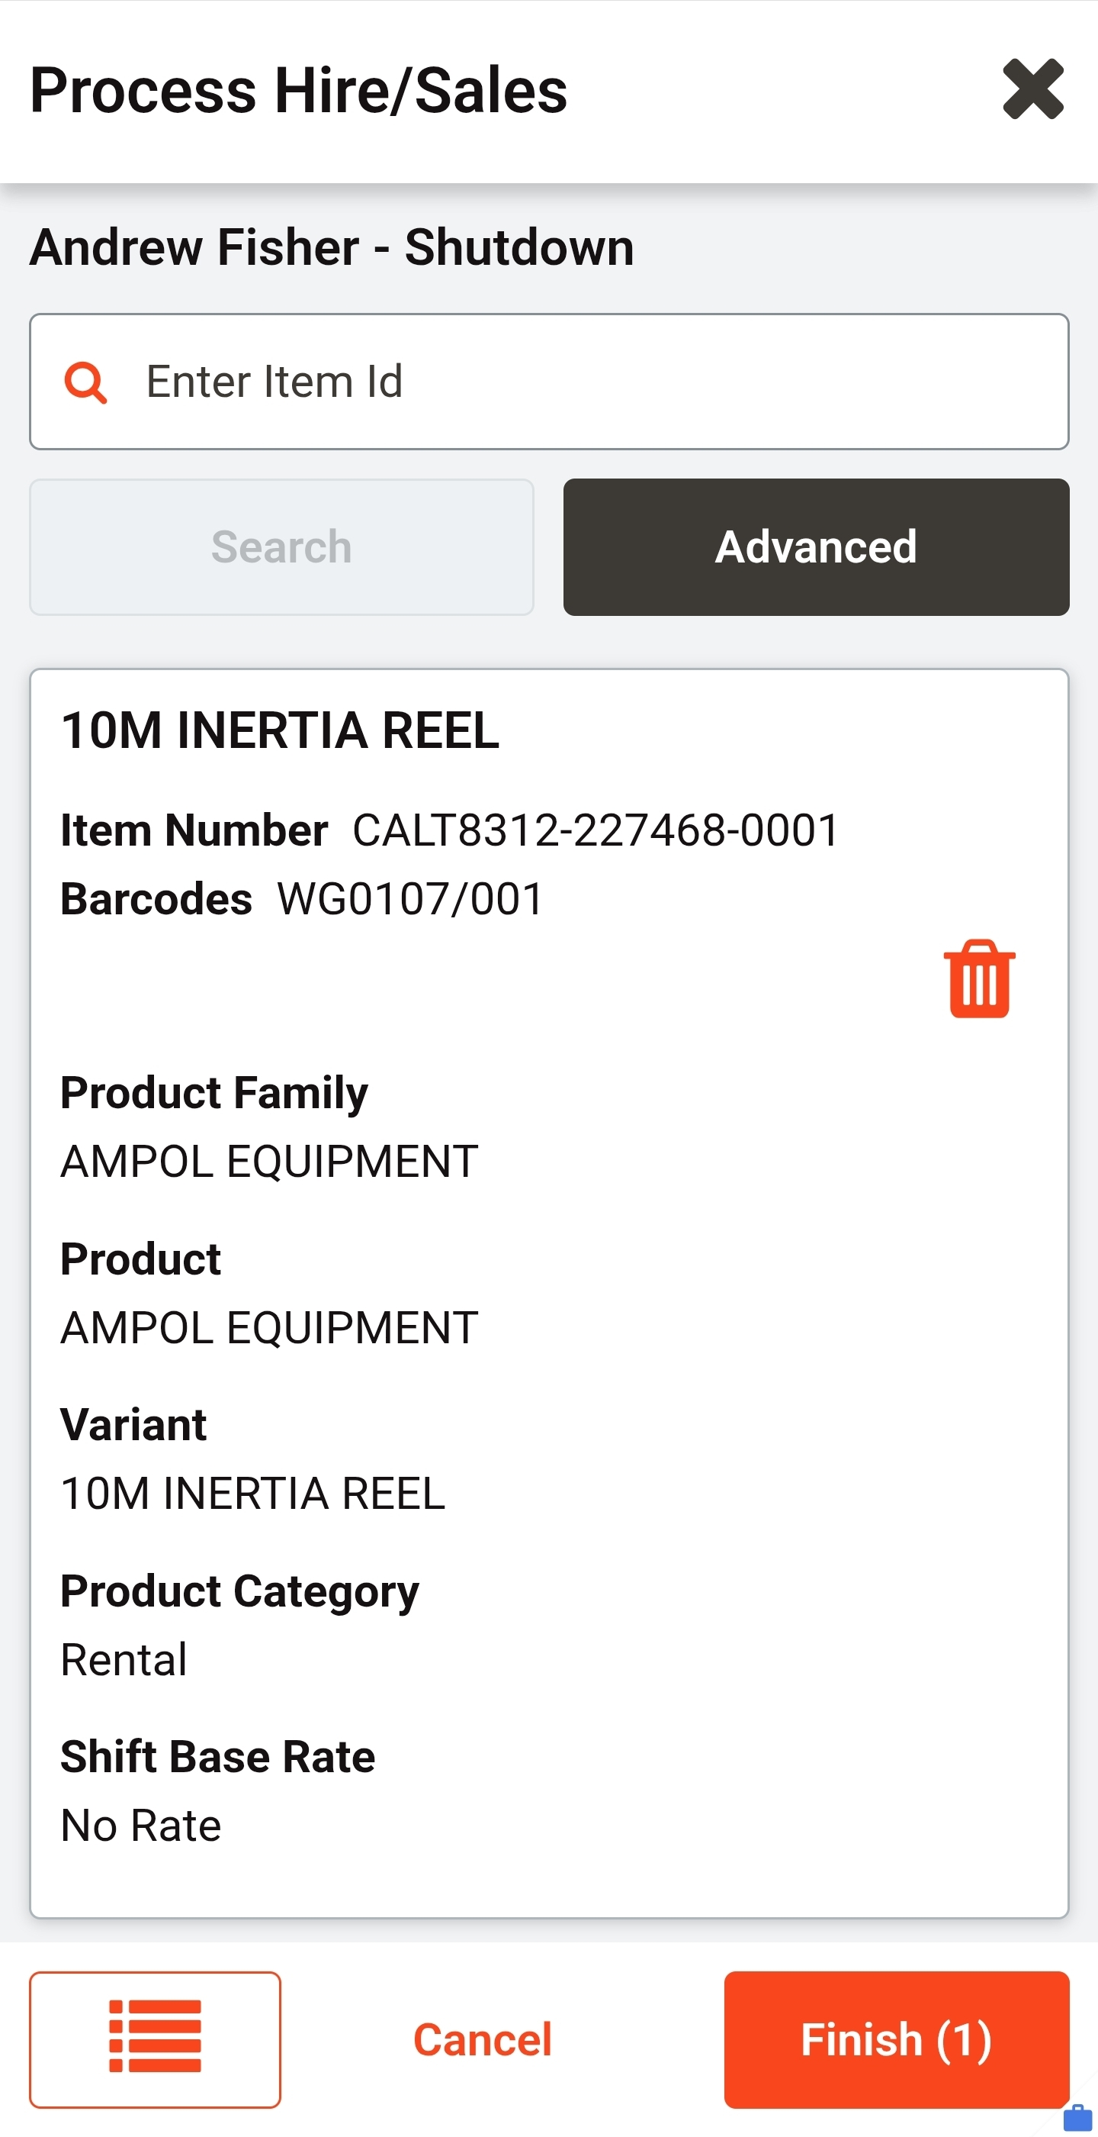
First item scanned — details shown, Finish (1)

Step 5 — Scan remaining items (double scan every item)
- Move to the next item. Scan it.
- Stop. Look at the scanner. Confirm the description matches the item in your hand and the Finish count has ticked up by one.
- Scan the same barcode a second time.
- Stop. Look at the scanner again. Confirm the description is still correct and the count is still right.
- Repeat for every item. Scan, look. Scan, look. Same rhythm, same discipline, no shortcuts.
- Never scan two different items back to back without a full double scan on each one.

Step 6 — Final count check
- Once everything is scanned, count your physical items against the number shown on Finish.
- They must match. If they don't, stop and re-scan until every item is accounted for.

Step 7 — Press Finish
- Once the count is confirmed correct, press “Finish.” This is what puts everything on hire.
- Do not let any tools leave with the hirer until Finish has been pressed.

Accuracy over speed
This process is not a race. Take the time to check each item properly — rushing is how wrong items, missed damage, and count errors happen. A slower correct issue is always better than a fast wrong one.

Golden rule
Clear the screen → check quality and compliance → scan → look at the screen → scan again → look at the screen → confirm item and count are correct → only then move to the next item. Every item, every time. The scan isn't complete until you've looked. Never scan multiple different items in a row without a full double scan on each one. Never scan an item that hasn't passed its quality check.
Why this is a Coates Way discipline
This is not a scanner tip. It is how Coates operates.
If we don't scan it properly, it goes out wrong. If it goes out wrong, we can't track it. If we can't track it, we can't invoice it, we can't recover it, we can't reconcile it at the end of the shutdown, and we can't stand behind our records with the customer. The standard is broken from the first missed look.
This is the same discipline we apply to every other safety-critical process — pre-starts, isolations, permits, inspections, gas monitor bump tests. Stop. Check. Verify. In the store, on the job, every day.
The Coates Way lens applies:
— People: accountability sits with the user, not the software. Do the process properly and the standard holds.
— Operations: right gear, right hirer, right count, right first time — no rework, no missed items, no friction downstream.
— Assets: our fleet stays tracked, our replacement cost exposure stays visible, and our records reflect what is actually on hire.
— Financials: what leaves the store as tracked hire is what we can invoice and recover. Untracked gear is a write-off waiting to happen.
This does not hold up any works being done. Rushing does. Rework, missing gear searches, wrong-item disputes and end-of-shutdown reconciliation cost far more time than a second look at the screen ever will.
There is no need to rush. This is about doing things correctly with everything.

4. System Down — Paper Backup Process
Nothing leaves the store unless it is documented.
If the scanner or system is down, switch to the paper backup process immediately. The same standard applies — no shortcuts because the system isn't working.
- Write down the hirer's barcode number in full.
- Write down the hirer's first and last name in full — no initials, no shorthand.
- Write down the full description of each asset, not just a general name.
- Write down the asset number for each item.
- Record the date, time, and the name of the staff member issuing the gear.
- All quality and compliance checks in Section 2 still apply in full — test and tag, due date, damage, cleanliness, gas monitors bumped and charged, batteries charged.
- As soon as the system is back up, every paper record is entered in and scanned through properly. Paper is a bridge, not a substitute — it does not replace the scan.
- Paper records are not filed away until they've been reconciled into the system. Nothing sits on paper only.

5. Other Checks Worth Doing
- Confirm the hirer is inducted or certified for the equipment where that applies — particularly gas monitors, confined space, and working at heights gear. Being the right person doesn't automatically mean they're cleared for every item.
- Check the item is issued complete — chargers, calibration certificates, cases, and any accessories that belong with it. Incomplete kit going out usually means incomplete kit coming back.
- Note any pre-existing wear or minor damage at the point of issue. This protects both the hirer and the store when the item is returned and assessed.
- If something feels off and isn't covered above, stop and ask rather than guess.
Bottom line
The door stays closed, no one enters unattended, and no one but the stores team touches equipment. The screen is cleared before every hirer. Nothing out of date, due within a week, damaged, dirty, or unscanned leaves this store. Every item is double scanned — scan, look. Scan, look. The scan isn't complete until you've looked. Gas monitors bumped and charged, batteries fully charged, every item tracked through the scanner or fully documented on paper if the system is down. Take your time — accuracy over speed. Nothing goes out the door without Finish being pressed. Two scans. Two looks. One standard. Right first time — every item, every time. This is how Coates operates. The process is never to be broken.

Sign-Off & Acknowledgement
By signing below, I confirm I have read, understood, and agree to follow this SOP in full.
First Name | Last Name | Signature | Date
Author: Andrew Fisher
Issued: 10 July 2026

