RETURNING TOOLS — SOP
Quality, damage, and compliance checks — applies to every Coates shutdown toolstore and returns point. Mandatory for every return.
The Double Scan — Our Standard
Two scans. Two looks. One standard.
The return isn't complete until you've looked.
Nothing goes back on the shelf until it's clean and ready.
A Coates Way discipline — Stop. Check. Verify. The same standard we apply to every safety-critical process.
Returning gear carries just as much importance as issuing it.
Nothing goes back on the shelf unless it is clean, compliant, in date, and undamaged. If it isn't ready for the next hire, it doesn't go on the shelf — it goes to the correct area instead.

1. Store Access & Security
The front door is always closed.
No one enters the store unattended. No one apart from the stores team handles equipment — not to grab it, take it, or return it — in any form, unless directly supervised by a stores team member.
- The main front door stays closed at all times.
- No one is to enter the store unattended.
- No hirer, contractor, or visitor walks into the store to return gear themselves — under any circumstance, unless directly supervised by a stores team member.
- All returns are processed by the stores team. Gear is handed to a staff member, not placed back on the shelf or in the bin by the hirer.
- This is what makes every check in this SOP possible — if gear can be put back unsupervised, none of the quality, compliance, or damage checks below can be guaranteed.

2. Quality & Compliance Check — On Return
Every returned item is checked before it goes anywhere near the shelf.
- Check the equipment for damage.
- Assess the equipment properly — don't just glance at it.
- Check the quality of the item.
- Check compliance and the tag to ensure nothing is out of date or due for calibration.
- Check for cleanliness.
- Check the item is returned complete — chargers, cases, calibration certificates, and any accessories that belong with it. Note anything missing.
- Gas monitors and radios must be checked for charge state on return. If it's come back flat, it goes on charge before it's ready for hire — it does not sit in the bin uncharged.
- Harnesses and slings get extra care on inspection — these are safety-critical and get checked thoroughly, not just glanced at.
Nothing is returned unless it is scanned.
Every single item coming back must go through the scanner — no exceptions, no “I'll add it later.” If it isn't scanned, it isn't tracked, and an untracked item is invisible to the system no matter where it physically sits.

Shelf rule
Nothing goes on the shelf unless it is ready for hire.
Clean. Compliant. In date. Not due for calibration. Not damaged. If an item fails any one of these, it does not go on the shelf — no exceptions.

3. Scanner Process — Returns
The Double Scan — Scan, look. Scan, look.
Every item is scanned twice on return, and you look at the scanner both times. Scan, then stop and look. Scan again, then stop and look again. The return isn't complete until you've looked.
It adds seconds per item and does not delay any works being done. It is how we ensure the description on screen matches the item in your hand and the count is correct before the gear is accepted back.
This is a Coates Way discipline. If we don't scan it properly, it comes back untracked. Untracked gear ends up on the wrong shelf, missing from the register, or booked against the wrong hirer. Same discipline as skipping a pre-start, isolating without a lock, or entering a permit space without a tag. Same discipline, same accountability.
This is our standard on every shutdown, in every store, at every scanner. No exceptions.
Returns don't require scanning a hirer first the way issuing does. The steps below walk through the actual screens.

Step 1 — Starting screen
Always clear the screen before you start a return. Fresh screen, fresh transaction, every time. No return is ever started on top of another. The screen must show an empty search bar and “No Hirer or Item to Display” before you press Return. If anything else is on screen, cancel it out and reset before you go any further.
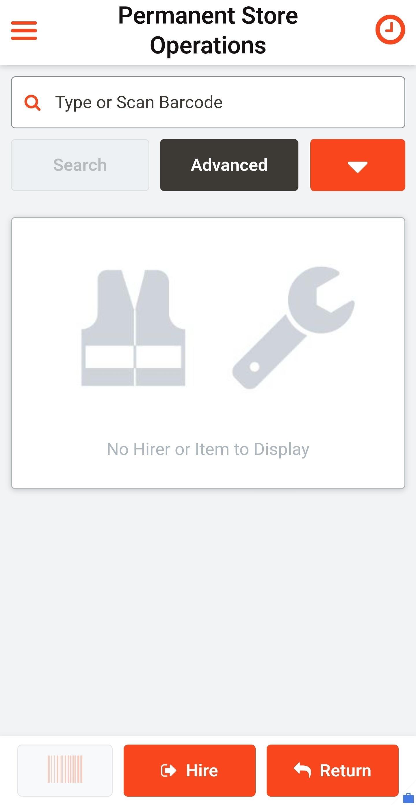
Starting screen — press Return

Step 2 — Return in bulk
- With no hirer selected, the system asks: “No Hirer selected, do you want to return in bulk, on behalf of Hirers?”
- Press “Return in bulk.”
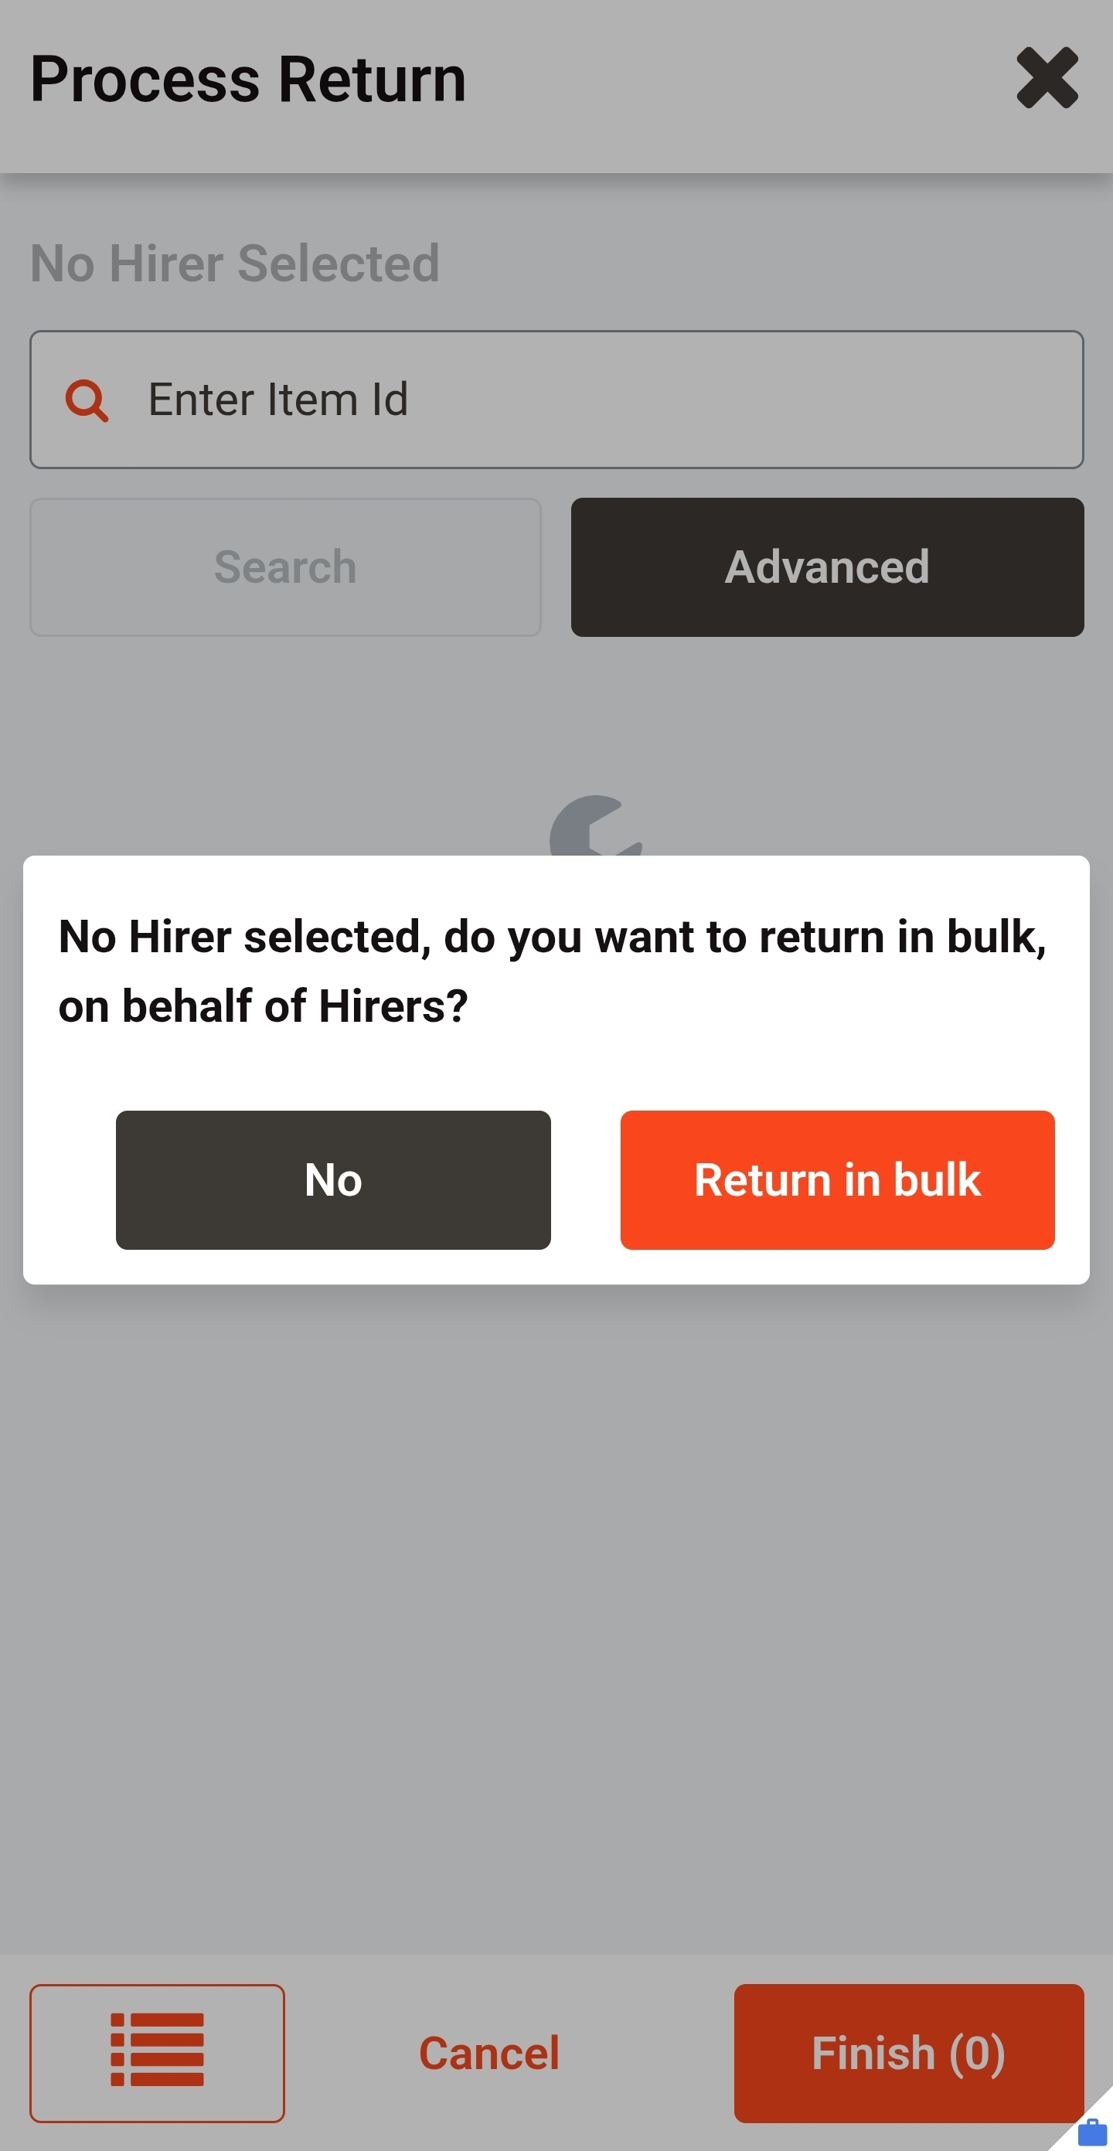
Bulk return prompt — press Return in bulk

Step 3 — Start scanning
This opens the item entry screen with “No Items to Display” and Finish (0). Start scanning items in.
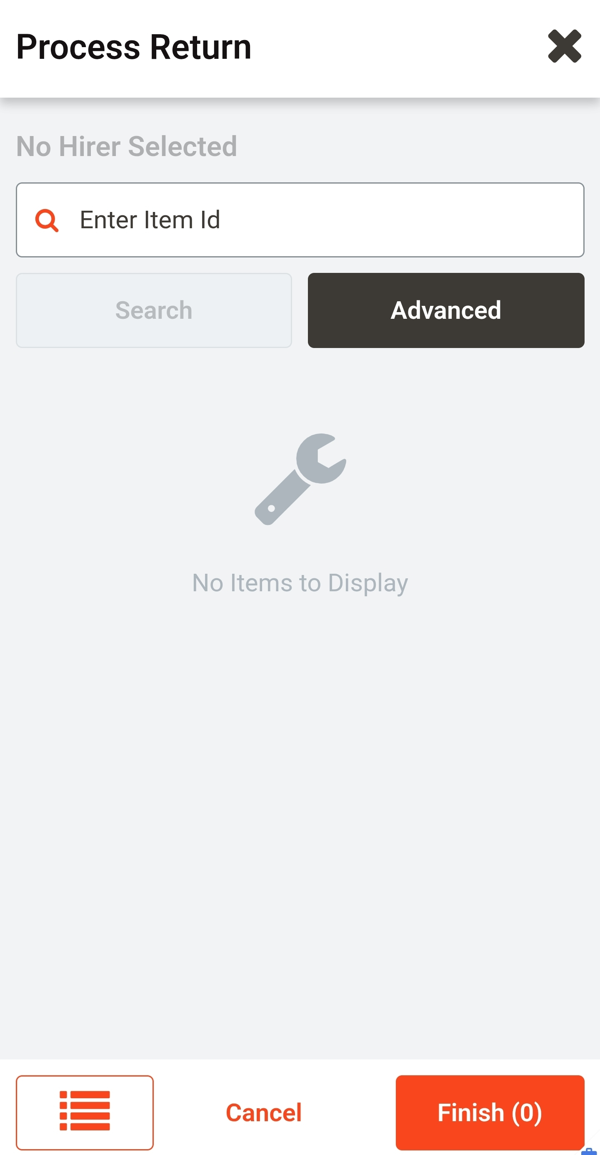
Item entry screen — no items scanned, Finish (0)

Step 4 — Scan the item (double scan: scan, look. Scan, look.)
- Scan the item's barcode — not the box or packaging it came in.
- Stop. Look at the scanner. Read the description on screen and confirm it matches the item in your hand. Check the Transaction Condition field — it defaults to “Normal” and stays on Normal for the return scan. Check the Finish button — it should now read Finish (1).
- Scan the same barcode a second time. The return isn't complete until you've looked at it twice.
- Stop. Look at the scanner again. Confirm the description is still correct and the count is still right. If anything doesn't match, stop and sort it out before you go any further.
- Repeat for every item. Scan, look. Scan, look. Same rhythm, same discipline, no shortcuts.
- Never scan two different items back to back without a full double scan on each one.
- Damage is not recorded on the Transaction Condition field. Damaged items are flagged separately through the Out of Service tag process in Section 7.
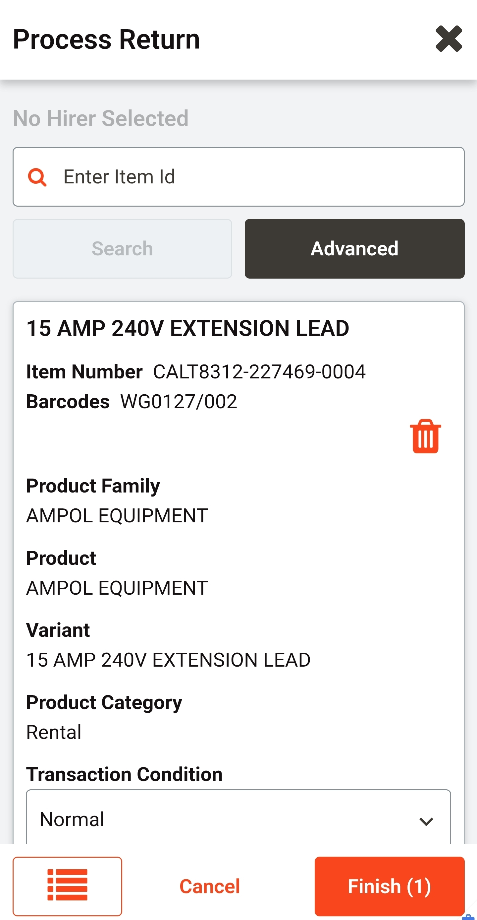
Item scanned — Transaction Condition stays Normal, Finish (1)

Step 5 — Final count and Finish
- Once everything is scanned, count your physical items against the number on Finish. If you scanned 4, it should show 4.
- If the count doesn't match, stop and restart the count. If you're unsure about any item, rescan it — don't guess.
- Once the count is confirmed correct, press “Finish.”

4. System Down — Paper Backup Process
Nothing is returned unless it is documented.
If the scanner or system is down, switch to the paper backup process immediately. The same standard applies — no shortcuts because the system isn't working.
- Write down the hirer's barcode number in full, and their first and last name.
- Write down the full description of each asset being returned, not just a general name.
- Write down the asset number for each item.
- Record the date, time, and the name of the staff member processing the return.
- Note the condition of each item on the paper record if it's anything other than normal — damaged items are flagged separately through the Out of Service tag process, not through the Transaction Condition field.
- All quality and compliance checks in Section 2 still apply in full.
- As soon as the system is back up, every paper record is entered in and scanned through properly. Paper is a bridge, not a substitute.
- Items are not returned to their shelf location — or into the Ampol Aisle Stock Location bin, where applicable — until their paper record has been reconciled into the system.
Site Variation — Ampol Tool Store: bin first, stock-take before shelf
The next two sections (5 and 6) apply at Ampol only. At Ampol, returned gear does not go straight from the receiving check to the shelf. It goes into the Aisle Stock Location bin first, then is stock-taken to its shelf location. This is an Ampol-specific requirement to keep the on-site register aligned with what is physically on hand.
On every other Coates shutdown, once an item has passed its return, quality and compliance checks — and its scan is reconciled into the system — it goes directly to its shelf location. There is no holding bin and no separate stock-take step.
Either way, the standard is the same. The double scan applies. The receiving check applies. The clean-and-ready rule applies. Nothing goes back on the shelf until it's clean and ready for the next hire. The bin, at Ampol, is a staging point — not a bypass.

5. Ampol Variation — Aisle Stock Location Holding Bin
Once an item has passed its return, quality, and compliance checks, it goes into the allocated bin — the Aisle Stock Location — not straight onto the shelf.
Scan it in before it goes in the bin.
The item must be scanned as returned in the system before it is physically placed in the bin. Never place an item in the bin first and scan it later — the system and the shelf must always agree on what's actually there.
Nothing goes into the bin unless it's ready for hire.
Clean. Compliant. In date. The bin is not a place to put items you haven't finished checking — if it's in the bin, it has already passed every check in Section 2.
- Gas monitors and radios can be placed into a smaller bin for this same process.
- The Aisle Stock Location is a holding point, not a shortcut — items still need to complete the stock take step below before they're truly ready on the shelf.

6. Ampol Variation — Stock Take — Confirming Location
This is the second step: taking the item from the Aisle Stock Location bin and stock-taking it to the shelf location it belongs in.

Step 1 — Open Stocktake
- From the main screen, press the orange dropdown arrow next to Actions.
- Select “Stocktake” from the menu.
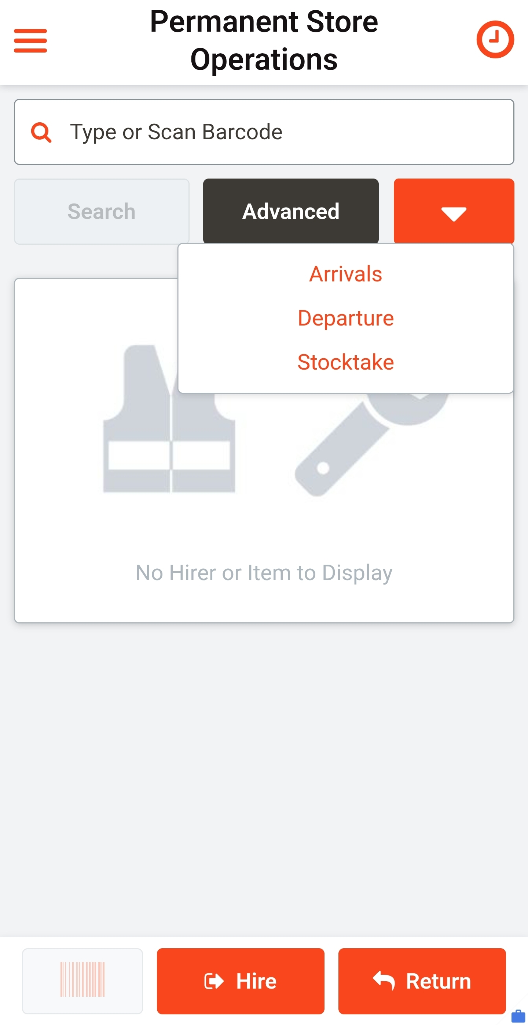
Dropdown menu — Arrivals, Departure, Stocktake

Step 2 — Select the storage unit
- A Storage Unit must be selected before continuing.
- Select the correct location the asset is actually going to — this must match where you are physically placing it.
- Press “Select.”
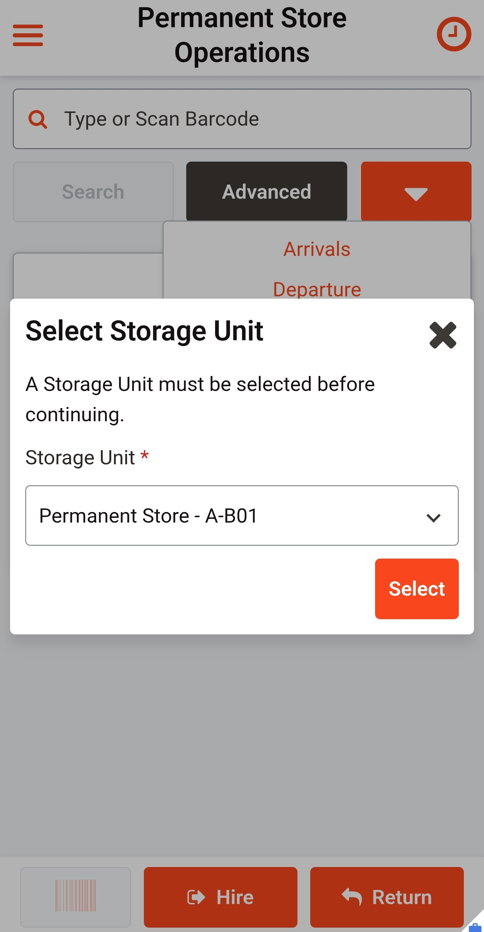
Select Storage Unit — must match the physical location

Step 3 — Scan the asset to the location
- The screen now shows “Process Stocktake of [location]” with an empty item list.
- Scan the asset. It will automatically be stock-taken to the location you selected.
- This also confirms the item is not currently on hire before it's accepted into that location.
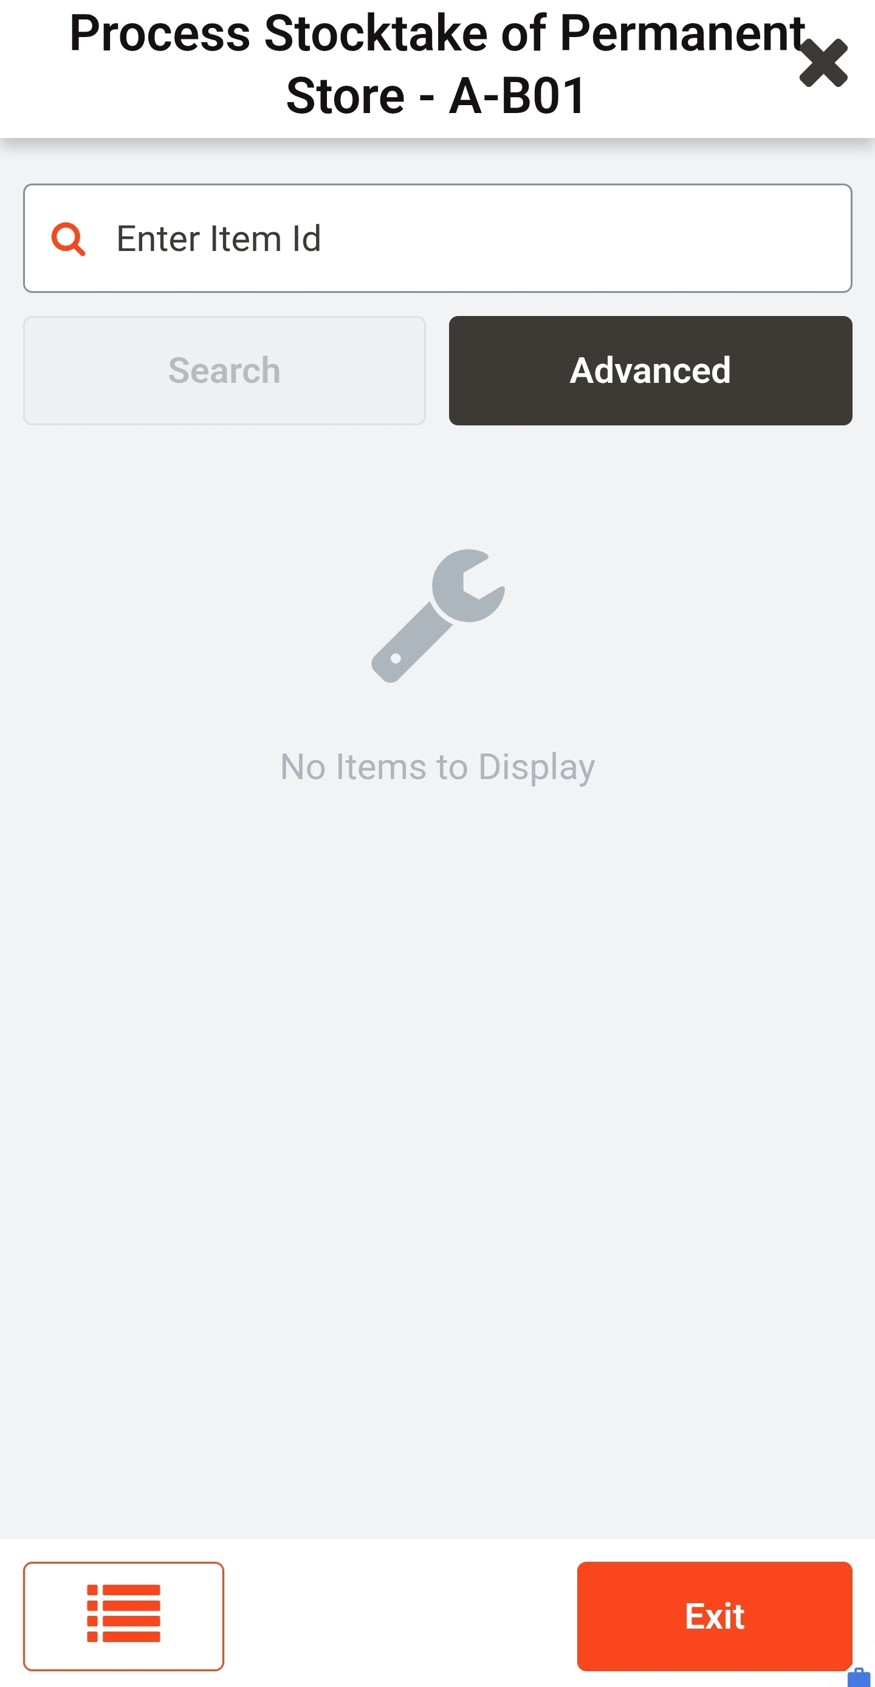
Process Stocktake screen — scan the asset to confirm location
- Stock-taking the asset records that it has been placed at that location.
- It also double-checks the item is not currently on hire before it's allowed back on the shelf.
Reminder
Nothing goes on the shelf unless it's ready for hire — this check is the final gate before that happens.

7. Damaged Items — Out of Service Process
If an item comes back damaged, it is addressed immediately, not left for later.
- Note which hirer returned the damaged item.
- Take a photo of the damage for the record.
- Fill in an Out of Service tag with all details: Company, Hirer, Asset Number, and a clear description of the damage.
- Attach the Out of Service tag to the asset.
- Report the damage to the customer in writing — the same standard as computer work: nothing verbal, always documented.
- Place the item in the designated Damaged area.
- Scan the item in against the hirer it was returned from, so the system record matches its physical status and location.

8. Out of Date / Out of Compliance Items
Treated the same way as damaged items — these do not go back on the shelf under any circumstance.
- If an item is out of date, out of compliance, or due for calibration, it does not go on the shelf.
- Place it in the designated Out of Service area.
- Scan the item in against the hirer it was returned from, so the system record matches its physical status and location.

9. Not On System / Branch Pending — Inspection Departed Process
If a returned item registers as not on the system, or shows as branch pending, this means the asset has previously been departed or removed from the system.
- Do not place the item in the Aisle Stock Location bin or send it to the shelf.
- Put the item into the Inspection Departed bin for assessment.
Exception — gas monitors and radios
These can be reallocated back into the system, but only if checked against the register and the serial number is confirmed and registered. Do not add in double-up barcodes — check the register first before assigning anything new.
- Record the item on the correct register — the Gas Monitor Register or the Radio Register. There is one document for each; use the correct one for the asset type.
- Every time either register is updated, email the updated document to the Shutdown Manager, Andrew Fisher.
- Do not change the format of the original register document when updating it.

10. Scanning — Box vs Item
Scan what's inside the box, not the box itself.
A box barcode does not confirm what's actually inside it. Always scan the barcode on the item itself.

11. Damaged or Unreadable Barcodes — Replacement Process
If a barcode on a returned item is damaged, worn, or won't scan, it gets replaced properly — not patched over or left as is.
- Reprint a new barcode for the asset.
- Remove the old barcode from the asset completely before applying the new one.
- Take care to align the new barcode correctly when applying it. A misaligned barcode may not scan reliably and wastes a label — it will just need to be redone.
- Once the new barcode is applied straight and correctly, place a clear protective sticker over the top of it.
- Every barcode on every tool must have a clear protective sticker over it — no barcode goes on without one.

12. Other Checks Worth Doing
- Confirm the quantity being physically returned matches what the hirer had on hire. If they had 4 items out and only 3 come back, that's flagged before it's processed as a complete return.
- Confirm the person returning the gear is who they say they are, the same way you would at issue — if unsure, ask.
- If an item's condition is borderline and you're not sure whether it's damaged or just worn, treat it as damaged and let it go through the Out of Service process rather than guessing it's fine.
- If something feels off and isn't covered above, stop and ask rather than guess.

Golden rule
Clear the screen → check quality, damage, and compliance → scan → look at the screen → scan again → look at the screen → confirm item and count are correct → only then process the return. Every item, every time. The return isn't complete until you've looked. Only a clean, in-date, undamaged item goes on the shelf. Everything else goes to its correct area and is scanned and documented accordingly. Take your time — accuracy over speed applies to returns just as much as issuing.
Why this is a Coates Way discipline
This is not a scanner tip. It is how Coates operates.
If we don't scan it properly, it comes back untracked. If it comes back untracked, the next hirer could be issued gear that is not clean, not tested, or not ready. If a damaged or out-of-date item slips onto the shelf, it puts the next crew and the next job at risk. The standard is broken from the first missed look.
This is the same discipline we apply to every other safety-critical process — pre-starts, isolations, permits, inspections, gas monitor bump tests. Stop. Check. Verify. In the store, on the job, every day.
The Coates Way lens applies:
— People: accountability sits with the user, not the software. Do the process properly and the standard holds.
— Operations: right condition, right count, right shelf, right first time — no wrong gear reaching the next hirer, no rework, no friction downstream.
— Assets: our fleet condition stays visible, our register reflects reality, and our replacement cost exposure stays under control.
— Financials: only tracked, checked, clean-and-ready gear can be turned over into the next hire. Untracked or unchecked gear turns into disputes, write-offs and lost hire days.
This does not hold up any works being done. Rushing does. A wrong or unchecked item going back on the shelf costs far more time than a second look at the screen ever will.
There is no need to rush. This is about doing things correctly with everything.
Bottom line
The door stays closed, no one enters unattended, and every return is handed to the stores team — never placed back unsupervised. The screen is cleared before every return. Every item is double scanned — scan, look. Scan, look. The return isn't complete until you've looked. Nothing goes on the shelf — and at Ampol, nothing goes into the Aisle Stock Location bin — unless it's clean, compliant, in date, and undamaged. Damaged, out-of-service, and not-on-system items are tagged, reported in writing, and scanned or registered to their correct area every time. Take your time — accuracy over speed. Two scans. Two looks. One standard. Nothing goes back on the shelf until it's clean and ready. This is how Coates operates. The process is never to be broken.

Sign-Off & Acknowledgement
By signing below, I confirm I have read, understood, and agree to follow this SOP in full.
First Name | Last Name | Signature | Date
Author: Andrew Fisher
Issued: 10 July 2026

