CSCI 4711 Software Engineering

Initial Project Presentation

Date: Wed, September 7 (11:30AM)

- All teams to present during class session.
- Each team’s presentation will be 10 minutes.
- Every member has to present some aspects of the project. All team members should be prepared to answer questions.
- Contents of presentation: Use a dark color (black or dark blue) as foreground. Background color should be white. To determine appropriate number of slides for a presentation, the rule of thumb for appropriate number of slides is, half the number of presentation minutes. So in this case, the maximum number of slides is 5. The slides should be organized as such:
- Cover slide – Name of system, names of team members (1 slide).
- Use Case Diagram (not use case description) (1 slide). Make sure diagram (and lettering) is big enough so that is appears clearly when projected. Do not use filled boxes or ovals.
- Each of 2 additional use cases (use screen mockup to describe each) (2 slides)
- Conclusion (1 slide)
- Points will be awarded to the team for:
  - Logical Organization: Superb organization in logical sequence that is easily understood by the audience. Clear introduction; main points well stated with good transitions; clear summary and conclusion. Have slides ready on a usb thumb drive so that team transition is done quickly.
  - Technical Vocabulary: Exceptional use of technical terms; explains them well when necessary; uses language that is appropriate to the audience level. Use Case Diagram is technically correct, labeled, and produced using a CASE (Computer Aided Software Engineering) tool, in this case MS Visio.
  - Presentation Aids: Clear, informative, and engaging slide presentation. Must be in MS PowerPoint format.
  - Audience Interaction: Makes exceptional rapport with audience and responds to questions openly, honestly, and completely.
  - Attire: Dressing and grooming is appropriately and professional.

Please rehearse your presentation before you present in class!
Here are some good presentation tips for students
Verbal communication (i.e., how to speak during your speech)

1. Don’t simply read off a sheet of paper. It is always better to have your speech committed to memory as much as possible.

2. Slow down, don’t speak too fast. Pace yourself.

3. Try not to speak in a monotone voice, it becomes tedious to the listeners and they will stop listening. Be interested and enthusiastic about your topic, and your audience will be, too.

4. Speak articulately (no mumbling) and sufficiently loud.

5. Don’t worry about small silent pauses within your speech (the kind everyone naturally needs in order to collect their thoughts). It gives the audience time to process what has been said thus far.

6. Try to avoid using too many verbal pauses (such as “uh” “um” and the like). It can be distracting.

7. Address the audience in a friendly and personable way.

8. If you are giving a group presentation, introduce the next speaker when called for.

Non-verbal communication (i.e. how to behave during your speech)

1. Make frequent eye contact. Look at the people you are speaking to.

2. Try to avoid unnecessary hand motions, shuffling of papers, fidgeting with clothing, cracking your knuckles, etc.

3. Use confident body posture. Don’t slouch your shoulders. Keep your head up and facing the audience. Try to avoid balancing back and forth on either foot, swinging your arms, swinging your legs, other nervous gestures.

Making use of note cards

1. The best advice for using note cards is to be sure you are very familiar with your topic. Note cards should serve only to help you keep track of your location within your speech.

2. Use note cards that are easy to read. Write legibly and large. Avoid overcrowding on your note cards or else you will find yourself lost in reading.

3. Arrange them in the order of your presentation.

Timing your speech

1. Generally, prepare a speech that when ran through cold turkey (without an audience) will take up about 75-80% of the time allotted to you. This will allow for unexpected incidents during the actual presentation.

2. It’s a good idea to make a time-map outline of your speech on a single sheet of paper. For a 20 minute presentation, your outline would look something like the following:

• Introduce myself 20 seconds
• Introduce my topic 3 minutes
• Main body of my speech 10 minutes
• Conclusions 3 minutes
Of course, your outline should be a bit more detailed than this, with points under each of these bullets.

Visual aids (PowerPoint presentation and slides)

1. A good rule of thumb is to have one slide for every two minutes of your presentation.

2. Naturally, the slides should follow the same organization as your speech.

3. When using visual aids, good organization, fonts of different and sufficient (large) sizes and different colors will catch viewers’ eyes. Use dark font color over light background (black font over white background works best).

4. A picture says a thousand words: i.e., a good illustration (with a clear and informative heading) will speak for itself, so make use of them for optimal clarity and understanding.

5. Make sure that each slide is not too cluttered with words, or with too many illustrations. Keep it simple.

Transitions

When making a group presentation, it is a good idea to switch speakers naturally when the topic within the speech itself changes.

Feedback

Generally, the best preparation for handling questions and feedback is for you to be fully familiar with your topic and also to anticipate questions that your audience might have.

http://wiso-psychologie.uni-erlangen.de/download/studium/oralpresentationguidelines.pdf Example Use Case Diagram 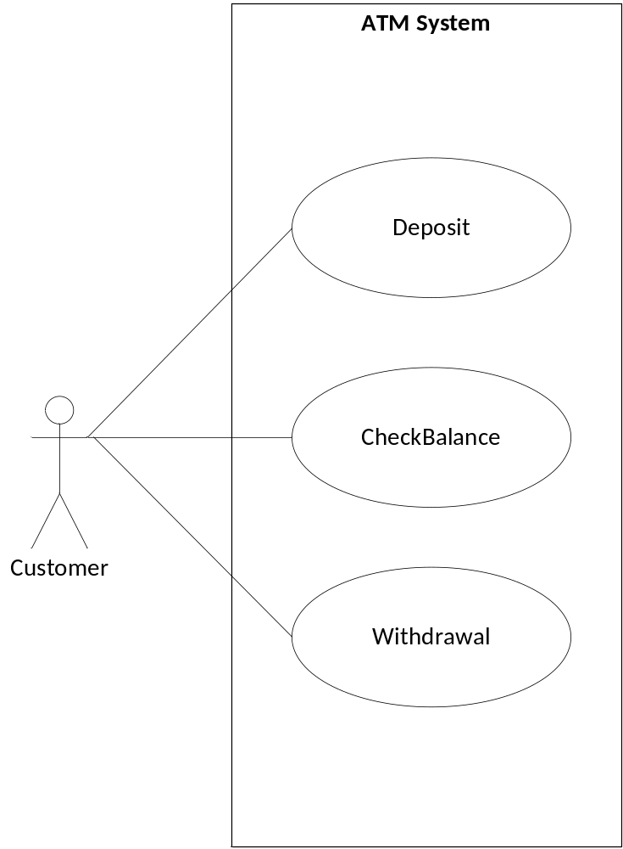 Example user interface mockups (created using Visio Wireframe diagrams) 