**GoalManager**

*User manual*

**Abstract**

GoalManager is an enterprise resource management tool that supplies an internal management interface for employee goals. The software features a web-based interactive front-end that serves as a shell for interacting with a rigorous multi-user role-based back-end. User roles include Employee, Supervisor, and Administrator. Employees work within a Department and can create, view, edit, and update Goals that align with Department Categories and Quarter dates as deadlines. Supervisors also share Employee functionality regarding Goals, and include two methods for analyzing reports: viewing Department-level reports, and individual Employee reports. Administrators handle the creation and modification of Employees, Supervisors, Departments, Categories, and Quarters. GoalManager uses a SQL database for all business data, and an Identity database for role-based authentication.

This document describes the user manual for operating GoalManager. The document is ordered as follows: Chapter 1 describes the program and its system requirements. Chapter 2 details user roles. Chapter 3 covers user role functions. Chapter 4 illustrates the main database schema and the ASP.NET Identity database. Chapter 5 reviews performance optimization. Chapter 6 explains implemented non-functional requirements, including security.

This document describes functionality of GoalManager v.1.0, dated 25 April 2017.

Table of Contents

1 System overview 1

1.1 Program interface 1

1.2 System requirements 1

2 Data Management 2

2.1 Data types 2

2.1.1 File format 2

2.1.2 Sample file structure 2

2.1.3 Group file structure 3

2.2 Uploading data 3

2.2.1 Open sample 3

2.2.2 Open group 4

2.3 Searching data 6

2.3.1 Reloading data 6

2.4 Deleting data 7

2.4.1 Delete sample 7

2.4.2 Delete group 8

3 Graphing 9

3.1 Generating a graph 9

3.2 Editing graph 10

3.2.1 Graph type 11

3.2.2 Graph legend 11

3.2.3 Graph symbol 11

3.3 Editing colors 11

3.3.1 Colors 11

3.3.2 Series colors 12

3.4 Editing text and fonts 13

3.4.1 Graph title 13

3.4.2 X-Axis label 14

3.4.3 Y-Axis label 14

3.4.4 Axes font 14

3.4.5 Tick labels font 15

3.4.6 Legend labels font 15

3.5 Editing grid and lines 15

3.5.1 Axes tick labels 16

3.5.2 Axes tick marks 16

3.5.3 Axes tick max count 17

3.5.4 Axes gridlines 17

3.5.5 Tick width and length 17

3.5.6 Series line width 18

3.6 Editing scale 18

3.6.1 X-axis scale 18

3.6.2 Y-axis scale 19

3.6.3 Resetting scales 19

4 Graphing tools 20

4.1 Tools overview 20

4.2 Move tool 20

4.3 Draw tool 20

4.3.1 Drawing a line 20

4.3.2 Deleting a line 20

4.4 Write tool 21

4.4.1 Creating text 21

4.4.2 Moving text 22

4.4.3 Deleting text 22

5 Exporting graphs 23

5.1 Export overview 23

5.2 Export as PNG 23

5.3 Export as PDF 23

5.4 Show export 24

6 Other functionality 25

6.1 Saving preferences 25

6.2 Sidepanel visibility 25

6.2.1 Show sidepanels 25

6.2.2 Hide sidepanels 25

6.2.3 Hide data panel only 25

6.3 Clearing options 25

6.3.1 Clear graph 25

6.3.2 Clear selection 26

6.4 Errors 26

# System overview

## Program interface

GoalManager includes an interactive user interface as displayed in Figure 1.1. All system functionality is accessible through this main interface through the Login portal. Role-based use cases are restricted to logged in users with the appropriate role.

Users can click the “Log in” button to access the log in portal. Only authorized users can log in. The TaxSlayer logo redirects to the /Home/Index page from any place on the website.

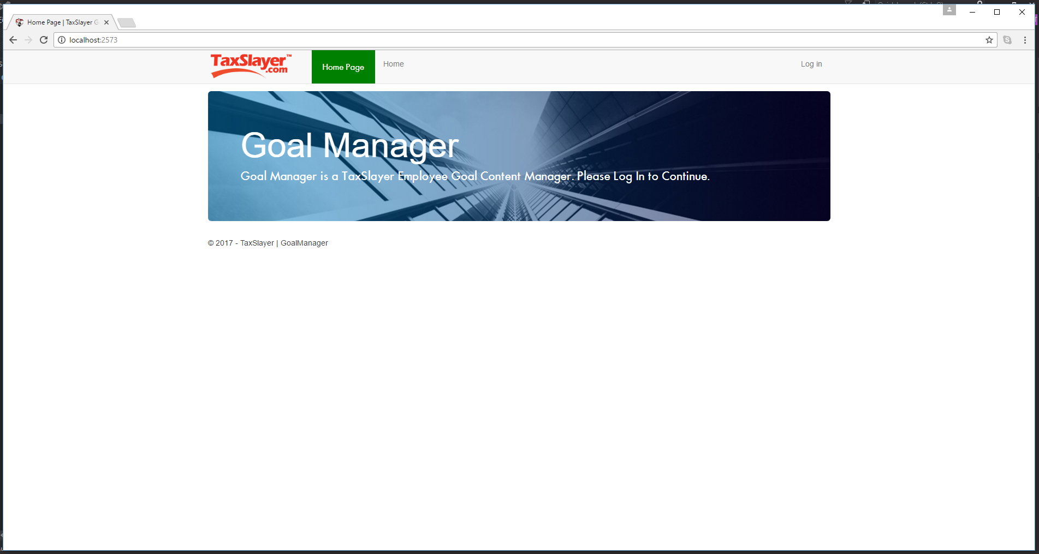

Figure 1.1. /Home/Index

1. [LABEL 1]
2. [LABEL 2]
3. [LABEL 3]
4. [LABEL 4]
5. [LABEL 5]

## System requirements

GoalManager is written in C# 7.0 within the .NET framework. GoalManager is implemented on ASP.NET MVC architecture. As a web-based application, GoalManager must be hosted on an internal web server for all operations.

# User Roles

## Roles

GoalManager provides three user roles: Employees, Supervisors, and Administrators.

### Employee

Employees are presented with EmployeeHome, featured in Figure 2.1. EmployeeHome displays any Pending Goals awaiting Supervisor approval, followed by all current Active Goals and each associated Update. Next are all Denied Goals, which have been denied by a Supervisor. Last are all Failed Goals, which detail all Goals that have a due date past the system time.

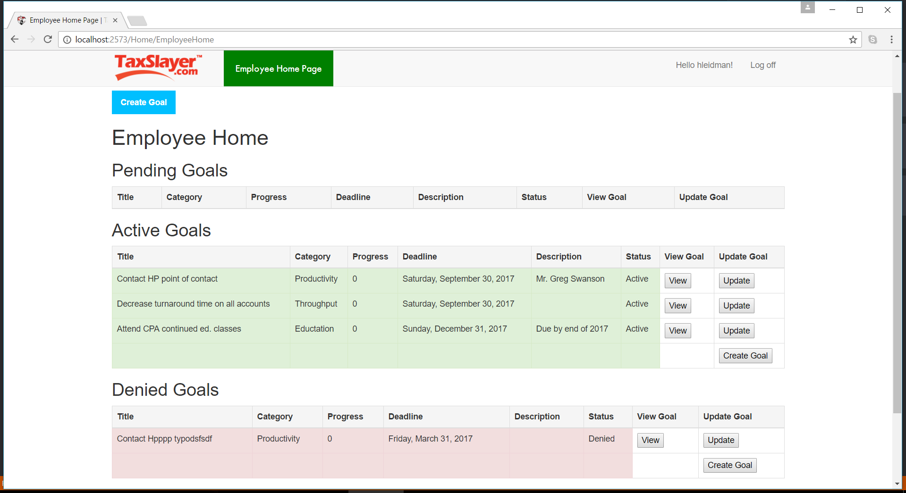

Figure 2.1. /Home/EmployeeHome

### Supervisor

Supervisors are delivered to SupervisorHome, which is shown in Figure 2.2. Supervisors differ from Employees primarily by the management role that every Supervisor has. A Supervisor manages a Department, and by extension, all Employees in that Department. Much like EmployeeHome, Supervisors have the same Goal tables as Employees, as detailed in 2.1.1. Furthermore, Supervisors have a Pending Goals queue not for their own goals, but for all managed Employees in their Department, where they can either Approve or Deny queued Goals from managed Employees.

Like Employees, Supervisors can click the “Create Goal” button to create a personal Goal, and view all their Goals via the “View” button.

Supervisors can add Department Categories through the “Add Category” button.

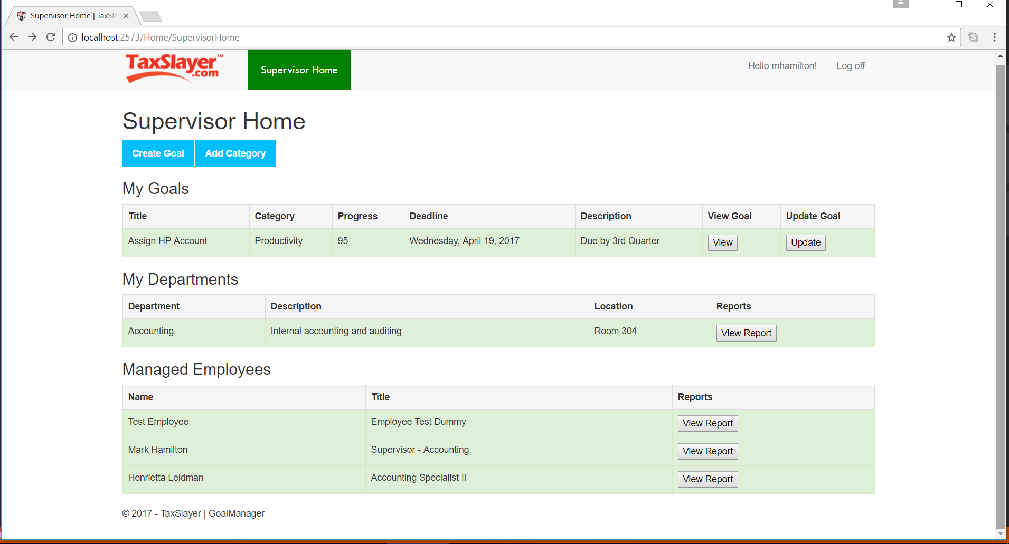

Figure 2.2. SupervisorHome

### Administrators

Administrators differ from Employees and Supervisors in that they do not have any Goal functionality, nor participate in conventional business Departments. All valid Administrators are restricted to the Administrators Department. Administrators are presented with AdminHome, which list a table of all current Administrators, a table of all Departments and their Supervisors, and a table for all non-Administrator users.

Administrators can modify a selected Department by clicking the “Modify” button attached to that Department. Modifying a Department includes adding Quarters, Categories, and changing the Supervisor of that Department. They can also modify Employees and Supervisors by clicking the “Modify” button attached to that Employee/Supervisor. Administrators can also modify other Administrators via the same interaction as modifying a Department or Employee/Supervisor.

Figure 2.3. /Home/AdminHome

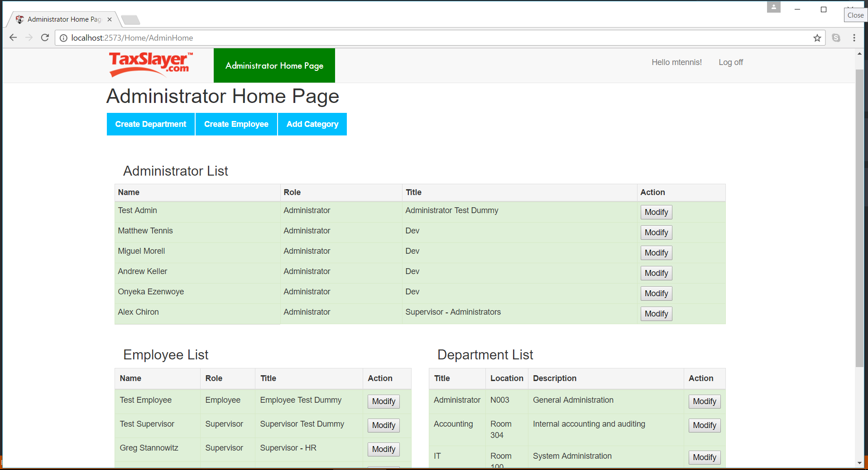

# Role-based Functions

## Employee Functions

Employees interfacing with GoalManager do so for its titular purpose: to manage Goals. Employees can first view any Goals currently assigned to them. Create Goal is displayed below as Figure 3.1. Employees can create Goals under Department Categories and Quarter dates. Employees can click the “Create Goal” button to create a new goal pending Supervisor approval.

### CreateGoal

Employees submit a valid Title, an optional Description, and a selected Department Category and Quarter date.

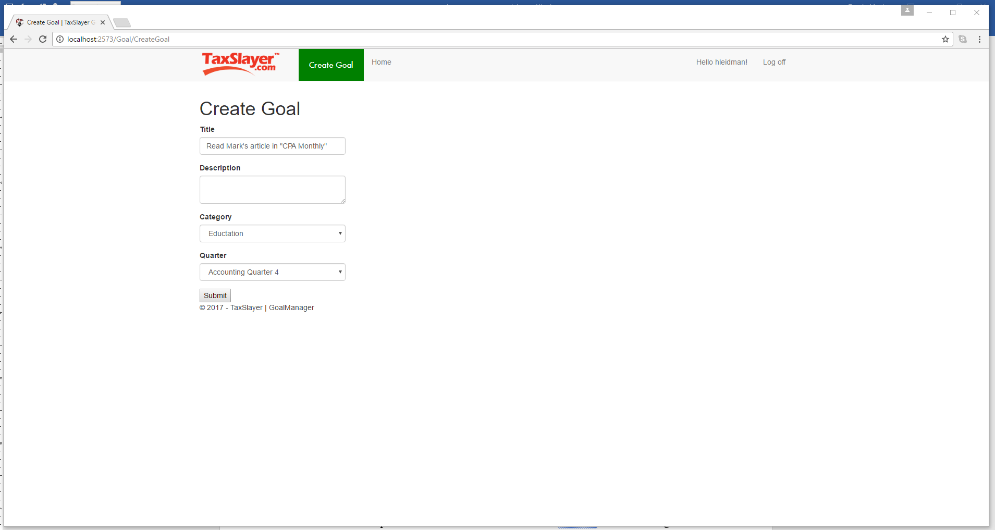

Figure 3.1. CreateGoal

### ViewGoal

Employees can also click the “View” button to view the history of that Goal, which includes all Updates applied to that Goal. Viewing detailed Goal history is featured in Figure 3.2.

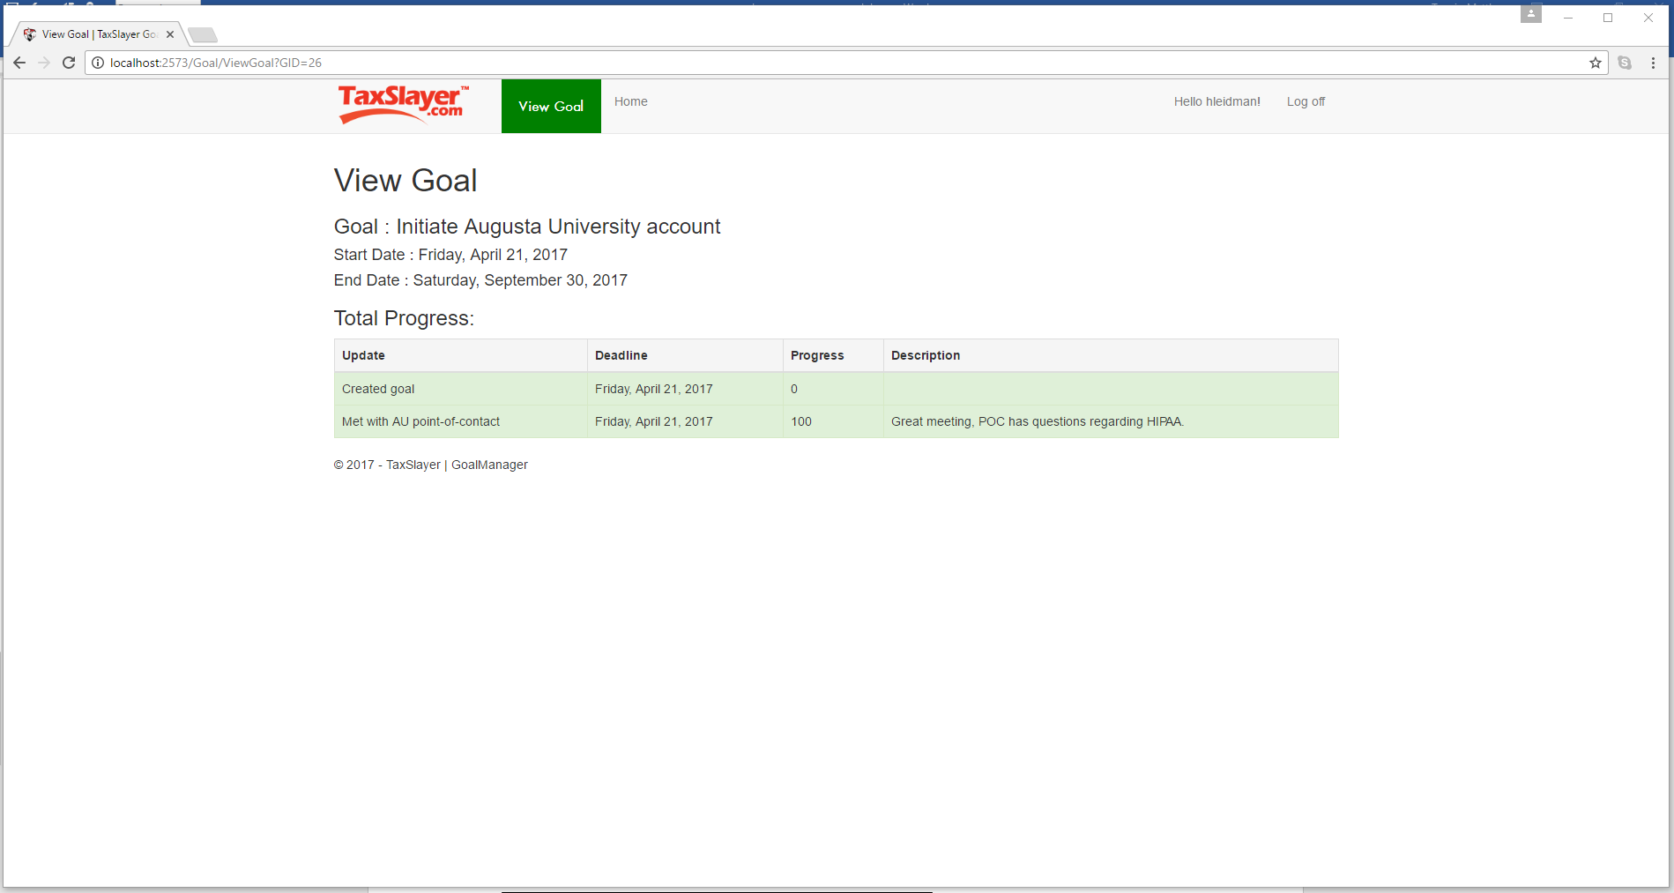

Figure 3.2. ViewGoal

### UpdateGoal

Employees can update a Goal by clicking the “Update” button attached to the Goal’s list element. The UpdateGoal page is featured in Figure 3.3.

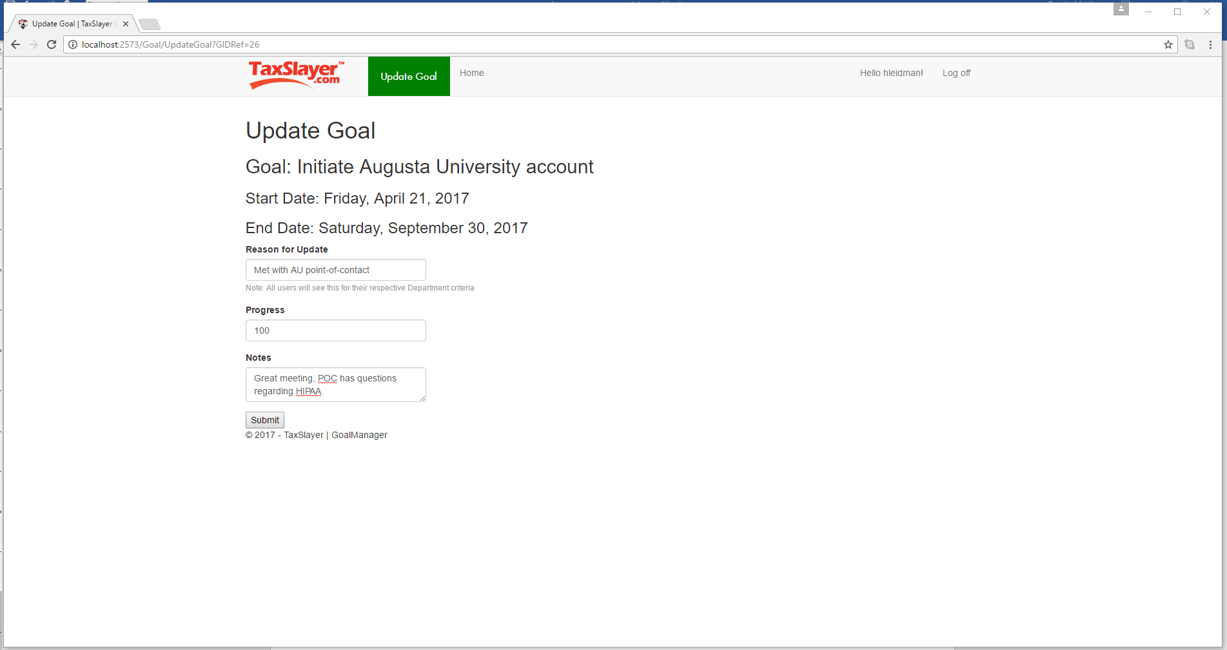

Figure 3.3. UpdateGoal

## Supervisor Functions

### CreateGoal

Supervisors can create Goals alongside the Quarter dates and Categories of the Department that they manage. However, Supervisor also have the ability to push a Goal out to every Employee in his or her Department. This is accomplished by the “Push to Department?” checkbox on the Create Goal page accessible only to Supervisors. Figure 3.4 displays this functionality.

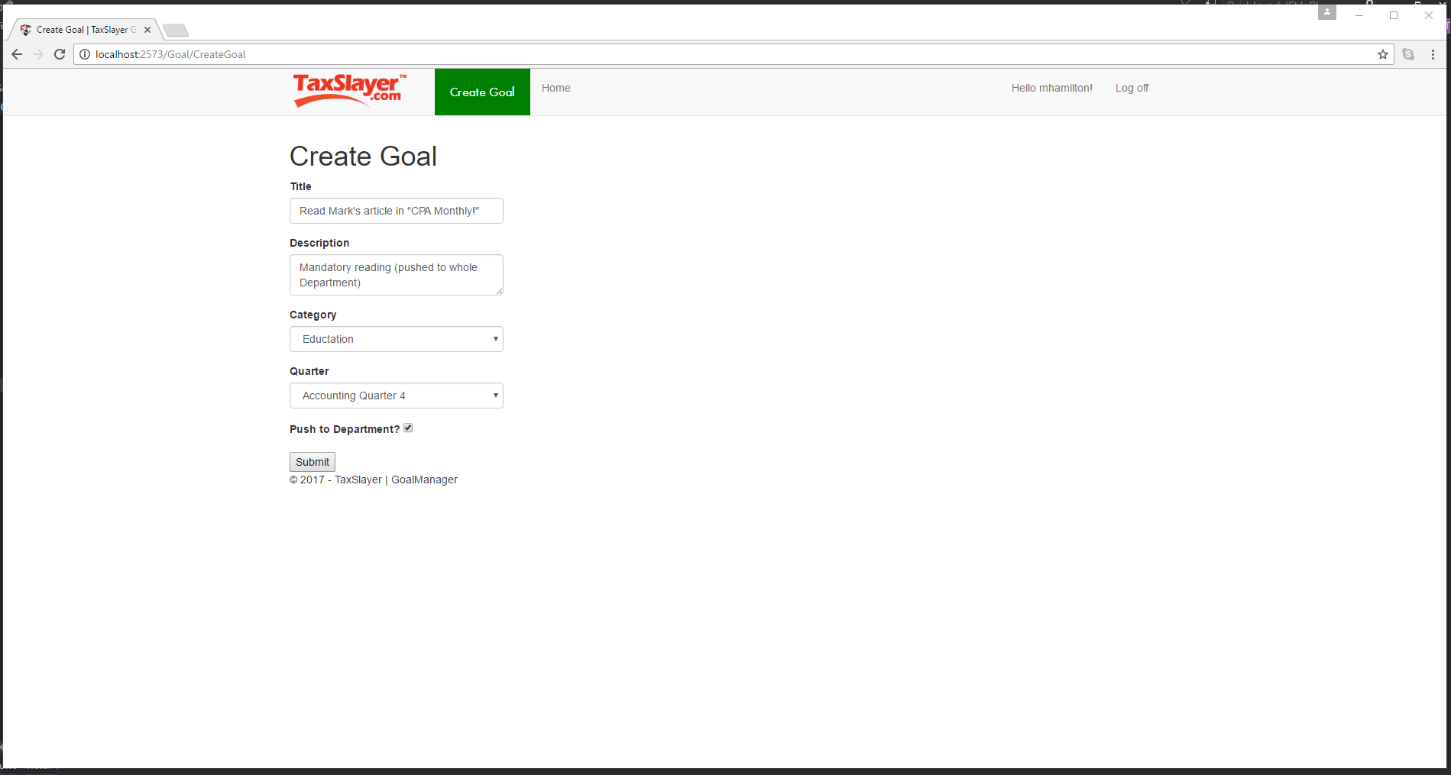

Figure 3.4. CreateGoal (Supervisor)

### ViewGoal

Like Employees, Supervisors can View one of their own Goals by clicking the View button. Figure 3.5 displays ViewGoal for Supervisors.

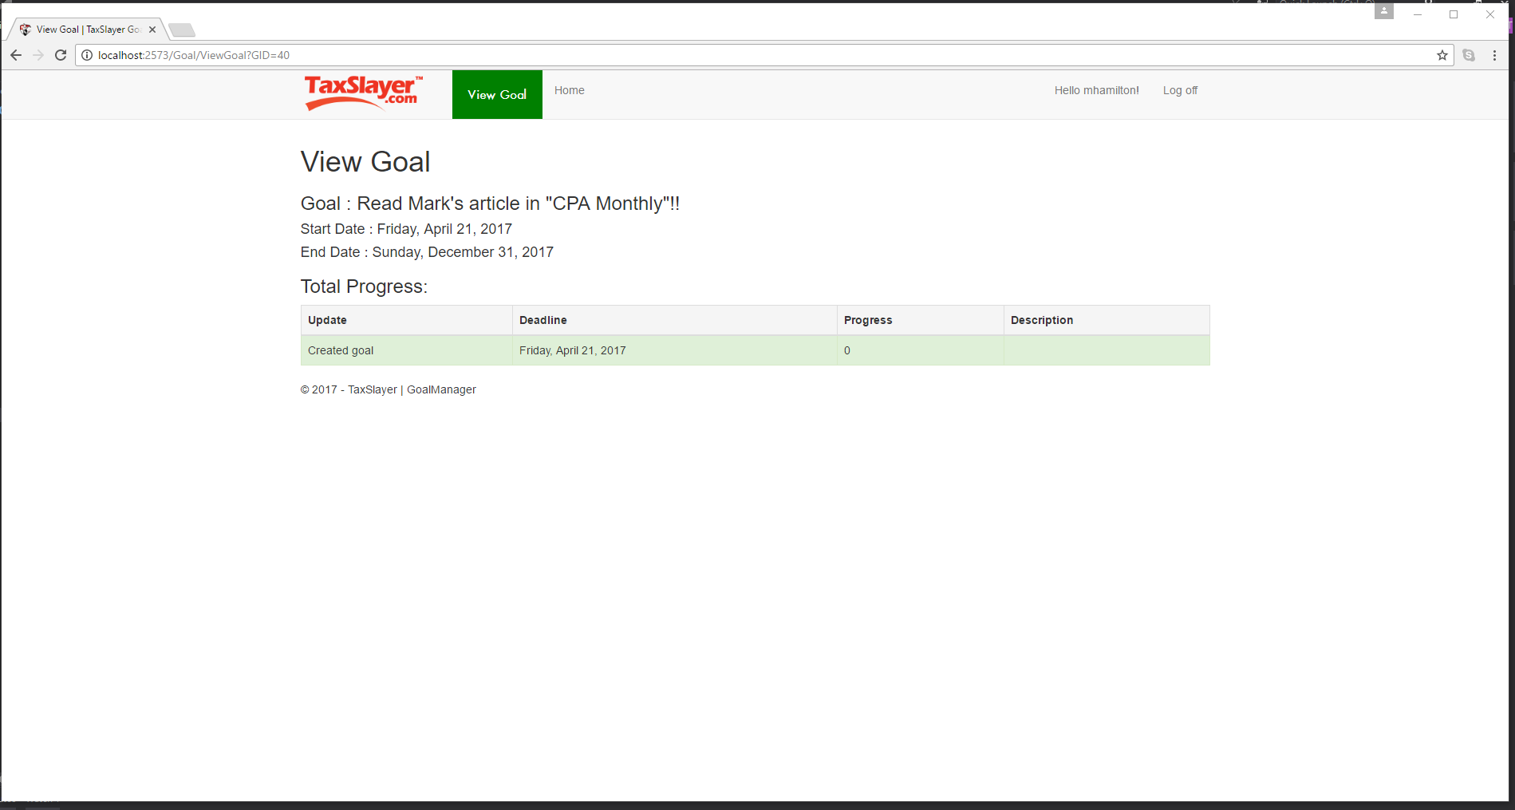

Figure 3.5. ViewGoal (Supervisor)

### UpdateGoal

Supervisors can also Update any of their own Goals with the same mechanic as Employees, as featured in Figure 3.6.

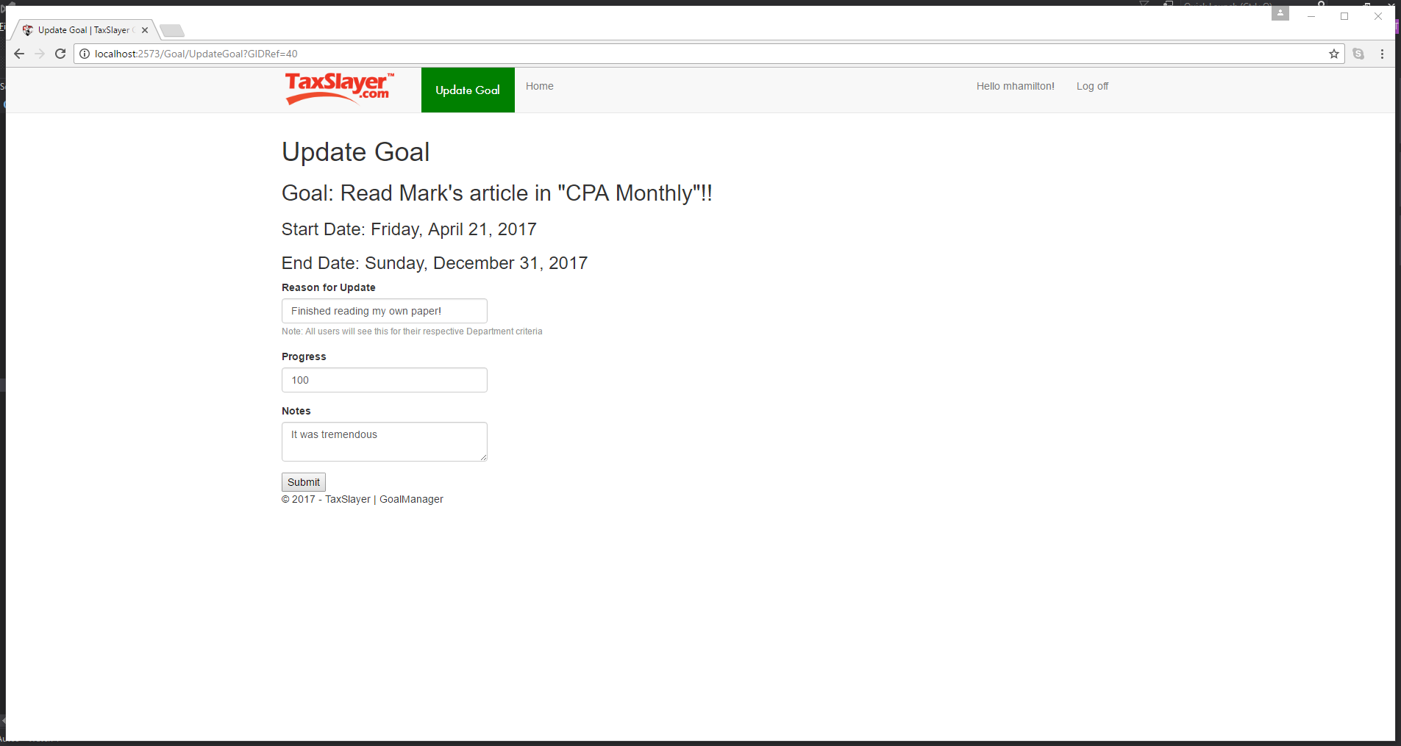

Figure 3.6. UpdateGoal (Supervisor)

### AddCategory

Supervisors can add Goal Categories for their Department. By clicking “Add Category” on SupervisorHome, a list of current Department Categories will be presented, alongside a form field for entering a new Category. AddCategory is featured in Figure 3.7.

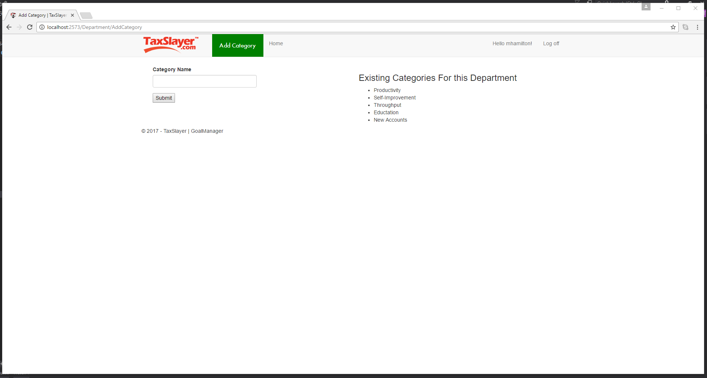

Figure 3.7. AddCategory

### ViewReport (Department)

Supervisors can view a report of the entire Department that he or she manages. On SupervisorHome, the Supervisor can click “View Report” on the Department list item. The departmental report presents aggregated Goal data across the entire Department. See Figure 3.8 for details on viewing departmental reports.

Figure 3.8. ViewReport (Department)

### ViewReport (Employee)

Similar to viewing a departmental report, a Supervisor can review any managed Employees by clicking the “View Report” button on an Employee’s list entry. The Employee report displays specific Goal data for that Employee, presenting those statistics in a graphical format. Figure 3.9 shows an individual Employee report.

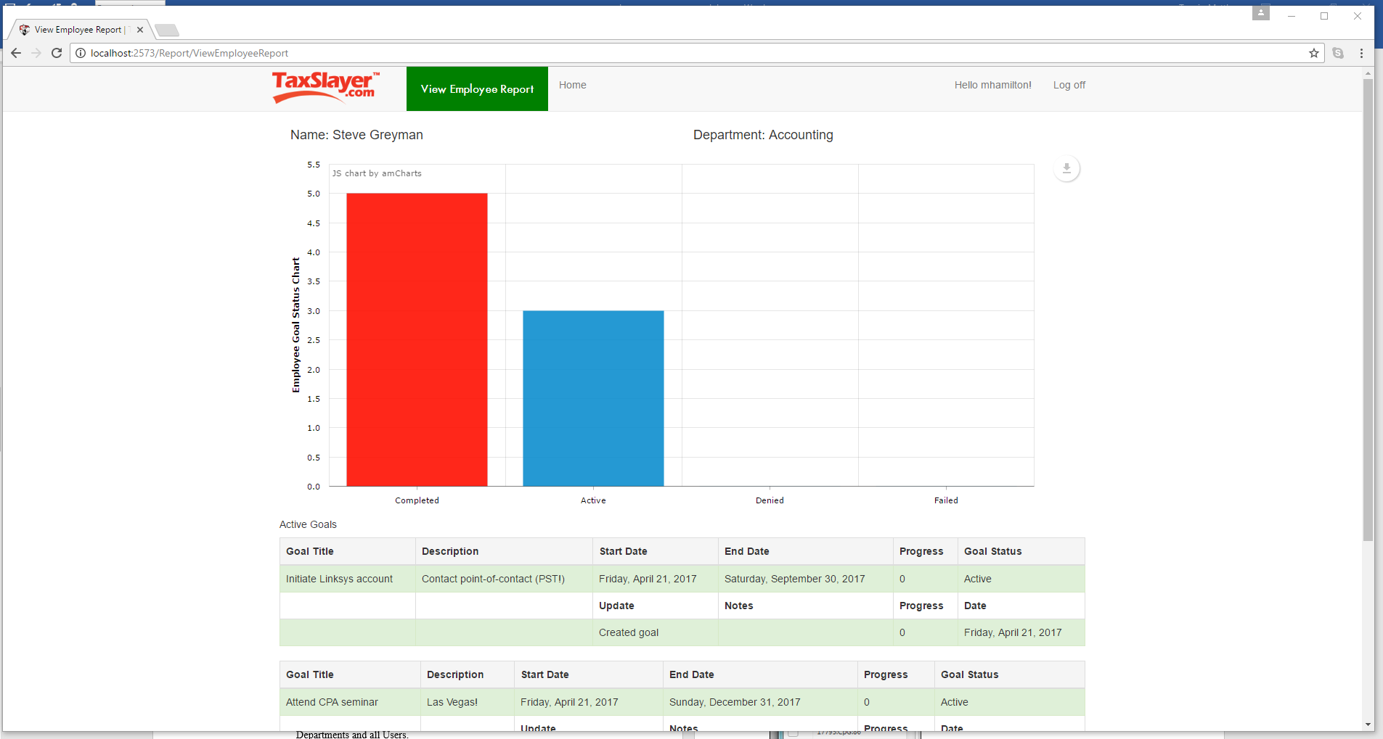

Figure 3.9. ViewReport (Employee)

## Administrator Functions

### CreateEmployee

Administrator functionality is limited to the creation and modification of Departments and all Users. Functions include CreateEmployee, CreateDepartment, ModifyEmployee, ModifyDepartment, and AddCategory.

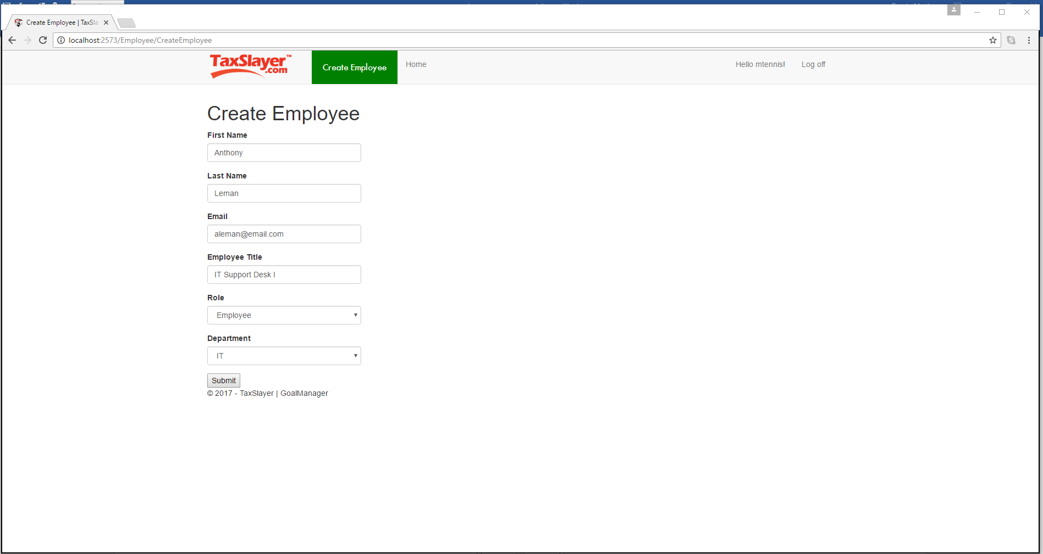

Figure 3.10. CreateEmployee

### CreateDepartment

Administrators can navigate to CreateDepartment by clicking on the “Create Department” button at the top of AdminHome. The Administrator must provide a name for the Department, a physical location, an optional description, select a Supervisor from the pool of Supervisors, provide at least one Category (in the Category 1 field), and four Quarters with valid, chronological dates. CreateDepartment is featured Figure 3.11.

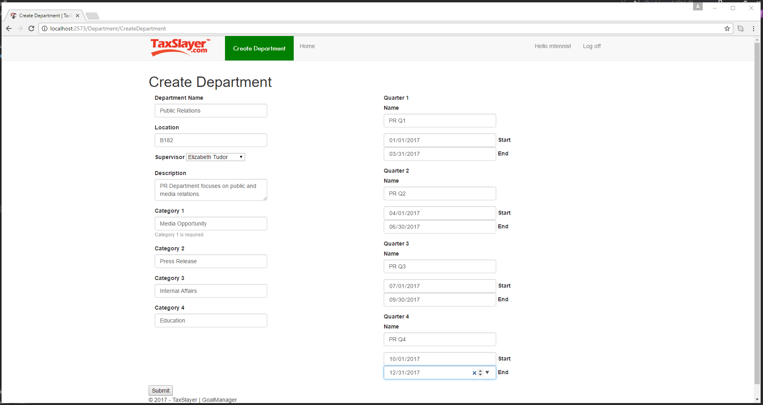

Figure 3.11. CreateDepartment

### ModifyEmployee

Administrators can navigate to ModifyEmployee by clicking on the “Modify” button attached to any User on AdminHome. The Administrator must provide a name for the Department, a physical location, an optional description, select a Supervisor from the pool of Supervisors, provide at least one Category (in the Category 1 field), and four Quarters with valid, chronological dates. CreateDepartment is featured Figure 3.11.

Figure 2.5. Open Group

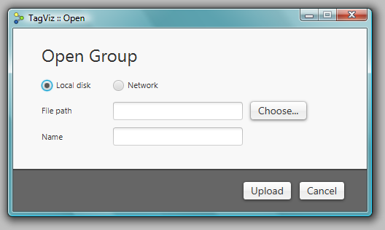

If the group file is hosted on the local disk use the “Choose..” button to navigate to the group file. If the group file is hosted on a network server, select the network radio button and copy paste the URL of the group file into the text field.

TagViz will automatically populate the group name field, but if you wish to rename the group and how it should appear in the system, enter the desired name in the name field. Finally, press the upload button.

After pressing the upload button, TagViz will attempt to retrieve and parse the requested file. A blue progress bar will appear in the interface to indicate upload process is being handled. After a group is successfully read, the group will appear in the user interface as shown in Figure 2.6.

Figure 2.6. Processed group

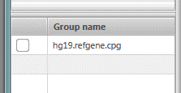

## Searching data

TagViz enables searching through uploaded features using a search function. To use this feature, navigate to the left of the interface, and look for a bar with label “Search features”. Clicking on the bar will toggle the visibility of the search field. The search field is displayed in Figure 2.7.

Figure 2.7. Search feature

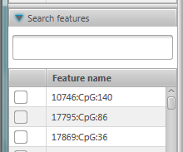

To search for specific features, type text into the search field and press ENTER. TagViz will search for matches in features whose name contains the substring entered into the search field. The search will list features that begin with the given search text first and then list all other features that contain but do not being with the given search text.

To clear the search results and redisplay a full list of features, either clear the input from the search field and press ENTER or click on the “Search features” bar. The latter will also hide the search field. Alternatively you can also reload all data tables, including features, by reloading data.

### Reloading data

Making changes to the data collection will automatically cause TagViz to reload data table lists displaying the data collections. However, to manually trigger data collections reload, use the top control bar and click on a button:

*Generate > Reload*

## Deleting data

### Delete sample

To delete a sample, navigate to the top menu bar and select:

*File > Delete Sample*

If there are no uploaded samples this option is disabled. Therefore uploading a sample is required before it can be deleted. Clicking on the “Delete Sample” menu item will generate the window displayed in Figure 2.8.

Figure 2.8. Delete Sample

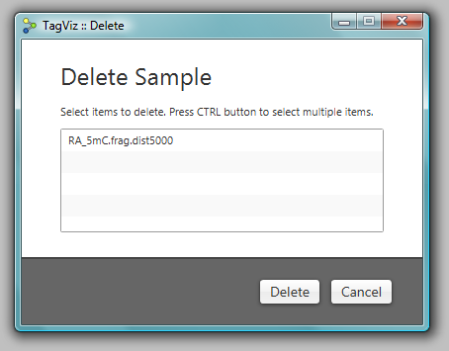

To delete a sample, click on the sample name and press the Delete button. To delete multiple samples, hold down CTRL on the keyboard, click on one or more sample names, and press the Delete button.

After pressing the Delete button TagViz will process the selection and delete the selected samples. The user interface will update and the sample and the features contained in the sample will no longer be visible in the lists of samples and features.

The list of feature names is a union of all features contained in the uploaded samples. Therefore if the same feature name exists in multiple samples, it will continue to display even if one of the samples is deleted. A feature name will be deleted when there are no references to that particular feature in the list of samples.

### Delete group

To delete a group, navigate to the top menu bar and select:

*File > Delete Group*

If there are no uploaded groups this option is disabled. Therefore uploading a group is required before it can be deleted. Clicking on the “Delete Group” menu item will generate the window displayed in Figure 2.9.

Figure 2.9. Delete Group

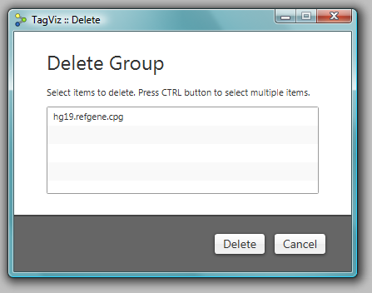

To delete a group, click on the group name and press the Delete button. To delete multiple groups, hold down CTRL on the keyboard, click on one or more group names, and press the Delete button.

After pressing the delete button TagViz will process the selection and delete the selected groups. The user interface will update and the selected groups will no longer be visible in the lists of groups.

# Graphing

## Generating a graph

Generating a graph requires that some data is first uploaded into the system. TagViz allows graphing a selection of samples, features, and groups.

To generate a graph navigate to the left of user interface and select the data items you wish to graph. Select one or more items from by clicking on the checkbox next to its name. Figure 3.1 illustrates selection of two features. To deselect a data item click on the checkbox again until the checkmark disappears. Alternatively, you can clear all checked items at once by navigating the top menu bar and selecting:

*View > Clear Data Selection*

Figure 3.1. Selecting data items

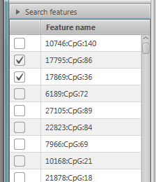

After selecting one or more items, click on the “Draw” button in the top left corner of the control bar. A graph will appear in the center graphing panel as shown in Figure 3.2.

Figure 3.2. Generated graph

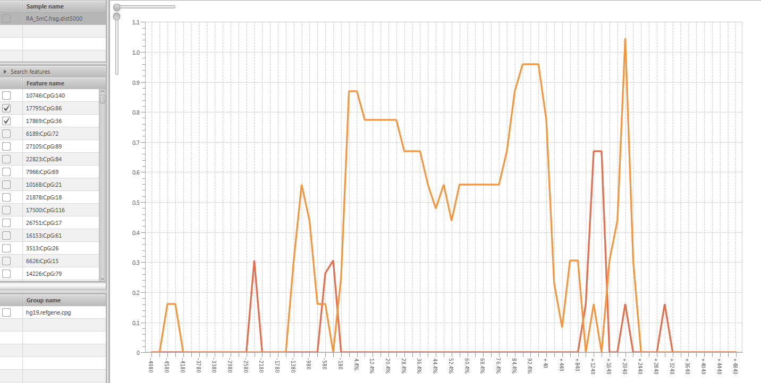

## Editing graph

TagViz allows customizing several aspects of the graph. Figure 3.3 displays the menu to control graph preferences.

Figure 3.3. Graph preferences menu

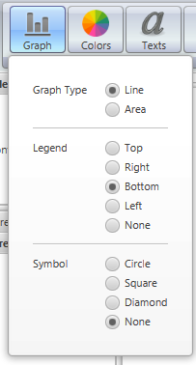

### Graph type

TagViz support two types of graphs: line and area. An area graph also includes a fill color, while line graph shows only a line. To change the type of graph navigate to:

*Preferences > Graph > Graph type*

Graph type will change as you change the current selection.

### Graph legend

TagViz allows customizing the position of the legend. The possible options are top, bottom, left, right, or none. Selecting none means no legend will be displayed.  
To change the legend position navigate to:

*Preferences > Graph > Legend*

Graph legend will change as you change the current selection.

### Graph symbol

TagViz allows customizing a data series symbol. Symbol appears along the graph data plot. The possible options are circle, square, diamond, or none. Selecting none means no symbol will be displayed. To change the symbol navigate to:

*Preferences > Graph > Symbol*

Graph symbol will change as you change the current selection.

## Editing colors

### Colors

TagViz allows customizing graph colors. You can change the following options: drawing area (graph background), graph area (plot background), graph border, graph title color, axes labels color, legend labels, legend background, x-axis gridlines, y-axis gridlines, tick labels (along axes), tick lines (along axes), symbol fill. These values can be set to any color in the RGB range. The graph colors menu is shown in Figure 3.4. To change any of the color options navigate to:

*Preferences > Colors*

Graph colors will change as you change the current selection.

Figure 3.4. Graph colors menu

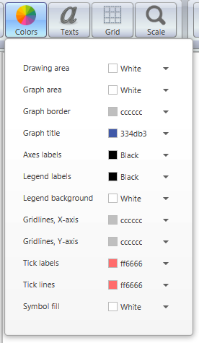

### Series colors

TagViz also allows customizing data series colors. To change a plot color, hover over the specific series line or area until the mouse cursor changes to a hand. Then right click on the mouse and a context menu will appear. For a line graph there is an option to change the line color. For an area graph there is an option to change the line color and area fill color. Changing the current selection will change the series color respectively. Figure 3.5 demonstrates the context menu for changing series options.

Figure 3.5. Series options menu for line graph

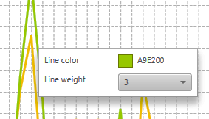

## Editing text and fonts

TagViz allows setting and changing graph title and axes labels. These are all optional and can also be left blank. Figure 3.6 shows the menu for editing text and fonts.

Figure 3.6. Graph text menu

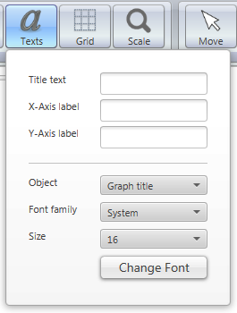

### Graph title

TagViz allows customizing graph title. To set or change the graph title navigate to:

*Preferences > Texts > Title text*

Type text in the text field and press ENTER. Graph title will change after pressing the ENTER key.

To change graph title font, navigate to:

*Preferences > Texts > Object > Graph title*

If or once the object is set to graph title, you will see the current settings for title font in the “Font family” and “Size” comboboxes. Font family lists all fonts found in your system, and sizes a preconfigured to range between 6-57 pixels. To change the settings select a font family and/or font size and press “Change font” button. Graph title will update after the button is clicked.

### X-Axis label

TagViz allows customizing x-axis label. To set or change the x-axis label navigate to:

*Preferences > Texts > X-Axis label*

Type text in the text field and press ENTER. X-axis label will change after pressing the ENTER key.

### Y-Axis label

TagViz allows customizing y-axis label. To set or change the y-axis label navigate to:

*Preferences > Texts > Y-Axis label*

Type text in the text field and press ENTER. Y-axis label will change after pressing the ENTER key.

### Axes font

TagViz allows customizing axes font. The axes font is controlled by the same variable and therefore cannot be set to different values for each axis.

To change the axes font, navigate to:

*Preferences > Texts > Object > Axes*

If or once the object is set to Axes, you will see the current settings for axes font in the “Font family” and “Size” comboboxes. Font family lists all fonts found in your system, and sizes a preconfigured to range between 6-57 pixels. To change the settings select a font family and/or font size and press “Change font” button. Axes will update after the button is clicked.

### Tick labels font

Tick labels are texts that appear along the axes. TagViz allows customizing tick labels fonts. The axes fonts are controlled by the same variable and therefore cannot be set to different values for each axis. To change the tick labels font navigate to:

*Preferences > Texts > Object > Tick labels*

If or once the object is set to Tick labels, you will see the current settings for tick labels font in the “Font family” and “Size” comboboxes. Font family lists all fonts found in your system, and sizes a preconfigured to range between 6-57 pixels. To change the settings select a font family and/or font size and press “Change font” button. Tick labels will update after the button is clicked.

### Legend labels font

Legend labels are texts that appear inside the graph legend. TagViz allows customizing legend labels fonts. To change the legend labels font navigate to:

*Preferences > Texts > Object > Legend labels*

If or once the object is set to Legend labels, you will see the current settings for legend labels font in the “Font family” and “Size” comboboxes. Font family lists all fonts found in your system, and sizes a preconfigured to range between 6-57 pixels. To change the settings select a font family and/or font size and press “Change font” button. Legend labels will update after the button is clicked.

## Editing grid and lines

TagViz allows customizing graph grid lines, tick marks and labels visibility, tick interval and max count, and tick width and length. The width of each data series line can also be customized.

Figure 3.7. Grid menu

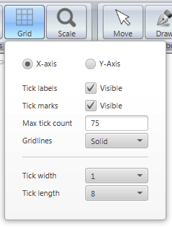

TagViz allows customizing several properties of the axes and these options are listed under grid menu shown in Figure 3.7. To change x-axis options first check that X-axis radiobox is selected, then proceed to change the options. To change y-axis options first check that Y-axis radiobox is selected, then proceed to change the options.

### Axes tick labels

Axes tick labels are text that appear along a specified axis. TagViz allows customizing the visibility of tick labels individually for each axis.

To toggle tick labels visibility, navigate to:

*Preferences > Grid > tick labels*

Tick labels will be visible when the checkbox is checked.

### Axes tick marks

Axes tick marks are lines that appear along a specified axis. TagViz allows customizing the visibility of tick labels individually for each axis.

To toggle tick marks visibility, navigate to:

*Preferences > Grid > tick marks*

Tick marks will be visible when the checkbox is checked.

### Axes tick max count

Tick max count controls the number of data plot points. The plot item number will not exceed the specified number of tick max count. If data item contains more values than the given maximum, the interval will adjust accordingly. The max tick count directly affects graphing performance: the higher the number of values, the longer it takes to generate the graph.

TagViz allows customizing the tick max count individually for each axis. To change tick max count, navigate to:

*Preferences > Grid > tick interval*

Enter a number in range 1-999 and press enter to change tick interval. To visualize the change in a graph after changing tick count value, select:

*Generate > Draw*

After clicking the Draw button TagViz will generate a graph implementing the max tick count setting.

### Axes gridlines

Gridlines are horizontal and vertical lines in the graph area background. TagViz allows customizing the appearance of gridlines individually for each axis. To change the gridlines navigate to:

*Preferences > Grid > Gridlines*

Select an option from the dropdown menu. Changing the current selection will update the setting.

### Tick width and length

Axes ticks are lines and associated labels that appear along an axis. TagViz allows customizing the width and length of tick marks. This option is controlled by the same variable therefore changing this option applies to both axes.

To change tick width, navigate to:

*Preferences > Grid > Tick width*

Select and option from the dropdown menu and graph axes tick lines with will update accordingly.

To change tick length, navigate to:

*Preferences > Grid > Tick length*

Select and option from the dropdown menu and graph axes tick lines with will update accordingly

### Series line width

TagViz also allows customizing data series width. To change a series line width, hover over the specific series line or area until the mouse cursor changes to a hand. Then right click on the mouse and a context menu will appear. Change the line width and the series line width will change accordingly.

## Editing scale

TagViz allows customizing the axis scale. The scale can be changed individually for each axis. The axes’ scale sliders are located in the graphing area, as shown in Figure 3.8. The scale range is 1-2.5 and defaults to 1. When scale value is set to one the size of the graph fills the graph panel width and height with no overlap.

Figure 3.8. Axis scale sliders

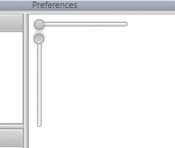

### X-axis scale

X-axis scale can be changed by hovering over the horizontal x-axis slider. Click on the control ball and drag mouse left or right to change the value. Graph x-axis scale will adjust accordingly. To see the current X-axis scaling factor, hover over Scale button in the top control bar.

### Y-axis scale

Y-axis scale can be changed by hovering over the vertical y-axis slider. Click on the control ball and drag mouse up or down to change the value. Graph y-axis scale will adjust accordingly. To see the current Y-axis scaling factor, hover over Scale button in the top control bar.

### Resetting scales

To reset scales to default values, navigate to top control bar and select:

*Scale > Reset axis scales*

This option is displayed in Figure 3.9. The graph axes will reset to value 1, and the graph will be fitted to the width and height of the graph panel with no overlap.

Figure 3.9. Scale menu

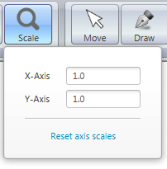

# Graphing tools

## Tools overview

TagViz provides multiple tools for further edit the appearance of a generated graph. To use these tools, user must first upload sample data and generate a graph. The tools are located in the control bar on top of the user interface, as show in figure 4.1.

Figure 4.1. Editing tools

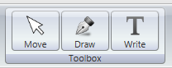

## Move tool

The move to allows moving a graph once its size exceeds the size of the graphing area. To enable the move tool, click on the move button. When move tool is enabled, hovering over the graph will show a hand cursor.

## Draw tool

Draw tool allows free-hand drawing over the graph area. To enable the draw tool, click on the draw button. When draw tool is enabled, hovering over the graph will show an arrow cursor.

### Drawing a line

To begin drawing press down on the left mouse button and continue to keep it down as you drag along the graph area. To stop drawing release the mouse button.

### Deleting a line

To delete a single drawing path, use the mouse and right-click over it. This will cause a single free-hand drawing to disappear from the graphing area.   
  
Alternatively, you can delete all drawings at once by navigating to:

*Tools > Draw > Clear drawings*

Deleting all drawings will leave the graph and possible custom text fields in place, but will erase all free-hand drawings.

## Write tool

Write tool allows adding custom texts over and around the graph area. To enable the write tool, click on the write button. When write tool is enabled, hovering over the graph will show a text cursor.

### Creating text

To begin writing, click somewhere on the graph area. TagViz will generate a text field width gray border and prompt text “Enter text” as shown in Figure 4.2. Change the text value by clicking on the field and typing, as shown in Figure 4.3. A finished label will show the text on a transparent background, as shown in Figure 4.4.

Figure 4.2. Created text field



Figure 4.3. Entering text



Figure 4.4. Final appearance



The size of the text field grows with respect to the length of the text and according to the selected font. There is no upper limit on how many text labels can be added to the screen at any given time.

### Moving text

You can move labels to any position by hovering over the text border. Once the cursor changes to a moving cursor, you can drag the text to any position on the graph area.

### Deleting text

To delete a single text field, use the mouse and right-click over it. This will cause a single text field to disappear from the graphing area.   
  
Alternatively, you can delete all text fields at once by navigating to:

*Tools > Write > Clear texts*

Deleting all texts will leave the graph and possible free-hand drawings in place, but will erase all custom text fields.

# Exporting graphs

## Export overview

TagViz allows saving a generated graph as an image or as a pdf file. The function will save an exact image of what is in the graph area excluding the scaling bars shown in Figure 3.8. This means it includes any changes to axes scaling and application of draw and write tools.

## Export as PNG

This feature will save an image of the generated graph. To being export, navigate to the top left menu bar and select:

*File > Export Graph > Export As PNG*

Clicking on the option will display a file chooser dialog that request a file name and file type. File type is preset to PNG and there are no other options. File name can be set freely. After setting the filename click “Save”. TagViz will then generate a snapshot of the graph area and save it as PNG image in the specified location.

The dimensions of the generated image are relative to the actual size of the graph area.

## Export as PDF

This feature will save a pdf file of the generated graph. To being export, navigate to the top left menu bar and select:

*File > Export Graph > Export As PDF*

Clicking on the option will display a file chooser dialog that request a file name and file type. File type is preset to PDF and there are no other options. File name can be set freely. After setting the filename click “Save”. TagViz will then generate a snapshot of the graph area and save it as a pdf file in the specified location.

The pdf document defaults to 1-page letter size. If the graph width exceed its heights, the generated pdf will be landscape, else it will be portrait. If the graph is scaled and the size of the graph exceeds the size of 1 letter page, the graph will scale down to fit the page size.

## Show export

TagViz enables setting an option to launch a generated PNG or PDF file upon export. This option is located in the menu bar, and can be change by navigating to:

*File > Export Graph > Display file*

If the checkbox is checked, TagViz will open an exported file automatically upon completion of the export function. If the checkbox is not checked, TagViz will generate the file but not open it for preview.

# Other functionality

## Saving preferences

TagViz will automatically save graph preferences such as graph type, colors, fonts etc. This functionality is enabled by default and will execute whenever preferences are changed. The settings will be saved in the same file where the executable application is saved, so it is advisable to save the application in a writable directory. The preferences are saved in a file titled “settings”. If this file is deleted or corrupted, graph preferences are set to their defaults.

## Sidepanel visibility

To enhance analyzing the graph, it is possible to toggle the visibility of both data panels on the left and control bar on top of the user interface.

### Show sidepanels

To hide both panels, press CTRL+1, or use the top menu bar and navigate to:

*View > Collapse Sidepanels*

### Hide sidepanels

To show both panels, press CTRL+2, or use the top menu bar and navigate to:

*View > Show Sidepanels*

### Hide data panel only

To adjust the size and/or visibility of data panels only, bovver over the vertical separator between the data panels and the graph area, click and drag the mouse. Dragging to the left will reduce the width or hide the panel, and dragging to the right will increase its width.

## Clearing options

### Clear graph

To clear a generated graph, navigate to top menu bar and select:

*View > Clear Graph Panel*

Clicking the option will cause the center graphing panel to be cleared of all drawings to include the graph and any free-hand drawings or custom text labels.

### Clear selection

To enable one-click deselecting of graph data, navigate to top menu bar and select:

*View > Clear Data Selection*

Clicking the option will cause the all selected data items to be deselected and the data tables to reload.

## Errors

TagViz will generate error messages when invalid requests occur. The error message appears in the top right corner of the user interface. The error message includes a header and short description of the cause. Error messages fade automatically after a few seconds, or it can be hidden immediately by clicking on a “X” icon in the top right corner. Figure 6.1 shows a sample error message.

Figure 6.1. Error message

