**TagViz**

*User manual*

**Abstract**

TagViz is a data visualization tool that enables analysis of genomic sequencing data. The software includes a highly interactive user interface and graphing tools with multiple options for customizing the graph. The software also includes utilities for uploading data and exporting the resulting graph in different formats.

This document contains the manual of how to use TagViz. The rest of the document is ordered as follows: Chapter 1 describes the overall program and system requirements. Chapter 2 contains explanation of how to upload and manage data. Chapter 3 includes instructions for graphing and setting graph preferences. Chapter 4 introduces editing tools. Chapter 5 describes how to export graphs. Chapter 6 discusses other system functionality and features.

This document describes functionality of TagViz v. 1.2, dated 22 April 2014.

Table of Contents

1 System overview 1

1.1 Program interface 1

1.2 System requirements 1

2 Data Management 2

2.1 Data types 2

2.1.1 File format 2

2.1.2 Sample file structure 2

2.1.3 Group file structure 3

2.2 Uploading data 3

2.2.1 Open sample 3

2.2.2 Open group 4

2.3 Searching data 6

2.3.1 Reloading data 6

2.4 Deleting data 7

2.4.1 Delete sample 7

2.4.2 Delete group 8

3 Graphing 9

3.1 Generating a graph 9

3.2 Editing graph 10

3.2.1 Graph type 11

3.2.2 Graph legend 11

3.2.3 Graph symbol 11

3.3 Editing colors 11

3.3.1 Colors 11

3.3.2 Series colors 12

3.4 Editing text and fonts 13

3.4.1 Graph title 13

3.4.2 X-Axis label 14

3.4.3 Y-Axis label 14

3.4.4 Axes font 14

3.4.5 Tick labels font 15

3.4.6 Legend labels font 15

3.5 Editing grid and lines 15

3.5.1 Axes tick labels 16

3.5.2 Axes tick marks 16

3.5.3 Axes tick max count 17

3.5.4 Axes gridlines 17

3.5.5 Tick width and length 17

3.5.6 Series line width 18

3.6 Editing scale 18

3.6.1 X-axis scale 18

3.6.2 Y-axis scale 19

3.6.3 Resetting scales 19

4 Graphing tools 20

4.1 Tools overview 20

4.2 Move tool 20

4.3 Draw tool 20

4.3.1 Drawing a line 20

4.3.2 Deleting a line 20

4.4 Write tool 21

4.4.1 Creating text 21

4.4.2 Moving text 22

4.4.3 Deleting text 22

5 Exporting graphs 23

5.1 Export overview 23

5.2 Export as PNG 23

5.3 Export as PDF 23

5.4 Show export 24

6 Other functionality 25

6.1 Saving preferences 25

6.2 Sidepanel visibility 25

6.2.1 Show sidepanels 25

6.2.2 Hide sidepanels 25

6.2.3 Hide data panel only 25

6.3 Clearing options 25

6.3.1 Clear graph 25

6.3.2 Clear selection 26

6.4 Errors 26

# System overview

## Program interface

TagViz includes an interactive user interface as displayed in Figure 1.1. All system functionality is accessible through this main interface.

Figure 1.1 Program interface

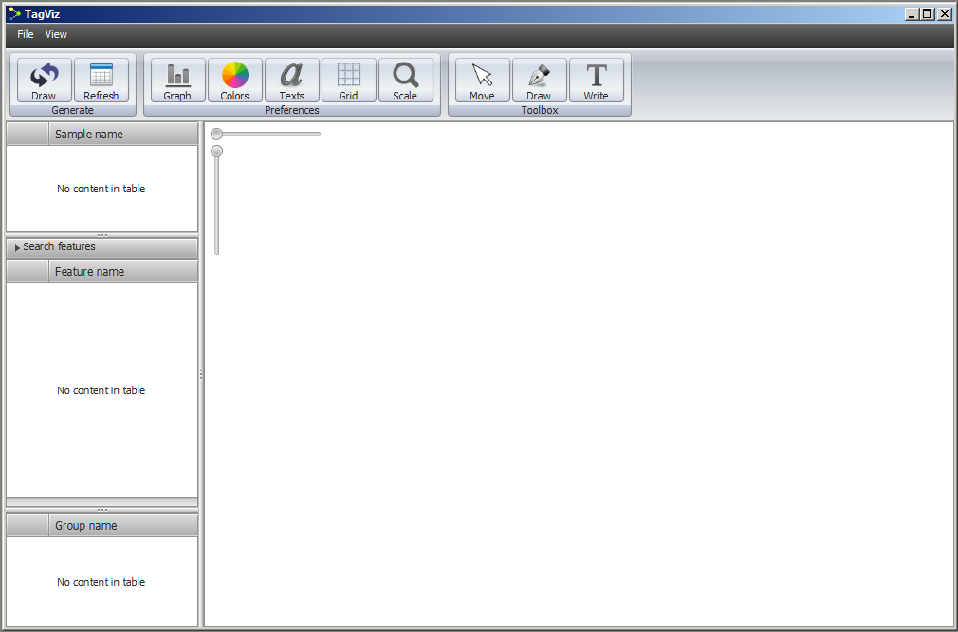

1. Top menu bar
2. Contol bar
3. Data tables
4. Graph scale sliders
5. Graph panel

## System requirements

TagViz is written in Java 7 and uses JavaFX 2.2 libraries. User must have Java version 7 installed on the computer before running the TagViz program.

# Data Management

## Data types

TagViz accepts data as a sample file or a group file. Sample and group files have to conform to specifications of acceptable file format and acceptable file structure.

### File format

Acceptable upload file formats are gzipped (.gz), text (.txt) or group (.group)

### Sample file structure

Sample file uses newline character as a row separator and tab as a column separator. There has to be the same number of columns for each row. The number of rows is not limited. The first row describes the data headers and will be used to populate the graph x-axis labels. All subsequent rows describe features and contain the plot data.

Figure 2.1 displays a simplified example of sample file structure. TagViz data parser will interpret sample columns as follows:

1. Feature name

2. Feature chromosome (type string)

3. Start value (type int)

4. End value (type int)

5. Ignored column

6…n Feature data (type double)

Figure 2.1. Example of sample file structure

|  |  |  |  |  |  |  |  |  |
| --- | --- | --- | --- | --- | --- | --- | --- | --- |
| #Gene | Ref | Start | End | Strand | -5000 | -4980 | -4960 | -4940 |
| CpG24 | chr1 | 1167000 | 1168985 | . | 1.844 | 1.800 | 1.862 | 1.895 |
| CpG27 | chr1 | 1173914 | 1174263 | . | 1.929 | 2.072 | 2.156 | 2.211 |
| CpG29 | chr1 | 327789 | 328229 | . | 0 | 0 | 0 | 0 |
| CpG94 | chr1 | 533218 | 534114 | . | 0.161 | 0.161 | 0.161 | 0.161 |
| CpG87 | chr1 | 1406843 | 140782 | . | 0 | 0 | 0 | 0 |
| CpG83 | chr1 | 1370766 | 1371449 | . | 0.438 | 0.438 | 0.438 | 0.438 |
| CpG25 | chr1 | 1322643 | 1322924 | . | 0.773 | 0.717 | 0.547 | 0.438 |

### Group file structure

Group file includes a list of feature names separated by tab characters. Figure 2.2 shows an example of group file structure. The purpose of the group file is to allow easy creation of subsets of features and calculating the average of the subset data. Therefore user should upload sample files before group files.

TagViz parser will read the contents of the group file and look for matches in the names of existing features. TagViz will ignore group file if it does not match any existing features.

Figure 2.2. Example of group file structure

21:NM_152486:SAMD11 22:NM_015658:NOC2L 23:NM_198317:KLHL17 28:NM_001142467:HES4 30:NM_198576:AGRN 32:NM_017891:C1orf159 39:NM_004195:TNFRSF18 41:NM_148902:TNFRSF18 45:NM_080605:B3GALT6 43:NM_016176:SDF4 44:NM_016547:SDF4 46:NM_001014980:FAM132A

## Uploading data

### Open sample

To upload a sample, navigate to the top menu bar and select:

*File > Open Sample*

Clicking on the menu option will generate the window illustrated in Figure 2.3.

Figure 2.3. Open Sample

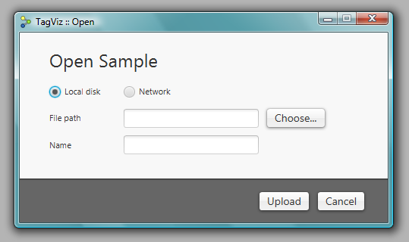

If the sample file is hosted on a local disk use the “Choose..” button to navigate to the sample. If the sample is hosted on a network server, select the network radio button and copy paste the URL of the sample file into the text field.

TagViz will automatically populate the sample name field, but if you wish to rename the sample and how it should appear in the system, enter the desired name in the name field. Finally, press the upload button.

After pressing the upload button, TagViz will attempt to retrieve and parse the requested file. A blue progress bar will appear in the interface to indicate upload process is being handled. After a sample is successfully read, the sample and its features will appear in the user interface as shown in Figure 2.4.

Figure 2.4. Processed sample

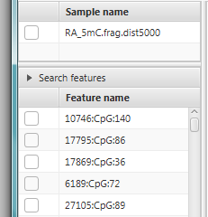

### Open group

To upload a group, navigate to the top menu bar and select:

*File > Open Group*

Clicking on the menu option will generate the window shown in Figure 2.5.

Figure 2.5. Open Group

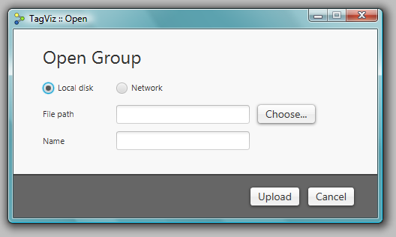

If the group file is hosted on the local disk use the “Choose..” button to navigate to the group file. If the group file is hosted on a network server, select the network radio button and copy paste the URL of the group file into the text field.

TagViz will automatically populate the group name field, but if you wish to rename the group and how it should appear in the system, enter the desired name in the name field. Finally, press the upload button.

After pressing the upload button, TagViz will attempt to retrieve and parse the requested file. A blue progress bar will appear in the interface to indicate upload process is being handled. After a group is successfully read, the group will appear in the user interface as shown in Figure 2.6.

Figure 2.6. Processed group

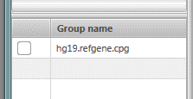

## Searching data

TagViz enables searching through uploaded features using a search function. To use this feature, navigate to the left of the interface, and look for a bar with label “Search features”. Clicking on the bar will toggle the visibility of the search field. The search field is displayed in Figure 2.7.

Figure 2.7. Search feature

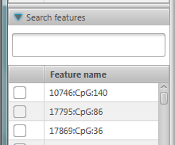

To search for specific features, type text into the search field and press ENTER. TagViz will search for matches in features whose name contains the substring entered into the search field. The search will list features that begin with the given search text first and then list all other features that contain but do not being with the given search text.

To clear the search results and redisplay a full list of features, either clear the input from the search field and press ENTER or click on the “Search features” bar. The latter will also hide the search field. Alternatively you can also reload all data tables, including features, by reloading data.

### Reloading data

Making changes to the data collection will automatically cause TagViz to reload data table lists displaying the data collections. However, to manually trigger data collections reload, use the top control bar and click on a button:

*Generate > Reload*

## Deleting data

### Delete sample

To delete a sample, navigate to the top menu bar and select:

*File > Delete Sample*

If there are no uploaded samples this option is disabled. Therefore uploading a sample is required before it can be deleted. Clicking on the “Delete Sample” menu item will generate the window displayed in Figure 2.8.

Figure 2.8. Delete Sample

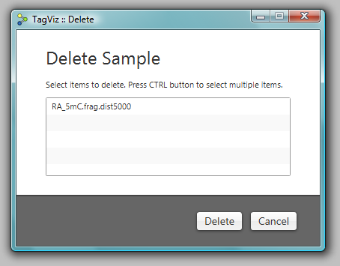

To delete a sample, click on the sample name and press the Delete button. To delete multiple samples, hold down CTRL on the keyboard, click on one or more sample names, and press the Delete button.

After pressing the Delete button TagViz will process the selection and delete the selected samples. The user interface will update and the sample and the features contained in the sample will no longer be visible in the lists of samples and features.

The list of feature names is a union of all features contained in the uploaded samples. Therefore if the same feature name exists in multiple samples, it will continue to display even if one of the samples is deleted. A feature name will be deleted when there are no references to that particular feature in the list of samples.

### Delete group

To delete a group, navigate to the top menu bar and select:

*File > Delete Group*

If there are no uploaded groups this option is disabled. Therefore uploading a group is required before it can be deleted. Clicking on the “Delete Group” menu item will generate the window displayed in Figure 2.9.

Figure 2.9. Delete Group

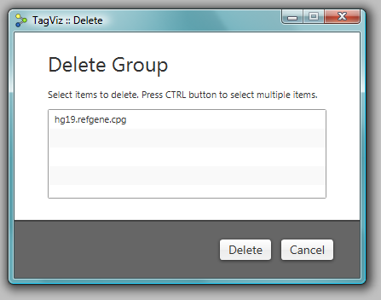

To delete a group, click on the group name and press the Delete button. To delete multiple groups, hold down CTRL on the keyboard, click on one or more group names, and press the Delete button.

After pressing the delete button TagViz will process the selection and delete the selected groups. The user interface will update and the selected groups will no longer be visible in the lists of groups.

# Graphing

## Generating a graph

Generating a graph requires that some data is first uploaded into the system. TagViz allows graphing a selection of samples, features, and groups.

To generate a graph navigate to the left of user interface and select the data items you wish to graph. Select one or more items from by clicking on the checkbox next to its name. Figure 3.1 illustrates selection of two features. To deselect a data item click on the checkbox again until the checkmark disappears. Alternatively, you can clear all checked items at once by navigating the top menu bar and selecting:

*View > Clear Data Selection*

Figure 3.1. Selecting data items

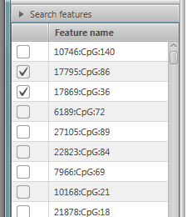

After selecting one or more items, click on the “Draw” button in the top left corner of the control bar. A graph will appear in the center graphing panel as shown in Figure 3.2.

Figure 3.2. Generated graph

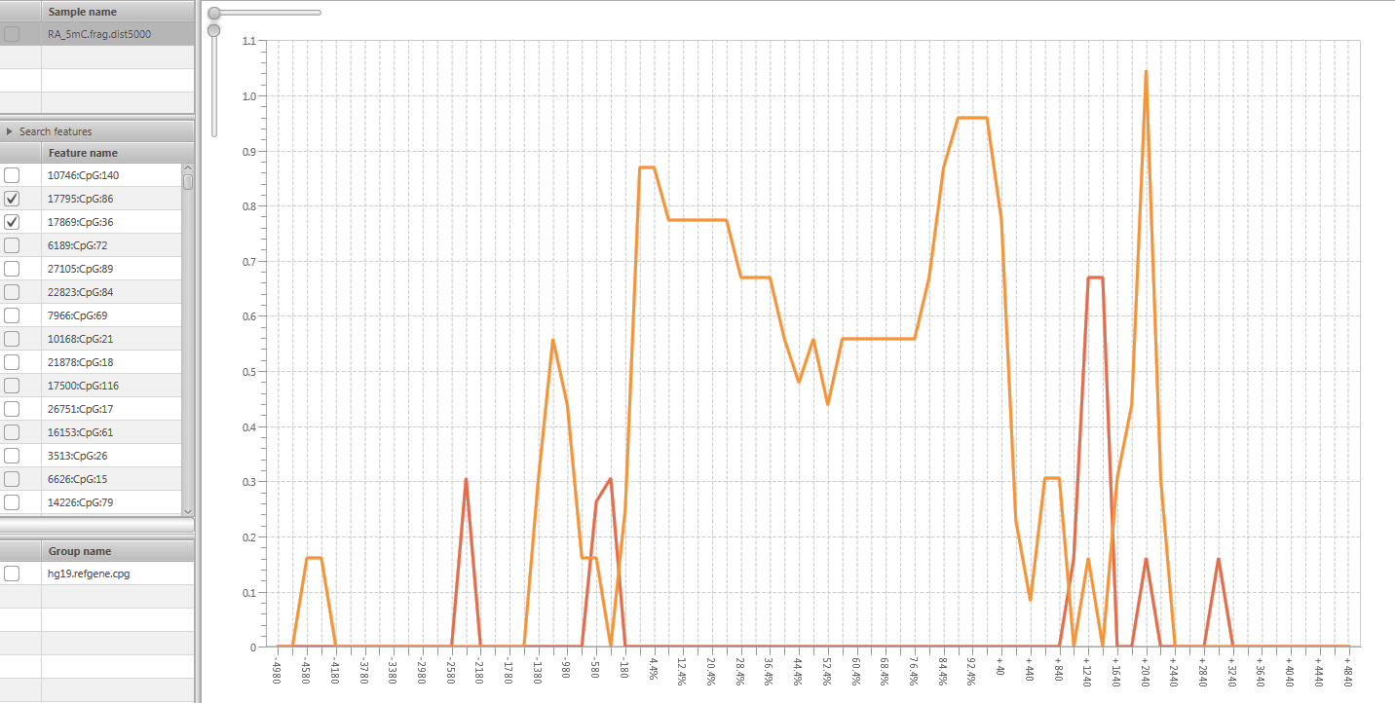

## Editing graph

TagViz allows customizing several aspects of the graph. Figure 3.3 displays the menu to control graph preferences.

Figure 3.3. Graph preferences menu

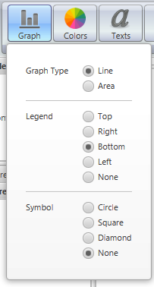

### Graph type

TagViz support two types of graphs: line and area. An area graph also includes a fill color, while line graph shows only a line. To change the type of graph navigate to:

*Preferences > Graph > Graph type*

Graph type will change as you change the current selection.

### Graph legend

TagViz allows customizing the position of the legend. The possible options are top, bottom, left, right, or none. Selecting none means no legend will be displayed.  
To change the legend position navigate to:

*Preferences > Graph > Legend*

Graph legend will change as you change the current selection.

### Graph symbol

TagViz allows customizing a data series symbol. Symbol appears along the graph data plot. The possible options are circle, square, diamond, or none. Selecting none means no symbol will be displayed. To change the symbol navigate to:

*Preferences > Graph > Symbol*

Graph symbol will change as you change the current selection.

## Editing colors

### Colors

TagViz allows customizing graph colors. You can change the following options: drawing area (graph background), graph area (plot background), graph border, graph title color, axes labels color, legend labels, legend background, x-axis gridlines, y-axis gridlines, tick labels (along axes), tick lines (along axes), symbol fill. These values can be set to any color in the RGB range. The graph colors menu is shown in Figure 3.4. To change any of the color options navigate to:

*Preferences > Colors*

Graph colors will change as you change the current selection.

Figure 3.4. Graph colors menu

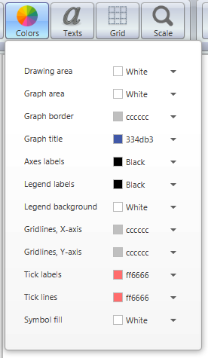

### Series colors

TagViz also allows customizing data series colors. To change a plot color, hover over the specific series line or area until the mouse cursor changes to a hand. Then right click on the mouse and a context menu will appear. For a line graph there is an option to change the line color. For an area graph there is an option to change the line color and area fill color. Changing the current selection will change the series color respectively. Figure 3.5 demonstrates the context menu for changing series options.

Figure 3.5. Series options menu for line graph

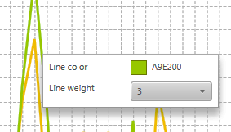

## Editing text and fonts

TagViz allows setting and changing graph title and axes labels. These are all optional and can also be left blank. Figure 3.6 shows the menu for editing text and fonts.

Figure 3.6. Graph text menu

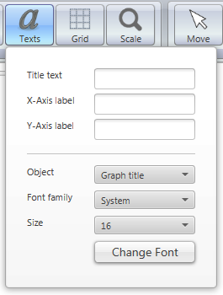

### Graph title

TagViz allows customizing graph title. To set or change the graph title navigate to:

*Preferences > Texts > Title text*

Type text in the text field and press ENTER. Graph title will change after pressing the ENTER key.

To change graph title font, navigate to:

*Preferences > Texts > Object > Graph title*

If or once the object is set to graph title, you will see the current settings for title font in the “Font family” and “Size” comboboxes. Font family lists all fonts found in your system, and sizes a preconfigured to range between 6-57 pixels. To change the settings select a font family and/or font size and press “Change font” button. Graph title will update after the button is clicked.

### X-Axis label

TagViz allows customizing x-axis label. To set or change the x-axis label navigate to:

*Preferences > Texts > X-Axis label*

Type text in the text field and press ENTER. X-axis label will change after pressing the ENTER key.

### Y-Axis label

TagViz allows customizing y-axis label. To set or change the y-axis label navigate to:

*Preferences > Texts > Y-Axis label*

Type text in the text field and press ENTER. Y-axis label will change after pressing the ENTER key.

### Axes font

TagViz allows customizing axes font. The axes font is controlled by the same variable and therefore cannot be set to different values for each axis.

To change the axes font, navigate to:

*Preferences > Texts > Object > Axes*

If or once the object is set to Axes, you will see the current settings for axes font in the “Font family” and “Size” comboboxes. Font family lists all fonts found in your system, and sizes a preconfigured to range between 6-57 pixels. To change the settings select a font family and/or font size and press “Change font” button. Axes will update after the button is clicked.

### Tick labels font

Tick labels are texts that appear along the axes. TagViz allows customizing tick labels fonts. The axes fonts are controlled by the same variable and therefore cannot be set to different values for each axis. To change the tick labels font navigate to:

*Preferences > Texts > Object > Tick labels*

If or once the object is set to Tick labels, you will see the current settings for tick labels font in the “Font family” and “Size” comboboxes. Font family lists all fonts found in your system, and sizes a preconfigured to range between 6-57 pixels. To change the settings select a font family and/or font size and press “Change font” button. Tick labels will update after the button is clicked.

### Legend labels font

Legend labels are texts that appear inside the graph legend. TagViz allows customizing legend labels fonts. To change the legend labels font navigate to:

*Preferences > Texts > Object > Legend labels*

If or once the object is set to Legend labels, you will see the current settings for legend labels font in the “Font family” and “Size” comboboxes. Font family lists all fonts found in your system, and sizes a preconfigured to range between 6-57 pixels. To change the settings select a font family and/or font size and press “Change font” button. Legend labels will update after the button is clicked.

## Editing grid and lines

TagViz allows customizing graph grid lines, tick marks and labels visibility, tick interval and max count, and tick width and length. The width of each data series line can also be customized.

Figure 3.7. Grid menu

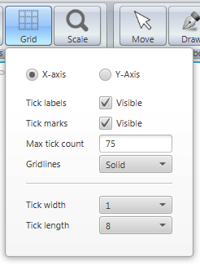

TagViz allows customizing several properties of the axes and these options are listed under grid menu shown in Figure 3.7. To change x-axis options first check that X-axis radiobox is selected, then proceed to change the options. To change y-axis options first check that Y-axis radiobox is selected, then proceed to change the options.

### Axes tick labels

Axes tick labels are text that appear along a specified axis. TagViz allows customizing the visibility of tick labels individually for each axis.

To toggle tick labels visibility, navigate to:

*Preferences > Grid > tick labels*

Tick labels will be visible when the checkbox is checked.

### Axes tick marks

Axes tick marks are lines that appear along a specified axis. TagViz allows customizing the visibility of tick labels individually for each axis.

To toggle tick marks visibility, navigate to:

*Preferences > Grid > tick marks*

Tick marks will be visible when the checkbox is checked.

### Axes tick max count

Tick max count controls the number of data plot points. The plot item number will not exceed the specified number of tick max count. If data item contains more values than the given maximum, the interval will adjust accordingly. The max tick count directly affects graphing performance: the higher the number of values, the longer it takes to generate the graph.

TagViz allows customizing the tick max count individually for each axis. To change tick max count, navigate to:

*Preferences > Grid > tick interval*

Enter a number in range 1-999 and press enter to change tick interval. To visualize the change in a graph after changing tick count value, select:

*Generate > Draw*

After clicking the Draw button TagViz will generate a graph implementing the max tick count setting.

### Axes gridlines

Gridlines are horizontal and vertical lines in the graph area background. TagViz allows customizing the appearance of gridlines individually for each axis. To change the gridlines navigate to:

*Preferences > Grid > Gridlines*

Select an option from the dropdown menu. Changing the current selection will update the setting.

### Tick width and length

Axes ticks are lines and associated labels that appear along an axis. TagViz allows customizing the width and length of tick marks. This option is controlled by the same variable therefore changing this option applies to both axes.

To change tick width, navigate to:

*Preferences > Grid > Tick width*

Select and option from the dropdown menu and graph axes tick lines with will update accordingly.

To change tick length, navigate to:

*Preferences > Grid > Tick length*

Select and option from the dropdown menu and graph axes tick lines with will update accordingly

### Series line width

TagViz also allows customizing data series width. To change a series line width, hover over the specific series line or area until the mouse cursor changes to a hand. Then right click on the mouse and a context menu will appear. Change the line width and the series line width will change accordingly.

## Editing scale

TagViz allows customizing the axis scale. The scale can be changed individually for each axis. The axes’ scale sliders are located in the graphing area, as shown in Figure 3.8. The scale range is 1-2.5 and defaults to 1. When scale value is set to one the size of the graph fills the graph panel width and height with no overlap.

Figure 3.8. Axis scale sliders

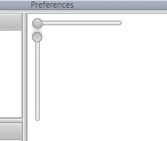

### X-axis scale

X-axis scale can be changed by hovering over the horizontal x-axis slider. Click on the control ball and drag mouse left or right to change the value. Graph x-axis scale will adjust accordingly. To see the current X-axis scaling factor, hover over Scale button in the top control bar.

### Y-axis scale

Y-axis scale can be changed by hovering over the vertical y-axis slider. Click on the control ball and drag mouse up or down to change the value. Graph y-axis scale will adjust accordingly. To see the current Y-axis scaling factor, hover over Scale button in the top control bar.

### Resetting scales

To reset scales to default values, navigate to top control bar and select:

*Scale > Reset axis scales*

This option is displayed in Figure 3.9. The graph axes will reset to value 1, and the graph will be fitted to the width and height of the graph panel with no overlap.

Figure 3.9. Scale menu

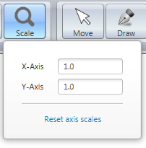

# Graphing tools

## Tools overview

TagViz provides multiple tools for further edit the appearance of a generated graph. To use these tools, user must first upload sample data and generate a graph. The tools are located in the control bar on top of the user interface, as show in figure 4.1.

Figure 4.1. Editing tools

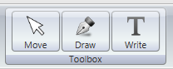

## Move tool

The move to allows moving a graph once its size exceeds the size of the graphing area. To enable the move tool, click on the move button. When move tool is enabled, hovering over the graph will show a hand cursor.

## Draw tool

Draw tool allows free-hand drawing over the graph area. To enable the draw tool, click on the draw button. When draw tool is enabled, hovering over the graph will show an arrow cursor.

### Drawing a line

To begin drawing press down on the left mouse button and continue to keep it down as you drag along the graph area. To stop drawing release the mouse button.

### Deleting a line

To delete a single drawing path, use the mouse and right-click over it. This will cause a single free-hand drawing to disappear from the graphing area.   
  
Alternatively, you can delete all drawings at once by navigating to:

*Tools > Draw > Clear drawings*

Deleting all drawings will leave the graph and possible custom text fields in place, but will erase all free-hand drawings.

## Write tool

Write tool allows adding custom texts over and around the graph area. To enable the write tool, click on the write button. When write tool is enabled, hovering over the graph will show a text cursor.

### Creating text

To begin writing, click somewhere on the graph area. TagViz will generate a text field width gray border and prompt text “Enter text” as shown in Figure 4.2. Change the text value by clicking on the field and typing, as shown in Figure 4.3. A finished label will show the text on a transparent background, as shown in Figure 4.4.

Figure 4.2. Created text field



Figure 4.3. Entering text



Figure 4.4. Final appearance



The size of the text field grows with respect to the length of the text and according to the selected font. There is no upper limit on how many text labels can be added to the screen at any given time.

### Moving text

You can move labels to any position by hovering over the text border. Once the cursor changes to a moving cursor, you can drag the text to any position on the graph area.

### Deleting text

To delete a single text field, use the mouse and right-click over it. This will cause a single text field to disappear from the graphing area.   
  
Alternatively, you can delete all text fields at once by navigating to:

*Tools > Write > Clear texts*

Deleting all texts will leave the graph and possible free-hand drawings in place, but will erase all custom text fields.

# Exporting graphs

## Export overview

TagViz allows saving a generated graph as an image or as a pdf file. The function will save an exact image of what is in the graph area excluding the scaling bars shown in Figure 3.8. This means it includes any changes to axes scaling and application of draw and write tools.

## Export as PNG

This feature will save an image of the generated graph. To being export, navigate to the top left menu bar and select:

*File > Export Graph > Export As PNG*

Clicking on the option will display a file chooser dialog that request a file name and file type. File type is preset to PNG and there are no other options. File name can be set freely. After setting the filename click “Save”. TagViz will then generate a snapshot of the graph area and save it as PNG image in the specified location.

The dimensions of the generated image are relative to the actual size of the graph area.

## Export as PDF

This feature will save a pdf file of the generated graph. To being export, navigate to the top left menu bar and select:

*File > Export Graph > Export As PDF*

Clicking on the option will display a file chooser dialog that request a file name and file type. File type is preset to PDF and there are no other options. File name can be set freely. After setting the filename click “Save”. TagViz will then generate a snapshot of the graph area and save it as a pdf file in the specified location.

The pdf document defaults to 1-page letter size. If the graph width exceed its heights, the generated pdf will be landscape, else it will be portrait. If the graph is scaled and the size of the graph exceeds the size of 1 letter page, the graph will scale down to fit the page size.

## Show export

TagViz enables setting an option to launch a generated PNG or PDF file upon export. This option is located in the menu bar, and can be change by navigating to:

*File > Export Graph > Display file*

If the checkbox is checked, TagViz will open an exported file automatically upon completion of the export function. If the checkbox is not checked, TagViz will generate the file but not open it for preview.

# Other functionality

## Saving preferences

TagViz will automatically save graph preferences such as graph type, colors, fonts etc. This functionality is enabled by default and will execute whenever preferences are changed. The settings will be saved in the same file where the executable application is saved, so it is advisable to save the application in a writable directory. The preferences are saved in a file titled “settings”. If this file is deleted or corrupted, graph preferences are set to their defaults.

## Sidepanel visibility

To enhance analyzing the graph, it is possible to toggle the visibility of both data panels on the left and control bar on top of the user interface.

### Show sidepanels

To hide both panels, press CTRL+1, or use the top menu bar and navigate to:

*View > Collapse Sidepanels*

### Hide sidepanels

To show both panels, press CTRL+2, or use the top menu bar and navigate to:

*View > Show Sidepanels*

### Hide data panel only

To adjust the size and/or visibility of data panels only, bovver over the vertical separator between the data panels and the graph area, click and drag the mouse. Dragging to the left will reduce the width or hide the panel, and dragging to the right will increase its width.

## Clearing options

### Clear graph

To clear a generated graph, navigate to top menu bar and select:

*View > Clear Graph Panel*

Clicking the option will cause the center graphing panel to be cleared of all drawings to include the graph and any free-hand drawings or custom text labels.

### Clear selection

To enable one-click deselecting of graph data, navigate to top menu bar and select:

*View > Clear Data Selection*

Clicking the option will cause the all selected data items to be deselected and the data tables to reload.

## Errors

TagViz will generate error messages when invalid requests occur. The error message appears in the top right corner of the user interface. The error message includes a header and short description of the cause. Error messages fade automatically after a few seconds, or it can be hidden immediately by clicking on a “X” icon in the top right corner. Figure 6.1 shows a sample error message.

Figure 6.1. Error message

