Spotify Song Mood Detection
Using Audio Features
Final Project Report
Winter in Data Science (WIDS)
Level-1 (Basic) Project

1. Introduction & Motivation

When I first heard about this project on Spotify song mood detection, I felt both excited and terrified at the same time. The excitement came from the idea of working with real music data – something I actually care about and listen to every day. The terror came from the fact that I had never done any machine learning project before.

And the word"dataset" itself sounded intimidating. I remember opening the Spotify dataset for the first time and just staring at rows and rows of numbers, feeling completely lost. There were terms like "acousticness," "valence," and "instrumentalness" that I had never encountered before.

I chose this project because I wanted to understand how music streaming platforms recommend songs to us. I had always wondered: How does Spotify know what mood I am in? Can a computer really understand if a song is happy or sad just by looking at numbers? These questions fascinated me, and I wanted to find answers through this project. My initial expectation was that I would simply follow some tutorial, run some code, and get results. The reality turned out to be very different – and much more educational.

In the beginning, I struggled to even understand what each column in the dataset meant. What is the difference between "energy" and "loudness"? Why do we need "tempo" and "time_signature" separately? These questions kept piling up, and I realized that before jumping into machine learning, I needed to understand the data itself. This project became my journey from confusion to clarity, from fear of code to confidence in building models. As a complete beginner, every small success – whether it was creating my first graph or getting my first model to run without errors – felt like a major achievement.

2. DATASET DESCRIPTION

The dataset used for this project is the Spotify Audio Features Dataset from Kaggle. It contains around 114,000 songs across 114 different genres. Each song has various audio features that Spotify's algorithms extract automatically.

Key Audio Features

Danceability: How suitable a track is for dancing (0.0 to 1.0)
Energy: Intensity and activity level of the track (0.0 to 1.0)
Loudness: Overall volume in decibels (-60 to 0 dB)
Valence: Musical positiveness - happy vs sad (0.0 to 1.0)
Tempo: Speed of the track in BPM
Acousticness: Whether the track uses acoustic instruments (0.0 to 1.0)
Instrumentalness: Predicts if track has no vocals (0.0 to 1.0)
The target variable is 'track_genre', which represents the music genre we're trying to predict. With 114 genres, this is a challenging classification task.

3. METHODOLOGY

3.1 Data Preprocessing
First, I checked for missing values and removed any rows that had them. Then I selected 11 numerical features for training: danceability, energy, popularity, loudness, speechiness, acousticness, instrumentalness, liveness, valence, tempo, and time_signature. Features like track_id and track_name were excluded since they're not useful for machine learning.

3.2 Exploratory Data Analysis
I created various visualizations to understand the data better. This included histograms to see feature distributions, correlation heatmaps to find relationships between features, and boxplots to compare energy levels across different genres. This step helped me understand which features are important and how different genres differ from each other.

3.3 Feature Scaling
I used StandardScaler to normalize all the features. This is important because features like loudness (ranging from -60 to 0) and danceability (ranging from 0 to 1) are on different scales. Standardization makes sure all features contribute equally to the model.

3.4 Model Training
The dataset was split into 80% training data and 20% testing data. I trained three different models:
Logistic Regression: A simple linear model that finds straight-line boundaries between classes.
K-Nearest Neighbors (KNN): Classifies songs based on the 5 most similar songs in the training data.
Decision Tree: Makes predictions by asking a series of yes/no questions about the features.

3.5 Evaluation
I evaluated the models using accuracy (percentage of correct predictions) and confusion matrices to see where the models were making mistakes.

4. RESULTS AND DISCUSSION

4.1 Data Distribution

Figure 1 shows how energy is distributed across all songs. Most songs have high energy levels (between 0.5 and 1.0), with a peak around 0.9. This makes sense since the dataset includes a lot of pop, rock, and electronic music.

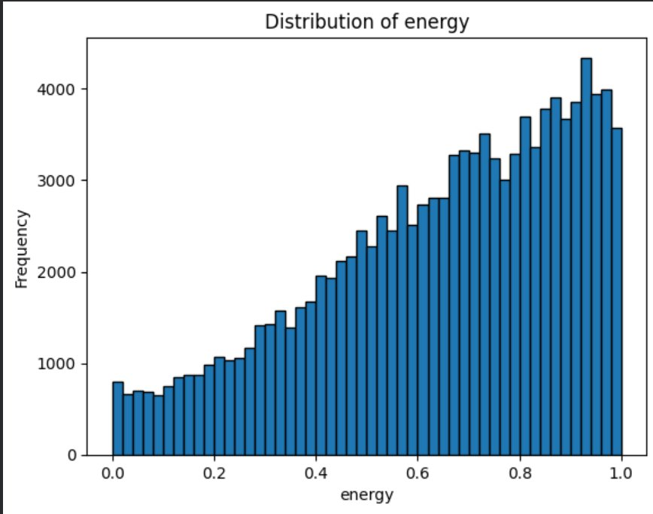
Figure 1: Distribution of Energy values

4.2 Feature Correlations

The correlation heatmap (Figure 2) shows how different features relate to each other. Strong positive correlation (red) means features increase together, while strong negative correlation (blue) means when one increases, the other decreases.
Key findings: Energy and loudness are strongly correlated (0.76), meaning energetic songs are usually loud. Energy and acousticness are negatively correlated (-0.73), meaning high-energy songs are usually electronic, not acoustic.
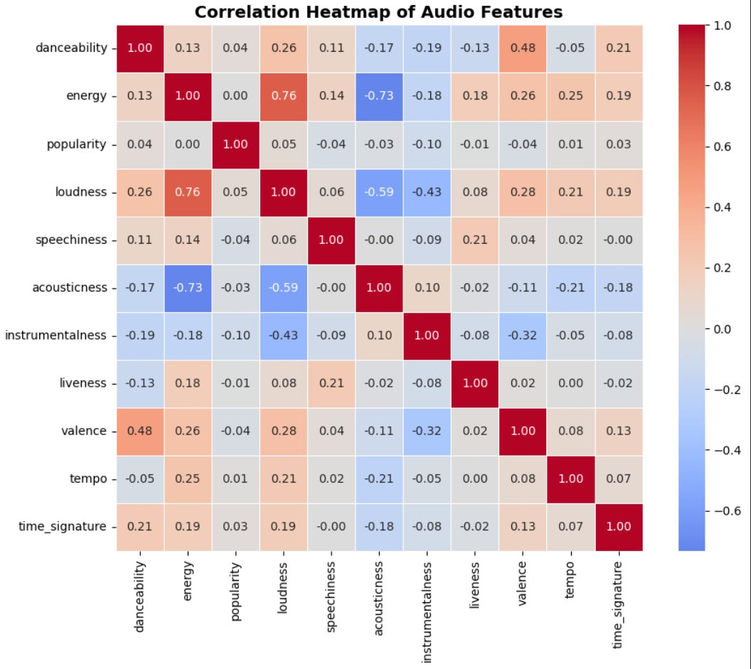
Figure 2: Correlation Heatmap of Audio Features

4.3 Energy Across Genres

Figure 3 compares energy levels across different genres. Black-metal and alt-rock have consistently high energy, while ambient music has very low energy. Genres like blues and brazil show more variation, with both calm and energetic songs.

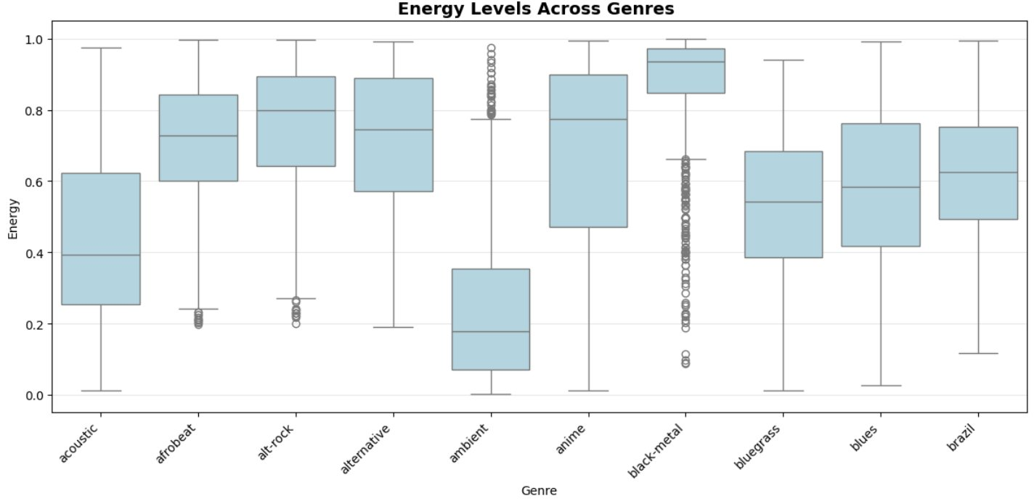
Figure 3: Energy Levels Across Different Genres

4.4 Model Performance
Figure 4 shows the accuracy of all three models. The results were:
• K-Nearest Neighbors: 20.13% accuracy
• Logistic Regression: 18.24% accuracy
• Decision Tree: 9.20% accuracy
These numbers might seem low, but remember we're trying to classify 114 different genres. Random guessing would only give 0.88% accuracy, so our models are actually performing about 20 times better than random. KNN performed the best because it can capture complex patterns in the data.
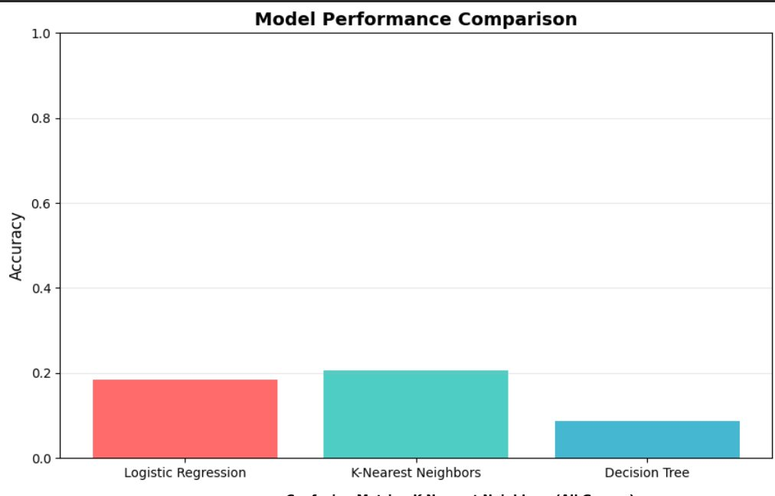
Figure 4: Model Performance Comparison

4.5 Testing on a Real Song
To test if the model works on real songs, I tested it on "Waka Waka" by Shakira. The song has these features:
• Danceability: 0.76 | Energy: 0.87 | Valence: 0.75 (happy mood)
• Loudness: -6 dB | Acousticness: 0.01 (electronic)
• Tempo: 138 BPM (fast-paced)
Result: All three models predicted the genre as "pop", which is correct! This shows that the models can actually work on new songs they've never seen before.

CONCLUSION
This project successfully built machine learning models to classify music genres using Spotify audio features. K-Nearest Neighbors performed the best with 20.13% accuracy on a challenging 114-genre classification task. The models were able to correctly predict the genre of "Waka Waka" by Shakira, showing they can work on real-world songs.

Key Learnings
• Understanding real-world data and how to clean it
• Creating meaningful visualizations to explore data
• Training and comparing different ML models
• Evaluating model performance on test data
• This was a Level-1 basic project and I did not attempted the advanced level project (optional) but I really enjoyed and learned a lot from this project.

