1. SELECT COUNT(Active)

FROM Employees

WHERE Active=1

1. SELECT JobPosition, COUNT(JobPosition)

FROM Employees

GROUP BY JobPosition

1. SELECT FirstName, LastName

FROM Employees

WHere Salary>=2000

4. SELECT JobPosition

FROM Employees

GROUP BY JobPosition

HAVING AVG(Salary)>=2000

1. SELECT FirstName, LastName

FROM Employees

WHERE ManagerID=(SELECT ManagerID FROM Managers WHERE FirstName like 'M*')

1. select e.FirstName, e.LastName, e.ManagerID, m.ManagerID from Employees e  
   right join Managers m

on e.ManagerID = m.ManagerID

|  |  |  |  |
| --- | --- | --- | --- |
| **FirstName** | **LastName** | **ManagerID** | **ManagerId** |
| John | Smith | 147 | 147 |
| Victoria | Mush | 147 | 147 |
| Harry | Thomason | 258 | 258 |
| Null | Null | Null | 369 |

Задание 2:

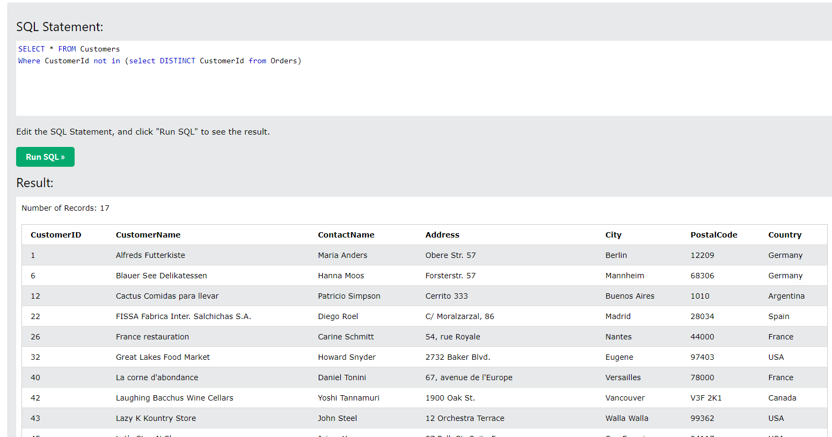

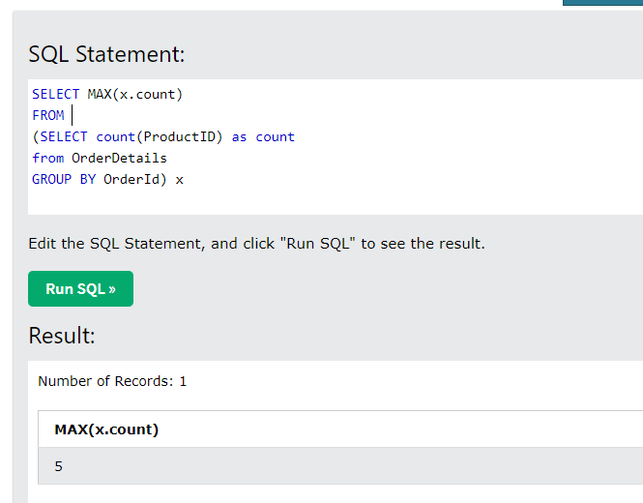

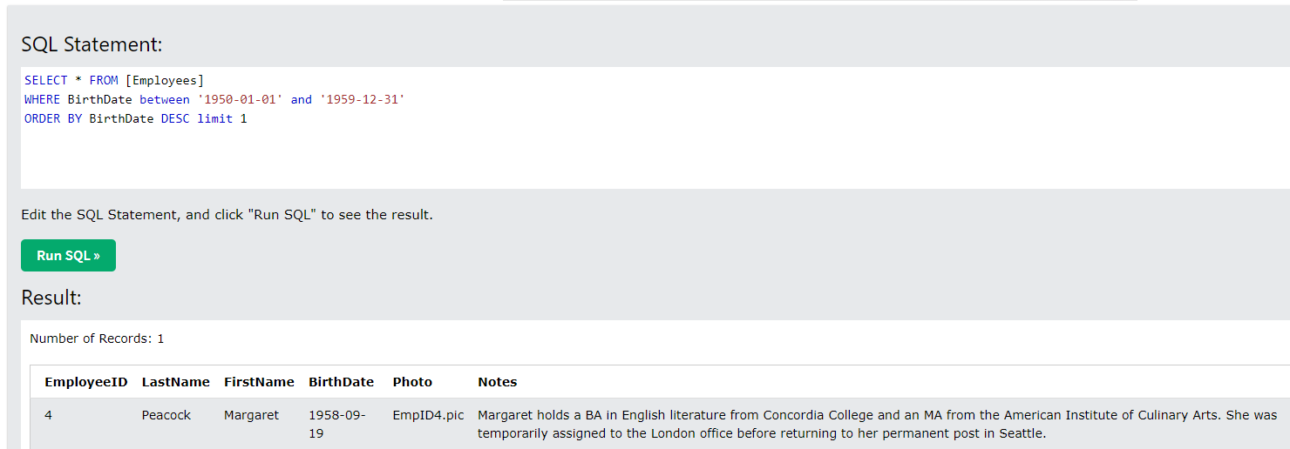

4.

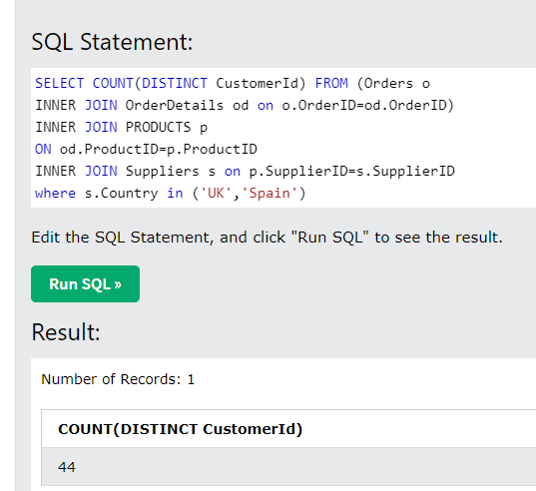

5.

FROM (SELECT * FROM Employees

Union ALL

SELECT * FROM Employees

Where LastName='Dodsworth' and FirstName='Anne')

Group by LastName

Having Count(*)>1

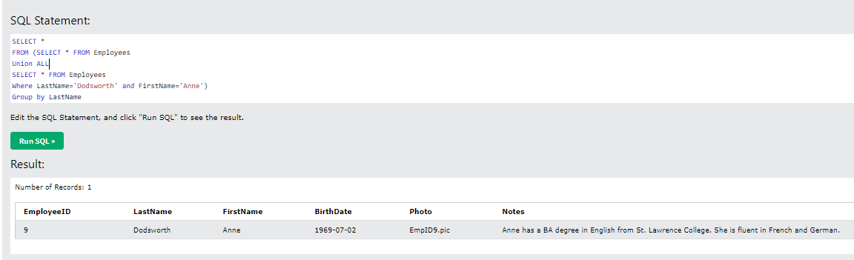

6.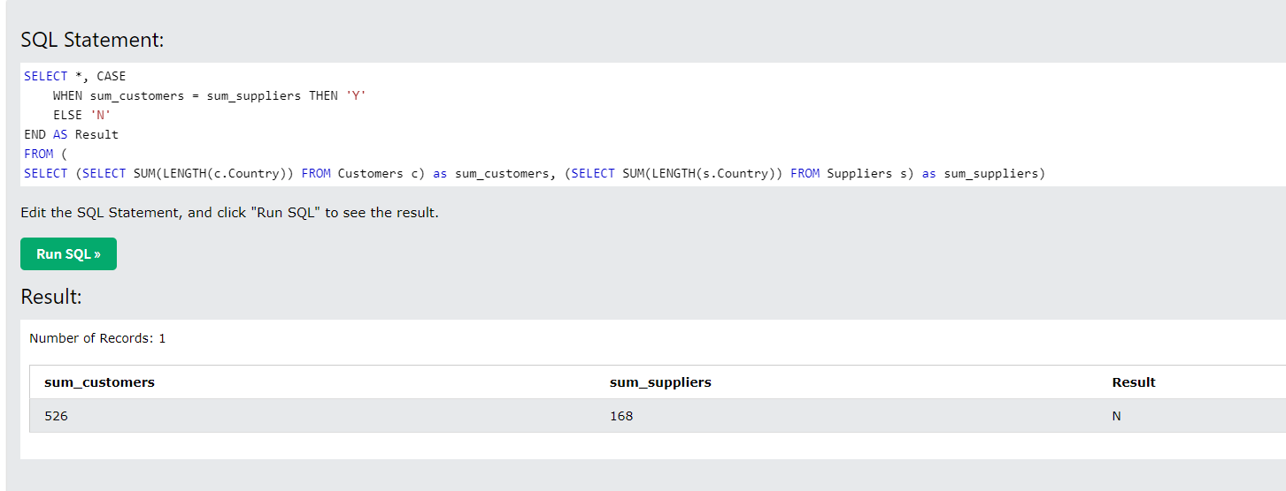

b) SELECT length(cus.country) as customer_country, length(sup.country) as supplier_country,

CASE

WHEN length(cus.country) = length(sup.country) THEN "Y"

ELSE "N"

END as Result

from

CUSTOMERS cus

INNER JOIN ORDERS o on cus.CustomerID=o.CustomerID

INNER JOIN OrderDetails od on o.OrderID=od.OrderID

INNER JOIN Products pr on od.ProductID=pr.ProductID

INNER JOIN Suppliers sup on sup.SupplierID=pr.SupplierID

7.

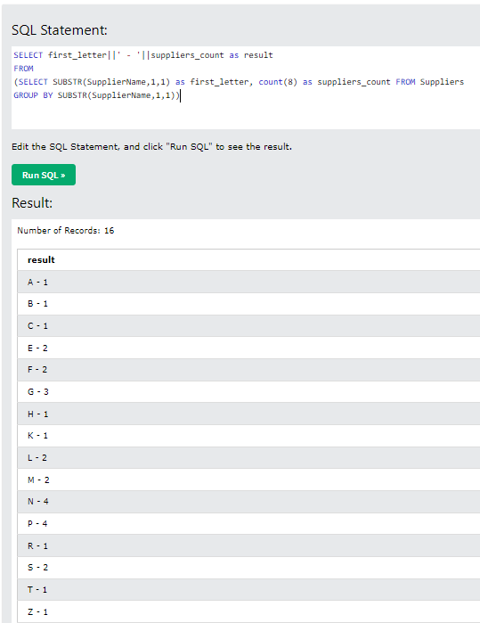

8.

SELECT DISTINCT o.CustomerID, c.CustomerName FROM Orders o

INNER JOIN Customers c on o.CustomerID=c.CustomerId

INNER JOIN OrderDetails od on o.OrderID=od.OrderID

INNER JOIN (SELECT * FROM Products ORDER BY Price DESC limit 2) p ON p.ProductID=od.ProductID

ORDER BY o.CustomerID