Chapter 1 – Proof of concept with Realsense-d435i

Summary:
The first stage of the project is to test our ability to run VINS-mono on a high-performance camera and IMU – in this case, the RBG global shutter camera of an intel-realsense d435i. We started with attempting to use the mounted IMU – but as it’s not synchronized with the RBG camera, and publishes a different topic for accelerometer and for gyroscope (with the union methods resulting in disordered time stamps), we end up using a bosch-bno055 IMU.
To run VINS-mono, we had to calibrate the camera and IMU, first separately, using imu_utils and Kalibr, and then synchronize between them, also using Kalibr.
With the calibration results we ran VINS-mono with relatively high accuracy.

Perquisites:
- Our github page, for configuration and launch files:
  - https://github.com/omer-gavish/ros_proj
- A linux distribution with kernel version over 4.8, and lower than 4.16 (Ubuntu 16, for instance).
- Many modules in the project depend on ceres-solver to solve non-linear equations. Follow the installation guide.
  - http://ceres-solver.org/installation.html
- Install ros-kinetic. Follow the installation guide up to creating your catkin_workspace.
  - http://wiki.ros.org/kinetic/Installation/Ubuntu
- Install the bno055_usb_stick ros package.
  - https://github.com/yoshito-n-students/bno055_usb_stick
- Install realsense-SDK and realsense-ros ros package.
  - https://github.com/IntelRealSense/librealsense/blob/master/doc/installation.md#video4linux-backend-preparation
  - https://github.com/IntelRealSense/realsense-ros
- For calibration, install imu_utils, Kalibr ros packages.
  - https://github.com/gaowenliang/imu_utils
  - https://github.com/ethz-asl/kalibr
- Install VINS-mono ros package.
  - https://github.com/HKUST-Aerial-Robotics/VINS-Mono

Calibration:
Start ros by typing ‘roscore’ in terminal. Throughout the calibration process, make sure to source devel workspace if it’s not in your .bashrc.

IMU Calibration
Before calibrating, copy the bosch.launch file from our github to imu_utils/launch. Connect the IMU, and make sure it remains stationary throughout the calibration process.
Open two terminals. In one, start the IMU node (left terminal in figure 1), in the other the calibration node (right terminal in figure 1). Wait 30 minutes for results. Logs and a summary will be created in imu_utils/data/bosch*.

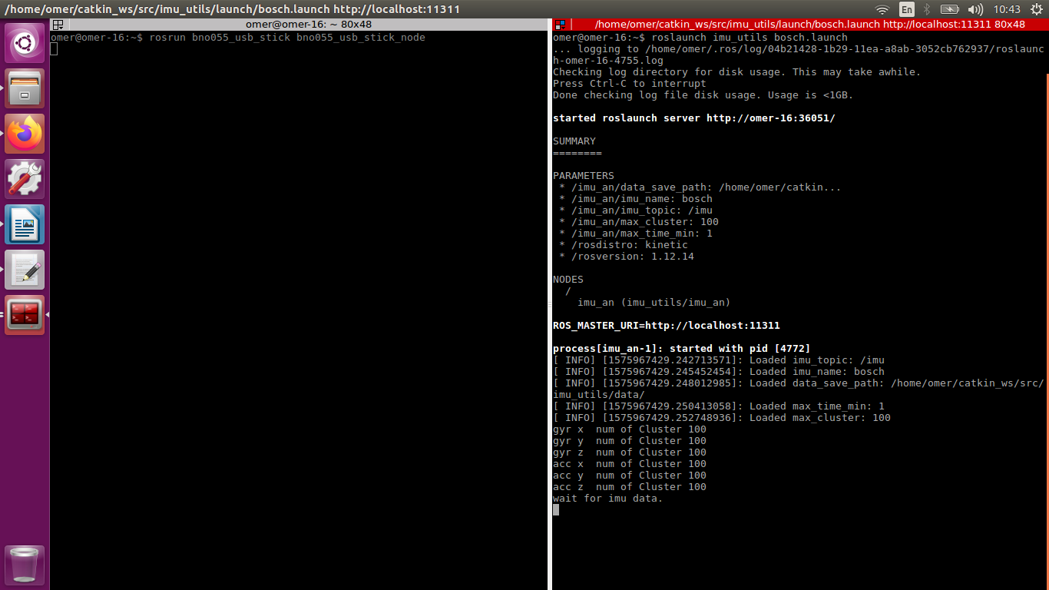
Figure 1: IMU Calibration

Camera Calibration
Make sure the IMU is still connected, and connect (USB3.*) the realsense camera.
Print the april grid in our github, measure it, and edit the april_grid.yaml accordingly.
Open three terminals. In one, start the IMU node, in the other the realsense node.
In the third, record a bag file the /camera/color/image_raw and /imu topics, according to the instructions in Kalibr’s github (figure 2).

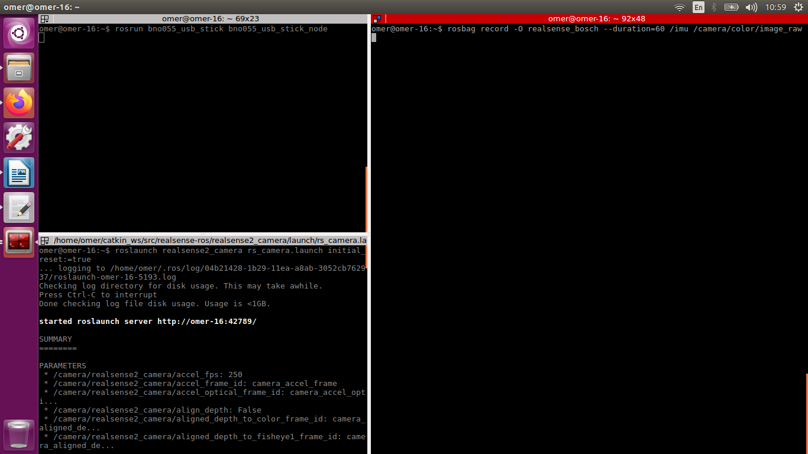
Figure 2: Camera Calibration
to calibrate run: kalibr_calibrate_cameras --model pinhole-radtan --target april_6x6.yaml --bag [].bag --topics /camera/color/image_raw replacing [] with a path to the bag file you just recorded. This might take a while to complete. The results will be written to []-camchain.yaml.

Synchronize IMU-Camera
edit the IMU calibration results to match Kalibr format, as seen in their example data set.
Run: kalibr_calibrate_imu_camera --cams [0].yaml --bag [1].bag --imu [2].yaml --target april_6x6.yaml, replacing [0] with the camera calibration results, [1] with your bag file, [2] with the edited IMU calibration results file.

VINS-mono:

Config:
Copy the vins_configuration file from our github to the VINS-Mono/config – edit camera intrinsic parameters with the results of camera calibration, imu_camera extrinsic parameters with the result of camera-imu synchronization, and imu parameters with the results of imu calibration.
In addition:
- Set estimate_extrinsic to 1: this will enable vins-mono to optimize around the camera-imu synchronization results.
- Set estimate_td to 1: the time offset between the camera and imu data is not constant. Enable online estimation.
- Set rolling_shutter to 1: we’re using a rolling shutter camera.
- Set rolling_shutter_tr to 0.03. (We ran a feature of Kalibr to estimate this as well, as we couldn’t find this value in the realsense datasheet. Got a result close to .3, couldn’t see major differences in performance when changing it back and forth).
- Set freq in feature tracker to as high as you can, up to to /camera/color/image_raw frequency. How high one can go depends on your setup, we stopped at 20 Hz as opposed to the topic’s 30 Hz.
- If tracking still drifts wildly, multiply imu parameters by a factor of 10, or even 100. This’ll optimize the Kalman gain of the algorithm to heavily rely on the camera.
- Edit output_path to an existing path that you set up for logs.

Execution:
- Copy the vins_mono.launch file from our github.
- Open 4 terminals (figure 3, 4):
  - In one, start vins-mono node.
  - In the second, start vins_rviz.
  - In the third and fourth terminals, start realsense-camera node and the imu node.

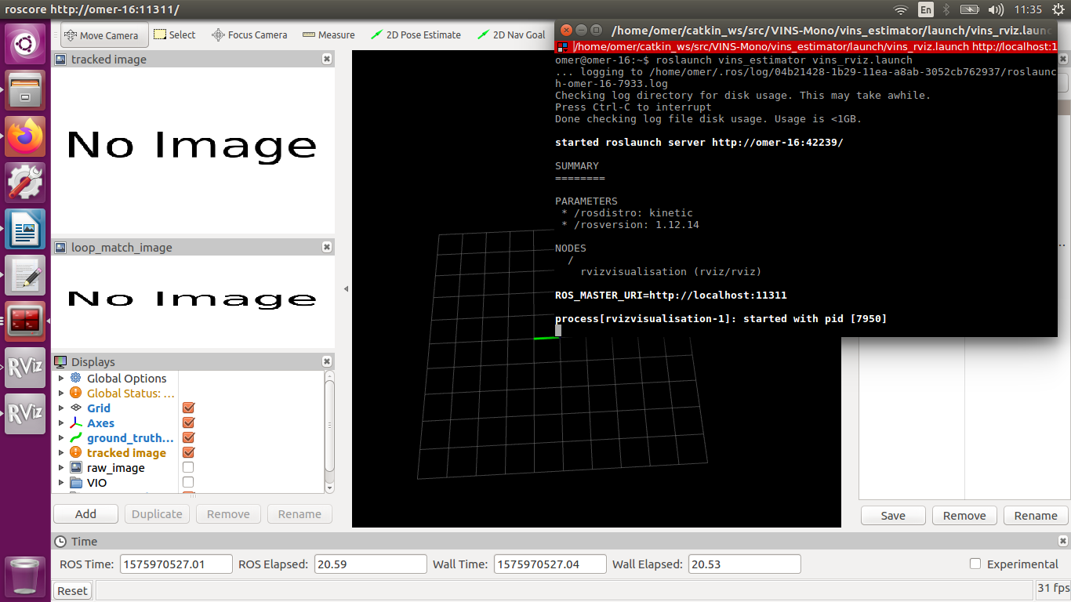
Figure 3: Rviz
Vins-mono will take a couple of seconds with camera & imu excitation to optimize the camera-imu synchronization values. When it’s done you’ll see the estimated position in the vins-mono node terminal, and a graphical representation in rviz (figure 5).
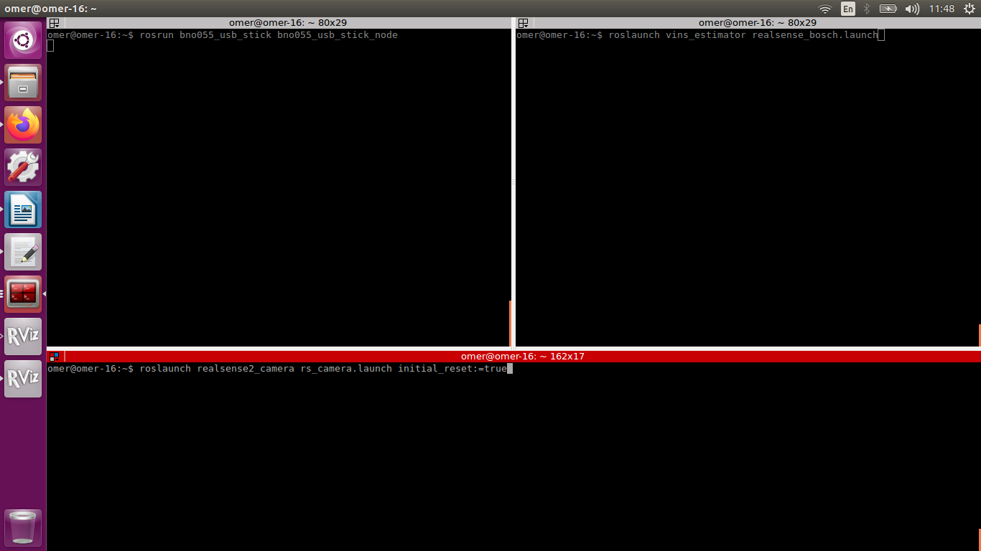
Figure 4: imu, camera and vins node

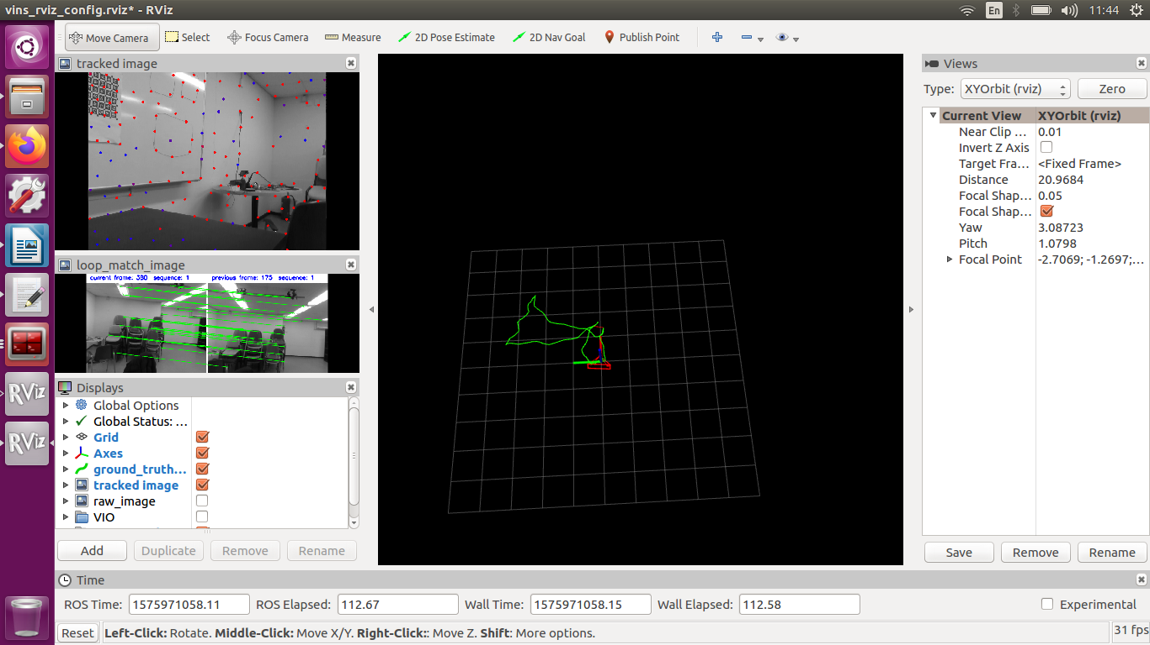
Figure 5: vins demo

