- Preparing the PI
  - Burn the official Raspbian image (https://www.raspberrypi.org/downloads/raspbian/) using Etcher (https://www.balena.io/etcher/) to a 64Gb SD card. Insert the card to an RPI-4b and plug it in.
  - Do a firmware update (https://jamesachambers.com/raspberry-pi-4-bootloader-firmware-updating-recovery-guide/), restart the PI. Check that the firmware version is now the latest, and shut the rpi4 down. This ensures the RPI’s boot & GPU firmware are up to date, and can only be (relatively easily) done with Raspbian.
  - Burn the pre-made Ubuntu image image (Link here) using Etcher to a 64Gb SD card. Insert the card to an RPI-4b and plug it in. This image already has built GPIO control, the bluefox3 SDK (Python, C++, API here https://www.matrix-vision.com/manuals/mvBlueFOX3/page_mvIMPACT_Acquire_SDK.html), ros-melodic, and the camera’s and IMU’s ros drivers as well as their dependencies.
  - Set up ros remote, either with Wi-Fi or Ethernet. Follow instructions here: https://github.com/ut-ims-robotics/tutorials/wiki/Running-ROS-over-multiple-computers.
- The camera - https://github.com/tau-adl/bluefox3_ros
  - Connect the camera to one of the PI’s USB3 ports. Wait for the ‘ready’ light to turn green. TODO – connect GPIO to cammera external trigger line.
  - To update the camera’s firmware, run mvDeviceConfigure. Follow instructions here https://www.matrix-vision.com/manuals/mvBlueFOX3/GUI_page_0.html#GUI_section_mvDeviceConfigure.
  - To check if the camera is working properly, in the terminal, run ‘wxPropView’. You should see the following screen:
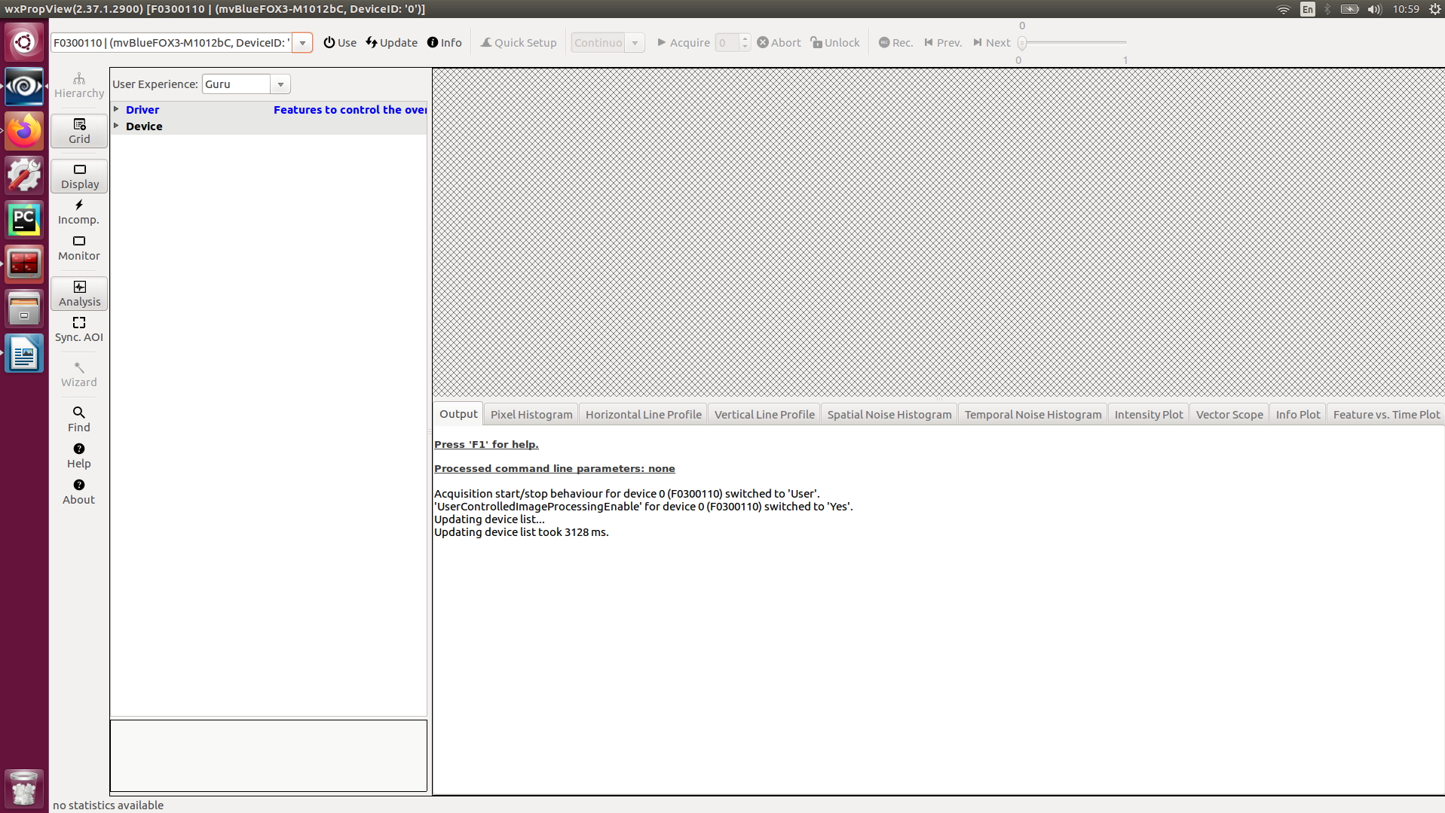
Notice the camera’s serial number in the upper-left corner. Copy it.
  - Click the ‘Use’ button. This would open up the camera’s GenICam interface. There, you can see all the camera’s properties, their current values and all possible values. You can also change them from this GUI. The properties that are relevant to VI-Slam are under ‘ImageFormatControl’, ‘AcquisitionControl’, ‘CounterAndTimerControl’, ‘DigitalIOControl’, ‘ChunkDataControl’ and ‘ImageDestination’. For further reading, check out https://www.matrix-vision.com/manuals/mvBlueFOX3/Features_page.html.
  - To start image acquisition, check that under ‘AcquisitionControl’:
    - AcquisitionMode – Continuous
    - ExposureMode – Timed
    - ExposureAuto – Continuous
    - TriggerSelector → TriggerMode – Off
    - Click Acquire. You should see an image stream:

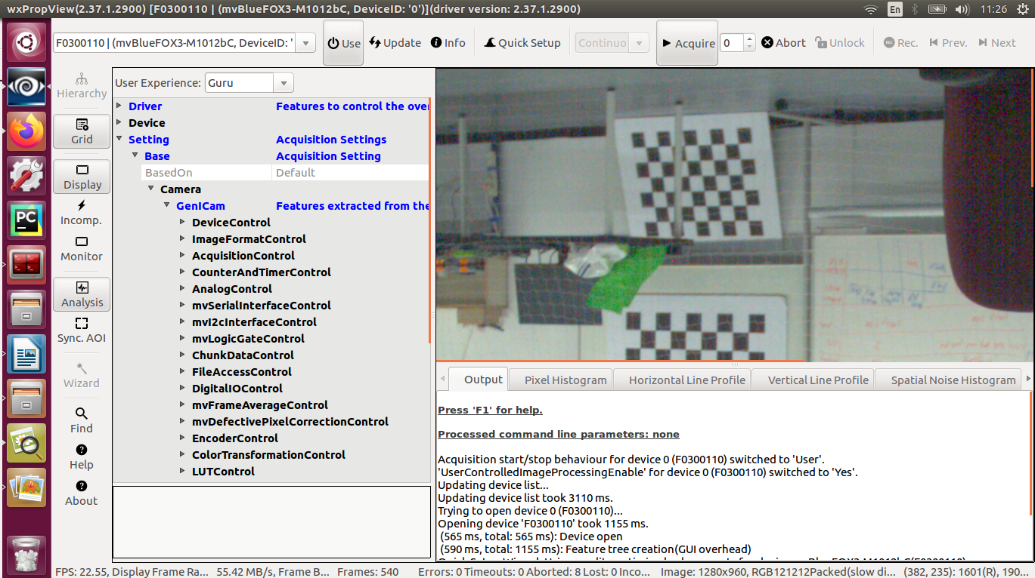
  - Click the ‘Use’ button again to close to the camera. Notice – the camera cannot be used by the ros driver and wxPropView simultaneously. This procedure both insures the camera is detected, and that its default parameters are loaded, initialy.
  - In terminal, launch the bluefox3 driver with the camera’s serial from (3):

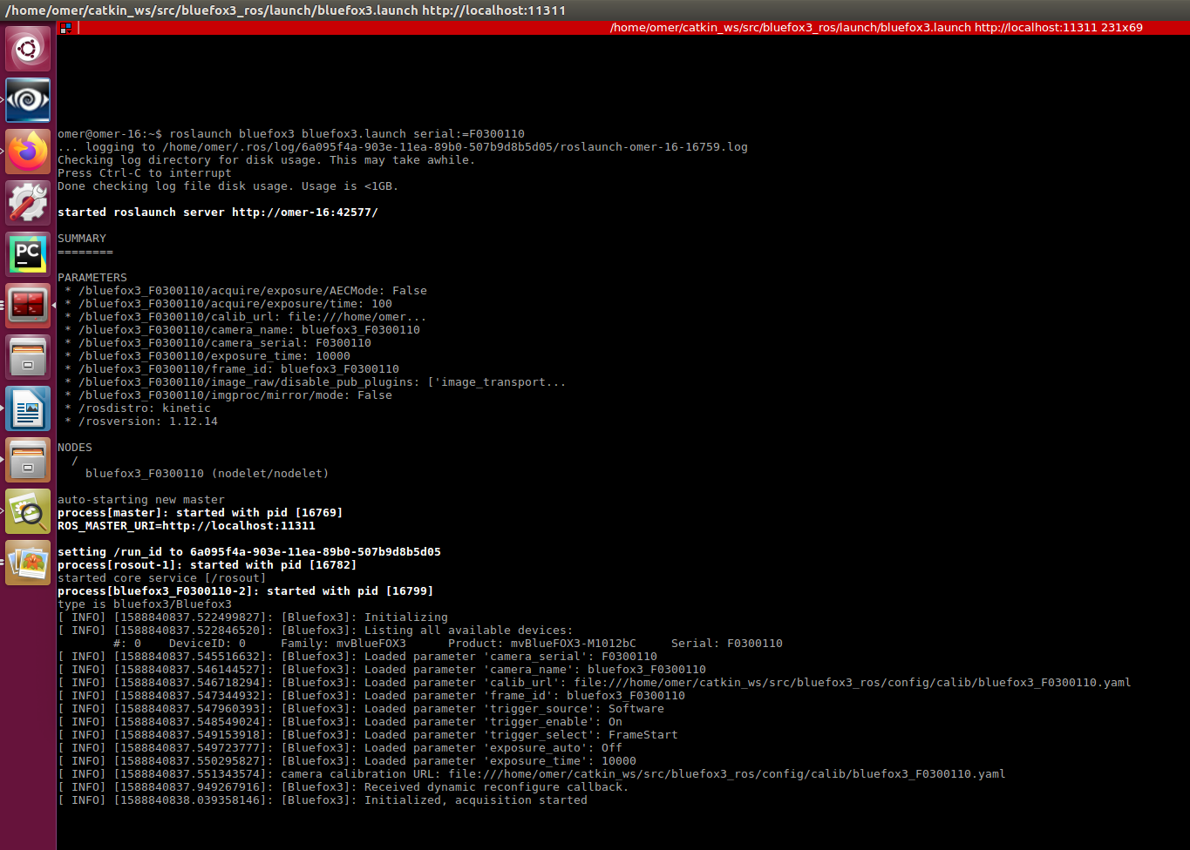
Notice camera is started with software triggering, and is waiting for triggers. Make sure the correct catkin workbench (_cb) is sourced.

  - In Software trigger mode, the camera’s driver waits for messages in the /trigger topic, and on subscriber callback sends a software trigger to the camera. The Frame’s timestamp is set according to the trigger timestamp. Do not use this mode for VISlam, it’s purely for demonstrative and simulation purposes.
  - To start acquisition in this mode, you can use command-line publishing as such:

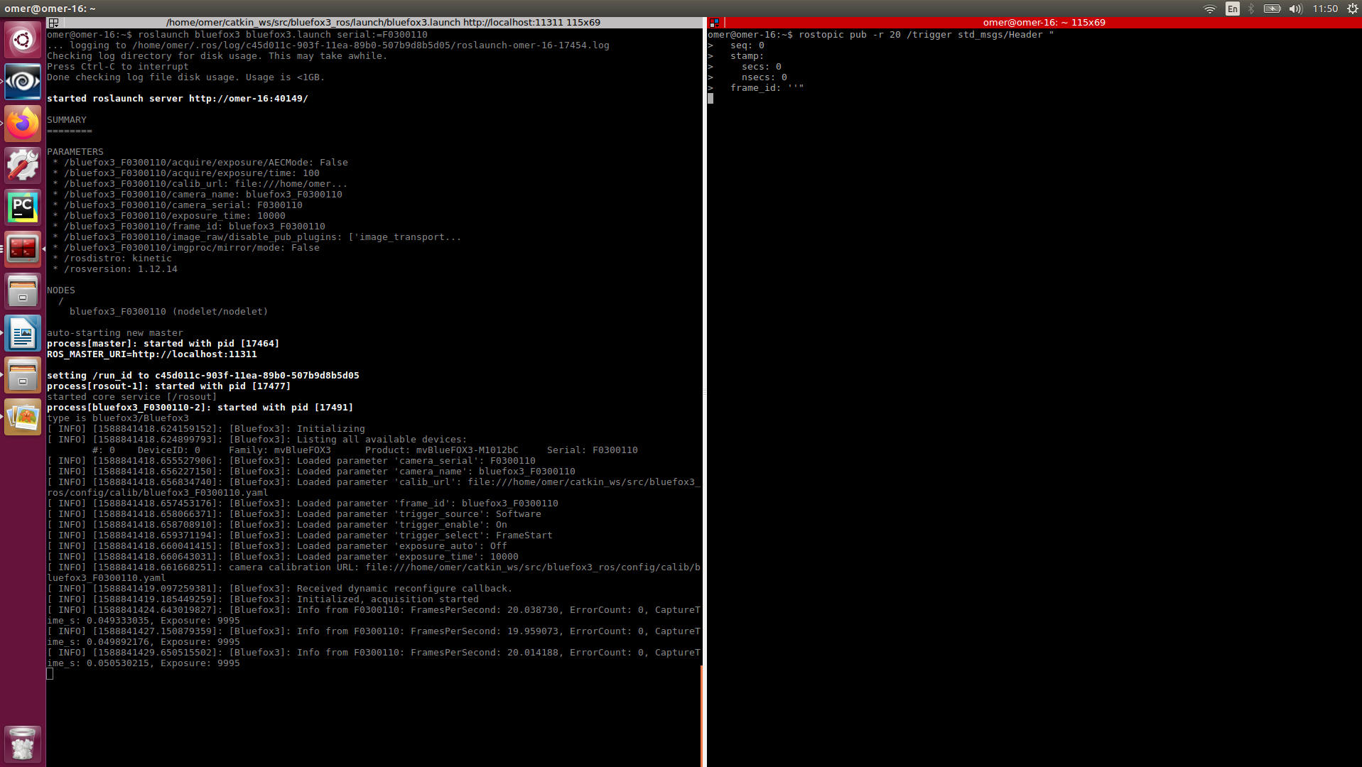
Make sure to start the camera node (left) before publishing (right). Use rqt_image_view to see camera stream.

  - You can also change modes -
    - Hardware Trigger (TODO)
    - Continuous – timestamps will be set according to time_of_callback – total_acquisition_time. This mode is also not very accurate, but it is possible to run VISlam with online offset estimation.

- IMU:
  - Running the IMU ros driver, other than fetching data from IMU, will start external/Software trigger to the camera’s node. The triggers are sent through the pigpio daemon. More here: http://abyz.me.uk/rpi/pigpio/. If you want to run with external triggering, start the daemon with sudo pigpiod -f, where the f-flag is to disable FIFO buffer. The default sample rate is 5 [μS].
  - There’s currently support for bno055 usb-stick IMU and MPU9150.
    - Bno055 - https://github.com/tau-adl/bno055_usb_stick
See repository for launch parameters.
    - MPU9150 - https://github.com/tau-adl/mpu9150 – i2c comms to the rpi. Trigger functionality enabled for minimal synch offset.

- Dynamic Reconfigure:
  - The camera driver supports some dynamic reconfigure parameters, namely those that do not require stopping acquisition. While the bluefox3 nodelet is running, you can change the parameters by:
    - In terminal, type rosrun rqt_reconfigure rqt_reconfigure. The following screen will pop up:
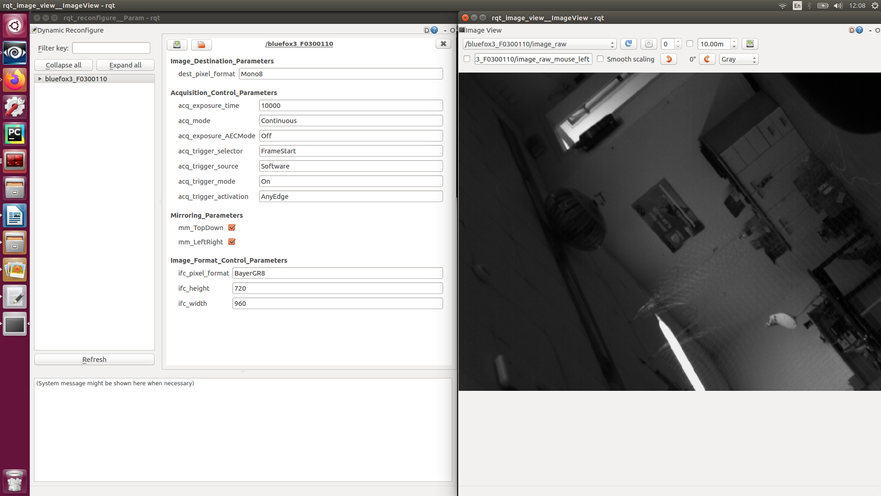

Notice these are the default settings – Manual exposure time of 1000 [μS], Acquisition mode is continuous (irrelevant if triggering is enabled), software triggering enabled, hardware triggering on AnyEdge and image format as Mono8.

    - These settings can be changed without ever stopping acquisition. For example, changing the format to ‘Auto’ will produce a color image:

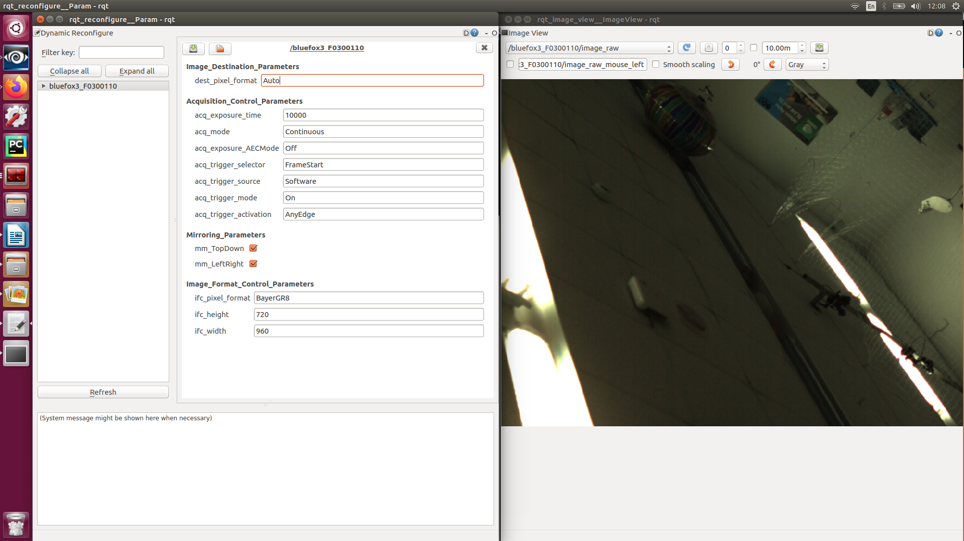

And setting trigger mode to ‘Off’ will start a maximal frequency (~50Hz) continuous acquisition. Notice auto-exposure is also on ‘Continuous’ - meaning we try to optimize the exposure time frame by frame, online.
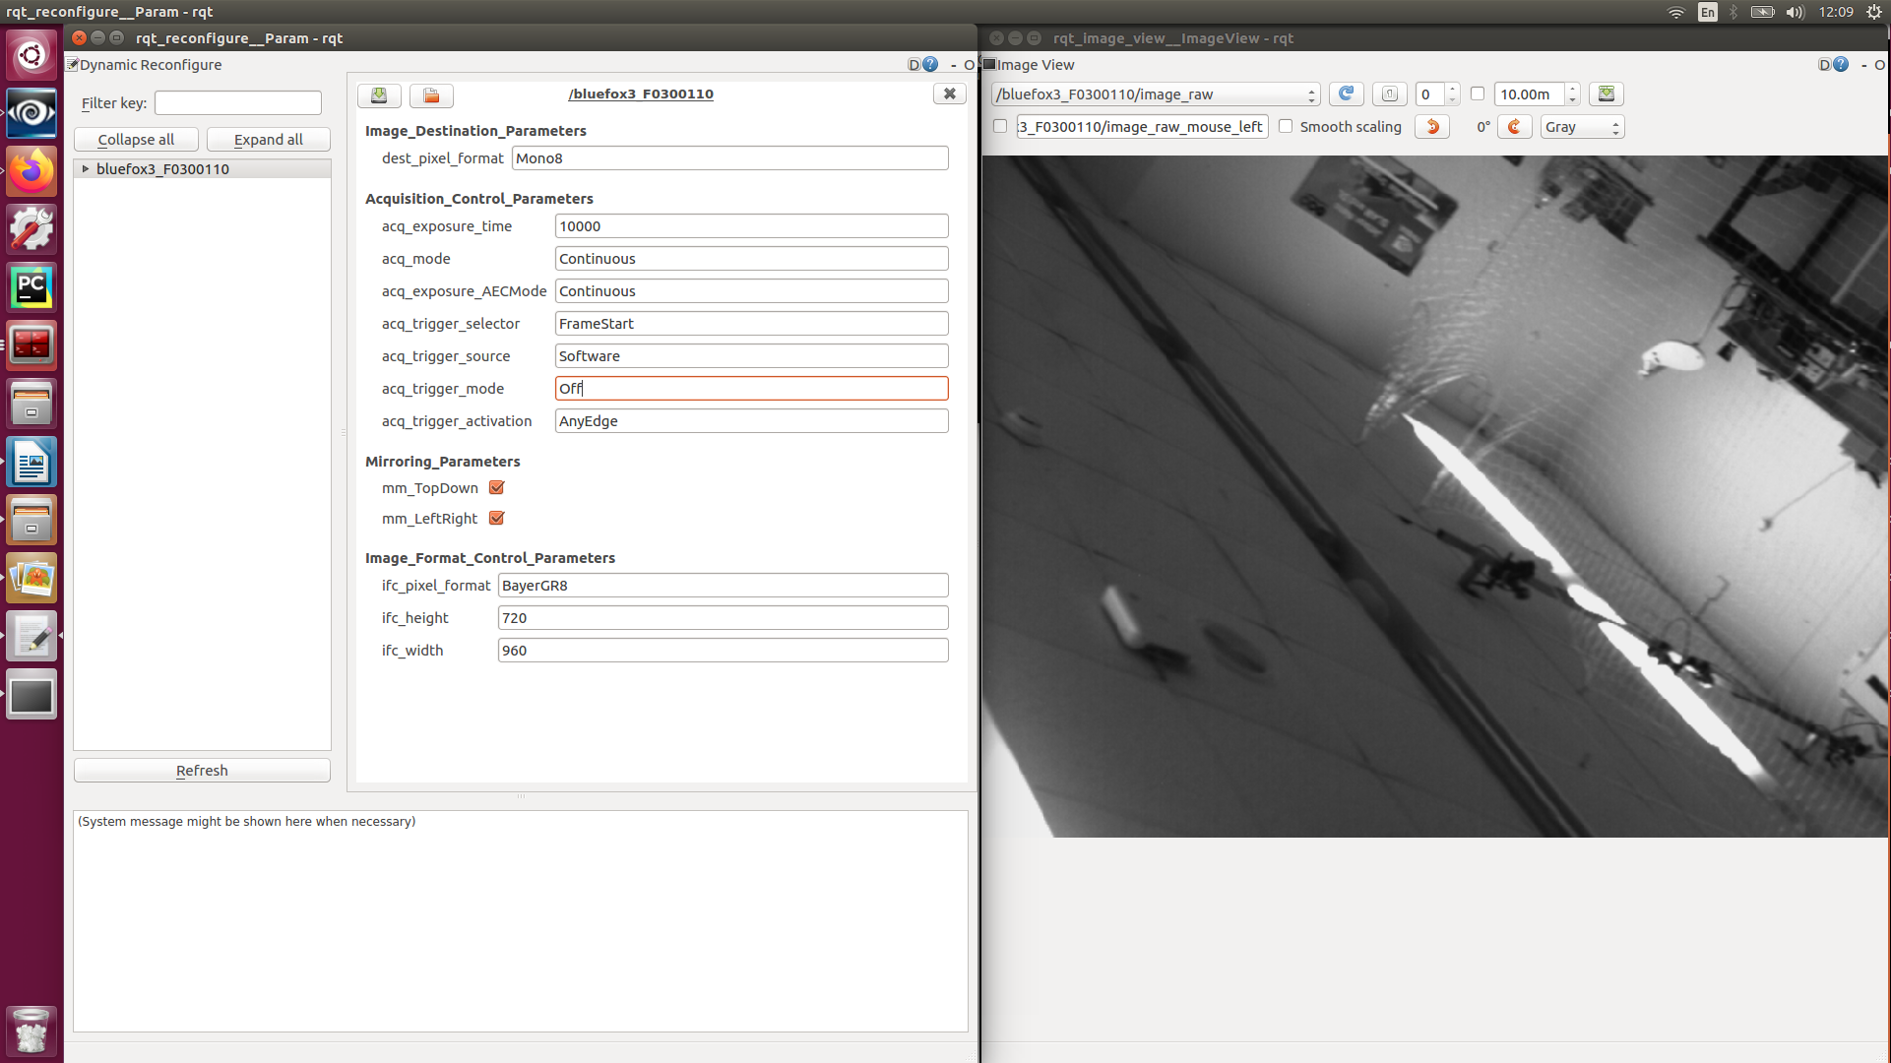

    - The image_format_control_parameters group can be changed only on launch (with launch parameters declaration) at the moment.
    - To see a full list of possible settings these parameters can be set in – check wxPropView.

- Triggering Options
  - It’s possible to connect an MPU-6050/9150/9250 (or any other i2c compatible one) directly to the camera. The mvImpact SDK has an i2c read/write bytes functionality as master. This approach will be harder to implement as it is ‘bare-bones’. Also, it will probably not be as accurate as the others – you cannot get the camera clock with the IMU measurement, so the timestamp will be set according to the RPI clock. The reading latency will be even higher compared to simply reading directly with the RPI as we introduced a middleman.
  - Connecting the IMU to the RPI, and reading with the IMU’s data FIFO buffer disabled. The measured read time was ~3[mS]. This introduces a possible timestamp error of ~6[mS]. Every other k’th data read from the IMU – send a HW trigger with pigpio (a couple dozen μS latency).
  - Connecting the IMU to RPI, including the IMU’s “data ready” interrupt pin, and with the FIFO buffer disabled. Now, with pigpio, we can create a pin rising/falling edge callback function (a couple dozen μS latency) associated with the IMU’s data ready interrupt. Setting the IMU to 200[Hz] update rate will ensure we have enough time, in the callback function, to read the data, convert it to a ros message (and fix the timestamp according to measured read-out time) and publish before the next set of IMU data is ready. Every other k’th data read from the IMU – send a HW trigger with pigpio (a couple dozen μS latency). This approach has a significant improvement for the timestamp error.
  - Connecting the IMU to RPI, including the IMU’s “data ready” interrupt pin, and with the FIFO buffer disabled. In addition – connect the IMU’s “data ready” interrupt pin to the cameras digital I/O line. Now, with pigpio, we can create a pin rising/falling edge callback function (a couple dozen μS latency) associated with the IMU’s data ready interrupt. Setting the IMU to 200[Hz] update rate will ensure we have enough time, in the callback function, to read the data, convert it to a ros message (and fix the timestamp according to measured read-out time) and publish before the next set of IMU data is ready. The difference from approach (3) – here, the camera’s trigger will not start a frame acquisition, but rather increment a built in count set to reset itself every other k’th increment. That counter reset can be used as the camera’s frame acquisition trigger.

