Chapter 1. Use Cases

ATM Startup Sequence--:
As soon as ATM exe launch the below menu appear
1-:Mentinace Mode
2-: Customer service Mode
Mentinace Mode-: This Mode is used when ATM has a cash requirement i.e. when ATM is running low cash or empty cash. Operator load the cash and exit from the exe and launch the exe in
Customer Service Mode.Now ATM is ready to serve the customer.
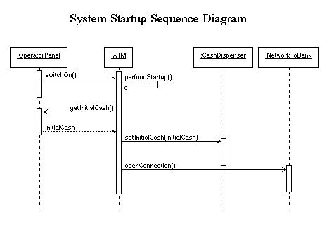
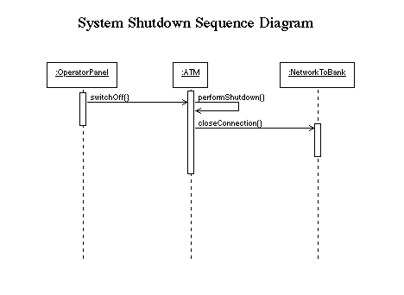

Customer Service Mode-:
In This mode ATM will intract with the customer .The below action will perform in this mode.
1. User Authentication(Session initiation)
2. Transcation
a. Withdrawl
b. Deposite.
c. Balance Inquire

1. User Authentication(Session initiation)-:
A session is started when user enter user id and ATM will checks with banks to identification of this id .If Identification failed ,the session will be aborted and asked for valid user id .if the user enter the valid user id then asked for 4/6 digit pin and goes bank to verify pin against the user id,if the pin is not valid then session will be aborted. User has only 3 chance for valid pin if the attempt will more than 3 then the user id will be blocked until it will not be unblocked by the bank. A valid id and pin , a customer will allow to go for transcation and it will be chosen from the menu.After each transaction, the customer is asked whether he/she would like to perform another. When the customer is through performing transactions, the ATM is ejected from transcation menu mode and the session ends.
The customer may abort the session by pressing the Cancel option from the menu when entering a PIN or choosing a transaction type.

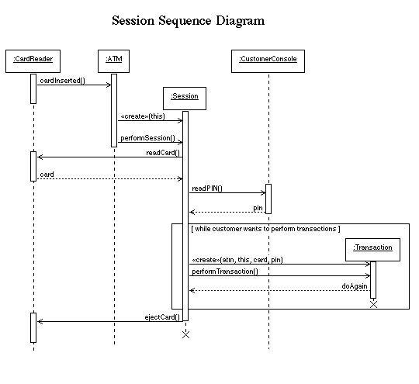

2 . Transcation-:
A transaction will be started within a session when a customer choose an appropriate transcation option from the transcation menu(withdrawl, balance inquire, deposite) and after giving the valid bank details (type==saving/credit,).The transaction will then be sent to the bank, along with information from the customer and the PIN the customer entered.
If the bank approves the transaction, any steps needed to complete the transaction (e.g. dispensing cash or accepting an envelope) will be performed, and then a receipt log will be printed. Then the customer will be asked whether he/she wishes to do another transaction.If a transaction is cancelled by the customer, or fails for any reason other than repeated entries of an invalid PIN, a screen will be displayed informing the customer of the reason for the failure of the transaction, and then the customer will be offered the opportunity to do another.All messages to the bank and responses back are recorded in the ATM's log.
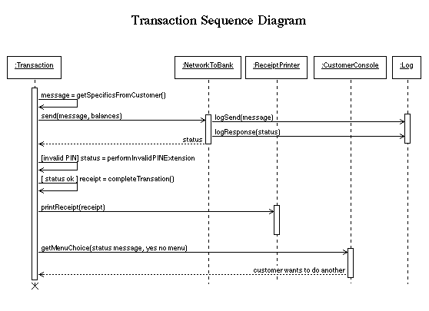
a.Withdrawl
A withdrawal transaction asks the customer to choose a type of account to withdraw from (e.g. checking) from a menu of possible accounts, and to choose a ruppees. amount from a menu of possible amounts. The system verifies that it has sufficient money on hand to satisfy the request before sending the transaction to the bank. (If not, the customer is informed and asked to enter a different amount.) If the transaction is approved by the bank, the appropriate amount of cash is dispensed by the machine before it issues a receipt. (The dispensing of cash is also recorded in the ATM's log.)
A withdrawal transaction can be cancelled by the customer pressing the Cancel key any time prior to choosing the rs. amount.
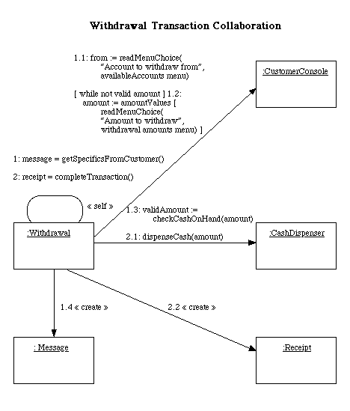

b.Deposite
A deposit transaction asks the customer to choose a type of account to deposit to (e.g. checking) from a menu of possible accounts, and to type in a rs amount on the keyboard. The transaction is initially sent to the bank to verify that the ATM can accept a deposit from this customer to this account. If the transaction is approved, the machine accepts an individual no of rs while not equal to the total(i.e. if customer want to deposite 1300 . and he has to enter no of 1000 rs note , no of 500 rs note , no of 100 rs note) from the customer containing cash and/or checks before it issues a receipt. Once the cash/checks has been received, a second message is sent to the bank, to confirm that the bank can credit the customer's account - contingent on manual verification of the deposit envelope contents by an operator later. (The receipt of an envelope is also recorded in the ATM's log.)
A deposit transaction can be cancelled by the customer pressing the Cancel key any time prior to inserting the the note ammount containing the deposit. The transaction is automatically cancelled if the customer fails to insert the no of note containing the deposit within a reasonable period of time after being asked to do so.
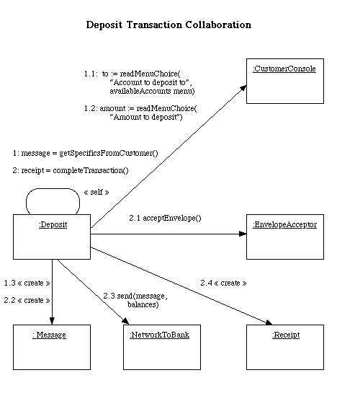

c. Balance Enquire
An inquiry transaction asks the customer to choose a type of account to inquire about from a menu of possible accounts. No further action is required once the transaction is approved by the bank before printing the receipt.An inquiry transaction can be cancelled by the customer pressing the Cancel key any time prior to choosing the account to inquire about.

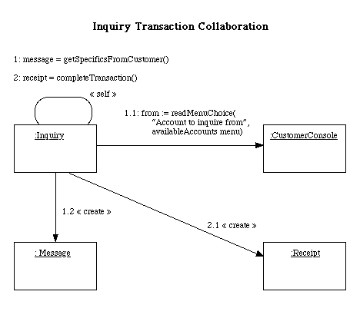

Chapter 2. Classes.

An initial reading of the use cases suggests that the following will be part of the system.
- A controller object representing the ATM itself (managing the boundary objects listed below.)
- Boundary objects representing the individual component parts of the ATM:
  - Operator panel.
  - User Reader.
  - Customer console, consisting of a display (Menu and reciept).
  - Network connection to the bank.
  - Cash dispenser.
  - Deposite acceptor.
  - Balance Enquire and reciept display.
  - Logger

- Controller objects corresponding to use cases. (Note: class ATM can handle the Startup and Shutdown use cases itself, so these do not give rise to separate objects here.)
  - Session
  - Transaction (abstract generalization, responsible for common features, with concrete specializations responsible for type-specific portions)

- An entity object representing the information encoded on the ATM card inserted by customer.
- An entity object representing the log of transactions maintained by the machine.
This leads to the following diagram of analysis classes:
