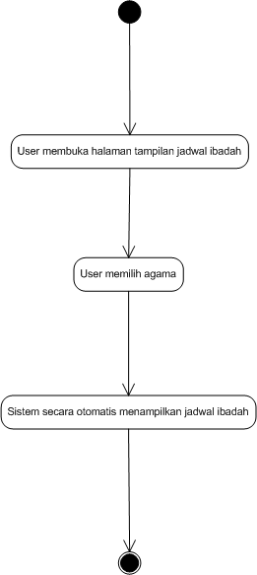

**ACTIVITY DIAGRAM**