COVID-19 CASES ANALYSIS WITH PYTHON PROGRAMMING

BATCH MEMBER

# 812121104032: MOHAMED YUSUF M

**PROJECT TITLE: COVID-19 CASES ANALYSIS**

**PHASE 3: DEVELOPMENT PART 1**

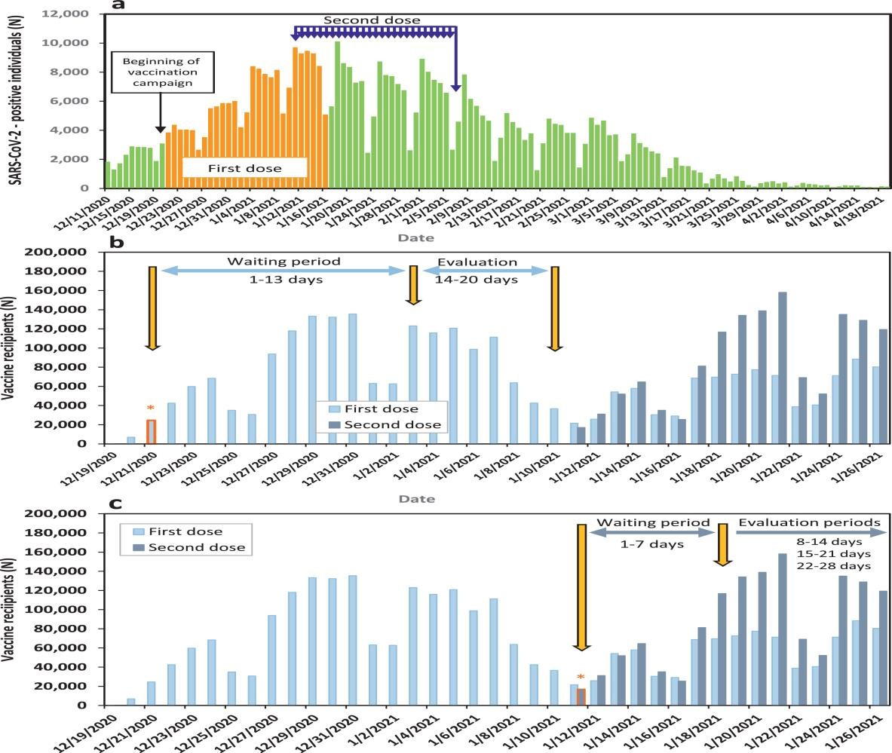

**INTRODUCTION:**

♦ The novel Coronavirus disease (COVID-19) in Wuhan, China, became a pandemic after its outbreak in January 2020. Countries one after the other are witnessing peak effects of the disease, and they need to learn from the experience of others already affected or peaked countries. Thus, this paper aims to analysis the effect of the COVID-19 pandemic on different countries through COVID-19 cases, resulting in deaths and recoveries.

♦ This study analyses quantitatively the lethal effects of the pandemic through the study of infections, deaths, and recoveries on the 13 most-affected COVID-19 countries as of 1 s t June. The daily changes in cases, deaths, and recoveries for all the 13 countries were considered. Combined analysis for comparison and separate analysis for the detailed study were both taken for every country. All the graphs were made in R Studio using the R programming language, as it is best for statistical analysis.

INPUT:

import pandas as pd *# data manipulation , analysis, cleaning*

import numpy as np *# mathmatical calculations*

*# Plotly - interactive, open-source, and browser-based graphing library for Python*

import plotly.express as px

import plotly.graph_objects as go

from plotly.subplots import make_subplots

country_wise = pd.read_csv('/kaggle/input/corona-virus-report/country_wise_latest.csv')

day_wise = pd.read_csv('/kaggle/input/corona-virus-report/day_wise.csv')

worldometer_data = pd.read_csv('/kaggle/input/corona-virus-report/worldometer_data.csv')

DD_CW1 = pd.read_csv('/kaggle/input/corona-virus-report/full_grouped.csv')

DD_CW2 = pd.read_csv('/kaggle/input/corona-virus-report/covid_19_clean_complete.csv')

usa = pd.read_csv('/kaggle/input/corona-virus-report/usa_county_wise.csv')

country_wise.head()

OUTPUT:

| sno | Country/Region | Confirmed | Deaths | Recovered | Active | New cases | New deaths | New recovered | Deaths / 100 Cases | Recovered / 100 Cases | Deaths / 100 Recovered | Confirmed last week | 1 week change | 1 week % increase | WHO Region |
| --- | --- | --- | --- | --- | --- | --- | --- | --- | --- | --- | --- | --- | --- | --- | --- |
| 0 | Afghanistan | 36263 | 1269 | 25198 | 9796 | 106 | 10 | 18 | 3.50 | 69.49 | 5.04 | 35526 | 737 | 2.07 | Eastern Mediterranean |
| 1 | Albania | 4880 | 144 | 2745 | 1991 | 117 | 6 | 63 | 2.95 | 56.25 | 5.25 | 4171 | 709 | 17.00 | Europe |
| 2 | Algeria | 27973 | 1163 | 18837 | 7973 | 616 | 8 | 749 | 4.16 | 67.34 | 6.17 | 23691 | 4282 | 18.07 | Africa |
| 3 | Andorra | 907 | 52 | 803 | 52 | 10 | 0 | 0 | 5.73 | 88.53 | 6.48 | 884 | 23 | 2.60 | Europe |
| 4 | Angola | 950 | 41 | 242 | 667 | 18 | 1 | 0 | 4.32 | 25.47 | 16.94 | 749 | 201 | 26.84 | Africa |