A GENERIC TOOL FOR MODELLING AND SIMULATION OF FIRE PROPAGATION USING CELLULAR AUTOMATA
Taufiqurrahman¹, Saiful Akbar²
School of Electrical Engineering and Informatics, Institut Teknologi Bandung
Bandung, Indonesia
¹taufiqurrahmanrusdy@gmail.com
² saiful@informatika.org

Abstract— In spite of their simplicity, Cellular Automata ( CA ) have a great potential for being used in modelling various natural phenomenon. CA receive widespread interest among researchers from diverse field to learn and use them in their application domain. Although CA can be used in diverse application domain, researchers usually develop CA model for their specific problems domain despite universality is the true nature of CA. In this research, we attempt to develop a tool to model and simulate CA. This is a general purpose tool that can be used to develop various CA based model. As a starting point, the tool will be implemented to modelling and simulating fire propagation. In consequence, literature study was conducted on some related research of fire propagation model to get the generic aspect from that models. The generic aspect then implemented into software artefact as a generic tool. In the end, the tools will be tested to implement rules from related research. Test result shows that with the same construction, the tool can implement various rule and fire propagation model.

Keywords— Simulation, Modelling, Cellular Automata, Fire Propagation
- Introduction
Toward understanding of natural phenomenon, researchers from diverse field use a variety of method to model the phenomenon into simple mathematical model. It aims to study and predict the behaviour of the phenomenon. Most of natural phenomenon are propagation phenomenon such as fire, swelling, gas propagation which are part of complex systems. This phenomenon can be viewed as a propagation cells in space which is same as the concept of cellular automata (CA)[1].
CA are mathematical model for complex natural systems containing large numbers of simple identical components with local interaction. CA can be seen as a uncomplicated spatial model which decentralized, composed of individual component that is called as cell. The cell can interact each other limited to the local interaction among cell. Each of this individual cell has a state that changes over time depends on its neighbourhood cell. The overall structure of CA can be viewed as a parallel processing device. However this simple structure will produce a complex pattern when it is iterated several times[2]. According to this, CA model does not only provide a mathematical model but it also provides a visual model through simple spatial model.
In order to modeling widely diverse application areas, researchers have struggled to establish simpler and more practical architecture of CA based on the logical concept of universality[2]. Universality defines as the property which is able to perform different tasks with the same underlying construction by simply being programmed in a different way[3]. Until the present time, there are some researches about CA and its implementation in various field (e.g., physics, chemistry, biology and ecology ) [4]. But, researchers from distinct field have intuitively described CA dynamics with problems in their own field , without necessarily being aware the capabilities of universality in CA [2].
In this research, we develop a tool to model and simulate CA. Based on the concept of universality, this tool can create different model with the same construction just by running the model in a different rule. By using this tool, the researchers can create various simulation model without being aware to rebuild the component for each model. For starting point this tool will be tested to modelling fire propagation from various research[5]–[7].
- Cellular automata
According to Wolfram, “CA are mathematical idealizations of physical systems in which space and time are discrete, and physical quantities take on a finite set of discrete values”[8].
- Basic Components of CA
The four components of CA are :
- Cell space. Cell space is an environment of CA that consists of cells on which the CA is computed . Usually, the shape of cells is equal in size and shape that can be present as triangles, squares or hexagons. The grid can be one dimension (e.g., elementary CA), two dimension (grid) or even higher.
- State. Each cell has its own state which is has its own colour or value. The number of state possibilities is typically finite . For example in binary automaton, e.g., Game of Life[9], there is two states available : "alive" and "dead" ( otherwise referred to as “on” and “off”).
- Neighbourhood. Neighbourhood in CA are composed by a cell and its adjacent cells that also have a role to determine the evolution of state of that cell. Neighbourhood in one dimensional CA consist of a cell and its two adjacent cells (in the right and left ). In two dimensional CA there are two types of neighbourhood : von Neumann neighbourhood and Moore neighbourhood. Von Neumann neighbourhood consist of a cell and the four adjacent cells (north, east, south and west) whereas Moore neighbourhood consist of the previous five cells and the four diagonal cells (north-east, south-east, south-west and north-west).
Neighbourhood in CA can be implemented in different range. Range of 1 means that only the nearest cells are considered as neighbour. In range of n, all of the cells in radius of n from a certain cell considered as neighbour of that cell.
- Rule. Rule determines the transition of a cell state and its neighbourhood from one discrete time step to another. It applies to all cell and occurs in parallel. The state transition formulation can be represented as
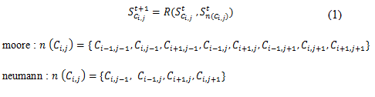
Where R is rule, S is state, t is time or time step , C is Cell and n represents neighbourhood . So that, state of a cell at time step t+1 determined by rule that acts upon state of a cell and its neighbourhood at time step t.
- Basic Implementation
The basic implementation for simulating CA uses two arrays of cell : the first one contains the global configuration at the current time step. Moreover, the second one refers to the result after the transition rule is applied. In every time step, all cells are scanned and after all cells have been computed, the result of the computation in the second array is copied into the first array and the time advances to the next time step. This process is repeated over time.
We assume a grid in size n x n which means the scanning process needs n2 amount of time to scan all cells at every time step. The scanning process should be focused on the cell that has a potential to change its state on the next time step. The basic principles to predict whether a cell possibly change state or not in a next time step are exposed in [10].
The CA are often simulated on a finite size of cell space. Because we can't scan all cells on an infinite cell space in a finite amount of time. But the problem with the finite size of cell space is the cells at the edge of cell space is lack of neighbours. Based on [11], there are three ways to overcome this problem :
- Edges remain constant. Never evaluate the cells at the edge and their state is always constant ( e.g., 1 or 0 ). This is the simplest and easiest solution.
- Toroidal cell space. Taping the left with the right edge of cell space. Also, taping the top with the bottom edge of cell space. This can be visualized as a doughnut shape of cell space.
- Edges have different neighbourhoods and rules. Defining a different kind of neighbourhoods and rules for the edge of cell space. This solution will make the system more complex.
- Fire Propagation Modelling with Cellular Automata
Basically, there are three factors that influences the fire propagation, namely fuel, heat and oxygen. In CA, fire propagation phenomena must be emulated by constructing some appropriate rules. So as to create a fire propagation by using the technique of CA, the probability formulation of fire spreading in the transition rules usually revolve around that three main factors.
There are some research about modelling fire propagation using CA, each of them using distinct both rules and parameters. in forest fire modelling, to determine the possibility of fire to spread in an area, the researchers in [5] use the ignition probability from neighbour cells, researchers in [6] use the parameter of wind condition and vegetation characteristics and researchers in [7] use the vegetation cells distribution across the lattice, the chance of a burning cell become burnt, and the chance of burning cell spread to a neighbouring vegetation cell. Moreover, in city fire spreading simulation, the researchers in [12], [13] use the fire spreading judgement index to calculate the probability of fire spread among the lattice. In this research we attempt to find the basic aspect to modelling fire propagation using CA from various previous research [5]–[7], [12]–[14]. So, based on that basic aspect we can create a generic tool that can modelling various fire propagation.

- Analysis of Basic Aspects on CA Model
There are four basic components of cellular automata : cell space, state, neighbourhood and rules. These are mandatory components to modelling using cellular automata. To create a model based on cellular automata, the researchers need to adjust these components based on their specific problems. Moreover, In modelling natural or physical phenomenon, a cell is not only has a state but also properties. For example, in fire propagation modelling on urban areas, the building condition is composed of building material, floor area and height that represent the characteristic of building[12]. These factors affect the probability of fire to spread across the building. Besides the cell properties, the result of simulation is also affected by environmental factors (e.g., weather or wind direction and velocity such in [6][15]) that is model properties. In contrast with cell properties that affect local cell, model properties affect all the cells in the lattice. Since both of these properties affect the result of the simulation especially on both natural and physical phenomenon simulation, we include those properties into state transition formulation.
Assumed P is cell properties and M is model properties, if we include both properties into Eq.(1) :

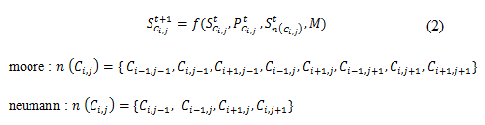

If cell C composed of state ( S ) and properties ( P ) and the state and properties of cell C will change on the next time step, so :
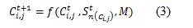
So, in order to create a generic tool that can create a various model CA, the tool should be fulfil the following capabilities :
- Providing a feature for user to create a custom cell space, save and reuse the cell space. So it can be used in other projects.
- Capabilities to manage a list of state. This feature provide access for users to add or delete states in model.
- Providing a feature for user to define a custom rule for model that they made
- Providing a feature for users to choose which neighbourhood that they use in their model
- Providing an access for user to use and define model properties. For example : in fire propagation modelling , the user can include wind condition into their model since this properties can affect the behaviour of fire spreading

- Software Architecture

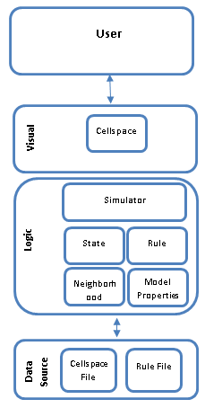
Fig. 1 Software architecture
Fig. 1 shows the architecture of tool that we develop in this research. For processing and computation, we use Java programming language (Java SE) and for GUI and visualization of simulation we use Java Swing and Processing programming language [16]. This tool consist of six modules, the six modules are :
- Cell space. The main capabilities of this module is being able to create cell space from image, create manually or generate grid randomly. To create a cell space from image, this component transforms pixels from image into array of cells and colour from the image as a property of cell. In short , this component manages the creation of cell space and the properties of each cells.
- Rule. This module receives and compiles the rule which is made by user. It also integrates that rule into main program. We use Java Compiler from Java programming language to compile the rule that user made.
- State. This module stores a list of state to be used in a simulation model. Given this module, users can add or delete a state to be used in the simulation model.
- Neighbourhood. This module provides the facility for users to define the type of neighbourhood that will be used in modelling CA. By default there are two types of neighbourhood are available, namely Moore and von Neumann.
- Model Properties. This module provides the facility for users to define the value of model properties. This module contains the variables associated with a model on a specific domain. For now, this module contains the settings of the wind condition used in fire propagation model.
- Simulator. This is the core of tool that integrates all the previous component. It controls which cell will be processed, what kind of neighbourhood will be used and how many iteration will be done, etc. Generally, it controls the entire simulation process.

- Fire Propagation Application
In this research, The tool will be tested to create fire propagation model using transition rule presented in [5]–[7]. Dimension of cell space that we use are 200 x 150 (30,000 cells) and 400 x 300 (120,000 cells). The data that we use as cell space in this testing is available at[17].
- Fire spreading model proposed by Quartieri et al. (2010)
In this model, the ignition probability of a cell depends only on the number of burning cell in its neighbourhood. The type of neighbourhood that used in this model is Moore neighbourhood. As shown in figure 2, three fire point have been chosen as initial conditions. After 30 time steps, as shown in figure 3, the fire shaped roughly circular like the pattern of fire spreading without wind condition which occur in the real world.
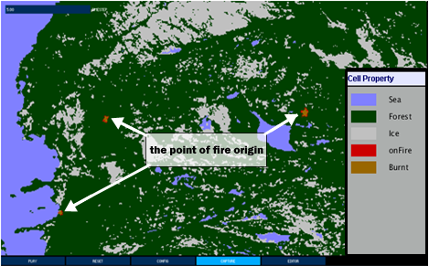
Fig. 2 Simulation result after 5 time steps with three initial burning cells

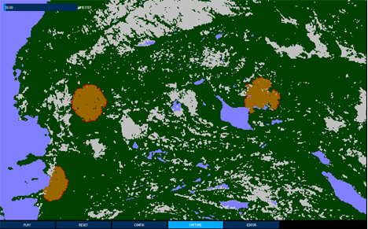
Fig. 3 Simulation result after 30 time steps

- Forest fire spreading model proposed by Bodrozic et al. (2006)

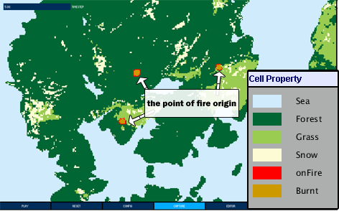
Fig. 4 Simulation result after 5 time steps with three initial burning cells

In this model, related researchers use parameter of vegetation characteristics and wind conditions as a factor that affect the behaviour of fire propagation. There are two types of vegetation in this model : forest with probability of burning 70% and short grass/vineyard with probability of burning 30%.
As shown in figure 4, three fire points have been chosen as initial conditions. One of the fire points is located near the grass field (rightmost). The simulation result after 30 time steps (figure 5), shows that the fire propagates among the forest is faster than in the grass because of the burning probability of forest is higher than grass.

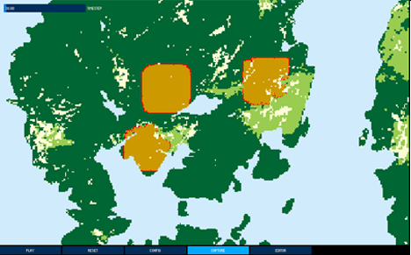
Fig. 5 Simulation result after 30 time steps

- CA model for wild land fire spreading dynamic proposed by Almeida and Macau (2011)
In this model, there are three factors that affect the behaviour of fire to spreads : First, The vegetation cells distribution across the lattice (D). Second, the chance of a burning cell become burnt (B), and Third, the chance of burning cell spread to a neighbouring vegetation cell (I).
As shown in the figure 6, we implemented a different parameter values to see changes in the behaviour of fire spreading. From the result of implementation shows that although all the simulation result are in the same time steps, the fire spreads in dissimilar behaviour.
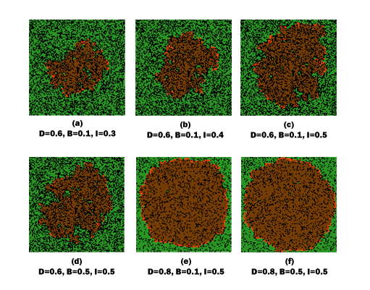
Fig. 6 The implementation result of fire spread dynamic model with different parameters values

From this experiment, we conclude that in a heterogeneous vegetation environment the level of burning cell remain burning (B) increase the influence of fire to spreads but in a heterogeneous vegetation environment that has more fuel, the variable of fire spreading probability (I) has a bigger influences than the variable of fire resistance (B) to cause fire spreading in a wider area.

- Conclusion
In this paper the authors develop a generic tool to modelling and simulating fire propagation from various previous research. We attempt to find the basic aspect to modelling fire propagation using CA from various previous research. So, based on that basic aspect we can create a generic tool that can modelling various fire propagation. The tool consist of six main modules : grid generator, state, neighbourhood, rule, model properties and cellular automata as a simulator. Subsequently, The tool tested to create fire propagation model using transition rule presented in related research.
From the results of the testing shows that with the same construction, the tool can create different models and implements distinct transition rule. Although some of the simulation result do not exactly match visually with the result obtained by related researchers, but there are similarities of fire behaviour. The main cause that make the difference in simulation result is due to the probability factor involved in the transition rule.
For future work, we attempt to improve the capabilities of this tool by adding some new features (e.g. neighbourhood creator) so this tool can create a more complex model. Instead of fire propagation model, we attempt to develop various model using this tool since all the CA based model consist of same component (cell space, rule, state, neighbourhood). To achieve this goal, we need to explore all the related research about CA based model.

References

[1] A. Muzy, E. Innocenti, A. Aïello, J. Santucci, P. Santoni, and D. R. C. Hill, “Dynamic Structure Cellular Automata In a Fire Spreading Application,” Informatics Control. Autom. Robot. I, pp. 247–254, 2006.
[2] N. Ganguly, B. K. Sikdar, A. Deutsch, G. Canright, and P. P. Chaudhuri, “A Survey on Cellular Automata,” Engineering, pp. 1–30, 2003.
[3] E. W. Weisstein, “Universality.” [Online]. Available: http://mathworld.wolfram.com/Universality.html. [Accessed: 05-May-2016].
[4] S. Wolfram, A New Kind of Science. Wolfram Media, Inc, 2002.
[5] J. Quartieri, N. E. Mastorakis, G. Iannone, and C. Guarnaccia, “A Cellular Automata Model for Fire Spreading Prediction,” pp. 173–179, 2010.
[6] L. Bodrožić, D. Stipaničev, and M. Šerić, “Forest fires spread modeling using cellular automata approach,” CEEPUS Summer Sch. Mod. trends Control, 2006.
[7] R. M. Almeida and E. E. N. Macau, “Stochastic cellular automata model for wildland fire spread dynamics,” J. Phys. Conf. Ser., vol. 285, p. 12038, 2011.
[8] S. Wolfram, “Statistical mechanics of cellular automata,” Rev. Mod. Phys., vol. 55, no. 3, pp. 601–644, 1983.
[9] E. W. Weisstein, “Game of Life.” [Online]. Available: http://mathworld.wolfram.com/GameofLife.html. [Accessed: 05-May-2016].
[10] Bernard P. Zeigler, T. G. Kim, and H. Praehofer, Theory of Modeling and Simulation. 2000.
[11] D. Shiffman, S. Fry, and Z. Marsh, The Nature of Code. 2012.
[12] A. Ohgai, Y. Gohnai, S. Ikaruga, M. Murakami, and K. Watanabe, “Cellular Automata Modeling for Fire Spreading as a Tool to Aid Community-Based Planning for Disaster Mitigation,” pp. 193–209, 2004.
[13] H. Wang and H. Zhou, “A Fire Spread Model Based on Cellular Automaton,” 2nd Int. Conf. Soft Comput. Inf. Commun. Technol., no. Scict, pp. 191–194, 2014.
[14] A. Tani, A. Takizawa, H. Kawamura, and A. Yamada, “Simulation of Spreads of Fire On City Site By Stochastic Cellular Automata,” Proc. 12th World Conf. Earthq. Eng. Auckland, New Zeal., vol. Paper No., pp. 1–8, 2000.
[15] I. Karafyllidis and A. Thanailakis, “A model for predicting forest fire spreading using cellular automata,” Ecol. Modell., vol. 99, no. 1, pp. 87–97, 1997.
[16] “Processing.org.” [Online]. Available: https://processing.org/. [Accessed: 06-Apr-2016].
[17] JRC FOREST Project, “Forest,” 2016. [Online]. Available: http://forest.jrc.ec.europa.eu/download/data/forest-data-download/. [Accessed: 15-Sep-2016].

