Assignment 1
- Write a java program to check given number is even number or odd number.
- Write a java program to check given number is prime number or not.
- Write a java program to check given number is divisible by 5 or not.
- Write a java program to check given character is alphabet or digit.
- Write a java program to read shoes brand name from keyboard, based on brand name print brand slogan like below:
Nike -> Just do it
Adidas -> Impossible is nothing
Puma -> Forever Faster
Reebok -> I Am What I Am
- Write a java program to read person basic salary and calculate Provident Fund amount from the basic salary.
Formula: Provident Fund is 12 % of Basic Salary.
- Write a java program to read person age and person salary and print his eligibility for marriage.
Condition: If person age less than 30 and salary greater than 1 lakh then eligible for marriage.
- Write a java program to find factorial of given number.
- Write a java program to print mathematical table of given number.
- Write a java program to print numbers from 100 to 1.
- Write a java program to find sum of 1 - 100 numbers.
- Write a java program to find sum of digits of given number.
- Write a java program to check given number is Armstrong number or not.
- Write a java program to print first 100 prime numbers.
- Write java programs to print below pattern 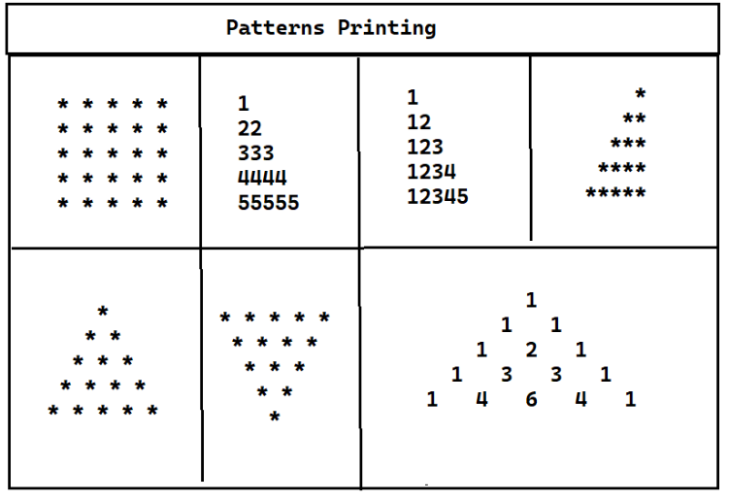
- Write a java program to print Descending order Pattern
5
5 4
5 4 3
5 4 3 2
5 4 3 2 1

