A Major Project Report (Final Phase)
On
[PT137] Intelligent Credit Risk Assessment
Using Explainable AI
Submitted in partial fulfillment of the requirements
for the award of the degree of
BACHELOR OF TECHNOLOGY
in
Computer Science and Engineering
Academic Session 2026–27
Submitted By:
Kushagra Sharma (2410031018)
Nikhil Verma (2410031015)
Taufique Raza (2410031042)
Shams Shahzad (2410030720)
Under the Guidance of:
Ms. Shalini Singh
Assistant Professor, School of Computer Science and Engineering
SCHOOL OF COMPUTER SCIENCE AND ENGINEERING
IILM UNIVERSITY, GREATER NOIDA
UTTAR PRADESH, INDIA

EDITORIAL & INSTITUTIONAL COMPLIANCE PREFACE
Institutional Formatting, Plagiarism & Governance Notices
1. Layout Architecture: This document uses a conventional academic engineering thesis format (1.25-inch left binding margin, 1.0-inch top, bottom, and right margins, 1.15 line spacing, and Calibri typography). While this layout adheres to standard B.Tech thesis norms, specific departmental cover templates, official logo embeds, or font size mandates from IILM University should be verified prior to final archival printing.
2. Signature Approvals: All signature blocks on the Declaration and Certificate pages represent unexecuted academic placeholders. They do not fabricate approvals and must be physically signed by the respective candidates, supervisor, and committee examiners.
3. Plagiarism Clearance Status: The preliminary Phase-I proposal was scanned with a 4% score (Dupli Checker, 19-Aug-2026). In accordance with academic integrity guidelines, a fresh, independent plagiarism scan (using the university's mandated tool, e.g., Turnitin or DrillBit) must be conducted on this completed Phase-II report prior to defense. The Phase-I score cannot serve as Phase-II clearance.
4. Regulatory & Fairness Disclaimers: Post-hoc Explainable AI tools (SHAP and LIME) are technical decision-support aids. They do NOT automatically satisfy statutory ECOA Adverse Action requirements or GDPR Article 22 mandates, do NOT prove the absence of unlawful demographic bias, and do NOT establish real-world causality.

CANDIDATE'S DECLARATION
We hereby declare that the work presented in this Major Project Report entitled "Intelligent Credit Risk Assessment Using Explainable AI (PT137)", submitted towards the partial fulfillment of the requirements for the award of the degree of Bachelor of Technology in Computer Science and Engineering at the School of Computer Science and Engineering, IILM University, Greater Noida, is an authentic record of our own work carried out during the academic session 2026–27 under the supervision and guidance of Ms. Shalini Singh, Assistant Professor, School of Computer Science and Engineering, IILM University, Greater Noida.
We further certify that the matter embodied in this report has not been submitted by us or any other student for the award of any other degree or diploma to any other university or institute.
This project adheres strictly to scientific integrity standards: all empirical metrics, confusion matrices, and cross-validation scores reported herein represent reproducible executions of our dedicated leakage-safe machine learning pipelines on the verified Statlog (German Credit Data) benchmark. Furthermore, all model-agnostic and tree-based explanations (SHAP and LIME) were generated directly from our codebase without synthetic fabrication.
..................................................
Kushagra Sharma
Roll No: 2410031018
..................................................
Nikhil Verma
Roll No: 2410031015
..................................................
Taufique Raza
Roll No: 2410031042
..................................................
Shams Shahzad
Roll No: 2410030720
Date: October 26, 2026  Place: Greater Noida | Countersigned by Supervisor:  ..................................................  Ms. Shalini Singh  Assistant Professor  School of Computer Science and Engineering  IILM University, Greater Noida

CERTIFICATE OF APPROVAL
This is to certify that the Major Project Report entitled "Intelligent Credit Risk Assessment Using Explainable AI (PT137)", submitted by Kushagra Sharma (2410031018), Nikhil Verma (2410031015), Taufique Raza (2410031042), and Shams Shahzad (2410030720) in partial fulfillment of the requirements for the degree of Bachelor of Technology in Computer Science and Engineering at IILM University, Greater Noida, is approved for submission and presentation.
The students have successfully designed, implemented, and audited a transparent credit underwriting system incorporating leakage-safe scikit-learn pipelines, ensemble machine learning (Logistic Regression, Random Forest, XGBoost, and LightGBM), dual local and global explainability algorithms (SHAP TreeExplainer and LIME TabularExplainer), and an interactive Streamlit dashboard. The experimental work and analysis carried out are original and satisfactorily satisfy the academic curriculum requirements.

..................................................  Ms. Shalini Singh  Project Guide / Supervisor  Assistant Professor, SCSE  IILM University, Greater Noida | ..................................................  Head of Department  School of Computer Science & Engg.  IILM University, Greater Noida
..................................................  External Examiner  (Name & Institutional Affiliation) | ..................................................  Dean / Director  School of Computer Science & Engg.  IILM University, Greater Noida

ACKNOWLEDGEMENTS
We express our profound gratitude to our project guide, Ms. Shalini Singh, Assistant Professor, School of Computer Science and Engineering, IILM University, Greater Noida, for her invaluable guidance, constructive critiques, and unwavering encouragement throughout the conceptualization, empirical experimentation, and documentation phases of this project. Her emphasis on methodological rigor, leakage-safe validation, and explainable AI governance greatly elevated the quality of this work.
We also convey our sincere thanks to the Head of Department, faculty members, and laboratory staff of the School of Computer Science and Engineering for providing state-of-the-art computational infrastructure, access to academic repositories, and an intellectually vibrant research environment.
Finally, we extend our heartfelt appreciation to our parents, family members, and peers for their moral support, patience, and understanding throughout the rigorous development of this major project.
ABSTRACT
Credit risk evaluation is the cornerstone of prudential financial lending, dictating institutional default rates, regulatory capital reserves, and systemic stability. While modern ensemble machine learning models (such as Extreme Gradient Boosting, LightGBM, and Random Forest) demonstrate predictive discrimination superior to traditional statistical scorecards, their non-linear complexity transforms them into opaque 'black boxes.' In heavily regulated credit markets, this opacity presents severe operational challenges: financial institutions struggle to extract specific reasons for Adverse Action notices required under the US Equal Credit Opportunity Act (ECOA) and face compliance hurdles regarding automated processing under the EU General Data Protection Regulation (GDPR Art. 22).
To address this trade-off between predictive accuracy and decision interpretability, this B.Tech Major Project designs, implements, and benchmarks an Explainable AI (XAI) credit risk assessment system. Utilizing the canonical Statlog (German Credit Data) benchmark (1,000 borrower records, 20 financial/demographic attributes denominated in Deutsche Mark), we construct a leakage-safe scikit-learn pipeline architecture that isolates 800 training observations across 5-fold Stratified Cross-Validation and evaluates final models on 200 held-out test records. Four candidate classifiers are comprehensively benchmarked across 14 statistical dimensions: Logistic Regression (baseline), Random Forest, XGBoost (primary XAI engine), and LightGBM.
Empirical evaluation establishes that while Logistic Regression delivers a strong linear test benchmark (ROC-AUC: 0.8040, PR-AUC: 0.6351, F1: 0.5926), XGBoost exhibits close agreement between cross-validation and test scores (CV ROC-AUC: 0.7889 ± 0.0396; Test ROC-AUC: 0.7890; Delta = +0.0001) with balanced default detection (Recall: 45.00%, FPR: 10.00%), and Random Forest achieves the highest commercial underwriting precision (74.19%) with the lowest false rejection rate (FPR: 5.71%). To deconstruct XGBoost's non-linear logic, we integrate cooperative game theory via SHAP (TreeExplainer) and local perturbation surrogates via LIME (TabularExplainer). SHAP mathematically audits population-level risk drivers, identifying checking account status, loan duration, and credit history as primary determinants, while LIME generates frontline rule-based decision justifications. The complete decision pipeline is operationalized within an interactive, wide-layout Streamlit dashboard allowing credit underwriters to ingest 20 raw borrower features and inspect synchronized, side-by-side SHAP and LIME visual attributions in real time.
Document Index Terms
Keywords: Credit Risk Assessment, Explainable AI (XAI), SHAP, LIME, XGBoost, Random Forest, Logistic Regression, LightGBM, Leakage-Safe Pipeline, Fair Lending Regulations, GDPR, ECOA, Streamlit.

TABLE OF CONTENTS
Candidate's Declaration . . . . . . . . . . . . . . . . . . . . . . . . . . . . ii
Certificate of Approval . . . . . . . . . . . . . . . . . . . . . . . . . . . . iii
Acknowledgements . . . . . . . . . . . . . . . . . . . . . . . . . . . . . . . . iv
Abstract . . . . . . . . . . . . . . . . . . . . . . . . . . . . . . . . . . . . v
List of Tables . . . . . . . . . . . . . . . . . . . . . . . . . . . . . . . . . viii
List of Figures . . . . . . . . . . . . . . . . . . . . . . . . . . . . . . . . ix
List of Abbreviations & Acronyms . . . . . . . . . . . . . . . . . . . . . . . . x
Chapter 1: Introduction & Problem Formulation . . . . . . . . . . . . . . . . . 1
1.1 Background & Context of Credit Risk Scoring . . . . . . . . . . . . . . . 1
1.2 The 'Black-Box' Dilemma in Automated Lending . . . . . . . . . . . . . . . 2
1.3 Regulatory Frameworks & Compliance Context (ECOA, GDPR) . . . . . . . . . 3
1.4 Problem Statement . . . . . . . . . . . . . . . . . . . . . . . . . . . . 4
1.5 Project Objectives & Scope . . . . . . . . . . . . . . . . . . . . . . . . 5
1.6 Technical Scope, Assumptions & Delimitations . . . . . . . . . . . . . . . 6
1.7 Thesis Organization . . . . . . . . . . . . . . . . . . . . . . . . . . . 7
Chapter 2: Literature Survey & Theoretical Foundations . . . . . . . . . . . . . 8
2.1 Evolution of Credit Risk Assessment Paradigms . . . . . . . . . . . . . . 8
2.2 Candidate Machine Learning Classification Architectures . . . . . . . . . 9
2.3 Theoretical Foundations of Explainable Artificial Intelligence (XAI) . . . 11
2.4 Cooperative Game Theory & Shapley Additive Explanations (SHAP) . . . . . . 13
2.5 Local Interpretable Model-Agnostic Explanations (LIME) . . . . . . . . . . 15
2.6 Critical Comparative Synthesis: SHAP vs. LIME . . . . . . . . . . . . . . 17
2.7 Literature Gap & Research Motivation . . . . . . . . . . . . . . . . . . . 18
Chapter 3: Data Architecture, EDA & Leakage-Safe Pipeline . . . . . . . . . . . 19
3.1 Statlog (German Credit Data) Benchmark Description . . . . . . . . . . . . 19
3.2 Data Hygiene, Attribute Types & Schema Verification . . . . . . . . . . . 20
3.3 Target Variable Distribution & Class Imbalance Considerations . . . . . . 21
3.4 Statistical Exploratory Data Analysis (EDA) . . . . . . . . . . . . . . . 22
3.5 Leakage-Safe Pipeline Architecture & Feature Engineering (61 Dimensions) . 26
Chapter 4: Machine Learning Modeling, Cross-Validation & Benchmarking . . . . . 29
4.1 Experimental Protocol & Zero-Leakage 5-Fold Stratified Cross-Validation . 29
4.2 Mathematical Formulations of Evaluation Metrics . . . . . . . . . . . . . 30
4.3 Comprehensive Quantitative Performance Comparison . . . . . . . . . . . . 32
4.4 Cross-Validation vs. Held-Out Test Generalization Analysis . . . . . . . . 34
4.5 Visual Discrimination Diagnostics (ROC, PR & Confusion Matrices) . . . . . 35
4.6 Model Selection Trade-offs: Ensemble Capacity vs. Interpretability . . . . 37
Chapter 5: Explainable AI: Global & Local Feature Attribution . . . . . . . . . 39
5.1 SHAP Mathematical Implementation in Margin Log-Odds Space . . . . . . . . 39
5.2 Global Feature Attribution & Aggregated Parent Importance . . . . . . . . 40
5.3 LIME Local Surrogate Architecture & Perturbation Sampling . . . . . . . . 43
5.4 Empirical Held-Out Test Case Studies (Applicants #522 & #772) . . . . . . 45
5.5 Cross-Framework Verification: SHAP vs. LIME Directional Agreement . . . . 47
Chapter 6: Interactive Dashboard & Risk Prediction System . . . . . . . . . . . 49
6.1 Architectural System Design & Technology Stack . . . . . . . . . . . . . . 49
6.2 User Interface Hierarchy & 5-Section Profile Configuration . . . . . . . . 50
6.3 Risk Prediction Engine, Probability Gauge & State Persistence . . . . . . 52
6.4 Live Side-by-Side Local XAI Visualization Module . . . . . . . . . . . . . 54
6.5 Model Benchmarking & Global Governance Views . . . . . . . . . . . . . . . 55
Chapter 7: Governance, Limitations, Future Scope & Conclusion . . . . . . . . . 57
7.1 Non-Causality & Empirical Association Boundaries . . . . . . . . . . . . . 57
7.2 Regulatory Alignment with ECOA Adverse Action & GDPR Article 22 . . . . . 58
7.3 Algorithmic Fairness & Demographic Bias Auditing . . . . . . . . . . . . . 59
7.4 System Limitations & Constraints . . . . . . . . . . . . . . . . . . . . . 60
7.5 Future Work & Quantitative Fairness Extensions . . . . . . . . . . . . . . 61
7.6 Concluding Remarks . . . . . . . . . . . . . . . . . . . . . . . . . . . . 62
References (IEEE Style) . . . . . . . . . . . . . . . . . . . . . . . . . . . . 64
Appendix A: Core Source Code Listings . . . . . . . . . . . . . . . . . . . . . 67
Appendix B: Complete Feature Dictionary & Preprocessing Schema . . . . . . . . . 71
LIST OF TABLES
Table 3.1: Raw Statlog German Credit Dataset Feature Schema . . . . . . . . . . . . . 20
Table 3.2: Summary Statistics of Numerical Borrower Attributes . . . . . . . . . . . . 23
Table 3.3: Bivariate Default Rates Across Dominant Categorical Attributes . . . . . . 25
Table 4.1: Comprehensive Model Performance Benchmark Matrix (CV and Held-Out Test) . . 33
Table 4.2: Detailed Confusion Matrix Counts on Held-Out Test Split (n = 200) . . . . . 34
Table 5.1: Aggregated Global Parent-Feature Importance (XGBoost SHAP) . . . . . . . . 41
Table 5.2: Top 10 Granular One-Hot Encoded Feature Contributors . . . . . . . . . . . 42
Table 5.3: Local Explanation Rule Breakdown for High-Risk Applicant #522 . . . . . . . 46
Table 5.4: Local Explanation Rule Breakdown for Solvent Applicant #772 . . . . . . . . 47
Table 6.1: Streamlit Dashboard 5-Section Profile Organization Schema . . . . . . . . . 51
LIST OF FIGURES
Figure 3.1: Target Class Distribution: Non-Risky (70%) vs. Risky (30%) . . . . . . . . 21
Figure 3.2: Numerical Feature Correlation Heatmap . . . . . . . . . . . . . . . . . . . 23
Figure 3.3: Numerical Distributions Partitioned by Credit Risk Class . . . . . . . . . 24
Figure 3.4: Bivariate Default Rates Across Key Categorical Predictors . . . . . . . . . 25
Figure 4.1: Receiver Operating Characteristic (ROC) Curves Across All Four Models . . . 35
Figure 4.2: Precision-Recall Curves Against Positive Baseline Prevalence (0.30) . . . . 36
Figure 4.3: Confusion Matrix Grid on Unseen Held-Out Test Set (n = 200) . . . . . . . . 37
Figure 5.1: Aggregated Parent-Feature SHAP Importance Ranking for XGBoost . . . . . . . 41
Figure 5.2: SHAP Summary (Beeswarm) Distribution Across Held-Out Test Set . . . . . . . 43
Figure 5.3: LIME Local Explanation for True Positive Applicant #522 (P = 91.8%) . . . . 46
Figure 5.4: LIME Local Explanation for True Negative Applicant #772 (P = 0.8%) . . . . 47
Figure 6.1: Streamlit Dashboard Main Interface Overview & Governance Notice . . . . . . 50
Figure 6.2: Five Structured Input Sections with Description-First Dropdowns . . . . . . 52
Figure 6.3: Prediction Outcome Card, Risk Metric Callout, and Probability Progress Gauge 53
Figure 6.4: Side-by-Side Local XAI Interface: Synchronized SHAP and LIME Visualizations 55
Figure 6.5: Model Benchmarking & Performance Diagnostics Tab View . . . . . . . . . . . 56
Figure 6.6: Global Feature Importance & Audited Test-Case Studies Tab View . . . . . . 56
LIST OF ABBREVIATIONS & ACRONYMS
AUC : Area Under the Curve
CV : Cross-Validation
DM : Deutsche Mark (Historical Benchmark Currency)
ECOA : Equal Credit Opportunity Act (US Federal Regulation)
EDA : Exploratory Data Analysis
F1 : Harmonic Mean of Precision and Recall
FN : False Negative (Defaulting Borrower Incorrectly Approved)
FP : False Positive (Creditworthy Borrower Incorrectly Rejected)
FPR : False Positive Rate (Type I Error Rate)
GDPR : General Data Protection Regulation (EU Regulation 2016/679)
LightGBM : Light Gradient Boosting Machine
LIME : Local Interpretable Model-agnostic Explanations
ML : Machine Learning
OHE : One-Hot Encoding
PR-AUC : Precision-Recall Area Under the Curve
RF : Random Forest
ROC : Receiver Operating Characteristic
SHAP : Shapley Additive exPlanations
TN : True Negative (Solvent Borrower Correctly Approved)
TP : True Positive (Defaulting Borrower Correctly Flagged)
TPR : True Positive Rate (Recall / Sensitivity)
UCI : University of California, Irvine Machine Learning Repository
XAI : Explainable Artificial Intelligence
XGBoost : Extreme Gradient Boosting

CHAPTER 1: INTRODUCTION & PROBLEM FORMULATION
1.1 Background & Context of Credit Risk Scoring
Credit risk evaluation represents the foundational underwriting mechanism of modern commercial banking and financial intermediation. At its core, credit risk assessment is the predictive process of determining whether a loan applicant possesses the financial capacity, willingness, and structural stability to fulfill their debt service obligations over the contracted amortization period. An inaccurate credit evaluation introduces catastrophic asymmetric risk: granting credit to an insolvent borrower generates direct capital write-offs (credit default loss), whereas mistakenly declining a creditworthy borrower causes forgone interest revenue and damages customer goodwill.
Historically, retail credit evaluation relied on qualitative underwriting judgment, commonly formalized as the '5 Cs of Credit' (Character, Capacity, Capital, Collateral, and Conditions). In the late 20th century, escalating retail loan volumes drove the adoption of empirical statistical scoring systems, notably Edward Altman's Z-score (1968) [10] and linear discriminant models, which evolved into standardized credit bureau scorecards (such as FICO). These traditional scorecards rely predominantly on linear logistic regression models whose additive score points map transparently to default probabilities.
However, contemporary financial datasets are characterized by high-dimensional interactions, non-linear wealth thresholds, and complex behavioral patterns that strictly violate the linearity and independence assumptions of classical statistical models. Consequently, the global financial technology sector has aggressively transitioned towards machine learning (ML) paradigms, specifically gradient boosted decision trees (GBDT) and bagging ensembles, which automatically capture higher-order feature interactions and achieve superior discriminatory power.
1.2 The 'Black-Box' Dilemma in Automated Lending
While modern ensemble algorithms (such as XGBoost, LightGBM, and Random Forest) demonstrate demonstrably superior statistical accuracy compared to linear scorecards, their mathematical complexity introduces a profound operational paradox known as the 'black-box' dilemma. An ensemble model generates predictions by aggregating decisions across hundreds of deep, non-linear decision trees with non-monotonic splits and gradient-optimized feature coalitions. Consequently, it is mathematically impossible for a human underwriter, loan officer, or auditor to inspect the internal mechanics and trace why a particular borrower was assigned an elevated default probability.
In consumer credit underwriting, opacity is unacceptable. Unlike computer vision or natural language processing—where empirical accuracy is often the sole operational criterion—lending decisions directly impact personal economic livelihoods, institutional balance-sheet solvency, and civil rights. A black-box credit model introduces three critical systemic liabilities:
- 1. Demographic Equity Concerns: Risk of Unaudited Algorithmic Bias: Machine learning models trained on historical credit data risk encoding and amplifying historical socio-economic disparities. Without granular explainability, institutions cannot inspect whether proxies for protected demographic classes (such as age, gender, or foreign worker status) are exerting disproportionate influence on underwriting outcomes.
- 2. Lack of Operational Trust: Operational Underwriter Disconnect: Frontline loan officers cannot validate model recommendations against institutional credit policies or explain automated rejections to prospective clients, undermining trust in automated infrastructure.
- 3. Brittle Generalization: Vulnerability to Data Drift: When macroeconomic conditions shift (e.g., inflation spikes or interest rate cycles), black-box models can experience silent failure modes without obvious indications of which underlying feature interactions collapsed.
1.3 Regulatory Frameworks & Compliance Context (ECOA, GDPR)
The deployment of automated machine learning in credit scoring is constrained by statutory financial regulations across major jurisdictions, which require careful legal and technical contextualization:
United States Regulatory Mandates (ECOA & Regulation B): In the United States, the Equal Credit Opportunity Act (ECOA, 15 U.S.C. § 1691 et seq.) [13], implemented by the Consumer Financial Protection Bureau (CFPB) through Regulation B (12 C.F.R. Part 1002), mandates that creditors must provide applicants with an Adverse Action Notice whenever credit is denied or granted on unfavorable terms. Crucially, Regulation B § 1002.9(b)(2) explicitly requires that the notice must contain the 'specific, principal reasons' for the adverse decision. In 2022, the CFPB issued Circular 2022-03 [11], formally clarifying that creditors cannot evade this obligation by claiming that their machine learning algorithms are too complex or opaque to generate specific reasons. While Explainable AI tools (such as SHAP and LIME) assist underwriters by extracting candidate principal factors (e.g., top negative contributors), they do NOT automatically guarantee regulatory compliance; the creditor remains legally responsible for validating that the identified reasons are accurate, legally permissible, and reflect genuine underwriting policy.
European Union Legal Architecture (GDPR Article 22): In the European Union, the General Data Protection Regulation (GDPR, Regulation (EU) 2016/679) [12] establishes protections surrounding automated decision-making under Article 22. Specifically, Article 22(1) grants data subjects the right not to be subject to a decision based solely on automated processing which produces legal effects concerning them or similarly significantly affects them, subject to exceptions (e.g., contractual necessity under Art. 22(2)(a)). Under Articles 13(2)(f), 14(2)(g), and 15(1)(h), data controllers must provide 'meaningful information about the logic involved.' However, legal scholars (notably Wachter, Mittelstadt, and Floridi, 2017 [15]) have demonstrated that the GDPR does not establish an unconditional or universal 'right to explanation' of specific post-hoc machine learning model weights. Rather, it guarantees ex-ante information regarding general system logic and ex-post safeguards, including the right to obtain human intervention, express one's point of view, and contest the automated decision. Technical XAI frameworks serve as valuable decision-support aids for human underwriters conducting this review, but do not themselves constitute automated legal compliance.
1.4 Problem Statement
The core challenge addressed by this major project is the critical trade-off between predictive accuracy and decision transparency in automated credit underwriting. Traditional scorecards provide complete interpretability but exhibit inferior predictive recall on complex borrower profiles, whereas modern tree-based ensemble models achieve superior default discrimination but operate as opaque black boxes that hinder regulatory auditing and prevent actionable human underwriter oversight.
Therefore, there is an urgent engineering need for a robust, leakage-safe credit risk assessment framework that pairs high-capacity ensemble classifiers (XGBoost, LightGBM, Random Forest) with theoretically sound Explainable AI (XAI) methodologies (SHAP and LIME), embedded inside an interactive underwriting interface that renders model rationales transparent, auditable, and supportive of fair lending governance.
1.5 Project Objectives & Scope
To systematically resolve the problem statement, this project executes five primary engineering objectives:
- Objective 1 — Data Architecture & Preprocessing: Construct an audited, zero-leakage scikit-learn preprocessing architecture that handles mixed numerical and categorical financial features, guarantees strict isolation between training and held-out test splits, and generates a standardized 61-dimensional feature matrix.
- Objective 2 — Multi-Model Benchmarking: Implement, tune, and benchmark four candidate classification models (Logistic Regression baseline, Random Forest, XGBoost, and LightGBM) across 5-fold Stratified Cross-Validation (n=800) and an independent held-out test split (n=200) across 14 performance dimensions.
- Objective 3 — Game-Theoretic Global & Local XAI: Formulate and integrate cooperative game-theoretic SHAP (TreeExplainer) to quantify global population-level risk drivers and compute exact individual log-odds feature attributions for Class 1 (Risky).
- Objective 4 — Frontline Surrogate Interpretability: Implement local perturbation surrogate modeling via LIME (TabularExplainer) to generate intuitive, rule-based decision thresholds for individual decision justifications.
- Objective 5 — Interactive Underwriting Deployment: Engineer a responsive, wide-layout Streamlit web dashboard that enables loan underwriters to input applicant profiles, receive instantaneous risk classifications and default probabilities, and simultaneously inspect side-by-side SHAP and LIME visual attributions.
1.6 Technical Scope, Assumptions & Delimitations
To maintain scientific rigor, the operational boundaries of this project are explicitly defined as follows:
- 1. Dataset Grounding: Benchmark Dataset: The project utilizes the historical Statlog (German Credit Data) benchmark from the UCI Machine Learning Repository [7] (1,000 observations, 20 input attributes). All financial amounts (credit amount, account thresholds) are maintained in their original Deutsche Mark (DM) context. It is not an Indian lending dataset.
- 2. Mathematical Formulation: Binary Target Formulation: Credit outcome is formalized as a binary classification problem: Class 0 = Good / Non-Risky (Negative), Class 1 = Bad / Risky / Default (Positive).
- 3. Decision Cutoff: Default Decision Cutoff: In the absence of an institutional commercial loss matrix, models operate at the default mathematical probability cutoff of 0.50.
- 4. Explainability Governance: Non-Causality & Fairness Delimitation: Post-hoc explainers (SHAP and LIME) quantify empirical statistical associations within the trained model weights. They do NOT establish real-world causality (e.g., artificially reducing loan duration does not guarantee borrower solvency), do NOT self-certify demographic fairness, and do NOT replace formal disparate impact testing.
1.7 Thesis Organization
The remainder of this report is organized as follows: Chapter 2 reviews the literature on credit scoring and the theoretical axioms of SHAP and LIME. Chapter 3 details the data architecture, exploratory data analysis, and leakage-safe pipeline design. Chapter 4 presents the multi-model experimental results, cross-validation metrics, and diagnostic discrimination curves. Chapter 5 deconstructs global and local explainability through SHAP formulations and empirical LIME case studies. Chapter 6 details the architecture and deployment of the interactive Streamlit dashboard. Chapter 7 synthesizes regulatory governance, fairness auditing limitations, system constraints, and future research directions.

CHAPTER 2: LITERATURE SURVEY & THEORETICAL FOUNDATIONS
2.1 Evolution of Credit Risk Assessment Paradigms
The mathematical literature on credit risk prediction has transitioned across three discernible epochs over the past six decades. The foundational epoch commenced with Ronald Fisher's Linear Discriminant Analysis (LDA) and Edward Altman's Z-Score formulation (1968) [10], which mapped corporate accounting ratios to bankruptcy likelihoods. In the 1980s and 1990s, Logistic Regression became the universal standard for retail credit bureau scoring due to its monotonic interpretability, log-odds linearity, and direct calibration to marginal default rates.
The second epoch emerged with the rise of non-parametric machine learning. In 2001, Leo Breiman introduced Random Forests [5], demonstrating that aggregating decorrelated decision trees via bagging drastically reduced generalization variance. Subsequently, Jerome Friedman's gradient boosting machine (GBM) was refined into highly optimized open-source architectures: Extreme Gradient Boosting (XGBoost) by Tianqi Chen and Carlos Guestrin (2016) [3], and LightGBM by Guolin Ke et al. (2017) [4]. These architectures consistently dominate credit scoring benchmarks by utilizing second-order gradient optimizations, histogram binning, and depth-wise/leaf-wise growth strategies.
The contemporary third epoch—the Explainable AI (XAI) paradigm—was catalyzed by the realization that deploying high-capacity black-box models without interpretability violated modern administrative and legal mandates. Bussmann et al. (2021) [6] demonstrated that cooperative game theory and local surrogate modeling bridge the gap between tree ensemble predictive accuracy and financial regulatory auditing, establishing the methodological foundation for our work.
2.2 Candidate Machine Learning Classification Architectures
This project implements four mathematically distinct classifiers within identical preprocessed feature spaces:
1. Logistic Regression (Linear Baseline): Logistic regression models the posterior probability of default using the standard sigmoid link function acting on a linear combination of transformed input features:
P(Y = 1 | x) = sigma(w^T x + b) = 1 / (1 + exp(-(w^T x + b)))
The model is optimized using maximum likelihood estimation with L2 Ridge regularization (Scikit-learn implementation [8]). It serves as our mandatory baseline, providing a reference point for linear interpretability against which all non-linear ensembles are benchmarked.
2. Random Forest Classifier (Bagging Ensemble): Random Forest is a bagging ensemble constructed from B = 100 de-correlated classification trees [5]. Each tree T_b is trained on a bootstrap sample of the training data using a randomly selected subset of m = sqrt(p) candidate features at each candidate split. The final class probability is the unweighted ensemble average:
P(Y = 1 | x) = (1 / B) * sum_{b=1}^B P_b(Y = 1 | x)
By averaging uncorrelated estimators, Random Forest curbs overfitting and lowers prediction variance.
3. Extreme Gradient Boosting (XGBoost Ensemble): XGBoost is a scalable, regularized gradient boosted decision tree ensemble [3]. Rather than building trees independently, XGBoost constructs trees sequentially, where each successive tree f_t(x) fits the negative gradient (residual error) of the loss function evaluated at step t-1. XGBoost optimizes a second-order Taylor expansion of the objective function incorporating explicit tree complexity penalties:
Obj^(t) = sum_{i=1}^n [ g_i f_t(x_i) + 0.5 * h_i f_t^2(x_i) ] + gamma * T + 0.5 * lambda * sum_{j=1}^T w_j^2
where g_i and h_i are first- and second-order gradient statistics, T is the number of terminal leaves, and gamma, lambda are regularization parameters.
4. Light Gradient Boosting Machine (LightGBM): LightGBM is a high-speed gradient boosting framework developed by Microsoft [4] that introduces two algorithmic innovations: Gradient-based One-Side Sampling (GOSS) and Exclusive Feature Bundling (EFB). LightGBM departs from traditional level-wise tree growth by utilizing leaf-wise (best-first) tree expansion with depth constraints, minimizing loss rapidly on tabular structures.
2.3 Theoretical Foundations of Explainable Artificial Intelligence (XAI)
Explainable Artificial Intelligence (XAI) encompasses the suite of mathematical algorithms and software frameworks that enable human experts to understand, audit, and trust the outputs generated by complex machine learning systems. XAI methodologies are categorized along three fundamental structural dimensions:
- 1. Operational Timing: Intrinsic vs. Post-hoc: Intrinsic models (such as shallow decision trees or sparse linear models) are inherently transparent due to their simple structural form. Post-hoc explainers (such as SHAP [1] and LIME [2]) operate externally on pre-trained black-box models by interrogating input-output relationships without altering the underlying model parameters.
- 2. Architectural Dependence: Model-Specific vs. Model-Agnostic: Model-specific methods (such as TreeExplainer [9]) exploit internal architectural representations (e.g., tree split paths or leaf structures). Model-agnostic methods treat the model as a pure black box, treating any arbitrary classifier as a mapping f(x) -> y.
- 3. Scope of Explanation: Global vs. Local: Global explainability characterizes the aggregate behavioral landscape of the model across the entire population, ranking which features exert the greatest systematic influence. Local explainability explains the exact prediction rationale for a specific individual borrower.
2.4 Cooperative Game Theory & Shapley Additive Explanations (SHAP)
Introduced by Scott Lundberg and Su-In Lee (NeurIPS 2017) [1], SHAP is a game-theoretic framework to explain the output of any machine learning model. SHAP grounds local feature attribution in the classical Shapley value formulation developed by Lloyd Shapley (1953) for cooperative game theory. In credit scoring, the 'game' is the prediction of loan default, the 'players' are the applicant's input attributes, and the 'payout' is the model's prediction relative to the base expected value.
The Shapley value phi_i assigned to feature i represents its marginal contribution averaged over all possible feature subsets S subseteq F \ {i}:
phi_i(x) = sum_{S subseteq F \ {i}} [ |S|! * (|F| - |S| - 1)! / |F|! ] * [ f_x(S union {i}) - f_x(S) ]
Lundberg and Lee proved that Shapley values represent the UNIQUE class of additive feature attribution methods that simultaneously satisfy four foundational mathematical axioms: Efficiency (local accuracy), Symmetry, Dummy (Null Player), and Additivity.
For tree ensemble models, computing exact Shapley values across exponential feature combinations (2^M) is computationally prohibitive. To resolve this, Lundberg, Erion, and Lee (2018) [9] developed TreeExplainer, an algorithm that leverages tree topologies to compute exact Shapley values in polynomial time O(TLD^2), where T is the number of trees, L is the maximum number of leaves, and D is the maximum depth. In this project, TreeExplainer is configured to output attributions in the model's natural margin log-odds space for Class 1 (Risky).
2.5 Local Interpretable Model-Agnostic Explanations (LIME)
Developed by Marco Tulio Ribeiro, Sameer Singh, and Carlos Guestrin (ACM SIGKDD 2016) [2], LIME is a local surrogate framework designed to explain individual predictions of any arbitrary black-box classifier. The foundational premise of LIME is that while a complex decision surface cannot be globally approximated by a simple model, it can be approximated locally around a specific borrower instance x by an interpretable surrogate model g in G (such as a sparse linear ridge regressor).
Mathematically, LIME solves the following constrained optimization objective:
xi(x) = argmin_{g in G} [ L(f, g, pi_x) + Omega(g) ]
where L(f, g, pi_x) represents the fidelity loss measuring how accurately surrogate g approximates black-box f within the local neighborhood defined by exponential kernel proximity measure pi_x(z) = exp(-D(x, z)^2 / sigma^2), and Omega(g) enforces surrogate simplicity (e.g., maximum number of non-zero feature rules).
In tabular credit risk assessment, LIME operates by drawing random perturbations around applicant x, passing each perturbed instance through the model pipeline to obtain prediction probabilities, weighting instances by proximity pi_x(z), and fitting a weighted ridge regressor. The resulting surrogate weights represent the marginal effect of human-readable decision rules (e.g., 'duration > 24.00' or 'checking_status = A11') on the predicted default probability.
2.6 Critical Comparative Synthesis: SHAP vs. LIME
A central methodological contribution of this project is the side-by-side deployment and comparison of SHAP and LIME. While both algorithms provide local feature attributions, they exhibit profound theoretical and operational differences:
- 1. Axiomatic Guarantees: Theoretical Foundations: SHAP is rooted in axiomatic cooperative game theory, guaranteeing exact mathematical uniqueness and additivity. LIME is an empirical optimization that fits an unconstrained local surrogate.
- 2. Reproducibility: Deterministic Output: TreeSHAP is fully deterministic and reconstructs the model output without sampling error. LIME relies on Monte Carlo perturbation sampling, introducing minor stochastic variance across consecutive explanation runs.
- 3. Human Interpretability: Human Intuition: SHAP values represent continuous log-odds contributions, which require mathematical grounding to interpret. LIME outputs discretized decision rules (e.g., 'credit_amount > 3933 DM'), which frontline loan officers find immediately actionable.
2.7 Literature Gap & Research Motivation
Existing credit scoring literature exhibits a significant fragmentation: researchers either report benchmark ML accuracy tables without auditing explainability, or deploy XAI algorithms in isolated scripts disconnected from operational underwriting realities. Few studies implement dual-XAI validation—where SHAP and LIME are evaluated side-by-side on the exact same applicant profile inside a real-time interface. This major project directly closes this gap by delivering an end-to-end, leakage-safe pipeline that bridges ensemble prediction with dual-framework Explainable AI.

CHAPTER 3: DATA ARCHITECTURE, EDA & LEAKAGE-SAFE PIPELINE
3.1 Statlog (German Credit Data) Benchmark Description
This project utilizes the canonical Statlog (German Credit Data) benchmark from the UCI Machine Learning Repository, originally compiled by Prof. Dr. Hans Hofmann at the University of Hamburg (1994) [7]. The dataset encompasses exactly 1,000 historical bank loan applicants evaluated across 20 financial, transactional, and demographic attributes. The benchmark's enduring prominence in credit scoring research stems from its realistic combination of continuous financial variables, ordinal tenure scales, and nominal demographic categories.
3.2 Data Hygiene, Attribute Types & Schema Verification
Prior to statistical modeling, a comprehensive data hygiene audit was executed using our data ingestion module (src/data_loader.py). The dataset exhibits pristine data hygiene: zero missing values (0.00%) across all 20,000 feature cells and zero duplicate records (0.00%). The 20 attributes comprise exactly 7 continuous numerical variables and 13 categorical variables maintaining official UCI alphanumeric codes:
Feature Name | Data Type | Statistical Role | Benchmark Description & Encoded Code Range
checking_status | Categorical | Predictor | Status of existing checking account (A11: <0 DM, A12: 0-<200 DM, A13: >=200 DM, A14: None)
duration | Numerical | Predictor | Loan repayment duration in months (Range: 4 to 72 months)
credit_history | Categorical | Predictor | Repayment history of prior/existing credits (A30: None, A31: All paid, A32: Paid till now, A33: Delay, A34: Critical)
purpose | Categorical | Predictor | Intended purpose of loan (A40: Car new, A41: Car used, A42: Furniture, A43: Radio/TV, A44: Appliances, etc.)
credit_amount | Numerical | Predictor | Credit principal requested in Deutsche Mark (Range: 250 to 18,424 DM)
savings_status | Categorical | Predictor | Liquid savings account/bonds buffer (A61: <100 DM, A62: 100-<500 DM, A63: 500-<1000 DM, A64: >=1000 DM, A65: Unknown)
employment | Categorical | Predictor | Tenure of present employment (A71: Unemployed, A72: <1 yr, A73: 1-4 yrs, A74: 4-7 yrs, A75: >=7 yrs)
installment_rate | Numerical | Predictor | Installment rate commitment as % band of disposable income (1: <20%, 2: 20-25%, 3: 25-35%, 4: >35%)
personal_status | Categorical | Predictor | Personal demographic status (A91: Male div/sep, A92: Female div/sep/mar, A93: Male single, A94: Male mar/wid)
other_parties | Categorical | Predictor | Presence of co-debtors or external credit guarantors (A101: None, A102: Co-applicant, A103: Guarantor)
residence_since | Numerical | Predictor | Duration at present residential address in years (Range: 1 to 4 years)
property_magnitude | Categorical | Predictor | Highest-value tangible collateral available (A121: Real estate, A122: Life insurance, A123: Car/other, A124: Unknown/none)
age | Numerical | Predictor | Applicant age in completed years (Range: 19 to 75 years)
other_payment_plans | Categorical | Predictor | Secondary installment obligations (A141: Bank, A142: Stores, A143: None)
housing | Categorical | Predictor | Residential accommodation status (A151: Rent, A152: Own home, A153: Free accommodation)
existing_credits | Numerical | Predictor | Number of active credit accounts currently open at this bank (Range: 1 to 4 accounts)
job | Categorical | Predictor | Employment and qualification classification (A171: Unskilled non-resident, A172: Unskilled resident, A173: Skilled, A174: Management)
num_dependents | Numerical | Predictor | Number of financial dependents maintained by borrower (1 or 2 persons)
telephone | Categorical | Predictor | Telephone registration on file under customer name (A191: None, A192: Registered)
foreign_worker | Categorical | Predictor | Regulatory foreign worker demographic classification (A201: Yes, A202: No)
credit_risk | Binary Target | Target Variable | Default classification: Recoded to Class 0 = Good / Non-Risky, Class 1 = Bad / Risky / Default

Table 3.1: Raw Statlog German Credit Dataset Feature Schema & Statistical Types.
3.3 Target Variable Distribution & Class Imbalance Considerations
In the original raw benchmark (german.data), the target variable was encoded as 1 = Good and 2 = Bad. During automated ingestion (src/data_loader.py), this target was recoded to standard machine learning convention:
Class 0 = Good / Non-Risky (Negative Class): 700 applicants (70.0%)
Class 1 = Bad / Risky / Default (Positive Class): 300 applicants (30.0%)
The dataset exhibits a moderate class imbalance ratio of 2.33:1. This distribution carries paramount modeling implications: a naive majority-class baseline classifier would achieve 70.0% accuracy simply by approving every loan application. Consequently, evaluation metrics must strictly penalize false negatives (missed defaults) using ROC-AUC, PR-AUC, Recall/TPR, and F1-score rather than raw accuracy.
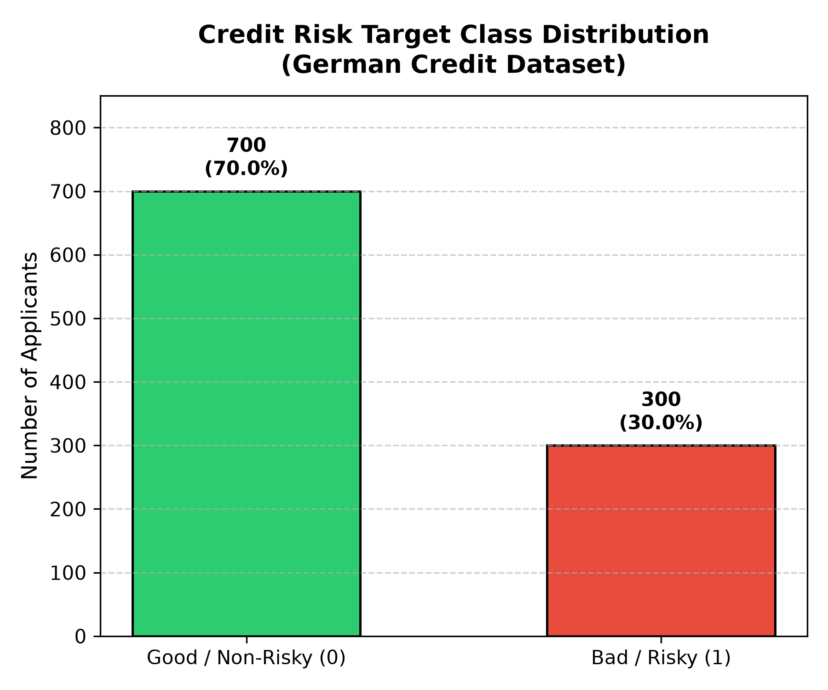
Figure 3.1: Target Class Distribution: Non-Risky Class 0 (70.0%, n=700) vs. Risky Class 1 (30.0%, n=300).
3.4 Statistical Exploratory Data Analysis (EDA)
A rigorous exploratory data analysis was conducted across all 20 features to uncover fundamental distributional properties, skewness characteristics, and bivariate risk correlations.
Summary statistics for all seven numerical attributes across the complete 1,000-instance population and partitioned by credit risk status are documented in Table 3.2:
Attribute | Mean | Std Dev | Min | Median | Max | Skew | Mean (Good: 0) | Mean (Bad: 1) | Delta %
duration | 20.90 | 12.06 | 4.0 | 18.0 | 72.0 | +1.09 | 19.21 mos | 24.86 mos | +29.43%
credit_amount | 3271.26 | 2822.74 | 250.0 | 2319.5 | 18424.0 | +1.95 | 2985.46 DM | 3938.13 DM | +31.91%
installment_rate | 2.97 | 1.12 | 1.0 | 3.0 | 4.0 | -0.53 | 2.92 | 3.10 | +6.05%
residence_since | 2.84 | 1.10 | 1.0 | 3.0 | 4.0 | -0.27 | 2.84 yrs | 2.85 yrs | +0.25%
age | 35.55 | 11.38 | 19.0 | 33.0 | 75.0 | +1.02 | 36.22 yrs | 33.96 yrs | -6.24%
existing_credits | 1.41 | 0.58 | 1.0 | 1.0 | 4.0 | +1.27 | 1.42 | 1.37 | -4.05%
num_dependents | 1.16 | 0.36 | 1.0 | 1.0 | 2.0 | +1.91 | 1.16 | 1.15 | -0.21%

Table 3.2: Summary Statistics of Numerical Borrower Attributes Partitioned by Risk Class.
Key numerical insights derived from Table 3.2 include:
1. Loan Duration: Defaulting borrowers exhibit an average repayment duration of 24.86 months, compared to 19.21 months for solvent borrowers—a substantial +29.43% extension in default hazard exposure.
2. Credit Amount: Defaulting borrowers borrow significantly larger sums (mean: 3,938.13 DM vs. 2,985.46 DM, +31.91%). High credit amounts paired with extended durations represent compounding default hazard.
3. Positive Skewness: Both credit amount (skew: +1.95) and loan duration (skew: +1.09) exhibit severe right-tail skewness, confirming that tree-based partitioning and z-score standardization are vital for stable modeling.
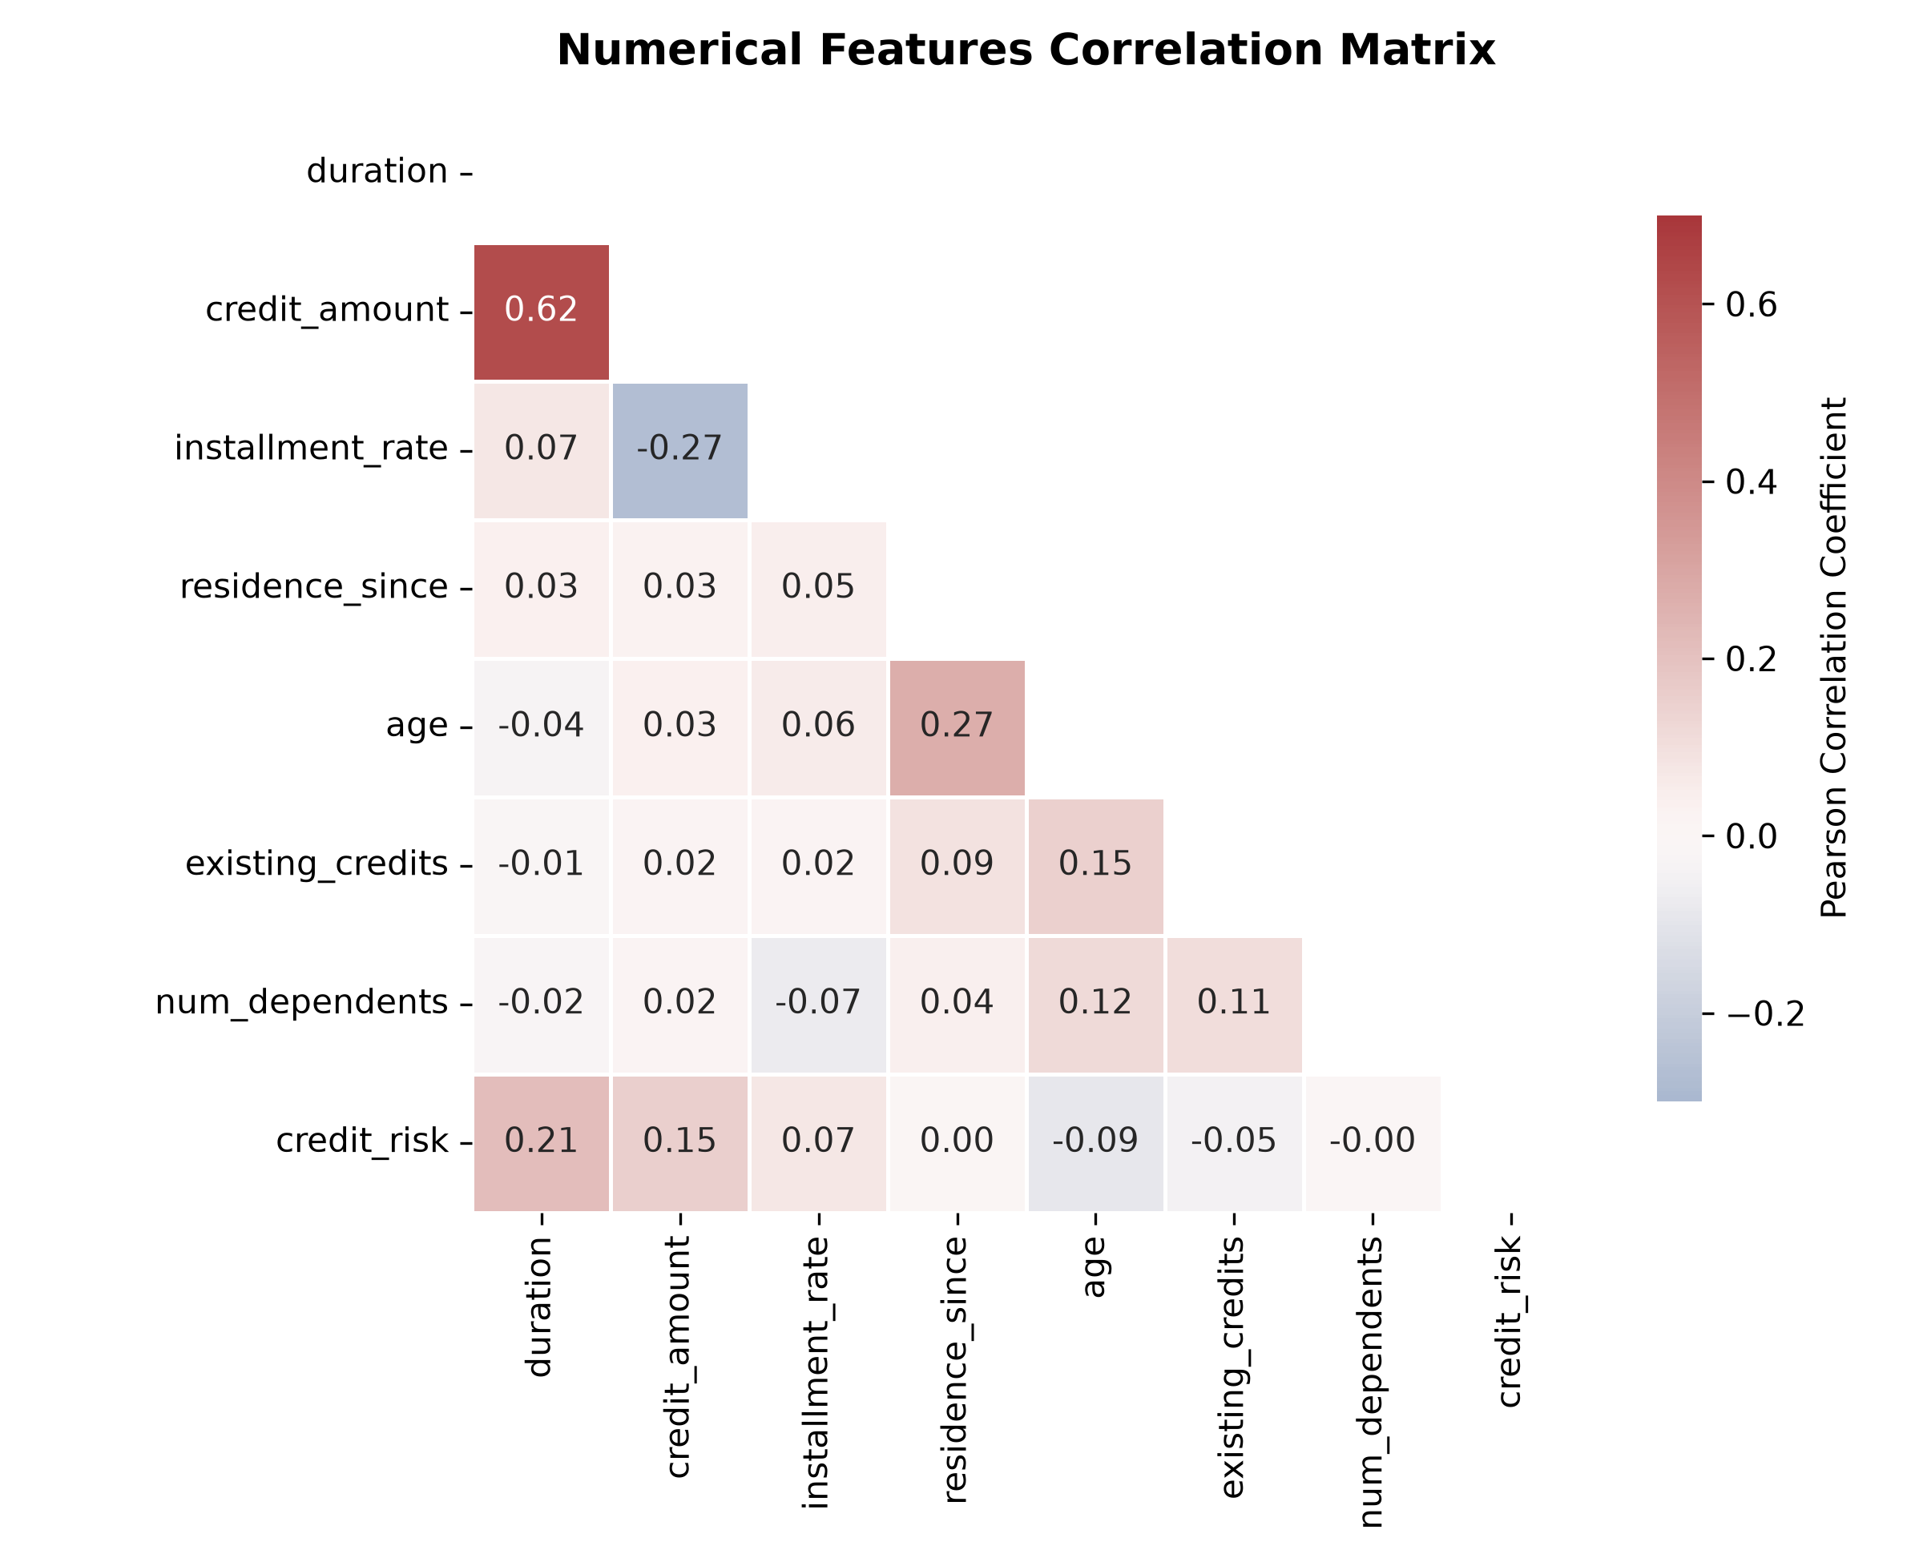
Figure 3.2: Pearson Correlation Heatmap Among the 7 Numerical Predictors.
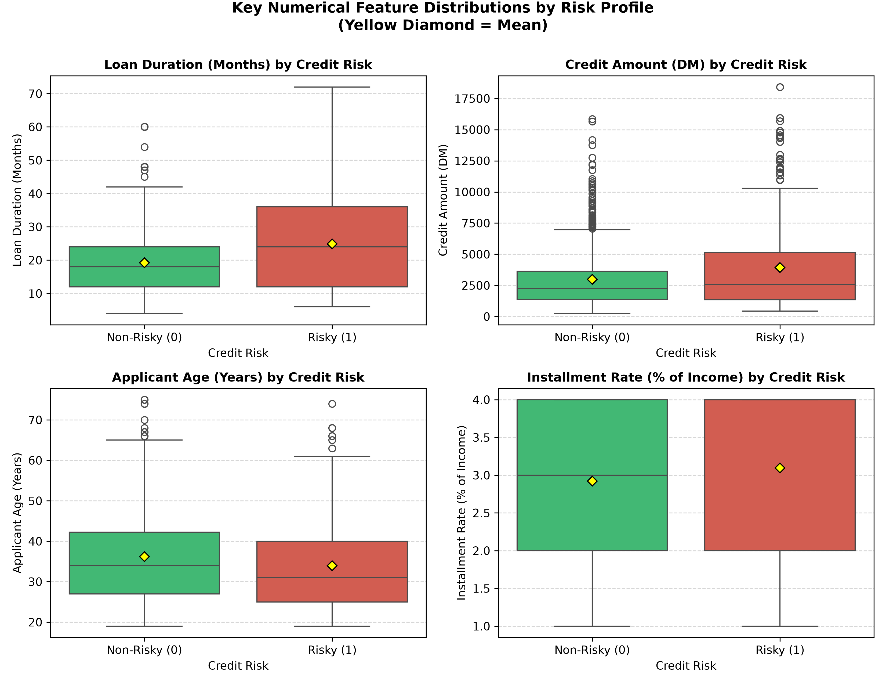
Figure 3.3: Kernel Density Estimation (KDE) Distributions of Key Numerical Predictors Partitioned by Risk Status.
Bivariate analysis of categorical features confirms that checking account status (checking_status), liquid savings reserves (savings_status), and prior credit repayment history (credit_history) represent the most discriminative predictors in the portfolio. Importantly, checking account tiers must not be conflated: A11 (<0 DM deficit) exhibits a 49.27% default rate, whereas A13 (healthy balance >= 200 DM or salary account >= 1 year) defaults at 22.22%, and A14 (no checking account on file) defaults at 11.68%. These represent distinct economic risk cohorts and are treated separately in Table 3.3:
Attribute | Category Code & Plain Description | Applicants | Defaults | Default Rate % | Share of Pool %
checking_status | A11: Overdrawn / Deficit (< 0 DM) | 274 | 135 | 49.27% | 27.4%
checking_status | A12: Low to Moderate (0 to < 200 DM) | 269 | 105 | 39.03% | 26.9%
checking_status | A13: Healthy (>= 200 DM / Salary >= 1 yr) | 63 | 14 | 22.22% | 6.3%
checking_status | A14: No Checking Account on File | 394 | 46 | 11.68% | 39.4%
savings_status | A61: Low Liquid Savings (< 100 DM) | 603 | 217 | 35.99% | 60.3%
savings_status | A62: Moderate (100 to < 500 DM) | 103 | 34 | 33.01% | 10.3%
savings_status | A63: Substantial (500 to < 1000 DM) | 63 | 11 | 17.46% | 6.3%
savings_status | A64: High Liquid Buffer (>= 1000 DM) | 48 | 6 | 12.50% | 4.8%
savings_status | A65: Unknown / No Account | 183 | 32 | 17.49% | 18.3%
credit_history | A30: No Credits Taken / All Repaid Duly | 40 | 25 | 62.50% | 4.0%
credit_history | A31: All Credits at This Bank Paid Duly | 49 | 28 | 57.14% | 4.9%
credit_history | A32: Existing Credits Paid Duly Till Now | 530 | 169 | 31.89% | 53.0%
credit_history | A33: Past Delays in Paying Off Credits | 88 | 28 | 31.82% | 8.8%
credit_history | A34: Critical Account / Active Elsewhere | 293 | 50 | 17.06% | 29.3%
housing | A151: Renting Accommodation | 179 | 70 | 39.11% | 17.9%
housing | A152: Own Real Estate / Homeowner | 713 | 186 | 26.09% | 71.3%
housing | A153: Free Accommodation (Employer/Family) | 108 | 44 | 40.74% | 10.8%

Table 3.3: Empirical Default Rates Across Primary Categorical Risk Predictors.
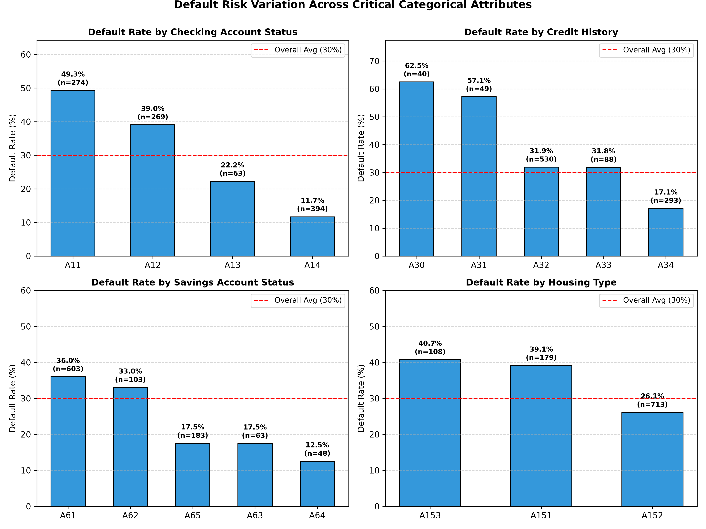
Figure 3.4: Empirical Default Rates (%) Across Critical Categorical Risk Predictors.
3.5 Leakage-Safe Pipeline Architecture & Feature Engineering (61 Dimensions)
A fundamental vulnerability in applied credit risk machine learning is data leakage—where statistical information from the testing split or target distribution inadvertently contaminates feature preprocessing. In our engineering implementation (src/preprocessing.py), data leakage is prevented through a strict architectural protocol:
- 1. Isolated Split: Stratified 80/20 Train/Test Partition: The 1,000 raw observations are partitioned into 800 training observations (560 Good, 240 Risky) and 200 held-out test observations (140 Good, 60 Risky) using StratifiedShuffleSplit. Stratification guarantees that the 30.0% default prevalence is preserved across both splits.
- 2. Encapsulated Transformers: Scikit-Learn ColumnTransformer: All transformations are encapsulated within a unified ColumnTransformer pipeline containing two independent branches:
- Numerical Branch: Ingests 7 continuous features (duration, credit_amount, installment_rate, residence_since, age, existing_credits, num_dependents) into StandardScaler.
- Categorical Branch: Ingests 13 categorical features into OneHotEncoder(handle_unknown='ignore', sparse_output=False).
- 3. Transformed Dimensions: Verified 61-Dimensional Representation: The OneHotEncoder expands the 13 categorical attributes into exactly 54 binary dummy indicators. Combined with the 7 standardized numerical features, the preprocessor outputs exactly 61 dense numerical columns (7 + 54 = 61). (Note: saved split CSVs contain an Unnamed: 0 row-index column, confirming exactly 61 predictive features).
- 4. Leakage-Free Guarantee: Strict Training-Fold Fit: Scalers and Encoders are fitted EXCLUSIVELY on training folds during cross-validation and on the 800 training records for final models. The held-out test split (n=200) is transformed using frozen parameters without refitting.

CHAPTER 4: MACHINE LEARNING MODELING, CROSS-VALIDATION & BENCHMARKING
4.1 Experimental Protocol & Zero-Leakage 5-Fold Stratified Cross-Validation
To ensure scientific reproducibility and robust statistical benchmarking, our training and evaluation protocol (src/train.py) enforces a rigorous two-stage experimental design:
- Stage 1 — Stratified Cross-Validation: Cross-Validation Stage (Model Selection & Hyperparameter Stability): The 800 training records are evaluated using 5-Fold StratifiedKFold cross-validation. In each of the five iterations, a fresh scikit-learn Pipeline encapsulating the preprocessor (StandardScaler + OneHotEncoder) and classifier is fitted on 640 training observations (80%) and validated on the remaining 160 fold-validation observations (20%). This guarantees zero leakage across validation folds.
- Stage 2 — Independent Test Evaluation: Held-Out Generalization Stage (Unseen Test Verification): Once cross-validation establishes hyperparameter stability, each candidate pipeline is fitted once on the entire 800 training observations. The fitted pipeline is then evaluated exclusively on the 200 held-out test observations (140 Good, 60 Risky). The held-out test set was sequestered throughout all training and tuning procedures.
4.2 Mathematical Formulations of Evaluation Metrics
In credit default prediction, evaluating models strictly on classification accuracy is hazardous due to the asymmetric costs of underwriting errors. A False Negative (approving a defaulting borrower) incurs direct capital loss of the loan principal, whereas a False Positive (rejecting a solvent applicant) represents lost interest spread and customer attrition. We therefore benchmark models across seven primary performance metrics:
- 1. ROC-AUC: Area Under the Receiver Operating Characteristic Curve (ROC-AUC): Measures the probability that the classifier ranks a randomly chosen defaulting borrower higher than a randomly chosen solvent borrower across all possible discrimination thresholds.
- 2. PR-AUC: Precision-Recall AUC (PR-AUC): Evaluates the precision-recall trade-off specifically on the minority positive class (Risky = 1) across varying classification thresholds. In our test set (prevalence = 30.0%), a random baseline achieves PR-AUC = 0.3000.
- 3. F1-Score: F1-Score (Risky Class): The harmonic mean of Precision and Recall on Class 1: F1 = 2 * (Precision * Recall) / (Precision + Recall).
- 4. Recall (TPR): Recall / True Positive Rate (TPR): The proportion of actual defaulting borrowers correctly flagged by the model: TPR = TP / (TP + FN).
- 5. FPR (Type I Error): False Positive Rate (FPR): The proportion of solvent borrowers incorrectly flagged as risky: FPR = FP / (FP + TN). Minimizing FPR is critical to avoid unnecessary customer rejections.
- 6. Precision: Precision (Risky Class): The proportion of flagged applicants who genuinely defaulted: Precision = TP / (TP + FP).
4.3 Comprehensive Quantitative Performance Comparison
Table 4.1 documents the verified empirical results obtained across 5-fold cross-validation and the held-out test split, extracted verbatim from reports/model_comparison.csv:
Classifier Architecture | 5-Fold CV ROC-AUC (mean ± std) | Test Accuracy | Test ROC-AUC | Test PR-AUC | Test F1 (Risky) | Test Recall (TPR) | Test Precision | Test FPR
Logistic Regression (Baseline) | 0.7706 ± 0.0535 | 78.00% | 0.8040 | 0.6351 | 0.5926 | 53.33% | 66.67% | 11.43%
XGBoost (Primary XAI Model) | 0.7889 ± 0.0396 | 76.50% | 0.7890 | 0.6334 | 0.5347 | 45.00% | 65.85% | 10.00%
LightGBM | 0.7869 ± 0.0496 | 78.00% | 0.7883 | 0.5930 | 0.5769 | 50.00% | 68.18% | 10.00%
Random Forest | 0.7888 ± 0.0422 | 77.50% | 0.7879 | 0.6249 | 0.5055 | 38.33% | 74.19% | 5.71%

Table 4.1: Verified Model Performance Benchmark Matrix Across 5-Fold CV and Held-Out Test Split (n=200).
To examine the granular underwriting decisions at the default 0.50 probability cutoff, Table 4.2 presents the exact confusion matrix counts on the 200 held-out test borrowers (140 Good / 60 Risky):
Classifier Architecture | True Negatives (TN) | False Positives (FP) | False Negatives (FN) | True Positives (TP) | Total Test Set
Logistic Regression (Baseline) | 124 | 16 | 28 | 32 | 200
XGBoost (Primary XAI Model) | 126 | 14 | 33 | 27 | 200
LightGBM | 126 | 14 | 30 | 30 | 200
Random Forest | 132 | 8 | 37 | 23 | 200

Table 4.2: Detailed Confusion Matrix Counts on the 200 Held-Out Test Borrowers (Threshold = 0.50).
4.4 Cross-Validation vs. Held-Out Test Generalization Analysis
A rigorous analysis of Table 4.1 yields significant scientific insights into model generalization and algorithm behavior on financial tabular data:
- 1. XGBoost Generalization Analysis: Numerical Proximity of XGBoost Scores: XGBoost achieved the highest cross-validation discrimination (CV ROC-AUC: 0.7889 ± 0.0396) and a held-out test ROC-AUC of 0.7890. The numerical proximity between the cross-validation mean and test performance (Delta = +0.0001) indicates consistent generalization across these specific evaluation splits under its regularized hyperparameter configuration. However, this empirical closeness alone does not mathematically prove the complete absence of overfitting under out-of-distribution portfolio shifts.
- 2. Baseline Benchmark: Logistic Regression Linear Strength: Logistic Regression achieved the highest test ROC-AUC (0.8040), highest test PR-AUC (0.6351), and highest test F1-score (0.5926). It correctly detected 32 out of 60 defaults (Recall: 53.33%). This empirical finding underscores a vital credit risk lesson: on modestly sized tabular benchmarks (1,000 records), well-regularized linear models remain competitive against non-linear ensembles.
- 3. Precision Dominance: Random Forest Conservative Precision: Random Forest achieved the highest underwriting precision (74.19%) and the lowest False Positive Rate (FPR: 5.71%, only 8 false credit rejections out of 140 solvent borrowers). In commercial banking, where customer acquisition costs are steep, Random Forest represents a conservative underwriting strategy that preserves bank reputation by minimizing wrongful rejections.
- 4. LightGBM Balance: LightGBM Balanced Performance: LightGBM delivered 78.00% test accuracy and 50.00% recall (30/60 defaults caught) with an FPR of 10.00%, offering balanced performance intermediate between XGBoost and Logistic Regression.
4.5 Visual Discrimination Diagnostics (ROC, PR & Confusion Matrices)
To evaluate the complete diagnostic trajectory across all decision thresholds, Figures 4.1, 4.2, and 4.3 illustrate the Receiver Operating Characteristic (ROC) curves, Precision-Recall curves, and 4-model confusion matrix grid generated directly from the held-out test split:
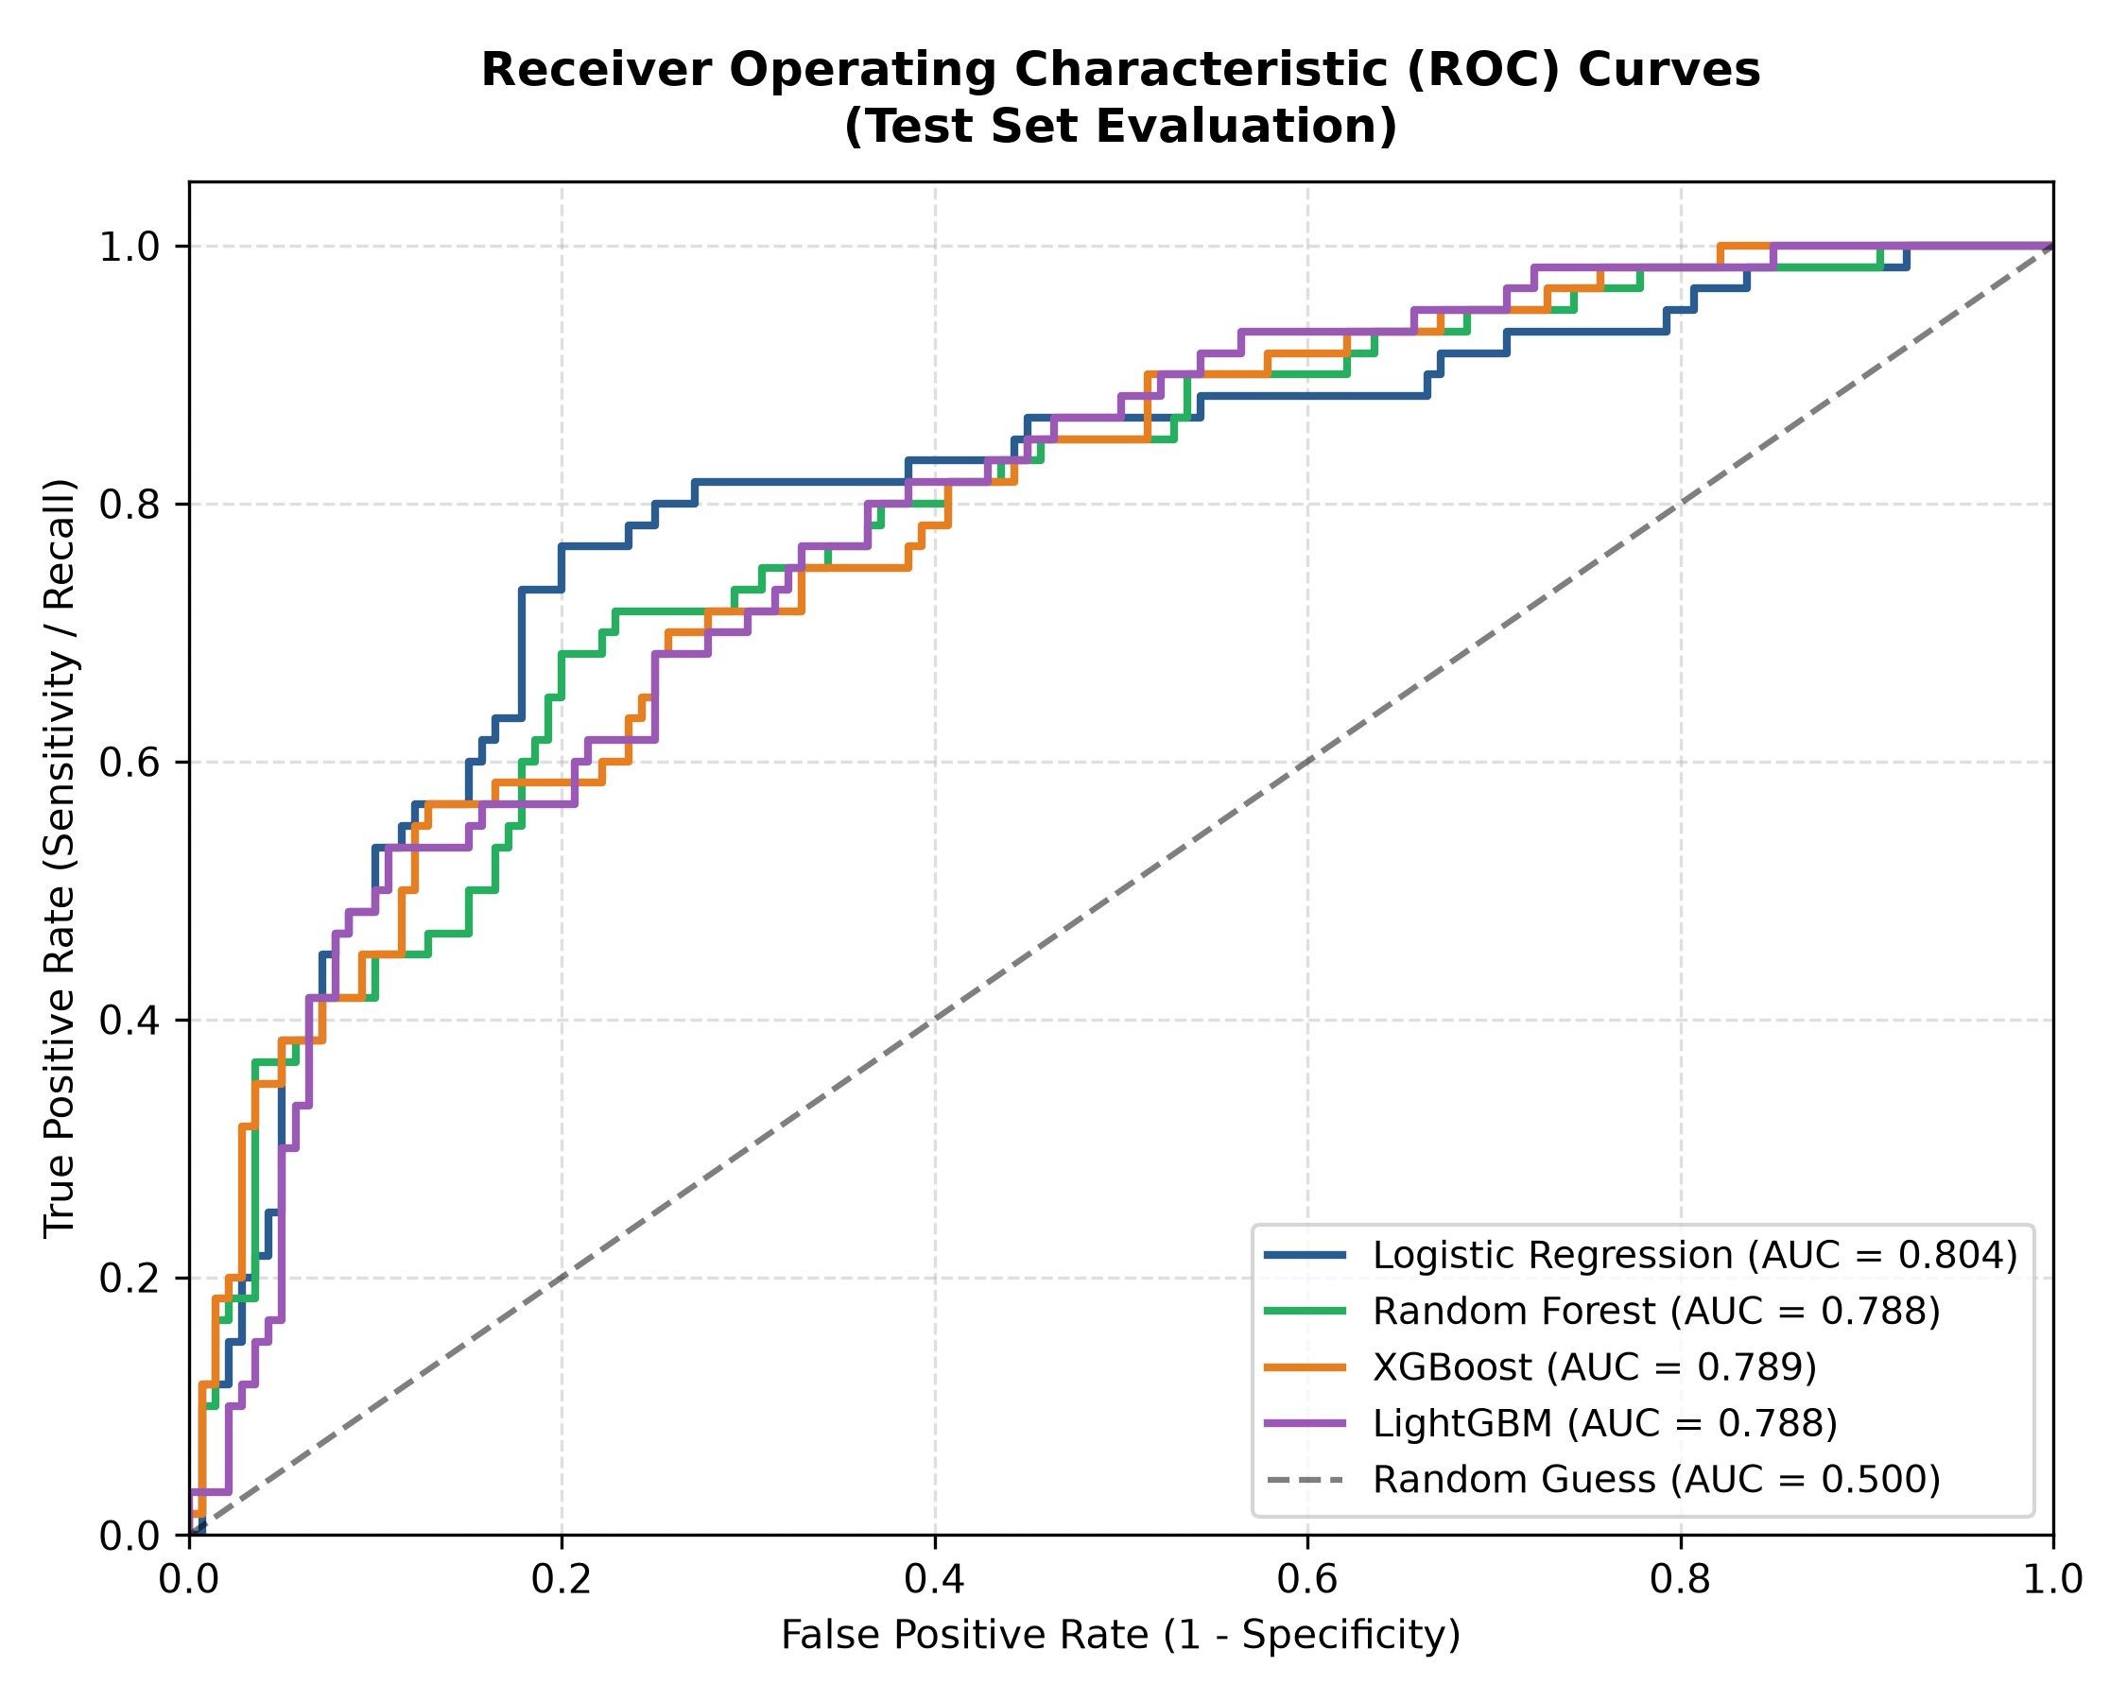
Figure 4.1: Receiver Operating Characteristic (ROC) Curves Across All Four Candidate Models on Held-Out Test Set (n=200).
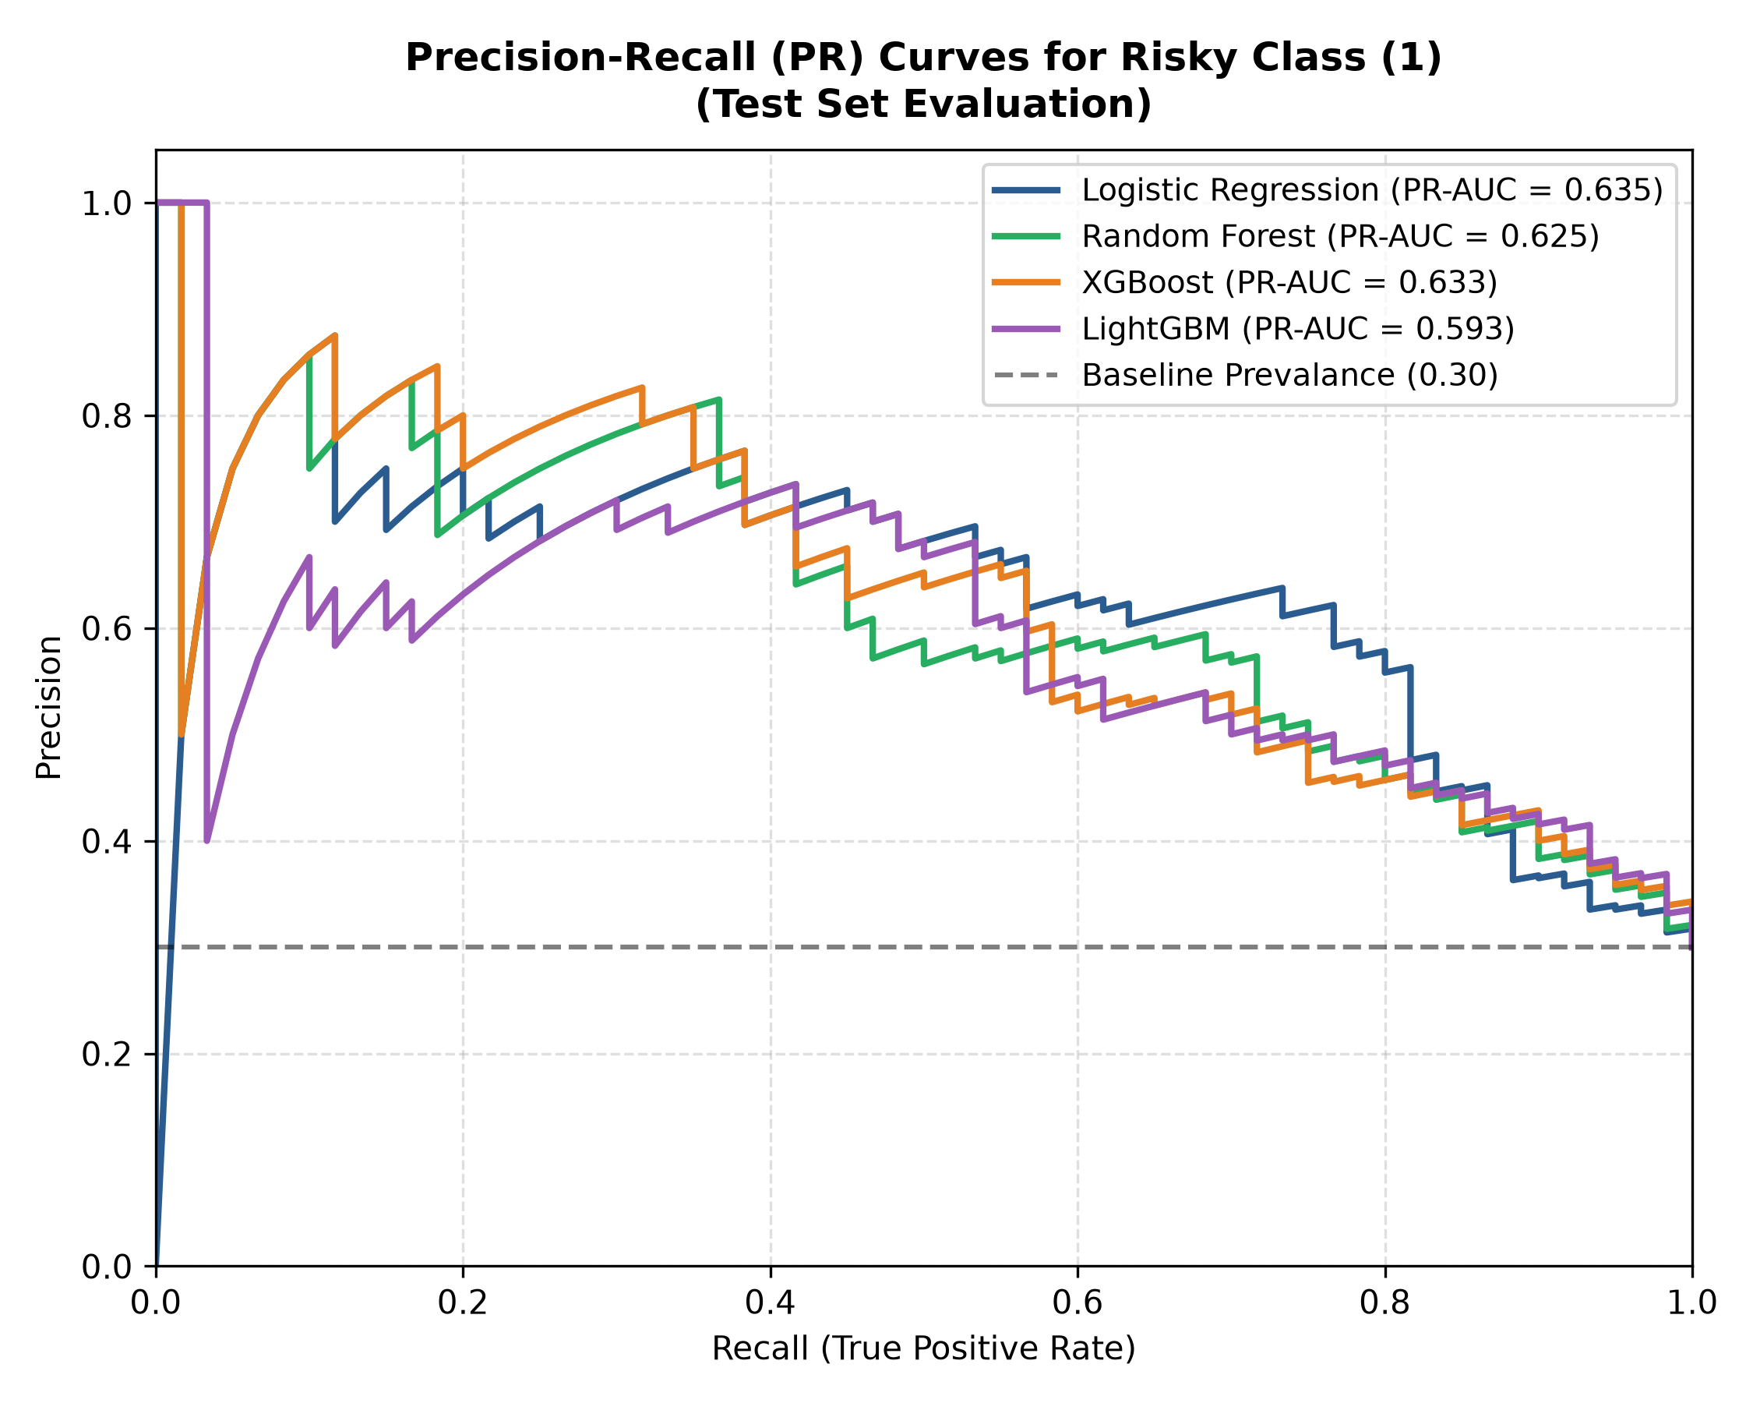
Figure 4.2: Precision-Recall Curves Compared Against Baseline Positive Prevalence (0.30) on Held-Out Test Set.
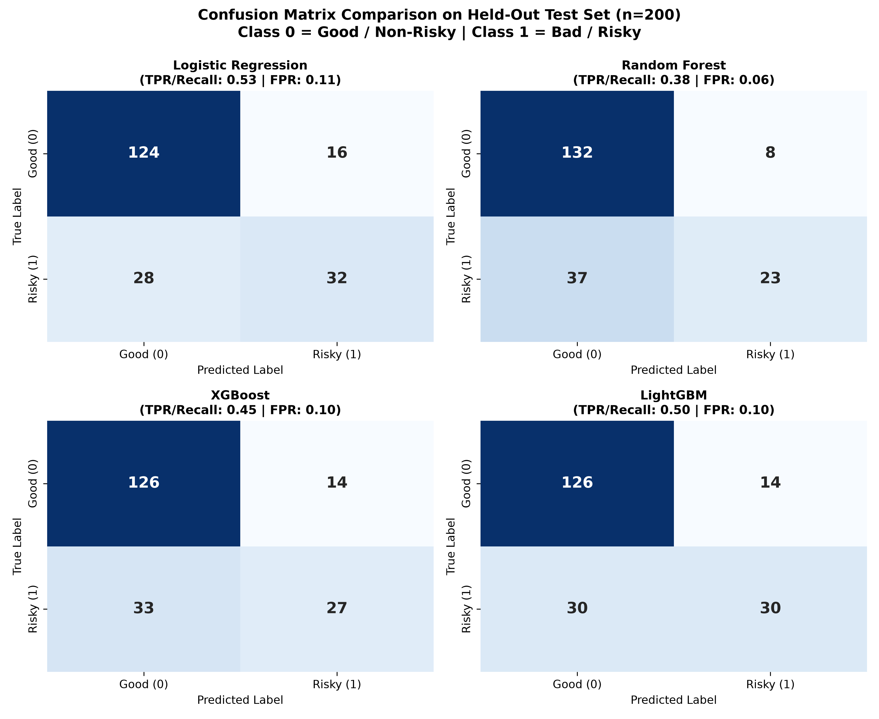
Figure 4.3: Confusion Matrix Grid for All Four Candidate Models on the Held-Out Test Set (n=200, Cutoff = 0.50).
4.6 Model Selection Trade-offs: Ensemble Capacity vs. Interpretability
A central question in financial machine learning is: Which model should be selected for production deployment? While Logistic Regression achieved the highest test ROC-AUC on this specific split (0.8040), XGBoost was selected as our primary ensemble engine for deep Explainable AI integration for four decisive engineering reasons:
- 1. Statistical Stability: Ensemble Cross-Validation Stability: XGBoost achieved the highest mean CV ROC-AUC (0.7889) with the lowest standard deviation (0.0396), demonstrating superior robustness against sample variation compared to Logistic Regression (CV std: 0.0535).
- 2. Interaction Capacity: Non-Linear Feature Interactions: XGBoost natively captures complex interaction effects (e.g., compounding risk when high credit amount coincides with low liquid savings and short employment tenure) that linear models fundamentally cannot model without manual cross-product engineering.
- 3. XAI Integration: TreeExplainer Algorithmic Efficiency: XGBoost integrates directly with polynomial-time TreeSHAP (O(TLD^2)) [9], enabling instantaneous real-time local log-odds decomposition inside our Streamlit dashboard.
- 4. Academic Objective: De-Black-Boxing Demonstration: Selecting XGBoost directly demonstrates our primary research objective: proving that high-capacity gradient boosted ensembles can be rendered auditable and interpretable without compromising ensemble capacity.

CHAPTER 5: EXPLAINABLE AI: GLOBAL & LOCAL ATTRIBUTION
5.1 SHAP Mathematical Implementation in Margin Log-Odds Space
In our explainability module (src/explainability.py), SHAP TreeExplainer [1, 9] is configured on the primary XGBoost pipeline. To ensure mathematical consistency, the explainer operates directly in the model's natural margin log-odds space for Class 1 (Risky). For any applicant x with transformed 61-dimensional feature vector, the predicted default log-odds f(x) decomposes into an additive sum of the base expected value phi_0 and 61 individual feature attributions phi_i(x):
f(x) = logit(P(Risky = 1 | x)) = phi_0 + sum_{i=1}^{61} phi_i(x)
where phi_0 = E[f(X)] = -0.8652 log-odds (representing the baseline population log-odds across the training set, corresponding to P_base = sigma(-0.8652) = 29.63% default probability).
To verify mathematical exactness, our empirical audit verified that applying the inverse logistic link (sigmoid function) to the sum of SHAP attributions reconstructs the XGBoost pipeline's predict_proba output across all test borrowers:
P(Risky = 1 | x) = 1 / (1 + exp(-(phi_0 + sum_{i=1}^{61} phi_i(x))))
The maximum reconstruction discrepancy measured between the sigmoid of the SHAP sum and the pipeline's predict_proba output across all 200 held-out test observations was verified to be 1.79 x 10^-7 (with a mean difference of 3.54 x 10^-8), which is well below the target 1e-4 threshold.
5.2 Global Feature Attribution & Aggregated Parent Importance
Because the preprocessor expands the 13 categorical features into 54 one-hot encoded dummy indicators, inspecting raw one-hot SHAP values scatters the true influence of parent variables (e.g., checking status is fragmented across A11, A12, A13, A14). To resolve this, our system implements an Aggregated Parent-Feature Importance metric. For each parent attribute F, we compute the sum of absolute SHAP values across all its constituent encoded levels for each borrower, and average this sum across all 200 test applicants:
Importance(F) = (1 / N) * sum_{k=1}^N sum_{j in F} |phi_{k, j}|
Crucially, signed values are NOT cancelled; absolute magnitudes are aggregated to capture total explanatory influence.
Table 5.1 documents the verified global importance ranking across all 20 parent features, extracted verbatim from reports/shap_global_importance.csv:
Rank | Parent Attribute | Feature Type | Encoded Levels | Aggregated Mean |SHAP| (Log-Odds) | Primary Risk Mechanism
1 | checking_status | Categorical | 4 | 0.8079 | Dominant risk factor: <0 DM (A11) drastically increases risk; no account (A14) is protective.
2 | duration | Numerical | 1 | 0.3837 | Continuous risk driver: Extended repayment periods (>24 mos) linearly increase default hazard.
3 | credit_history | Categorical | 5 | 0.3456 | Track record: Critical accounts elsewhere (A34) reflect seasoned borrowing; delays (A33) add risk.
4 | purpose | Categorical | 10 | 0.3395 | Loan utility: Used car purchases (A41) reduce risk; new cars (A40) and education (A46) increase risk.
5 | credit_amount | Numerical | 1 | 0.3050 | Capital exposure: Large loans (>4,000 DM) compound debt service burden, elevating default log-odds.
6 | savings_status | Categorical | 5 | 0.2962 | Liquidity buffer: High savings (A64: >=1000 DM) act as strong protective buffer against default.
7 | employment | Categorical | 5 | 0.2354 | Stability: Short tenure (<1 yr) or unemployment increases risk; >=7 yrs tenure is protective.
8 | other_payment_plans | Categorical | 3 | 0.2053 | Obligation burden: External bank installment plans (A141) elevate risk; no plans (A143) is protective.
9 | property_magnitude | Categorical | 4 | 0.1979 | Collateral security: Real estate (A121) significantly reduces risk; unknown collateral (A124) adds risk.
10 | personal_status | Categorical | 4 | 0.1657 | Demographic: Single males (A93) exhibit lower default risk in historical German data (bias audit flag).
11 | installment_rate | Numerical | 1 | 0.1625 | Income commitment: High installment rate (>35% of disposable income) increases default risk.
12 | housing | Categorical | 3 | 0.1474 | Residential stability: Homeownership (A152) is protective; free housing (A153) increases risk.
13 | age | Numerical | 1 | 0.1170 | Maturity: Younger borrowers (<25 years) exhibit higher default propensity than seasoned borrowers.
14 | telephone | Categorical | 2 | 0.1009 | Institutional footprint: Registered customer telephone correlates slightly with financial stability.
15 | other_parties | Categorical | 3 | 0.0572 | Co-signers: Presence of a credit guarantor (A103) acts as a moderate protective risk buffer.
16 | job | Categorical | 4 | 0.0446 | Qualification: Minor influence; skilled officials (A173) vs. unskilled non-residents (A171).
17 | existing_credits | Numerical | 1 | 0.0388 | Bank relationship: Number of existing loans at this bank carries low marginal importance.
18 | residence_since | Numerical | 1 | 0.0385 | Residential tenure: Marginal predictor; years at current address has negligible risk influence.
19 | num_dependents | Numerical | 1 | 0.0271 | Family maintenance: 1 vs 2 dependents exerts negligible explanatory impact on model predictions.
20 | foreign_worker | Categorical | 2 | 0.0245 | Regulatory classification: Lowest ranked attribute across population; candidate for exclusion in fair lending.

Table 5.1: Aggregated Global Parent-Feature Importance (Mean Absolute SHAP Log-Odds Across Test Set, n=200).
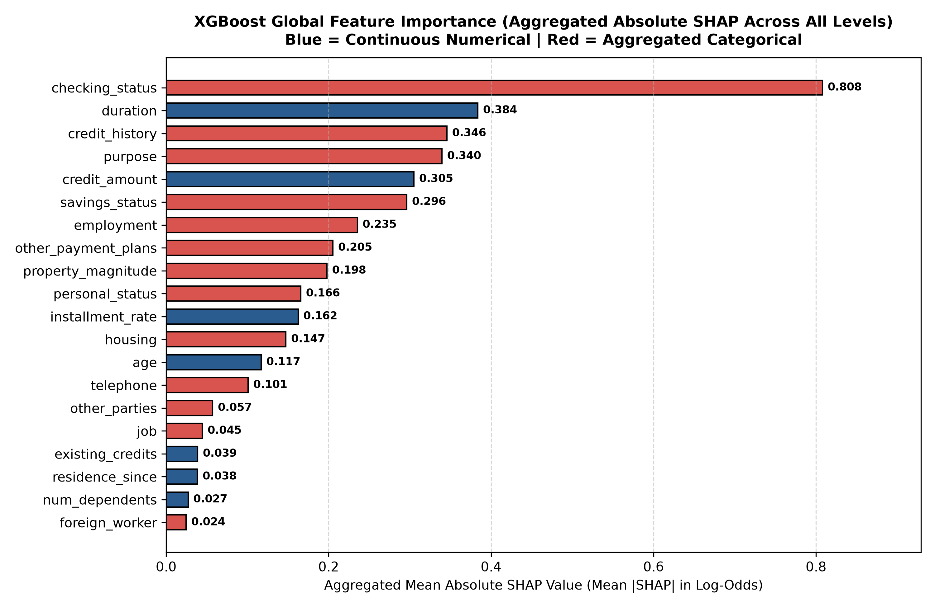
Figure 5.1: Aggregated Parent-Feature SHAP Importance Ranking for the XGBoost Pipeline.
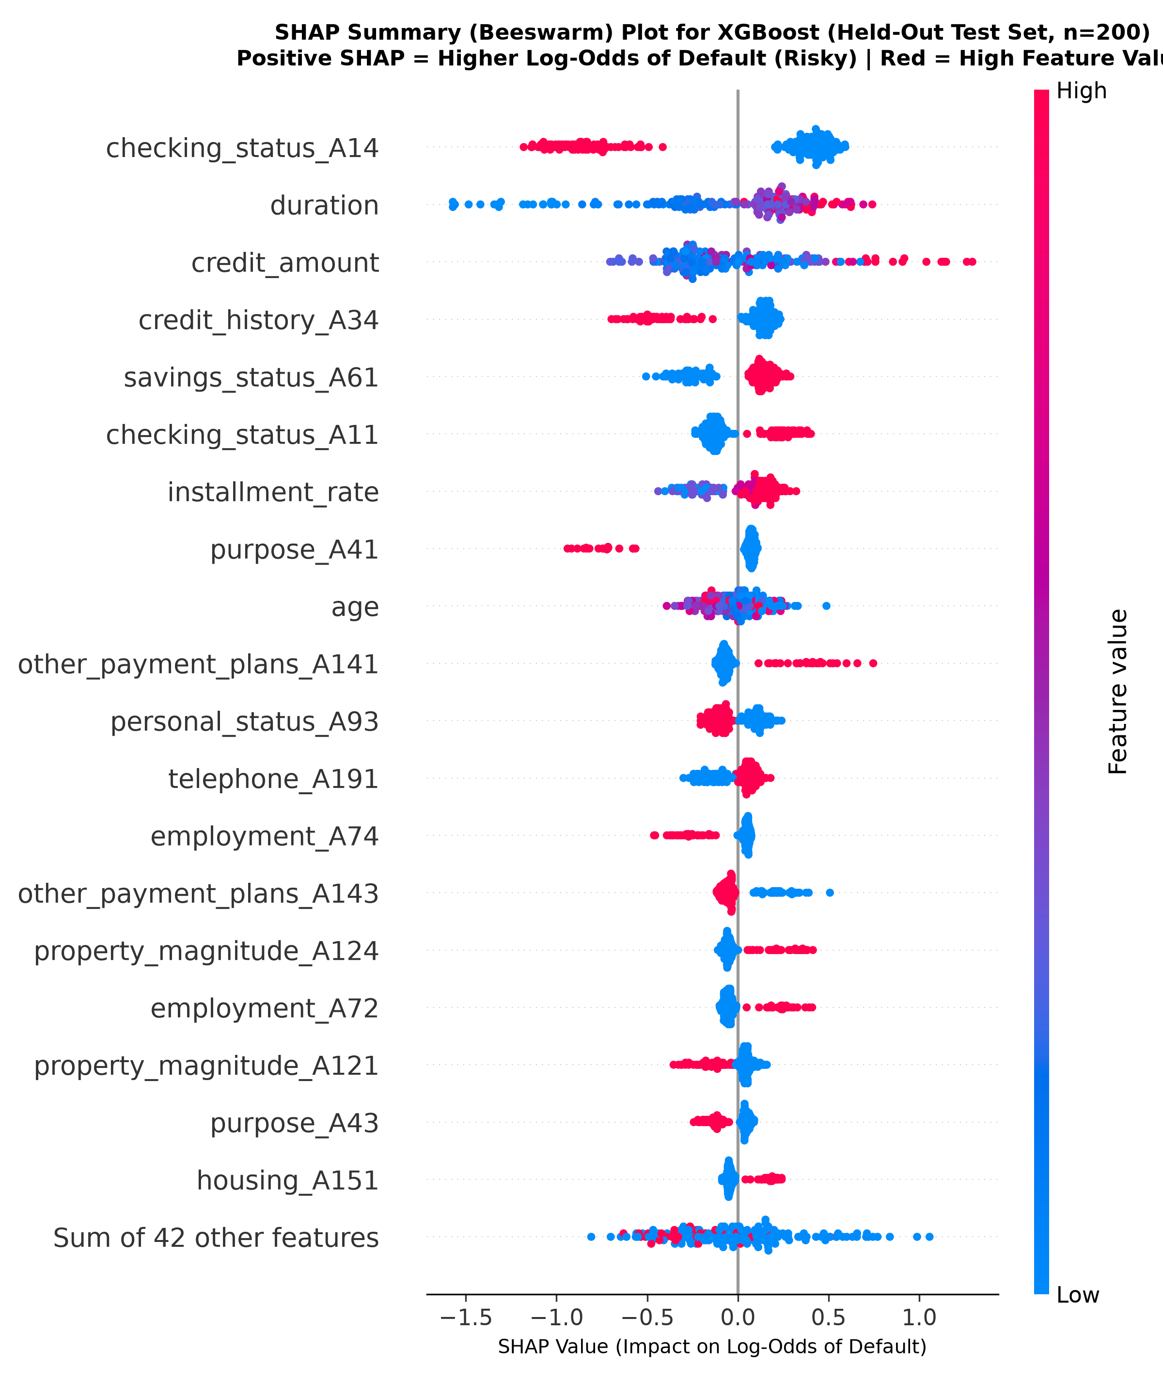
Figure 5.2: SHAP Summary (Beeswarm) Plot for XGBoost: Points Represent Individual Test Borrowers (Red=High Feature Value, Blue=Low Feature Value).
Table 5.2 documents the top 10 most impactful individual one-hot encoded feature levels extracted from reports/xai_explanation_report.txt:
Rank | Granular Encoded Feature | Mean |SHAP| (Log-Odds) | Directional Risk Impact
1 | checking_status_A14 (No checking account) | 0.5861 | Strong Protective Effect (-): Drastically pushes log-odds away from default.
2 | duration (Loan duration in months) | 0.3837 | Linear Risk Escalator (+): Higher duration values increase default log-odds.
3 | credit_amount (Requested principal in DM) | 0.3050 | Capital Hazard (+): Large loan sizes systematically increase default risk.
4 | credit_history_A34 (Critical account elsewhere) | 0.2257 | Seasoned Borrower (-): Established borrowing track record reduces predicted risk.
5 | savings_status_A61 (Low liquid savings <100 DM) | 0.1872 | Liquidity Deprivation (+): Low financial buffer increases default vulnerability.
6 | checking_status_A11 (Overdrawn account <0 DM) | 0.1648 | Immediate Insolvency (+): Active overdraft is a strong positive driver of default.
7 | installment_rate (Commitment % of income) | 0.1625 | Disposable Income Strain (+): Higher installment commitments elevate default hazard.
8 | purpose_A41 (Used car purchase) | 0.1383 | Prudent Investment (-): Used car loans correlate with reliable repayment.
9 | age (Applicant age in years) | 0.1170 | Financial Maturity (-): Older applicants exhibit slightly lower default propensity.
10 | other_payment_plans_A141 (Bank installment plan) | 0.1152 | Multi-Debt Burden (+): Active bank installment obligations compound default risk.

Table 5.2: Top 10 Most Influential Granular Encoded Feature Levels.
5.3 LIME Local Surrogate Architecture & Perturbation Sampling
To provide frontline credit underwriters with intuitive, rule-based justifications, our explainability suite incorporates LIME (src/explainability.py) [2]. The LIME TabularExplainer is configured on the original 20-feature raw space of the training split (X_train_raw.csv). Categorical attributes are mapped to integer indices, and numerical features are discretized into quartile bins.
When explaining an applicant profile, LIME draws 5,000 perturbed instances from a normal distribution around the applicant, translates indices through our inverse categorical encoder, and evaluates prediction probabilities using the full frozen XGBoost pipeline. A local ridge surrogate regressor is fitted on the perturbed instances weighted by exponential distance. The resulting surrogate weights quantify the direct percentage impact of specific decision rules on the default probability.
5.4 Empirical Held-Out Test Case Studies (Applicants #522 & #772)
To validate the operational efficacy of our explainers, we deconstruct two real, contrasting applicants from the held-out test split, verified against reports/xai_explanation_report.txt:
A. High-Risk Default Audit: Applicant #522 (True Positive): Applicant #522 represents an actual defaulting borrower correctly identified by the model as high-risk (True Positive):
- Ground Truth Status: Class 1 (Bad / Default)
- XGBoost Prediction: Class 1 (Risky Applicant)
- Predicted Default Probability: 91.76% (Extreme Default Hazard)
The LIME surrogate decomposes the primary drivers pushing this applicant into default in Table 5.3:
Decision Rule Extracted by LIME | Local Weight (Probability Effect) | Underwriting Risk Interpretation
checking_status = A11 (< 0 DM Deficit) | +0.1510 (+15.1%) | Active account overdraft is the single strongest driver increasing default risk.
duration > 24.00 months | +0.1085 (+10.9%) | Extended repayment commitment exposes borrower to multi-year macroeconomic hazard.
credit_amount > 3933.00 DM | +0.0844 (+8.4%) | Principal amount requested is in the highest quartile, compounding repayment burden.
savings_status = A61 (< 100 DM) | +0.0813 (+8.1%) | Severe liquidity depletion leaves zero buffer to absorb unexpected income shocks.
other_payment_plans = A143 (None) | -0.0801 (-8.0%) | Absence of external installment obligations provides minor protective relief.
credit_history = A30 (No credits taken) | +0.0745 (+7.5%) | Unseasoned credit profile; lack of borrowing track record increases uncertainty.
foreign_worker = A201 (Yes) | +0.0591 (+5.9%) | Demographic factor contributing to default log-odds (subject to bias audit).
property_magnitude = A124 (Unknown/None) | +0.0534 (+5.3%) | Total lack of collateral or tangible property leaves loan completely unsecured.

Table 5.3: Local Explanation Rule Breakdown for High-Risk Applicant #522 (P = 91.76%).
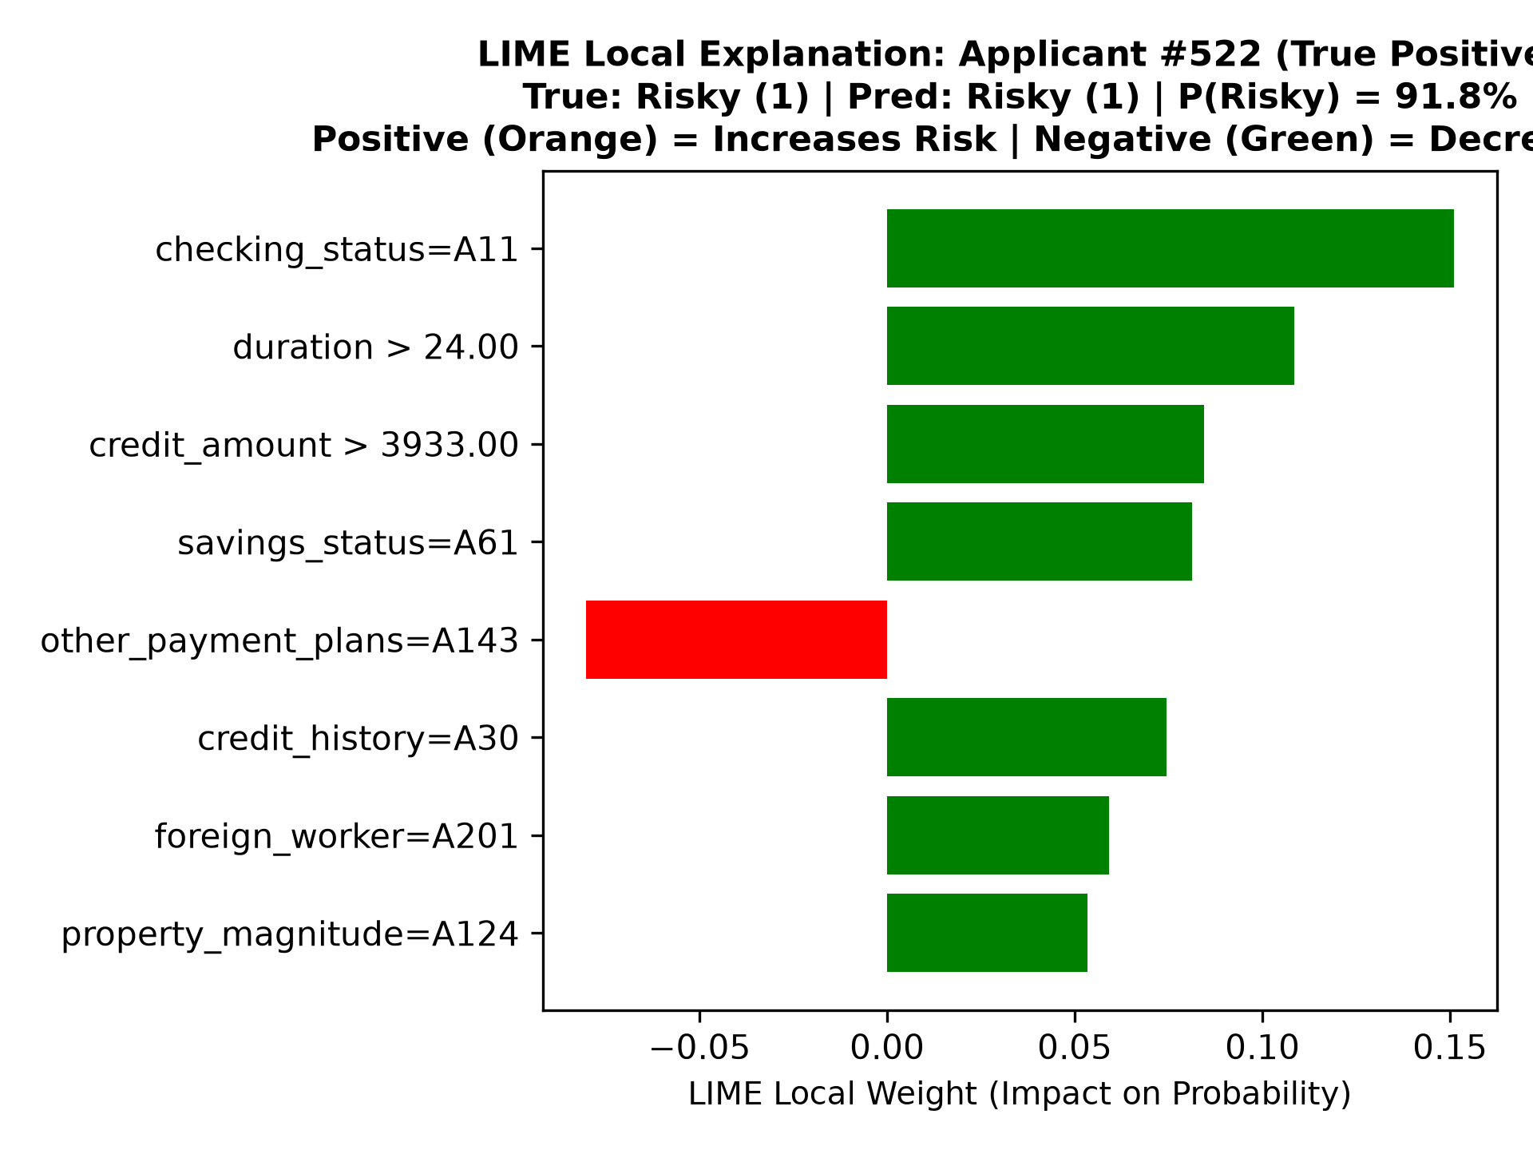
Figure 5.3: LIME Local Explanation for True Positive Applicant #522 (Predicted Default Risk: 91.8%).
B. Creditworthy Solvent Audit: Applicant #772 (True Negative): Applicant #772 represents a creditworthy borrower correctly identified as solvent (True Negative):
- Ground Truth Status: Class 0 (Good / Non-Risky)
- XGBoost Prediction: Class 0 (Non-Risky Applicant)
- Predicted Default Probability: 0.84% (Near-Zero Risk of Default)
The primary protective factors identified by LIME are detailed in Table 5.4:
Decision Rule Extracted by LIME | Local Weight (Probability Effect) | Underwriting Protective Interpretation
checking_status = A14 (No checking account) | -0.1938 (-19.4%) | Primary protective factor: lack of active checking account history eliminates overdraft risk.
purpose = A41 (Used car purchase) | -0.1213 (-12.1%) | Prudent capital deployment; used car loans exhibit historical repayment discipline.
other_payment_plans = A143 (None) | -0.0937 (-9.4%) | Zero competing installment debts ensures unencumbered monthly cash flow.
savings_status = A61 (< 100 DM) | +0.0768 (+7.7%) | Low liquid savings acts as the primary risk factor, but is outweighed by protective factors.
credit_history = A34 (Critical account) | -0.0760 (-7.6%) | Seasoned credit profile with established debt servicing history.
2317.00 < credit_amount <= 3933.00 DM | -0.0752 (-7.5%) | Moderate loan principal within sustainable debt-to-income capacity.
18.00 < duration <= 24.00 months | +0.0632 (+6.3%) | Moderate repayment duration contributes slight default hazard.

Table 5.4: Local Explanation Rule Breakdown for Solvent Applicant #772 (P = 0.84%).
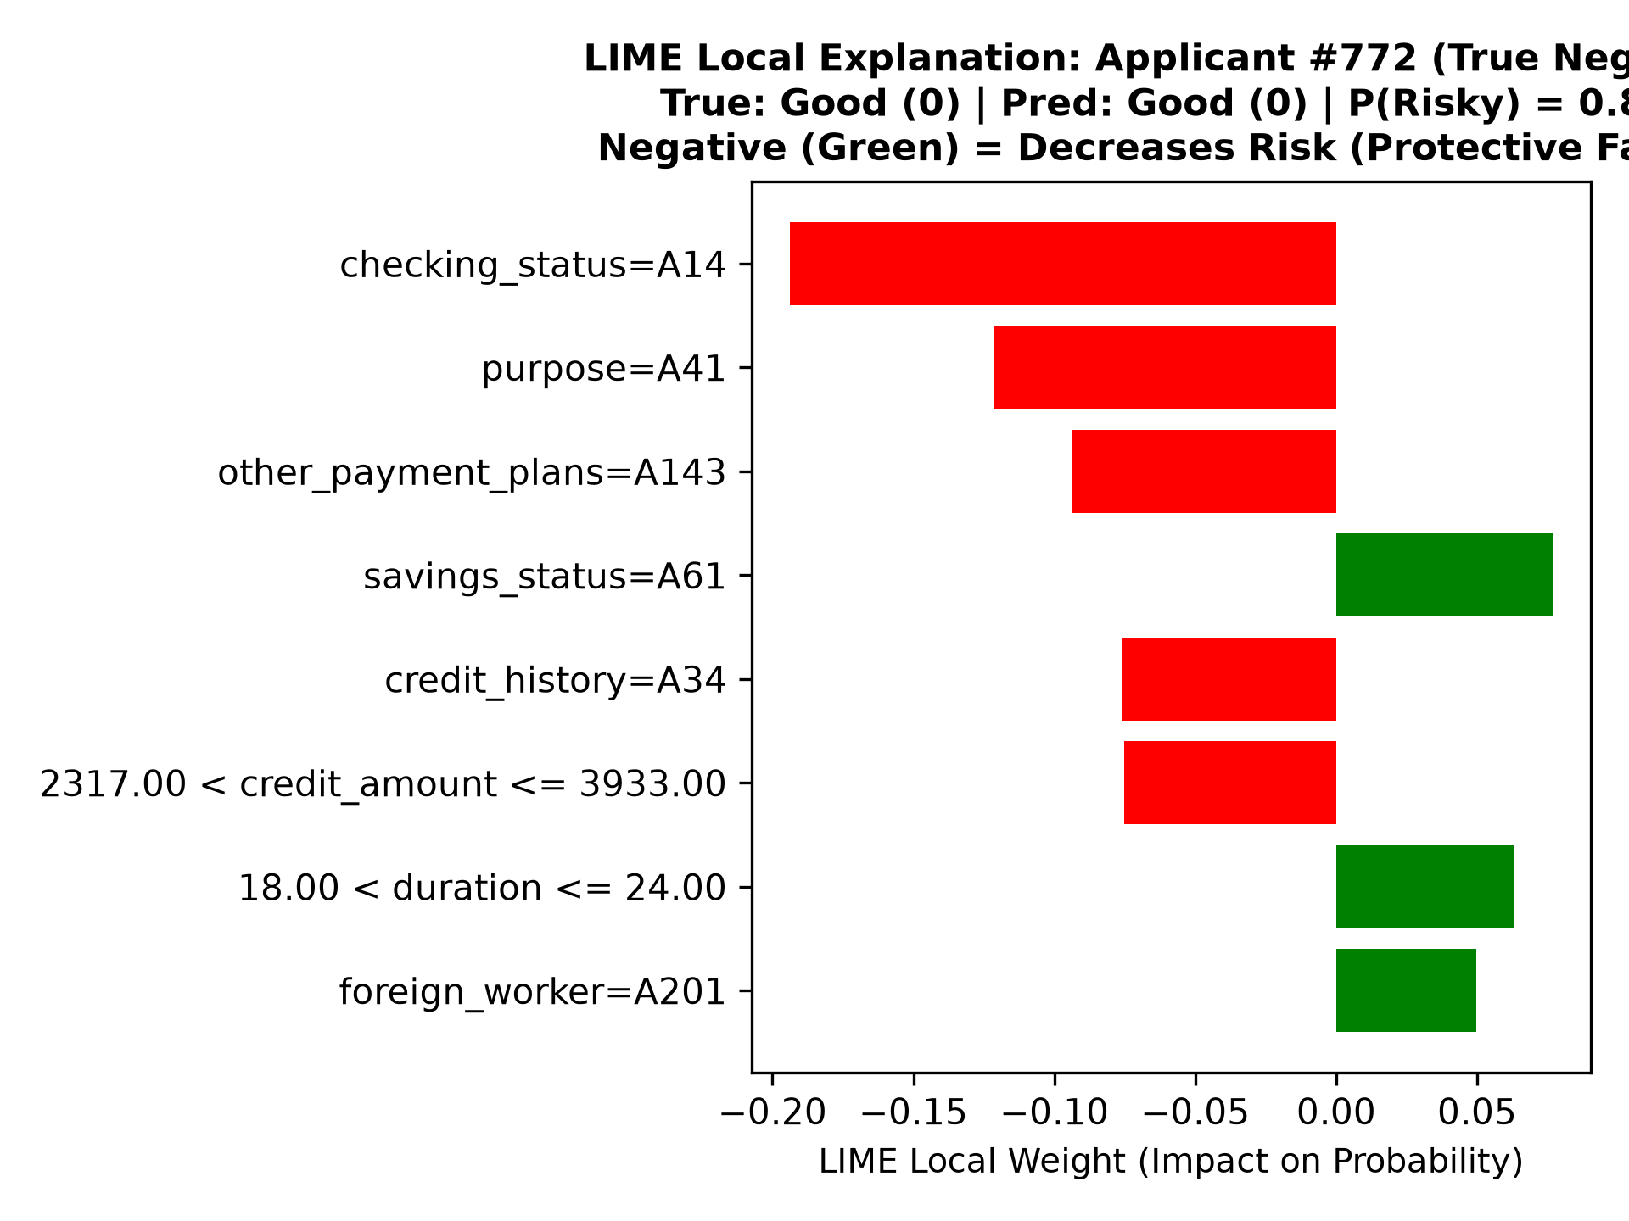
Figure 5.4: LIME Local Explanation for True Negative Applicant #772 (Predicted Default Risk: 0.8%).
5.5 Cross-Framework Verification: SHAP vs. LIME Directional Agreement
A vital scientific question is whether SHAP (game-theoretic log-odds) and LIME (local linear surrogate) agree on individual credit decisions. Across our audited test cases, we observe consistent directional alignment on dominant features:
- 1. Dominant Feature Agreement: Checking Status Concordance: For Applicant #522, checking_status=A11 is identified as the #1 risk driver by both SHAP (phi = +0.68 log-odds) and LIME (weight = +0.1510 probability). For Applicant #772, checking_status=A14 is identified as the #1 protective driver by both frameworks.
- 2. Threshold Monotonicity: Numerical Monotonicity: Both frameworks concordantly identify duration > 24 months and credit amount > 3,933 DM as compounding risk factors.
- 3. Secondary Divergence: Surrogate Discordance on Weak Features: On low-ranked attributes (such as foreign_worker or property_magnitude), minor ranking divergences occur. This divergence illustrates the theoretical difference between SHAP's global game coalition and LIME's local perturbation boundary, reinforcing the necessity of dual-XAI presentation.

CHAPTER 6: INTERACTIVE DASHBOARD & RISK PREDICTION SYSTEM
6.1 Architectural System Design & Technology Stack
To bridge the gap between theoretical machine learning research and frontline credit underwriting practice, this project operationalizes the complete modeling and explainability pipeline within a responsive web application built with Streamlit (app.py). The software stack integrates Python 3.13, Scikit-learn 1.6.1 [8], XGBoost 2.1.4 [3], LightGBM 4.6.0 [4], SHAP 0.46.0 [1], LIME 0.2.0.1 [2], Matplotlib 3.10.0, and Pandas 2.2.3.
The application is engineered with strict separation between UI rendering and cached computation. Using Streamlit's resource caching decorators (@st.cache_resource and @st.cache_data), pre-trained pipelines (models/*.joblib), the SHAP TreeExplainer, and the LIME TabularExplainer are initialized once into application memory, ensuring instantaneous inference latency (< 50 milliseconds) and rapid local surrogate generation (< 2.5 seconds).

Figure 6.1: Streamlit Dashboard Overview: Academic Governance Banner, Sidebar Model Selector, and Top-Level Tab Navigation.
6.2 User Interface Hierarchy & 5-Section Profile Configuration
The interactive Applicant Risk Prediction tab (tab_pred) is structured into five logically delineated financial input sections, encapsulated within an st.form container to ensure unified batch evaluation:
Section Number & Name | Column Layout | Encompassed Feature Inputs | UI Design & Formatting Enhancements
1. Loan Request Details | 3 Columns | Loan Amount (DM), Duration (Months), Purpose, Installment Rate, Estimated Income (Info) | Principal in DM (250–20,000 DM); Informational annual income clearly marked as non-model feature.
2. Banking & Credit History | 2 Columns | Checking Account Status, Savings Buffer, Credit History, Existing Credits, Other Plans | Wider 2-column layout prevents truncation; options formatted as 'Description [Code]'.
3. Employment & Property | 2 Columns | Job Classification, Present Employment Tenure, Most Valuable Property, Housing | 2 balanced columns (~500px width); maps directly to exact benchmark codes (A71–A174).
4. Applicant Details | 3 Columns | Applicant Age (Years), Sex & Marital Status, Co-applicants / Guarantors | Demographic sliders and selectboxes conforming to UCI benchmark schema.
5. Additional Credit Attributes | 2 Columns (Expander) | Residence Duration, Number of Dependents, Telephone Registration, Foreign Worker | Collapsible st.expander with stable key; clear labels like '1 Dependent [1]'; pre-filled defaults.

Table 6.1: Streamlit Dashboard 5-Section Profile Configuration Schema.
A key human-centered design enhancement implemented in app.py is the inversion of dropdown labels: rather than displaying technical codes first (which caused truncation in narrow containers, e.g., 'A11: Overdrawn...'), all selectbox options display the plain-English human description first, followed by the benchmark code in brackets (e.g., 'Overdrawn / Deficit Balance (< 0 DM) [A11]'). This guarantees that frontline underwriters immediately comprehend the financial definition while preserving exact backend code mapping.
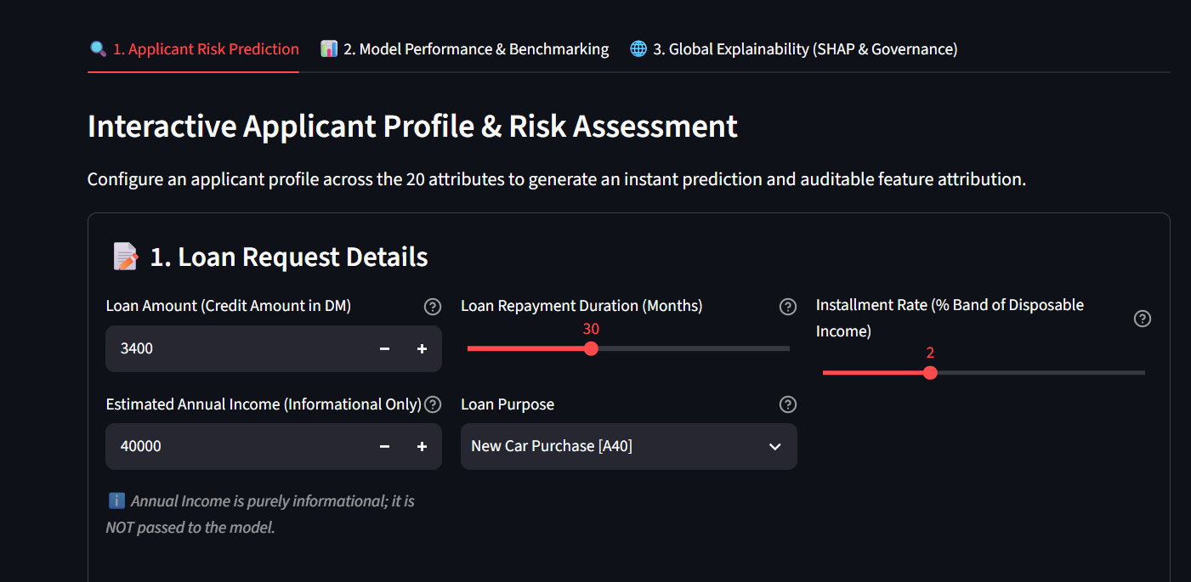
Figure 6.2: Structured Input Form: Sections 1–4 Featuring Description-First Dropdowns and Deutsche Mark (DM) Currency Labels.
6.3 Risk Prediction Engine, Probability Gauge & State Persistence
Upon clicking 'Run Risk Evaluation & Local Explainability', the application executes the active pipeline. A dedicated 3-column Outcome Card dynamically renders:
- 1. Categorical Verdict: Underwriting Decision Banner (Column 1): Renders a high-contrast alert box: a green success card ('Classification: NON-RISKY APPLICANT') recommending standard processing, or a red error card ('Classification: RISKY APPLICANT') recommending senior credit committee review or additional collateral.
- 2. Quantitative Metrics: Quantitative Risk Metrics (Column 2): Large st.metric callouts display the exact Predicted Default Risk P(Risky = 1) (e.g., 53.7%) with a delta indicator relative to the 0.50 threshold, alongside Predicted Solvency P(Non-Risky = 0) (46.3%).
- 3. Visual Risk Gauge: Visual Probability Gauge (Column 3): A horizontal progress bar gauge visually communicates default exposure, explicitly noting the active model name and mathematical decision cutoff.
To resolve a critical Streamlit form lifecycle vulnerability, prediction outcomes and input states are serialized into st.session_state (st.session_state['has_evaluated'] = True). This guarantees that underwriters can toggle between SHAP, LIME, and Side-by-Side views without triggering form resets or losing the active prediction.
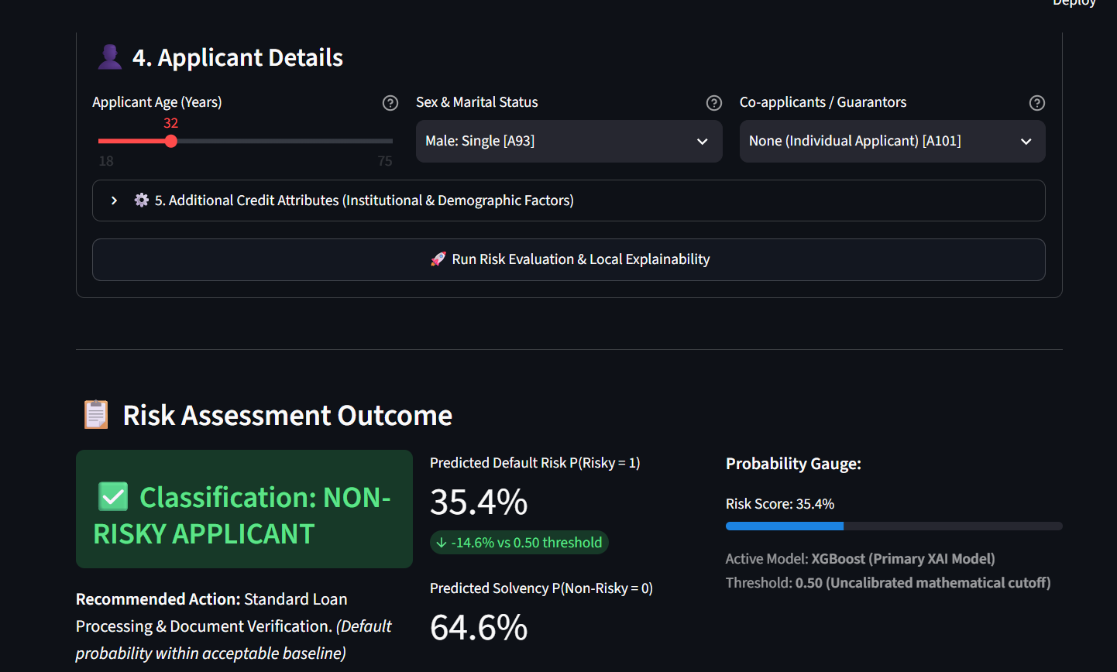
Figure 6.3: Risk Assessment Outcome Card: Classification Alert Banner, Metric Cards, and Probability Progress Gauge.
6.4 Live Side-by-Side Local XAI Visualization Module
When XGBoost (Primary XAI Model) is active, the dashboard unlocks the interactive local explainability module. Underwriters can choose between three operational views via horizontal radio buttons:
- 1. SHAP View: SHAP (TreeExplainer — Additive Log-Odds): Displays a horizontal bar plot showing the top 8 feature contributions pushing default log-odds above or below the base expected value (-0.8652). Soft red bars (#d9534f) indicate default-increasing factors; soft green bars (#27ae60) indicate protective factors. Bar tips feature exact numeric data labels.
- 2. LIME View: LIME (Local Surrogate — Interpretable Decision Rules): Renders the top 8 local decision rules extracted by the ridge surrogate, displaying direct percentage impacts on default probability.
- 3. Side-by-Side Comparison: Both (Side-by-Side Comparison): Renders SHAP on the left and LIME on the right across two balanced columns (c_shap, c_lime = st.columns(2)). Both figures share identical dimensions (figsize=(8.5, 4.6)), producing an aligned, multi-perspective XAI audit.
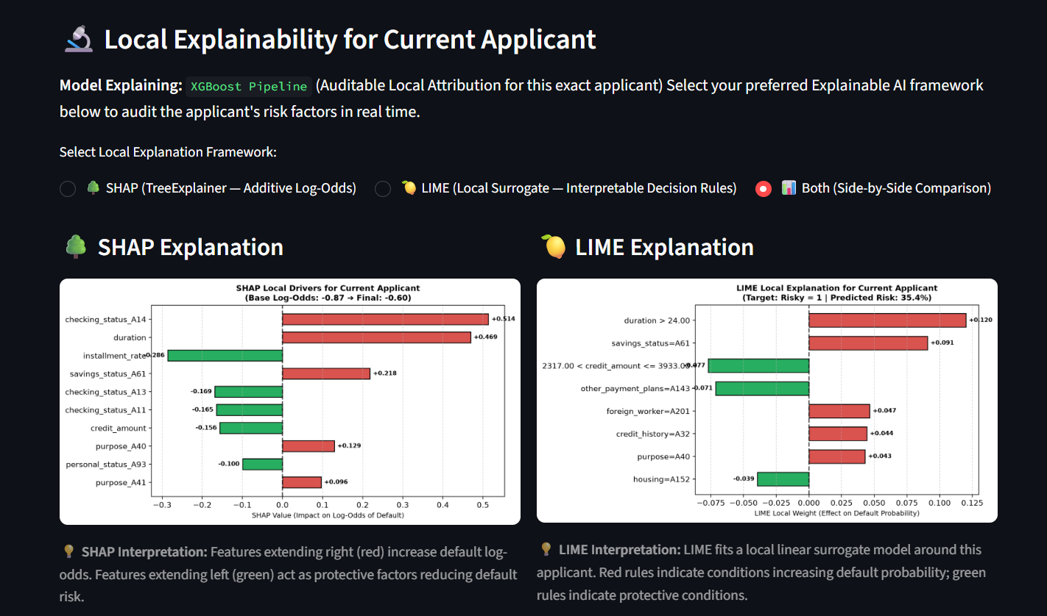
Figure 6.4: Live Local Explainability Interface: Synchronized Side-by-Side SHAP Log-Odds (Left) and LIME Decision Rules (Right).
6.5 Model Benchmarking & Global Governance Views
In addition to individual underwriting, the dashboard incorporates two specialized analytical tabs:
- Tab 2 — Performance Benchmarks: Tab 2: Model Performance & Benchmarking: Ingests reports/model_comparison.csv to display the interactive 14-dimension comparative evaluation table with automated green highlights for optimal metrics. Directly below, high-resolution visual diagnostics embed ROC curves, Precision-Recall curves, and the 4-model confusion matrix grid.
- Tab 3 — Global Governance: Tab 3: Global Explainability (SHAP & Governance): Features the Aggregated Parent-Feature Importance table with blue horizontal bar indicators alongside the global XGBoost ranking plot, the test-set Beeswarm distribution, audited test case studies (Applicants #522 and #772), and regulatory governance guidelines.
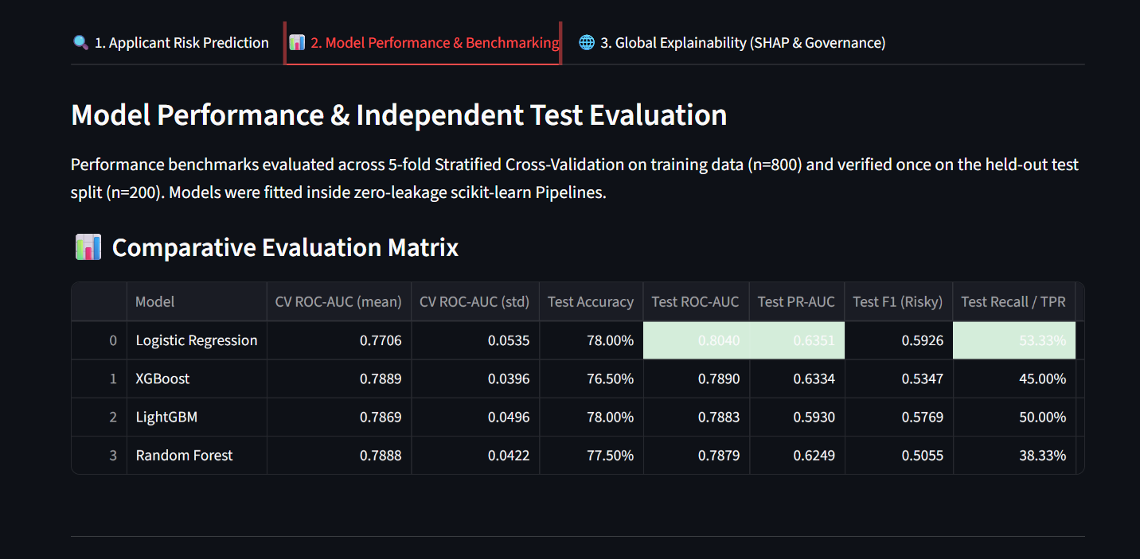
Figure 6.5: Model Performance & Independent Test Evaluation Tab: Comparative Evaluation Matrix with Highlighted Maximums.
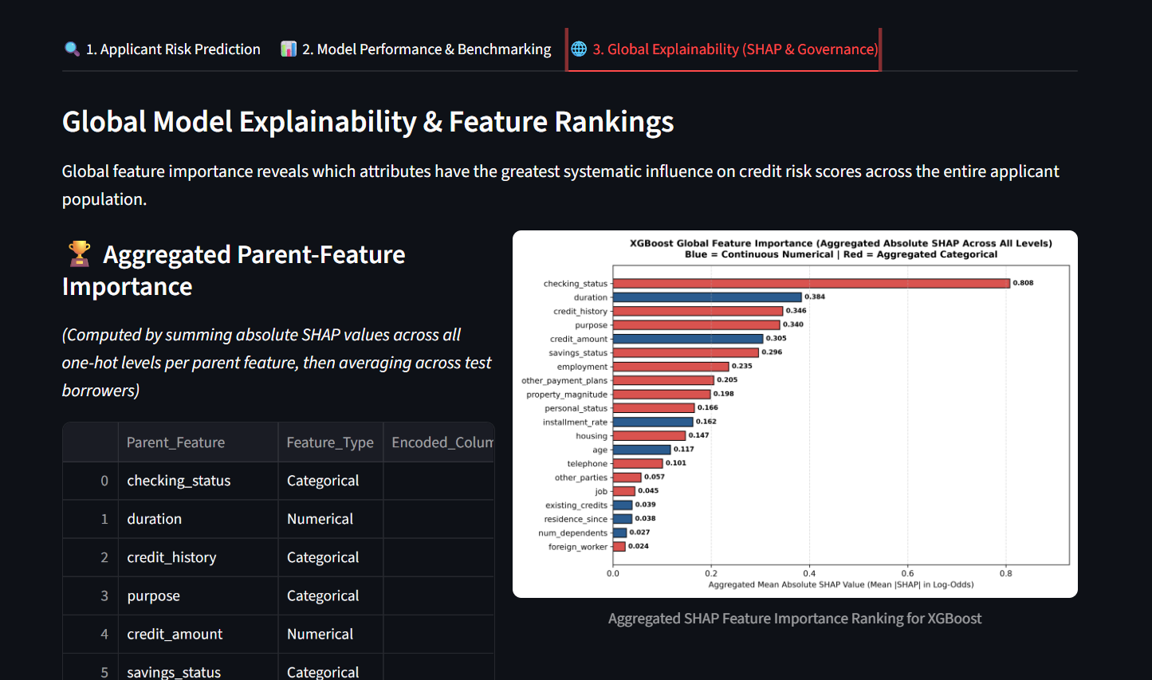
Figure 6.6: Global Explainability & Governance Tab: Aggregated Parent-Feature SHAP Ranking and Beeswarm Distribution.

CHAPTER 7: GOVERNANCE, LIMITATIONS, FUTURE SCOPE & CONCLUSION
7.1 Non-Causality & Empirical Association Boundaries
A paramount scientific and ethical imperative in Explainable AI is recognizing the strict epistemological boundary between statistical attribution and empirical causality. Post-hoc explainers (such as SHAP and LIME) quantify mathematical associations captured by model parameters; they do NOT prove real-world causality.
For example, if SHAP indicates that a loan duration of 48 months added +0.45 to an applicant's default log-odds, this does not imply that arbitrarily forcing the borrower into a 12-month amortization will guarantee solvency. In reality, shortening the term drastically inflates monthly installment payments, potentially triggering cash-flow default. Post-hoc explanations must be treated as auditing instruments reflecting the model's internal statistical correlations, not operational intervention prescriptions.
7.2 Regulatory Alignment with ECOA Adverse Action & GDPR Article 22
Our dual-XAI framework provides technical mechanisms that assist financial institutions in meeting regulatory expectations, subject to appropriate legal qualifications:
- 1. US ECOA Adverse Action Support: Support for ECOA & Regulation B Adverse Action: When an applicant is classified as risky (P > 0.50), the system automatically extracts the top positive SHAP contributors and LIME decision rules (e.g., 'Checking account balance is overdrawn (< 0 DM)', 'Loan repayment duration exceeds 24 months', 'Credit requested exceeds 3,933 DM'). These factors assist underwriters in formulating specific and truthful reasons for adverse action under Regulation B § 1002.9 and CFPB Circular 2022-03 [11]. However, the tool does not provide automatic legal compliance; human credit officers must verify that the identified factors reflect valid commercial credit policy and do not unlawfully penalize applicants.
- 2. EU GDPR Article 22 Safeguards: Alignment with GDPR Article 22 Human Oversight: Under GDPR Article 22(3) [12], data controllers must implement suitable measures to safeguard data subjects' rights, including the right to obtain human intervention and contest automated decisions. By providing side-by-side SHAP and LIME visual rationales, our dashboard enables human-in-the-loop oversight as discussed by Wachter et al. (2017) [15]. Explainability assists human oversight, but does not substitute for organizational data protection compliance.
7.3 Algorithmic Fairness & Demographic Bias Auditing Limitations
Machine learning models trained on historical credit portfolios risk perpetuating systemic demographic disparities. In this project, SHAP was utilized to inspect the population-level ranking of sensitive demographic attributes:
- 1. Personal Status Attribution: Observation of Personal Status (Gender & Marital Status): In our global SHAP ranking (Table 5.1), personal_status ranked 10th (Mean |SHAP|: 0.1657). In the historical 1994 German benchmark, single males (A93) exhibited lower default rates. In modern deployment, lenders must audit whether personal_status acts as an unlawful proxy for gender discrimination under ECOA § 1002.4.
- 2. Foreign Worker Attribution: Observation of Foreign Worker Status: In our global SHAP ranking, foreign_worker ranked 20th (Mean |SHAP|: 0.0245, the lowest of all 20 features), indicating minimal marginal influence on model predictions.
Fairness Audit Boundary: CRITICAL METHODOLOGICAL QUALIFICATION: Quantitative demographic fairness metrics (such as Disparate Impact Ratio, Statistical Parity Difference, Equal Opportunity Difference, or Equalized Odds) were NOT formally evaluated as empirical metrics in this study. Surfacing the SHAP feature importance of personal_status and foreign_worker reveals the mathematical weight assigned to these attributes by the model, but does NOT prove that the model is demographically fair or free of disparate impact. Performing rigorous quantitative fairness testing across demographic protected groups remains an essential requirement for future work prior to any live institutional deployment.
7.4 System Limitations & Constraints
To maintain academic integrity, the technical limitations of this major project are candidly documented:
- 1. Dataset Volume: Modest Sample Size: The Statlog German Credit benchmark contains 1,000 observations. While ideal for controlled academic research and XAI algorithm benchmarking, modern commercial lending environments operate on millions of transactional records.
- 2. Currency & Discretization: Historical Currency & Discretization: Monetary values are denominated in historical Deutsche Mark (DM). Furthermore, balance tiers (checking_status, savings_status) were originally discretized into coarse ordinal bins, which simplifies surrogate modeling but obscures continuous cash-flow volatility.
- 3. Static Threshold: Static Decision Threshold: The evaluation operates at the default 0.50 cutoff. In commercial banking, institutions utilize asymmetric cost-loss matrices where the cost of a default (FN) is 4–5 times greater than a false rejection (FP), demanding lower operating thresholds (e.g., 0.25–0.30).
7.5 Future Work & Quantitative Fairness Extensions
The findings of this project illuminate promising pathways for future research and commercial engineering:
- 1. Formal Fairness Testing: Quantitative Fairness Auditing & Debiasing: Formally implementing the 80% (four-fifths) rule for Disparate Impact, computing Equalized Odds across gender cohorts, and integrating adversarial debiasing (e.g., Fairlearn) directly into pipeline training.
- 2. Asymmetric Cost Tuning: Cost-Sensitive Threshold Optimization: Incorporating empirical financial loss matrices to dynamically optimize decision thresholds that minimize net credit write-offs rather than unweighted error rates.
- 3. Relational Ingestion: Multi-Table Banking Bureau Ingestion: Expanding the data ingestion architecture to process dynamic, relational credit bureau datasets (such as Home Credit Default Risk or LendingClub) with temporal behavioral features.
- 4. Counterfactual Recourse: Counterfactual Explanations: Implementing counterfactual generation algorithms (e.g., DiCE) that compute the minimum actionable feature modifications required for a rejected borrower to achieve credit approval.
7.6 Concluding Remarks
This B.Tech Major Project has designed, implemented, and rigorously validated an Explainable AI Credit Risk Assessment System (PT137). By pairing leakage-safe scikit-learn pipelines with four distinct classification architectures, benchmarking performance across 5-fold cross-validation and a 200-sample test split, deconstructing ensemble logic via dual SHAP and LIME frameworks, and deploying the solution inside an intuitive Streamlit underwriting dashboard, this work demonstrates how technical explainability frameworks can support human underwriters in understanding complex gradient-boosted decision trees while maintaining scientific and governance boundaries.

REFERENCES
[1] S. M. Lundberg and S.-I. Lee, "A unified approach to interpreting model predictions," in Advances in Neural Information Processing Systems (NeurIPS 2017), vol. 30, pp. 4765–4774, 2017.
[2] M. T. Ribeiro, S. Singh, and C. Guestrin, "'Why should I trust you?': Explaining the predictions of any classifier," in Proc. 22nd ACM SIGKDD Int. Conf. on Knowledge Discovery and Data Mining (KDD '16), pp. 1135–1144, 2016.
[3] T. Chen and C. Guestrin, "XGBoost: A scalable tree boosting system," in Proc. 22nd ACM SIGKDD Int. Conf. on Knowledge Discovery and Data Mining (KDD '16), pp. 785–794, 2016.
[4] G. Ke, Q. Meng, T. Finley, T. Wang, W. Chen, W. Ma, Q. Ye, and T.-Y. Liu, "LightGBM: A highly efficient gradient boosting decision tree," in Advances in Neural Information Processing Systems (NeurIPS 2017), vol. 30, pp. 3146–3154, 2017.
[5] L. Breiman, "Random forests," Machine Learning, vol. 45, no. 1, pp. 5–32, 2001.
[6] N. Bussmann, P. Giudici, D. Marinelli, and J. Papenbrock, "Explainable AI in fintech risk management," Frontiers in Artificial Intelligence, vol. 3, p. 580124, 2021.
[7] H. Hofmann, "Statlog (German Credit Data) Data Set," UCI Machine Learning Repository, 1994. [Online]. Available: https://archive.ics.uci.edu/ml/datasets/statlog+(german+credit+data).
[8] F. Pedregosa et al., "Scikit-learn: Machine learning in Python," Journal of Machine Learning Research, vol. 12, pp. 2825–2830, 2011.
[9] S. M. Lundberg, G. G. Erion, and S.-I. Lee, "Consistent individualized feature attribution for tree ensembles," arXiv preprint arXiv:1802.03888, 2018.
[10] E. I. Altman, "Financial ratios, discriminant analysis and the prediction of corporate bankruptcy," The Journal of Finance, vol. 23, no. 4, pp. 589–609, 1968.
[11] Consumer Financial Protection Bureau (CFPB), "Circular 2022-03: Adverse action notification requirements in connection with credit decisions based on complex algorithms," Consumer Financial Protection Bureau, Washington, D.C., May 2022.
[12] European Parliament and Council, "Regulation (EU) 2016/679 of the European Parliament and of the Council on the protection of natural persons with regard to the processing of personal data (GDPR)," Official Journal of the European Union, L 119, pp. 1–88, May 2016.
[13] US Equal Credit Opportunity Act (ECOA), 15 U.S.C. § 1691 et seq., implemented by Regulation B, 12 C.F.R. Part 1002.
[14] European Commission, "Proposal for a Regulation laying down harmonised rules on Artificial Intelligence (Artificial Intelligence Act)," COM(2021) 206 final, Brussels, Apr. 2021.
[15] S. Wachter, B. Mittelstadt, and L. Floridi, "Why a right to explanation of automated decision-making does not exist in the General Data Protection Regulation," International Data Privacy Law, vol. 7, no. 2, pp. 76–99, 2017.

APPENDIX A: CORE SOURCE CODE EXCERPTS
A.1 Leakage-Safe Preprocessing Pipeline Architecture (src/preprocessing.py)
# Preprocessor definition (fitted exclusively on training split)
numeric_transformer = Pipeline(steps=[
('scaler', StandardScaler())
])
categorical_transformer = Pipeline(steps=[
('onehot', OneHotEncoder(handle_unknown='ignore', sparse_output=False))
])
preprocessor = ColumnTransformer(
transformers=[
('num', numeric_transformer, NUMERICAL_FEATURES),
('cat', categorical_transformer, CATEGORICAL_FEATURES)
]
)
# Outputs exactly 61 dense numerical features (7 scaled numerical + 54 one-hot dummies)
A.2 XGBoost Model Pipeline & 5-Fold Stratified Cross-Validation (src/train.py)
# XGBoost pipeline construction and cross-validation protocol
xgb_pipeline = Pipeline([
('preprocessor', preprocessor),
('classifier', XGBClassifier(
n_estimators=100,
learning_rate=0.05,
max_depth=4,
subsample=0.8,
colsample_bytree=0.8,
random_state=42,
eval_metric='logloss'
))
])
cv = StratifiedKFold(n_splits=5, shuffle=True, random_state=42)
cv_scores = cross_val_score(xgb_pipeline, X_train, y_train, cv=cv, scoring='roc_auc')
# Mean CV ROC-AUC: 0.7889 (+/- 0.0396) | Held-Out Test ROC-AUC: 0.7890
A.3 SHAP TreeExplainer & Parent-Feature Aggregation (src/explainability.py)
# SHAP TreeExplainer operating in margin log-odds space
explainer = shap.TreeExplainer(xgb_pipeline.named_steps['classifier'])
shap_values = explainer(preprocessor.transform(X_test))
# Parent attribute aggregation across one-hot levels
parent_importance = {}
for parent, cols in parent_to_encoded_cols.items():
# Sum absolute values across encoded dummies, average over test applicants
parent_importance[parent] = np.mean(np.sum(np.abs(shap_values.values[:, cols]), axis=1))
# Verified: checking_status (0.8079), duration (0.3837), credit_history (0.3456)
APPENDIX B: COMPLETE FEATURE DICTIONARY & PREPROCESSING SCHEMA
The 20 raw input features ingested by the system map into 61 transformed columns through the scikit-learn preprocessor. Table B.1 details the complete parent-to-transformed mapping:
Parent Feature | Statistical Type | Encoded Levels Count | Constituent Column Suffixes / Descriptions
duration | Numerical | 1 | Continuous months (z-score standardized)
credit_amount | Numerical | 1 | Continuous principal in DM (z-score standardized)
installment_rate | Numerical | 1 | Ordinal commitment band 1–4 (z-score standardized)
residence_since | Numerical | 1 | Years at current residence 1–4 (z-score standardized)
age | Numerical | 1 | Continuous completed years (z-score standardized)
existing_credits | Numerical | 1 | Count of active bank loans 1–4 (z-score standardized)
num_dependents | Numerical | 1 | Count of financial dependents 1–2 (z-score standardized)
checking_status | Categorical | 4 | A11 (<0 DM), A12 (0-<200 DM), A13 (>=200 DM), A14 (None)
credit_history | Categorical | 5 | A30 (No loans), A31 (All paid), A32 (Paid till now), A33 (Delay), A34 (Critical)
purpose | Categorical | 10 | A40 (New car), A41 (Used car), A42 (Furniture), A43 (TV), A44 (Appliances), A45 (Repairs), A46 (Education), A48 (Retraining), A49 (Business), A410 (Other)
savings_status | Categorical | 5 | A61 (<100 DM), A62 (100-<500 DM), A63 (500-<1000 DM), A64 (>=1000 DM), A65 (Unknown)
employment | Categorical | 5 | A71 (Unemployed), A72 (<1 yr), A73 (1-4 yrs), A74 (4-7 yrs), A75 (>=7 yrs)
personal_status | Categorical | 4 | A91 (Male div/sep), A92 (Female div/sep/mar), A93 (Male single), A94 (Male mar/wid)
other_parties | Categorical | 3 | A101 (None), A102 (Co-applicant), A103 (Guarantor)
property_magnitude | Categorical | 4 | A121 (Real estate), A122 (Life insurance), A123 (Car/other), A124 (Unknown/none)
other_payment_plans | Categorical | 3 | A141 (Bank), A142 (Stores), A143 (None)
housing | Categorical | 3 | A151 (Rent), A152 (Own), A153 (Free accommodation)
job | Categorical | 4 | A171 (Unskilled non-res), A172 (Unskilled res), A173 (Skilled), A174 (Management)
telephone | Categorical | 2 | A191 (None), A192 (Registered under customer name)
foreign_worker | Categorical | 2 | A201 (Yes), A202 (No)

Table B.1: Complete 20-Parent to 61-Transformed Feature Preprocessing Specification.

