SecureChat - Assignment #2
Information Security (Fall 2025)
Technical Documentation & Software Manual
Name: Tauha Imran
Roll No: 22i-1239
Section: Your Roll No
Repository: https://github.com/tauhaimran/securechat-A2

TABLE OF CONTENTS
SecureChat - Assignment #2
Information Security (Fall 2025)
Technical Documentation & Software Manual 1
1.Assignment Overview 2
1.1 System Architecture 2
1.2 Features Implemented 2
Repository Structure 3
2.Software Implementation Tables 4
2.1. app/client.py 4
2.2. app/server.py 4
2.3 app/crypto 4
2.3.1 crypto/aes.py 4
AES-128-ECB Helpers with PKCS#7: 4
2.3.2 crypto/dh.py 5
2.3.3 crypto/pki.py 5
Functions 5
2.3.4 crypto/sign.py 6
Functions 6
2.4 app/common 7
2.4.1 common/protocol.py 7
Pydantic Models 7
2.4.2 common/utils.py 7
Helper Functions: 7
2.5. scripts/ 8
2.5.1 scripts/gen_ca.py 8
Root CA Creation: 8
2.5.2 scripts/gen_cert.py 8
Issue Server/Client Certificate Signed by Root CA: 8
3. Evidence 8
3.1 Storage and Database tests 8
3.2 Full application Tests 10
3.3 Cryptography Tests 13
3.4 Scripts and Certificates tests 15
3.5 Common Functionality Tests 16

1.Assignment Overview
SecureChat is a secure end-to-end communication system designed to demonstrate key Information Security principles including confidentiality, authentication, integrity, and non-repudiation.
The project implements a full client–server secure messaging workflow using modern cryptographic primitives such as AES, Diffie–Hellman, RSA-based PKI, digital signatures, and certificate validation.
This assignment focuses on building:
- A secure handshake protocol (PKI + DH key exchange)
- An encrypted messaging channel (AES-128-ECB with PKCS#7 padding)
- A certificate-based trust system using a custom Root CA
- Secure storage and transcript logging
- Complete testing of all security components
The end result is a working secure chat application that enforces strong cryptographic guarantees and showcases security best-practices.

1.1 System Architecture
SecureChat follows a modular, layered architecture where each security component is isolated and testable.
The overall workflow is:

1. Client Initiation
- Client loads its certificate and private key
- Sends a Hello message containing its certificate
- The server validates it using the Root CA

2. Server Authentication
- Server returns its own certificate (ServerHello)
- Client validates the server identity and certificate chain

3. Diffie–Hellman Key Exchange
- Client sends DH parameters (p, g, A)
- Server responds with its DH public value (B)
- Both derive a shared AES-128 key using SHA-256 → 16 bytes

4. Encrypted Communication
- All messages are encrypted with AES-128-ECB + PKCS#7
- Chat messages use a structured JSON protocol
- Each message includes a digital signature for integrity and non-repudiation

5. Transcript Logging & Receipts
- Every encrypted message and receipt is stored in a transcript object
- Receipts include:
  - user identity
  - transcript hash
  - RSA signature
This allows both parties to later prove message delivery and content authenticity.

6. Storage Layer
- Simple database wrapper for storing:
  - Users
  - Password hashes
  - Message transcripts
This architecture ensures clean separation of:

Layer | Description
Crypto Layer | AES, DH, Signatures, PKI
Protocol Layer | Pydantic models, message formats
Network Layer | Client/server socket communication
Storage Layer | Transcript + database handling
Scripts | Certificate creation and debugging

1.2 Features Implemented

Security & Cryptography
- AES-128-ECB encryption with PKCS#7 padding
- Secure Diffie–Hellman key exchange (2048-bit MODP Prime)
- RSA-based PKI with custom Root CA
- Certificate verification:
  - signature validation
  - CA trust validation
  - hostname validation (CN / SAN)
  - validity period checks
- RSA digital signatures (SHA-256, PKCS#1 v1.5)

Messaging Protocol
- Authenticated handshake using certificates
- Encrypted and signed messages
- Delivery receipts with transcript hashing
- Pydantic-based structured protocol models

Server Functionality
- User registration and login (with hashed passwords)
- Secure session establishment
- Transcript logging per session
- User identity verification via certificate matching

Client Functionality
- Establish secure connections
- Validate server certificate
- Derive symmetric encryption keys
- Send encrypted signed messages
- Display receipts and transcript verification

Scripts & Utilities
- gen_ca.py — create self-signed Root CA
- gen_cert.py — issue server/client certificates
- Diagnostic script for PKI debugging
- Base64 helpers, hashing utilities, timestamping

Testing
- Encryption/decryption tests
- DH shared secret agreement tests
- PKI and certificate-validation tests
- Message signature tests
- Full client–server integration tests
- Database and transcript verification tests
Together, these features satisfy the core security principles:
Principle | Provided By
Confidentiality | AES encryption
Integrity | SHA-256 + signatures
Authentication | PKI certificates
Non-Repudiation | Digital signatures + transcripts

Quick Summary of Directories
- app/ — main application code
- app/crypto/ — all cryptography implementations
- app/common/ — protocol + utilities
- app/storage/ — message/database storage
- scripts/ — certificate generation, CA creation
- certs/ — Root CA + server/client certificates
- transcripts/ — saved chat transcripts
- tests/ — functional and security tests

Repository Structure

securechat-A2/
├─ README.md
├─ requirements.txt
├─ .gitignore
├─ certs/
│ ├─ MyRootCA_ca_cert.pem
│ ├─ MyRootCA_ca_key.pem
│ ├─ client.example.com_cert.pem
│ ├─ client.example.com_key.pem
│ ├─ myserver.example.com_cert.pem
│ ├─ myserver.example.com_key.pem
├─ transcripts/
│ └─ demo_session.json
├─ scripts/
│ ├─ gen_ca.py
│ ├─ gen_cert.py
│ ├─ diag_pki.py
│ ├─ cli_commands.txt
├─ scripts_ss/ # Support / dev scripts
├─ app/
│ ├─ .env
│ ├─ client.py
│ ├─ server.py
│ ├─ app_ss/ # Reference / assignments
│ ├─ common/
│ ├─ protocol.py
│ ├─ utils.py
│ ├─ common_ss/
│ ├─ crypto/
│ │ ├─ aes.py
│ │ ├─ dh.py
│ │ ├─ pki.py
│ │ ├─ sign.py
│ ├─ crypto_ss/
│ ├─ storage/
│ │ ├─ db.py
│ │ ├─ transcript.py
│ ├─ testing_files/
├─ tests/
│ └─ manual/
└─ NOTES.md

2.Software Implementation Tables

2.1. app/client.py
— add in

2.2. app/server.py
— add in

2.3 app/crypto

2.3.1 crypto/aes.py

AES-128-ECB Helpers with PKCS#7:
- pkcs7_pad(data: bytes) -> bytes — Pad input bytes to 16-byte block with PKCS#7
- pkcs7_unpad(data: bytes) -> bytes — Remove PKCS#7 padding; raises ValueError if invalid
- encrypt_aes(key: bytes, plaintext: bytes) -> bytes — AES-128-ECB encrypt with PKCS#7 padding
- decrypt_aes(key: bytes, ciphertext: bytes) -> bytes — AES-128-ECB decrypt and remove PKCS#7 padding
Notes:
- key must be exactly 16 bytes (AES-128).
- encrypt_aes outputs raw bytes (can be base64-encoded for JSON transport).
- decrypt_aes returns the original plaintext bytes.

2.3.2 crypto/dh.py
Constants:
- P_2048 — 2048-bit MODP safe prime
- G = 2 — generator
Functions:
- generate_dh_pair() -> Tuple[dh.DHPrivateKey, dh.DHPublicKey] — Generate fresh DH key pair
- get_dh_public_bytes(public_key: dh.DHPublicKey) -> int — Extract public value as integer
- compute_shared_secret(own_private_key: dh.DHPrivateKey, peer_public_value: int) -> bytes — Compute raw shared secret
- derive_aes_key(shared_secret: bytes) -> bytes — Truncate SHA-256 to 16 bytes for AES
- client_dh_initiate() -> Tuple[dh.DHPrivateKey, dict] — Client DH keypair + first message
- server_dh_respond(client_msg: dict, server_private_key: dh.DHPrivateKey) -> Tuple[bytes, dict] — Server DH response + AES key
- client_dh_finalize(client_private_key: dh.DHPrivateKey, server_msg: dict) -> bytes — Client computes AES key from server reply

2.3.3 crypto/pki.py

Functions
- load_certificate(pem_path: str) -> Certificate — Load X.509 certificate from PEM
- load_ca_certificate(ca_pem_path: str) -> Certificate — Load trusted Root CA cert
- verify_signature(ca_cert: Certificate, leaf_cert: Certificate) -> bool — Check leaf signed by CA
- check_validity(cert: Certificate) -> bool — Check cert validity window
- get_common_name(cert: Certificate) -> Optional[str] — Extract CN from subject
- get_san_dns_names(cert: Certificate) -> List[str] — Get DNS names from SAN
- verify_identity(cert: Certificate, expected_hostname: str) -> bool — Check CN/SAN matches hostname
- is_ca_certificate(cert: Certificate) -> bool — Check BasicConstraints ca=True
- validate_certificate(leaf_pem_path: str, ca_pem_path: str, expected_hostname: str) -> Certificate — Full cert validation (chain, CA, hostname)
- validate_server_certificate(server_cert_pem: str, ca_pem_path: str, expected_server_name: str) -> Certificate — Client-side server cert check
- validate_client_certificate(client_cert_pem: str, ca_pem_path: str, expected_client_name: Optional[str] = None) -> Certificate — Server-side client cert check

2.3.4 crypto/sign.py

Functions
- sign_data(private_key_pem: str, data: bytes) -> bytes — Sign data using RSA PKCS#1 v1.5 SHA-256
- verify_signature(public_key_pem: str, data: bytes, signature: bytes) -> bool — Verify RSA PKCS#1 v1.5 SHA-256 signature

2.4 app/common

2.4.1 common/protocol.py

Pydantic Models
- BaseMessage(type: str, timestamp: int) — Base message class for all messages
- Hello(client_cert: str) — Client hello / handshake message
- ServerHello(server_cert: str) — Server hello / handshake message
- Register(username: str, password_hash: str) — User registration message
- Login(username: str, password_hash: str) — User login message
- DHClient(p: str, g: str, A: str) — Client DH key exchange message
- DHServer(B: str) — Server DH key exchange message
- Message(sender: str, ciphertext: str) — Encrypted chat message
- Receipt(identity: str, transcript_hash: str, signature: str) — Message receipt / acknowledgement

2.4.2 common/utils.py

Helper Functions:
- now_ms() -> int — Current time in milliseconds
- b64e(b: bytes) -> str — Base64 encode bytes to string
- b64d(s: str) -> bytes — Base64 decode string to bytes
- sha256_hex(data: bytes) -> str — SHA-256 hash as hex string

2.5. scripts/

2.5.1 scripts/gen_ca.py

Root CA Creation:
- create_root_ca(ca_name: str, output_dir: str = "certs") -> None — Generate self-signed RSA Root CA

2.5.2 scripts/gen_cert.py

Issue Server/Client Certificate Signed by Root CA:
- issue_certificate(ca_name: str, cert_name: str, cert_type: str, output_dir: str = "certs") -> None — Generate server/client X.509 certificate

3. Evidence
The following screenshots are tests of individual segments and collective ones too covering all aspects of of confidentiality, Authenticity , Integrity and Non-Repudation

3.1 Storage and Database tests

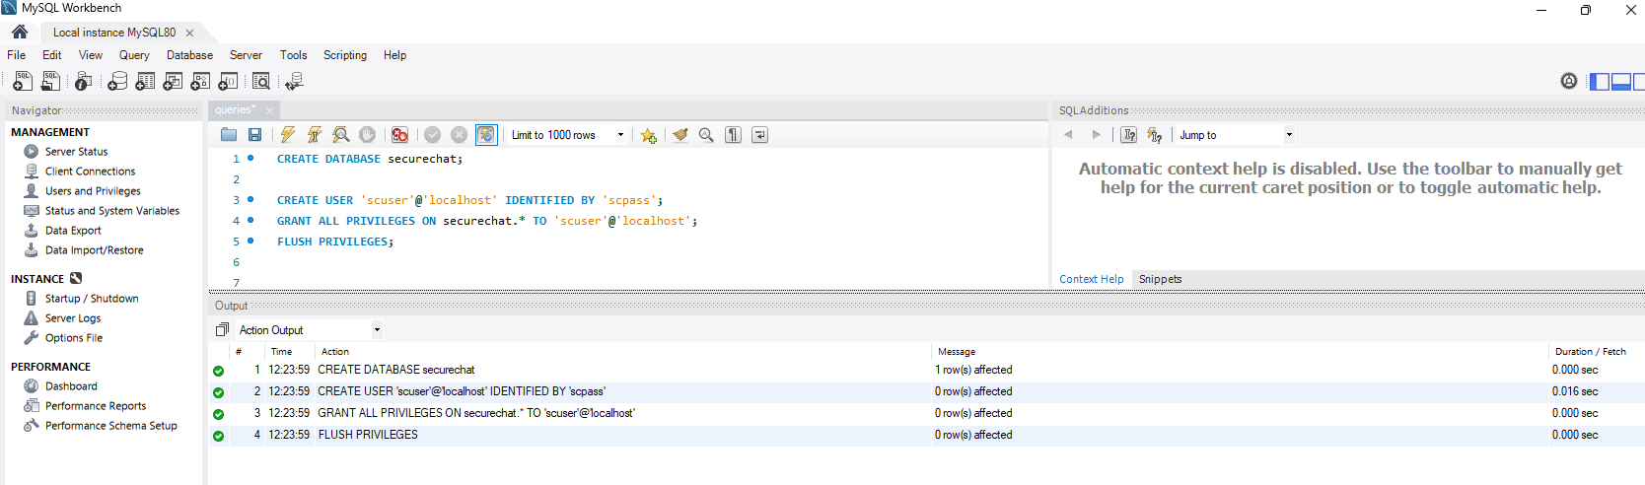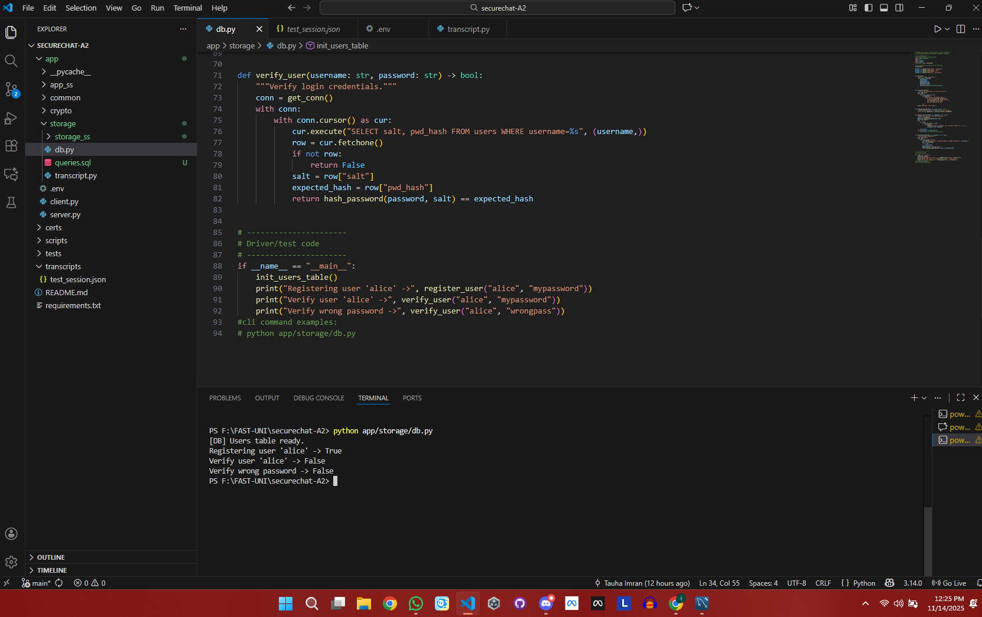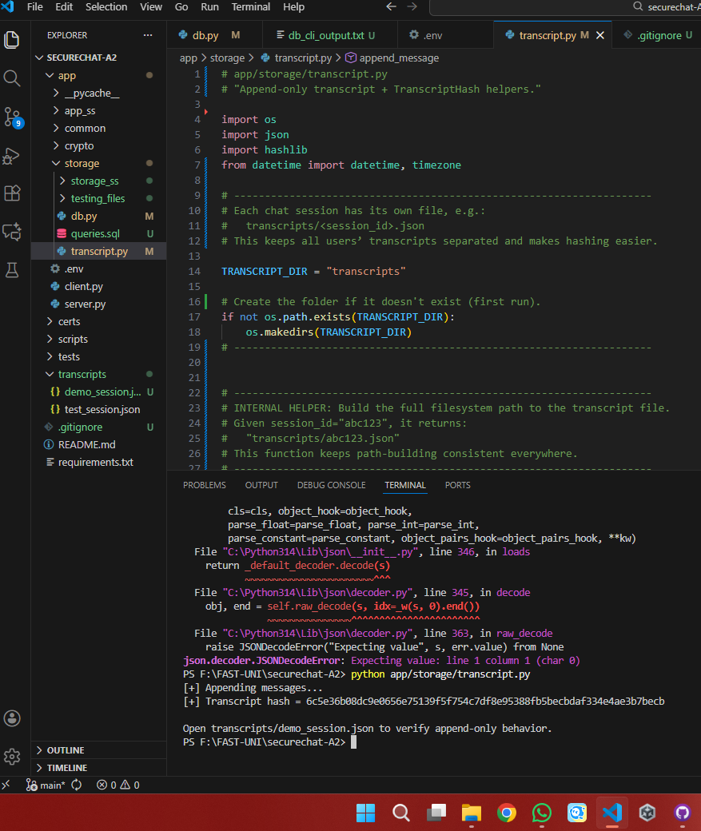

3.2 Full application Tests

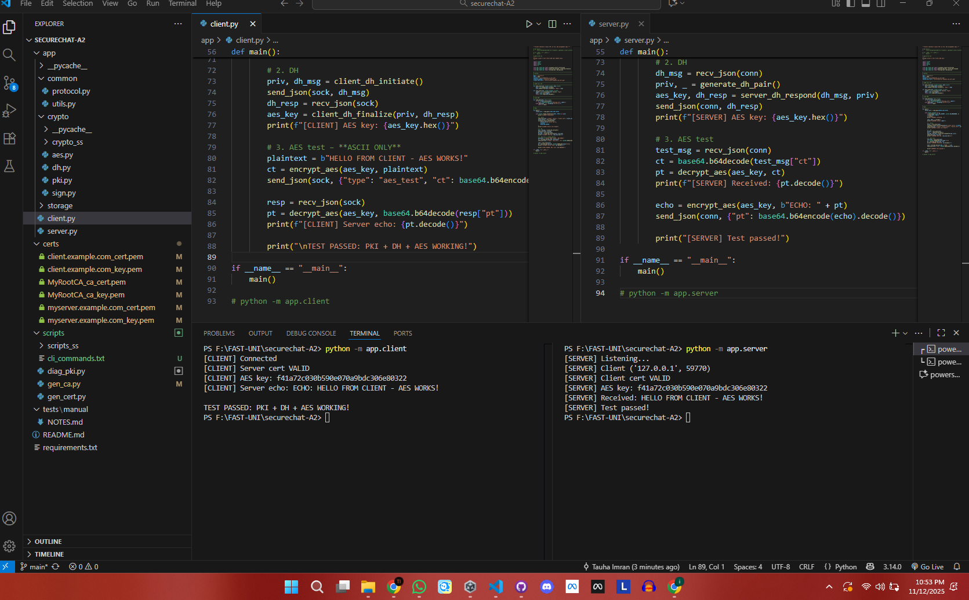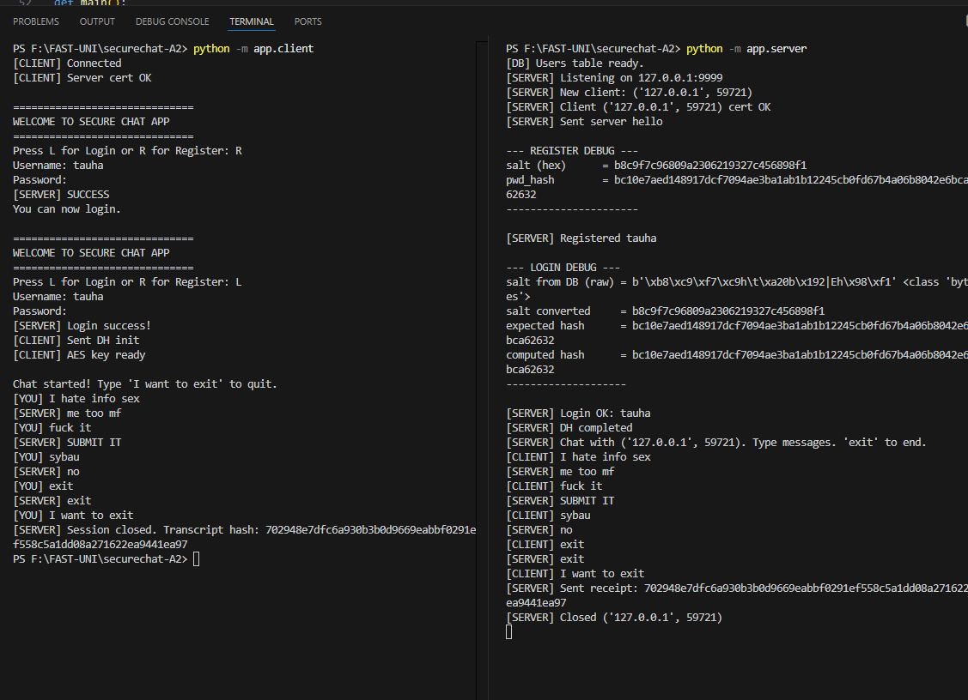

3.3 Cryptography Tests
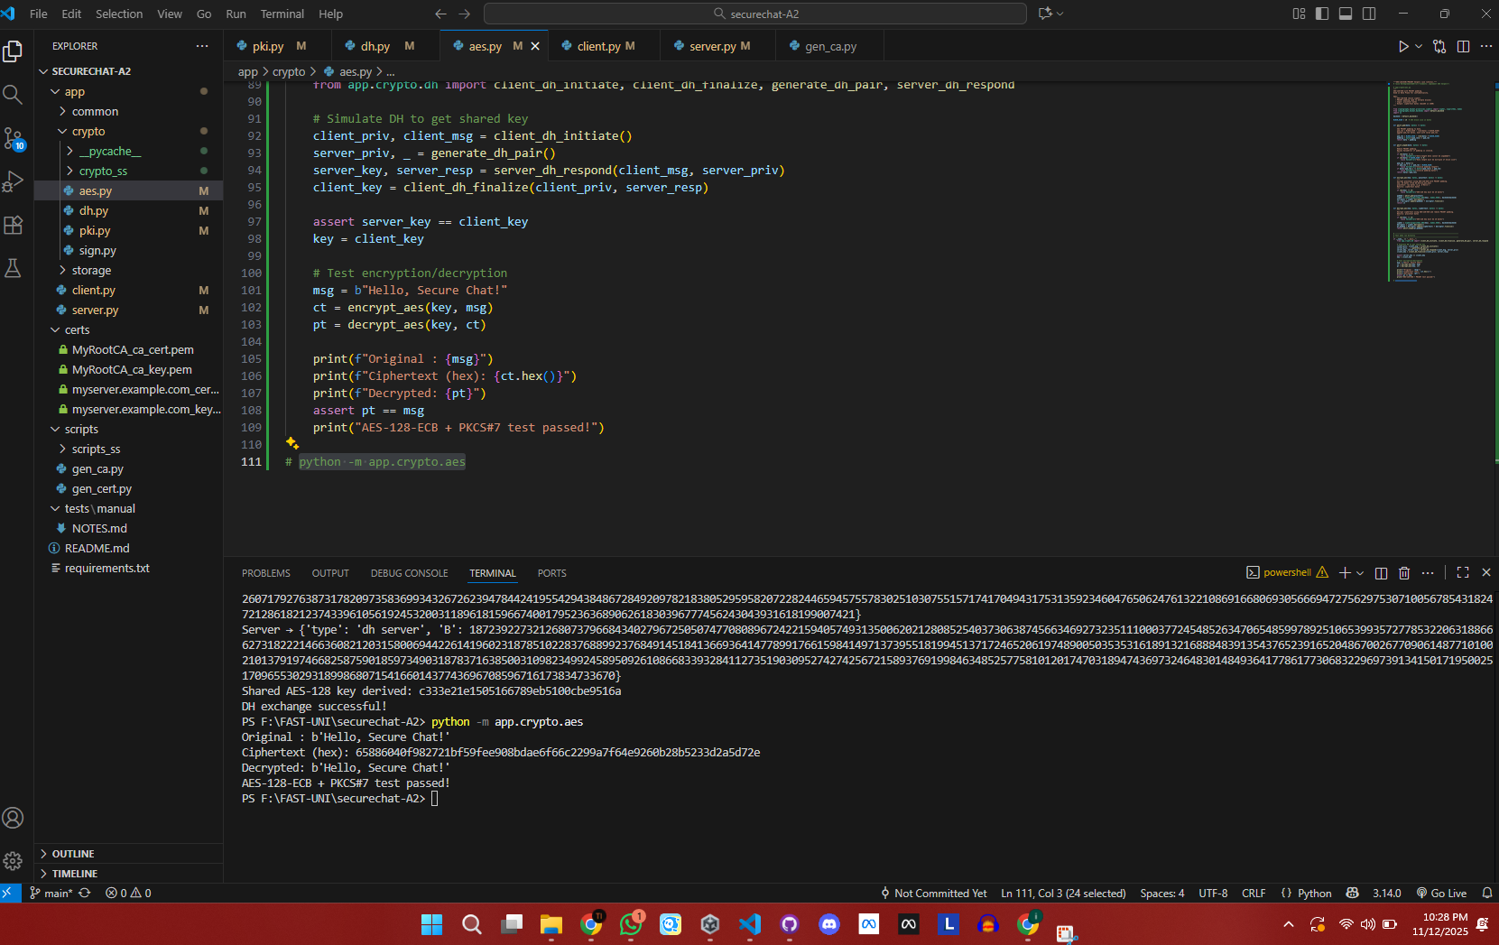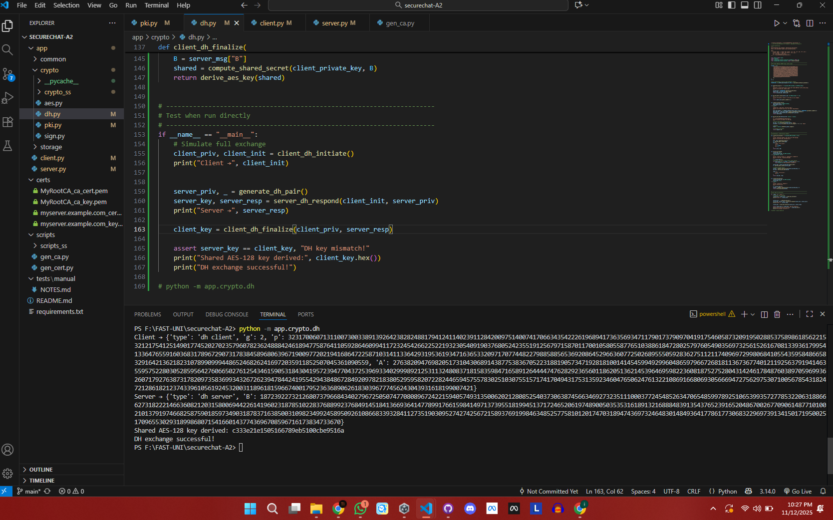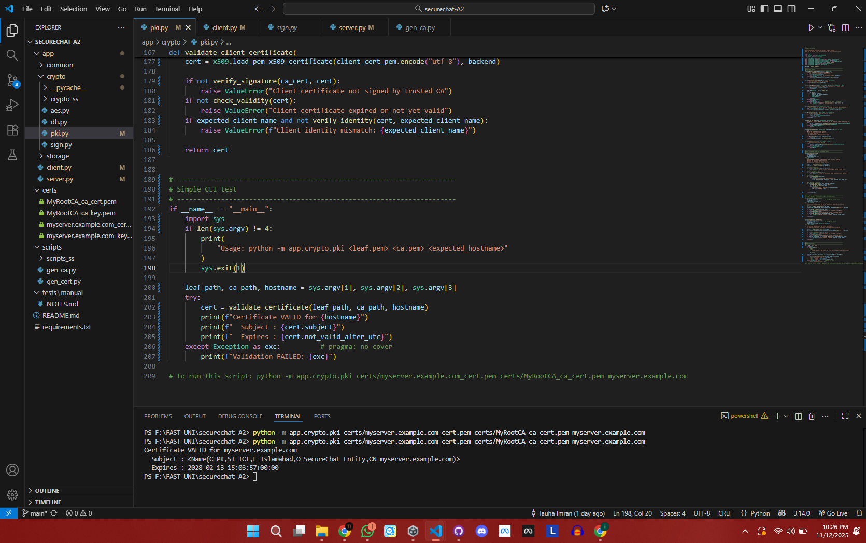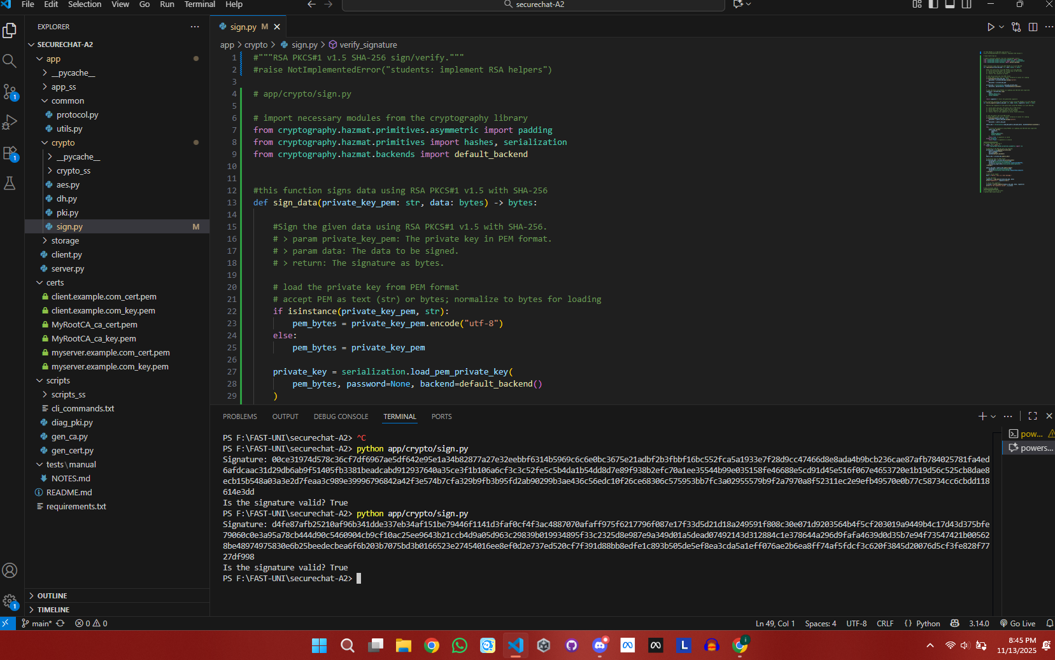

3.4 Scripts and Certificates tests

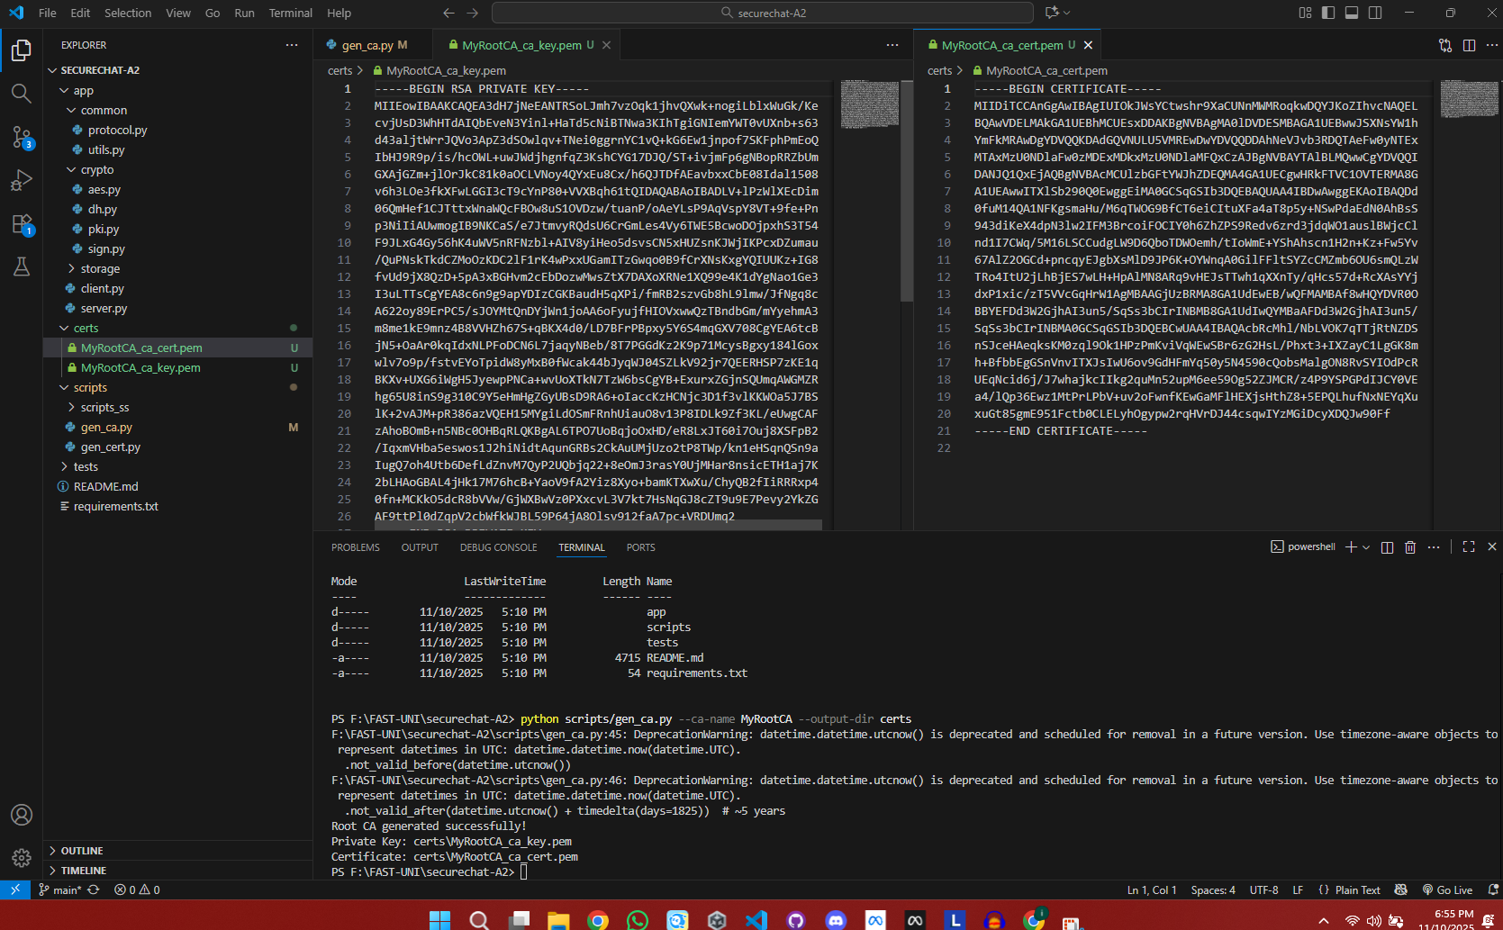

3.5 Common Functionality Tests
