ANN Architecture Documentation
Customer Churn Analysis for a Telecommunications Company, Stage 3 Deliverable 3-1
Purpose
We built an Artificial Neural Network (ANN) to predict whether a customer will churn, using the cleaned, encoded and scaled customer dataset prepared in Stage 2. The model takes a customer’s attributes as input and returns a churn probability between 0 and 1.
Input layer
The input layer takes 10 features per customer. These are gender, SeniorCitizen, Dependents, tenure, PhoneService, MultipleLines, InternetService, MonthlyCharges, and two one-hot columns for Contract (one year and two year). The numeric columns tenure and MonthlyCharges were standardised with StandardScaler, and the other features are 0/1 values.
Architecture
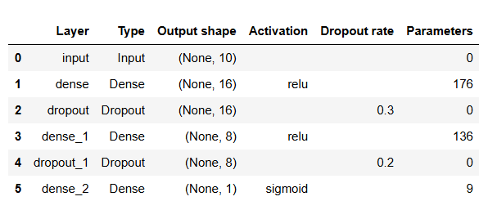
The model has 321 trainable parameters in total.
Why we chose this design
The hidden layers use ReLU activation, which is a standard choice for tabular classification and trains efficiently. The output layer is a single neuron with sigmoid activation, because churn is a yes or no outcome and sigmoid gives a probability. We kept the network small, with 16 and 8 neurons, because the dataset has only 10 features and about 6,700 customers, and a larger network gave no better results in our grid search. We added dropout after each hidden layer, 0.3 and then 0.2, because our baseline model without it showed mild overfitting.
Training configuration
Setting | Value
Optimiser | Adam, learning rate 0.0005
Loss function | Binary crossentropy
Batch size | 64
Maximum epochs | 100
Early stopping | Monitors validation loss, patience of 10 epochs, restores the best weights
Validation data | Last 20% of the training set (4,313 rows for training, 1,079 for validation)
Class weights | 0.68 for non-churners, 1.88 for churners
Random seed | 42, with deterministic operations switched on

We used class weights because only about 27% of customers churn. Without them the model reached 46% recall on churners. Weighting the loss so that missing a churner counts more raised recall to about 80%.
Training stopped by itself after 43 epochs, and the weights from epoch 33 were kept. We chose the hidden layer sizes, dropout, learning rate and batch size through a grid search of 16 combinations, scored on a validation split taken from the training data only.
Resulting performance on the test set
On the 1,349 customers held out for testing, the model reached accuracy of 0.715, precision of 0.478, recall of 0.804, F1 score of 0.600 and ROC-AUC of 0.816 for the churn class. It correctly identified 288 of the 358 customers who churned and missed 70. It also flagged 314 customers who did not churn.
Code
model = keras.Sequential([
layers.Input(shape=(10,)),
layers.Dense(16, activation='relu'),
layers.Dropout(0.3),
layers.Dense(8, activation='relu'),
layers.Dropout(0.2),
layers.Dense(1, activation='sigmoid')
])

model.compile(
optimizer=keras.optimizers.Adam(learning_rate=0.0005),
loss='binary_crossentropy',
metrics=['accuracy']
)

The model is trained with the following code:

from sklearn.utils.class_weight import compute_class_weight
from tensorflow.keras.callbacks import EarlyStopping

# Class weights so that missing a churner counts more during training
class_weights = compute_class_weight('balanced', classes=np.unique(y_train), y=y_train)
class_weight_dict = dict(enumerate(class_weights))

# Stop training when validation loss stops improving and keep the best weights
early_stop = EarlyStopping(monitor='val_loss', patience=10, restore_best_weights=True)

history = model.fit(
X_train, y_train,
validation_split=0.2,
epochs=100,
batch_size=64,
class_weight=class_weight_dict,
callbacks=[early_stop],
verbose=1
)

