Clustering Analysis Documentation

Customer Churn Analysis for a Telecommunications Company
Stage 2 Deliverable 2-2: Clustering Analysis

Purpose
We used K-Means clustering to segment customers into distinct groups based on tenure, monthly charges, senior citizen status, and related features. The goal was to identify customer segments with different churn behaviour, so that retention strategies can be targeted rather than applied uniformly across the whole customer base.

Determining the Optimal Number of Clusters
We used the elbow method to choose the number of clusters. We trained K-Means models for k values from 1 to 10 on the scaled feature set and plotted the inertia (within-cluster sum of squares) for each value of k. The chart below shows a steep drop in inertia up to around k=4, after which the curve flattens out and additional clusters give diminishing returns.
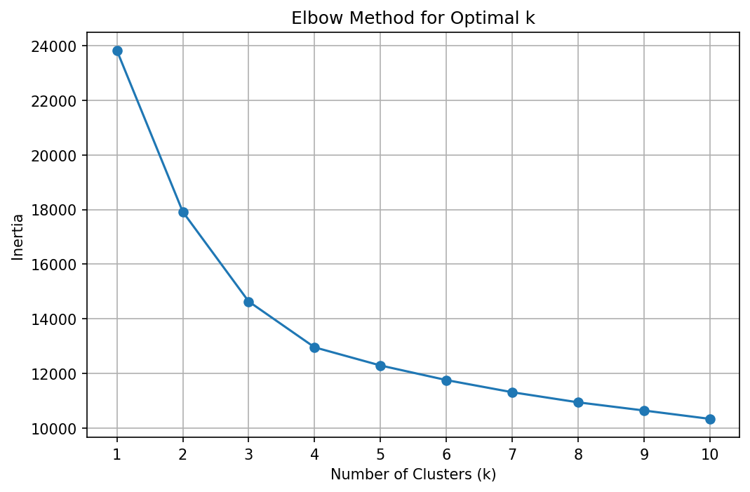
Based on this elbow point, we selected k=4 as the optimal number of clusters.

Training the K-Means Model
We trained the final K-Means model with n_clusters=4 on the scaled feature set, using n_init=10 to reduce the risk of the algorithm converging to a poor local minimum, and a fixed random_state for reproducibility.

Cluster Visualisation
Since the feature space has more than two dimensions, we used Principal Component Analysis (PCA) to reduce the features to two components purely for visualisation purposes. The scatter plot below shows the four clusters in this reduced space.
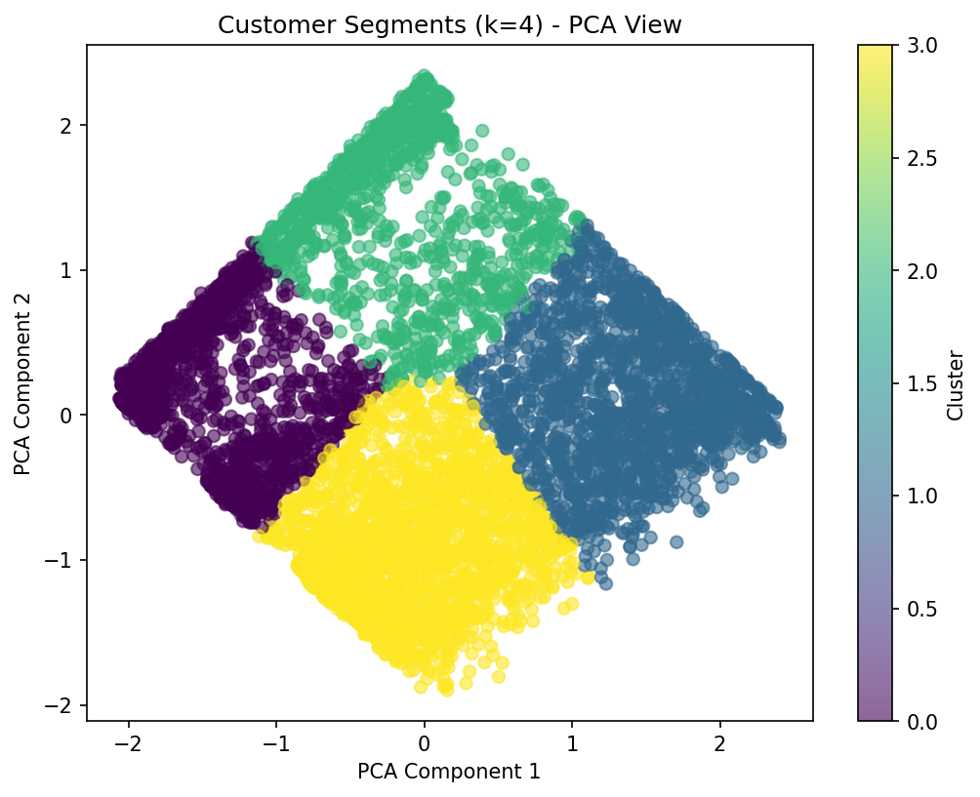

Cluster Interpretation and Labels
We interpreted the clusters by looking at the average tenure, monthly charges, senior citizen rate, and churn rate within each group. The table below summarises these averages and the label we assigned to each cluster.

Cluster | Avg tenure | Avg monthly charges | Senior citizen rate | Churn rate | Label
0 | 11.2 | 33.80 | 7.2% | 24.9% | New low-spend customers
1 | 58.7 | 93.17 | 21.6% | 15.6% | Loyal high-value customers
2 | 54.4 | 34.90 | 7.7% | 4.8% | Loyal low-spend customers
3 | 15.2 | 81.72 | 24.3% | 48.7% | High-risk new premium customers

Cluster 3 stood out as high-risk new premium customers. This group has low tenure, high monthly charges, and by far the highest churn rate at nearly 49 percent, along with the highest share of senior citizens. This is the group we would prioritise for retention efforts.
Cluster 2 represents loyal low-spend customers, with long tenure, lower monthly charges, and the lowest churn rate at under 5 percent.
Cluster 1 represents loyal high-value customers, with the longest tenure and the highest monthly charges. Their churn rate is moderate at around 15.6 percent, which is notable given how much revenue this group represents.
Cluster 0 represents new low-spend customers, with short tenure and lower monthly charges, and a moderate-to-high churn rate of about 24.9 percent.

Use in Later Stages
These cluster labels will be used later alongside the ANN churn predictions, to check whether the model's predicted high-risk customers align with the high-risk cluster identified here, and to help translate the model's output into retention strategies for each segment.

