Software Engineering
COSC612.101
Fall 2024
Group Name: I Have No Mouth and I Must Eat
Group Members:
Christopher Chung
Jamie Cooper
Ciana Hoggard
James Naurot
Bhuvan Sai Reddy Seelam
Date of Submission:

Christopher Chung Resume
EDUCATION
Master of Science: Applied Information Technology (08/2023 - TBD)
Towson University - Towson, MD
Bachelor of Science: Computer Information Systems (08/2021-05/2023)
Towson University - Towson, MD
- GPA: 3.4
College Certification: CISCO Network Design & Security (06/2019 - 12/2019)
Clover Park Technical College - Lakewood, WA
- GPA: 3.3

WORK HISTORY
Office Operations Supervisor (06/2020 -11/2020)
U.S. CENSUS BUREAU, Towson, MD
Salary: $48,880 USD Annually ($23.50/hourly) / Pay Grade: AD-00.
Hours worked: 40 hours per week.
Supervisor: Charlene Pistorio (410-296-0528)
Okay to contact this Supervisor: Contact me first
Duties: Managed and supervised a team of 10 clerks, overseeing and optimizing their performance in a variety of clerical functions, such as managing business data through Microsoft 365 applications. Communicated with members of the public as part of routine business. Resolved low-priority tickets in "Remedy." Led in-person training seminars using Microsoft PowerPoint, Microsoft Visio, and presentation and oral communication skills. Adhered to document control procedures for both P.I.I. and B.I.I. census data. Paid close attention to detail by following established office rules and cybersecurity procedures, ensuring no major failures during my tenure, and lastly, the 2020 census mission was a success.

PROJECTS
- Towson University “Sci-Scrape” Web Scrape Project
  - With a team of 6 members, we developed a web scraper primarily based on MS Power Automate to retrieve over 50 faculty, staff, and student publications and store them in a Structured Query Language (SQL) database. I helped provide crucial insight, such as describing the conceptual data model at various phases of the project in order to determine feasibility, efficiency, and adherence to project scope. I lead the presentation by describing the purpose of Sci-Scrape and the benefits that such a project would yield. The work performed here adhered to ethical and regulatory rules.
- U.S. Census Bureau Wide Training Coordination
  - This project was assigned to me by the Area Census Office manager, whose role oversought the entire field office. I negotiated with members of the public in requesting and reserving community halls across various regions of Maryland for Federal Census training operations, resulting in over 1,000 census employees being trained for the 2020 Decennial mission.

Jamie Cooper Resume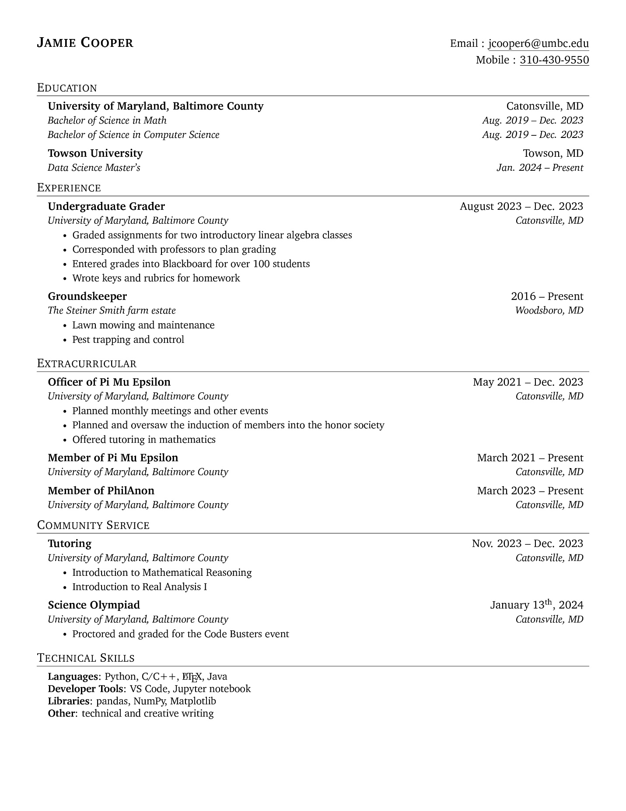

Ciana Hoggard Resume

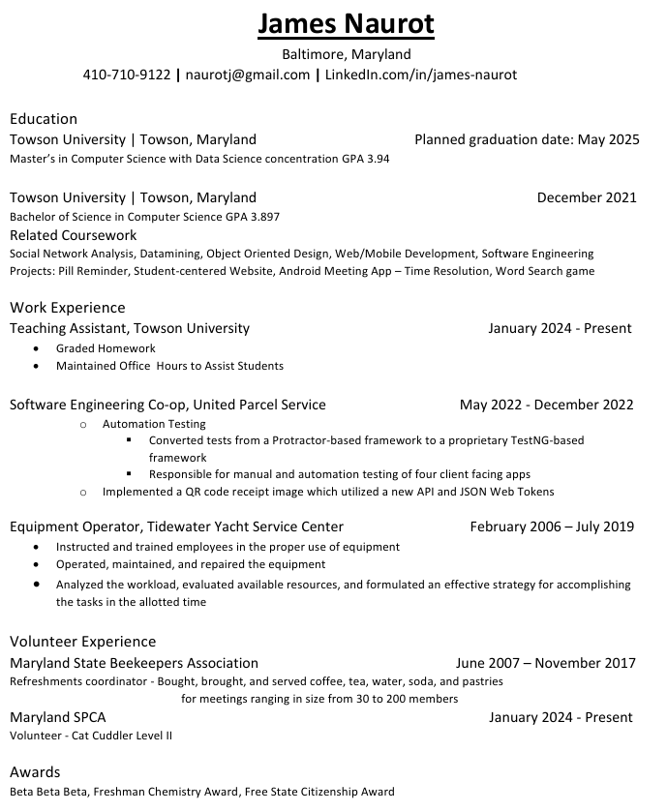

Bhuvan Sai Reddy Seelam Resume

Planning and Scheduling

Teamwork Basics Summary
Summarize ground rules: norms 1 – 5
Summarize hint for handling difficult behavior
Summarize hint for handling group problems

Problem Statement

System Requirement

Appendix (screenshots and links)

