# Writeup Behavior cloning

I decided to go with NVIDA model as suggested with in the course. The model part is straight forward. The trick part is really generating good training and validation data. Recording the data in an intelligent way, using the supplied test data and curating and annotating the data is key to success. In addition to the test data set which was provided by udacity, I recorded for track 1 a full track in the reverse direction. For track 2 I recorded two rounds.

I decided not to use generator. On my system (iMac) the time to train the model increased by a factor of 20 compared to the version without a generator. As I have enough memory and not been able to use a GPU this was the most efficient approach for me.

## Approach for curating and annotating the data

1. During my experiments it turned out that images with a zero steering angle create a lot of noise and doesn’t help the model to learn very well how to deal with curves. I decided to remove 92% of the data which doesn’t contain any curve steering information. I also decided to remove 50% of the data which contains only very limited steering (i.e. below .25 degree)  
   As an example the below figure shows the distribution of the steering angle before and after applying the above approach. 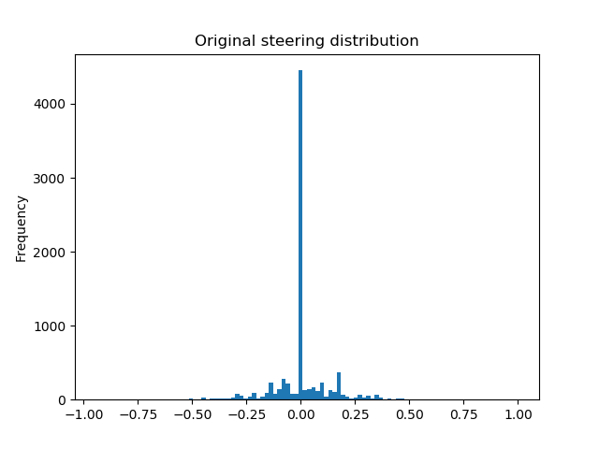

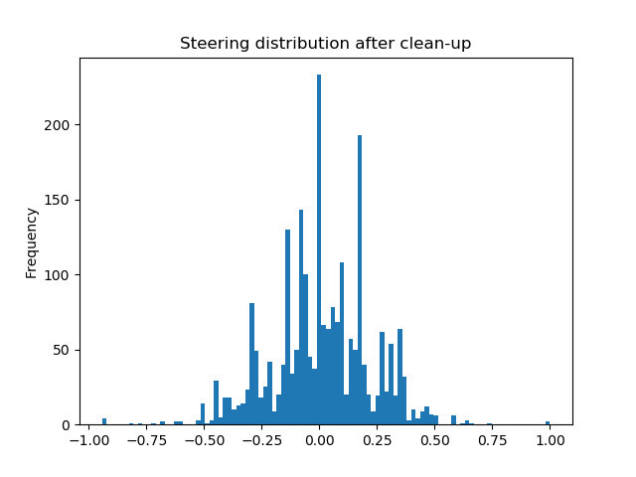

1. I’ve annotated the data by adding a certain percentage of additional data generated from the original data:
   1. Random shadows (60%)
   2. Random Brightness (60%)
   3. Flipped images (50%)

This increased the amount of training data.

## Rubric Points

Here I will consider the rubric points individually and describe how I addressed each point in my implementation.

## Model Architecture and Training Strategy

#### 1. An appropriate model architecture has been employed

My model consists of a convolution neural network with 3x3 filter sizes and depths between 32 and 128 (model.py lines 18-24)

The model includes RELU layers to introduce nonlinearity (code line 20), and the data is normalized in the model using a Keras lambda layer (code line 18).

The model I’ve implemented is the following

_________________________________________________________________

Layer (type) Output Shape Param #

=================================================================

input_1 (InputLayer) (None, 160, 320, 3) 0

_________________________________________________________________

cropping2d_1 (Cropping2D) (None, 105, 320, 3) 0

_________________________________________________________________

batch_normalization_1 (Batch (None, 105, 320, 3) 12

_________________________________________________________________

conv2d_1 (Conv2D) (None, 51, 158, 24) 1800

_________________________________________________________________

batch_normalization_2 (Batch (None, 51, 158, 24) 96

_________________________________________________________________

activation_1 (Activation) (None, 51, 158, 24) 0

_________________________________________________________________

conv2d_2 (Conv2D) (None, 24, 77, 36) 21600

_________________________________________________________________

batch_normalization_3 (Batch (None, 24, 77, 36) 144

_________________________________________________________________

activation_2 (Activation) (None, 24, 77, 36) 0

_________________________________________________________________

conv2d_3 (Conv2D) (None, 10, 37, 48) 43200

_________________________________________________________________

batch_normalization_4 (Batch (None, 10, 37, 48) 192

_________________________________________________________________

activation_3 (Activation) (None, 10, 37, 48) 0

_________________________________________________________________

conv2d_4 (Conv2D) (None, 8, 35, 64) 27648

_________________________________________________________________

batch_normalization_5 (Batch (None, 8, 35, 64) 256

_________________________________________________________________

activation_4 (Activation) (None, 8, 35, 64) 0

_________________________________________________________________

conv2d_5 (Conv2D) (None, 6, 33, 64) 36928

_________________________________________________________________

activation_5 (Activation) (None, 6, 33, 64) 0

_________________________________________________________________

flatten_1 (Flatten) (None, 12672) 0

_________________________________________________________________

dense_1 (Dense) (None, 100) 1267300

_________________________________________________________________

activation_6 (Activation) (None, 100) 0

_________________________________________________________________

dense_2 (Dense) (None, 50) 5050

_________________________________________________________________

activation_7 (Activation) (None, 50) 0

_________________________________________________________________

dense_3 (Dense) (None, 10) 510

_________________________________________________________________

activation_8 (Activation) (None, 10) 0

_________________________________________________________________

dense_4 (Dense) (None, 1) 11

=================================================================

Total params: 1,404,747

Trainable params: 1,404,397

Non-trainable params: 350

#### 2. Attempts to reduce overfitting in the model

During my experiments it turned out that images with a zero steering angle create a lot of noise and doesn’t help the model to learn very well how to deal with curves. I decided to remove 92% of the data which doesn’t contain any curve steering information. I also decided to remove 50% of the data which contains only very limited steering (i.e. below .25 degree)  
As an example the below figure shows the distribution of the steering angle before and after applying the above approach.





I’ve annotated the data by adding a certain percentage of additional data generated from the original data:

* 1. Random shadows (60%)
  2. Random Brightness (60%)
  3. Flipped images (50%)

This increased the amount of training data to 64k training data points and 16k validation datapoints

The model was tested by running it through the simulator and ensuring that the vehicle could stay on the track for both track 1 and the challenging track 2.

#### 3. Model parameter tuning

The model used an adam optimizer, so the learning rate was not tuned manually (model.py line 291).

#### 4. Appropriate training data

Training data was chosen to keep the vehicle driving on the road. I used a combination of center lane driving, recovering from the left and right sides of the road ...

For details about how I created the training data, see the next section.

### Model Architecture and Training Strategy

#### 1. Solution Design Approach

I decided to go with NVIDA model as suggested with in the course. The model part is straight forward. The trick part is really generating good training and validation data. Recording the data in an intelligent way, using the supplied test data and curating and annotating the data is key to success. In addition to the test data set which was provided by udacity, I recorded for track 1 a full track in the reverse direction. For track 2 I recorded two rounds.

I decided not to use generator. On my system (iMac) the time to train the model increased by a factor of 20 compared to the version without a generator. As I have enough memory and not been able to use a GPU this was the most efficient approach for me.

To combat the overfitting, I modified the model and added several BatchNormalization layers

At the end of the process, the vehicle is able to drive autonomously around the track without leaving the road.

#### 2. Final Model Architecture

The final model architecture (model.py lines 18-24) consisted of a convolution neural network with the following layers and layer sizes ...

Here is a visualization of the architecture (note: visualizing the architecture is optional according to the project rubric)

![alt text][image1]

#### 3. Creation of the Training Set & Training Process

To capture good driving behavior, I first recorded two laps on track one using center lane driving. Here is an example image of center lane driving:

![alt text][image2]

I then recorded the vehicle recovering from the left side and right sides of the road back to center so that the vehicle would learn to .... These images show what a recovery looks like starting from ... :

![alt text][image3]

![alt text][image4]

![alt text][image5]

Then I repeated this process on track two in order to get more data points.

To augment the data sat, I also flipped images and angles thinking that this would ... For example, here is an image that has then been flipped:

![alt text][image6]

![alt text][image7]

Etc ....

After the collection process, I had X number of data points. I then preprocessed this data by ...

I finally randomly shuffled the data set and put Y% of the data into a validation set.

I used this training data for training the model. The validation set helped determine if the model was over or under fitting. The ideal number of epochs was Z as evidenced by ... I used an adam optimizer so that manually training the learning rate wasn't necessary.