**Airflow**

**Core Component:**

* Web Server
* Scheduler
* MetaStore < postgres/mysql for storing task>
* Triggers
* Executor ->> Celery executor
  + Queue
  + Worker

**DAG:** Directe Acylict Grapgh

**Operator:**

Operators determine what actually gets done by task.

DAG not perform any actual computation. Instead, operators determine what actually gets done

Operator Types:

1. Action Operator
2. Transfer Operator
3. Sensor Operator

Tasks and Task Instance:

**Airflow is not for:**

Not a Data streaming solutions neither a data processing framework.

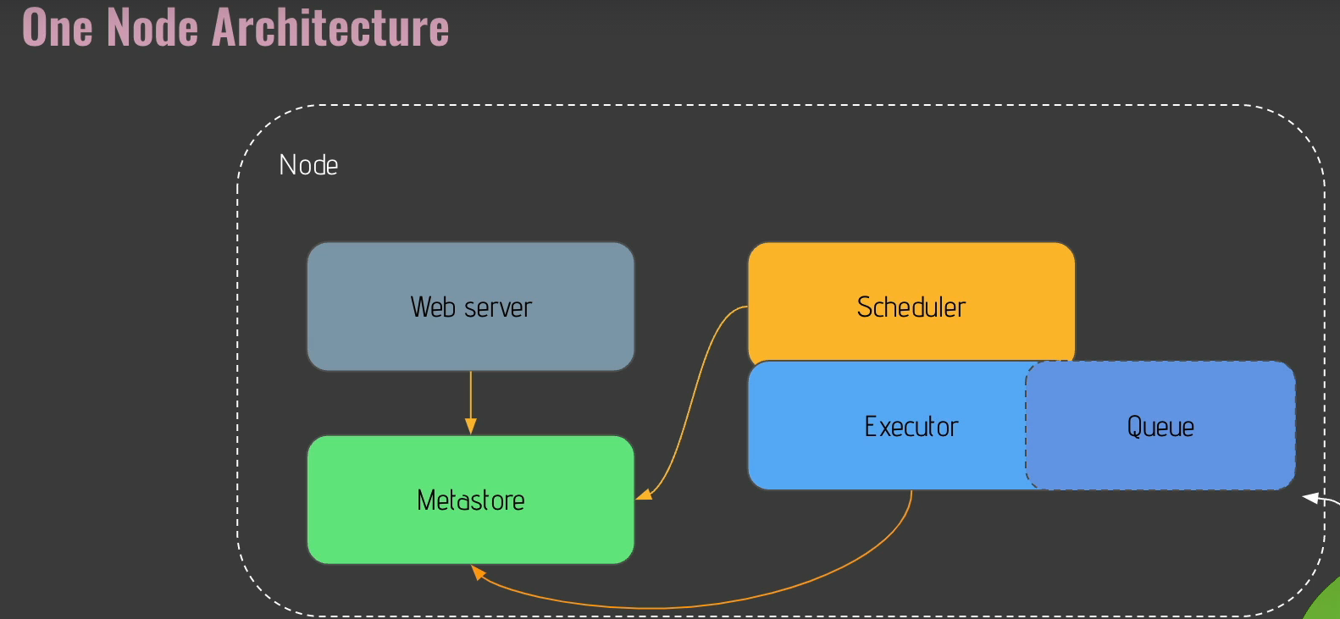

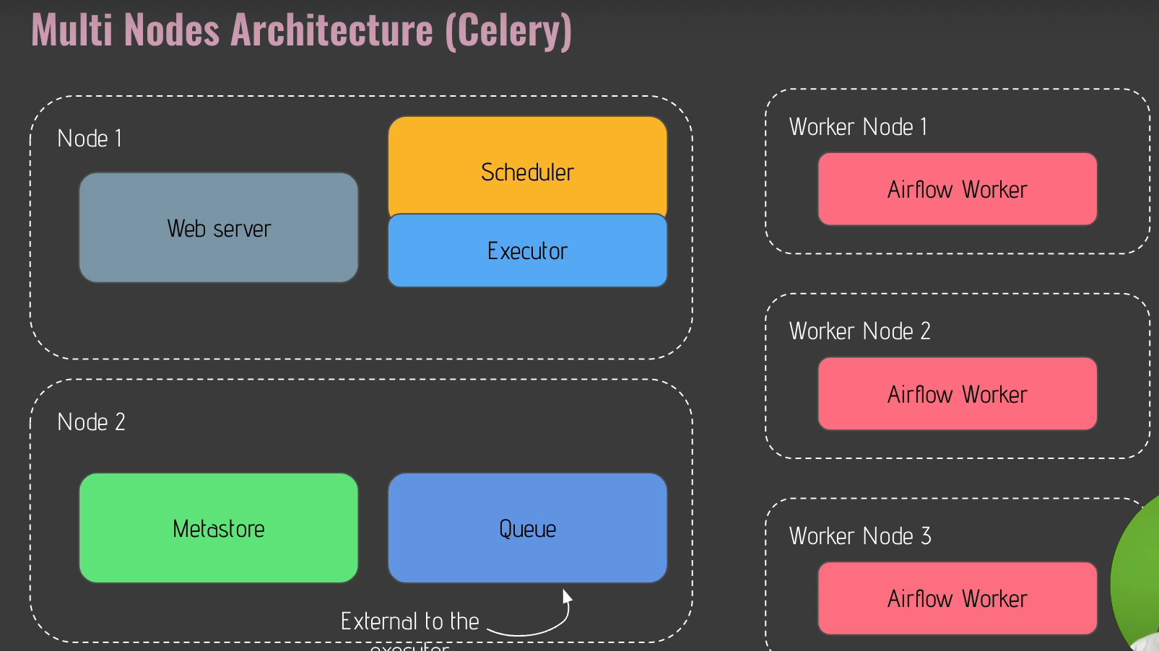

=====Go into Scheduler to test your task===

docker-compose ps

docker exec -it workflow-airflow-scheduler-1 /bin/bash

==Test Task

airflow tasks test user_procesing create_table 2023-01-01

Note: Always test your task to make sure it runs.

docker exec -it workflow-postgres-1 /bin/bash

psql -U airflow

Select * from users2;

Bakfilling.

Celere Floawer:

docker-compose --profile flower up

http://localhost:5555/

docker-compose down && docker-compose --profile flower up -d