**R-Square**: It is used to minimize sum of square of y and y^

R square is for goodness of fit(greater is better)

**Problem**: It does not work properly with multiple regression model because when we add new variable the R2 will never decrease.

R-square will never be greater than 1.

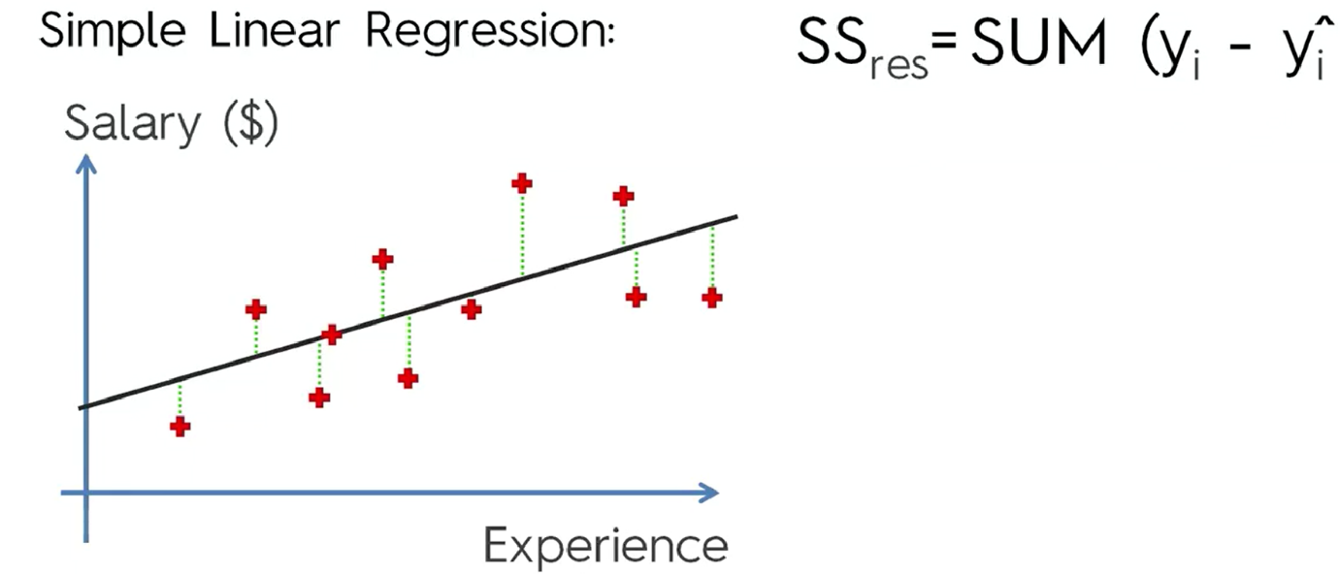

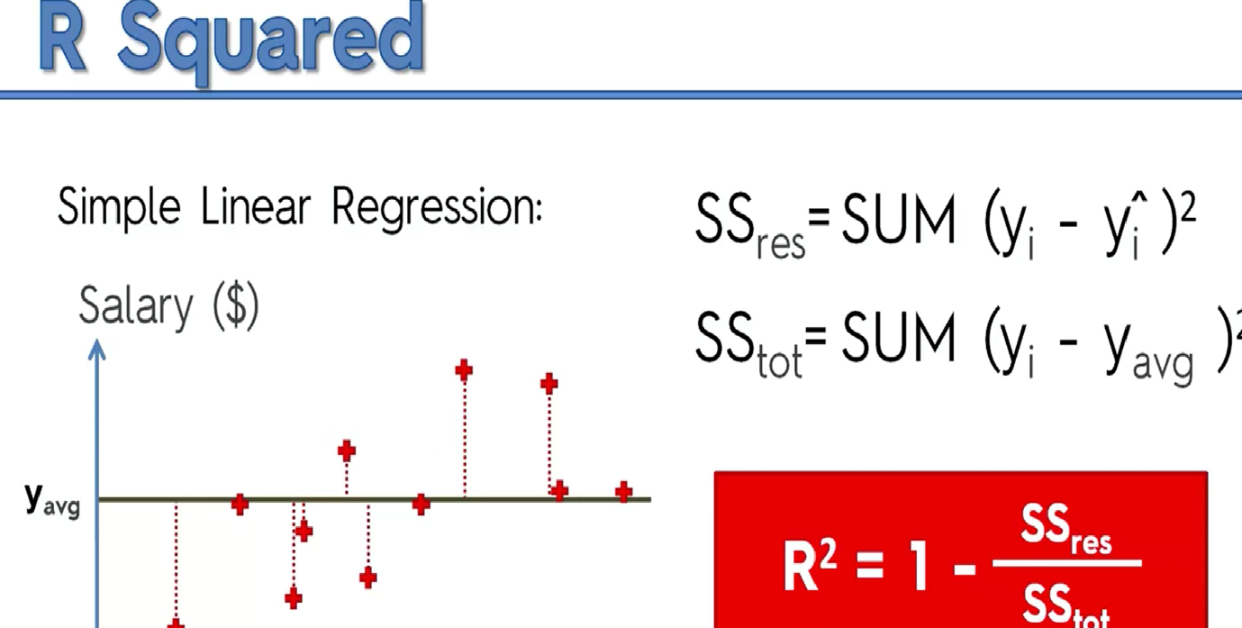

**Adjustable R-squared:**

Adjustable R-square is the correction of R-square to support multiple regressor.

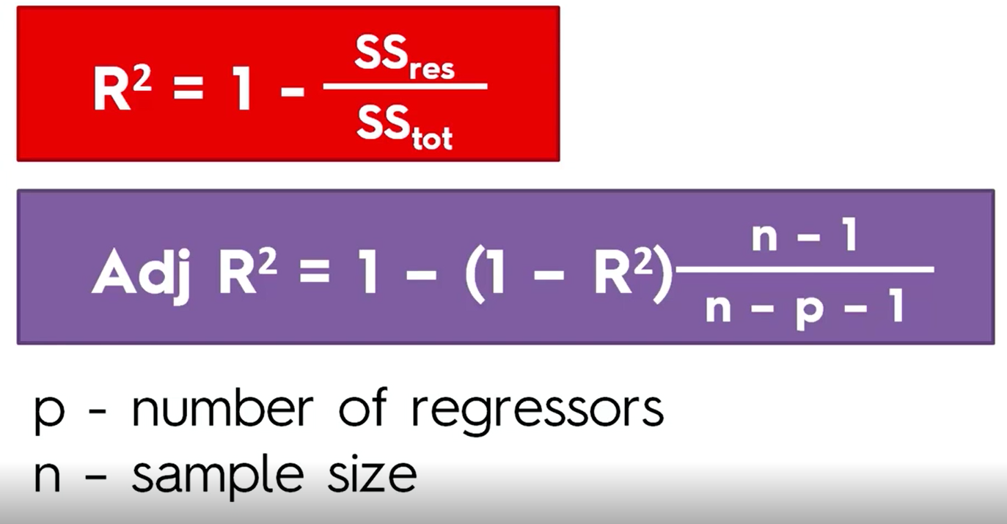

P = number of regressor (independent variable)

N = sample size

Here, if p increase, it will decrease the value, and ratio of n-1/n-p-1 will increase.

So this formula is best for regressor. R-square or ad-R-Square tell how strong is independent variable using back-propagation. Like removing variable to find best correlation between predictor and response.