

CSIT242 - Mobile Application Development

Native Android Apps Development
Firebase Authentication + RealTime Database

Week 8 – Lab 7
Version | Author | Effective Date | Change Description
1.0 | Mr. Tauqeer Faiz | January 7, 2025 | Define the first version

Student number: | Name:

Lab Session: | Instructor:

Contents
Instructions 3
Learning Outcomes 3
Marking Criteria 3
Introduction 4
App Menu: 7
Lab Tasks 10
Submission Instructions 11

Instructions
Lab Instructions:
Work in pairs of two students to complete this lab. Please show your work to the tutor present in the lab before submitting.
Submission Due: End of laboratory class, submit the file on Moodle at least 10 minutes before the end of laboratory class.
Total Marks = 2.0 marks
Marks will be given only to students who attend and participate during 2-hour laboratory class. Submission on Moodle is mandatory as evidence of participation.

Learning Outcomes

LO3 | Demonstrate an understanding of the mobile application development life cycle and associated programming paradigms.
LO4 | Utilize modern environments and development tools to develop mobile applications.
LO5 | Develop mobile applications that leverage the functionality/services commonly available on mobile platforms (including animations, graphics, sound; touch, multi-touch and motion events; working with data, and web services).
LO6 | Demonstrate an understanding for publishing the applications to its intended audience.

Marking Criteria

Task Details | Submission Requirements | Marks
Firebase Authentication + RealTime Database | Same Word file containing the source code and screenshots of output. | 2.0
 | Total | 2.0

Introduction
- In this lab, we will implement Firebase Authentication and learn Firebase RealTime database operations.
- Use your this week lab tutorial project and follow the instructions below:
- Load the console.firebase.google.com url, signup with you gmail account.
https://console.firebase.google.com/
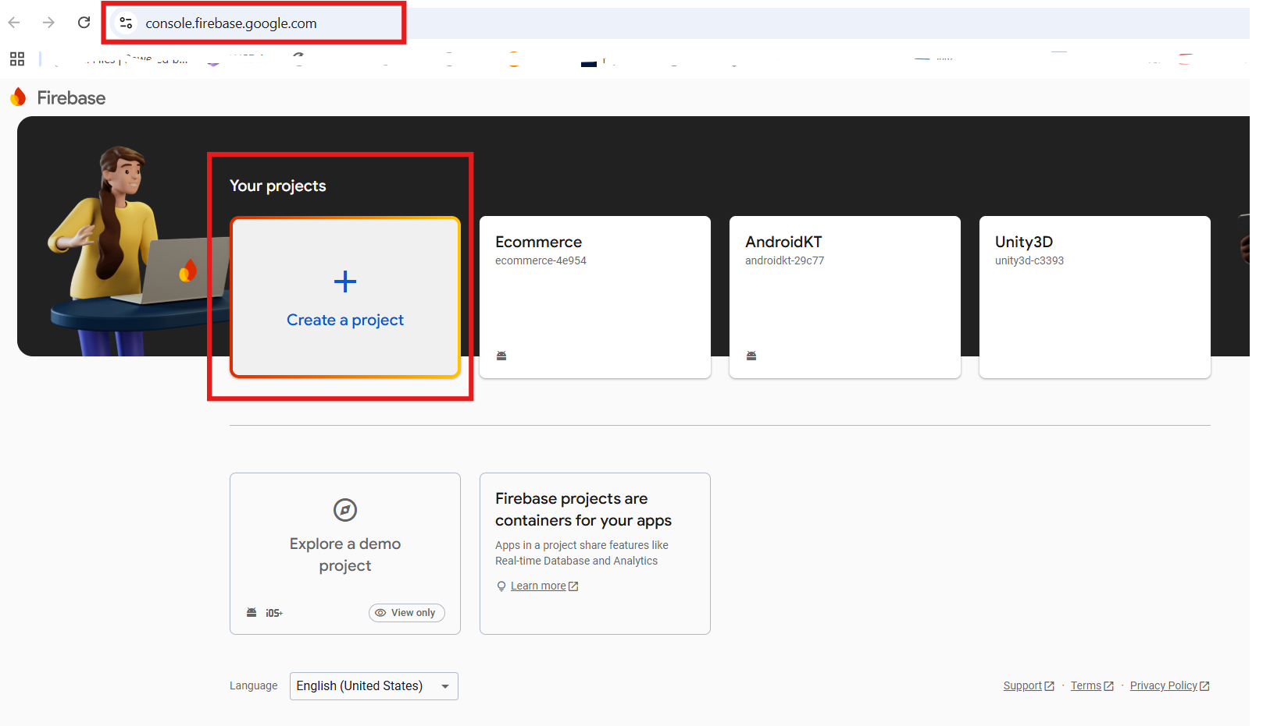
3.1 You will be asked to enter the project name. Choose any project relevant to your android app and enter here, click continue.
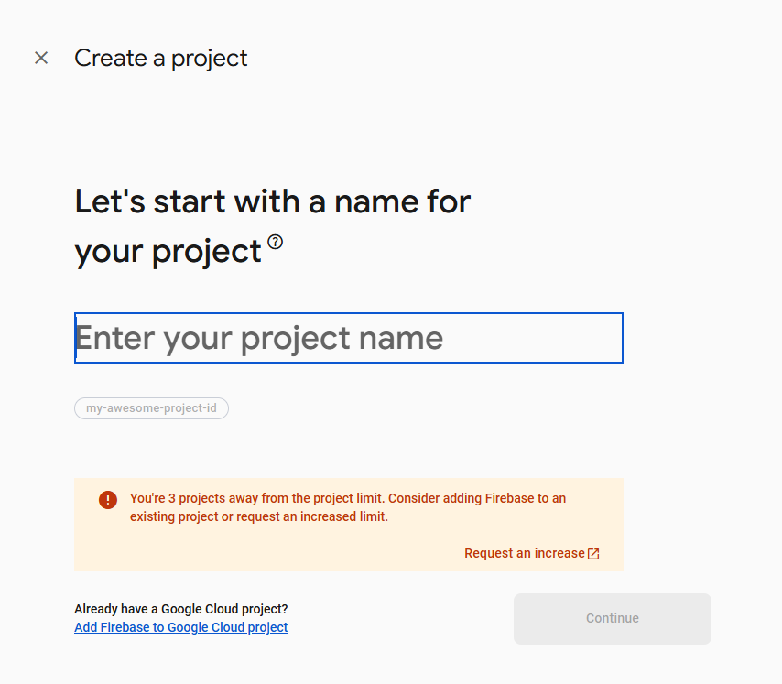
3.2 Go with default settings of Google Analytics for your firebase project and hit continue.
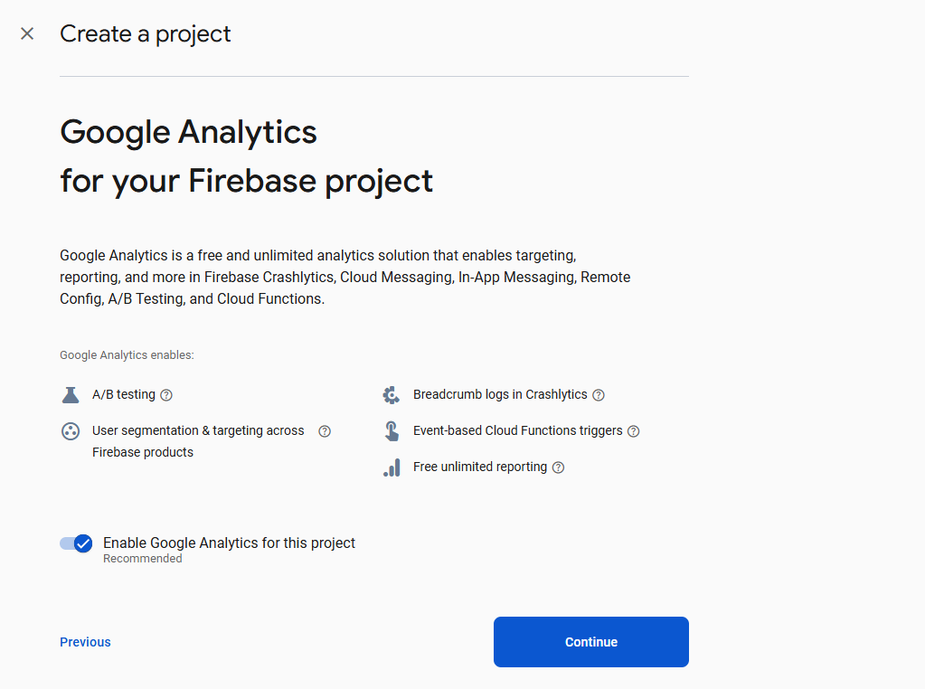
3.3 Pick Default Account for Firebase and click create project
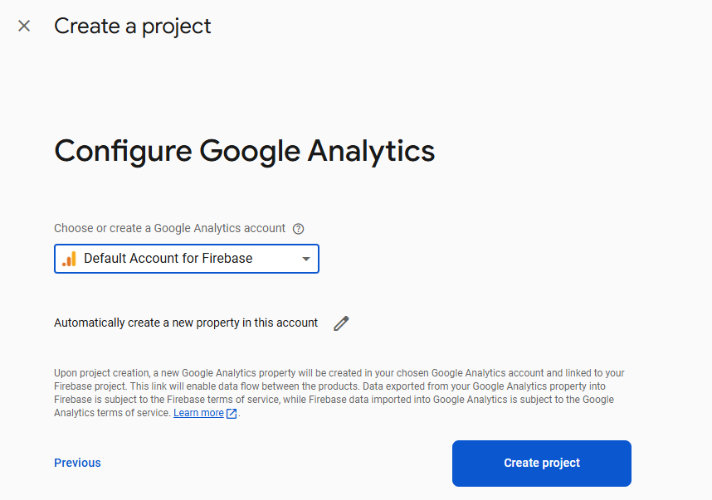
3.4 Google will process your request to setup the project:
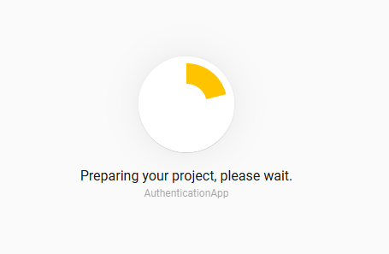
3.5 Once the project is created, Open your AuthenticationApp project and click on Android icon as shown below:
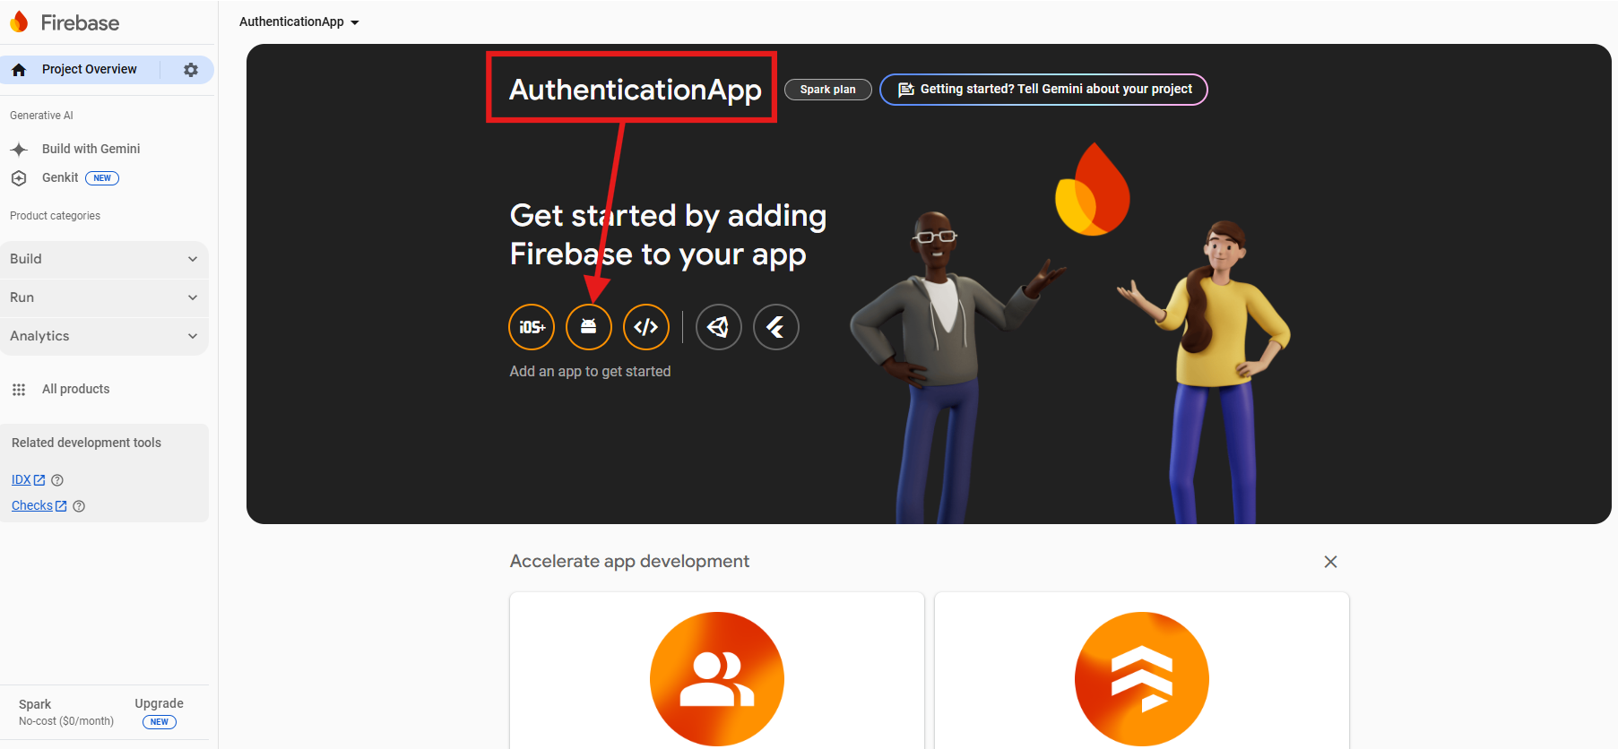
3.6 The next screen will ask to register your android package for Google Firebase database. You can find the android package information in your build.gradle.kts (Module:app) file.
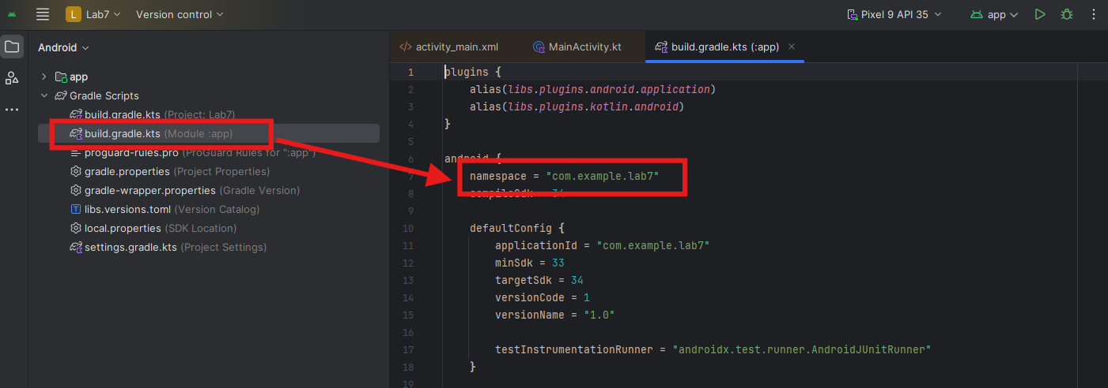
3.7 In my example, the package name is com.example.lab7. Make sure to copy your project package information.
3.8 Fill the required field and click register app:
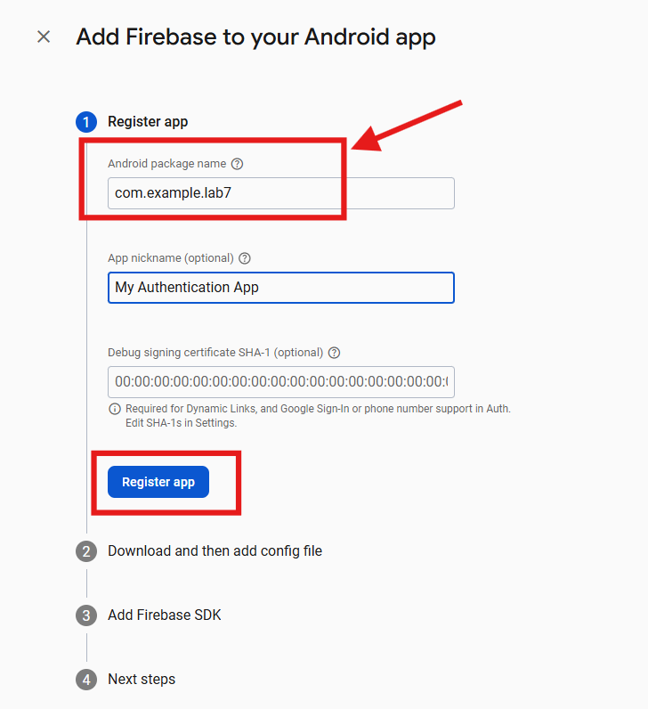
3.9 Follow the on-screen instructions.
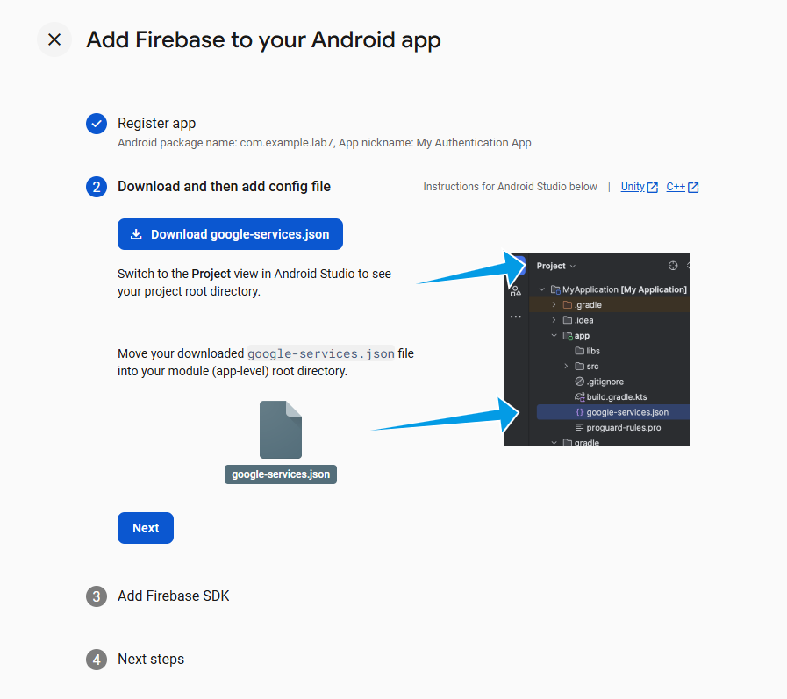
3.10 Download the google_services.json file and paste it under the app folder in your android project
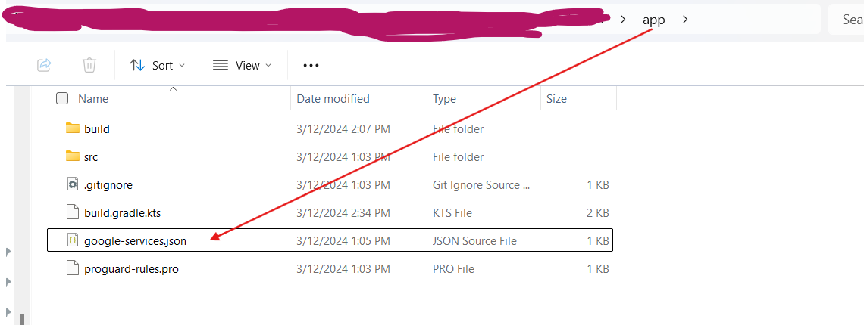
3.11 Click Next
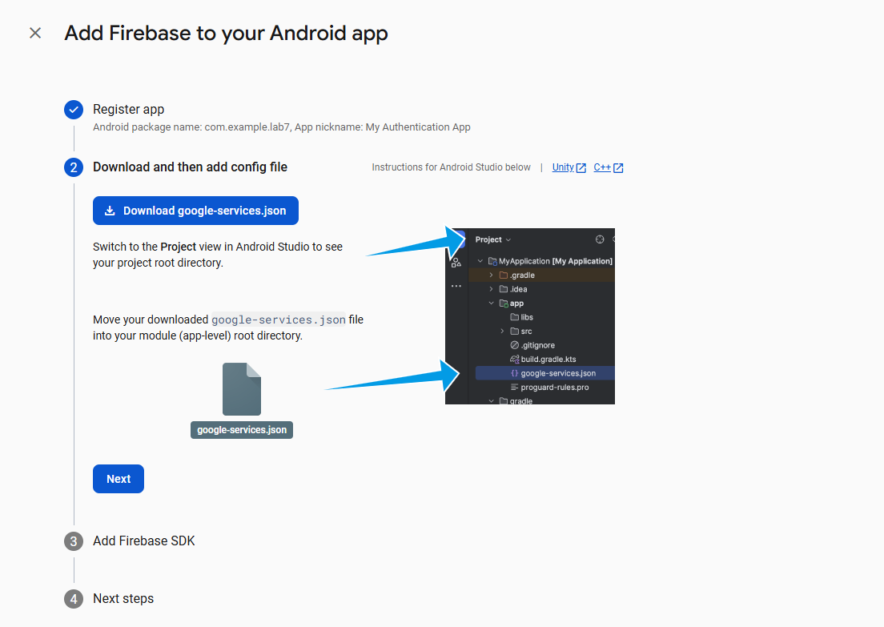
3.12 Now add the following dependencies
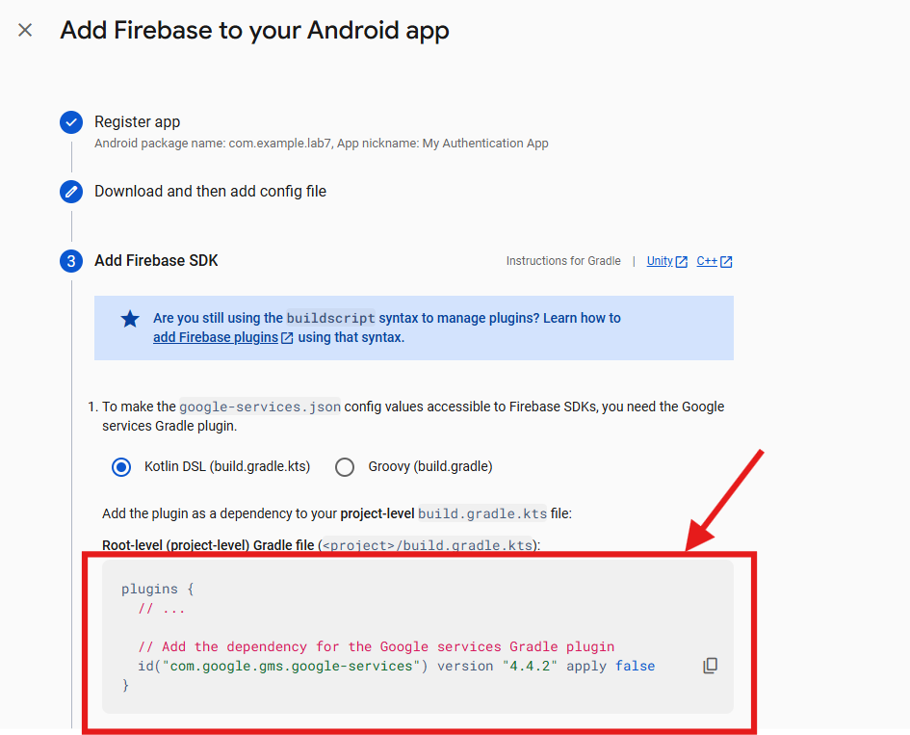
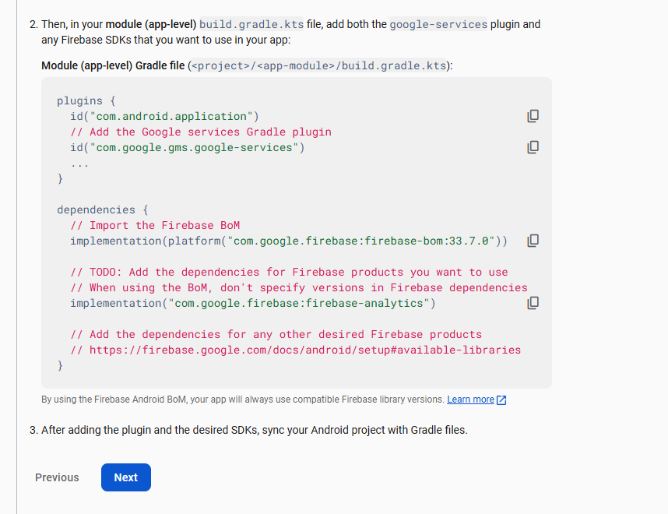
3.13 Click Next and continue to console.
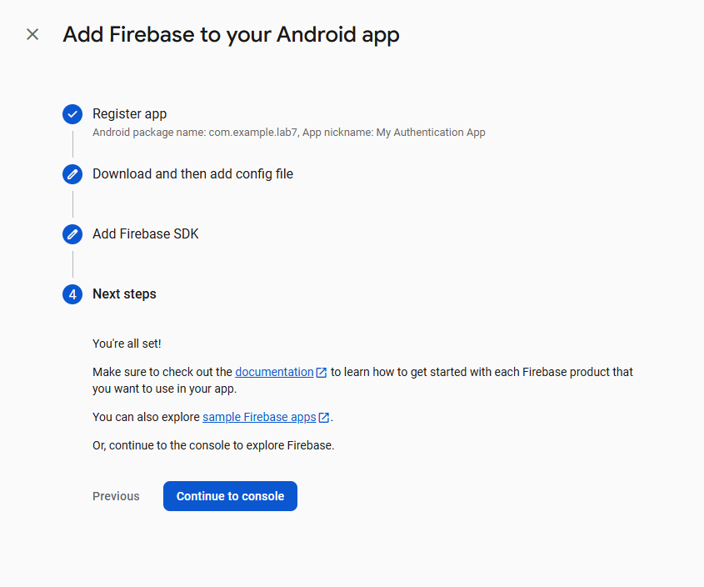
Build.gradle.kts (Project: ProjectName)
// Top-level build file where you can add configuration options common to all sub-projects/modules.
plugins {
alias(libs.plugins.android.application) apply false
alias(libs.plugins.kotlin.android) apply false
//------------------Add this dependency------------------------
id("com.google.gms.google-services") version "4.4.2" apply false
}

build.gradle.kts (Module:app)
plugins {
alias(libs.plugins.android.application)
alias(libs.plugins.kotlin.android)
//----------------Add this dependency------------------
id("com.google.gms.google-services")
}
android {
namespace = "com.example.lab7"
compileSdk = 35
defaultConfig {
applicationId = "com.example.lab7"
minSdk = 33
targetSdk = 34
versionCode = 1
versionName = "1.0"
testInstrumentationRunner = "androidx.test.runner.AndroidJUnitRunner"
}
buildTypes {
release {
isMinifyEnabled = false
proguardFiles(
getDefaultProguardFile("proguard-android-optimize.txt"),
"proguard-rules.pro"
)
}
}
compileOptions {
sourceCompatibility = JavaVersion.VERSION_11
targetCompatibility = JavaVersion.VERSION_11
}
kotlinOptions {
jvmTarget = "11"
}
}
dependencies {
implementation(libs.androidx.core.ktx)
implementation(libs.androidx.appcompat)
implementation(libs.material)
implementation(libs.androidx.activity)
implementation(libs.androidx.constraintlayout)
testImplementation(libs.junit)
androidTestImplementation(libs.androidx.junit)
androidTestImplementation(libs.androidx.espresso.core)
//-----------------Add these dependencies----------------
implementation(platform("com.google.firebase:firebase-bom:33.7.0"))
implementation("com.google.firebase:firebase-analytics")
implementation("com.google.firebase:firebase-database-ktx:21.0.0")
implementation("com.google.firebase:firebase-auth:23.1.0")
}

Note: Click on Sync Now after making changes in any of the build gradle file.
3.14 Back to firebase console, define the authentication method by choosing email/password.
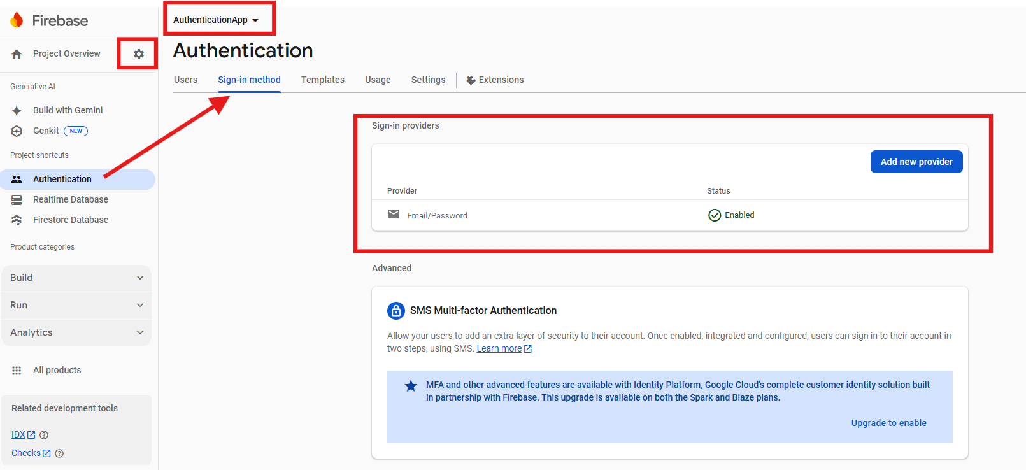
3.15 Click on Realtime Database, and activate the database in test mode.
Note: Since we have chosen email/password, so enter email in username place of your main activity, otherwise, you will receive error message. See the screenshot below:
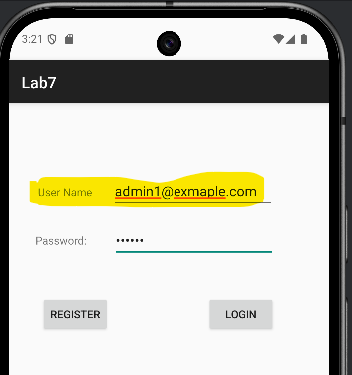

- We have already designed the following activity in the lab tutorial otherwise; design the following main_activity interface:
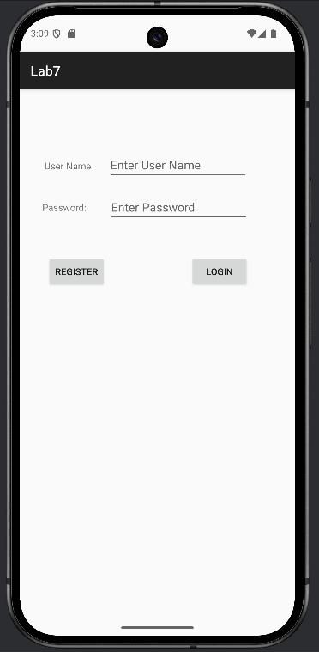
The main activity has the following elements:
- User Name Text View
- Enter User Name Edit Text
- Password: Text View
- Enter Password Edit Text
- Register Button
- Login Button
- Replace the main activity code with the following code:
MainActivity.kt
package com.example.lab10fb
import android.content.Intent
import android.os.Bundle
import android.widget.Button
import android.widget.EditText
import android.widget.Toast
import androidx.activity.enableEdgeToEdge
import androidx.appcompat.app.AppCompatActivity
import androidx.core.view.ViewCompat
import androidx.core.view.WindowInsetsCompat
import com.google.android.material.snackbar.Snackbar
import com.google.firebase.auth.FirebaseAuth
class MainActivity : AppCompatActivity() {
private lateinit var auth: FirebaseAuth
override fun onCreate(savedInstanceState: Bundle?) {
super.onCreate(savedInstanceState)
enableEdgeToEdge()
setContentView(R.layout.activity_main)
ViewCompat.setOnApplyWindowInsetsListener(findViewById(R.id.main)) { v, insets ->
val systemBars = insets.getInsets(WindowInsetsCompat.Type.systemBars())
v.setPadding(systemBars.left, systemBars.top, systemBars.right, systemBars.bottom)
insets
}
val btnReg = findViewById<Button>(R.id.btnRegister)
val btnLogin = findViewById<Button>(R.id.btnLogin)
val etUser = findViewById<EditText>(R.id.etUser)
val etPass = findViewById<EditText>(R.id.etPass)
auth = FirebaseAuth.getInstance()
btnReg.setOnClickListener {
createUser(etUser.text.trim().toString(), etPass.text.trim().toString())
}
btnLogin.setOnClickListener {
if (etUser.text.trim().toString().isNotEmpty() || etPass.text.trim().toString().isNotEmpty()){
login(etUser.text.trim().toString(),etPass.text.trim().toString())
}else{
Snackbar.make(findViewById(R.id.btnLogin),"User does not exist", Snackbar.LENGTH_LONG).show()
}
}
}
fun createUser(email:String, password:String){
auth.createUserWithEmailAndPassword(email, password)
.addOnCompleteListener(this) {
task ->
if (task.isSuccessful){
Toast.makeText(this, "User created Successfully...",Toast.LENGTH_LONG).show()
}
else{
Snackbar.make(findViewById(R.id.btnRegister), "Enter a valid username and password of 6 characters", Snackbar.LENGTH_LONG).show()
}
}
}
fun login(username:String, password:String){
auth.signInWithEmailAndPassword(username,password)
.addOnCompleteListener(this){
task ->
if (task.isSuccessful){
startActivity(Intent(this, Products::class.java))
}else{
Toast.makeText(this, "In-correct username and password",Toast.LENGTH_LONG).show()
}
}
}
}

- We have already added a basic view activity called Products, if not then do so. Products activity has two edit texts product name, and price, two buttons and a list view.
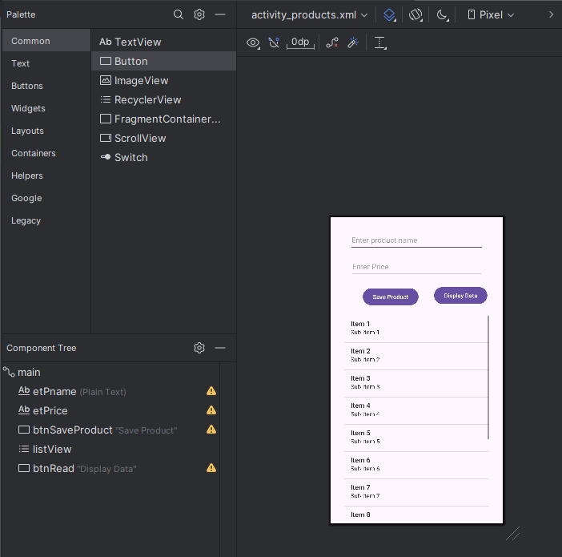
- Create a menu file after creating a menu folder under the res project folder and add the following lines of code:
Menu.xml This menu has only one item for logging out of the system.
<?xml version="1.0" encoding="utf-8"?>
<menu xmlns:android="http://schemas.android.com/apk/res/android"
xmlns:app="http://schemas.android.com/apk/res-auto">
<item android:id="@+id/logout" android:title="Logout" app:showAsAction="never"/>
</menu>

- Do not forget to add menu creation and onmenuitem selection code in the Products.kt file. Replace the Products.kt file code with the following.
Products.kt
package com.example.lab10fb
import android.content.Intent
import android.os.Bundle
import android.view.Menu
import android.view.MenuItem
import android.widget.ArrayAdapter
import android.widget.Button
import android.widget.EditText
import android.widget.ListView
import android.widget.Toast
import androidx.activity.enableEdgeToEdge
import androidx.appcompat.app.AppCompatActivity
import androidx.core.view.ViewCompat
import androidx.core.view.WindowInsetsCompat
import com.google.firebase.auth.FirebaseAuth
import com.google.firebase.database.DataSnapshot
import com.google.firebase.database.DatabaseError
import com.google.firebase.database.FirebaseDatabase
import com.google.firebase.database.ValueEventListener
data class Product_data(val name: String = "", val price: Double = 0.0)
class Products : AppCompatActivity() {
private lateinit var auth: FirebaseAuth
private val database = FirebaseDatabase.getInstance()
private val dbReference = database.getReference("products")
private val productList = ArrayList<String>()
private lateinit var adapter: ArrayAdapter<String>
private lateinit var listView: ListView
override fun onCreate(savedInstanceState: Bundle?) {
super.onCreate(savedInstanceState)
enableEdgeToEdge()
setContentView(R.layout.activity_products)
ViewCompat.setOnApplyWindowInsetsListener(findViewById(R.id.main)) { v, insets ->
val systemBars = insets.getInsets(WindowInsetsCompat.Type.systemBars())
v.setPadding(systemBars.left, systemBars.top, systemBars.right, systemBars.bottom)
insets
}
auth = FirebaseAuth.getInstance()
val etProductName = findViewById<EditText>(R.id.etPname)
val etPrice = findViewById<EditText>(R.id.etPrice)
val btnSave = findViewById<Button>(R.id.btnSaveProduct)
val btnRead = findViewById<Button>(R.id.btnRead)
listView = findViewById(R.id.listView)
productList.add("Welcome")
adapter = ArrayAdapter<String>(this, android.R.layout.simple_list_item_1, productList)
listView.adapter = adapter
btnSave.setOnClickListener {
val text = etProductName.text.toString()
val price = etPrice.text.toString().toDoubleOrNull()
val product = price?.let { it1 -> Product_data(text, it1) }
if (text.isNotEmpty()) {
val id = dbReference.push().key
id?.let {
dbReference.child(it).setValue(product)
Toast.makeText(this, "Saved to Firebase", Toast.LENGTH_SHORT).show()
etProductName.text.clear()
}
} else {
Toast.makeText(this, "Input field is empty", Toast.LENGTH_SHORT).show()
}
}
btnRead.setOnClickListener {
dbReference.addValueEventListener(object : ValueEventListener {
override fun onDataChange(snapshot: DataSnapshot) {
productList.clear()
for (productSnapshot in snapshot.children) {
val product = productSnapshot.getValue(Product_data::class.java)
product?.let {
productList.add("${it.name} - $${it.price}")
}
}
adapter.notifyDataSetChanged()
}
override fun onCancelled(error: DatabaseError) {
Toast.makeText(this@Products, "Failed to load data: ${error.message}", Toast.LENGTH_SHORT).show()
}
})
}
}
override fun onCreateOptionsMenu(menu: Menu?): Boolean {
menuInflater.inflate(R.menu.menu, menu)
return super.onCreateOptionsMenu(menu)
}
override fun onOptionsItemSelected(item: MenuItem): Boolean {
return when (item.itemId) {
R.id.logout -> {
auth.signOut()
startActivity(Intent(this, MainActivity::class.java))
true
}
else -> {
Toast.makeText(this, "Hello",Toast.LENGTH_LONG).show()
false
}
}
}
}

The working model of Products view:
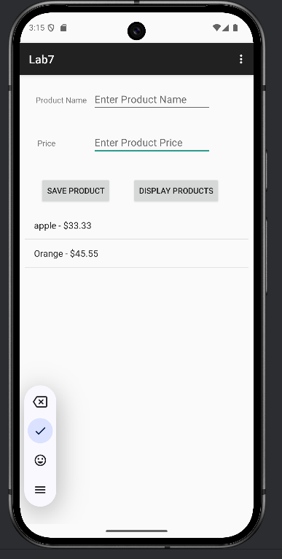
- Add internet permission in the manifest file:
<uses-permission android:name="android.permission.INTERNET" />

- Just make sure firebase real time database is active. No need to create product table as it will be created using the code.
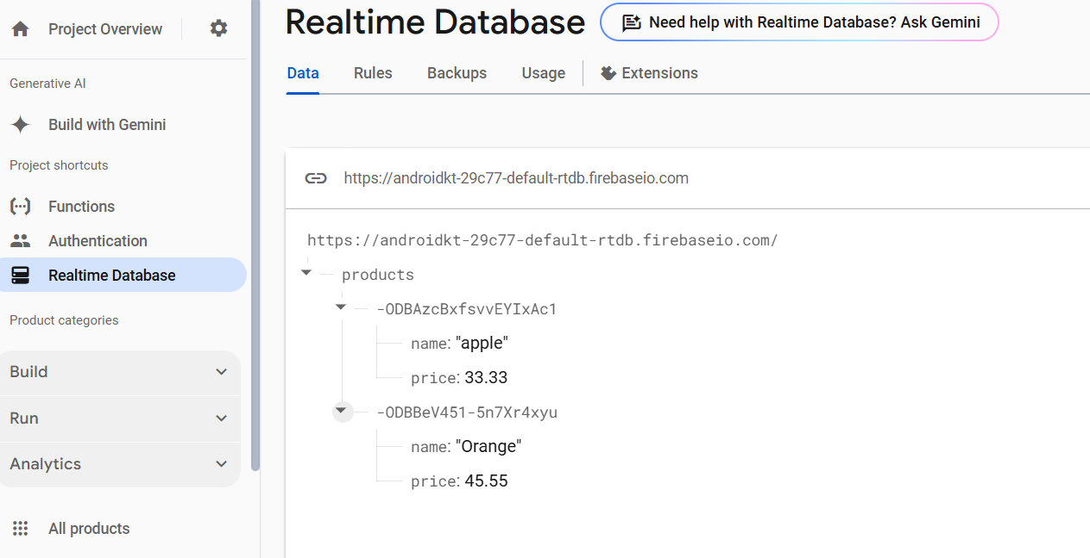

Lab Task
Register five users and at-least 10 products using the android application and submit the XML views and Kotlin Classes screenshots along with firebase users and collections.

Submit your code below:
Main_menu.xml
MainActivity.kt
Products.xml
Products.kt
Users
Products Collection

Submission Instructions
- Submit your answers in this word file by renaming it in the format “CSIT242_ _Lab8_Student IDs” and uploading on Moodle in the appropriate submission link.

Please conform to the naming convention of the file. In case if you worked on the assignment as a group, make sure that every member in the group will submit the same files on Moodle.

END OF LABORATORY

