+

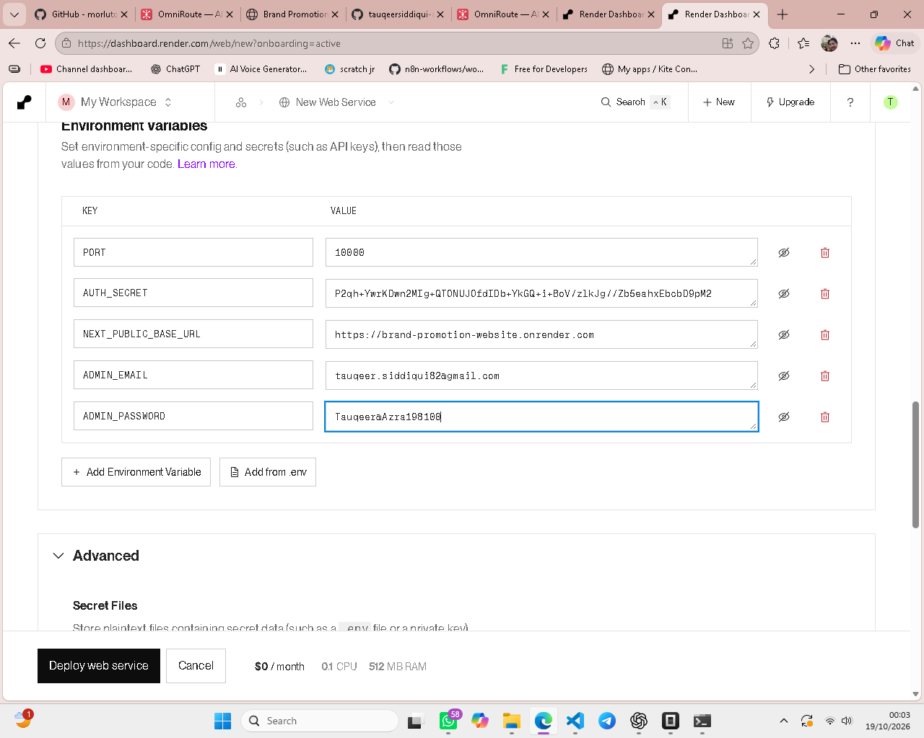
AUTH_SECRET = P2qh+YwrKDwn2MIg+QTONUJOfdIDb+YkGQ+i+BoV/zlkJg//Zb5eahxEbcbD9pM2
NEXT_PUBLIC_BASE_URL = https://brand-promotion-website.onrender.com
ADMIN_EMAIL = admin@brandpromotion.in
ADMIN_PASSWORD = (choose a strong password — NOT ChangeMe@123)-Tauqeer@Azra198100

