|  |  |
| --- | --- |
| **Course Code: CSL602** | **Course Name: SPCC LAB** |
| **Class : TE-CO B-3** | **Date: 8/04/2021** |
| **Roll no : 18CO63** | **Name : SHAIKH TAUSEEF MUSHTAQUE ALI** |

**Experiment :06**

**Aim:** To study LEX tool & YACC tool for finding spaces , lines , characters, line in given text file.

**Program:**

%{

int ch=0,wd=0,l=0,sp=0;

%}

%%

(" ") {sp++;}

[\n] {l++;}

[^ \t \n]+ {wd++; ch=ch+yyleng;}

%%

int main()

{

yyin=fopen("kit.txt","r");

yylex();

printf("char=%d \n words=%d \n spaces=%d \n lines=%d \n",ch,wd,sp,l);

return 0;

}

**Input:**

a = B * aiktc

panvel aiktc

group 1

**Output:**

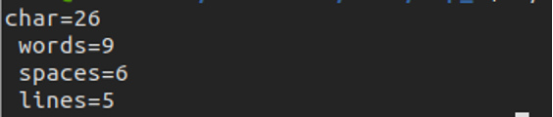

**Conclusion:**

|  |
| --- |
| With the help of this Experiment we get to know about the LEX Program. |