**Date - 8/04/2021**

**EXPT - 6**

### AIM - To write LEX program to count number of characters, words , spaces , lines from given text file.

**LEX program :**  
  
%{  
int ch=0,wd=0,l=0,sp=0;  
%}  
%%  
(" ") {sp++;}  
[\n] {l++;}  
[^ \t \n]+ {wd++; ch=ch+yyleng;}  
%%  
main()  
{  
yyin=fopen("kit.txt","r");  
yylex();  
printf("char=%d \t words=%d \t spaces=%d \t lines=%d",ch,wd,sp,l);  
}  
  
STEP1:  
  Each yac program consist of 3 parts  
                                 Definition --  
                                 %%  
                                 Rules --  
                                 %%  
                                 Subroutines --  
  
after compiling yac program is converted into equivalent c program. In that definition part of yac is introduced without any modification.  
so in the above program ch=0,wd=0,l=0,sp=0 are globally declared.

STEP2:  
     (" ") matches the space character when it encounters a space character sp will be incremented. [\n] matches the single new line character l will be incremented when lex encounters a new line in the file.   
[^ \t \n]+ -----> ^ implies negation of operators present to next to it matches string of any number of digits or characters and/or both. which is nothing but a word. hence wd will be incremented each time and yyleng is inbuilt method that gives the length of each word. Hence the instruction  
     ch=ch+yyleng.  
  
**STEP3:  
         kit.txt consist of some data  
         Above program must be saved with .l extension  
 to compile and run use following commands  
 $ lex program_name.l  
 $ cc lex.yy.c -lfl  
 $./a.out**

------------------------------------------xxxxx---------xxxx------------------------------

# LEX

* Lex is a program that generates lexical analyzer. It is used with YACC parser generator.
* The lexical analyzer is a program that transforms an input stream into a sequence of tokens.
* It reads the input stream and produces the source code as output through implementing the lexical analyzer in the C program.

### The function of Lex is as follows:

* Firstly lexical analyzer creates a program lex.1 in the Lex language. Then Lex compiler runs the lex.1 program and produces a C program lex.yy.c.
* Finally C compiler runs the lex.yy.c program and produces an object program a.out.
* a.out is lexical analyzer that transforms an input stream into a sequence of tokens.

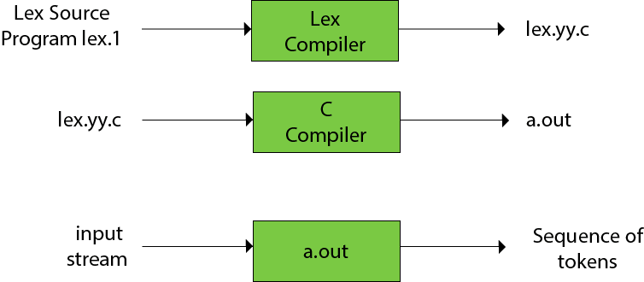

**Steps to install LEX tool & YACC tool in Linux Ubuntu / Mint-**

1 sudo apt-get update

1. sudo apt-get install flex
2. sudo apt-get install bison
3. sudo apt-get install byacc
4. sudo apt-get install bison++
5. sudo apt-get install byacc -j