**Product API Documentation**

**Project Architecture**

ProdAPI.DB

ProdAPI.Repository

ProdAPI.Controller

ProdAPI.BL

.NET 6

**Steps for running the code.**

* This project uses SQL Server MDF file to store product details and follows the *code first* approach.
* Please use the following commands in Package manager console to generate tables and insert dummy products
  + *> add-migration initialmigration*
  + Once this command is executed, run the following command to update the database –

*> update-database*

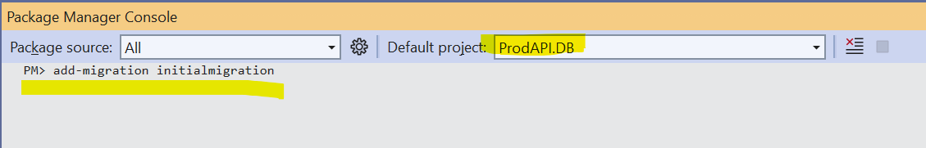

* Postman can be used to test the APIs.

API Details :

|  |  |  |
| --- | --- | --- |
| End point | Verb | Description |
| /api/product | GET | Returns list of all products |
| /api/product/{id} | GET | Returns a product with the matching {id} |
| /api/product | POST | Adds a new product |
| /api/product | PUT | Updates a product |
| /api/products/decrement-stock/{id}/{quantity} | PUT | Decrements quantity of the product with the matching {id} |
| /api/products/add-to-stock /{id}/{quantity} | PUT | Increments quantity of the product with the matching {id} |
| /api/product/{id} | DELETE | Deletes a product |