Business Template

MUSEUM Database System


Author: Greta Tautaviciute
greta.tautaviciute@gmail.com
Contents

Business Description 3

1.1 Project Vision 3

2 Model description 4

2.1 Step-by-step approach to modelling 4

2.2 Objects 11

2.3.1. Author 11
2.3.2. Collection 12
2.3.3. Staff 14
2.3.4. Visitor 15
2.3.5. Exhibition 16
2.3.6. Ticket 17
2.3.7. Collection_author 19
2.3.8. Exhibition_items 20

Business Description

Project Vision

This document presents the documentation of the Museum Database System model.
The system is designed to manage a museum's internal operations, its diverse art collection, and visitor interactions.
Core operations:
- Collection Management: The database tracks the museum's items, categorized by type (paintings, sculptures, photography). It stores critical data such as the creation year, estimated value, and specific storage locations (e.g., Main Vault, Gallery Display).
- Curatorial Oversight: The system maintains a detailed record of Authors (artists) and links them to specific items in the collection, supporting many-to-many relationships where multiple artists may collaborate on a single work.
- Exhibition Planning: Staff members, particularly Curators, organize Exhibitions. The system tracks which collection items are assigned to which exhibition and manages the duration (start and end dates) of these events.
- Visitor Services & Revenue: The system facilitates Ticket sales, linking visitors to specific exhibitions. It records purchase timestamps and applies tiered pricing based on visitor types (Standard, Discounted, Child).

Staff & Administration:
- Human Resources: All employees (Staff) are represented with defined roles (e.g., Curator, Guide, Security, Manager). The model ensures that staff assignments to exhibitions and ticket sales are tracked for accountability.
- Data Integrity & Security: The database is in 3rd Normal Form (3NF).

Historical Consistency
The system is designed to be historically consistent. It tracks when staff roles were valid and maintains a permanent record of all financial transactions (tickets) and collection history. Any changes in item status or exhibition context are recorded without losing previous states, ensuring that the museum's historical and financial data remains intact for auditing and analytics.

Model description

Step-by-step approach to modelling

Step 1. Conceptual model
It all starts with an idea about the database, entities and relationships. No data types, no keys, just a logic behind.
During the ideation level the tables identified – collection, exhibition, author, staff, visitor, ticket.
Relationships:
- Author creates collection items → M:N → needs junction table collection_author
- Collection items appear in exhibitions → M:N → needs junction table exhibition_items
- Staff manages exhibition → 1:N
- Staff sells ticket → 1:N
- Visitor buys ticket → 1:N
- Exhibition has tickets → 1:N
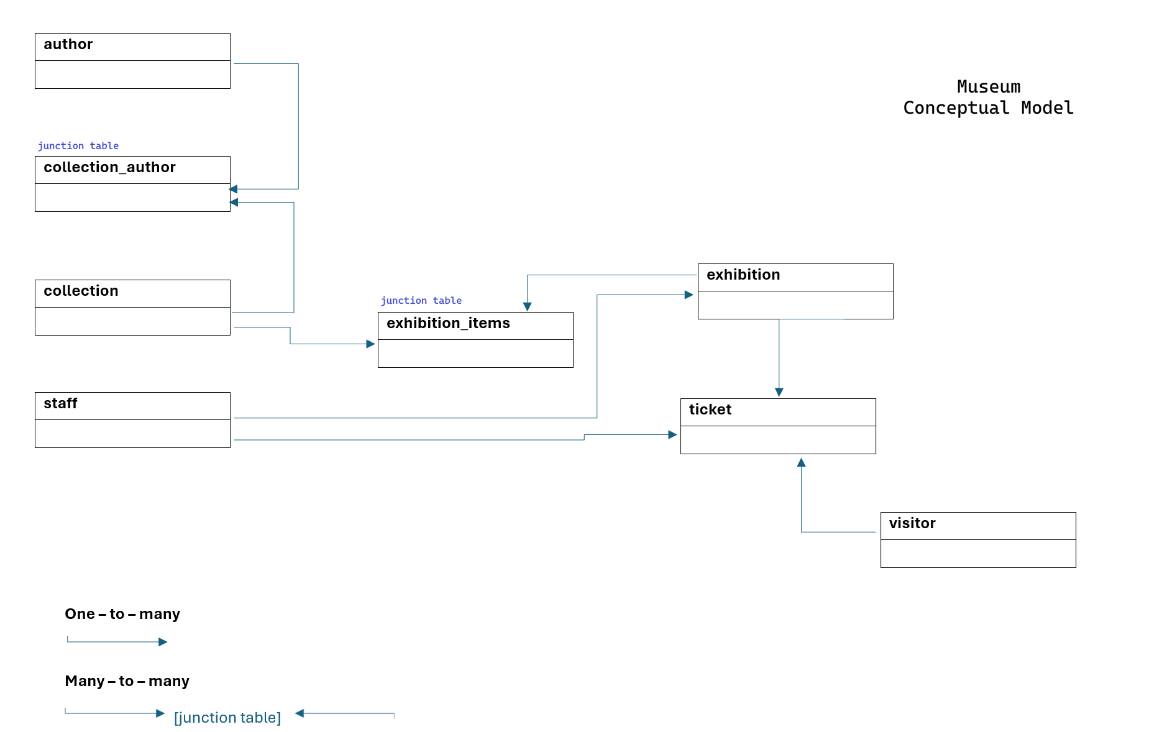

Step 2. Logical model
In this step, the model grows with the attributes, primary keys, foreign keys, data types, constraints.
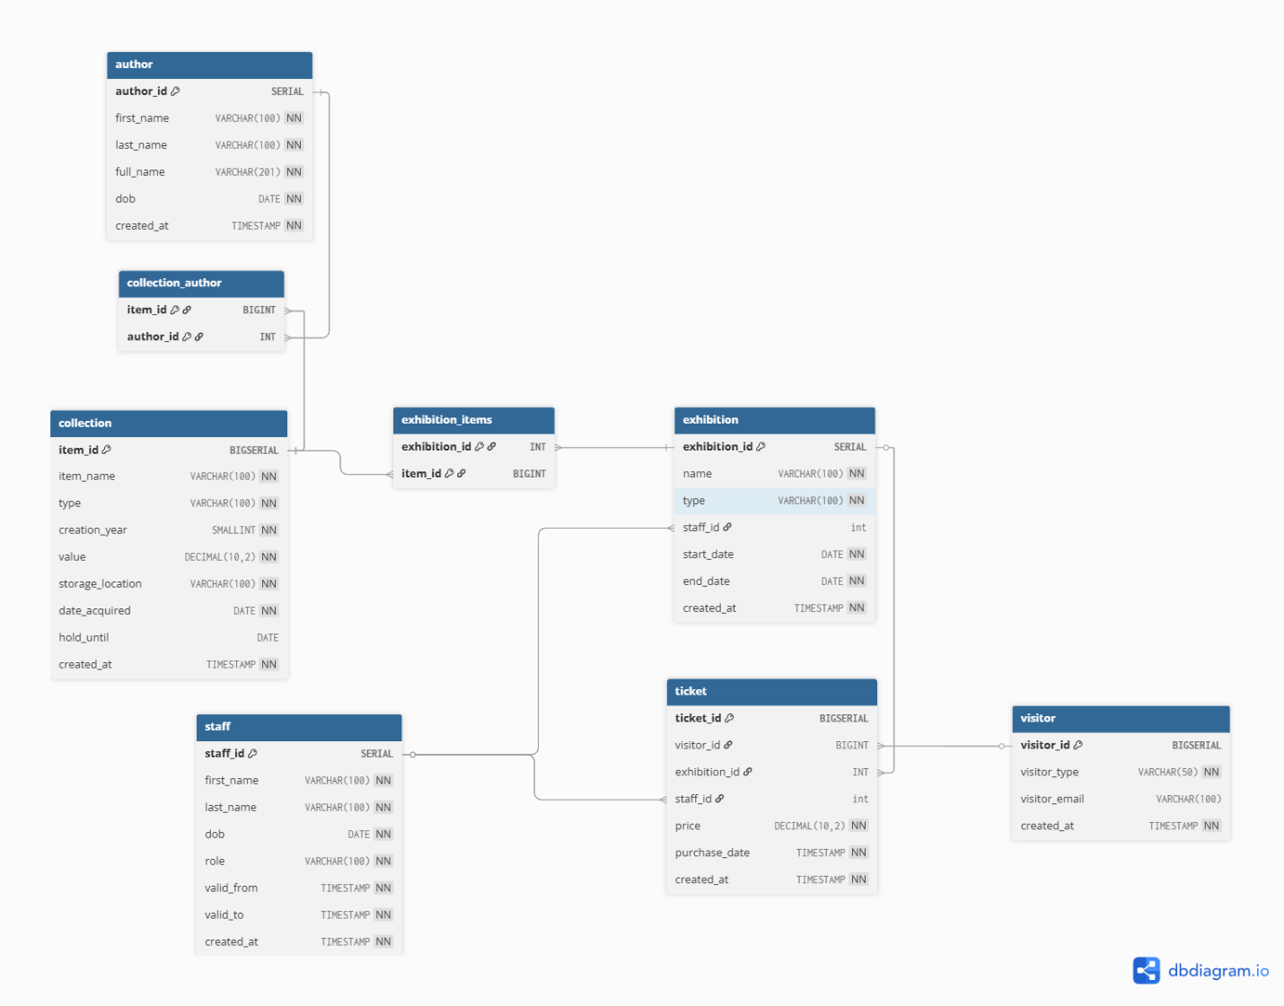

Step 3. Physical Model
In this step we are taking the logical model and start to build the physical model in the DBeaver.
First, we are creating the database and schema.

DATABASE & SCHEMA

CREATE DATABASE museum;
CREATE SCHEMA museum_data;

TABLES
Then the building part started - tables were built in the correct order (first parent tables, then child).
Tables and their adding order:
- author
- collection
- staff
- visitor
- exhibition
- ticket
- collection_author
- exhibition_items

Appropriate data types for each column were applied.

Data type | Used for | Description / reasoning
SERIAL | author_id, staff_id, exhibition_id | Auto-incrementing integer PK
BIGSERIAL | item_id, visitor_id, ticket_id | Auto-incrementing integer PK for tables expected to grow large
VARCHAR(n) | names, roles, types, email | Variable-length text with limit to prevent too long values
SMALLINT | creation_year | Sufficient for storing only a year value.
DECIMAL(10,2) | price, value | Exact precision for monetary values.
DATE | dob, start_date, end_date, valid_from, valid_to, date_acquired, hold_until | Date only (no time needed)
TIMESTAMP | purchase_date, created_at | Date + time needed for precise historical tracking

DEFAULT, GENERATED ALWAYS AS columns were added as required.
DEFAULT – used for created_at columns.
GENERATED ALWAYS AS was used in the table author. For combining first_name and last_name of the author.

Primary and foreign keys were added.
More about the tables in part 2.2– ‘Objects’.

CONSTRAINTS

After building the tables constraints were build. As required in the task, constraints were added by using ALTER TABLE.

Table | Constraints | Description
author | ALTER TABLE museum_data.author  ADD CONSTRAINT uq_author_identity  UNIQUE (first_name, last_name, dob); | Constraint sets the unique identity of the author by using first_name, last_name, dob columns.  first_name and last_name alone are insufficient as authors may share the same name. Adding dob ensures uniqueness.
collection | ALTER TABLE museum_data.collection  ADD CONSTRAINT uq_collection_identity UNIQUE (item_name, creation_year); | Constraint sets the unique identity of the collection item by using item_name and creation_year.  Just the item_name cannot alone identify the collection item as different authors can name the item in the same name. Of course, just the creation year should not be enough also, it may have a identification number. Let’s leave it for future corrections.
 | ALTER TABLE museum_data.collection  ADD CONSTRAINT ck_collection_type_list  CHECK (type IN ('painting', 'sculpture', 'photography')); | Constraint sets the possible values for the collection item type, which are restricted to painting, sculpture, photography.
 | ALTER TABLE museum_data.collection  ADD CONSTRAINT ck_collection_year_positive  CHECK (creation_year > 0); | Constraints checks that creation year is a positive value (greater than 0).
 | ALTER TABLE museum_data.collection  ADD CONSTRAINT ck_collection_value_non_negative  CHECK (value >= 0); | Constraint checks that item value is non-negative (zero or greater).
 | ALTER TABLE museum_data.collection  ADD CONSTRAINT ck_collection_valid_storage  CHECK (storage_location IN ('Main Vault', 'Archive Room', 'Off-site Warehouse', 'Restoration Lab', 'Gallery Display')); | Constraint sets the possible values for the collection storage location, which are restricted to 'Main Vault', 'Archive Room', 'Off-site Warehouse', 'Restoration Lab', 'Gallery Display'.
 | ALTER TABLE museum_data.collection  ADD CONSTRAINT ck_collection_dates_logical  CHECK (hold_until IS NULL OR hold_until > date_acquired); | Constraint ensures logical date order — hold_until must be later than date_acquired. NULL is allowed as it indicates the item is currently active in the collection.
staff | ALTER TABLE museum_data.staff  ADD CONSTRAINT ck_staff_dates_logical  CHECK (valid_to > valid_from); | Constraint ensures logical date order — valid_to must be later than valid_from. This supports preserving historical staff records.
 | ALTER TABLE museum_data.staff  ADD CONSTRAINT uq_staff_identity UNIQUE (first_name, last_name, dob); | Constraint sets the unique identity of the staff member by using first_name, last_name, dob columns.  first_name and last_name alone are insufficient as authors may share the same name. Adding dob ensures uniqueness.
 | ALTER TABLE museum_data.staff  ADD CONSTRAINT ck_staff_valid_from_2026  CHECK (valid_from > '2026-01-01'); | Constraint ensures that no staff records are created before the museum's operational start date (January 1, 2026).
visitor | ALTER TABLE museum_data.visitor  ADD CONSTRAINT ck_visitor_type_enum  CHECK (visitor_type IN ('Standard', 'Discounted', 'Child')); | Constraint sets the possible values for the visitor type, which are restricted to 'Standard', 'Discounted', 'Child'.
 | ALTER TABLE museum_data.visitor  ADD CONSTRAINT uq_visitor_email  UNIQUE (visitor_email); | Constraint ensures that each email address is unique across all visitor records, preventing duplicate registrations. NULL values are permitted as anonymous visitors without an email are allowed.
exhibition | ALTER TABLE museum_data.exhibition  ADD CONSTRAINT ck_start_date  CHECK (start_date > '2026-01-01'); | Constraint ensures that no exhibition can be scheduled before the museum's operational start date (January 1, 2026).
 | ALTER TABLE museum_data.exhibition  ADD CONSTRAINT ck_exhibition_type_enum  CHECK (type IN ('Online', 'On-site')); | Constraint sets the possible values for exhibition type, which are restricted to 'Online', 'On-site'.
 | ALTER TABLE museum_data.exhibition  ADD CONSTRAINT uq_exhibition UNIQUE (name, start_date); | Constraint sets the unique identity of the exhibition by name and start_date, as the same exhibition name could potentially be reused in future seasons (e.g. annual event/exhibition).
ticket | ALTER TABLE museum_data.ticket  ADD CONSTRAINT ck_price_value_non_negative  CHECK (price >= 0); | Constraint ensures that ticket price is non-negative (zero or greater). Zero is allowed as some visitors, such as staff or special guests, may receive complimentary tickets.
 | ALTER TABLE museum_data.ticket  ADD CONSTRAINT ck_ticket_purchase_date  CHECK (purchase_date > '2026-01-01'); | Constraint ensures that no ticket can be purchased before the museum's operational start date (January 1, 2026).

INSERTING DATA
After adding constraints, the tables were inserted with the data.
The order was maintained as in the table creation stage: first the parent tables, then the child tables, then the junction tables.

To make code rerunnable, the strategy below was used:
ON CONFLICT DO NOTHING:
- for the tables, which had unique constraints (natural keys). Valid for author, collection, staff tables.
- for visitor table, where email is unique.
- for exhibition, exhibition_items and collection_author tables, ON CONFLICT DO NOTHING was used together with JOIN for staff_id, exhibition, item and author lookups.

WHERE NOT EXISTS:
- for the table which does not have natural unique key. Valid for ticket table.

An exception is made at the visitor table.

New records appear every time the script is executed. This reflects a real-world scenario
where anonymous visitors at the ticket office are treated as unique individuals. Without identifying data (e.g., name, surname, or DOB), rerunability for anonymous records is challenging.

Step 4. Functions & Views

FUNCTIONS

After completing all the models (conceptual, logical and physical) the functions were created.

First function update_collection modifies the data in the collection table.

The function updates a specified column in the collection table. It accepts three input arguments: p_item_id (the row to update), p_name (the column name to update), and p_new_value (the new value as text, cast internally to the appropriate data type).

The function supports updating the following columns: item_name, type, creation_year, value, storage_location, date_acquired and hold_until.

Exceptions:
- If an unsupported column name is provided, an exception is raised.
- If no row is found with the given p_item_id, an exception is raised.

On success, the function returns the updated row.

Second function add_ticket inserts a new ticket record into the ticket table.

The function automatically creates a new record. It accepts three input arguments: p_exhibition_name p_staff_last_name (staff member's last name as a natural key), and p_visitor_type (visitor type, default - 'Standard').
The ticket price is calculated automatically based on the visitor type: Standard: 20.00, Discounted: 12.00, Child: 7.00.

Exceptions:
- If the exhibition is not found, an exception is raised.
- If no active staff member is found, an exception is raised.
- If an invalid visitor type is provided, a constraint violation is raised.

On success, the function returns confirmation text: ‘Success: Ticket added'

VIEWS

The sales_revenue view presents ticket sales analytics for the most recently available quarter in the database, based on the latest recorded ticket purchase date.

The view joins the ticket and visitor tables and filters records dynamically to include only those belonging to the most recent year and quarter derived from the data.
The view returns the following fields:
- current_quarter — the year and quarter in the format (e.g. '2026-Q2')
- visitor_type — the visitor category (Standard, Discounted, Child)
- visitor_count — the number of tickets sold per visitor type
- total_sales — the total revenue per visitor type
Results are grouped by quarter and visitor type, ensuring that only relevant and non-duplicated aggregated data is returned.

Step 4. Data control management

A read-only role was created for the museum manager following the principle of least privilege — granting only the minimum permissions required.

First, a group role manager was created without login capability.
CREATE ROLE manager;

Then a specific user for Margaret was created with a password.
CREATE USER manager_margaret_t WITH PASSWORD 'pswrd1875!';

Then the manager was given a possibility to connect to the museum database
GRANT CONNECT ON DATABASE museum TO manager;

Then an access to the museum_data was given to the manager role.
GRANT USAGE ON SCHEMA museum_data TO manager;

Then read-only access to the database tables were granted to the manager role.
GRANT SELECT ON ALL TABLES IN SCHEMA museum_data TO manager;
All the queries above were done to make sure that there would be less work for the administrator to grant permissions to other managers in the future.

Then the manager role (with all its permissions) was granted to Margaret.
GRANT manager TO manager_margaret_t;

Objects
Tables created in the database.

- author
- collection
- staff
- visitor
- exhibition
- ticket
- collection_author
- exhibition_items

2.3.1. Author
The author table stores information about the authors of the museum’s collection items.

PRIMARY KEY
author_id SERIAL
A simple single-column PK was chosen as author records are not expected to change over time — authors are historical figures whose identity remains fixed.

GENERATED COLUMN
full_name VARCHAR(201)
Automatically derived from first_name and last_name using GENERATED ALWAYS AS ... STORED. Eliminates redundancy and ensures consistency — the full name is always up to date without manual input.

Table Name | Field name | Field Description | Data Type
author | author_id | Author identifier, auto-incremented | SERIAL PRIMARY KEY
 | first_name | Author's first name | VARCHAR(100) NOT NULL
 | last_name | Author's last name | VARCHAR(100) NOT NULL
 | full_name | Generated full name | VARCHAR(201)
 | dob | Date of birth | DATE NOT NULL
 | created_at | Record creation timestamp | TIMESTAMP NOT NULL DEFAULT NOW()

Constraints
UNIQUE (first_name, last_name, dob);

Comments on table relationships | author table has 1 active relationship:
MANY-TO-MANY author.author_id -> collection_author.author_id -> collection.item_id
One author can create multiple collection items, and one collection item can have multiple authors. This relationship is implemented via the collection_author junction table.

Example with data:

author_id | first_name | last_name | full_name | dob | created_at
1 | Michelangelo | Caravaggio | Michelangelo Caravaggio | 1571-09-29 | 2026-04-22 10:09:44.901
2 | Gian Lorenzo | Bernini | Gian Lorenzo Bernini | 1598-12-07 | 2026-04-22 10:09:44.901
3 | Hieronymus | Bosch | Hieronymus Bosch | 1450-01-01 | 2026-04-22 10:09:44.901
4 | Auguste | Rodin | Auguste Rodin | 1840-11-12 | 2026-04-22 10:09:44.901
5 | Ansel | Adams | Ansel Adams | 1902-02-20 | 2026-04-22 10:09:44.901
6 | Henri | Cartier-Bresson | Henri Cartier-Bresson | 1908-08-22 | 2026-04-22 10:09:44.901

2.3.2. Collection
The collection table stores information about all art items in the museum's collection.

PRIMARY KEY
item_id BIGSERIAL
An auto-incrementing key. BIGSERIAL was chosen over SERIAL as the collection is expected to grow large over time.

Table Name | Field name | Field Description | Data Type
collection | item_id | Item identifier | BIGSERIAL PRIMARY KEY
 | item_name | Name of the art item | VARCHAR(100) NOT NULL
 | type | Item type (painting, sculpture, photography) | VARCHAR(100) NOT NULL
 | creation_year | Year the item was created | SMALLINT NOT NULL
 | value | Estimated value | DECIMAL(10, 2) NOT NULL
 | storage_location | Current physical location | VARCHAR(100) NOT NULL
 | date_acquired | Date the item was acquired | DATE NOT NULL
 | hold_until | Date the item left the collection. NULL indicates the item is currently active | DATE
 | created_at | Record creation timestamp | TIMESTAMP NOT NULL DEFAULT NOW()

Constraints
UNIQUE (item_name, creation_year)
CHECK (type IN ('painting', 'sculpture', 'photography'));
CHECK (creation_year > 0);
CHECK (value >= 0);
CHECK (storage_location IN ('Main Vault', 'Archive Room', 'Off-site Warehouse', 'Restoration Lab', 'Gallery Display'));
CHECK (hold_until IS NULL OR hold_until > date_acquired);

Comments on table relationships | collection table has 2 active relationships:
MANY-TO-MANY collection.item_id -> collection_author.item_id -> author.author_id
One collection item can have multiple authors, and one author can be linked to multiple collection items. This relationship is implemented via the collection_author junction table.
MANY-TO-MANY collection.item_id -> exhibition_items.item_id -> exhibition.exhibition_id
One collection item can appear in multiple exhibitions, and one exhibition can display multiple items. This relationship is implemented via the exhibition_items junction table.

Example with data:

item_id | item_name | type | creation_year | value | storage_location | date_acquired | hold_until | created_at
1 | The Calling of Saint Matthew | painting | 1600 | 15000000.00 | Gallery Display | 2026-02-15 | [NULL] | 2026-04-22 10:10:16.706
2 | Apollo and Daphne | sculpture | 1625 | 2000000.00 | Gallery Display | 2026-02-15 | [NULL] | 2026-04-22 10:10:16.706
3 | The Garden of Earthly Delights | painting | 1500 | 25000000.00 | Main Vault | 2026-02-20 | [NULL] | 2026-04-22 10:10:16.706
4 | The Thinker | sculpture | 1904 | 5000000.00 | Gallery Display | 2026-02-20 | [NULL] | 2026-04-22 10:10:16.706
5 | America In Passing | photography | 1940 | 150000.00 | Archive Room | 2026-02-01 | [NULL] | 2026-04-22 10:10:16.706
6 | The Decisive Moment | photography | 1952 | 85000.00 | Archive Room | 2026-02-01 | [NULL] | 2026-04-22 10:10:16.706

2.3.3. Staff
The staff table stores information about all museum staff members (curator, guide, security, manager, restorer, ticket agent, etc.).

PRIMARY KEY
staff_id SERIAL
An auto-incrementing surrogate key. Its sole purpose is to give each staff member a stable identifier, allowing other tables such as exhibition and ticket to reference staff records without duplicating staff data.

Table Name | Field name | Field Description | Data Type
staff | staff_id | Staff identifier | SERIAL PRIMARY KEY
 | first_name | Staff member's first name | VARCHAR(100) NOT NULL
 | last_name | Staff member's last name | VARCHAR(100) NOT NULL
 | dob | Date of birth | DATE NOT NULL
 | role | Staff member's role | VARCHAR(100) NOT NULL
 | valid_from | Date from which the record is valid | DATE NOT NULL
 | valid_to | Date until which the record is valid. '2999-01-01' indicates currently active | DATE NOT NULL
 | created_at | Record creation timestamp | TIMESTAMP NOT NULL DEFAULT NOW()
valid_from and valid_to fields are used. When a staff member's information changes (e.g. role), the existing record is closed by setting valid_to to the current date, and a new record is inserted. This preserves full historical data without overwriting.

Constraints
UNIQUE (first_name, last_name, dob);
CHECK (valid_to > valid_from);
CHECK (valid_from > '2026-01-01');

Comments on table relationships | staff table has 2 active relationships:
ONE–TO-MANY staff.staff_id -> exhibition.staff_id
One staff member (curator) can be responsible for multiple exhibitions.

ONE–TO-MANY staff.staff_id -> ticket.staff_id
One staff member (ticket agent) can sell many tickets.

Example with data:

staff_id | first_name | last_name | dob | role | valid_from | valid_to | created_at
1 | James | Cunningham | 1980-05-15 | Curator | 2026-02-05 | 2999-01-01 | 2026-04-22 10:10:38.016
2 | Eleanor | Rigby | 1992-11-24 | Guide | 2026-02-02 | 2999-01-01 | 2026-04-22 10:10:38.016
3 | Arthur | Shelby | 1975-03-10 | Security | 2026-03-02 | 2999-01-01 | 2026-04-22 10:10:38.016
4 | Margaret | Thatcher | 1965-10-13 | Manager | 2026-02-05 | 2999-01-01 | 2026-04-22 10:10:38.016
5 | William | Blackwood | 1988-07-02 | Restorer | 2026-03-23 | 2999-01-01 | 2026-04-22 10:10:38.016
6 | Rose | Dawson | 1995-04-06 | Ticket Agent | 2026-02-05 | 2999-01-01 | 2026-04-22 10:10:38.016

2.3.4. Visitor
The visitor table stores information about museum visitors.

PRIMARY KEY
visitor_id BIGSERIAL
An auto-incrementing surrogate key. Its sole purpose is to give each visitor a stable identifier, allowing other tables such as ticket to reference visitor records without duplicating visitor data.

Note on anonymous visitors visitor_email is nullable — anonymous visitors who purchase tickets at the office are not required to provide an email. This means multiple visitor records without an email can exist simultaneously, which is an intentional design decision.

Table Name | Field name | Field Description | Data Type
visitor | visitor_id | Visitor identifier | BIGSERIAL PRIMARY KEY
 | visitor_type | Visitor category (Standard, Discounted, Child) | VARCHAR(100) NOT NULL
 | visitor_email | Visitor's email address | VARCHAR(100)
 | created_at | Record creation timestamp | TIMESTAMP NOT NULL DEFAULT NOW()
Constraints
UNIQUE (visitor_email);
CHECK (visitor_type IN ('Standard', 'Discounted', 'Child'));

Comments on table relationships | visitor table have 1 active relationship:
ONE–TO-MANY staff.staff_id -> exhibition.staff_id
One visitor can buy multiple tickets over time.

Example with data:

visitor_id | visitor_type | visitor_email | created_at
1 | Standard | m.that@gmail.com | 2026-04-22 14:04:16.229
2 | Child | young.rigby@school.uk | 2026-04-25 14:05:16.229
3 | Discounted | [NULL] | 2026-04-27 14:05:16.229
4 | Standard | [NULL] | 2026-04-28 15:05:16.229
5 | Standard | [NULL] | 2026-04-28 15:08:16.229
6 | Child | [NULL] | 2026-04-28 14:08:16.229

2.3.5. Exhibition
The exhibition table stores information about museum exhibitions.

PRIMARY KEY
Exhibition_id SERIAL
An auto-incrementing surrogate key. Its sole purpose is to give each exhibition a stable identifier, allowing other tables such as ticket and exhibition_items to reference exhibition records without duplicating exhibition data.

FOREIGN KEY
staff_id INT
References staff.staff_id. Each exhibition is assigned to one curator who is responsible for it.

Table Name | Field name | Field Description | Data Type
exhibition | exhibition_id | Exhibition identifier | SERIAL PRIMARY KEY
 | name | Exhibition name | VARCHAR(100) NOT NULL
 | type | Exhibition type (Online, On-site) | VARCHAR(100) NOT NULL
 | staff_id | FK referencing staff.staff_id | INTEGER  REFERENCES museum_data.staff(staff_id),
 | start_date | Exhibition start date | DATE NOT NULL
 | end_date | Exhibition end date | DATE NOT NULL
 | created_at | Record creation timestamp | TIMESTAMP NOT NULL DEFAULT NOW()
Constraints
UNIQUE (name, start_date);
CHECK (start_date > '2026-01-01');
CHECK (type IN ('Online', 'On-site'));
Comments on table relationships | exhibition table has 3 active relationships:
MANY–TO-ONE exhibition.staff_id -> staff.staff_id
Multiple exhibitions can be managed by the same curator.

MANY-TO-MANY exhibition.exhibition_id -> exhibition_items.exhibition_id -> collection.item_id
One exhibition can display multiple collection items, and one collection item can appear in multiple exhibitions. This relationship is implemented via the exhibition_items junction table.

ONE-TO-MANY exhibition.exhibition_id → ticket.exhibition_id
One exhibition can have multiple tickets purchased for it.

Example with data:

exhibition_id | name | type | staff_id | start_date | end_date | created_at
1 | Baroque Masterpieces | On-site | 1 | 2026-02-02 | 2026-04-30 | 2026-04-22 10:11:13.869
2 | Renaissance Echoes | On-site | 1 | 2026-03-01 | 2026-05-31 | 2026-04-22 10:11:13.869
3 | Modern Photography | On-site | 1 | 2026-02-20 | 2026-04-20 | 2026-04-22 10:11:13.869
4 | Abstract Impressions | On-site | 1 | 2026-04-01 | 2027-07-01 | 2026-04-22 10:11:13.869
5 | Security & Preservation | On-site | 1 | 2026-04-10 | 2029-12-31 | 2026-04-22 10:11:13.869
6 | The Surreal World | Online | 1 | 2026-02-10 | 2026-05-10 | 2026-04-22 10:11:13.869
7 | The Golden Age of Art | Online | 1 | 2026-03-15 | 2027-06-15 | 2026-04-22 10:11:13.869

2.3.6. Ticket
The ticket table stores information about ticket purchases. It serves as the main transaction table of the museum database.

PRIMARY KEY
ticket_id BIGSERIAL
An auto-incrementing surrogate key. BIGSERIAL was chosen over SERIAL as the number of tickets is expected to be the largest among all tables. Its sole purpose is to give each ticket a stable identifier, allowing the database to uniquely track every purchase without duplicating ticket data

FOREIGN KEYS
visitor_id BIGINT references visitor.visitor_id
Each ticket is linked to the visitor who purchased it.

exhibition_id INT references exhibition.exhibition_id
Each ticket is linked to the exhibition it was purchased for.

staff_id INT references staff.staff_id
Each ticket is linked to the staff member (ticket agent) who sold it.

Table Name | Field name | Field Description | Data Type
ticket | ticket_id | Ticket identifier | BIGSERIAL PRIMARY KEY
 | visitor_id | FK referencing visitor.visitor_id | BIGINT  REFERENCES museum_data.visitor(visitor_id)
 | exhibition_id | FK referencing exhibition.exhibition_id | INT  REFERENCES museum_data.exhibition(exhibition_id)
 | staff_id | FK referencing staff.staff_id | INT  REFERENCES museum_data.staff(staff_id)
 | price | Ticket price | DECIMAL(10, 2) NOT NULL
 | purchase_date | Date and time of purchase | TIMESTAMP NOT NULL
 | created_at | Record creation timestamp | TIMESTAMP NOT NULL DEFAULT NOW()

Constraints
CHECK (price >= 0);
CHECK (purchase_date > '2026-01-01');

Comments on table relationships | ticket table has 3 active relationships:
MANY–TO-ONE ticket.visitor_id -> visitor.visitor_id
Multiple tickets can be purchased by the same visitor.

MANY-TO-ONE ticket.exhibition_id -> exhibition.exhibition_id
Multiple tickets can be purchased for the same exhibition.

MANY-TO-ONE ticket.staff_id -> staff.staff_id
Multiple tickets can be sold by the same staff member.

Example with data:

ticket_id | visitor_id | exhibition_id | staff_id | price | purchase_date | created_at
1 | 5 | 2 | 6 | 20.00 | 2026-04-10 11:20:00.000 | 2026-03-01 10:15:10.318
2 | 4 | 1 | 6 | 20.00 | 2026-03-22 16:45:00.000 | 2026-03-14 12:12:10.218
3 | 1 | 1 | 6 | 20.00 | 2026-02-05 10:30:00.000 | 2026-03-18 16:15:01.129
4 | 2 | 6 | 6 | 7.00 | 2026-02-18 14:15:00.000 | 2026-04-22 10:15:10.643
5 | 6 | 7 | 6 | 7.00 | 2026-04-21 13:10:00.000 | 2026-04-22 10:15:11.243
6 | 3 | 3 | 6 | 12.00 | 2026-03-07 09:00:00.000 | 2026-04-22 10:23:10.309

2.3.7. Collection_author
The collection_author table is a junction table that resolves the many-to-many relationship between the collection and author tables.

PRIMARY KEY
(item_id, author_id) Composite PK
A composite primary key was chosen instead of a surrogate key, as the combination of item_id and author_id is naturally unique and sufficient to identify each record.

FOREIGN KEYS
item_id BIGINT references collection.item_id
Each item is linked to the collection.

author_id INT references author.author_id
Each item is linked to the author or authors.

Table Name | Field name | Field Description | Data Type
collection_author | item_id | FK referencing collection.item_id | BIGINT  REFERENCES museum_data.collection (item_id)
 | author_id | FK referencing visitor.visitor_id | INT  REFERENCES museum_data.author(author_id)
Constraints
PRIMARY KEY (item_id, author_id)

Comments on table relationships | collection_author table has 2 active relationships:
MANY–TO-ONE collection_author.item_id -> collection.item_id
Multiple authors can be linked to the same collection item.

MANY-TO-ONE collection_author.author_id -> author.author_id
Multiple collection items can be linked to the same author.

Example with data:

item_id | author_id
1 | 1
2 | 2
3 | 3
4 | 4
5 | 5
6 | 6

2.3.8. Exhibition_items
The exhibition_items table is a junction table that resolves the many-to-many relationship between the exhibition and collection tables.

PRIMARY KEY
(exhibition_id, item_id) Composite PK
A composite primary key was chosen instead of a surrogate key, as the combination of exhibition_id and item_id is naturally unique and sufficient to identify each record.

FOREIGN KEYS
exhibition_id INT references exhibition.exhibition_id
Links each record to a specific exhibition.

item_id BIGINT references collection.item_id
Links each record to a specific item in the collection.

Table Name | Field name | Field Description | Data Type
exhibition_items | exhibition_id | FK referencing exhibition.exhibition_id | INT  REFERENCES museum_data.exhibition(exhibition_id)
 | item_id | FK referencing collection.item_id | BIGINT  REFERENCES museum_data.collection(item_id)
Constraints
PRIMARY KEY (exhibition_id, item_id)

Comments on table relationships | exhibition_items table has 2 active relationships:
MANY–TO-ONE exhibition_items.exhibition_id -> exhibition.exhibition_id
Multiple collection items can be linked to one exhibition.

MANY-TO-ONE exhibition_items.item_id -> collection.item_id
Multiple exhibitions can be linked to museums collection.

Example with data:

exhibition_id | item_id
1 | 2
1 | 1
2 | 1
3 | 6
3 | 5
6 | 3
7 | 4

