Assignment 4 Forms and Validation
  - HTML and Bootstrap implementation report
Student: Shalkar Tauyekeluly
Group: IT-2510
Course: Web Technologies
GitHub repository URL: ____________________________________

Overview
This project contains three forms: a train ticket form, an AITU Hack 2026 registration form, and an improved café reservation form. The pages use HTML, Bootstrap 5.3.3 and custom CSS. They contain no JavaScript, no novalidate attribute and no pattern attribute.
Native HTML constraints check input values. Bootstrap provides the grid and form styles. The forms are front-end practice pages: they validate data, but they do not create real tickets, registrations or reservations. Their POST actions need a server endpoint for real data processing.

Task 1 Train ticket form
The train form follows the supplied design. It uses Montserrat, the five required colors, rounded corners and a soft shadow. The layout has two or three columns on a laptop and one column on a phone. Custom CSS does not use fixed layout widths or absolute positioning.
Form part | Implementation
From and To | Bootstrap form-floating with connected labels.
Dates and passengers | Native date inputs and a select with 1–6 adults.
Journey and carriage | Real radio inputs; each group has a shared name.
Phone | Bootstrap input-group with the +7 prefix.
SMS and agreement | Bootstrap form-switch and form-check.
Buttons | Native reset and submit buttons with custom colors.

The required fields are From, To, Departure, Passengers, Carriage class, Phone, Email and the carriage rules agreement. Return and SMS are optional. The blank initial state has no checked radios, filled values or nonempty default selection, so Clear really empties the form.
The HTML button order is always Clear, then Find trains. The classes flex-column-reverse flex-md-row show Find trains above Clear on a phone and restore the horizontal order on a laptop.

Task 1 Desktop comparison at 1280 px
The reference and the implemented form are shown below. The implementation screenshot was captured from the actual HTML at a viewport width of 1280 px.
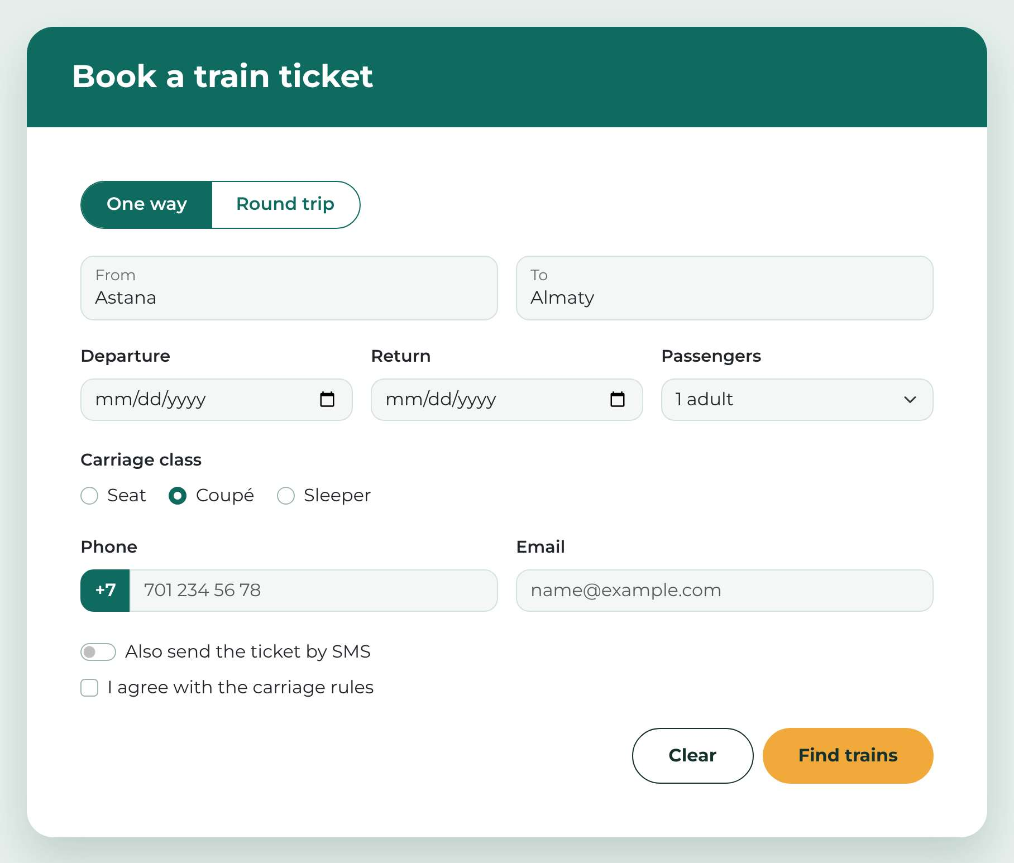
Figure 1. Supplied desktop design from the assignment.
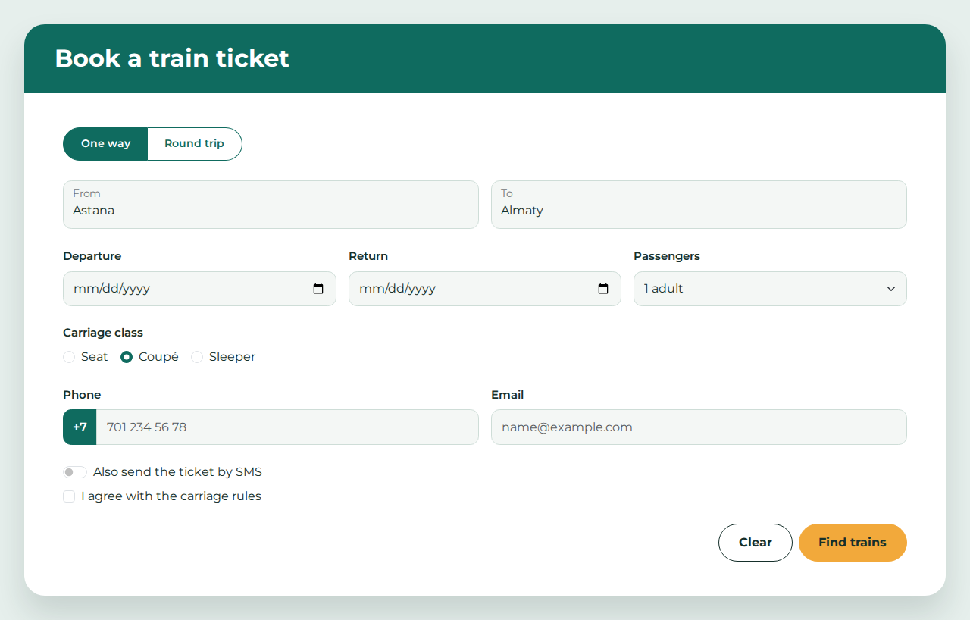
Figure 2. Implemented train form at 1280 px. Astana, Almaty and the radio choices were entered for the comparison.
The From and To fields share one row. Departure, Return and Passengers share another row. Phone and Email remain side by side. Clear is to the left of Find trains.

Task 1 Phone comparison at 375 px
The reference is on the left and the implementation is on the right. Both show the single-column layout and Find trains above Clear.
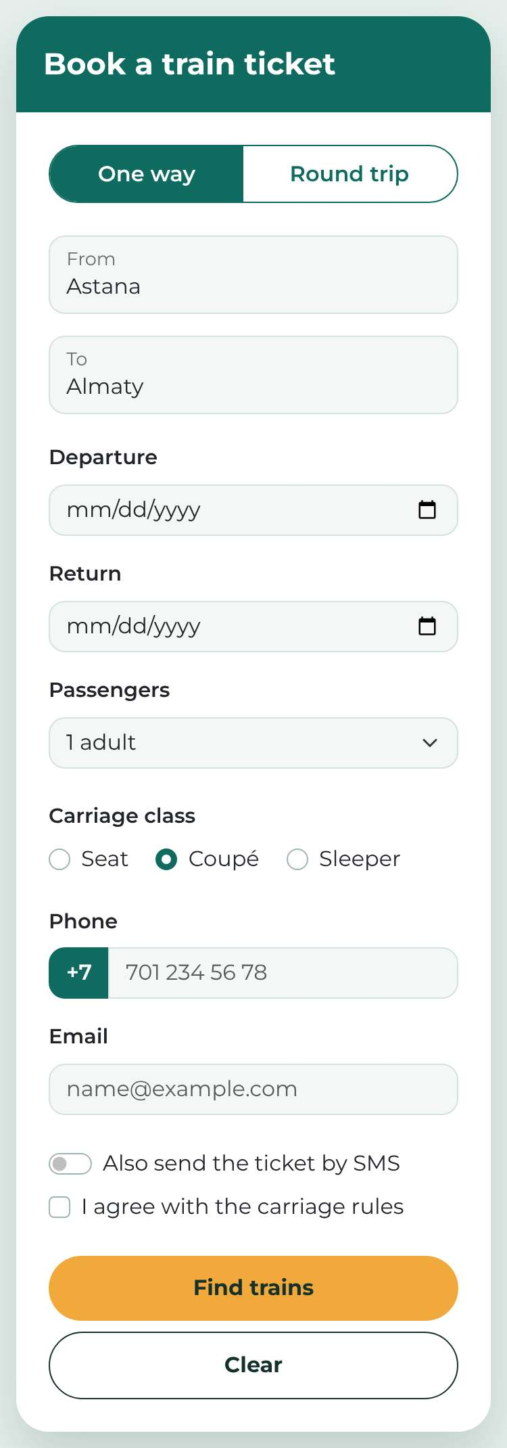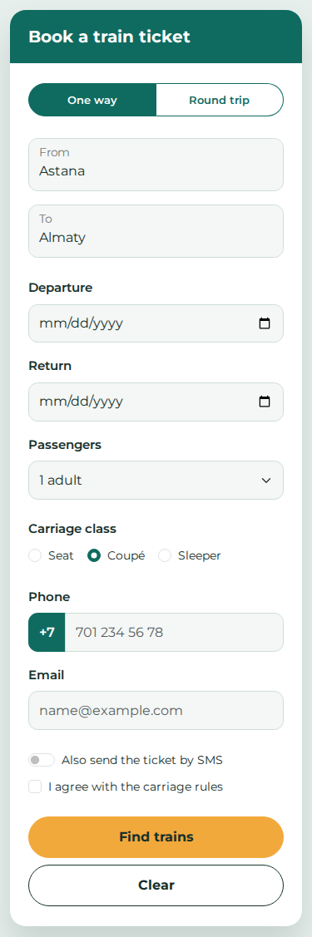
Figure 3. Phone comparison. The implementation has no horizontal overflow at 375 px. Its HTML button order is unchanged.

Task 2 AITU Hack registration form
The registration form uses the browser to check every rule. Fields marked with an asterisk are required. This screenshot contains valid sample values from the assignment.
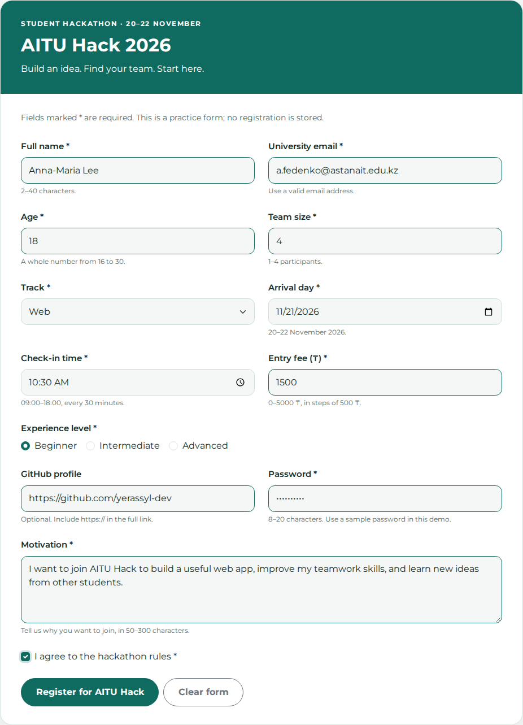
Figure 4. Complete AITU Hack 2026 form with valid sample data.

Task 2 Validation results
Each value below was entered in Chromium 155.0.8059.84. Accepted means the relevant control passed native constraint validation; rejected means the browser reported it as invalid. All required sample outcomes matched the assignment.
Field | HTML rules | Accepted | Rejected
Full name | text; required; minlength=2; maxlength=40 | Anna-Maria Lee | A
University email | email; required | a.fedenko@  astanait.edu.kz | a.fedenko;  a.fedenko@
Age | number; required; min=16; max=30; step=1 | 18 | 15; 31
Team size | number; required; min=1; max=4; step=1 | 4 | 5; 2.5
Track | select; required; empty placeholder value | Web | Choose…  (value="")
Arrival day | date; required; min=2026-11-20; max=2026-11-22 | 21.11.2026 | 25.11.2026
Check-in | time; required; min=09:00; max=18:00; step=1800 | 10:30 | 10:15; 19:00
Entry fee | number; required; min=0; max=5000; step=500 | 1500 | 1250; 6000
Experience | radio; required; one shared name | Beginner | Nothing chosen
GitHub | url; optional | Empty; full  https:// URL¹ | github.com/  yerassyl-dev
Password | password; required; minlength=8; maxlength=20 | Astana2026 | short
Motivation | textarea; required; minlength=50; maxlength=300 | 120 characters | 49 characters
Agreement | checkbox; required | Ticked | Not ticked

¹ Accepted full URL: https://github.com/yerassyl-dev
For time inputs, step is measured in seconds: 30 × 60 = 1800. For numeric inputs, step defines the distance between allowed values. Therefore, 10:15 is not a valid half-hour slot, and 1250 is not a valid multiple of 500 within the fee range.
The email rule checks email syntax; it does not restrict the domain to astanait.edu.kz. The optional URL rule checks a full URL; it does not prove that a GitHub account exists. These choices match the rules in the assignment.

Task 2 Feedback and boundary checks
An untouched form shows no error messages. The CSS uses :user-invalid, so feedback appears after interaction with an invalid field. After entering A and leaving the Full name field, exactly one red message becomes visible.
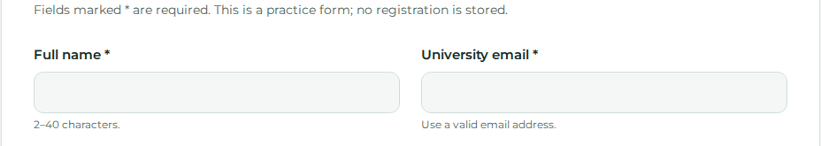
Figure 5. Initial state. No error messages are shown.
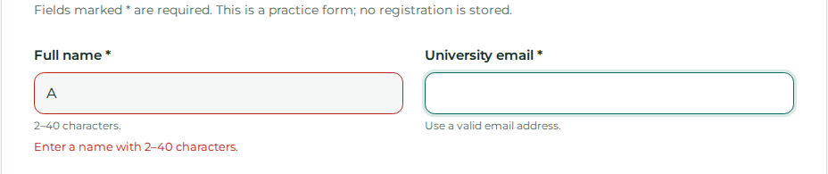
Figure 6. After editing Full name to A. Only that field shows an error.
input:user-invalid ~ .invalid-feedback,
select:user-invalid ~ .invalid-feedback,
textarea:user-invalid ~ .invalid-feedback {
display: block;
}
The radio fieldset uses :has(input:user-invalid) to show one group message. Text controls link their help and error text with aria-describedby. The experience fieldset references the group error.
Additional test | Result
Ages 16 and 30; ages 15, 31 and 18.5 | Endpoints accepted; invalid values rejected.
Arrival on 20 and 22 November; 19 November | Endpoints accepted; 19 November rejected.
Times 09:00 and 18:00; fees 0 and 5000 | All endpoints accepted.
Names of 2 and 40 characters; passwords of 8 and 20 | All length endpoints accepted.
Motivation of 50 and 300 characters | Both endpoints accepted.
Typing past maxlength for name, password and motivation | Extra characters were prevented at the limit.

The test set contained 57 cases, including the assignment values, boundary values and length limits. Every case passed. A complete valid registration form also passed checkValidity(). No registration was submitted to an external service.

Task 3 Problems in the original form
The line numbers refer to the snippet in the assignment: line 1 is <h2>Reserve a table</h2>, and line 21 is </form>. Fourteen problems were identified and fixed while keeping all nine original fields.
Original line | Problem for the user | Fix in task3.html
1. Line 3  Name input | A placeholder disappears while typing, so the user loses the field name. | Add a visible label with for="guest-name" and a matching unique id.
2. Line 4  Email input | type="text" accepts a value such as abc as an email and gives a less suitable phone keyboard. | Use type="email", required, autocomplete="email" and a connected label.
3. Lines 5–6  Phone label | The label has no for attribute. Clicking Phone does not focus its input. | Connect for="guest-phone" to id="guest-phone". Use type="tel".
4. Lines 7–8  Guests label | for="guests" points to no input because the input id is people. | Use for="guests" and id="guests" consistently.
5. Line 8  Guests input | A text field allows letters, zero or fractional guest counts. | Use type="number", min="1", step="1" and required.
6. Line 10  Date input | A text field does not provide a date picker or native date syntax checks. | Use type="date" and required with id="reservation-date".
7. Lines 10 and 12  Duplicate id | Both a date input and a radio use id="date". Labels and accessibility references become ambiguous. | Assign unique ids: reservation-date, seating-inside and seating-terrace.

The rebuilt page also includes a language, page title, viewport meta tag, Bootstrap grid columns and a clear focus style. On a phone the fields stack vertically. No positive tabindex values are used.

Task 3 Remaining problems and alternatives
Original line | Problem for the user | Fix in task3.html
8. Lines 12–13  Radio names | The two radios have different names, so the user can select both seating options. | Give both name="seating" and distinct values inside and terrace.
9. Lines 11–13  Seating labels | The options are plain text, and the group is only introduced by a paragraph. Its purpose is not structurally connected. | Use fieldset with legend Seating and a connected label for each radio.
10. Lines 14–17  Meal select | The select has no label or name. The user has little context, and its value is not included in form data. | Add a Meal label, id="meal", name="meal" and explicit option values.
11. Line 18  Comments | The textarea relies on a placeholder and has no name, so its text is not included in the submission. | Add a visible label, id="comments" and name="comments".
12. Line 19  Terms checkbox | The text is not a label, the choice has no name, and the form does not require agreement. | Add id, name, value="accepted", required and a connected label.
13. Line 20  Reserve div | A styled div is not a native button. It is not normally reached by Tab and does not submit the form. | Replace it with button type="submit" and keep Bootstrap button classes.
14. Lines 3–10  Unnamed inputs | The main input fields have no name attributes. Their values are omitted from submitted form data. | Add stable name attributes for guest_name, email, phone, guests and date.

Alternative fix for the name label
The input could be placed inside a label element instead of using for and id. The explicit connection was chosen because it keeps the visible label and the control separate in the Bootstrap layout and makes the relationship easy to check.

Alternative fix for seating
A select containing Inside and Terrace would also allow only one choice. Radio buttons were kept because there are only two options, both remain visible, and the original form already used radios. Arrow keys can change the selected option.

Task 3 Rebuilt reservation form
The rebuilt form keeps the name, email, phone, guests, date, seating, meal, comments and terms fields. Comments remain optional. The screenshot shows valid sample data.
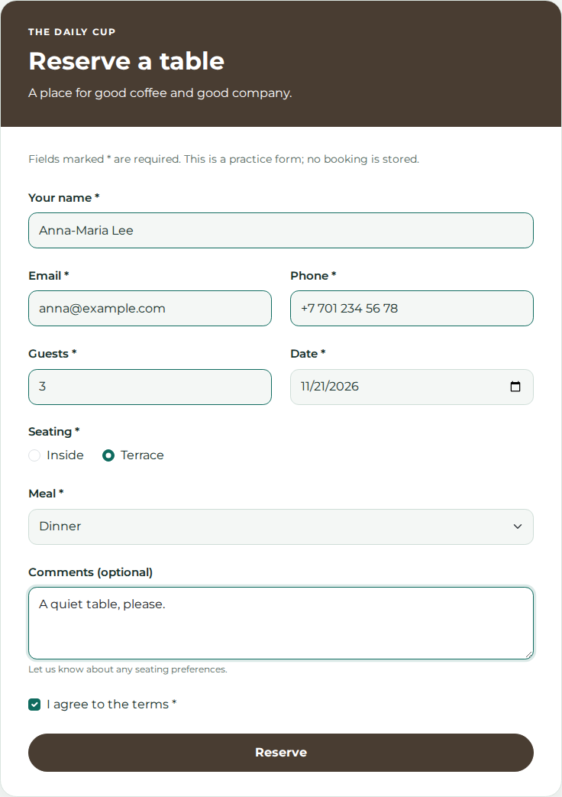
Figure 7. Corrected café reservation form. All nine values are included in the form data.

Verification and conclusion

Verified behavior
Check | Observed result
HTML validation | All four pages passed the local Nu HTML Checker, version 26.10.12 (0a70d65), with 0 errors and 0 warnings.
Task 1 responsive layout | No horizontal overflow at 375 px or 1280 px. The visual button order changed as required; the DOM order stayed Clear, Find trains.
Task 1 reset | All text, date and select values became empty. Radios and checkboxes became unchecked.
Task 2 native validation | 57 cases passed. The fully completed valid form passed native validation.
Task 2 delayed feedback | 0 visible errors on load; 1 after editing only the name to A.
Task 3 keyboard | Tab reached each field and Reserve. ArrowRight selected Terrace. Space toggled the terms checkbox.
Task 3 form data | All 9 expected keys were present, including seating, meal, comments and terms.
Source restrictions | No script elements, pattern or novalidate. Every data-entry control has a name and an associated label.

The browser checks used local files in Chromium 155.0.8059.84. Date controls can have several internal Tab stops for day, month and year. This is native keyboard behavior, not a duplicate control. Cross-browser testing and real server processing were outside this implementation.

Conclusion
This assignment shows how Bootstrap and HTML work together to build useful forms. The grid changes the layout for different screen sizes, and native attributes reject invalid input. Correct labels, radio groups, names and buttons make a form easier to use with a keyboard and assistive technology. The main lesson is that a form should look clear and also collect the intended data correctly.

References
Assignment 4 supplied PDF, pages 1–4. Requirements, reference design and original café snippet.
Bootstrap 5.3 forms: https://getbootstrap.com/docs/5.3/forms/overview/
MDN user-invalid: https://developer.mozilla.org/en-US/docs/Web/CSS/:user-invalid
MDN time input: https://developer.mozilla.org/en-US/docs/Web/HTML/Element/input/time
Nu HTML Checker: https://github.com/validator/validator

