Pinging the Raspberry PI from the lab machine 10 times at 100ms.
We are unable to ping at an interval of 100 ms. (Probably because we lack root permission on the Lab Machine)

Pinging the Raspberry PI from the lab machine 10 times at 200ms.
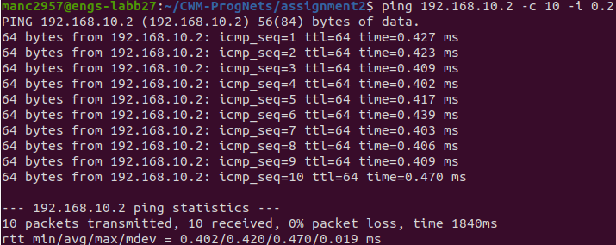
We see it takes about 400ms for each packet to be received.

Pinging the lab machine from the Raspberry PI 10 times at 100 ms.
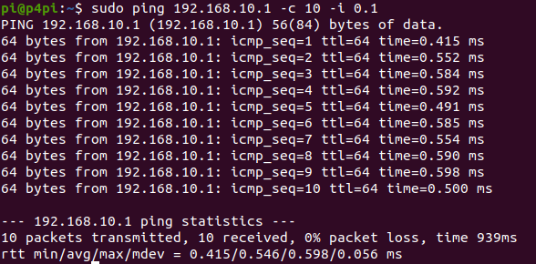
We see that it takes about half a second for each packet to be received. This is about the same time as above.

Pinging the lab machine from the Raspberry PI 100 times at 1 ms.
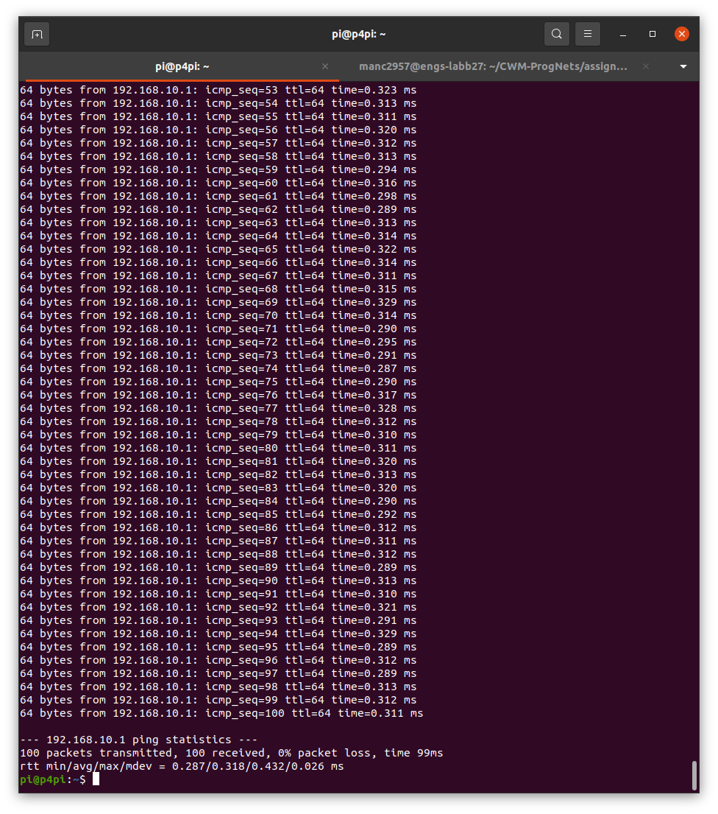
We see that it takes about 300 ms for each packet to be received. Minimum round trip time is 287 ms, maximum round trip time is 432 ms. Standard deviation is 26 ms. We see that the variance of RTT is actually quite significant, this becomes apparent when we observe a larger sample size of data packets.

Pinging the lab machine from the Raspberry PI 10000 times with flooding.
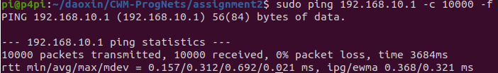
We still see the same average RTT around 300ms.

Pinging the lab machine from the Raspberry PI 2000 times at 10 ms.
rtt min/avg/max/mdev = 0.313/0.543/0.621/0.060 ms
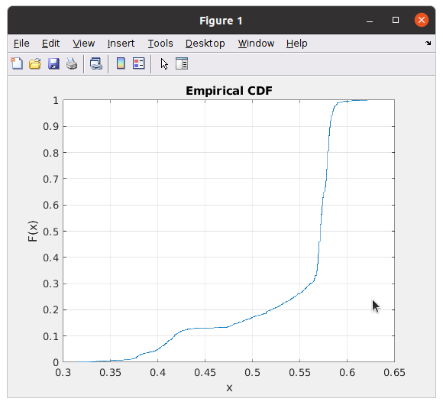

Pinging the lab machine from the Raspberry PI 2000 times at 1 ms.
rtt min/avg/max/mdev = 0.303/0.485/0.560/0.046 ms
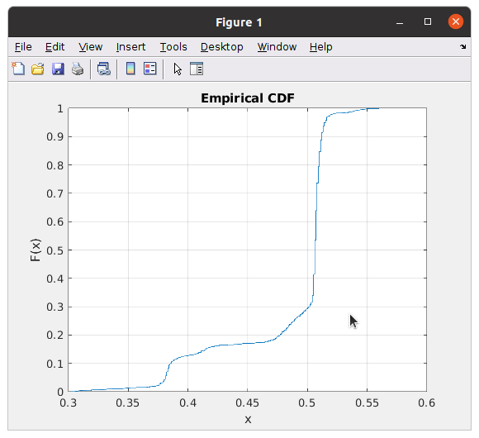

Pinging the lab machine from the Raspberry PI 2000 times at 0.1 ms.
rtt min/avg/max/mdev = 0.301/0.444/0.516/0.060 ms
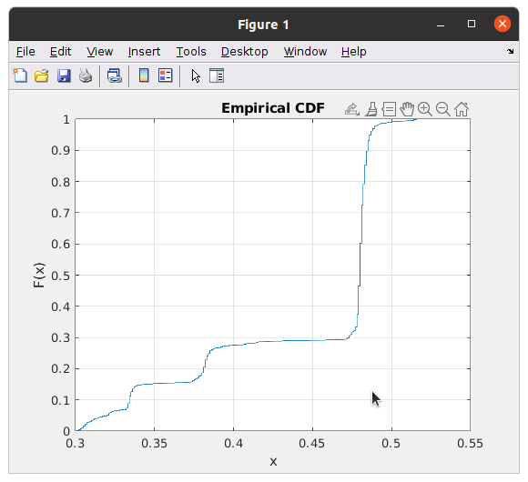

The longer RTT for the lower interval experiment can most likely be attributed some higher layer process going on beyond the transport layers. There may be some delay within the Lab computer OS that comes minimised when it is pinged at shorter interval.

Latency is the time it takes for data to travel between the sending endpoint and receiving endpoint alone. Hence, it ignores any higher level delay. Thus the experiment at 0.1ms interval gives a more accurate estimate of latency.

Setting the Lab Machine as the iperf server and the Raspberry PI as the client.
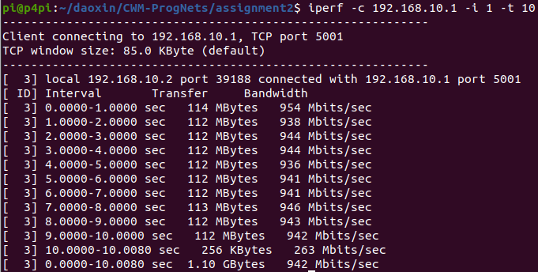
We see that the effective bandwidth of the PI to the Lab Machine is around 942 Mbits/s. Not quite sure about the strange dip to 256 Mbits/s at the 9 sec mark.

Setting the Raspberry PI as the iperf server and the as the Lab Machine client.
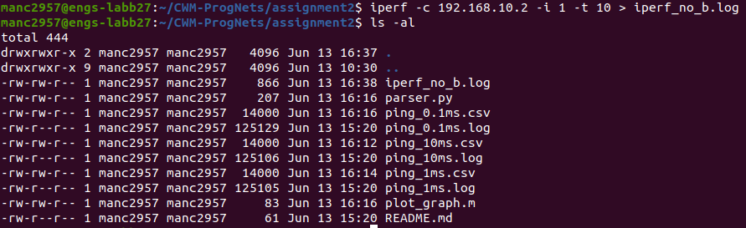
Graphing the Bandwidth.
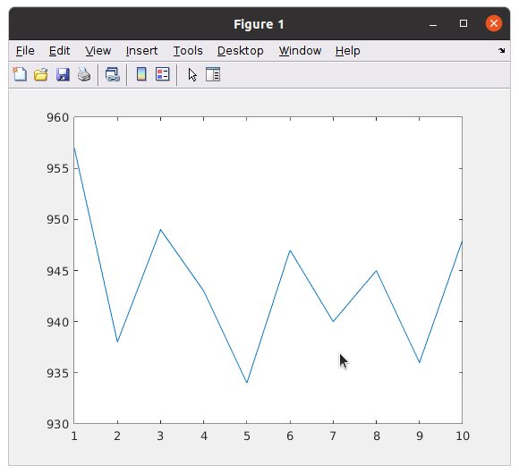

Setting the Raspberry PI as the iperf server and the as the Lab Machine client, with bi-directional iperf.
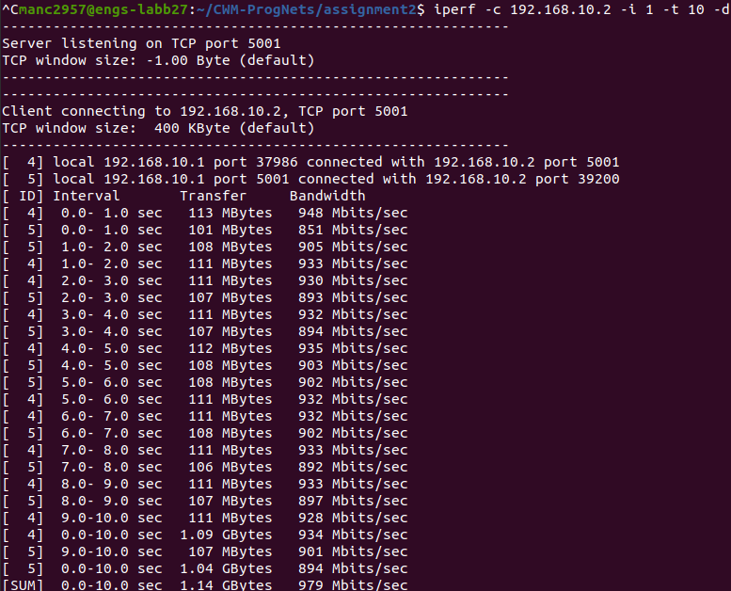
Link 4 is the forward connection (from Lab Machine to Raspberry Pi). Link 5 is the backward connection (from Raspberry Pi to the Lab Machine). Note the backward connection is now slower, at 900ms.

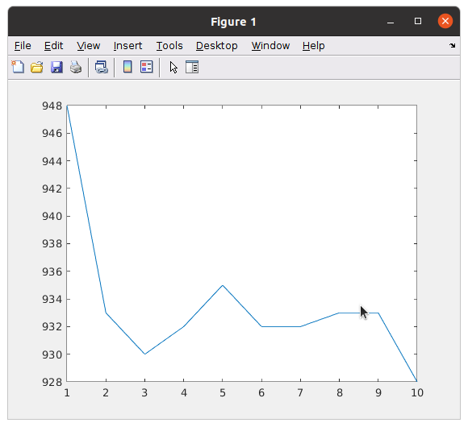
Graph of forward connection speed.

Graph of backward connection speed.
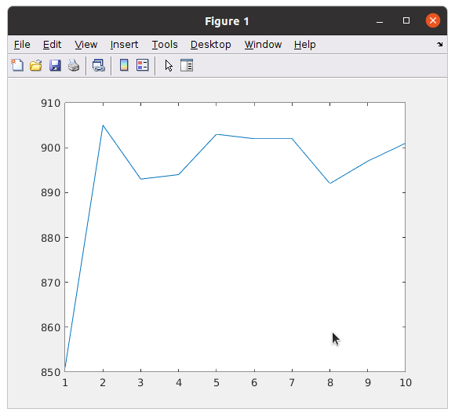

Setting the Raspberry Pi as a one way iperf UDP server and the Lab Machine as the client.

At 100kbits/s,
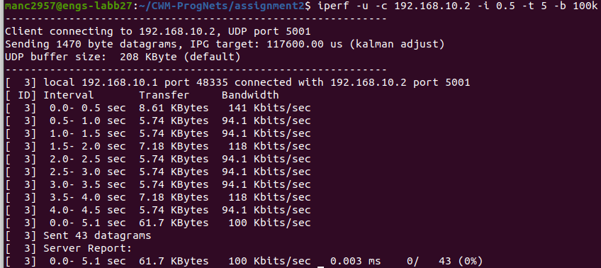
At 1 Mbits/s,
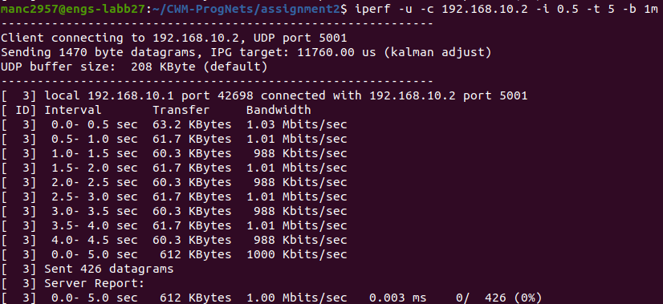
At 100 Mbits/s,
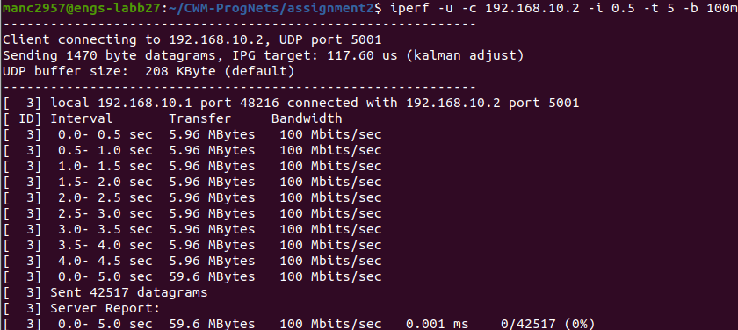
All 3 trials saw no packets dropped. However, if we were to push up the transmission bandwidth to value beyond the carrying bandwidth of the connection (at 10 Gbits/s), we can see some of the packets dropping.
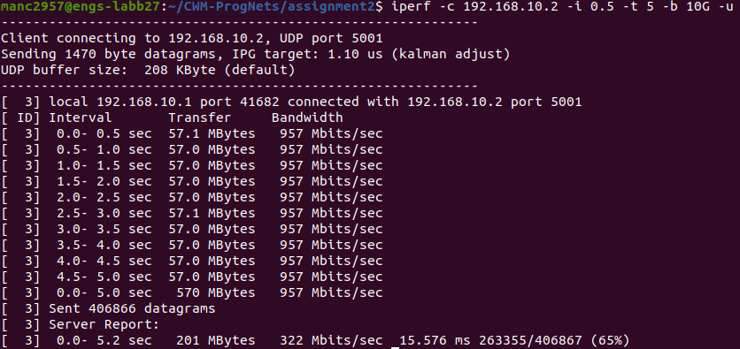
Setting up the Raspberry PI as the iperf3 server and the Lab Machine as the client.

Sending a message across via TCP.
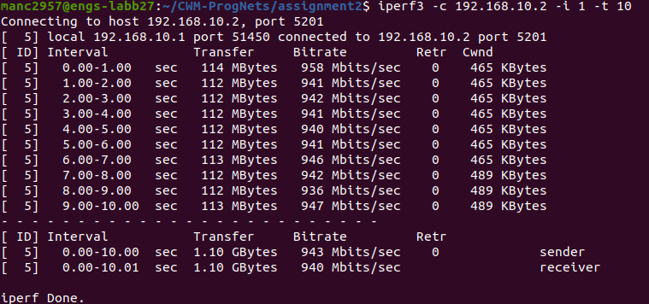
The bandwidth of the connection is around 940 Mbits/s.

Graphing the bandwidth.
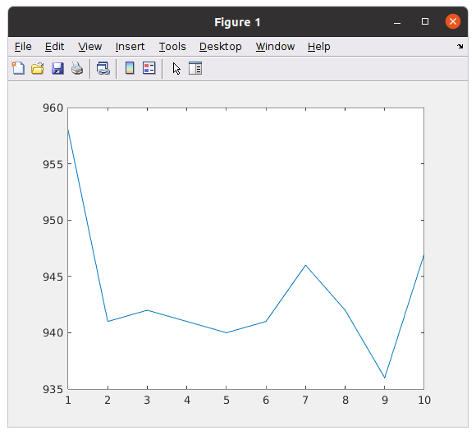

Sending a message across via UDP at 100kbits/s.
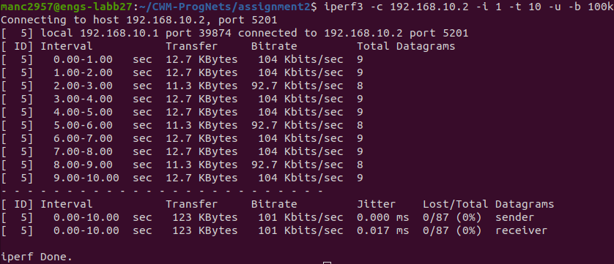
Sending a message across via UDP at 1 Mbits/s.
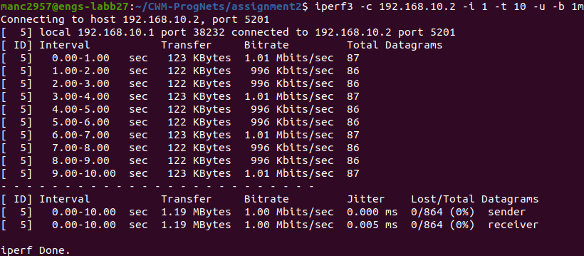
Sending a message across via UDP at 100 Mbits/s.
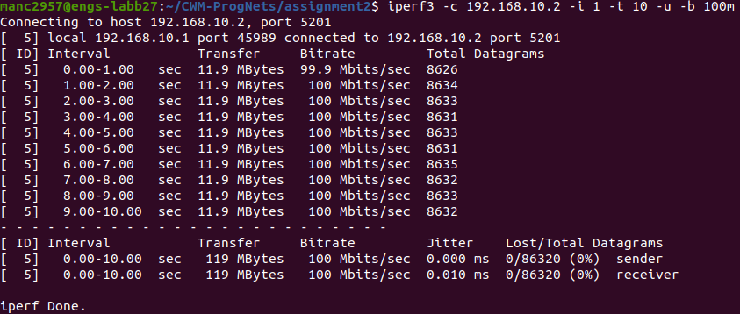
Once again because the data rate is so much smaller than no bandwidth, no packets are lost.

Interestingly if we send data over at 10 Gbits/s again.
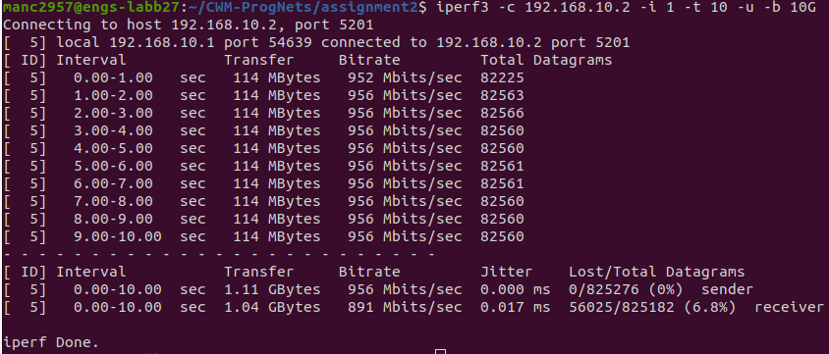
We notice that our link has a much lower lost rate than before.

