Setting up the table on the switch CLI.
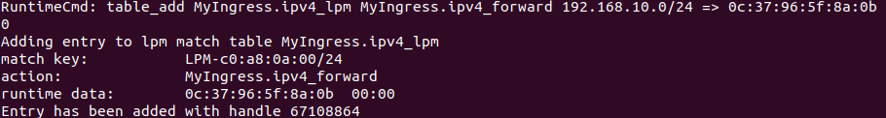
We see that there is a duplicate ping when we try to ping our host machine.
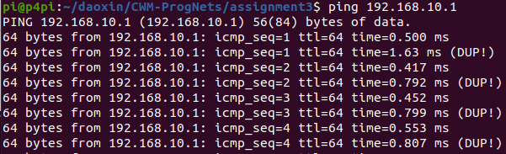
If we set up the Raspberry PI as the iperf server and ping it from the lab machine.
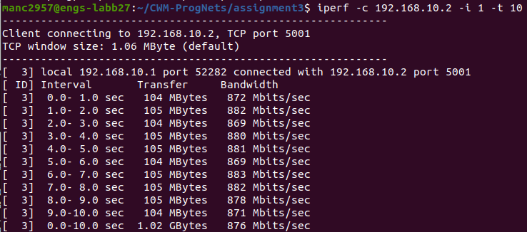
We notice that the data bandwidth is now slower than before, averaging around 890 Mbits/sec.

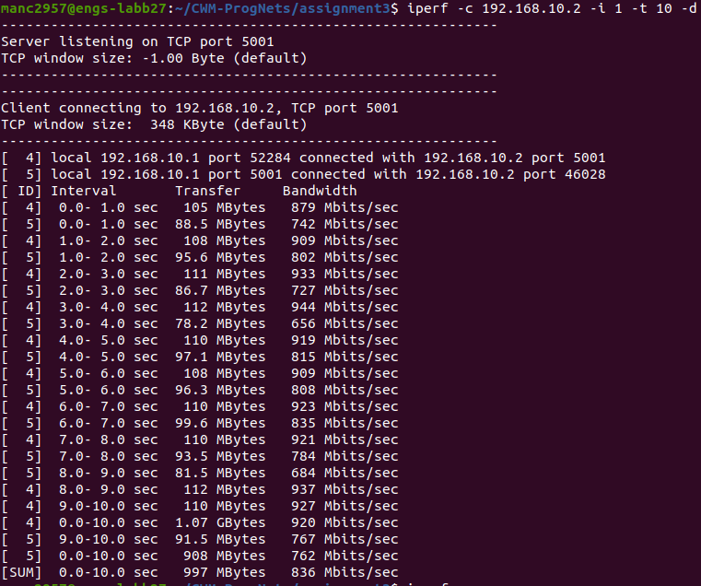
The delay becomes more apparent if we ping the machine in bi-directional mode.

If we set up the lab machine as the iperf server and ping it from the Raspberry PI.
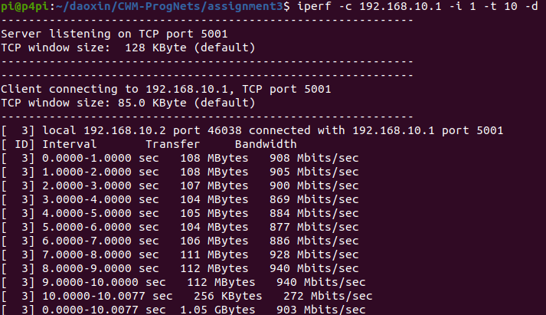
We can see that no handshaking occurs. The bitrate of the link is also not significantly affected.

