Wordle On the Switch_v1

Start-up:
1) Compile the wordle.p4 with

p4c --target bmv2 --arch v1model --std p4-16 wordle.p4

2) Load wordle.json file onto the switch

sudo simple_switch -i 0@eth0 wordle.json

3) Run wordle_sender.py

sudo python3 wordle_sender.py

4) Run wordle_receiver.py

sudo python3 wordle_receiver.py

Documentation:

wordle.p4

Right Now, this is the world’s worse game of wordle.

This is our Packet Format.
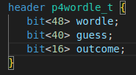

p4wordle_t.wordle : This is just the word “WORDLE”. It is used a check in the wordle_receiver.py to make sure that we are looking at the correct script.
p4wordle_t.guess: This represents our guess. wordle_sender.py rescripts the guess to a 5 character Uppercase word.
p4wordle_t.outcome: This is represents the whether our guess was correct. wordle_receiver.py will process this value. Note: We are only using 10 bits to check our word. However, we have to send our packets in groups of 8 bits, hence we are sending 16 bits for p4wordle_t.outcome here.

I have created some values in metadata.
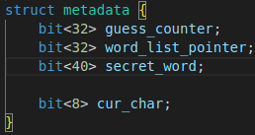

These are some recurring values that I will be using in my functions.

To remember the word list counter values between consecutive packets, we use a bunch of registers.
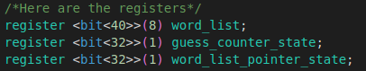

Here is the word list.
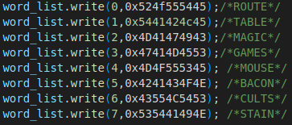

There are only 8 words at the moment, but it is relatively trivial to add more.

Whenever a valid packet is sent to the switch. We load up the correct values from the register into our metadata.
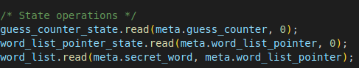

The word comparison operation is done via two nested functions. This is just to make the code look neater.
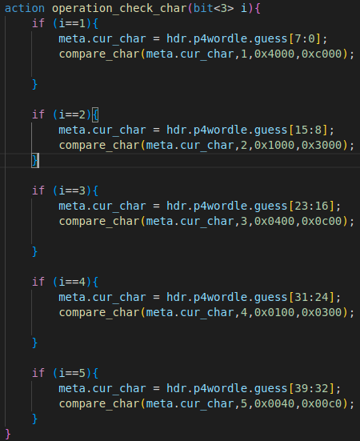

This function select the character for comparison and and defines the output binary values to be applied to p4calc_t.output.

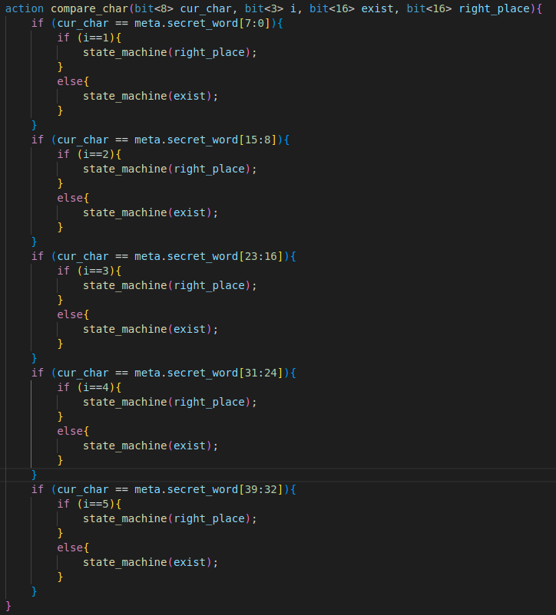
The second function decides whether the character exist and if it is in the right place.
We have two flags:
exists = 0
right_place = 0

If a char is found anywhere in the word, exists = 1
(Note: This is not strictly speaking how wordle works, but the limited computational ability of the switch makes storing information of each char count difficult)

If a char is in the correct place, right place = 1

We then load these flag into p4wordle_t.outcome
right_place | exists | right_place | exists | right_place | exists | right_place | exists | right_place | exists | Unused
1st Char of Guess |  | 2nd Char of Guess |  | 3rd Char of Guess |  | 4th Char of Guess |  | 5th Char of Guess |  | Unused

So, if you think about the possible states of the system.

If the char does not exist, we get 00
If the char exists but not at the right place, we get 01
If the char exists and is at the right place, we get 11

We have hard coded for this comparison to done on each char.
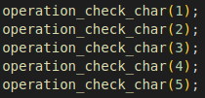

Finally we increment our guess_counter and pointer.
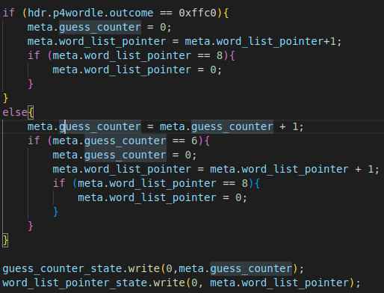

wordle_sender.py

The structure of this piece of code is very similar to calc_sender.py.
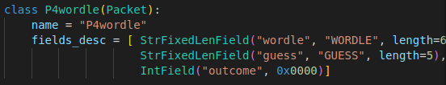

This is the format of the packet we expect to receive.
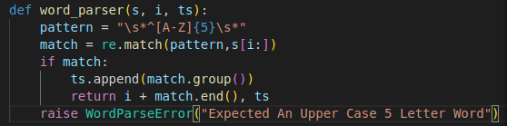

This is our custom parser that seeks to process the packet it receives.

wordle_receiver.py

The structure of this piece of code is very similar to calc_receiver.py

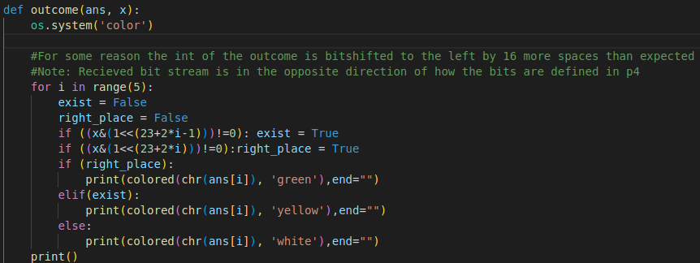
Essentially we want to print our outcome based on the classic color scheme of Wordle.

Note: Due to some weird parsing of the received packet, we see that we get a 32 bit outcome int.

We will be only dealing with the first 16 bits.

Furthermore, due to some incompatibility of how the outcome string is defined. The received outcome bitstream looks like this.

right_place | exist | right_place | exist | right_place | exist | right_place | exist | right_place | exist
5th Char of Guess |  | 4th Char of Guess |  | 3rd Char of Guess |  | 2nd Char of Guess |  | 1st Char of Guess

