**Grid in Transition: Balancing Solar Growth and Energy Security in an Emerging Economy**

## ****Author****

**Aghasi A. Tavadyan**¹

¹ Russian-Armenian (Slavonic) University, 123 Hovsep Emin St, Yerevan, 0051 Armenia

## Corresponding Author

**Aghasi A. Tavadyan  
Email:** [a.tavadyan@gmail.com](mailto:a.tavadyan@gmail.com)  **Phone: +374 93 954020  
Address: 7a Alikhanyan St., 0019, Yerevan, Armenia**

**Keywords:** Solar energy transition; Electricity grid modernization; Energy security; Developing economies; Sustainable development

**JEL Classification: Q42 - Alternative Energy Sources Q47 - Energy Forecasting O13 - Economic Development: Agriculture; Natural Resources; Energy; Environment; Other Primary Products P28 - Natural Resources; Energy; Environment**

**Abstract**

This study examines the rapid transformation of a small, landlocked nation's electricity production landscape from 2015 to 2024, with projections to 2026. Leveraging comprehensive data analysis and advanced forecasting models, we explore the country's shifting energy mix, focusing on the exponential growth of solar power and its implications for grid management and energy security. Our findings reveal a dramatic increase in solar energy's contribution, from negligible levels to over 10% of total electricity generation, challenging traditional reliance on nuclear and thermal power. This transition presents both opportunities for enhanced energy independence and challenges for grid stability and infrastructure adaptation. The study offers critical insights into the technical, economic, and policy considerations that developing nations must navigate as they balance energy security, environmental sustainability, and economic development. By examining this case study, we contribute to the broader discourse on energy transitions in emerging economies and provide valuable lessons for policymakers, energy planners, and researchers worldwide grappling with similar challenges in the global shift towards sustainable energy systems.

**1. Introduction**

The global energy landscape is undergoing a profound transformation, driven by the imperative of sustainable development and the rapid advancement of renewable technologies. This transition is particularly challenging for developing nations, which must balance energy security, environmental sustainability, and economic development. Armenia, a small landlocked country in the South Caucasus, presents a compelling case study in this evolving energy paradigm.

Armenia's unique geopolitical position and historical reliance on imported fossil fuels make its journey towards energy security and sustainability especially noteworthy. The country's efforts align with the broader theoretical framework of sustainability transitions, which examines the long-term, multi-dimensional, and fundamental transformation processes through which established socio-technical systems shift to more sustainable modes of production and consumption (Markard et al., 2012).

This study examines Armenia's electricity production landscape from 2015 to 2024, with projections extending to 2026. By leveraging comprehensive data analysis and advanced forecasting models, we explore the country's shifting energy mix, focusing particularly on the rapid growth of solar power and its implications for grid management and energy security. This research is guided by the following questions:

1. How has Armenia's electricity production mix evolved from 2015 to 2024, and what are the projected trends up to 2026?
2. What factors are driving the growth of solar energy in Armenia, and how does this growth align with or challenge existing theories of energy transition in developing economies?
3. What are the implications of Armenia's changing energy mix for grid stability, infrastructure adaptation, and overall energy security?
4. How do Armenia's experiences inform our understanding of the challenges and opportunities facing developing nations in their energy transitions?

Our analysis reveals a complex interplay of factors shaping Armenia's energy future. The country's traditional reliance on nuclear and thermal power is being challenged by the exponential growth of solar energy, which accounted for 10.1% of electricity generation as of July 2024. This shift aligns with the multi-level perspective on socio-technical transitions (Geels, 2002, 2011), which emphasizes the interplay between niche innovations (like solar power), existing regimes, and broader landscape pressures.

The study is particularly timely, as Armenia grapples with frequent power outages and infrastructure vulnerabilities while simultaneously pursuing ambitious renewable energy targets. This context provides an opportunity to examine the practical challenges of implementing theoretical transition pathways in a real-world setting.

Through a rigorous examination of production data, forecasting models, and policy implications, this research contributes to the broader discourse on energy transitions in developing economies. It offers critical insights into the technical, economic, and policy considerations that must be navigated as countries like Armenia seek to balance energy security, environmental sustainability, and economic development.

As we delve into the intricacies of Armenia's electricity production and its future trajectory, this paper aims to provide advice for policymakers, energy planners, and researchers grappling with similar challenges in other regions. The findings presented here not only illuminate Armenia's specific context but also contribute to our understanding of the global energy transition, offering a nuanced perspective on the path towards a more sustainable and resilient energy future.

**2. Literature Review**

The integration of variable renewable energy sources (VRES) into existing power systems presents both opportunities and challenges for grid operators and policymakers. As Armenia aims to increase its share of renewable energy, particularly solar power, it faces a unique set of circumstances that require careful consideration of international experiences and best practices.

Sinsel et al. (2020) provide a comprehensive overview of the challenges associated with VRES integration and potential solution technologies. They highlight that as the share of VRES increases, power systems face issues related to grid stability, reliability, and flexibility. For Armenia, which is seeking to rapidly expand its solar capacity, these challenges are particularly relevant. The authors emphasize the importance of developing a portfolio of solution technologies, ranging from improved forecasting methods to energy storage systems, to effectively manage high penetrations of VRES.

Forecasting plays a crucial role in the successful integration of VRES. Zamo et al. (2014) present a benchmark of statistical regression methods for short-term forecasting of photovoltaic (PV) electricity production. Their study, which compares various statistical methods without relying on technical information about the power plants, is particularly relevant to Armenia's context, where detailed technical data may not always be available. The authors' findings on the effectiveness of different forecasting methods could inform Armenia's approach to predicting solar power output, which is essential for grid stability and market operations.

The impact of VRES on power quality is another critical consideration. Liang (2016) discusses the emerging power quality challenges due to the integration of renewable energy sources. Issues such as voltage and frequency fluctuations, which are caused by the variability of renewable resources, are highlighted. As Armenia increases its solar capacity, addressing these power quality concerns will be essential to maintain grid stability and reliability.

Beyza et al. (2019) apply complex network theory to assess the vulnerability of interdependent energy infrastructures. Their approach, which uses statistical indexes from graph theory as an alternative to power-flow techniques, could provide valuable insights for Armenia as it plans its grid expansion and modernization. The authors' methodology for analyzing cascading failures in coupled electric power and natural gas transmission systems may be particularly relevant if Armenia considers expanding its use of natural gas in conjunction with renewable energy.

The transition to a high-VRES system also has significant policy implications. Lehmann et al. (2019) discuss the economic rationale for additional renewable energy targets and instruments in the context of EU climate and energy policy. While Armenia is not part of the EU, the authors' analysis of the costs and benefits of various policy instruments could inform Armenia's own policy decisions as it sets targets for renewable energy integration.

Gulagi et al. (2020) present a case study of Bangladesh, another developing country transitioning to renewable energy. Their analysis of different energy transition pathways, considering various policy scenarios and the impact of greenhouse gas emission costs, provides a useful framework for considering Armenia's own transition options.

Jonaitis et al. (2018) offer valuable insights from Lithuania's experience in integrating wind power into their electric power system. Their study identifies two key technical objectives: determining the power transmission capacity of the electricity network and balancing the energy generated by wind power plants related to forecasting error control. While focused on wind energy, these challenges are equally applicable to solar integration in Armenia. The authors' analysis of forecast errors, balancing demands, and control reserves could provide a useful framework for Armenia to assess its own grid capabilities and requirements as it increases its solar capacity.

Kalehsar (2019) examines Iran's transition to renewable energy, highlighting both challenges and opportunities. Although focused on Iran, this study offers relevant insights for Armenia, as both countries are rich in renewable energy sources but heavily dependent on fossil fuels. Kalehsar emphasizes the importance of appropriate policy formulations and strategies in leveraging Renewable Energy Technologies (RETs) for socio-economic development. This underscores the need for Armenia to develop comprehensive policies that not only promote renewable energy adoption but also ensure its integration contributes to broader economic and social goals.

This literature review underscores the multifaceted nature of the challenges and opportunities Armenia faces in its renewable energy transition. As we analyze Armenia's electricity production and potential for solar integration, we will draw on these insights to contextualize our findings and provide recommendations that are both technically sound and policy-relevant.

**3. Methodology**

This study employs a comprehensive approach to analyze and forecast Armenia's electricity production, utilizing both historical data analysis and advanced forecasting techniques.

Data Sources and Collection Methods

The primary data for this study was sourced from official Armenian government statistics, specifically from the Public Services Regulatory Commission of Armenia (psrc.am). The dataset encompasses monthly electricity production values from 2015 to 2024, disaggregated by energy source including thermal power plants, nuclear power, hydroelectric power, and solar energy. To ensure transparency and reproducibility, the complete dataset and analysis code have been made publicly available on GitHub.[1]

Analytical Techniques

Our analysis employs a combination of descriptive statistics and time series forecasting models. The R programming language was used for all data processing, analysis, and visualization tasks.

For forecasting future electricity production, we implemented and compared four different time series models:

1. Auto-regressive Integrated Moving Average (ARIMA): We used an automatic ARIMA model selection process, which chooses the optimal model based on the Akaike Information Criterion (AIC) or Bayesian Information Criterion (BIC) (Hyndman & Khandakar, 2008).
2. Exponential Smoothing State Space Model (ETS): This model uses exponential smoothing methods to capture trend and seasonal components in the time series (Hyndman et al., 2008).
3. Bayesian Automatic Time Series Analysis (BATS): This model can handle complex seasonal patterns and automatically select the best model using a Bayesian approach (De Livera et al., 2011).
4. Seasonal and Trend decomposition using Loess (STL) with ETS: This method first decomposes the time series into seasonal, trend, and remainder components using STL, then applies ETS forecasting to the seasonally adjusted data (Cleveland et al., 1990).

Each model was applied to the monthly historical data for each energy source, generating forecasts up to 24 months ahead. This approach allows us to capture both seasonality and trend in the data.

To assess forecast uncertainty, we generated prediction intervals at 50%, 80%, and 95% confidence levels (Tavadyan, 2022). The results from all four models were compared to provide a comprehensive view of potential future scenarios in Armenia's electricity production.

Data Aggregation and Visualization

While the forecasting was performed on monthly data to capture seasonal patterns accurately, we aggregated the results into year-over-year (YoY) values for visualization and interpretation purposes. This aggregation was done using efficient rolling window calculations. The YoY aggregation was performed after the forecasting process, ensuring that the seasonal information was fully utilized in the predictions.

This multi-model approach, combined with the YoY aggregation for visualization, allows us to capture different aspects of the time series data and provides a robust basis for analyzing trends and making projections about Armenia's future energy landscape. It balances the need for detailed forecasting with the requirement for easily interpretable results, crucial for informing policy decisions in the energy sector.

**4. Current State of Armenia's Electricity Production**

Armenia's electricity production landscape has undergone significant changes in recent years, characterized by a diversification of energy sources and a gradual shift towards renewable energy. This section analyzes the current state of electricity production by source and examines recent trends and challenges facing the sector.

Analysis of Production by Source

As of July 2024, Armenia's electricity production is derived from four primary sources: thermal power plants (TPPs), nuclear power, hydroelectric power plants (HPPs), and solar energy. The distribution of these sources has evolved over the past decade, reflecting both policy decisions and technological advancements (Figure 1).

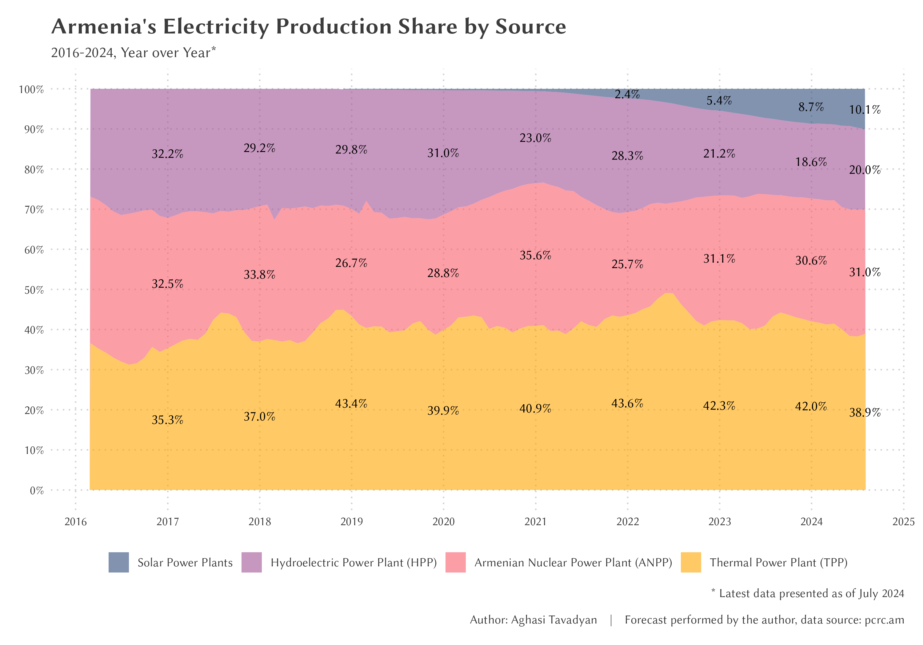*Figure 1: Armenia's Electricity Production Share by Source, 2016-2024*

1. Thermal Power Plants (TPPs): TPPs continue to play a significant role in Armenia's electricity mix, accounting for 38.9% of total year-over-year (YoY) production in July 2024. This represents a slight decrease from previous years, likely due to the increasing share of renewable sources. TPPs primarily utilize natural gas imported from Russia, rendering this sector vulnerable to external price fluctuations and geopolitical tensions.
2. Nuclear Power: The Armenian Nuclear Power Plant (ANPP) remains a crucial baseload power source, contributing 31% of the country's YoY electricity in July 2024. This share has remained relatively stable over the years, underscoring the plant's importance in ensuring energy security. However, the aging infrastructure of the ANPP raises potential reliability and safety concerns.
3. Hydroelectric Power Plants (HPPs): HPPs have historically been a significant source of renewable energy for Armenia. However, their share has experienced a gradual decline, dropping from 32.2% in 2016 to 20% in July 2024. This decrease may be attributed to changing precipitation patterns and the increasing role of other renewable sources.
4. Solar Energy: The most notable trend in Armenia's electricity production is the rapid growth of solar energy. From a negligible share in 2016, solar power has grown to contribute 10.1% of the country's YoY electricity by July 2024. This exponential growth reflects both government initiatives to promote renewable energy and decreasing costs of solar technology.

Recent Trends and Challenges

1. Shift Towards Renewables: The most significant trend in Armenia's electricity sector is the rapid adoption of solar energy. This shift aligns with global trends towards cleaner energy sources and offers potential for increased energy independence.
2. Declining Hydroelectric Production: The decrease in hydroelectric power production is a concerning trend, potentially linked to climate change impacts on water resources. This decline underscores the need for diversification in renewable energy sources.
3. Infrastructure Vulnerabilities: Recent years have witnessed frequent power outages, particularly in urban areas such as Yerevan. These outages highlight the vulnerabilities in the existing power distribution infrastructure. Data from 2024 indicates that a significant portion of cable damages (69%) were caused by the electric company itself during maintenance or upgrade work, pointing to potential issues in infrastructure management and maintenance practices.
4. Regional Disparities: Analysis of power outages across different regions of Armenia reveals disparities in infrastructure reliability. Some areas experience a higher frequency of outages, suggesting uneven distribution of resources for maintenance and upgrades.
5. Aging Nuclear Infrastructure: While the ANPP continues to provide a stable baseload, its aging infrastructure presents ongoing challenges. Periodic shutdowns for maintenance and safety upgrades impact the overall stability of the electricity supply.
6. Dependence on Imported Fuel: The significant role of TPPs in electricity production means that Armenia remains dependent on imported natural gas, primarily from Russia. This dependence exposes the country to potential supply disruptions and price volatility.

These trends and challenges highlight the complex landscape of Armenia's electricity sector. While the growth in renewable energy, particularly solar, presents opportunities for increased energy independence and sustainability, issues such as infrastructure vulnerabilities and the decline in hydroelectric production pose significant challenges. Addressing these challenges will be crucial for ensuring a stable, efficient, and sustainable electricity supply for Armenia in the coming years.

**5. Digital Forecasting of Electricity Production**

The application of digital forecasting techniques to Armenia's electricity production provides valuable insights into future trends and potential challenges. This section presents the forecasting models employed and discusses their results, reliability, and implications for Armenia's energy sector.

Presentation of Forecasting Models and Results

To project future electricity production trends in Armenia, we employed multiple advanced time series forecasting models. These include Auto-Regressive Integrated Moving Average (ARIMA), Bayesian Structural Time Series (BATS), and Exponential Smoothing State Space (ETS) models. Each model was applied to historical data from 2015 to 2024 for the four primary sources of electricity production: thermal power plants (TPPs), nuclear power, hydroelectric power plants (HPPs), and solar energy.

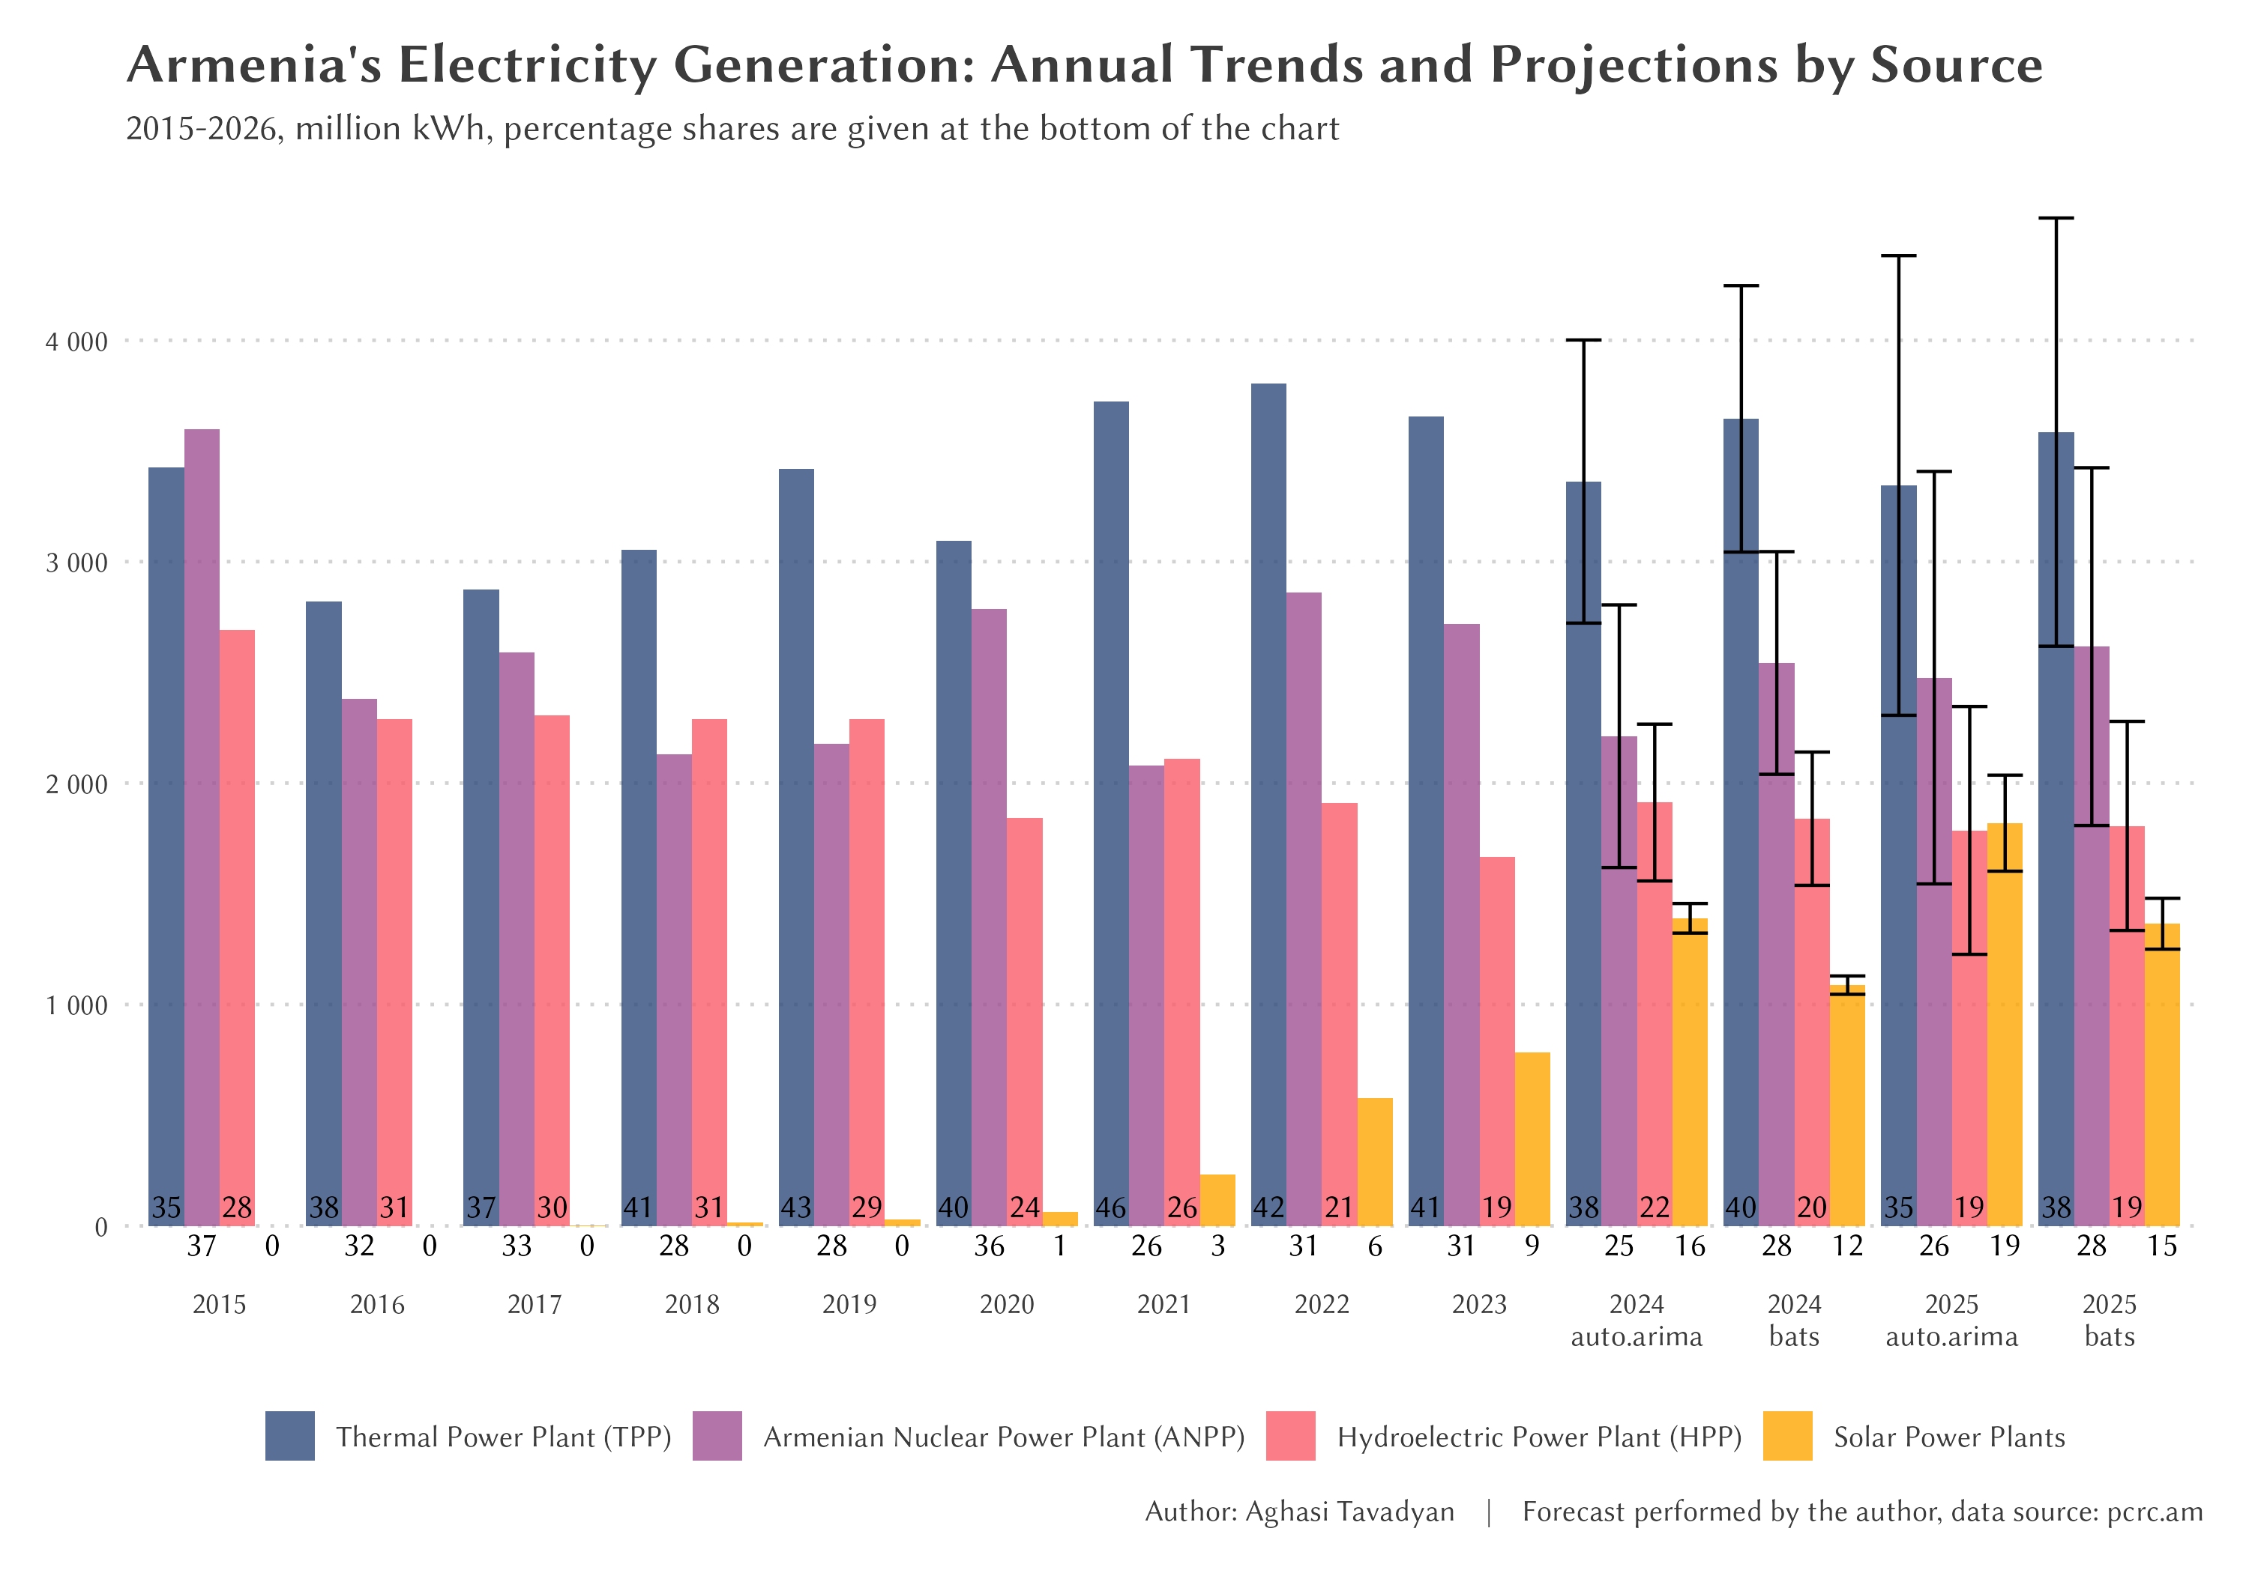*Figure 2: Armenia's Electricity Generation: Annual Trends and Projections by Source, 2015-2026*

Figure 2 illustrates the forecasted electricity production for each energy source up to 2026. The forecasts reveal several significant trends:

1. Thermal Power Plants (TPPs): The models predict a slight decline in TPP production, from 38.9% in July 2024 to approximately 38% by 2026. This trend suggests a gradual reduction in reliance on fossil fuels, albeit at a slower pace than might be desired for rapid decarbonization.
2. Nuclear Power: Production from the Armenian Nuclear Power Plant (ANPP) is forecasted to remain relatively stable, maintaining its share at around 31% through 2026. This stability underscores the continued importance of nuclear energy in Armenia's electricity mix.
3. Hydroelectric Power Plants (HPPs): The models project a continued gradual decline in hydroelectric production, potentially dropping to around 19% by 2026. This forecast aligns with the observed historical trend and raises concerns about the long-term viability of hydropower in Armenia's changing climate.
4. Solar Energy: The most dramatic growth is predicted in solar energy production. The forecasts suggest that solar could contribute up to 15-16% of Armenia's electricity production by 2026, continuing its rapid upward trajectory.

Discussion of the Reliability and Implications of Forecasts

Reliability of Forecasts: The forecasting models employed in this study have demonstrated robust performance in capturing historical trends and seasonality. However, it is crucial to acknowledge inherent uncertainties in long-term forecasts, particularly in a rapidly evolving sector such as energy.

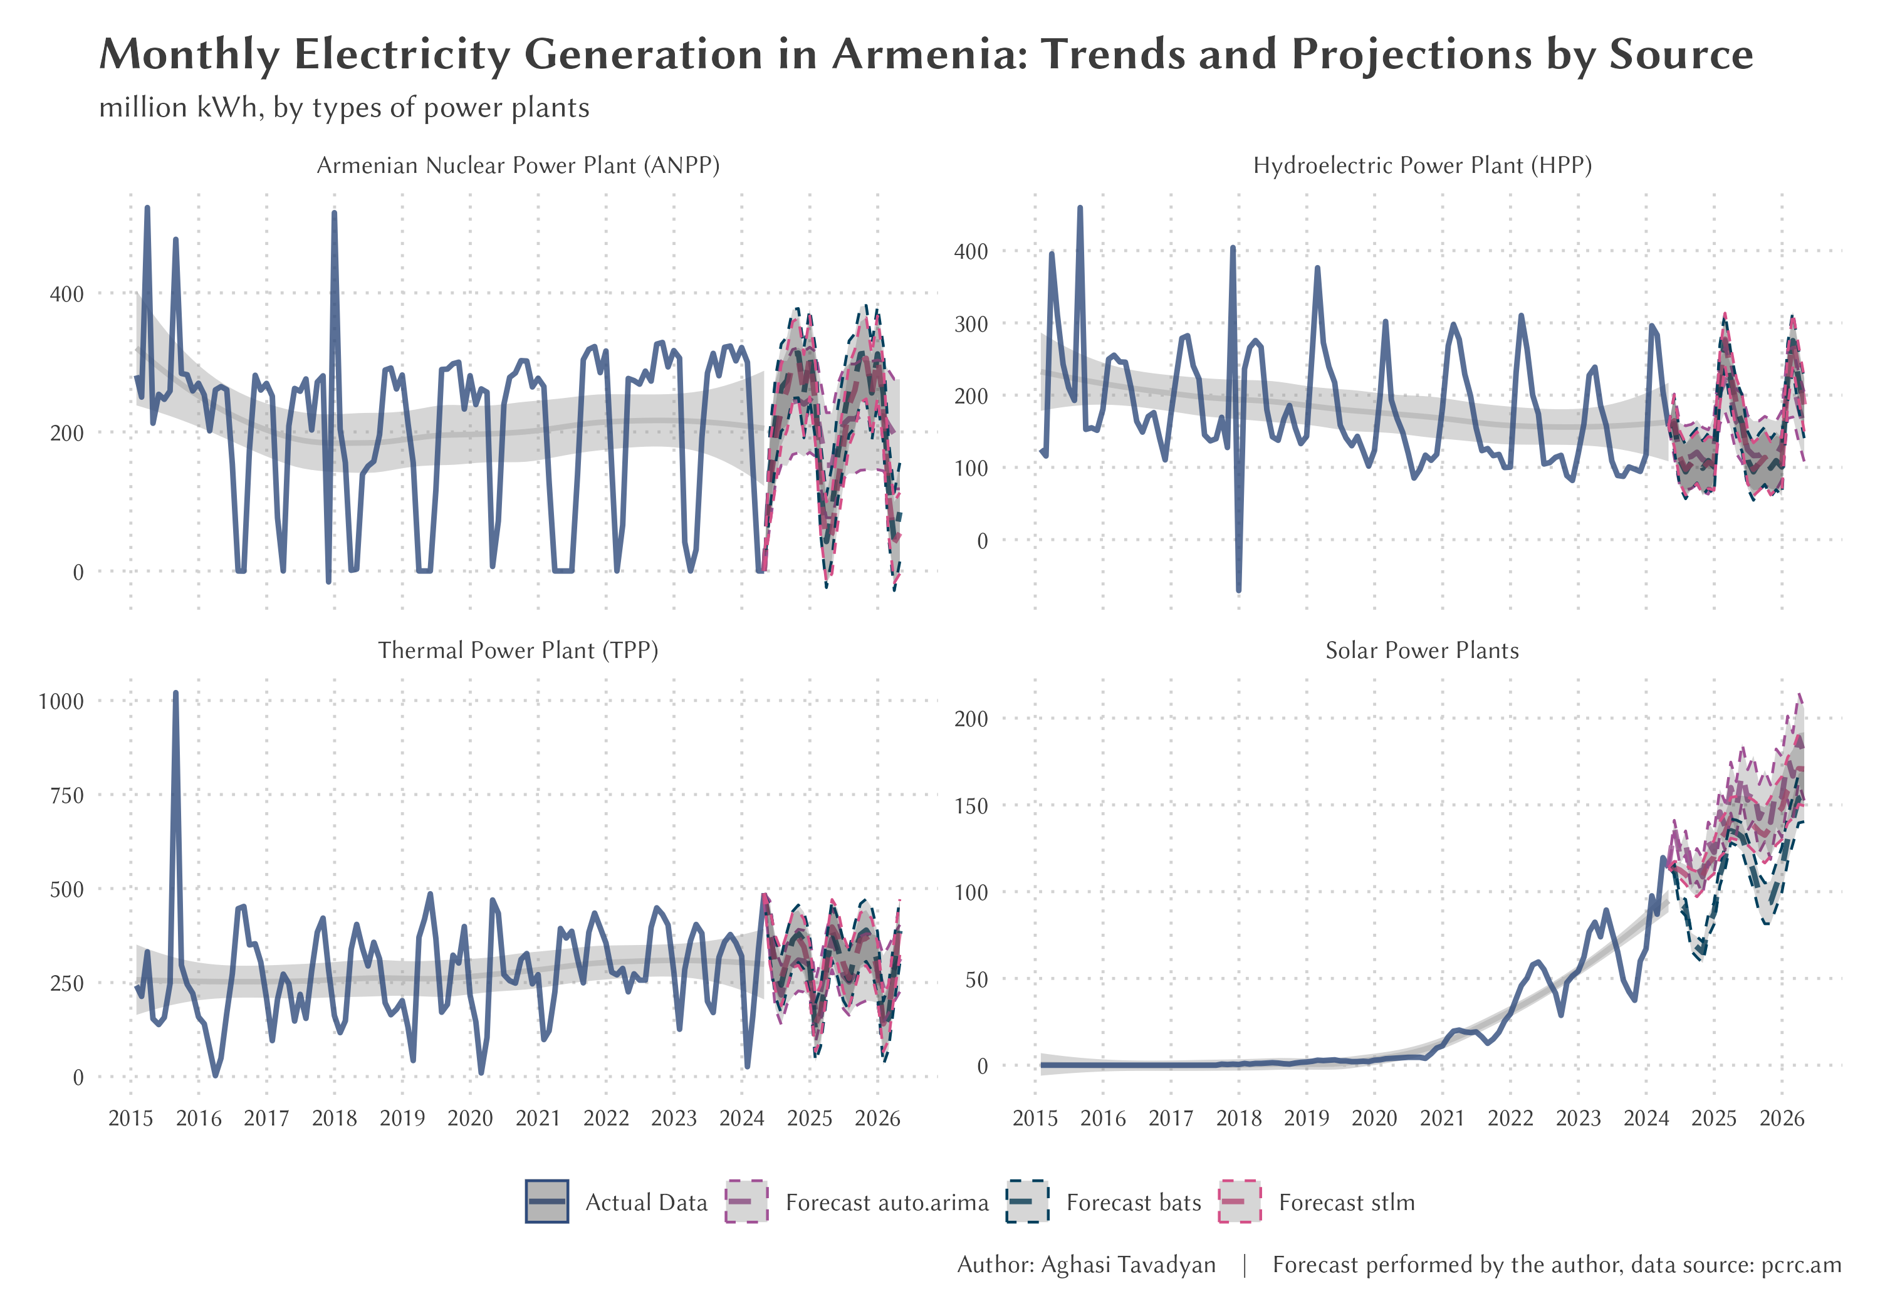*Figure 3: Monthly Electricity Generation in Armenia: Trends and Projections by Source*

Figure 3 presents a comparison of the reliability measures for each forecasting model across different energy sources. The shaded areas represent prediction intervals, providing a visual representation of forecast uncertainty. Notably, the forecasts for solar energy production show wider prediction intervals, reflecting the higher uncertainty associated with this rapidly growing sector.

Implications of Forecasts:

1. Transition to Renewables: The projected growth in solar energy production aligns with Armenia's goals for increasing renewable energy adoption. However, the pace of this transition may need to accelerate to meet ambitious climate targets.
2. Grid Stability Challenges: The forecasted increase in intermittent solar power, coupled with the decline in baseload hydroelectric power, suggests potential challenges for grid stability. This underscores the need for investment in energy storage and smart grid technologies.
3. Energy Security: The continued reliance on TPPs, albeit slightly decreasing, implies ongoing dependence on imported natural gas. This forecast highlights the importance of diversifying energy sources to enhance energy security.
4. Infrastructure Investment: The stable forecast for nuclear power production emphasizes the need for continued investment in maintaining and potentially upgrading the aging ANPP infrastructure.
5. Climate Adaptation: The projected decline in hydroelectric power production underscores the need for climate adaptation strategies in the energy sector, including diversification of renewable energy sources.
6. Policy Implications: These forecasts provide valuable input for policymakers, suggesting a need for policies that support the growth of solar energy while addressing the challenges of declining hydropower and the environmental impact of thermal power plants.

In conclusion, while these digital forecasts provide crucial insights into potential future scenarios for Armenia's electricity production, they should be interpreted with caution. Regular updates and refinements to these models, incorporating new data and evolving trends, will be essential for maintaining their relevance and reliability in guiding energy policy and investment decisions.

**6. Challenges and Solutions in Armenia's Energy Transition**

Armenia's energy sector is undergoing a significant transformation, characterized by a rapid increase in renewable energy production, particularly solar power, and the concurrent need for grid modernization. This section examines the challenges faced in this transition and explores potential solutions, with a focus on digital technologies and infrastructure improvements.

Renewable Energy Growth and Integration Challenges

As illustrated in Figure 2, solar power's contribution to Armenia's national grid has grown exponentially, reaching 10.1% of total year-over-year production by July 2024. This growth, while promising for sustainability and energy independence, presents significant challenges:

1. Production-Consumption Mismatch: Solar energy production peaks at midday, while electricity consumption typically peaks in the evening, creating a temporal disparity.
2. Grid Capacity Limitations: The current power grid struggles to handle surplus electricity generated during peak solar production hours.
3. Regulatory Constraints: Existing regulations, such as the 150 kW limit on solar installations and reduced tariffs for excess electricity, may impede sector development.

Infrastructure Vulnerabilities and Grid Management Issues

Recent data from 2024 highlights critical vulnerabilities in Armenia's power distribution infrastructure, particularly in Yerevan:

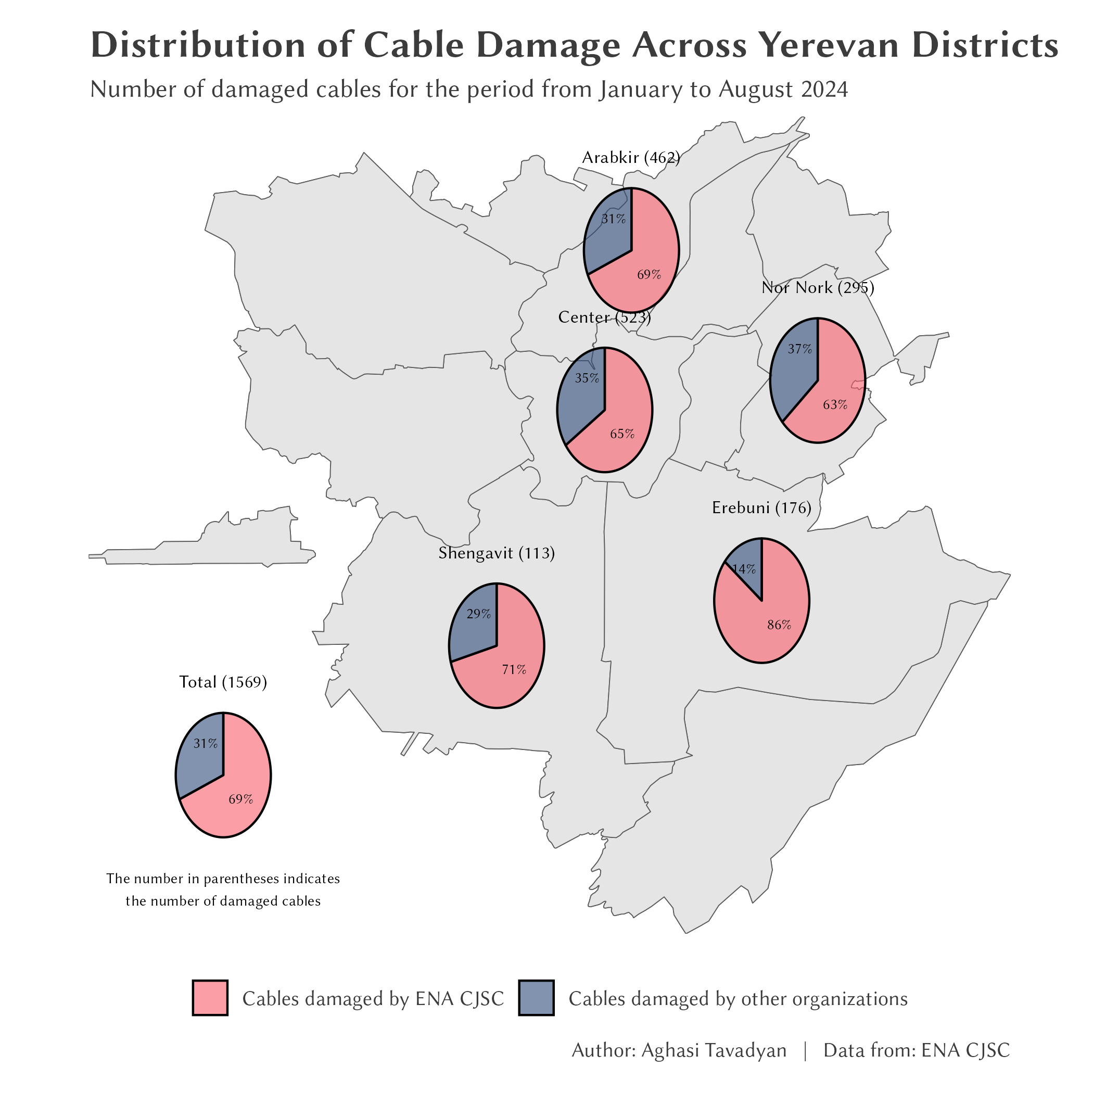*Figure 4: Distribution of Cable Damage Across Yerevan Districts*

Figure 4 illustrates the distribution of electrical network damage across Yerevan's districts in 2024. Key findings include:

1. From January to October 2024, 1,569 cases of cable damage were recorded in Yerevan.
2. Surprisingly, 69% of these damages were caused by the electric company itself during maintenance or upgrade work.
3. Some districts, notably Kentron and Arabkir, experienced higher rates of damage.

These issues underscore the urgent need for infrastructure upgrades and improved maintenance practices.

Integrated Solutions: Digital Tools and Infrastructure Improvements

Addressing these challenges requires a comprehensive approach combining digital technologies and infrastructure enhancements:

1. Advanced Forecasting and Grid Management Systems: Implementing machine learning algorithms for accurate solar output prediction and smart grid technologies for real-time monitoring and control.
2. Energy Storage Solutions: Developing capabilities such as pumped hydroelectric storage or battery systems to balance production-consumption mismatches.
3. Distribution Automation and Predictive Maintenance: Employing AI-powered analytics for proactive maintenance and automated systems for fault isolation and power rerouting.
4. Virtual Power Plants (VPPs) and Demand Response Programs: Digitally aggregating distributed resources and implementing programs to match consumption with production patterns.
5. Inter-state Grid Connections: Exploring connections to broader regional power grids to manage excess production and improve stability.
6. Regulatory Reform: Revising policies to encourage larger-scale solar installations and fair compensation for excess energy production.

The adoption of these integrated solutions is crucial for managing the increasing share of renewable energy while addressing infrastructure vulnerabilities. As Armenia continues its energy transition, the synergy between renewable integration and grid modernization will be key to ensuring a stable, efficient, and sustainable electricity supply.

This holistic approach to energy transition highlights the interconnected nature of renewable energy adoption and grid management challenges. It emphasizes the need for coordinated efforts in technological innovation, infrastructure investment, and policy reform to achieve Armenia's energy goals.

**7. Discussion and Strategic Recommendations**

Our analysis of Armenia's electricity production landscape from 2015 to 2024, with projections to 2026, reveals significant shifts in the country's energy mix and highlights several challenges and opportunities in its energy transition. This section discusses our findings in relation to our research questions and existing literature, and proposes strategic recommendations.

1. Evolution of Armenia's Electricity Production Mix Our findings show a dramatic increase in solar energy's contribution, from negligible levels to 10.1% by July 2024, with projections reaching 15-16% by 2026. This rapid growth aligns with global trends in renewable energy adoption (Scientific Research Institute of Energy, 2024) but exceeds the pace observed in many developing countries. The decline in hydroelectric production, however, presents a challenge to Armenia's renewable energy goals.
2. Drivers of Solar Energy Growth The exponential growth of solar energy in Armenia can be attributed to falling technology costs, supportive policies, and increasing energy security concerns. This aligns with the multi-level perspective on socio-technical transitions (Geels, 2011), where niche innovations (solar power) are challenging the existing regime (traditional power sources).
3. Implications for Grid Stability and Energy Security The increasing share of intermittent renewable sources poses challenges for grid stability, as seen in other countries with high renewable penetration (Kroposki et al., 2017). Armenia's experience underscores the need for grid modernization and energy storage solutions to manage these challenges effectively.
4. Lessons for Developing Nations in Energy Transition Armenia's case offers useful insights for other developing nations, particularly in balancing rapid renewable growth with grid stability and energy security. The country's experience highlights the importance of comprehensive planning and investment in infrastructure to support the energy transition.

Based on these findings, we propose the following strategic recommendations:

1. Accelerate Solar Energy Integration: Increase investment in solar infrastructure and revise regulations to encourage larger-scale installations.
2. Modernize Grid Infrastructure: Implement smart grid technologies and invest in energy storage solutions to manage intermittent renewable sources.
3. Diversify Renewable Energy Sources: Explore wind and geothermal energy to complement solar and address the decline in hydroelectric production.
4. Enhance Infrastructure Reliability: Implement a comprehensive upgrade program, prioritizing vulnerable areas and improving coordination with urban development initiatives.
5. Strengthen Energy Security: Develop a plan for reducing thermal power plant reliance and explore regional energy cooperation opportunities.
6. Prepare for Increased Electrification: Develop long-term plans to scale up production and distribution capacity, anticipating growth in demand from electric vehicles and heating.
7. Enhance Data-Driven Decision Making: Invest in advanced forecasting systems and develop a centralized energy information system.
8. Address Climate Change Impacts: Develop adaptation strategies for the energy sector, particularly for optimizing hydroelectric production.

These recommendations aim to build on progress of developing counties while addressing identified challenges. By implementing these strategies, Armenia can enhance its energy security, improve grid reliability, and move towards a more sustainable energy future, providing a model for other developing nations in their energy transitions.

**8. Conclusion**

This study has examined Armenia's electricity production landscape from 2015 to 2024, with projections extending to 2026, providing critical insights into the country's energy transition. Our analysis reveals several key findings:

1. Armenia has experienced a rapid growth in solar energy production, reaching 10.1% of total electricity generation by July 2024, with projections suggesting further growth to 15-16% by 2026.
2. This growth in solar energy is challenging the traditional reliance on nuclear and thermal power, presenting both opportunities and challenges for the country's energy security and grid stability.
3. The decline in hydroelectric production poses a challenge to Armenia's renewable energy goals and highlights the need for diversification of renewable sources.
4. Armenia's energy infrastructure faces significant vulnerabilities, as evidenced by frequent power outages, particularly in urban areas.

These findings directly address our research questions, demonstrating the evolution of Armenia's electricity production mix, identifying the factors driving solar energy growth, and highlighting the implications for grid stability and energy security. Moreover, Armenia's experience offers valuable lessons for other developing nations navigating the complexities of energy transition.

The significance of this study lies in its comprehensive analysis of a developing nation's rapid transition towards renewable energy, particularly solar power. It provides a nuanced understanding of the technical, economic, and policy challenges involved in such a transition, offering insights that can inform policy-making and energy planning in similar contexts.

However, this study has limitations. The projections are based on current trends and policies, and unforeseen technological advancements or policy changes could alter the trajectory. Additionally, the focus on electricity production does not fully capture the broader energy consumption landscape.

Future research could explore the social and economic impacts of Armenia's energy transition, examine the potential for other renewable sources such as wind and geothermal energy, and investigate the long-term implications of increased electrification in transportation and heating sectors.

In conclusion, Armenia's journey towards a more sustainable energy future, while challenging, offers a compelling case study in energy transition for developing nations. By addressing the identified challenges and leveraging its progress in solar energy adoption, Armenia has the potential to significantly enhance its energy security and contribute to global efforts in combating climate change.

**References:**

* Beyza, J., Garcia-Paricio, E., & Yusta, J. M. (2019). Applying complex network theory to the vulnerability assessment of interdependent energy infrastructures. Energies, 12(3), 421.
* Cleveland, R. B., Cleveland, W. S., McRae, J. E., & Terpenning, I. (1990). STL: A seasonal-trend decomposition. J. Off. Stat, 6(1), 3-73.
* De Livera, A. M., Hyndman, R. J., & Snyder, R. D. (2011). Forecasting time series with complex seasonal patterns using exponential smoothing. Journal of the American Statistical Association, 106(496), 1513-1527.
* Geels, F. W. (2002). Technological transitions as evolutionary reconfiguration processes: a multi-level perspective and a case-study. Research policy, 31(8-9), 1257-1274.
* Geels, F. W. (2011). The multi-level perspective on sustainability transitions: Responses to seven criticisms. Environmental innovation and societal transitions, 1(1), 24-40.
* Gulagi, A., Ram, M., Solomon, A. A., Khan, M., & Breyer, C. (2020). Current energy policies and possible transition scenarios adopting renewable energy: A case study for Bangladesh. Renewable Energy, 155, 899-920.
* Hyndman, R. J., & Khandakar, Y. (2008). Automatic time series forecasting: the forecast package for R. Journal of Statistical Software, 27, 1-22.
* Hyndman, R., Koehler, A. B., Ord, J. K., & Snyder, R. D. (2008). Forecasting with exponential smoothing: the state space approach. Springer Science & Business Media.
* Jonaitis, A., Gudzius, S., Morkvenas, A., Azubalis, M., Konstantinaviciute, I., Baranauskas, A., & Ticka, V. (2018). Challenges of integrating wind power plants into the electric power system: Lithuanian case. Renewable and Sustainable Energy Reviews, 94, 468-475.
* Kalehsar, O. S. (2019). Iran's Transition to Renewable Energy: Challenges and Opportunities. Middle East Policy, 26(2).
* Kroposki, B., Johnson, B., Zhang, Y., Gevorgian, V., Denholm, P., Hodge, B. M., & Hannegan, B. (2017). Achieving a 100% renewable grid: Operating electric power systems with extremely high levels of variable renewable energy. *IEEE Power and energy magazine*, *15*(2), 61-73.
* Lehmann, P., Gawel, E., & Strunz, S. (2019). EU climate and energy policy beyond 2020: Are additional targets and instruments for renewables economically reasonable?. The European Dimension of Germany’s Energy Transition: Opportunities and Conflicts, 11-26.
* Liang, X. (2016). Emerging power quality challenges due to integration of renewable energy sources. IEEE Transactions on Industry Applications, 53(2), 855-866.
* Markard, J., Raven, R., & Truffer, B. (2012). Sustainability transitions: An emerging field of research and its prospects. Research policy, 41(6), 955-967.
* Scientific Research Institute of Energy. (2024). Energy Balance of the Republic of Armenia for 2022. Yerevan.
* Sinsel, S. R., Riemke, R. L., & Hoffmann, V. H. (2020). Challenges and solution technologies for the integration of variable renewable energy sources—a review. renewable energy, 145, 2271-2285.
* Tavadyan, A. (2022). Uncertainty Bands: A Guide to Predicting and Regulating Economic Processes. Anthem Press.
* Zamo, M., Mestre, O., Arbogast, P., & Pannekoucke, O. (2014). A benchmark of statistical regression methods for short-term forecasting of photovoltaic electricity production, part I: Deterministic forecast of hourly production. Solar Energy, 105, 792-803.

1. Code and data are available at: <https://github.com/tavad/articles/tree/master/2024_09_armenia_power>