**Redirection of Russian Oil Exports: Analyzing the Impact of Western Sanctions**

**Authors**

Ashot A. Tavadyan; Aghasi A. Tavadyan¹

¹ Russian-Armenian (Slavonic) University, 123 Hovsep Emin St, Yerevan, 0051 Armenia  
  
**Authors info**  
**D.Sc., Professor Ashot A. Tavadyan  
Ph.D in Economics, Associate Professor Aghasi A. Tavadyan**  
  
**Corresponding Author**

**Aghasi A. Tavadyan  
Email:** [a.tavadyan@gmail.com](mailto:a.tavadyan@gmail.com)  **Phone: +374 93 954020**

**Keywords:** Economic sanctions; Russian oil exports; Mirror statistics; Trade redirection; Energy geopolitics

**JEL Classification: F14 - Empirical Studies of Trade; F51 - International Conflicts; Negotiations; Sanctions; Q37 - Issues in International Trade; Q43 - Energy and the Macroeconomy; C82 - Methodology for Collecting, Estimating, and Organizing Macroeconomic Data; Data Access**

**Abstract**

This study illuminates how Western sanctions against Russia in 2022 catalyzed a dramatic restructuring of global oil trade patterns. Through innovative application of mirror statistics, we investigate the causes and consequences of this radical shift in Russian oil export dynamics, revealing transformative impacts on world economic trajectories. By 2023, our estimates indicate that 38.6% of Russian oil exports were redirected through India, accompanied by significant price anomalies. This sanctions-induced trade shift led to a sharp increase of oil imports by India, playing a crucial role in mitigating the impact on Russian oil exports while potentially boosting India's GDP. We provide causal evidence of how this phenomenon led to substantial GDP growth revisions in both Russia and oil-importing countries. Our findings extend beyond oil trade, offering vital insights into the broader economic consequences of sanctions and the resilience of export-dependent growth. This research not only expands our understanding of contemporary sanctions evasion techniques but also provides critical guidance for policymakers grappling with the complex interplay of geopolitical pressures and global trade patterns.

**1. Introduction**

The global oil market has undergone significant transformations in recent years, with geopolitical tensions and international sanctions reshaping long-established trade patterns. At the epicenter of this shift is Russia, a key player in the world oil market, consistently ranking among the top global producers and exporters of crude oil. The events of 2022, particularly Western sanctions, have catalyzed a dramatic reconfiguration of Russian oil export routes, sending ripples through the global energy landscape and economic systems.

Prior to 2022, Russian oil exports followed well-established patterns, with a substantial portion flowing to European and Asian markets. In 2021, Russia exported a total of 231.6 million tons of crude oil, with China being the largest importer at 30.7% (71.02 million tons), followed by the Netherlands at 16.1% (37.36 million tons) and Germany at 8.3% (19.17 million tons). This stable trade relationship formed a cornerstone of both Russian economic strategy and the energy security of importing nations.

However, the imposition of wide-ranging sanctions by Western nations in response to the Ukraine conflict precipitated a seismic shift in this status quo. The sanctions, designed to exert economic pressure on Russia, included restrictions on oil imports, financial transactions, and technology transfers. These measures, coupled with corporate withdrawals from Russian markets, effectively closed off much of the Western market to Russian oil exports.

In response to these challenges, Russia has pivoted eastward, dramatically increasing its oil exports to Asian markets, particularly India. This shift is starkly illustrated by the change in Russian oil exports to India: from a mere 1.92 million tons (0.8% of Russian exports) in 2021, it surged to 37.0 million tons (15.2% of India's imports) in 2022, and further to 88.9 million tons (38.6% of India's imports) in 2023. This remarkable increase has not only altered global oil trade routes but has also raised questions about the effectiveness of sanctions, the resilience of the Russian economy, and the changing dynamics of global energy geopolitics.

This study aims to provide a comprehensive analysis of these changes in Russian oil exports, focusing on the period from 2022 to early 2024. A significant challenge in this analysis is that following the commencement of its military operation in Ukraine in February 2022, Russia ceased publishing official trade statistics. To overcome this data limitation, we employ mirror statistics, using import data from Russia's trading partners to estimate Russian oil exports.

Our research objectives are:

1. To quantify and analyze the changes in volume and structure of Russian oil exports following the imposition of sanctions in 2022, with a particular focus on:

a) The redirection of trade flows from European to Asian markets, especially India.

b) The year-over-year changes in export volumes to key countries, as reflected in mirror statistics.

1. To examine the economic implications of these shifts, including:

a) The estimated impact on Russia's oil export revenues and overall economic indicators, based on partner country import data.

b) The effects on the economies of new primary importers, particularly India.

c) The broader consequences for global oil market dynamics and pricing.

1. To explore the wider implications of this phenomenon, including:

a) The effectiveness of economic sanctions in altering long-term trade patterns, as evidenced by the observed changes in trade flows.

b) The resilience and adaptability of international trade networks under geopolitical pressure.

c) The potential long-term impacts on global energy security and policy.

By utilizing mirror statistics and other available data sources, this study aims to provide a robust analysis of Russian oil export trends despite the lack of official Russian trade data. This approach allows us to offer insights into the rapidly evolving landscape of global oil trade in the context of significant geopolitical tensions.

**2. Literature Review**

The analysis of Russian oil export dynamics in the wake of Western sanctions requires a multifaceted examination of trade data discrepancies, the effects of economic sanctions, and the broader implications for oil trade and economic diversification. This literature review synthesizes key findings from these interconnected fields, providing a foundation for our subsequent analysis.

*Trade Data Discrepancies and Mirror Statistics*

The accuracy and reliability of international trade statistics have long been subjects of academic debate, particularly in the context of countries with transitional economies or those facing geopolitical challenges. Linsi et al. (2023) highlight what they term the "mirror problem" in international trade data, where bilateral trade flows reported by exporting and importing countries often show discrepancies. This issue is particularly relevant when studying trade flows between countries with complex economic relationships, such as Russia and its trading partners in the current geopolitical climate.

Benita and Urzúa (2016) offer a methodological framework for analyzing mirror trade statistics, demonstrating its application in the context of China-Latin America trade. Their approach provides valuable insights for examining potential discrepancies in trade data between Russia and its oil importers. The use of mirror statistics as a tool for uncovering hidden economic activity is further developed by Eberstadt (1998) in his study of North Korea's capital goods trade. This methodology proves particularly relevant when official data from one country (in our case, Russia) may be incomplete or unreliable due to sanctions or other factors.

Ferrantino et al. (2012) delve deeper into the causes of trade data discrepancies, focusing on the evasive behaviors of exporters and importers. Their findings on US-China trade relations provide a useful framework for understanding potential motives for discrepancies in oil trade statistics. Phan Thi Thu and Hung (2017) offer additional perspectives on the application of mirror statistics in countries with transitional economies, which can be particularly insightful for our analysis of Russian oil exports.

The work of Tavadyan and Tavadyan (2023) on navigating uncertainty in export dynamics provides a crucial link between trade data discrepancies and the specific context of transitional economies like Armenia and Russia. Our interval method offers a novel approach to uncovering export dynamics that could be particularly useful in our analysis of Russian oil exports under sanctions. This builds upon work by Tavadyan (2022) on the principle of minimum interval of uncertainty and intervals of uncertainty in the economy, which provides a theoretical foundation for dealing with data inconsistencies in transitional economies.

*Economic Sanctions and Their Effects*

The role of economic sanctions in shaping international trade patterns is critical to understanding the dynamics of Russian oil exports. Gurvich and Prilepskiy (2015) provide an analysis of how Western financial sanctions affected the Russian economy, offering a baseline for understanding the pre-2022 sanctions environment. However, the sanctions landscape has changed dramatically since 2022.

Manushin (2024a, 2024b) offers a comprehensive analysis of Russia's anti-sanction and sanction economic policy from 2022 to 2025, highlighting the shift from reactive measures to a more strategic approach in countering sanctions. This work is crucial for understanding Russia's evolving strategies to mitigate the impact of sanctions, including the potential use of countries as trade intermediaries.

Astrov et al. (2024a, 2024b) provide insights into monitoring the impact of sanctions on the Russian economy, particularly focusing on sanctions evasion through third countries. Their methodology for normalizing export values offers a useful tool for analyzing potential sanctions evasion through third countries.

Kholodilin and Netšunajev (2019) and Gold et al. (2024) offer additional perspectives on the impact of sanctions on the Russian economy and its trading partners, providing a broader context for understanding the current situation.

*Oil Trade Dynamics and Economic Diversification*

The specific dynamics of oil trade in the international economy form another critical pillar of our analysis. Mehrotra and Carbonnier (2021) investigate abnormal pricing in international commodity trade, with a particular focus on Switzerland. Their methodologies and findings on price discrepancies in high-value commodities like oil provide valuable insights for examining Russian oil export flows.

Drobyshevsky and Pavlov (2018) offer a decomposition of economic growth in the Russian Federation up to 2024, providing a baseline for expected economic trajectories prior to the latest round of sanctions. Their work allows for a comparison between projected and actual economic development post-2022 sanctions.

Skufina et al. (2022) analyze forecast documents for the socio-economic development of the Russian Arctic, providing valuable insights into regional economic planning and potential changes in resource extraction and trade patterns that may affect oil flows. Jensen and Tarr (2012) and Malkina and Balakin (2024) offer additional perspectives on economic diversification and development in the context of transitional economies and under sanctions. Tavadyan's and Adilbayev’s (2017) analysis of prospects for economic relations between Armenia and Kazakhstan provides a regional perspective on economic diversification efforts that could influence oil trade patterns.

This comprehensive review of literature sets the stage for our analysis of Russian oil export dynamics in the face of Western sanctions. By synthesizing insights from trade data analysis, the impacts of economic sanctions, and the specific dynamics of oil trade and economic diversification, we establish a robust foundation for examining how Russia has adapted its oil export strategies in response to geopolitical pressures. Our study aims to build upon this existing body of knowledge by providing a detailed analysis of recent changes in Russian oil export patterns, with a particular focus on the redirection of trade flows to Asian markets and the economic implications of these shifts.

**3. Methodology**

This study employs a mixed-method approach, combining quantitative analysis of trade data with qualitative assessment of policy changes and market dynamics. Our methodology is designed to overcome the challenges associated with data limitations, particularly the absence of recent official Russian export data. To ensure transparency and reproducibility, the complete dataset and analysis code have been made publicly available on GitHub.[1]

*Data Sources and Time Period*

Our primary data sources include:

1. UN Comtrade Database: We use this for historical trade data up to 2021 for Russia. For all other countries, we have HS6 trade data up to and including the first quarter of 2024.
2. National Statistical Offices: We utilize data from the Federal State Statistics Service (Rosstat) of the Russian Federation for available Russian economic indicators.
3. World Oil Council Reports: These provide insights into global oil market trends and prices (World Oil Council, 2024).
4. Supplementary Sources: We also draw from the OECD Bilateral Trade Database (OECD, 2023) and the World Bank's World Integrated Trade Solution (WITS) database (World Bank, 2021).

Our analysis primarily focuses on the period from 2019 to the first quarter of 2024. However, we include data from 2017 where relevant to establish longer-term trends and provide additional context. This extended time frame allows us to:

1. Establish pre-sanctions baselines and long-term trends (2017-2021)
2. Identify the immediate impact of sanctions (2022)
3. Track the evolution of trade patterns post-sanctions (2023)

*Mirror Statistics Approach*

To address the lack of recent Russian export data, we employ the "mirror statistics" or "reverse statistics" method, a widely recognized approach in international trade analysis (United Nations, 2011). This method involves using import data from partner countries to estimate the exports of the country under study. Our approach follows these steps:

1. Identify the latest available period of direct reporting for each country.
2. Use original export data up to this period.
3. Estimate subsequent export data using import reports from partner countries.

This approach aligns with the International Monetary Fund's (IMF) recommendations for addressing asymmetries in trade statistics (IMF, 2022) and is endorsed by the World Bank for filling data gaps in international trade analysis (World Bank, 2021).

*Statistical Analysis Methods*

Our analysis incorporates several statistical methods:

1. Trend Analysis: We examine the dynamics of oil export trends over time.
2. Comparative Analysis: We compare reported prices and volumes between countries to identify anomalies.
3. Economic Impact Assessment: While we don't conduct formal correlation analysis, we examine how changes in oil export dynamics affect GDP and other economic indicators for Russia and major oil importers. This assessment is based on a comparative analysis of economic data before and after significant changes in oil exports, considering potential distortions in economic indicators caused by this phenomenon.

*Limitations and Considerations*

While mirror statistics provide valuable estimates, they are not without limitations. Discrepancies can arise due to differences in valuation methods, timing, and classification practices between countries (OECD, 2023). We acknowledge these potential discrepancies and interpret our results with due caution.

Moreover, the lack of recent data from key partners, may affect the accuracy of our estimates. To address this, we conduct sensitivity analysis to account for potential changes in the data.

Given the sensitive nature of the topic and its geopolitical implications, we maintain a strict commitment to objectivity and academic integrity throughout our analysis. We rely exclusively on official and publicly available data sources, and our interpretations are based on empirical evidence rather than political considerations.

This methodology enables us to conduct a comprehensive analysis of the changing dynamics of Russian oil exports, offering insights into the economic implications of these changes while acknowledging and addressing the inherent limitations in the available data.

**4. Results and Analysis**

The period from 2019 to 2023 witnessed significant shifts in the volume and structure of Russian oil exports, largely influenced by geopolitical events and subsequent economic sanctions. To illustrate these changes, we will examine several key visualizations.

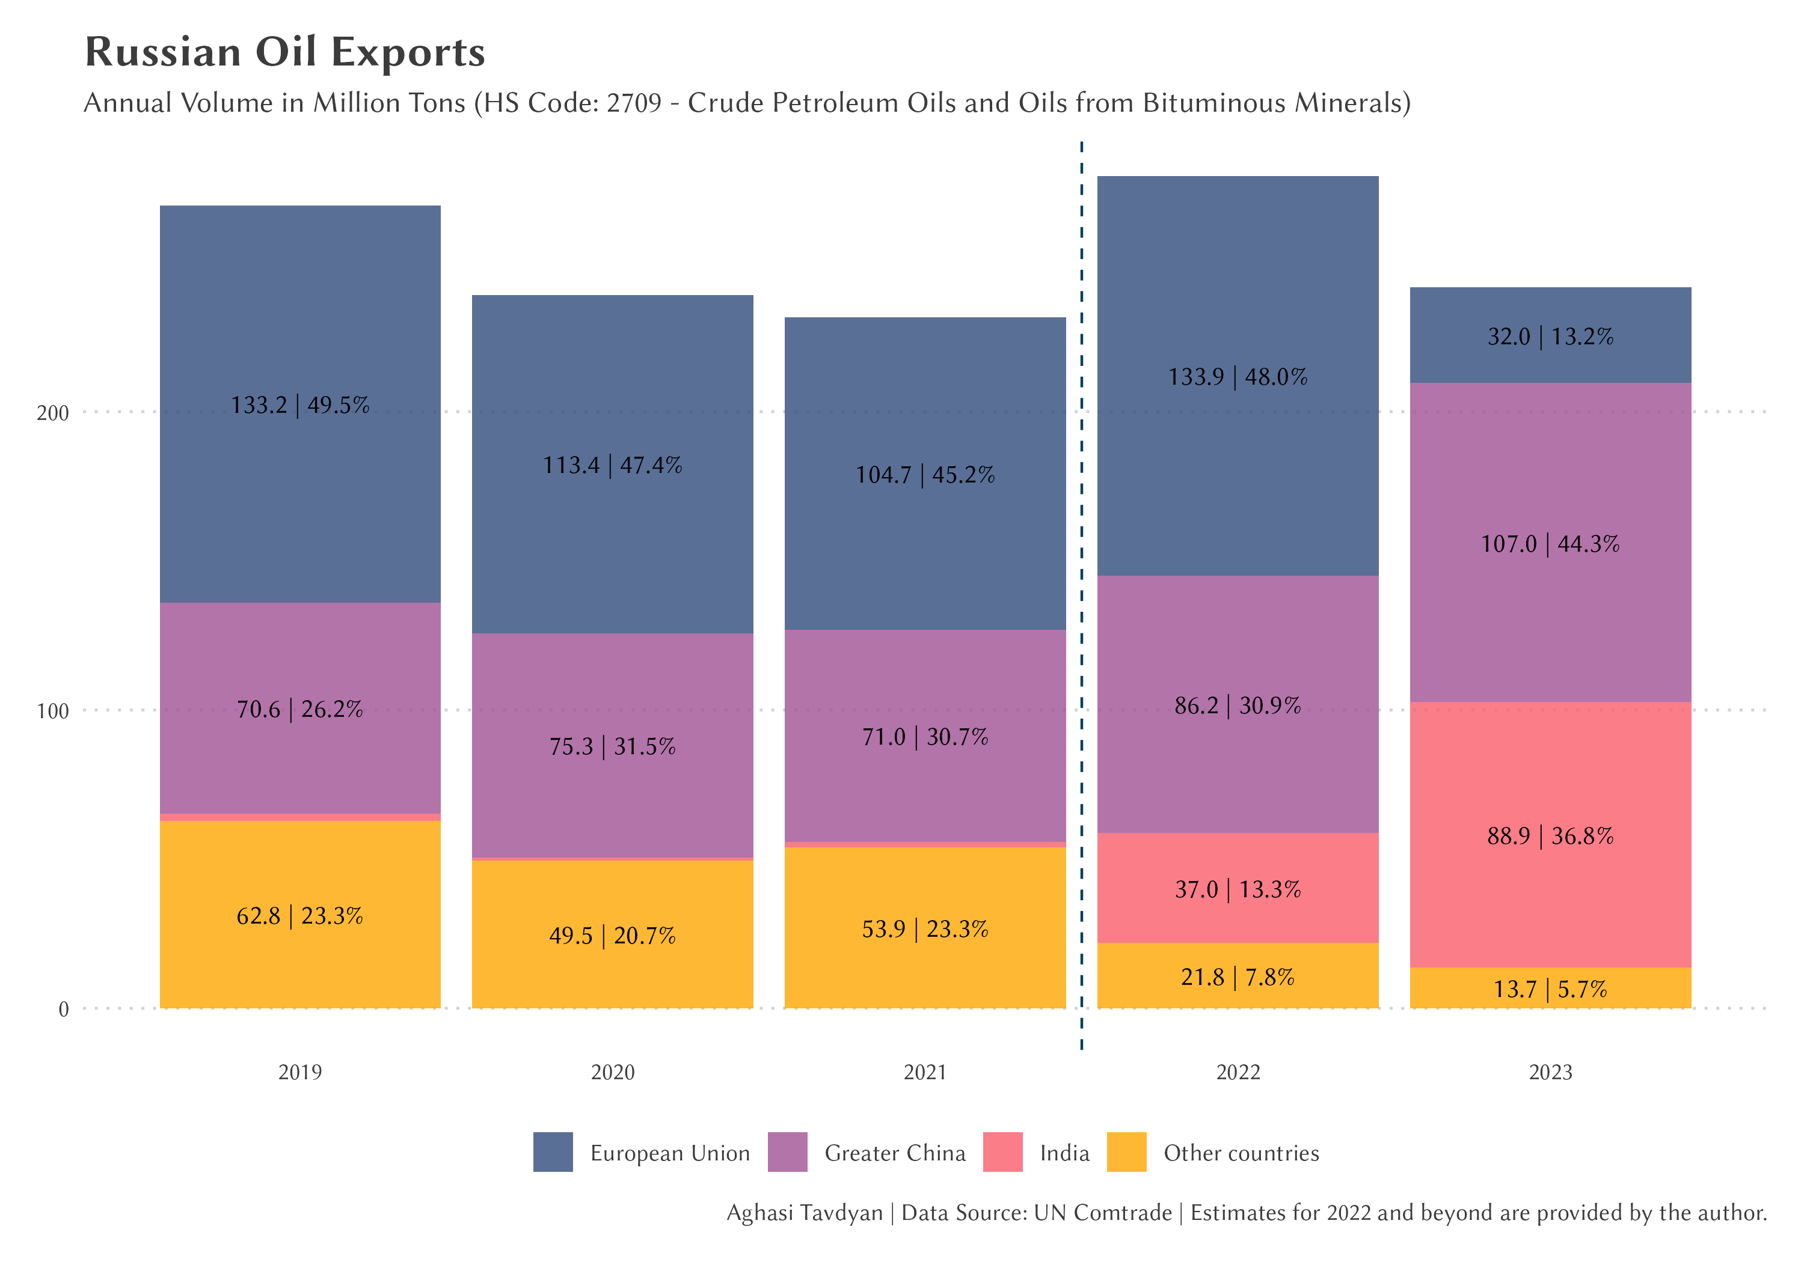

Figure 1 presents the annual volume of Russian oil exports from 2019 to 2023. The data reveals several notable trends:

1. Pre-sanction stability (2019-2021): Russian oil exports remained relatively stable, fluctuating between 231.6 and 266.6 million tons annually. This period was characterized by established trade relationships, primarily with European countries and China.
2. Post-sanction surge (2022): Following the imposition of Western sanctions in 2022, Russian oil exports surprisingly increased to 279.0 million tons. This unexpected rise can be attributed to several factors, including: a) Stockpiling by traditional buyers before sanctions took full effect b) Increased purchases by non-Western countries, particularly India and China c) Possible data discrepancies due to the challenges in tracking Russian exports post-sanctions
3. Adjustment and decline (2023): The volume of exports decreased to 241.6 million tons in 2023, reflecting the impact of sanctions and the restructuring of Russia's oil trade partnerships.

To further understand these changes, we'll examine the shifting structure of Russian oil exports.

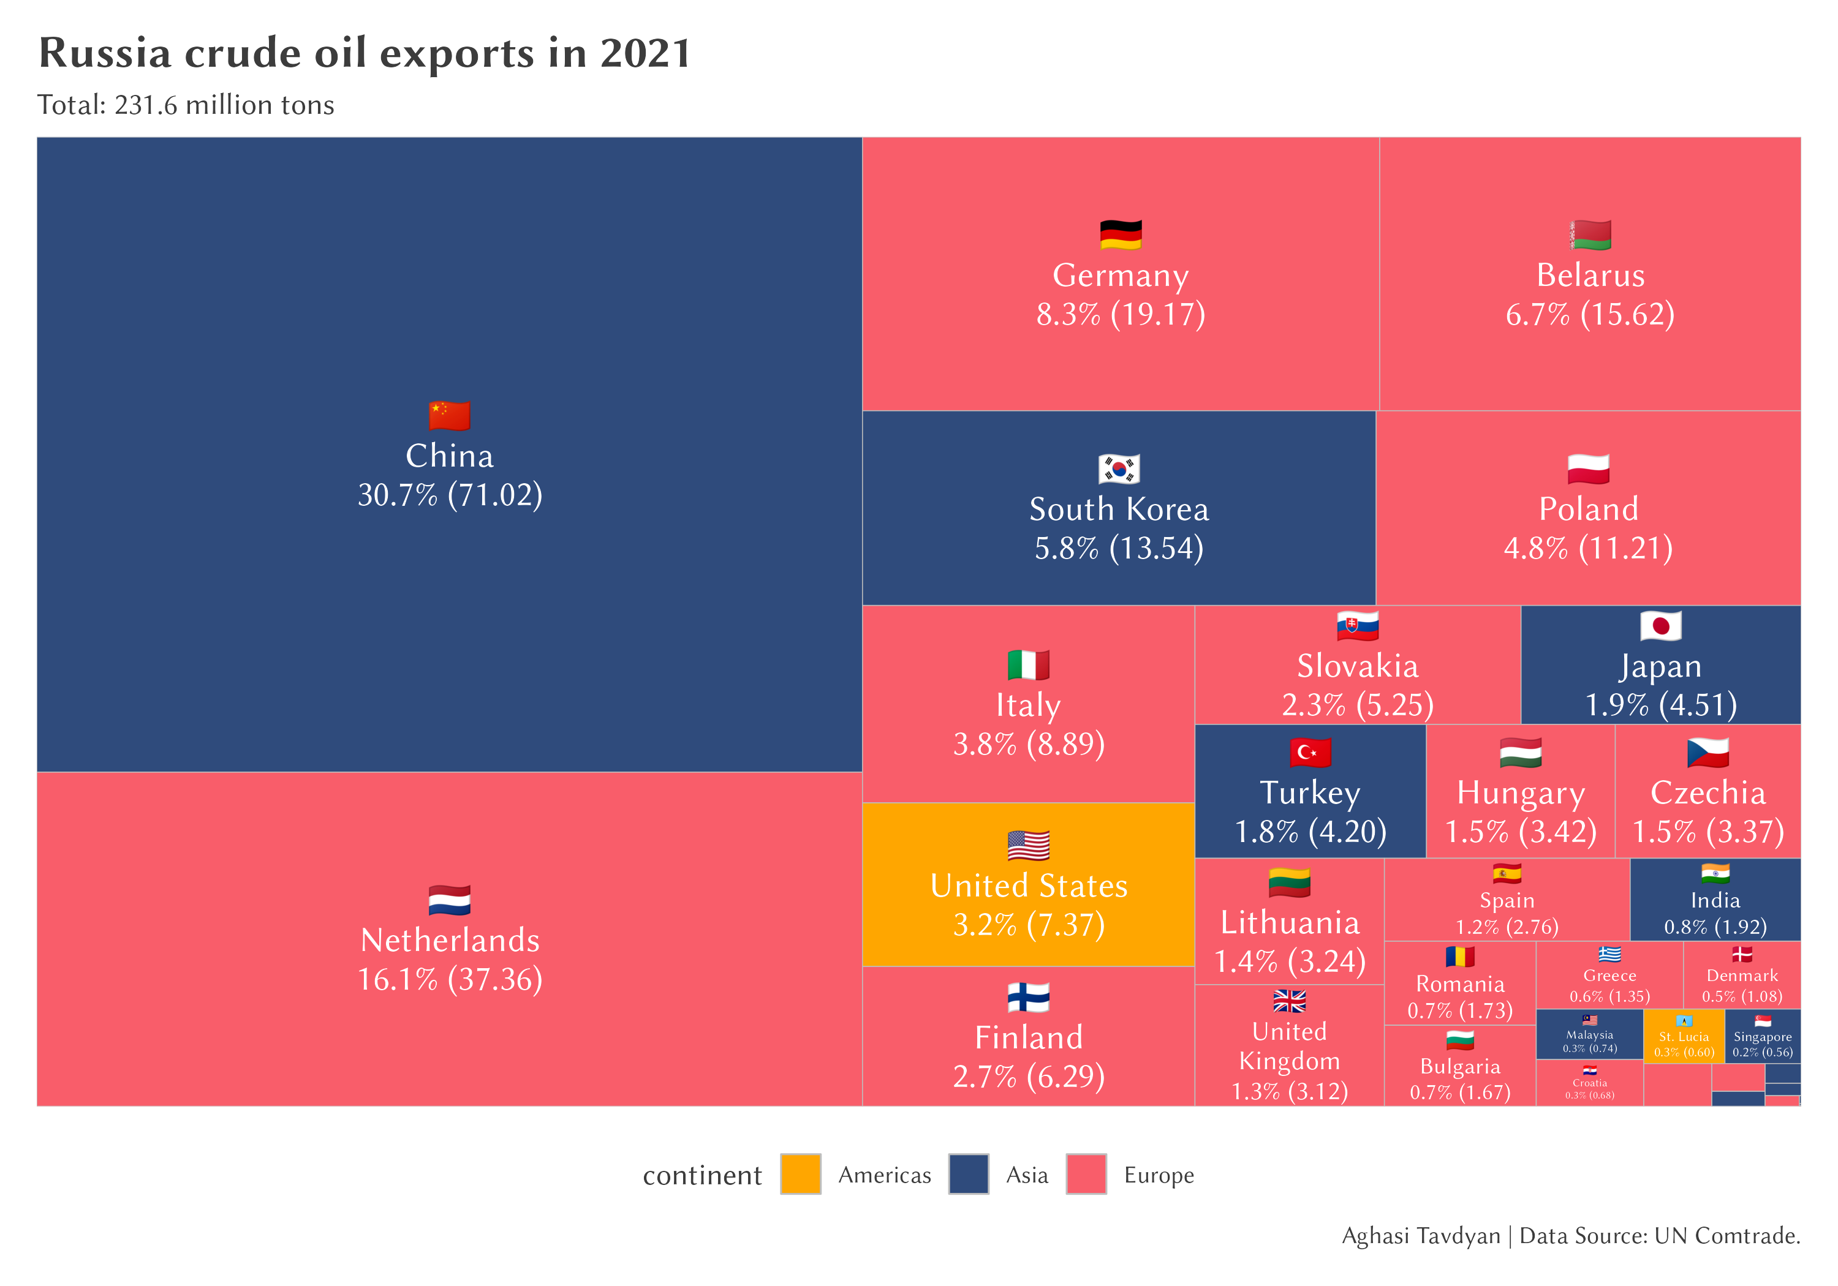Figure 2 illustrates the distribution of Russian oil exports in 2021, before the imposition of sanctions. Key observations include:

1. China was the largest importer, accounting for 30.7% (71.02 million tons) of Russian oil exports.
2. European countries collectively represented a significant portion of exports, with the Netherlands (16.1%), Germany (8.3%), and Poland (4.8%) being major importers.
3. India's share was minimal at 0.8% (1.92 million tons), highlighting its limited role in Russian oil imports pre-sanctions.

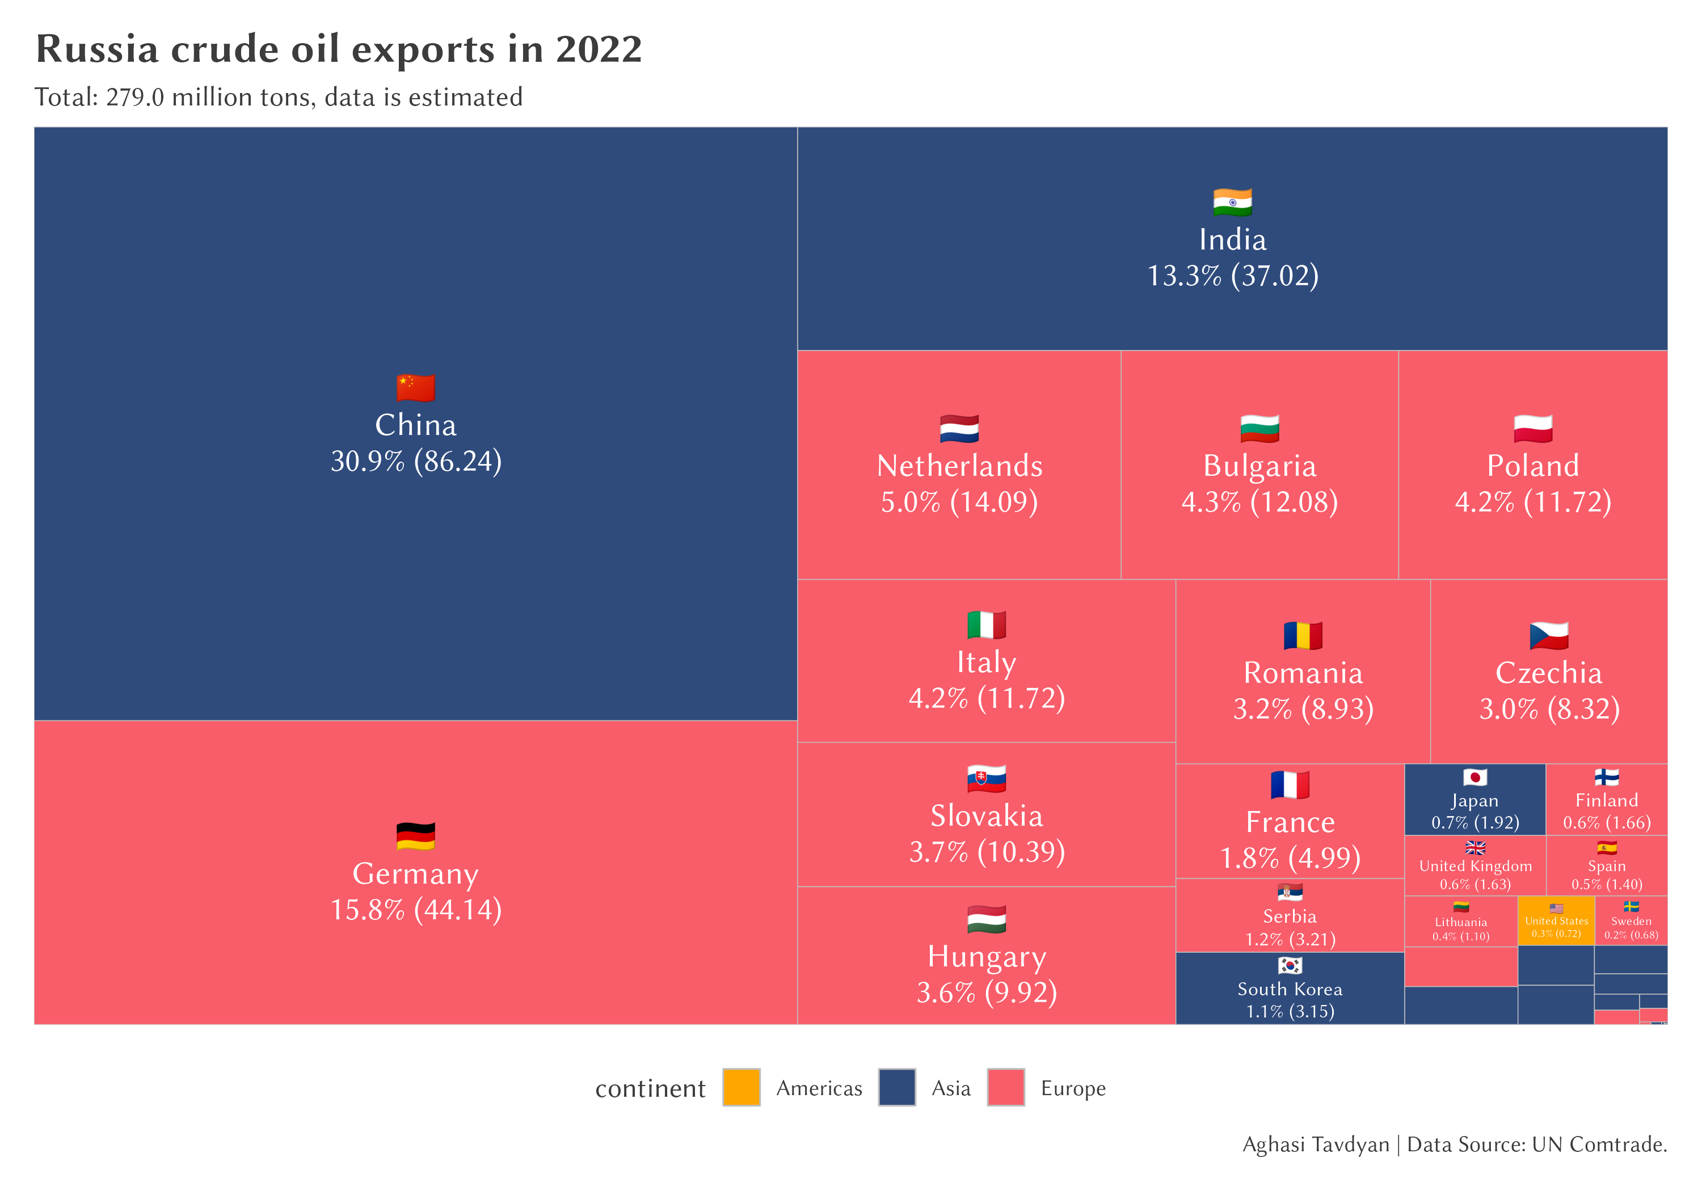Figure 3 shows the estimated distribution of Russian oil exports in 2022, reflecting the immediate impact of sanctions:

1. China maintained its position as the largest importer, slightly increasing its share to 30.9% (86.24 million tons).
2. India emerged as a significant new buyer, with its share jumping to 13.3% (37.02 million tons), a dramatic increase from the previous year.
3. European countries, while still present, showed reduced imports. Germany's share, for instance, increased to 15.8% (44.14 million tons), possibly due to stockpiling before stricter sanctions were implemented.

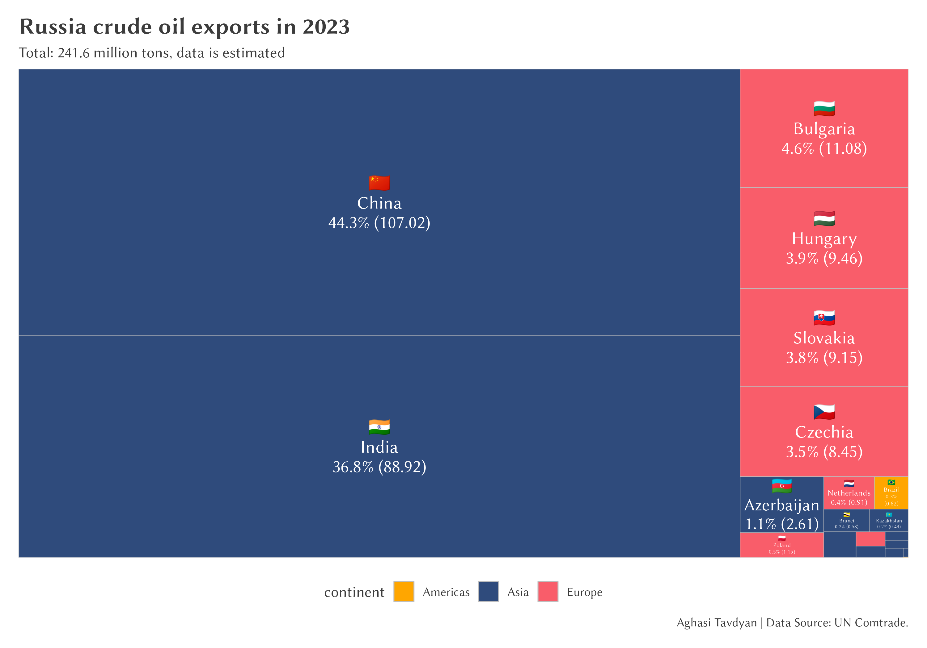Figure 4 depicts the estimated structure of Russian oil exports in 2023, revealing a dramatic shift in trade patterns:

1. China's dominance grew substantially, accounting for 44.3% (107.02 million tons) of Russian oil exports.
2. India solidified its position as the second-largest importer, with its share rising to 36.8% (88.92 million tons).
3. European countries' shares diminished significantly, with only a few countries like Bulgaria (4.6%) and Hungary (3.9%) maintaining notable imports.

These visualizations clearly demonstrate the profound impact of Western sanctions on Russian oil exports. The most striking changes include:

1. A significant eastward shift in export destinations, with China and India becoming the dominant buyers.
2. A sharp decline in exports to traditional European markets.
3. An overall reduction in export volume from the peak in 2022 to 2023, indicating the challenges Russia faces in redirecting its oil exports.

This restructuring of Russian oil exports has far-reaching implications for global energy markets, geopolitical relationships, and the effectiveness of economic sanctions as a policy tool. The next sections will delve into the broader economic impacts on Russia and its new primary importing countries.

**4.2 Economic Impact on Russia and Importing Countries**

The redirection of Russian oil exports following Western sanctions has had significant economic implications for both Russia and its new primary importing countries, particularly India. This shift in trade patterns has reshaped the global oil market and affected the economies of involved nations.

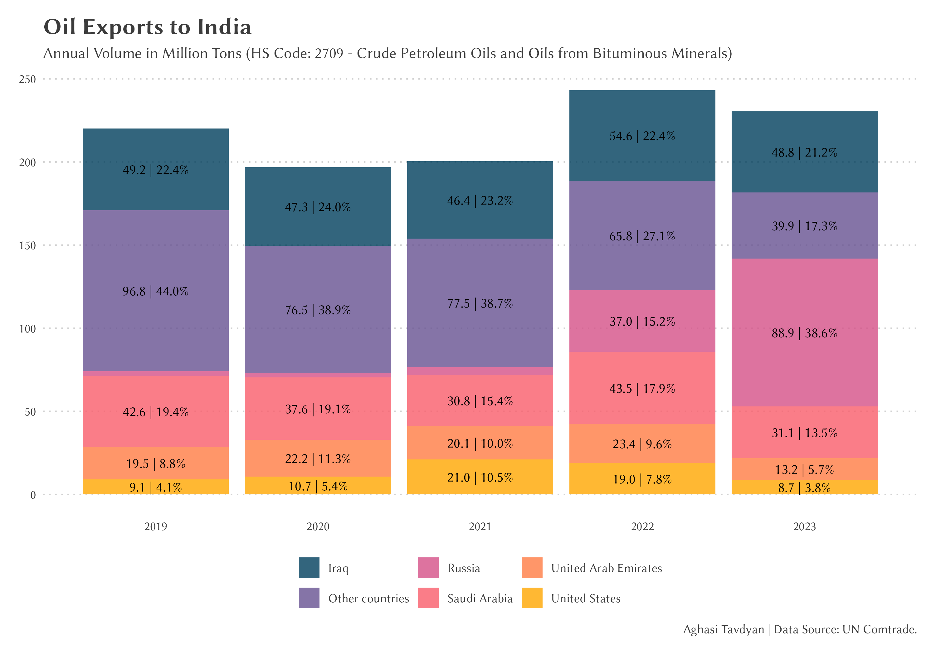Figure 5: Annual Oil Imports to India by Country (2019-2023)

As Figure 5 illustrates, India's oil import landscape has undergone a dramatic transformation since 2021. The most striking change is the surge in Russian oil imports:

1. Pre-sanctions (2019-2021): Russian oil imports to India were minimal, accounting for only 1.9 million tons (0.8% of India's total oil imports) in 2021.
2. Post-sanctions (2022-2023): Russian oil imports to India skyrocketed to 37.0 million tons (15.2% of India's imports) in 2022, further increasing to 88.9 million tons (38.6% of India's imports) in 2023.

This rapid increase in Russian oil imports has several implications:

1. For Russia:
   * Mitigation of sanctions impact: The pivot to Asian markets, particularly India, has allowed Russia to partially offset the loss of European buyers.
   * Potential price concessions: To attract new buyers, Russia may have offered discounts, potentially affecting its oil revenues.
2. For India:
   * Energy security: Increased imports from Russia have diversified India's oil sources, potentially enhancing its energy security.
   * Economic opportunity: As a major importer of crude oil, India has capitalized on potentially discounted Russian oil, which could benefit its national economy.
   * Refining industry boost: India's significant crude oil imports, coupled with its lack of crude oil exports, suggest a thriving refining industry. The country processes imported crude oil into various petroleum products.
3. Global market impact:
   * Shift in trade flows: The redirection of Russian oil to Asian markets has reshaped global oil trade routes.
   * Price dynamics: Changes in supply patterns may have influenced global oil prices and regional price differentials.

It's important to note that while India has dramatically increased its imports of Russian crude oil, it does not export crude oil itself. Instead, India processes the imported crude in its refineries, potentially exporting refined petroleum products. This aspect of India's oil trade warrants further investigation, particularly regarding:

1. The destination of India's refined petroleum product exports
2. Potential price discrepancies in these exports
3. The overall impact on India's trade balance and economic growth
4. **Discussion**

The dramatic shift in Russian oil export patterns following Western sanctions in 2022 has far-reaching implications for global energy markets, economic sustainability, and international relations. This section discusses the key implications of this export redirection, the sustainability of economic growth based on oil exports, and the regulatory and policy considerations that arise from these changes.

*5.1 Implications of Export Redirection*

The redirection of Russian oil exports from Western markets to Asian countries, particularly India and China, has several significant implications:

1. Geopolitical Realignment: The shift has strengthened economic ties between Russia and major Asian economies, potentially leading to new geopolitical alliances. This realignment could have long-term effects on global power dynamics and international cooperation.
2. Sanctions Effectiveness: The ability of Russia to redirect its oil exports raises questions about the effectiveness of Western sanctions. While the sanctions have disrupted traditional trade patterns, they have partially isolated Russia from the global oil market.
3. Global Energy Market Dynamics: The redirection has altered global oil supply chains, potentially affecting price stability and energy security for various regions. Countries that have increased their reliance on Russian oil may face new vulnerabilities or opportunities.
4. Economic Interdependence: The increased oil trade between Russia and countries like India creates new economic interdependencies. This could influence future diplomatic relations and policy decisions among these nations.

*5.2 Sustainability of Economic Growth Based on Oil Exports*

The heavy reliance on oil exports for economic growth, as exemplified by Russia's pivot to new markets, raises concerns about long-term economic sustainability:

1. Volatility Risk: Economies heavily dependent on oil exports are vulnerable to price fluctuations in the global oil market. This volatility can lead to unpredictable government revenues and economic stability development.
2. Resource Depletion: Over-reliance on non-renewable resources like oil is inherently unsustainable in the long term. Countries focused on oil exports may neglect the development of other economic sectors.
3. Diversification Challenges: For both exporting and importing countries, the current situation underscores the need for economic diversification. However, the short-term benefits of oil trade may disincentivize investments in alternative industries or energy sources.
4. Technological Disruption: The global push towards renewable energy and electric vehicles poses a long-term threat to oil-dependent economies. Failure to adapt to these trends could result in significant economic challenges in the future.

The redirection of Russian oil exports represents a significant shift in global energy trade with multifaceted implications. While it has allowed Russia to mitigate some effects of Western sanctions, it also highlights the vulnerabilities of oil-dependent economies and the complex interplay between energy trade, geopolitics, and economic sustainability. Both oil-exporting and importing countries should implement policies that promote economic diversification to reduce vulnerability to oil market fluctuations. As the global energy landscape continues to evolve, adaptive and forward-looking policies will be essential to navigate these challenges and opportunities.

1. **Limitations and Future Research**

While this study provides valuable insights into the dynamics of Russian oil exports and their economic implications, it's important to acknowledge several limitations that also point to directions for future research.

A primary limitation of this study is the lack of recent trade data from key partners, particularly China and India, which have become major importers of Russian oil. The absence of data from these countries in UN Comtrade for 2022, 2023, and 2024 may affect the accuracy of our estimates of Russian oil exports.

The reliability of mirror statistics, while a valuable tool in the absence of direct export data. However, we acknowledge that using mirror statistics may give approximate estimates, especially when data from key trading partners is missing.

Our study primarily focuses on the Russian oil export sector.

Future research should:

1. Include a more detailed analysis of how other sectors of the Russian economy are functioning in relation to the changed direction of oil exports and its price dynamics.
2. Explore potential spillover effects of changes in oil trade on other areas of the economy.
3. Analyze the long-term sustainability of economic growth dependent on the oil factor.
4. **Conclusion**

This study has examined the significant shifts in Russian oil exports following the imposition of Western sanctions in 2022, revealing substantial changes in global oil trade patterns and their economic implications.

Summary of Key Findings

1. Dramatic Shift in Export Destinations: Our analysis reveals a marked redirection of Russian oil exports from Western markets to Asian countries, particularly India and China. This shift represents a fundamental change in global oil trade dynamics.
2. Surge in India's Russian Oil Imports: The most striking finding is the exponential growth in India's imports of Russian oil. From a mere 1.92 million tons (0.8% of India's imports) in 2021, Russian oil imports to India surged to 37.0 million tons (15.2%) in 2022 and further to 88.9 million tons (38.6%) in 2023.
3. Resilience of Russian Oil Exports: Despite Western sanctions, Russia has managed to maintain significant oil export volumes by pivoting to new markets, demonstrating the adaptability of global oil trade networks.
4. Economic Implications: The redirection of oil exports has had substantial economic impacts, not only for Russia but also for importing countries like India, potentially influencing their economic growth and energy policies.
5. Data Challenges: The study highlighted some challenges in accurately tracking oil trade flows due to the absence of official Russian data and inconsistencies in international trade statistics.

Future Outlook for Russian Oil Exports

The future of Russian oil exports remains subject to several key factors:

1. Geopolitical Dynamics: The ongoing geopolitical situation, including the duration and intensity of Western sanctions, will continue to play a crucial role in shaping Russian oil export patterns.
2. Global Energy Transition: The pace of global transition towards renewable energy sources will impact long-term demand for oil, potentially affecting Russia's export strategies.
3. Economic Adaptations: Russia's ability to maintain and potentially expand its new export markets, particularly in Asia, will be critical for the sustainability of its oil-dependent economy.
4. Technological Developments: Advancements in oil extraction, transportation, and alternative energy technologies could influence the competitiveness and viability of Russian oil exports.
5. Market Competition: The response of other major oil producers to Russia's market shifts could lead to increased competition in Asian markets, potentially affecting prices and trade volumes.

The redirection of Russian oil exports represents a significant shift in global energy trade with far-reaching implications. While it has allowed Russia to mitigate some effects of Western sanctions, it also highlights the interconnectedness of global energy markets and the complex interplay between energy trade, geopolitics, and economic policy. As the global energy landscape continues to evolve, adaptive strategies and forward-looking policies will be essential for all stakeholders in navigating these challenges and opportunities. Future research, particularly focusing on the role of major importers like India and China, will be crucial in fully understanding the long-term implications of these shifts in global oil trade patterns.

**References:**

* Astrov, V., Scheckenhofer, L., Semelet, C., & Teti, F. (2024a). *Are Western Trade Sanctions Effective?* (No. 6). The Vienna Institute for International Economic Studies, wiiw.
* Astrov, V., Kochnev, A., Scheckenhofer, L., Stamer, V., & Teti, F. (2024b). *Monitoring the Impact of sanctions on the Russian Economy* (No. 46). EconPol Policy Report.
* Benita, F., & Urzua, C. M. (2016). Mirror trade statistics between China and Latin America. *Journal of Chinese Economic and Foreign Trade Studies*, *9*(3), 177-189.
* Drobyshevsky, S., & Pavlov, P. (2018). Decomposition of Economic Growth in the Russian Federation Through 2024. *Russian Economy in*, 305-310.
* Eberstadt, N. (1998). The DPRK's International Trade in Capital Goods, 1970-1995: Indications from" Mirror Statistics". *The Journal of East Asian Affairs*, *12*(1), 165-223.
* Ferrantino, M. J., Liu, X., & Wang, Z. (2012). Evasion behaviors of exporters and importers: Evidence from the US–China trade data discrepancy. *Journal of international Economics*, *86*(1), 141-157.
* Gold, R., Hinz, J., & Valsecchi, M. (2024). To Russia with love? The impact of sanctions on regime support.
* Gurvich, E., & Prilepskiy, I. (2015). The impact of financial sanctions on the Russian economy. *Russian journal of economics*, *1*(4), 359-385.
* Jensen, J., & Tarr, D. (2012). Deep trade policy options for Armenia: The importance of trade facilitation, services and standards liberalization. Economics, 6(1), 20120001.
* Kholodilin, K. A., & Netšunajev, A. (2019). Crimea and punishment: the impact of sanctions on Russian economy and economies of the euro area. Baltic Journal of Economics, 19(1), 39-51.
* Linsi, L., Burgoon, B., & Mügge, D. K. (2023). The problem with trade measurement in international relations. International Studies Quarterly, 67(2).
* Malkina, M. Y., & Balakin, R. V. (2024). Trends in the Russian Economy Development during the New Anti-Russian Sanctions. Russ. J. Econ. & L., 287.
* Manushin, D. V. (2024a). Anti-sanction and sanction economic policy of Russia in 2022--2025. Part 2: Aftermaths of sanctions war, management of changes, clarification of research concepts. RUSSIAN JOURNAL OF ECONOMICS AND LAW, 18, 37.
* Manushin, D. V. (2024b). Anti-Sanction and Sanction Economic Policy of Russia in 2022-2025. Part 3: Analysis of Anti-Crisis Measures, Managing Russian Sanctions and Anti-Sanctions. Russ. J. Econ. & L., 332.
* Mehrotra, R., & Carbonnier, G. (2021). Abnormal pricing in international commodity trade: Empirical evidence from Switzerland. Resources Policy, 74, 102352.
* Phan Thi Thu, H., & Hung, N. V. (2017). Mirror Study of Vietnam's International Merchandise Trade: Findings and Implications on Cross-Border Trade Administration. SECO/WTI Academic Cooperation Project Working Paper Series, 26.
* Skufina, T. P., Baranov, S. V., & Samarina, V. P. (2022). Analysis of forecasting documents for the socio-economic development of the Russian Arctic. Arctic, (48), 49-63.
* Tavadyan, A. (2022). Uncertainty Bands: A Guide to Predicting and Regulating Economic Processes. Anthem Press.
* Tavadyan, A., & Adilbayev, J. (2017). Перспективы развития экономических связей Армении и Казахстана. [Prospects for the development of economic relations between Armenia and Kazakhstan. 21st century] (2 (43)), 81-90.
* Tavadyan, A., & Tavadyan, Ag. (2023). Navigating Uncertainty: an Interval Method to Uncover Export Dynamics–Insights from the Republic of Armenia. International Journal of Professional Business Review: Int. J. Prof. Bus. Rev.

1. Code and data are available at: <https://github.com/tavad/articles/tree/main/2024_09_russia_oil_exports>